Week 3

Task2: Java Substring Comparisons
import java.io.*;
import java.util.*;

public class Solution {

public static String getSmallestAndLargest(String s, int k) {

String smallest = s.substring(0, k);
String largest = s.substring(0, k);

for (int i = 1; i <= s.length() - k; i++) {

String current = s.substring(i, i + k);

if (current.compareTo(smallest) < 0) {
smallest = current;
}

if (current.compareTo(largest) > 0) {
largest = current;
}
}

return smallest + "\n" + largest;
}

public static void main(String[] args) {
Scanner sc = new Scanner(System.in);
String s = sc.next();
int k = sc.nextInt();
sc.close();

System.out.println(getSmallestAndLargest(s, k));
}
}
Output:
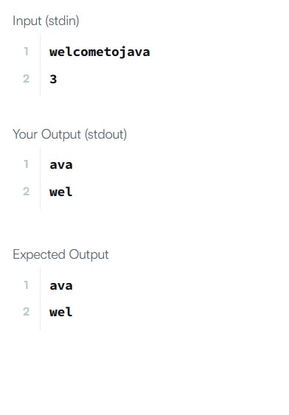

Task3: Java Comparator
import java.util.*;

class Player {
String name;
int score;

Player(String name, int score) {
this.name = name;
this.score = score;
}
}

class Checker implements Comparator<Player> {

@Override
public int compare(Player p1, Player p2) {

// Sort by score descending
if (p1.score != p2.score) {
return p2.score - p1.score;
}

// If score same, sort by name ascending
return p1.name.compareTo(p2.name);
}
}

public class Solution {
public static void main(String[] args) {

Scanner scan = new Scanner(System.in);
int n = scan.nextInt();

Player[] player = new Player[n];

for(int i = 0; i < n; i++){
player[i] = new Player(scan.next(), scan.nextInt());
}

scan.close();

Checker checker = new Checker();
Arrays.sort(player, checker);

for(int i = 0; i < player.length; i++){
System.out.printf("%s %s\n", player[i].name, player[i].score);
}
}
}
Output:
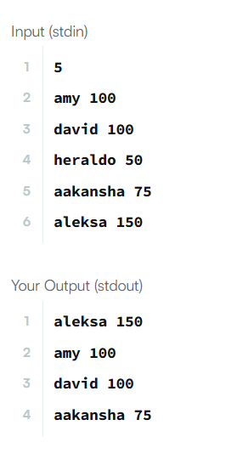

Task4:java sort
import java.util.*;

class Student {
private int id;
private String fname;
private double cgpa;

public Student(int id, String fname, double cgpa) {
this.id = id;
this.fname = fname;
this.cgpa = cgpa;
}

public int getId() {
return id;
}

public String getFname() {
return fname;
}

public double getCgpa() {
return cgpa;
}
}

public class Solution {
public static void main(String[] args) {

Scanner in = new Scanner(System.in);
int testCases = Integer.parseInt(in.nextLine());

List<Student> studentList = new ArrayList<>();

while(testCases > 0){
int id = in.nextInt();
String fname = in.next();
double cgpa = in.nextDouble();

Student st = new Student(id, fname, cgpa);
studentList.add(st);

testCases--;
}

// Sorting logic
studentList.sort(
Comparator.comparing(Student::getCgpa).reversed()
.thenComparing(Student::getFname)
.thenComparing(Student::getId)
);

for(Student st: studentList){
System.out.println(st.getFname());
}
}
}
Output:
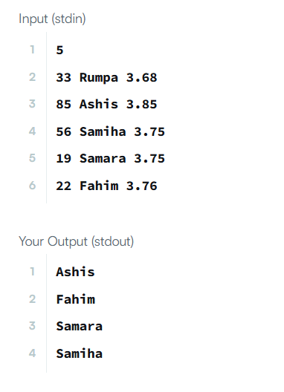
Task5:addition using strings
public String addNumberStrings(String input1, String input2) {

int i = input1.length() - 1;
int j = input2.length() - 1;
int carry = 0;

StringBuilder result = new StringBuilder();

while (i >= 0 || j >= 0 || carry != 0) {

int digit1 = (i >= 0) ? input1.charAt(i) - '0' : 0;
int digit2 = (j >= 0) ? input2.charAt(j) - '0' : 0;

int sum = digit1 + digit2 + carry;

result.append(sum % 10);
carry = sum / 10;

i--;
j--;
}

return result.reverse().toString();
}

Output:

Task6:sort the people
class Solution {
public String[] sortPeople(String[] names, int[] heights) {
int n = names.length;
// Create array of indices
Integer[] index = new Integer[n];
for (int i = 0; i < n; i++) {
index[i] = i;
}
// Sort indices based on heights descending
Arrays.sort(index, (a, b) -> heights[b] - heights[a]);
String[] result = new String[n];
for (int i = 0; i < n; i++) {
result[i] = names[index[i]];
}
return result;
}
}
Output:
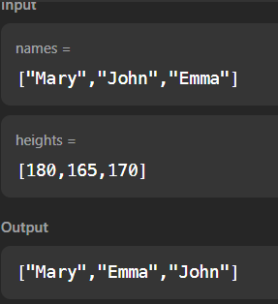

Task7: nth prime number
public int NthPrime(int input1){

int count = 0;
int number = 1;

while (count < input1) {
number++;

if (isPrime(number)) {
count++;
}
}

return number;
}

private boolean isPrime(int num){

if (num <= 1) return false;
if (num == 2) return true;
if (num % 2 == 0) return false;

for (int i = 3; i * i <= num; i += 2) {
if (num % i == 0)
return false;
}

return true;
}

Output:
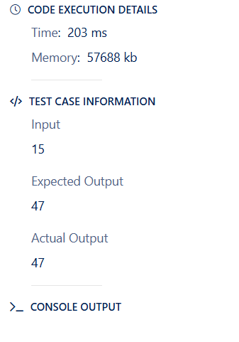

Task8: Task 8:Generate series and find Nth element
public int findNth(int n) {
int value = 1;
int diff = 1;

for (int i = 2; i <= n; i++) {
value += diff;
diff++;
}

return value;
}
Output:

