WEEK – 4
TASK-1: Determine if String Halves Are Alike
class Solution {
public boolean halvesAreAlike(String s) {
int count1=0;
int count2=0;
int mid=s.length()/2;
String vowels="aeiouAEIOU";
for(int i=0;i<mid;i++){
if(vowels.indexOf(s.charAt(i)) != -1){
count1++;
}
}
for(int i=mid;i<s.length();i++){
if(vowels.indexOf(s.charAt(i)) != -1){
count2++;
}
}
return count1==count2;

}
}
OUTPUT:
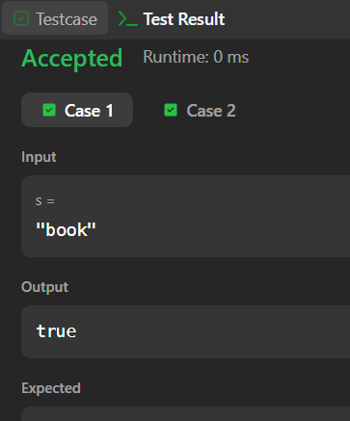
TASK 2:LAPINDROMES
import java.util.*;
import java.lang.*;
import java.io.*;
class Codechef
{
public static void main (String[] args) throws java.lang.Exception
{
Scanner sc = new Scanner(System.in);
int t = sc.nextInt(); // number of test cases

while(t-- > 0){
String s = sc.next();
int n = s.length();
int[] freq = new int[26];
// first half
for(int i = 0; i < n/2; i++){
freq[s.charAt(i) - 'a']++;
}
// second half
for(int i = (n%2==0 ? n/2 : n/2 + 1); i < n; i++){
freq[s.charAt(i) - 'a']--;
}
boolean isLapindrome = true;
for(int i = 0; i < 26; i++){
if(freq[i] != 0){
isLapindrome = false;
break;
}
}

if(isLapindrome){
System.out.println("YES");
} else {
System.out.println("NO");
}
}
}
}OUTPUT:
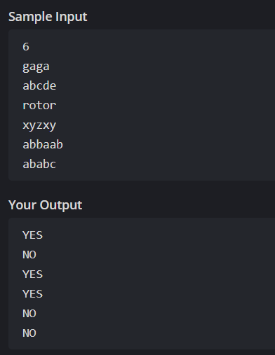
TASK 3: Compare the Triplets
import java.util.*;
public class Solution {
public static void main(String[] args) {
Scanner sc = new Scanner(System.in);
int[] a = new int[3];
int[] b = new int[3]
// Input for Alice
for(int i = 0; i < 3; i++) {
a[i] = sc.nextInt();
}
// Input for Bob
for(int i = 0; i < 3; i++) {
b[i] = sc.nextInt();
}
int aliceScore = 0;
int bobScore = 0;
for(int i = 0; i < 3; i++) {
if(a[i] > b[i]) {
aliceScore++;
} else if(a[i] < b[i]) {
bobScore++;
}
}
System.out.println(aliceScore + " " + bobScore);
}
}
OUTPUT:
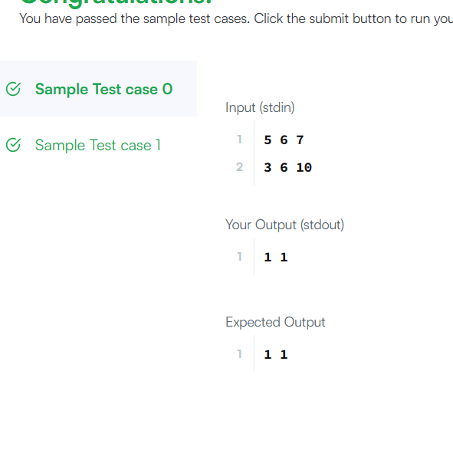

TASK 4:contains duplicate
class Solution {
public boolean containsDuplicate(int[] nums) {
HashSet<Integer> set=new HashSet<>();
for(int num:nums){
if(set.contains(num)){
return true;
}
set.add(num);
}
return false;
}
}
OUTPUT:
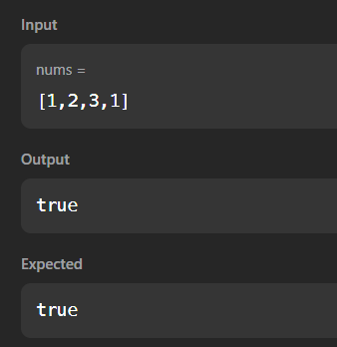

TASK 5: Time Conversion
import java.util.*;
public class Solution {
public static void main(String[] args) {
Scanner sc = new Scanner(System.in);
String s = sc.next();
String period = s.substring(8);
int hour = Integer.parseInt(s.substring(0, 2));
String rest = s.substring(2, 8);
if(period.equals("AM")) {
if(hour == 12) {
hour = 0;
}
} else {
if(hour != 12) {
hour += 12;
}
}
System.out.printf("%02d%s\n", hour, rest);
}
}
OUTPUT:
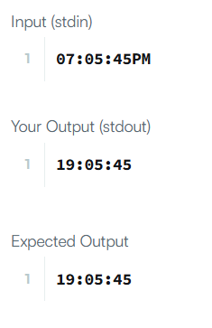

TASK6: MOVE ZEROS
class Solution {
public void moveZeroes(int[] nums) {
int j = 0;
for(int i = 0; i < nums.length; i++) {
if(nums[i] != 0) {
int temp = nums[i];
nums[i] = nums[j];
nums[j] = temp;

j++;
}
}
}
}
Output:
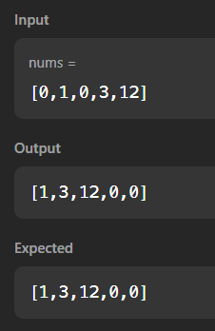
TASK7: Diagonal Difference
import java.util.*;
public class Solution {
public static void main(String[] args) {
Scanner sc = new Scanner(System.in);
int n = sc.nextInt();
int[][] matrix = new int[n][n];
for(int i = 0; i < n; i++) {
for(int j = 0; j < n; j++) {
matrix[i][j] = sc.nextInt();
}
}
int primary = 0;
int secondary = 0;

for(int i = 0; i < n; i++) {
primary += matrix[i][i];
secondary += matrix[i][n - i - 1];
}
System.out.println(Math.abs(primary - secondary));
}
}
Output:
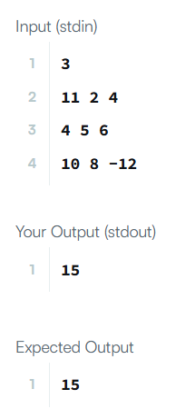
TASK8: Transporse matrix
class Solution {
public int[][] transpose(int[][] matrix) {
int m = matrix.length;
int n = matrix[0].length;
int[][] result = new int[n][m];
for(int i = 0; i < m; i++) {
for(int j = 0; j < n; j++) {
result[j][i] = matrix[i][j];
}
}
return result;
}
}

OUTPUT:
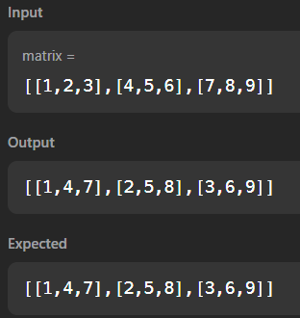

TASK 9: Matrix Block Sum
class Solution {
public int[][] matrixBlockSum(int[][] mat, int k) {
int m = mat.length;
int n = mat[0].length;
int[][] prefix = new int[m + 1][n + 1];
for(int i = 1; i <= m; i++) {
for(int j = 1; j <= n; j++) {
prefix[i][j] = mat[i-1][j-1]
+ prefix[i-1][j]
+ prefix[i][j-1]
- prefix[i-1][j-1];
}
}
int[][] result = new int[m][n];
for(int i = 0; i < m; i++) {
for(int j = 0; j < n; j++) {
int r1 = Math.max(0, i - k);
int c1 = Math.max(0, j - k);
int r2 = Math.min(m - 1, i + k);
int c2 = Math.min(n - 1, j + k);
r1++; c1++; r2++; c2++;
result[i][j] = prefix[r2][c2]
- prefix[r1-1][c2]
- prefix[r2][c1-1]
+ prefix[r1-1][c1-1];
}
}

return result;
}
}
Output:
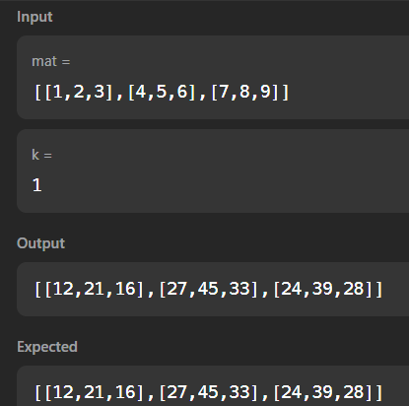

TASK10: Matrix Layer Rotation
import java.util.*;
public class Solution {
public static void main(String[] args) {
Scanner sc = new Scanner(System.in);
int m = sc.nextInt();
int n = sc.nextInt();
int r = sc.nextInt();
int[][] matrix = new int[m][n];
for(int i = 0; i < m; i++) {
for(int j = 0; j < n; j++) {
matrix[i][j] = sc.nextInt();
}
}
int layers = Math.min(m, n) / 2;
for(int layer = 0; layer < layers; layer++) {
List<Integer> list = new ArrayList<>();
int top = layer, left = layer;
int bottom = m - layer - 1;
int right = n - layer - 1;
for(int i = left; i <= right; i++) list.add(matrix[top][i]);
for(int i = top + 1; i <= bottom; i++) list.add(matrix[i][right]);
for(int i = right - 1; i >= left; i--) list.add(matrix[bottom][i]);
for(int i = bottom - 1; i > top; i--) list.add(matrix[i][left]);
int len = list.size();
int rot = r % len;
List<Integer> rotated = new ArrayList<>();
rotated.addAll(list.subList(rot, len));
rotated.addAll(list.subList(0, rot));
int idx = 0;
for(int i = left; i <= right; i++) matrix[top][i] = rotated.get(idx++);
for(int i = top + 1; i <= bottom; i++) matrix[i][right] = rotated.get(idx++);
for(int i = right - 1; i >= left; i--) matrix[bottom][i] = rotated.get(idx++);
for(int i = bottom - 1; i > top; i--) matrix[i][left] = rotated.get(idx++);
}
for(int i = 0; i < m; i++) {
for(int j = 0; j < n; j++) {
System.out.print(matrix[i][j] + " ");
}
System.out.println();
}
}
}
Output:
