WEEK – 6
TASK-1: String Similarity
import java.util.*;
class Solution {
public static void main(String[] args) {
Scanner sc = new Scanner(System.in);
int t = sc.nextInt();
while (t-- > 0) {
String s = sc.next();
System.out.println(stringSimilarity(s));
}
}
public static int stringSimilarity(String s) {
int n = s.length();
int[] z = new int[n];
int l = 0, r = 0;
for (int i = 1; i < n; i++) {
if (i <= r) {
z[i] = Math.min(r - i + 1, z[i - l]);
}
while (i + z[i] < n && s.charAt(z[i]) == s.charAt(i + z[i])) {
z[i]++;
}
if (i + z[i] - 1 > r) {
l = i;
r = i + z[i] - 1;
}
}
int sum = n;
for (int val : z) {
sum += val;
}
return sum;
}
}
OUTPUT:
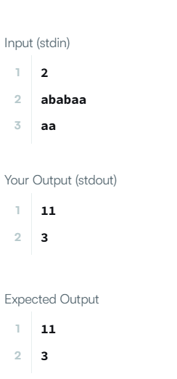
TASK 2: 459. Repeated Substring Pattern
class Solution {
public boolean repeatedSubstringPattern(String s) {
String t = s + s;
return t.substring(1, t.length() - 1).contains(s);
}
}
OUTPUT:
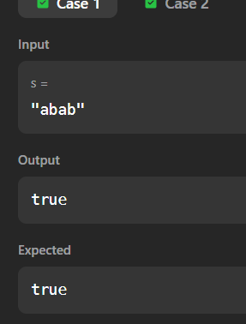

TASK 3: Two Strings
import java.util.*;
class Solution {
public static void main(String[] args) {
Scanner sc = new Scanner(System.in);
int t = sc.nextInt();
while (t-- > 0) {
String s1 = sc.next();
String s2 = sc.next();
System.out.println(twoStrings(s1, s2));
}
}
public static String twoStrings(String s1, String s2) {
Set<Character> set = new HashSet<>();
for (char c : s1.toCharArray()) {
set.add(c);
}
for (char c : s2.toCharArray()) {
if (set.contains(c)) {
return "YES";
}
}
return "NO";
}
}
OUTPUT:
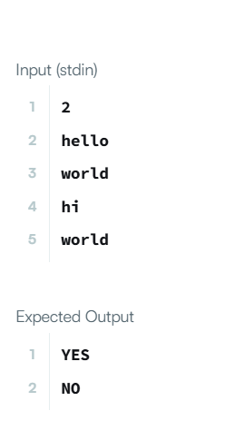
TASK 4: 796. Rotate String
class Solution {
public boolean rotateString(String s, String goal) {
if (s.length() != goal.length()) {
return false;
}
String doubled = s + s;
return doubled.contains(goal);
}
}
OUTPUT:
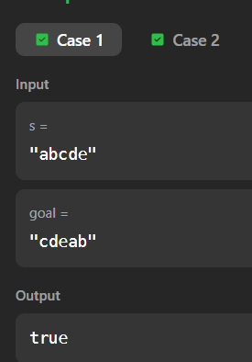

TASK 5: Mars Exploration
import java.util.*;
class Solution {
public static void main(String[] args) {
Scanner sc = new Scanner(System.in);
String s = sc.next();
int count = 0;
for (int i = 0; i < s.length(); i++) {
if (i % 3 == 0 && s.charAt(i) != 'S') {
count++;
}
else if (i % 3 == 1 && s.charAt(i) != 'O') {
count++;
}
else if (i % 3 == 2 && s.charAt(i) != 'S') {
count++;
}
}
System.out.println(count);
}
}OUTPUT:
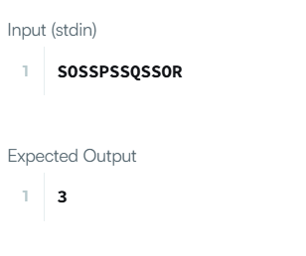
TASK6: 438. Find All Anagrams in a String
import java.util.*;
class Solution {
public List<Integer> findAnagrams(String s, String p) {
List<Integer> res = new ArrayList<>();
if (s.length() < p.length()) return res;
int[] count = new int[26];
for (char c : p.toCharArray()) {
count[c - 'a']++;
}
int left = 0, right = 0, k = p.length();
while (right < s.length()) {
if (count[s.charAt(right) - 'a']-- > 0) {
k--;
}
right++;
if (k == 0) {
res.add(left);
}
if (right - left == p.length()) {
if (count[s.charAt(left) - 'a']++ >= 0) {
k++;
}
left++;
}
}
return res;
}
}

Output:
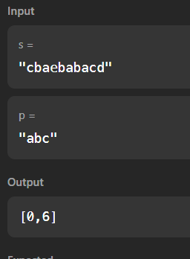
TASK7: Palindrome Index
import java.util.*;
class Solution {
public static void main(String[] args) {
Scanner sc = new Scanner(System.in);
int t = sc.nextInt();
while (t-- > 0) {
String s = sc.next();
System.out.println(palindromeIndex(s));
}
}
public static int palindromeIndex(String s) {
int left = 0, right = s.length() - 1;
while (left < right) {
if (s.charAt(left) != s.charAt(right)) {
if (isPalindrome(s, left + 1, right)) return left;
if (isPalindrome(s, left, right - 1)) return right;
return -1;
}
left++;
right--;
}
return -1;
}
private static boolean isPalindrome(String s, int l, int r) {
while (l < r) {
if (s.charAt(l) != s.charAt(r)) return false;
l++;
r--;
}
return true;
}
}
Output:
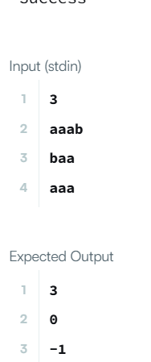
___________________________________________
TASK8: 890. Find and Replace Pattern
import java.util.*;
class Solution {
public List<String> findAndReplacePattern(String[] words, String pattern) {
List<String> res = new ArrayList<>();
for (String word : words) {
if (match(word, pattern)) {
res.add(word);
}
}
return res;
}
private boolean match(String w, String p) {
if (w.length() != p.length()) return false;
Map<Character, Character> m1 = new HashMap<>();
Map<Character, Character> m2 = new HashMap<>();
for (int i = 0; i < w.length(); i++) {
char c1 = w.charAt(i);
char c2 = p.charAt(i);
if (m1.containsKey(c1) && m1.get(c1) != c2) return false;
if (m2.containsKey(c2) && m2.get(c2) != c1) return false;
m1.put(c1, c2);
m2.put(c2, c1);
}
return true;
}
}
OUTPUT:
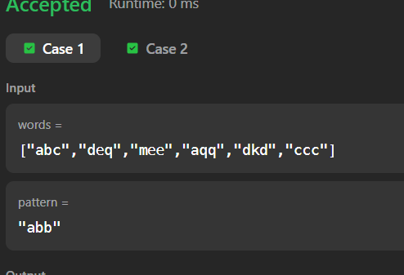

TASK 9: 1408. String Matching in an Array
import java.util.*;
class Solution {
public List<String> stringMatching(String[] words) {
List<String> res = new ArrayList<>();
for (int i = 0; i < words.length; i++) {
for (int j = 0; j < words.length; j++) {
if (i != j && words[j].contains(words[i])) {
res.add(words[i]);
break;
}
}
}
return res;
}
}
Output:
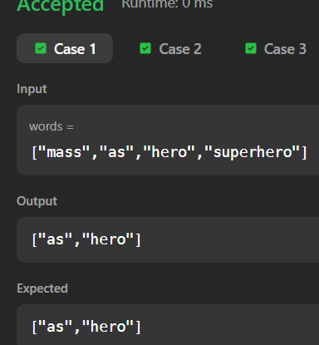

TASK10: Naive pattern search
import java.util.*;
public class Solution {
public static void main(String[] args) {
Scanner sc = new Scanner(System.in);
int m = sc.nextInt();
int n = sc.nextInt();
int r = sc.nextInt();
int[][] matrix = new int[m][n];
for(int i = 0; i < m; i++) {
for(int j = 0; j < n; j++) {
matrix[i][j] = sc.nextInt();
}
}
int layers = Math.min(m, n) / 2;
for(int layer = 0; layer < layers; layer++) {
List<Integer> list = new ArrayList<>();
int top = layer, left = layer;
int bottom = m - layer - 1;
int right = n - layer - 1;
for(int i = left; i <= right; i++) list.add(matrix[top][i]);
for(int i = top + 1; i <= bottom; i++) list.add(matrix[i][right]);
for(int i = right - 1; i >= left; i--) list.add(matrix[bottom][i]);
for(int i = bottom - 1; i > top; i--) list.add(matrix[i][left]);
int len = list.size();
int rot = r % len;
List<Integer> rotated = new ArrayList<>();
rotated.addAll(list.subList(rot, len));
rotated.addAll(list.subList(0, rot));
int idx = 0;
for(int i = left; i <= right; i++) matrix[top][i] = rotated.get(idx++);
for(int i = top + 1; i <= bottom; i++) matrix[i][right] = rotated.get(idx++);
for(int i = right - 1; i >= left; i--) matrix[bottom][i] = rotated.get(idx++);
for(int i = bottom - 1; i > top; i--) matrix[i][left] = rotated.get(idx++);
}
for(int i = 0; i < m; i++) {
for(int j = 0; j < n; j++) {
System.out.print(matrix[i][j] + " ");
}
System.out.println();
}
}
}
Output:
