**Topic Seminar**

on

**AUTONOMOUS UNDERWATER VEHICLES**

By

Vijay .S   
(U.S.N.4PS07ME093)  
DEPARTMENT OF MECHANICAL ENGG.  
P.E.S.C.E. MANDYA

**INTRODUCTION:**

An Autonomous Underwater Vehicle (AUV) is a robotic device that is driven through the water by a propulsion system, controlled and piloted by an onboard computer, and maneuverable in three dimensions. This level of control, under most environmental conditions, permits the vehicle to follow precise preprogrammed trajectories wherever and whenever required. Sensors on board the AUV sample the ocean as the AUV moves through it, providing the ability to make both spatial and time series measurements. Sensor data collected by an AUV is automatically geospatially and temporally referenced and normally of superior quality. Multiple vehicle surveys increase productivity, can insure adequate temporal and spatial sampling, and provide a means of investigating the coherence of the ocean in time and space.

Autonomous underwater vehicle fall in to mobile robotics sector and are of brilliant importance to the present world military and commercial requirements. The need to find cutting edge in military research induces the invention of AUVs. This paper gives a glimpse on autonomous underwater vehicles and its applications.

An autonomous underwater vehicle (AUV) is a robot which travels underwater without requiring input from an operator. AUVs constitute part of a larger group of undersea systems known as unmanned underwater vehicles, a classification that includes non-autonomous remotely operated underwater vehicles (ROVs) – controlled and powered from the surface by an operator/pilot via an umbilical or using remote control. In military applications AUVs more often referred to simply as unmanned undersea vehicles (UUVs).

**HISTORY:**

The first AUV was developed at the Applied Physics Laboratory at the [University of Washington](http://en.wikipedia.org/wiki/University_of_Washington) as early as 1957 by Stan Murphy, Bob Francois and later on, Terry Ewart. The "Special Purpose Underwater Research Vehicle", or [SPURV](http://en.wikipedia.org/wiki/SPURV), was used to study diffusion, acoustic transmission, and submarine wakes.

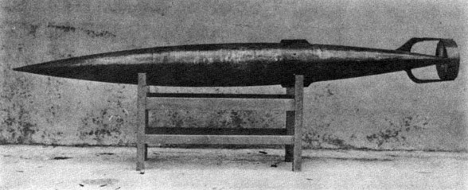  
Newport's Auto-Mobile "Fish" Torpedo (1871)

The torpedo had a two-cylinder reciprocating engine, operated by compressed air, which drove a 1-foot diameter, four-bladed propeller. A hydrostatic depth control mechanism was also used. The first torpedo trial was in 1871. The torpedo did run, but difficulty was encountered in obtaining a water-tight hull and an air-tight air flask. Azimuth control was a problem although the depth mechanism worked well.

The origin of AUV’s should probably be linked to the Whitehead Automobile “Fish” Torpedo. Robert Whitehead is credited with designing, building, and demonstrating the first Torpedo in Austria in 1866. Torpedoes are named after the Torpedo fish, which is an electric ray capable of delivering a stunning shock to its prey. Whitehead’s first torpedo achieved a speed of over 3.0 m/s and ran for 700 m. The vehicle was driven by compressed air and carried an explosive charge. If one ignores the fact that it carried an explosive charge, it might be considered the first AUV.

Other early AUVs were developed at the [Massachusetts Institute of Technology](http://en.wikipedia.org/wiki/Massachusetts_Institute_of_Technology) in the 1970s. One of these is on display in the Hart Nautical Gallery in MIT. At the same time, AUVs were also developed in the [Soviet Union](http://en.wikipedia.org/wiki/Soviet_Union)[[1]](http://en.wikipedia.org/wiki/Autonomous_underwater_vehicle#cite_note-0) (although this was not commonly known until much later).

**OVERVIEW:**

Mobile robots have the capability to move around in their environment and are not fixed to one physical location. In contrast, industrial robots usually consist of a [jointed arm](http://en.wikipedia.org/wiki/Jointed_arm) (multi linked manipulator) and [gripper](http://en.wikipedia.org/wiki/Gripper) assembly (or [end effector](http://en.wikipedia.org/wiki/Robot_end_effector)) that is attached to a fixed surface.

Mobile robots are the focus of a great deal of current research and almost every major university has one or more labs that focus on mobile robot research. Mobile robots are also found in industry, military and security environments. They also appear as consumer products, for entertainment or to perform certain tasks like vacuum.

**CLASSIFICATION:**

Mobile robots may be classified by the environment in which they travel:

* Land or home robots. ([humanoid](http://en.wikipedia.org/wiki/Humanoid_robot), or resembling animals or insects).
* Aerial robots are usually referred to as [unmanned aerial vehicles](http://en.wikipedia.org/wiki/Unmanned_aerial_vehicles) (UAVs)
* Underwater robots are usually called [autonomous underwater vehicles](http://en.wikipedia.org/wiki/Autonomous_Underwater_Vehicle) (AUVs)
* Polar robots, designed to navigate icy, [crevasse](http://en.wikipedia.org/wiki/Crevasse) filled environments

**VEHICLE** **DESIGNS:**

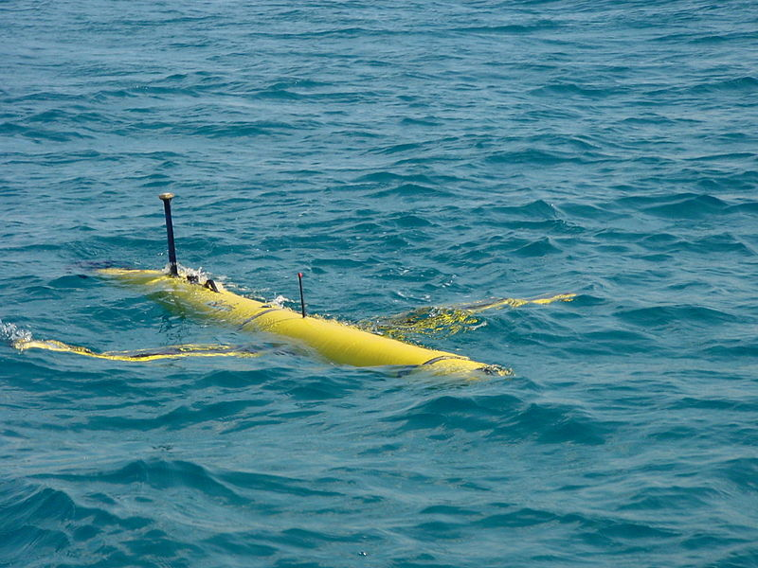

Bluefin-12 AUV

Hundreds of different AUVs have been designed over the past 50 or so years, but only a few companies sell vehicles in any significant numbers. There are about 10 companies that sell AUVs on the international market, including Kongsberg Maritime, Hydroid (now owned by Kongsberg), Bluefin Robotics, International Submarine Engineering Ltd. and Hafmynd.

Vehicles range in size from man portable lightweight AUVs to large diameter vehicles of over 10 metres length. Once popular amongst the military and commercial sectors, the smaller vehicles are now losing popularity. It has been widely accepted by commercial organizations that to achieve the ranges and endurances required to optimize the efficiencies of operating AUVs a larger vehicle is required. However, smaller, lightweight and less expensive AUVs are still common as a budget option for universities.

Some manufacturers have benefited from domestic government sponsorship including Bluefin and Kongsberg. The market is effectively split into three areas: scientific (including universities and research agencies), commercial offshore (oil and gas etc.) and military application (mine countermeasures, battle space preparation). The majority of these roles utilize a similar design and operate in a cruise mode. They collect data while following a preplanned route at speeds between 1 and 4 knots.

Commercially available AUVS include various designs such as the small REMUS 100 AUV developed by [Woods Hole Oceanographic Institution](http://en.wikipedia.org/wiki/Woods_Hole_Oceanographic_Institution) in the US and now marketed by Hydroid, Inc.; the larger HUGIN 1000 and 3000 AUVs developed by [Kongsberg Maritime](http://en.wikipedia.org/wiki/Kongsberg_Maritime) and [Norwegian Defense Research Establishment](http://en.wikipedia.org/wiki/Norwegian_Defence_Research_Establishment); the Bluefin Robotics 12-and-21-inch-diameter (300 and 530 mm) vehicles and the International Submarine Engineering Ltd. Explorer. Most AUVs follow the traditional torpedo shape as this is seen as the best compromise between size, usable volume, hydrodynamic efficiency and ease of handling. There are some vehicles that make use of a modular design, enabling components to be changed easily by the operators.

The market is evolving and designs are now following commercial requirements rather than being purely developmental. The next stage is likely to be a hybrid AUV/ROV that is capable of surveys and light intervention tasks. This requires more control and the ability to hover. Again, the market will be driven by financial requirements and the aim to save money and expensive ship time.

Today, while most AUVs are capable of unsupervised missions most operators remain within range of acoustic telemetry systems in order to maintain a close watch on their investment. This is not always possible. For example, Canada has recently taken delivery of two AUVs (ISE Explorers) to survey the sea floor underneath the Arctic ice in support of their claim under Article 76 of the United Nations Convention of the Law of the Sea. Also, ultra-low-power, long-range variants such as [underwater gliders](http://en.wikipedia.org/wiki/Underwater_glider) are becoming capable of operating unattended for weeks or months in littoral and open ocean areas, periodically relaying data by satellite to shore, before returning to be picked up.

As of 2008, a new class of AUVs are being developed, which mimic designs found in nature. Although most are currently in their experimental stages, these [biomimetic](http://en.wikipedia.org/wiki/Biomimetic) (or [bionic](http://en.wikipedia.org/wiki/Bionic)) vehicles are able to achieve higher degrees of efficiency in propulsion and maneuverability by copying successful designs in nature. Two such vehicles are [Festo](http://en.wikipedia.org/wiki/Festo)'s [AquaJelly](http://en.wikipedia.org/w/index.php?title=AquaJelly&action=edit&redlink=1) and [Evologics](http://en.wikipedia.org/w/index.php?title=Evologics&action=edit&redlink=1)' [Bionik Manta](http://en.wikipedia.org/w/index.php?title=Bionik_Manta&action=edit&redlink=1).

### SENSORS:

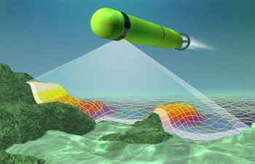  
AUV Model with sonar scanning

Sonar (originally an [acronym](http://en.wikipedia.org/wiki/Acronym) for SOund Navigation And Ranging) is a technique that uses [sound](http://en.wikipedia.org/wiki/Sound) propagation (usually underwater, as in [Submarine navigation](http://en.wikipedia.org/wiki/Submarine_navigation)) to [navigate](http://en.wikipedia.org/wiki/Navigation), communicate with or detect other vessels. Two types of technology share the name "sonar": passive sonar is essentially listening for the sound made by vessels; active sonar is emitting pulses of sounds and listening for echoes. Sonar may be used as a means of [acoustic location](http://en.wikipedia.org/wiki/Acoustic_location) and of measurement of the echo characteristics of "targets" in the water. [Acoustic location](http://en.wikipedia.org/wiki/Acoustic_location) in air was used before the introduction of [radar](http://en.wikipedia.org/wiki/Radar). Sonar may also be used in air for robot navigation.

AUVs carry sensors to navigate autonomously and map features of the ocean. Typical sensors include [compasses](http://en.wikipedia.org/wiki/Compass), depth sensors, [sidescan](http://en.wikipedia.org/wiki/Side_scan_sonar) and other [sonars](http://en.wikipedia.org/wiki/Sonar), [magnetometers](http://en.wikipedia.org/wiki/Magnetometer), [thermistors](http://en.wikipedia.org/wiki/Thermistor) and conductivity probes. A demonstration at [Monterey Bay](http://en.wikipedia.org/wiki/Monterey_Bay) in [California](http://en.wikipedia.org/wiki/California) in September 2006 showed that a 21-inch (530 mm) diameter AUV can tow a 300 feet (91 m) long hydrophone array while maintaining a 3-knot (5.6 km/h) cruising speed.

### NAVIGATION:

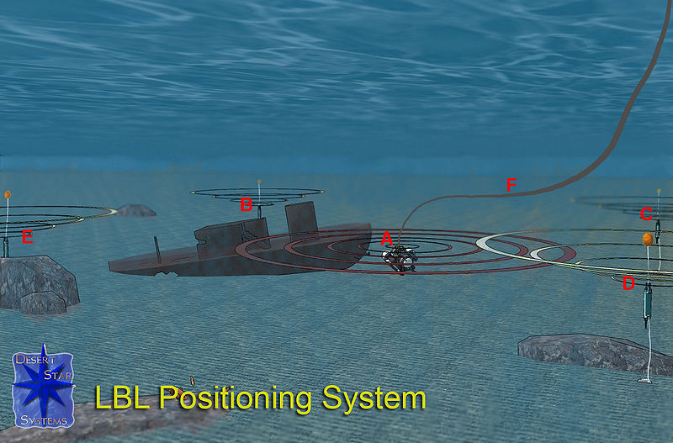  
Long Base Line navigation system (LBL)

Discription: Operation of a Long Baseline (LBL) underwater acoustic positioning system for ROV. Interrogator (A) mounted on the ROV transmits an acoustic signal that is received by baseline transponders (B, C, D, E). The reply of the baseline transponders is received by (A). Either the time-of-flight or the corresponding distances A-B, A-C, A-D and A-E are transmitted via the ROV umbilical (F) to the surface, where the ROV position is computed and displayed on a tracking screen.

AUVs can navigate using an [underwater acoustic positioning system](http://en.wikipedia.org/wiki/Underwater_Acoustic_Positioning_System). When operating within a net of sea floor deployed baseline transponders this is known as [LBL navigation](http://en.wikipedia.org/wiki/Long_Baseline_Acoustic_Positioning_System)

When a surface reference such as a support ship is available, [ultra-short baseline](http://en.wikipedia.org/wiki/Ultra-short_baseline) (USBL) or [short-baseline (SBL)](http://en.wikipedia.org/wiki/Short_Baseline_Acoustic_Positioning_System) positioning is used to calculate where the subsea vehicle is relative to the known ([GPS](http://en.wikipedia.org/wiki/GPS)) position of the surface craft by means of acoustic range and bearing measurements. When it is operating completely autonomously, the AUV will surface and take its own GPS fix. Between position fixes and for precise maneuvering, an [inertial navigation system](http://en.wikipedia.org/wiki/Inertial_navigation_system) on board the AUV measures the acceleration of the vehicle and Doppler velocity technology is used to measure rate of travel. A pressure sensor measures the vertical position. These observations are [filtered](http://en.wikipedia.org/wiki/Kalman_filter) to determine a final navigation solution. An emerging alternative is using an [inertial navigation system](http://en.wikipedia.org/wiki/Inertial_navigation_system) in conjunction with either a GPS receiver, or an additional magnetic compass for [Dead Reckoning](http://en.wikipedia.org/wiki/Dead_Reckoning) whenever the GPS signal is lost.

### PROPULSION:

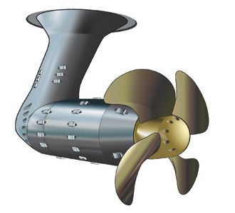  
AUV Propeller

AUVs can rely on a number of propulsion techniques, but [propeller](http://en.wikipedia.org/wiki/Propeller) based [thrusters](http://en.wikipedia.org/wiki/Thruster) or [Kort_nozzles](http://en.wikipedia.org/wiki/Kort_nozzle) are the most common by far. These thrusters are usually powered by electric motors and sometimes rely on a lip seal in order to protect the motor internals from corrosion. One consideration which impacts this process of waterproofing is the decision to use [brushed motors](http://en.wikipedia.org/wiki/Brushed_motor) or [brushless motors](http://en.wikipedia.org/wiki/Brushless_motor). This same consideration also impacts reliability, efficiency, and cost.

### POWER:

Most AUVs in use today are powered by rechargeable batteries ([lithium ion](http://en.wikipedia.org/wiki/Lithium_ion), [lithium polymer](http://en.wikipedia.org/wiki/Lithium_polymer), [nickel metal hydride](http://en.wikipedia.org/wiki/Nickel_metal_hydride) etc), and are implemented with some form of [Battery Management System](http://en.wikipedia.org/wiki/Battery_Management_System). Some vehicles use primary batteries which provide perhaps twice the endurance—at a substantial extra cost per mission. A few of the larger vehicles are powered by aluminum based semi-[fuel cells](http://en.wikipedia.org/wiki/Fuel_cell), but these require substantial maintenance, require expensive refills and produce waste product that must be handled safely. An emerging trend is to combine different battery and power systems with [Ultra-capacitors](http://en.wikipedia.org/wiki/Ultra-capacitors).

## APPLICATIONS:

Until recently, AUVs have been used for a limited number of tasks dictated by the technology available. With the development of more advanced processing capabilities and high yield power supplies, AUVs are now being used for more and more tasks with roles and missions constantly evolving.

### COMMERCIAL:

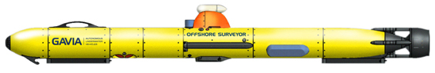GAVIA Commercial AUV for oil rigs

The Gavia is the global provider of commercial AUVs known for its performance and adoptability. Best for surveying work as well as oil rig maintenance.

The oil and gas industry uses AUVs to make detailed maps of the seafloor before they start building subsea infrastructure; pipelines and sub sea completions can be installed in the most cost effective manner with minimum disruption to the environment. The AUV allows survey companies to conduct precise surveys or areas where traditional bathymetric surveys would be less effective or too costly. Also, post-lay pipe surveys are now possible.

### MILITARY:

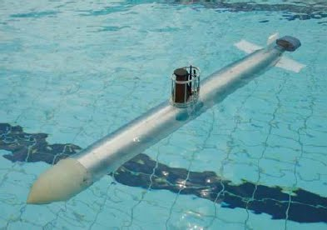  
Starfish 2 U.S.A. navy

A typical military mission for an AUV is to map an area to determine if there are any mines, or to monitor a protected area (such as a harbor) for new unidentified objects. AUVs are also employed in anti-submarine warfare, to aid in the detection of manned submarines.

On the military side of the equation, AUVs have been under development for decades, and they are now reaching an operational status. Their initial fleet application will be for mine hunting, which was also the case for fleet introduction of ROVs. However, in the case of AUVs, they will operate from a submarine and not a surface ship. The U.S. Navy’s submarine launched AUV is the Long Term Mine Reconnaissance System (LMRS), which is scheduled for initial operation in 2003.

### RESEARCH:

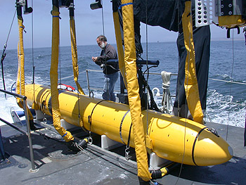  
Sea duane 2 AUV from Flinders University Adelaide Australia.

There is a ton of development in research sector of AUVs but the latest goes to Sea Duane 2 of Flinders University Australia. SD2 is used for underwater surface scanning and life assessment of deep sea organisms.

Scientists use AUVs to study lakes, the ocean, and the ocean floor. A variety of sensors can be affixed to AUVs to measure the concentration of various elements or compounds, the absorption or reflection of light, and the presence of microscopic life.

### HOBBY:

Many roboticists construct AUVs as a hobby. Several competitions exist which allow these homemade AUVs to compete against each other while accomplishing objectives. Like their commercial brethren, these AUVs can be fitted with cameras, lights, or sonar. As a consequence of limited resources and inexperience, hobbiest AUVs can rarely compete with commercial models on operational depth, durability, or sophistication. Finally, these hobby AUVs are usually not oceangoing, being operated most of the time in pools or lakebeds.

**FUTURE POSSIBILITIES:**

“The trouble with our times is that the future is not what it used to be”. **–**Paul Valery

AUVs are now at an early stage of acceptance. As they work their way into the phase of operational acceptance on a commercial level, their numbers will grow. Academia is not only using AUVs but also spinning off firms to supply commercial versions. And the US Navy is gearing up to push the technology, ensuring that cost-effective systems are available for use by the fleet in the future.

Finding better ways of observing and reporting on the interior of the ocean, its seafloors and coastal boundaries remain principal objectives of the oceanographic community. Utilizing productive and affordable technologies that offer a new perspective of the ocean by providing sampling methodologies that merge the high spatial resolution of ship-based surveys with the endurance and temporal resolution of moorings may be one “better way” The broad use of this technology by the ocean science community is hopefully in our future.

C&C Technologies, Inc.’s AUV Hugin has proven that the cost of deep water survey operations can be reduced by 40% to 60% by using AUV’s rather than conventional methods, while improving the quality of the data that is collected [12]. Given the budgetary constraints that face the oceanographic community and the need for high quality data, it is unwise to ignore this potential.

**REFERENCE:**

1. “Autonomous underwater vehicles” – Stefan Ericson et.al., Bluefin Robotics, Cambridge, U.S.A.
2. “Individual and swarm style AUVs” – Dr. Uwe R. Zimmer, Australian National University - Canberra, Australia
3. “Underwater imaging, AUVs” – Dr. Steve Tetlow, Cranfield University - Cranfield , U.K.
4. “Sonar for underwater inspection” - Morten Lind, Technical University of **Denmark** - Lyngby, Denmark