LMS Project details
Database schema:
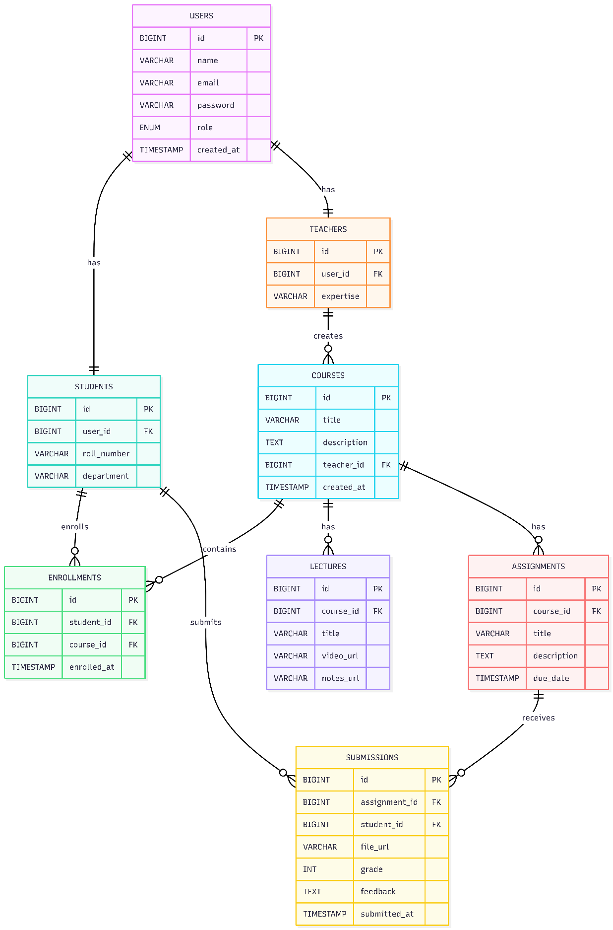
APIs

🔐 1. AUTHENTICATION APIs
(PUBLIC for login only)
⚠️ NO public student/teacher registration
Method | URL | Description
POST | /api/auth/login | Login Student /Teacher/Admin
POST | /api/auth/logout | Logout (optional – token based)
GET | /api/auth/me | Get logged-in user info
POST | /api/auth/first-login/reset-password | Reset password on first login
✅ Industry truth:
Registration is admin-only, login is public.

🛡️ 2. ADMIN APIs (ROLE: ADMIN)
Admin = system owner
👤 User Management
Method | URL | Description
POST | /api/auth/register/student | Create student
POST | /api/auth/register/teacher | Create teacher
GET | /api/admin/users | View all users
GET | /api/admin/users/{id} | Get user details
PUT | /api/admin/users/{id} | Update user
DELETE | /api/admin/users/{id} | Disable / delete user
🔐 Admin creates credentials and shares them securely

🎓 Student Management
Method | URL | Description
GET | /api/admin/students | View all students
GET | /api/admin/students/{id} | View student profile
DELETE | /api/admin/students/{id} | Remove student

👨‍🏫 Teacher Management
Method | URL | Description
GET | /api/admin/teachers | View all teachers
PUT | /api/admin/teachers/{id}/approve | Approve teacher
DELETE | /api/admin/teachers/{id} | Remove teacher

📊 Platform Monitoring
Method | URL | Description
GET | /api/admin/stats | LMS statistics
GET | /api/admin/audit-logs | Admin action logs

👨‍🎓 3. STUDENT APIs (ROLE: STUDENT)
👤 Profile
Method | URL | Description
GET | /api/students/me | Get own profile
PUT | /api/students/me | Update profile

📚 Courses & Enrollment
Method | URL | Description
GET | /api/courses | View all courses
GET | /api/courses/{courseId} | Course details
POST | /api/students/enroll/{courseId} | Enroll in course
GET | /api/students/courses | My courses

📝 Assignments & Submissions
Method | URL | Description
GET | /api/students/assignments | View assignments
POST | /api/students/submissions/{assignmentId} | Submit assignment
GET | /api/students/submissions | My submissions

👨‍🏫 4. TEACHER APIs (ROLE: TEACHER)
👤 Profile
Method | URL | Description
GET | /api/teachers/me | Get own profile
PUT | /api/teachers/me | Update profile

📚 Course Management
Method | URL | Description
POST | /api/teachers/courses | Create course
GET | /api/teachers/courses | My courses
PUT | /api/teachers/courses/{courseId} | Update course
DELETE | /api/teachers/courses/{courseId} | Delete course

🎥 Lecture Management
Method | URL | Description
POST | /api/teachers/courses/{courseId}/lectures | Add lecture
GET | /api/courses/{courseId}/lectures | View lectures
DELETE | /api/lectures/{lectureId} | Delete lecture

📝 Assignment & Grading
Method | URL | Description
POST | /api/teachers/courses/{courseId}/assignments | Create assignment
GET | /api/teachers/assignments | View own assignments
PUT | /api/assignments/{id} | Update assignment
DELETE | /api/assignments/{id} | Delete assignment
GET | /api/assignments/{id}/submissions | View submissions
PUT | /api/submissions/{id}/grade | Grade submission

📘 5. PUBLIC COURSE APIs (READ-ONLY)
Method | URL | Description
GET | /api/courses | View all courses
GET | /api/courses/{courseId} | Course details
🔐 Students must be logged in to enroll

🔒 SECURITY RULES (FINAL)
Role | Permissions
PUBLIC | Login, view courses
STUDENT | Enroll, submit assignments
TEACHER | Create content, grade
ADMIN | Full system control

