ITC209
Mobile Application
Development

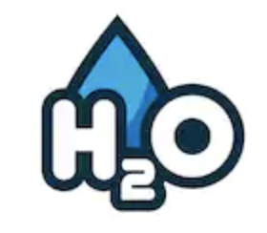

Umut Oztuna
11645869
30/07/2019

Table of Contents
Introduction 3
Myself 3
Project Scope 3
Project Tiers 3
H2O App 3
Main Screen 3
History Screen 3
Settings 3
Project Design 4
Full Use Case Descriptions 4
Use Case 1: Set Weight 4
Use Case 2: Set Target Water 5
Use Case 3: Set Notifications 5
Use Case 4: Input 6
Use Case 5: View Daily Usage 6
Use Case 6: View History 7
Sequence Diagrams 8
Class Diagram 11
Project Requirements 11
GUI Mock-Up 12

Introduction

Myself
Currently, I’m studying Bachelor of IT, with Software Design & Development specialisation. It’s my last year, and I developed some programming skills during my study. I don’t have any knowledge about “Mobile Software Development”, but I’m willing to learn. The subjects I completed which related with this subject;
- Programming in Java I-II
- Object Oriented Systems Analysis and Design
- Human Computer Interaction
- Introduction to Database Systems

Project Scope
Unfortunately, it isn’t always easy to know for sure that we’re getting the right amount of water in our daily life. That’s where hydration apps come in. H2O is designed to track and improve the daily water intake of the user. It calculates how much water the body need based on user body weight or personal goal. Then, it sends reminders all day long, making it easy to hit users’ target intake. Create custom cups for fast, simple logging, and browse the hydration history to see the progress. The aim is to help people to drink more water

Project Tiers
- T1-1Meaningful User Interaction
- T1-2 Loading and playing Media
- T1-3 File, State and Database Saving
- T1-4 Push Notifications/Alerts
- T2-6 Visualization (chart)

H2O App
The app includes three different screens and also loading screen. User can switch between screens with buttons which are located in the bottom part of the screen.

Main Screen
Main screen allows to user to manage their daily hydration. It shows the amount of daily intake in a pie chart, and also allows user to input the water intake in different amounts such as 1 glass of water (200ml), ½ glass of water (100ml), and Australian standard bottle water (600ml). User can click on the desired icon to input the amount of water consumption.

History Screen
User will be able to track the history of the water consumption. H20 app keeps the records of last 4 weeks and shows it as a chart in daily basis

Settings
This section allows user to input his/her weight, so app can calculate the correct amount of daily target. User can also setup the desired target amount manually. In addition, notification of the app can be turn on and off from this section.

Project Design
H2O project will design to work on Android devices. Android Studio will be used to develop the software with JAVA programming language. Android is selected as a planform due to high market share, so it will be available to the large numbers of customer.

IOS provides lot more potential for developers and apps, but it’s only limited to iPhone and iPad. On the other hand, Windows Mobile has very small share on the market, and not supported by many app developers.

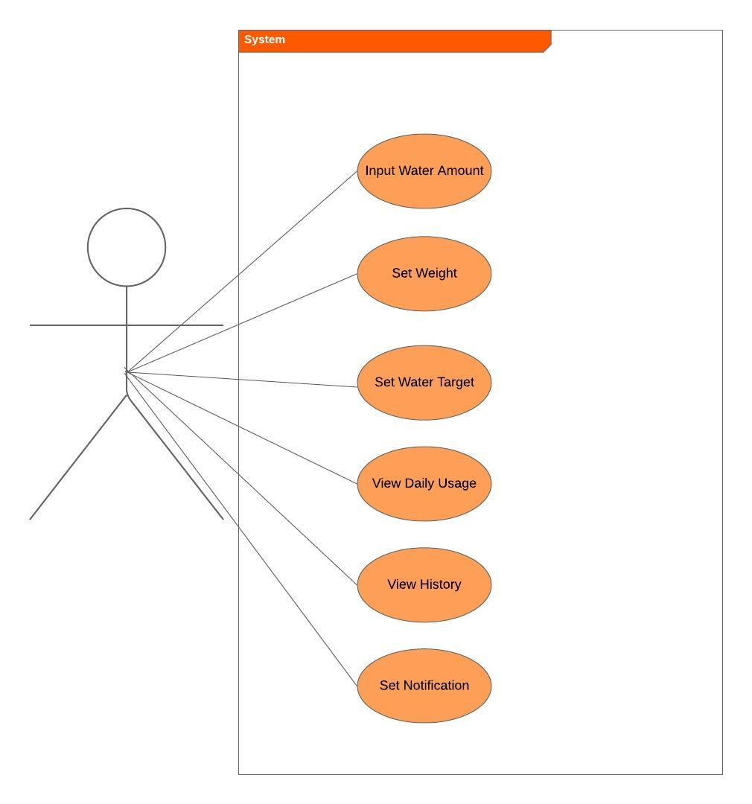

Full Use Case Descriptions

Use Case 1: Set Weight
- Brief Description
User can set her/his weight to set the recommended daily water target. To change the weight, user can go to the setting screen and can change the weight.
- Actors
User – Owner of the phone, H2O app support single user only.
- Pre-Conditions
User be able to access setting screen with settings icon which located in the bottom part of the screen
- Normal Flow
User selects his/her weight from the combo box.
- Alternative Flows
There is no alternative flow for this use case.
- Sub Flows
There is no sub flow for this use case.
- Key Scenarios
User sets his/her weight in to the system.
- Post-Conditions
User sets his/her weight – System sets the target water amount automatically
- Special Requirements
There is no special requirement for this use case

Use Case 2: Set Target Water
- Brief Description
User can to set his/her daily water target manually. To change the target water amount, user can go to the setting screen and can change the target value.
- Actors
User – Owner of the phone, H2O app support single user only.
- Pre-Conditions
User be able to access setting screen with settings icon which located in the bottom part of the screen
- Normal Flow
User selects his/her preferred water amount from the combo box.
- Alternative Flows
There is no alternative flow for this use case.
- Sub Flows
There is no sub flow for this use case.
- Key Scenarios
User sets his/her preferred water amount in to the system.
- Post-Conditions
User sets his/her preferred water amount – System sets the target water amount manually
- Special Requirements
There is no special requirement for this use case

Use Case 3: Set Notifications
- Brief Description
User can turn on/off system notifications for water reminders. To change the notification settings, user can go to the setting screen and can turn on/off notifications.
- Actors
User – Owner of the phone, H2O app support single user only.
- Pre-Conditions
User be able to access setting screen with settings icon which located in the bottom part of the screen
- Normal Flow
User can go to setting screen and turn on the notifications.
- Alternative Flows
User can go to setting screen and turn on the notifications.
- Sub Flows
There is no sub flow for this use case.
- Key Scenarios
User sets his/her preferred option for notifications.
- Post-Conditions
System sends notifications to user to remind the drink water.
- Special Requirements
There is no special requirement for this use case

Use Case 4: Input
- Brief Description
User can add water amount to his/her daily water amount. Home screen allows user to input the water intake in different amounts such as 1 glass of water (200ml), ½ glass of water (100ml), and Australian standard bottle water (600ml).
- Actors
User – Owner of the phone, H2O app support single user only.
- Pre-Conditions
User need to be on the home screen of the app
- Normal Flow
User click on the full glass of water icon, System updates the daily water consumption graph automatically
- Alternative Flows
User click on the full glass of water icon, System updates the daily water consumption graph automatically.
- Sub Flows
There is no sub flow for this use case.
- Key Scenarios
User sets his/her preferred option for notifications.
- Post-Conditions
System updates the daily water consumption graph automatically.
- Special Requirements
There is no special requirement for this use case

Use Case 5: View Daily Usage
- Brief Description
User can see the amount of water consumption of current day
- Actors
User – Owner of the phone, H2O app support single user only.
- Pre-Conditions
User need to be on the home screen of the app
- Normal Flow
User run the apps, and can see the daily graph on the home screen
- Alternative Flows
There is no alternative flow for this use case.
- Sub Flows
There is no sub flow for this use case.
- Key Scenarios
User can see the daily graph and target.
- Post-Conditions
There is no post condition for this use case.
- Special Requirements
There is no special requirement for this use case

Use Case 6: View History
- Brief Description
User can see the history of water consumption of last 4
- Actors
User – Owner of the phone, H2O app support single user only.
- Pre-Conditions
User need to be on the history screen of the app
- Normal Flow
User run the apps, and click oh history icon from the bottom of the screen, and can see the historical graph of the water consumption
- Alternative Flows
There is no alternative flow for this use case.
- Sub Flows
There is no sub flow for this use case.
- Key Scenarios
User can see the daily graph and target.
- Post-Conditions
There is no post condition for this use case.
- Special Requirements
There is no special requirement for this use case

Sequence Diagrams
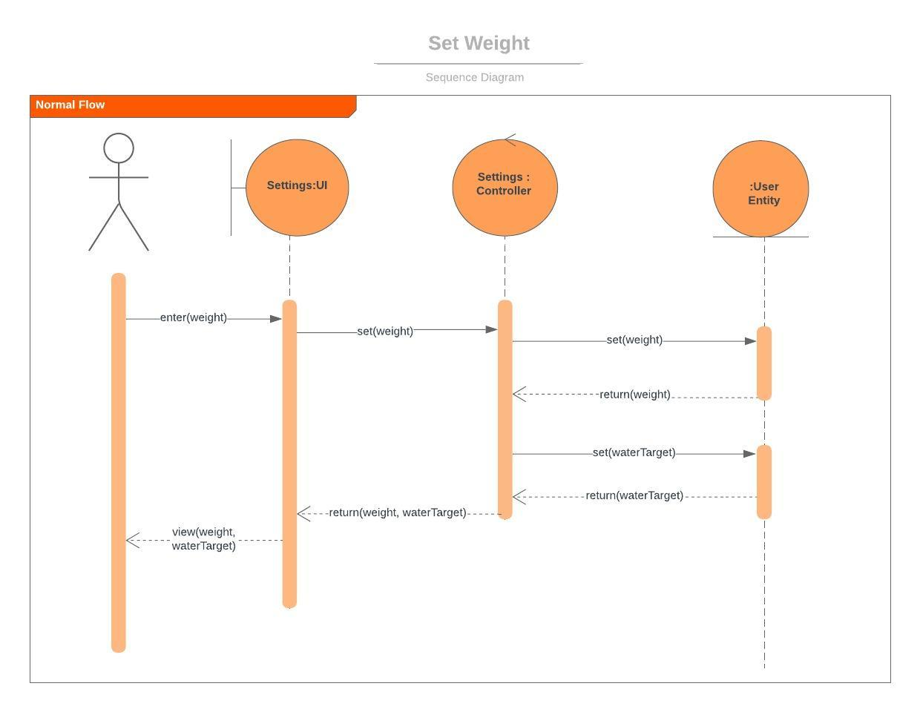

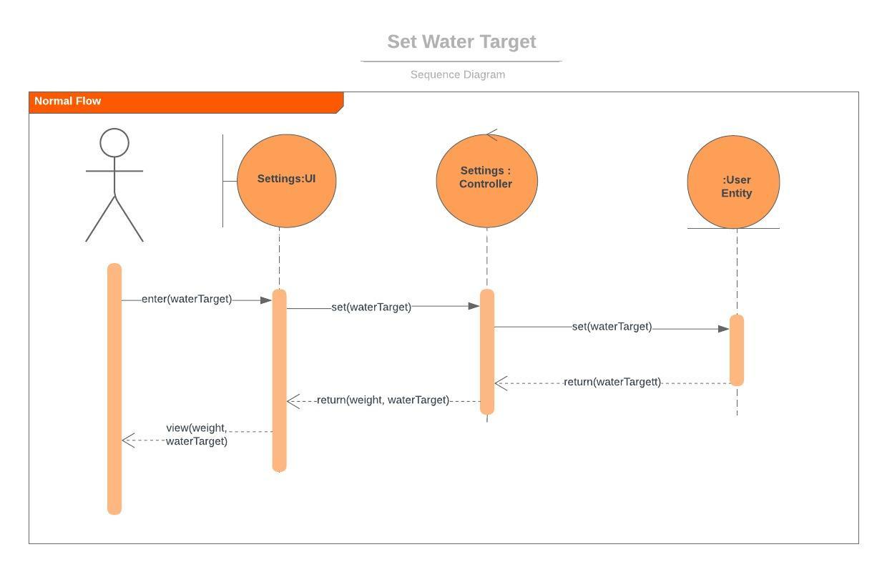

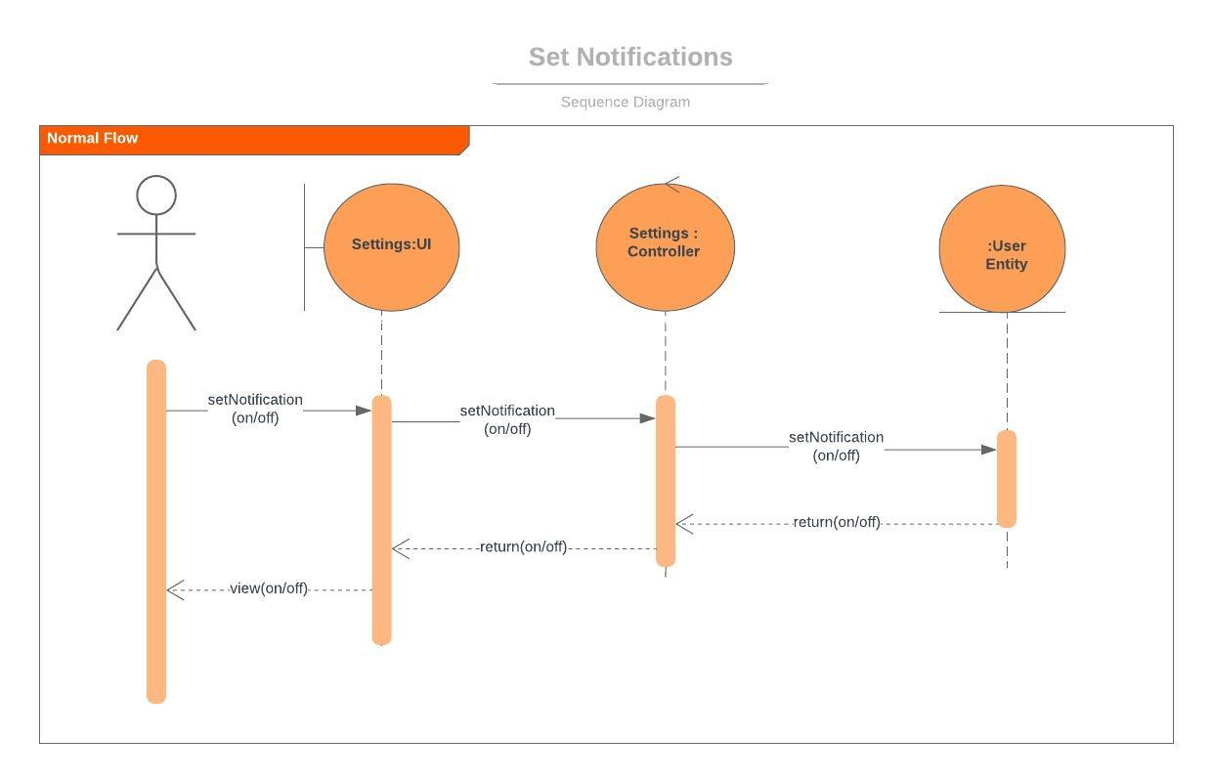
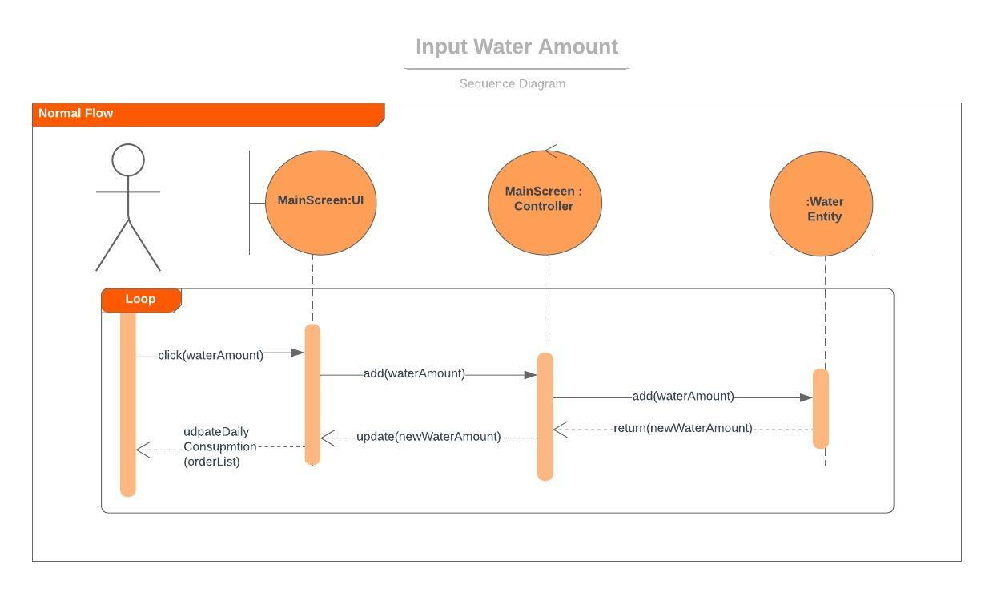
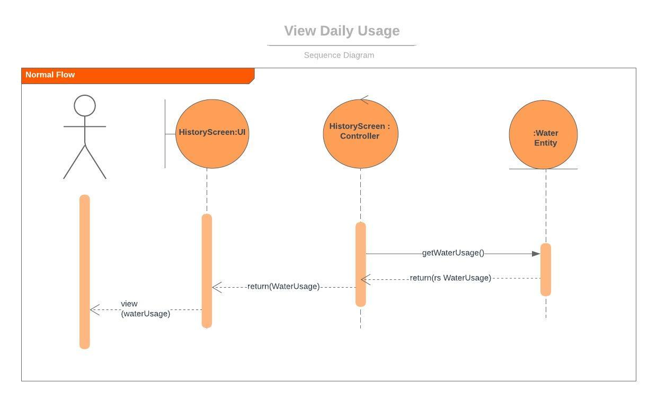
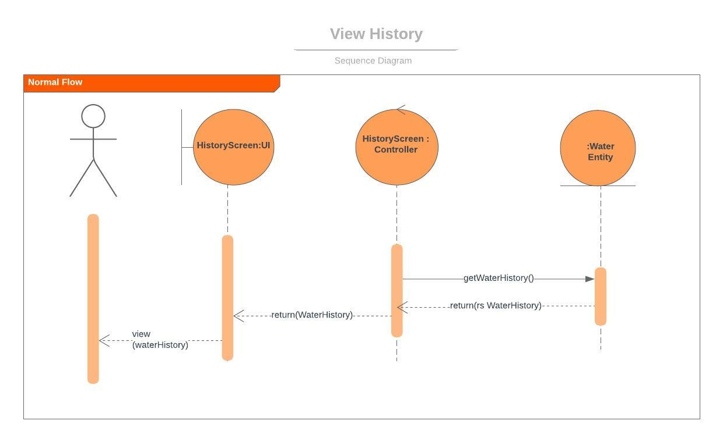

Class Diagram
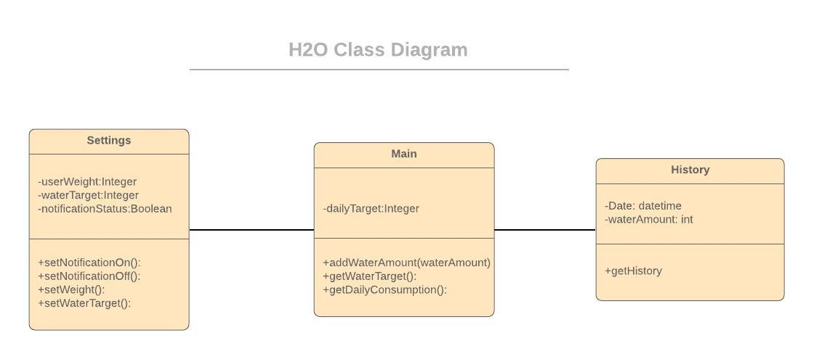

Project Requirements

The requirements of the H2O app as follows;
- Android 7 Nougat version or higher
- API 18 or higher
- Touchscreen interface
- 50MB disk space
- Internet connection is not required
- Minimum resolution 480x360

GUI Mock-Up

