Medical Device project

# Using React, Node, Express, MongoDB and Typescript

# Instruction

## Home Page:

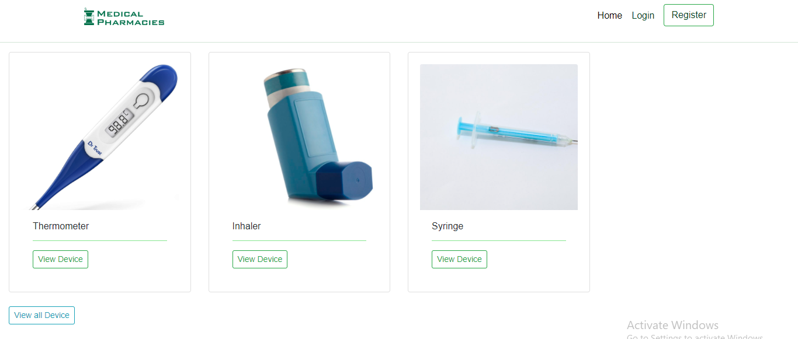

## Click ‘View all Device’:

**URL:** /modeltype

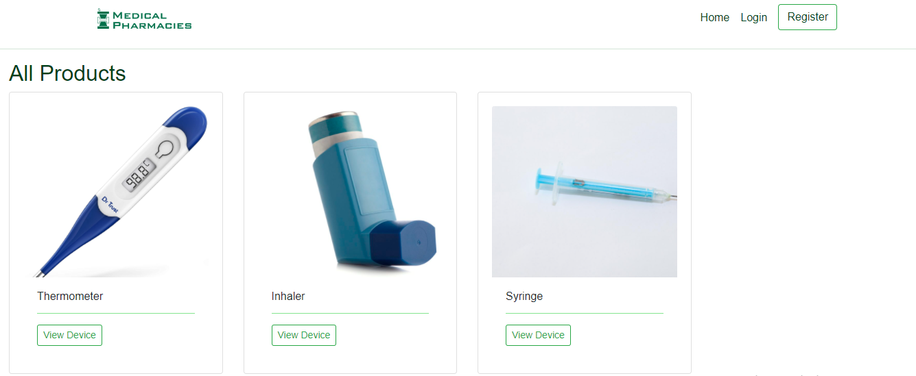

## Click ‘View Device’:

**URL:** /modeldata/{deviceID}

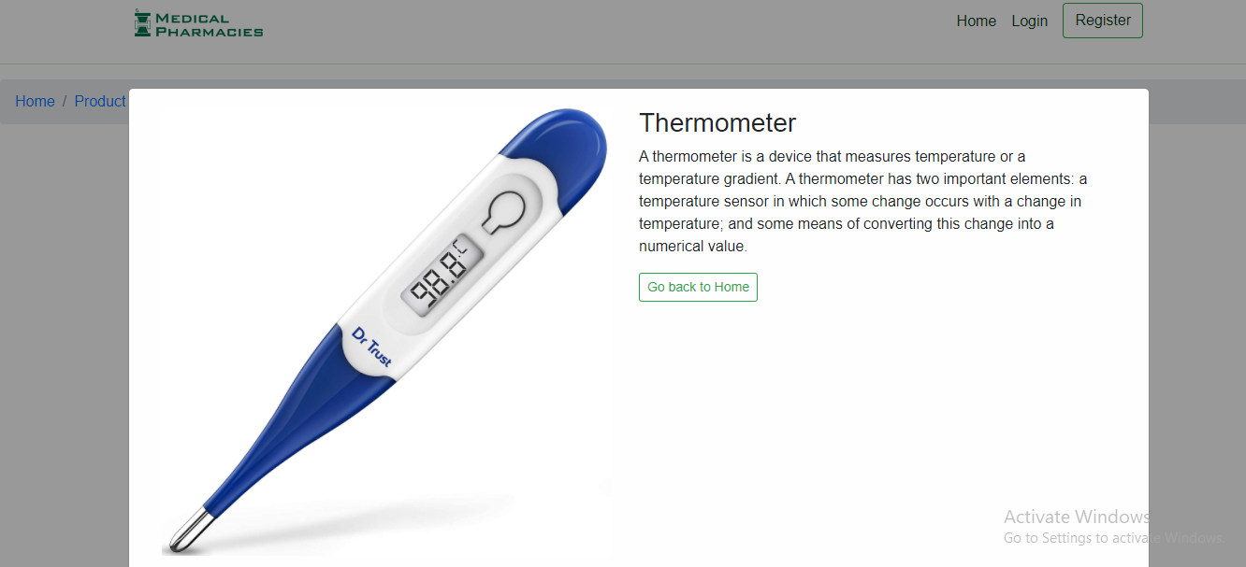

## Login: URL: /login

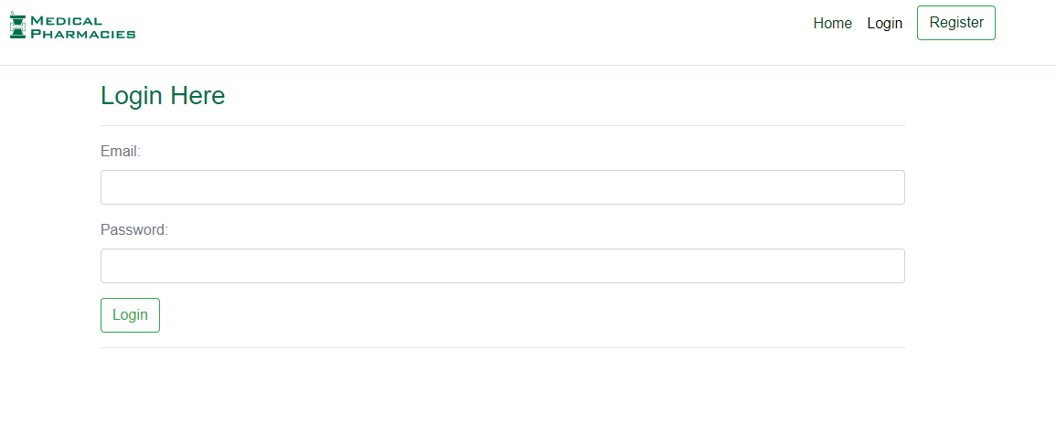

|  |
| --- |
| Role: Admin Email: [khan@gmail.com](mailto:khan@gmail.com)  Password: 123456 |
| Role: User Email: [khanmashrur03@gmail.com](mailto:khanmashrur03@gmail.com)  Password: 123456 |

## Register as a user: URL: /register

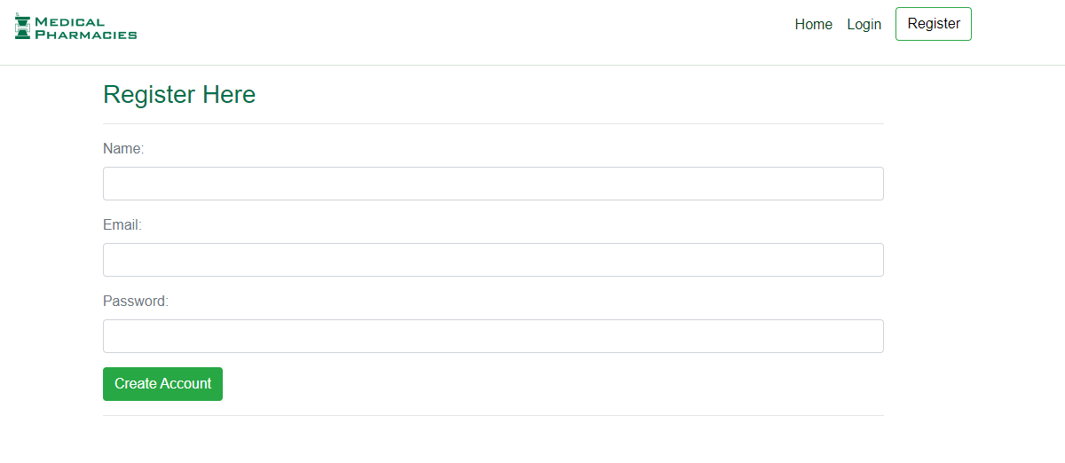

## User dashboard:

##### URL: /user/dashboard

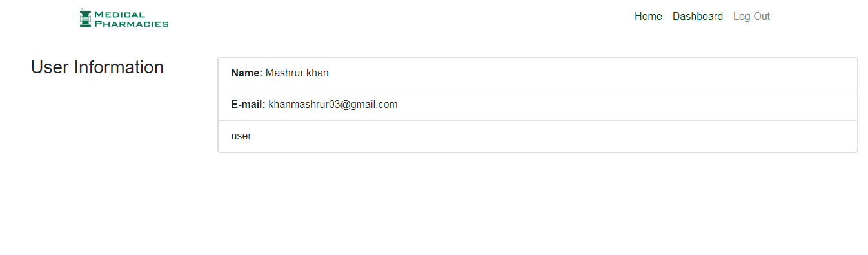

## Admin dashboard:

##### URL: /admin/dashboard

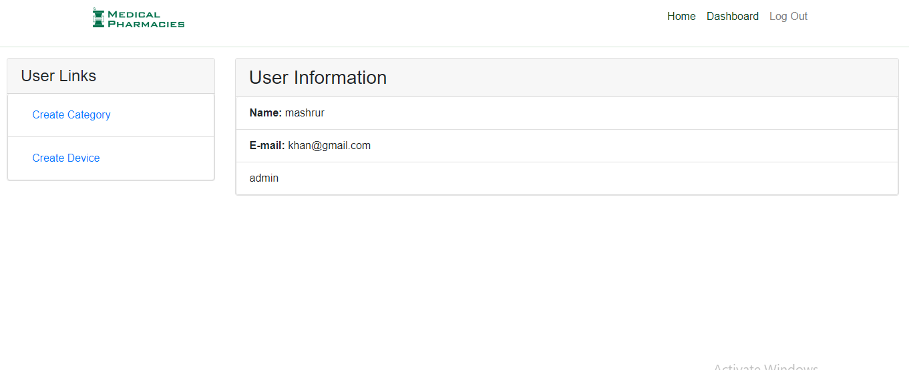

## Click ‘create category’

URL: /devicetype

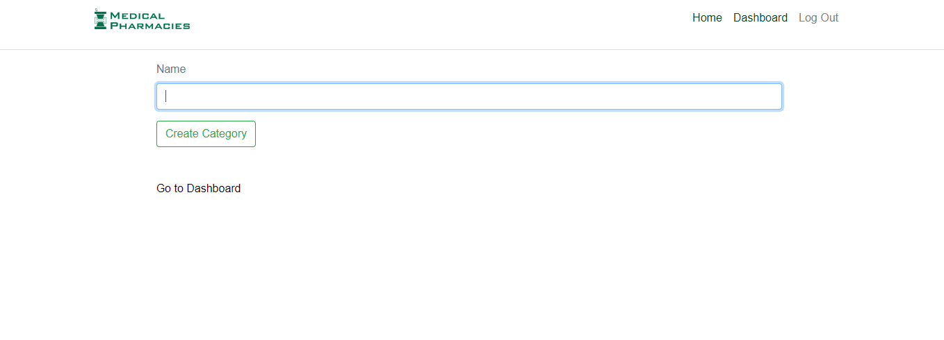

## Click ‘create category’

URL: /devicemodel

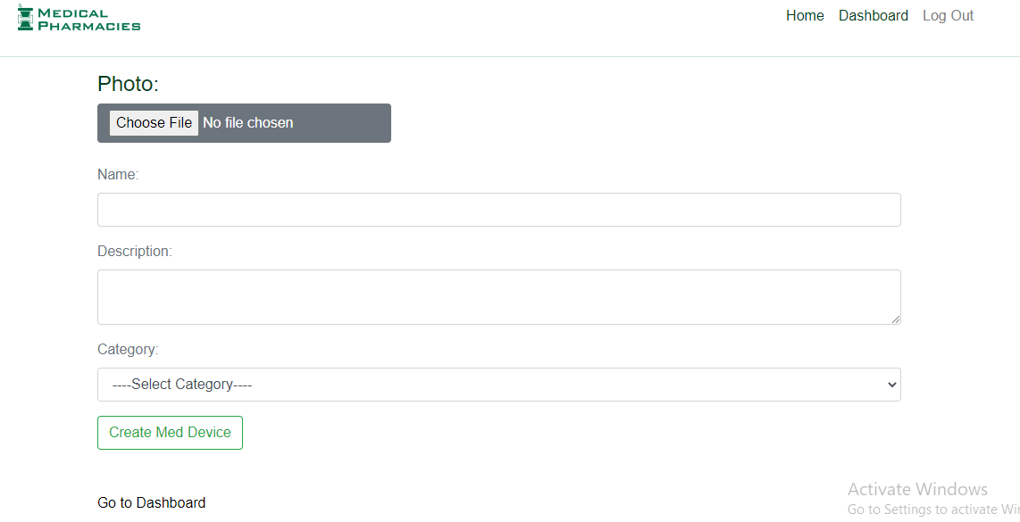

I have used Nodejs, express JS and mongo DB for the backend of the project.

Why node JS?

* Node and react both are JavaScript language.
* Reactjs code directly in the Nodejs environment.
* Fast and scalable network applications.
* Lightweight and efficient.

Why mongo DB?

* + free through the open source community edition
  + Stores data in JSON format.

# File Structure

# Backend:

**controllers**/

categoryControllers.js

categoryControllers.ts

productController.js

productController.ts

userControllers.js

userControllers.ts

**middlewares**/

admin.js

admin.ts

authorize.js

authorize.ts

error.js

error.ts

**models**/

category.js

category.ts

product.js

product.ts

user.js

user.ts

**routers**/

categoryRouter.js

categoryRouter.ts

productRouter.js

productRouter.ts

userRouter.js

userRouter.ts

.env

App.js

App.ts

Package-lock.json

Package.json

Server.js

Server.ts

Tconfig.json

# Frontend:

**public**/

favicon.ico

index.html

logo192.png

logo512.png

manifest.json

**src**/

api/

apiAdmin.js

apiAdmin.ts

apiAuth.js

apiAuth.ts

apiProduct.js

apiProduct.ts

assets/

logo.svg

components/

admin/

AdminDashboard.js

CreateCategory.js

CreateProduct.js

home/

AllProduct.js

Card.js

Home.js

ProductDetails.js

protecteRoutes/

AdminRouters.js

PrivateRoute.js

user/

Dashboard.ja

Login.js

Register.js

Layout.js

Main.js

Menu.js

utils/

auth.js

config.js

messages.js

App.js

index.js

react-app-env.d.ts

.env

Package-lock.json

Package.json

Tconfig.json