/\*\*\*\*\*\*\*\*\*\*\*\*\*\*\*\*\*\*\*\*\*\*\*\*\*\*\*\*\*\*\*\*\*\*\*\*\*\*\*\*\*\*\*\*\*\*\*\*\*\*\*\*\*\*\*\*\*\*\*\*\*\*\*\*\*\*\*\*\*\*\*\*\*\*\*\*\*\* UNX510 –Assignment 1\* I declare that this assignment is my own work in accordance with Seneca Academic \* Policy. \* No partof this assignment has been copied manually or electronically from any other \* source (including web sites) or distributed to other students.\* \* Name: Fahim Hussain Student ID: 105446181 Date:June21,2021

\*\*\*\*\*\*\*\*\*\*\*\*\*\*\*\*\*\*\*\*\*\*\*\*\*\*\*\*\*\*\*\*\*\*\*\*\*\*\*\*\*\*\*\*\*\*\*\*\*\*\*\*\*\*\*\*\*\*\*\*\*\*\*\*\*\*\*\*\*\*\*\*\*\*\*\*\*\*\*/

Q1A) cat ~shahdad.shariatmadar/myData/credential.txt

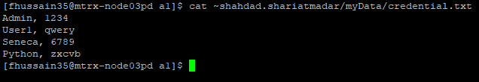

Q1B) ls -l ~shahdad.shariatmadar/myData/credential.txt



Q2)

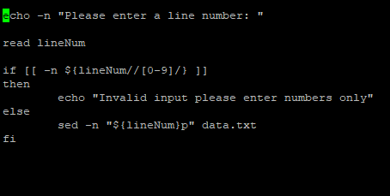

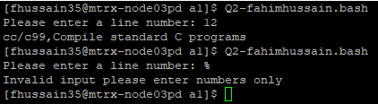

Q3)

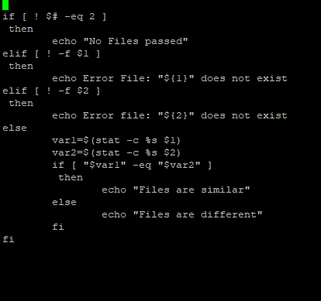

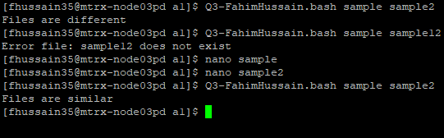

Q4A) sed -n ‘1,5p’ Bookstore.txt

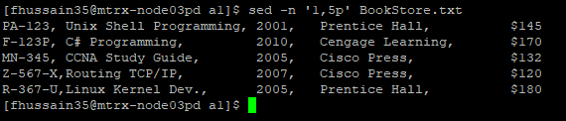

Q4B) grep -v 'Cengage Learning' BookStore.txt

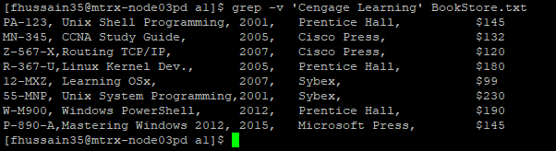

Q4C) grep -i 'Prentice Hall' BookStore.txt | tr '[:lower:]' '[:upper:]'

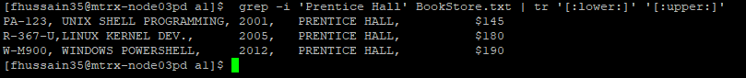

Q4D) awk -F, '$3 > 2010' BookStore.txt

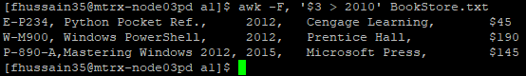

Q4E) awk -F, '$1 ~ /[A-Z]-[0-9][0-9][0-9]-[A-Z]/' BookStore.txt

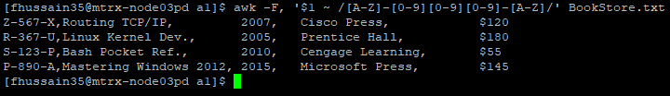

Q4F) awk -F, 'BEGIN {printf "%0s%12s%18s%13s%20s\n---------------------------------------------------------------------\n", "BookID","Book Title","Year", "Publisher","Price"} {printf "%0s%10s%1s%3s%0s\n",$1 " ",$2" ",$3,$4,$5}' BookStore.txt

The first Capture is just to show that the command above is entered and the second picture shows a much clearer image of the output.

