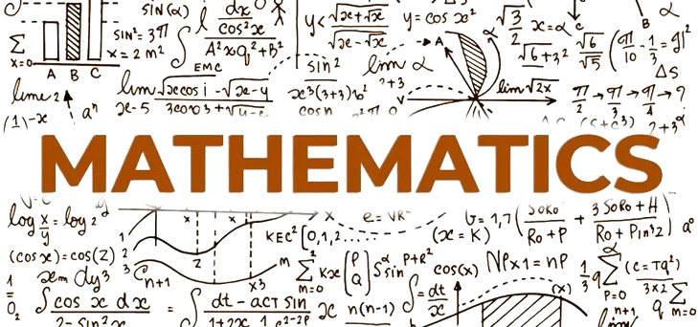

|  |
| --- |
| **MOHAMMAD FAHIM** |
| **ID:- 242002112** |

**What is Mathematics?**

Answer: Mathematics is *the science and study of quality, structure, space, and change.*

**[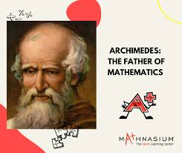](https://www.google.com/imgres?q=mathematics&imgurl=https%3A%2F%2Fwww.mathnasium.com%2Fstorage%2Fapp%2Fuploads%2Fpublic%2F643%2F649%2Fa28%2F643649a28db5c193113528.png&imgrefurl=https%3A%2F%2Fwww.mathnasium.com%2Fmath-centers%2Fnorthvancouverwa%2Fnews%2Ffather-mathematics-nv&docid=62RgQPSoUQsvhM&tbnid=kvyAGlen2EmcCM&vet=12ahUKEwiCmci6irWGAxX6d2wGHYRBCtgQM3oECCkQAA..i&w=940&h=788&hcb=2&ved=2ahUKEwiCmci6irWGAxX6d2wGHYRBCtgQM3oECCkQAA)**

**Why Math is Important?**

Answer:

[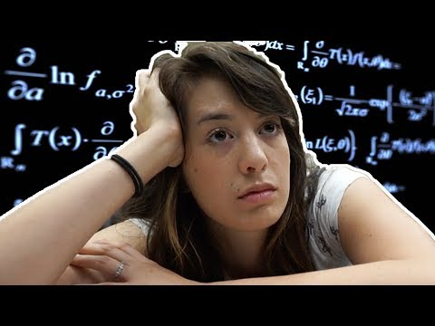](https://www.youtube.com/watch?v=KX608C2RZek&t=9s)

**Science’s Relationship with Mathematics:**

* Physics
* Chemistry
* Biology
* Geosciences
* Computation
* Economics
* Philosophy

**Areas of Mathematics:**

1. Numbers Theory
   1. Natural Number (**N**)
   2. Integer (**Z**)
   3. Rational Number (**Q**)
2. Geometry
   1. Lines
   2. Angels
   3. Circles

Circle

1. Calculus
   1. Integration
   2. Differentiation Etc.

**Branches of Mathematics:**

**Some Equation of Mathematics**

|  |
| --- |
| * (a + b)2= a2+2ab+b2 |
| * (a - b)2= a2-2ab+b2 |
| * (a + b)3= a3+3a2b+3ab2+b2 |
| * (a - b)3= a3-3a2b+3ab2-b2 |
| * sin2Ɵ+cos2Ɵ=1 |
|  |
|  |

**Some Formula of Chemistry Using Mathematics:**

* Water: H20
* Sand: Sio2
* Gas: O2,H2,CO2

**Demand of mathematics:**

**Best Mathematics book**: ***Fermat’s Last Theorem***

**Regular price: ~~1200/-~~**

**Discount price: 1000/-**

* Click For more information: [Mathematics](https://en.wikipedia.org/wiki/Mathematics)

**THANK YOU**