PROJECT REPORT
Retail Sales & Profit Analysis
Python • SQL • Excel • Power BI — End-to-End Data Analysis Project

Fahim Shahenshah Yadgir
fahimyadgir07@gmail.com
GitHub: github.com/fahim-yadgir
LinkedIn: linkedin.com/in/fahim-yadgir-32b842344
July 2026

• | Table of Contents

1. Project Overview 3
2. Tools Used 3
3. Data Collection 4
4. Data Cleaning 5
5. Exploratory Data Analysis (EDA) 6
6. SQL Analysis 7
7. Python (Pandas) Analysis 11
8. Power BI Dashboard 13
9. Key Insights 18
10. Business Recommendations 18
11. Conclusion 19

01 | Project Overview

Objective
The goal of this project is to analyze a retail superstore's historical sales data to uncover patterns in sales, profit, discounting, and regional performance, and to present those findings through an interactive Power BI dashboard supported by Python and SQL-based analysis.

Business Problem
The business wants to understand which regions, categories, products, and customer segments drive the most revenue and profit, where discounting is eroding margins, and how sales performance has trended over time. These insights are used to guide marketing focus, inventory planning, and discount policy.

Dataset Description
The dataset used is a retail “Superstore” style sales dataset, covering orders placed across the United States between 2014 and 2017 (with a small number of records into 2018). It captures order and shipping details, customer information, product/category details, and the sales, quantity, discount, and profit for each line item.

Tech Stack
This project was built using the following tools, covering the full pipeline from raw data to a shareable, decision-ready dashboard:
SQL (MySQL)  Data cleaning, transformation, and exploratory analysis on sales_analysis_demo. | Python (Pandas)  Scripted cleaning, aggregation, and ranking as a portable, repeatable alternative to SQL.
Excel  Initial data inspection and quick calculations before loading into SQL/Power BI. | Power BI  Interactive multi-page dashboard with KPI cards, charts, slicers, and navigation.
Git  Version control for scripts, queries, and report source files. | GitHub  Hosting the project repository, SQL scripts, and documentation.

02 | Data Collection

The dataset is a classic retail “Superstore Sales” dataset (loaded into MySQL as sales_analysis_demo and mirrored into a pandas DataFrame for scripting), commonly used for sales/profit analysis practice. It contains one row per order line item.
Source | Superstore-style retail sales dataset (CSV, imported into MySQL and read via pandas.read_csv)
Table / DataFrame name | sales_analysis_demo
Number of columns | 21
Approx. number of rows | ~9,994 line items (5,009 unique orders, 531 cities — confirmed from dashboard KPI cards)
Time period | 2014 – 2017 (with a small number of records extending into 2018)
Column list:
- Row ID, Order ID, Order Date, Ship Date, Ship Mode
- Customer ID, Customer Name, Segment, Country, City, State, Postal Code, Region
- Product ID, Category, Sub-Category, Product Name
- Sales, Quantity, Discount, Profit

03 | Data Cleaning

Before analysis, the raw table was cleaned and standardized directly in SQL (and mirrored in pandas for the Python workflow):
- Created a dedicated database (sales) and imported the raw CSV table.
- Renamed the table from the messy default name `sales analysis demo` to a clean, query-friendly sales_analysis_demo.
- Renamed every column with spaces or inconsistent naming (e.g. “Order ID”, “Ship Mode”, “Customer Name”, “Postal Code”, “Product ID”, “Sub-Category”, “Product Name”) to underscore_case columns (Order_ID, Ship_Mode, Customer_Name, Postal_Code, Product_ID, Sub_Category, Product_Name).
- Fixed data types: Order_Date and Ship_Date were stored as text in “DD-MM-YYYY” format and were converted to proper date fields (SQL STR_TO_DATE / pandas pd.to_datetime), enabling all date-based analysis (year/month/quarter/weekday grouping, shipping-time calculations) used later.
- Standardized text formatting: converted Customer_Name to uppercase throughout, so the same customer is never split across differently-cased entries.
- Checked for and reviewed NULL/zero-value records where relevant (e.g. filtering Discount = 0 and Profit < 0 rows) to understand data completeness rather than blindly deleting rows.

04 | Exploratory Data Analysis (EDA)

Using SQL aggregate queries (cross-checked with pandas), the following core business questions were answered before moving into Power BI. The headline numbers match the KPI cards on the dashboard:
5,009  TOTAL ORDERS | 531  CITIES | 38K  UNITS SOLD | $2.30M  TOTAL SALES | $286.40K  TOTAL PROFIT

- Average Sales per line item, average discount, max/min profit per transaction
- Top Products — ranked by total sales and by total profit
- Top Customers — ranked by total spend and by total profit generated
- Best / Worst Category — Technology leads on sales; category-by-category profit was compared to find the weakest performer
- Monthly / Yearly / Quarterly Sales Trend — sales and profit grouped by year, month, quarter and weekday to spot seasonality
- Shipping performance — average and maximum shipping time (days between Ship_Date and Order_Date)

05 | SQL Analysis

All SQL analysis in this project was performed on a single cleaned table, sales_analysis_demo. Below are the core SQL concepts used, grouped by category, with representative queries pulled directly from the project.

SELECT, WHERE, ORDER BY — filtering & sorting
SELECT Product_ID, Product_Name, State
FROM sales_analysis_demo
WHERE State = 'California';

SELECT * FROM sales_analysis_demo
WHERE Sales BETWEEN 500 AND 1000;

SELECT * FROM sales_analysis_demo
ORDER BY Sales DESC;
Used throughout the project to filter records by state, category, discount, sales range, product name pattern (LIKE), and to sort results for top/bottom analysis.

GROUP BY & Aggregate Functions
SELECT Category, ROUND(SUM(Sales),2) AS total_sales
FROM sales_analysis_demo
GROUP BY Category;

SELECT YEAR(Order_Date) AS order_year, ROUND(SUM(Sales),2) AS total_sales
FROM sales_analysis_demo
GROUP BY YEAR(Order_Date)
ORDER BY order_year;
Used to compute total sales/profit by category, state, region, ship mode, sub-category, and by year/month/quarter/weekday for trend analysis.

HAVING — filtering aggregated results
SELECT Customer_Name, SUM(Sales) AS spending_money
FROM sales_analysis_demo
GROUP BY Customer_Name
HAVING SUM(Sales) > 3000;
Used to isolate high-value customers, states with more than 10 orders, and regions with above-average profit.

CASE — conditional bucketing
SELECT Product_Name, Sales, Discount,
CASE WHEN Sales < 100 THEN 'Low'
WHEN Sales BETWEEN 100 AND 500 THEN 'Medium'
WHEN Sales > 500 THEN 'High'
END AS Sales_category
FROM sales_analysis_demo;
Used to bucket records into Profit/Loss flags, Sales categories (Low/Medium/High), Discount status, and Quantity levels.

Window Functions — RANK(), DENSE_RANK(), ROW_NUMBER(), running totals
SELECT Product_Name, ROUND(SUM(Sales),2) AS rank_sales,
RANK() OVER (ORDER BY SUM(Sales) DESC) AS sales_rank
FROM sales_analysis_demo
GROUP BY Product_Name;

SELECT *, SUM(Profit) OVER (ORDER BY Row_id) AS cumulative_sum
FROM sales_analysis_demo;
RANK() and DENSE_RANK() were used to rank products and customers by sales/profit; ROW_NUMBER() to rank states by profit; and SUM()/AVG() OVER (ORDER BY ...) to compute running totals and moving averages of sales and profit.

Subqueries & Derived Tables
SELECT Customer_Name, Sales AS above_avg_sales
FROM sales_analysis_demo
WHERE Sales > (SELECT AVG(Sales) FROM sales_analysis_demo);

SELECT * FROM (
SELECT Product_Name, Category, SUM(Sales) AS total_sales,
DENSE_RANK() OVER (PARTITION BY Category ORDER BY SUM(Sales) DESC) AS top_3
FROM sales_analysis_demo
GROUP BY Product_Name, Category
) AS rank_table
WHERE top_3 <= 3;
Scalar subqueries compared each row against dataset-wide averages/max/min (e.g. above-average sales, highest-profit product). A derived table combined with a PARTITION BY window function was used to find the top 3 best-selling products within each category.

Date Functions — shipping time & seasonality
SELECT Order_ID, Order_Date, Ship_Date,
DATEDIFF(Ship_Date, Order_Date) AS shipping_time
FROM sales_analysis_demo;
YEAR(), MONTH(), QUARTER(), WEEKDAY() and DATEDIFF() were used to analyze seasonality and shipping performance.

DISTINCT — unique values
SELECT DISTINCT Category
FROM sales_analysis_demo;

SELECT DISTINCT State
FROM sales_analysis_demo;
Used to quickly check the unique Category and State values present in the dataset before writing filters against them.

Multiple CASE Conditions — profit/loss, discount status, quantity level
SELECT *,
CASE WHEN Profit > 0 THEN 'Profit' ELSE 'Loss' END AS Profit_and_loss
FROM sales_analysis_demo;

SELECT Product_Name, Sales, Quantity, Discount, Profit,
CASE WHEN Discount <= 0 THEN 'No Discount'
WHEN Discount <= 0.3 THEN 'Low Discount'
WHEN Discount > 0.3 THEN 'High Discount'
END AS Discount_status
FROM sales_analysis_demo;

SELECT Product_Name, Sales, Quantity, Discount, Profit,
CASE WHEN Quantity < 3 THEN 'Low'
WHEN Quantity < 7 THEN 'Medium'
WHEN Quantity >= 7 THEN 'High'
END AS Quantity_level
FROM sales_analysis_demo;
Three separate CASE expressions were used to tag every line item with a Profit/Loss flag, a Discount status band, and a Quantity level — turning continuous numeric columns into business-readable categories for slicing in Power BI.

Finding the Nth Highest Value
SELECT Product_Name, Sales AS second_highest_sale
FROM sales_analysis_demo
WHERE Sales = (
SELECT MAX(Sales) FROM sales_analysis_demo
WHERE Sales < (SELECT MAX(Sales) FROM sales_analysis_demo)
);
A nested subquery (max of everything below the overall max) was used to find the second-highest sale value — a classic SQL interview-style pattern.

PARTITION BY — ranking within each group
SELECT *
FROM (
SELECT Row_id, Order_ID, Ship_Mode, Customer_Name, Product_ID,
Product_Name, Sales, Quantity, Discount, Profit,
DENSE_RANK() OVER (PARTITION BY Ship_Mode ORDER BY Sales DESC) AS sales_category
FROM sales_analysis_demo
) AS sales_cat
WHERE sales_category <= 3
ORDER BY Ship_Mode, sales_category;
PARTITION BY resets the ranking for every Ship_Mode group, so this query pulls the top 3 highest-sale orders within each shipping mode separately, rather than the top 3 across the whole table.

Moving Averages — AVG() OVER
SELECT Customer_Name, Country, Sales,
ROUND(AVG(Sales) OVER (ORDER BY Row_id DESC), 2) AS moving_avg
FROM sales_analysis_demo;
An AVG() window function (ordered by row) produces a rolling/moving average of sales, complementing the running-total SUM() OVER used earlier.

Regional Loss Analysis
SELECT Region, ROUND(SUM(Profit), 2) AS total_loss
FROM sales_analysis_demo
WHERE Profit < 0
GROUP BY Region;

SELECT *, SUM(Profit) OVER (ORDER BY Row_id DESC) AS total_loss
FROM sales_analysis_demo
WHERE Profit < 0;
Combining a WHERE filter (Profit < 0) with GROUP BY and a running-total window function isolates exactly which regions and transactions are dragging down overall profitability — directly feeding the discount/profit recommendation in Section 9.
Note on scope: sales_analysis_demo is a single, denormalized table, so JOINs and CTEs (WITH clauses) were not required for this project — subqueries and derived tables served the same purpose. LAG()/LEAD() were not used here but would be a natural next step for month-over-month comparisons; this is noted as a future improvement in the Conclusion.

06 | Python (Pandas) Analysis

To demonstrate the same analysis in a scripting workflow (useful for automation, repeatable reporting, and integration with other Python tools), the core SQL queries above were replicated in Python using pandas.

Loading & Cleaning
import pandas as pd

df = pd.read_csv('sales_analysis_demo.csv')
df.columns = df.columns.str.strip().str.replace(' ', '_').str.replace('-', '_')

df['Order_Date'] = pd.to_datetime(df['Order_Date'], format='%d-%m-%Y')
df['Ship_Date'] = pd.to_datetime(df['Ship_Date'], format='%d-%m-%Y')
df['Customer_Name'] = df['Customer_Name'].str.upper()
Mirrors the SQL cleaning step: renaming columns to a consistent underscore_case, parsing dates, and standardizing customer names — all in a few readable, reusable lines.

Filtering & Sorting
california = df[df['State'] == 'California'][['Product_ID', 'Product_Name', 'State']]
mid_range_sales = df[df['Sales'].between(500, 1000)]
top_20_by_sales = df.sort_values('Sales', ascending=False).head(20)

Group By & Aggregates
sales_by_category = df.groupby('Category')['Sales'].sum().round(2)

yearly_sales = (
df.groupby(df['Order_Date'].dt.year)['Sales']
.sum().round(2).rename_axis('order_year').sort_index()
)
Equivalent to the SQL GROUP BY queries — category totals and yearly sales trend, computed with a single groupby().sum() chain instead of a query.

HAVING Equivalent — filtering aggregated groups
spend_by_customer = df.groupby('Customer_Name')['Sales'].sum()
high_value_customers = spend_by_customer[spend_by_customer > 3000]

CASE Equivalent — conditional bucketing
import numpy as np

conditions = [df['Sales'] < 100, df['Sales'].between(100, 500), df['Sales'] > 500]
choices = ['Low', 'Medium', 'High']
df['Sales_category'] = np.select(conditions, choices)

Ranking & Running Totals — window function equivalents
product_sales = df.groupby('Product_Name')['Sales'].sum().round(2)
sales_rank = product_sales.rank(method='min', ascending=False)

df_sorted = df.sort_values('Row_id')
df_sorted['cumulative_profit'] = df_sorted['Profit'].cumsum()
pandas' .rank() reproduces RANK()/DENSE_RANK(), and .cumsum() after sorting reproduces the SQL running-total window function.

Subquery Equivalent — comparing rows to an aggregate
avg_sales = df['Sales'].mean()
above_avg_sales = df[df['Sales'] > avg_sales][['Customer_Name', 'Sales']]

top3_per_category = (
df.groupby('Product_Name').agg(total_sales=('Sales','sum'), Category=('Category','first'))
.groupby('Category')['total_sales']
.apply(lambda s: s.nlargest(3))
)

Date Functions — shipping time
df['shipping_time_days'] = (df['Ship_Date'] - df['Order_Date']).dt.days
avg_shipping_time = df['shipping_time_days'].mean()
max_shipping_time = df['shipping_time_days'].max()
The same DATEDIFF logic from SQL, expressed as a vectorized datetime subtraction in pandas.

07 | Power BI Dashboard

The dashboard is a 4-page interactive Power BI report with a landing/navigation page, built on top of the cleaned sales_analysis_demo dataset. Every page shares the same KPI card row (Total Orders, Total Cities, Total Quantity, Total Sales, Total Profit) and City / Region / Category / Ship Mode slicers, so filtering on one page carries the same look and feel across the report.

7.1 Home / Navigation Page
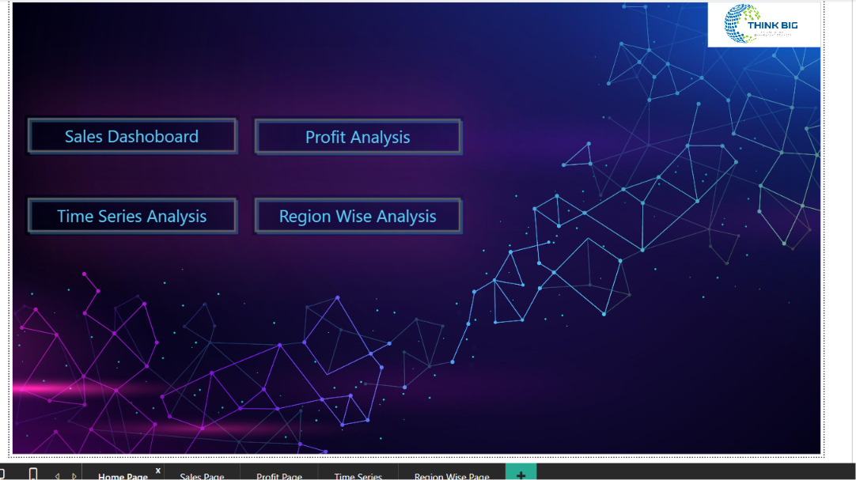
Figure 1 — Landing page with navigation buttons to the four report pages.
How it was built: a dedicated landing page with branded background and four button-shaped shapes (Sales Dashboard, Profit Analysis, Time Series Analysis, Region Wise Analysis), each wired with a Power BI “Page navigation” action so users can jump straight to the analysis they need.
Purpose / solution:
Gives the report a professional, guided entry point instead of dropping users straight onto a chart-heavy page — useful when sharing the dashboard with non-technical stakeholders.

7.2 Sales Dashboard
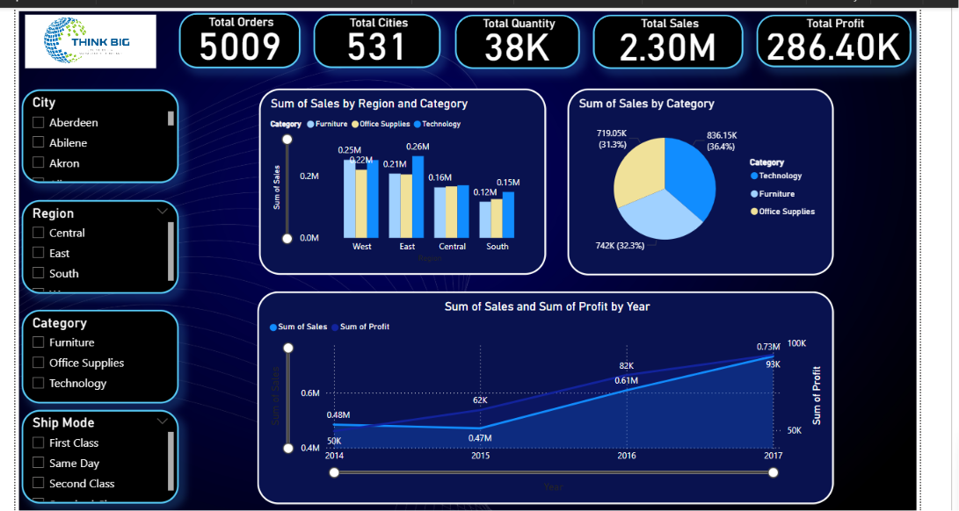
Figure 2 — Sales overview: sales by region & category, category share, and yearly sales/profit trend.
Visuals on this page: KPI cards (5,009 orders, 531 cities, 38K units, $2.30M sales, $286.40K profit); a clustered column chart of Sum of Sales by Region and Category; a donut chart of Sum of Sales by Category; and a combo line/area chart of Sum of Sales and Sum of Profit by Year with a year range slider.
How it happened:
The West region shows the strongest combined category sales, with the East close behind; Central and South trail. By category, Technology is the largest contributor (~836K, 36.4% of sales), followed closely by Office Supplies (~742K, 32.3%) and Furniture (~719K, 31.3%) — the three categories are fairly balanced. The year-over-year trend line shows both sales and profit climbing steadily from 2014 ($0.48M sales / ~$50K profit) to 2017 ($0.73M sales / ~$93K profit).
Solution / recommendation:
Since Technology drives the most revenue, prioritize inventory and marketing spend there, while investigating why Furniture sales don’t convert to proportional profit (addressed further in Section 7.3).

7.3 Profit Analysis
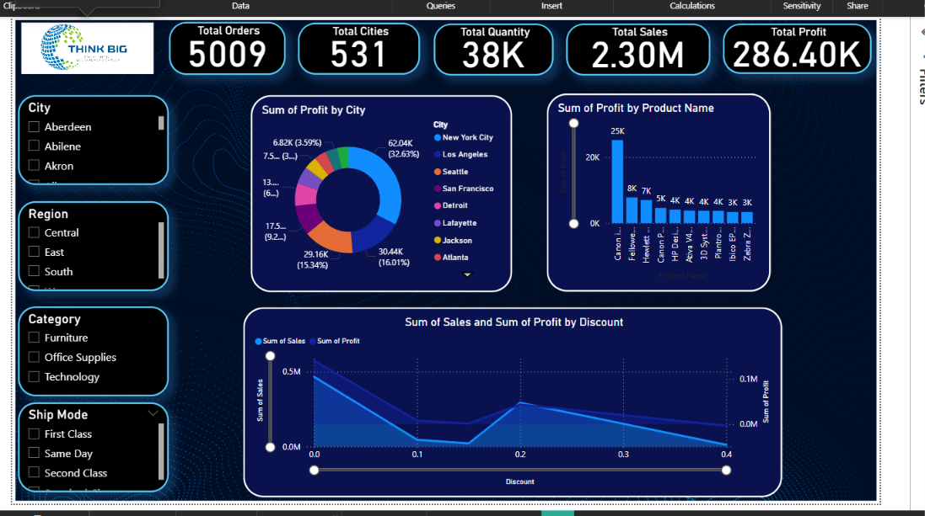
Figure 3 — Profit by city, profit by product, and the sales/profit vs. discount relationship.
Visuals on this page: a donut chart of Sum of Profit by City (New York City dominates at ~62K / 32.6%, followed by Los Angeles and Seattle); a bar chart of Sum of Profit by Product Name highlighting the top individual products (led by a Canon printer at ~25K profit); and a line chart of Sum of Sales and Sum of Profit against Discount level.
How it happened:
The discount-vs-profit line is the most important chart on this page: profit stays healthiest at low discount levels, holds up reasonably up to roughly a 0.2 discount, and then drops sharply as discount increases toward 0.3–0.4 — confirming that heavy discounting is compressing margins even when sales volume doesn’t justify it.
Solution / recommendation:
Cap discretionary discounts above ~20% except for clearly justified clearance stock, and monitor the small set of top-profit cities/products (New York City, the Canon printer line) as the accounts to protect and replicate elsewhere.

7.4 Time Series Analysis
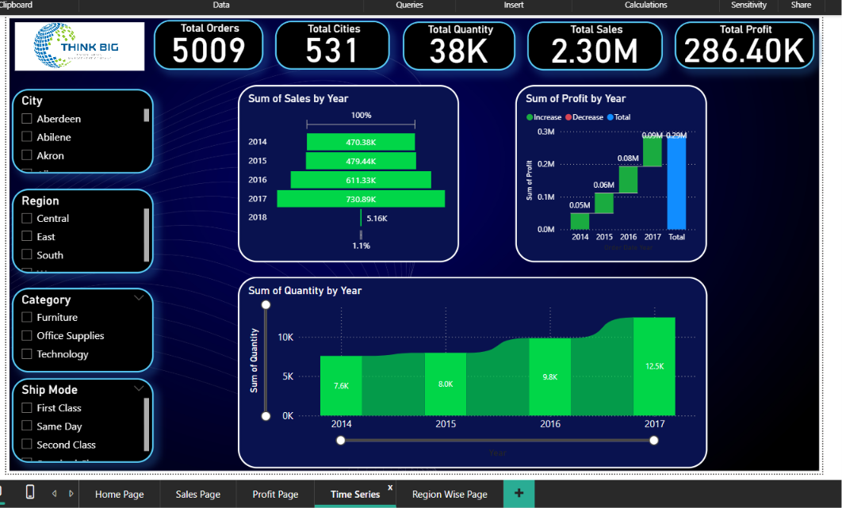
Figure 4 — Sales, profit, and quantity trends by year.
Visuals on this page: a bar chart of Sum of Sales by Year (2014: 470K → 2015: 479K → 2016: 611K → 2017: 731K, with a small partial 2018), a waterfall-style chart of Sum of Profit by Year showing the increase/decrease contribution each year, and an area chart of Sum of Quantity by Year (7.6K → 8.0K → 9.8K → 12.5K units).
How it happened:
Sales, profit and quantity all grow consistently year over year, with the largest jump between 2015 and 2017 — there is no year where the business contracted.
Solution / recommendation:
Use this consistent upward trend as a baseline for forecasting next year’s demand and for setting realistic (rather than flat) year-over-year growth targets.

7.5 Region-Wise Analysis
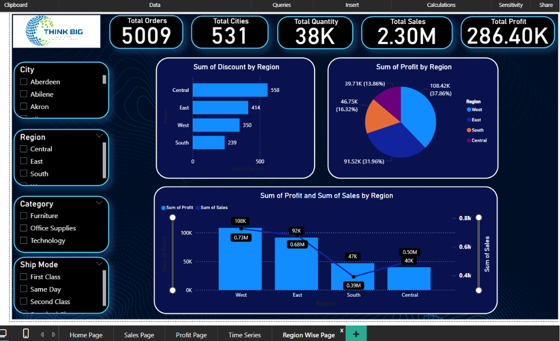
Figure 5 — Discount usage, profit share, and combined sales/profit by region.
Visuals on this page: a bar chart of Sum of Discount by Region (Central highest, followed by East, West, South), a donut chart of Sum of Profit by Region (West leads at ~108K / 37.9%, then East at ~92K / 32.0%, South at ~47K / 16.3%, and Central lowest at ~40K / 13.9%), and a combo chart comparing Sum of Profit and Sum of Sales across regions.
How it happened:
Central has the highest discount usage but the lowest share of profit — the same pattern seen on the Profit Analysis page, now confirmed at the regional level. West and East, which use comparatively less discounting, generate the most profit.
Solution / recommendation:
Revisit discount policy specifically in the Central region; the data suggests discounting there is not translating into proportional profit and may be reduced without materially hurting sales volume.

08 | Key Insights

- The West region generates the highest profit (~$108K, 37.9% of total), despite not having the highest discount usage.
- The Central region uses the most discounting but produces the lowest profit share (~13.9%) — discounting is not paying off there.
- Technology is the leading category by sales (~36.4% share), closely followed by Office Supplies and Furniture.
- Sales, profit, and quantity all grew every year from 2014 to 2017, with the sharpest acceleration between 2015 and 2017.
- Profit drops sharply once discounts exceed roughly 20% — some products are sold at high volume but low or negative margin.
- Profit is highly concentrated geographically: New York City alone accounts for close to a third of total profit.
- A small number of products (e.g. a top-selling Canon printer) contribute disproportionately to overall profit.

Recommendations
- Focus marketing and inventory investment on the West and East regions and on the Technology category, which consistently deliver the strongest profit.
- Reduce or cap discounts above ~20%, particularly in the Central region, where high discount usage is not converting into proportional profit.
- Increase inventory and promotional support for consistently top-selling, high-profit products such as the leading Canon printer line.
- Investigate underperforming products/sub-categories with high sales but low or negative profit, and consider re-pricing or discontinuing them.
- Use the steady 2014–2017 year-over-year growth trend to set data-driven sales targets and forecasts rather than flat or arbitrary goals.
- Replicate the discounting and merchandising practices used in high-profit regions (West, East) in underperforming regions (Central, South).

09 | Conclusion

This project walked through a complete, end-to-end data analysis workflow: cleaning and standardizing raw retail data in SQL and Python, exploring it with aggregate queries, window functions, subqueries, and their pandas equivalents, and communicating the findings through an interactive, multi-page Power BI dashboard with navigation, KPI cards, and cross-filtering slicers.
The analysis demonstrates the ability to translate a business problem — understanding sales, profit, and discount performance — into a data pipeline and a decision-ready dashboard, using both a database-first (SQL) and a scripting-first (Python/pandas) approach. It also demonstrates practical fluency with filtering, grouping, HAVING, CASE logic, ranking window functions, running totals, and subqueries — and the ability to interpret chart output into concrete, actionable business recommendations rather than just producing visuals.
As a next step, the project could be extended with JOINs across a normalized schema, CTEs for more readable multi-step queries, LAG()/LEAD() for month-over-month and year-over-year comparisons, a matplotlib/seaborn notebook for static reporting, and a Power BI forecast visual to project future sales and profit.

