**Project** **Description**

This project is a REST API based on python flask. It provides best deal for a certain food item based on users’ location and preferred price using data model and scrapping.

It scraps the websites of "Mad Chef" and "Pizza hut", two of the most popular food chains in Bangladesh and stores their location, menu, prices, and offers and updates then in a Firebase Realtime database. Then it runs a flask server to listen for get requests. From there based on user request a data models finds all menu items which matches with the user request and whose prices are within +-10% of the preferred price. The it calculates user location with all locations of both food chains and finds two nearest branches of each restaurant. Then the API responds to the get request with json response containing matched food items, nearest mad chef locations and nearest pizza hut locations

**Approaches**

This project can be divided into four major parts

1. Data collection
2. Database update
3. Data modelling to find best results
4. API building to connect and provide the results.

**Data Collection(Scraping)**

So to Collect data I have used two library namely BeatifulSoup and Selenium. As madchef website provides open access to its menu and locations it was easily collected using BeatifulSoup. A challenge arises while trying to access the “Pizza Hut” menu. As it requires much more user like approach I had to use Selenium to go to the actual menu.

The menu item name, price, short description, food category is collected for each item found in each website for item collection. For location collection, we have collected the branch name, address and phone numbers.

**Database**

For the database I have decided to use “Firebase Realtime database”. As it is easy to maintain and implement and I serve the projects purpose just fine.

**Data Modeling**

The model receives the user input FOOD ITEM, PREFERED PRICE and LOCATION from the API. At first all menu and location data is collected from database. Then we loop through all menu item of the restaurant and only collect the item where the input FOOD ITEM is present is either in item name, short description or in food category, and price of the item is within 90% to 110% of the preferred price. This collected items from both restaurant is our **“matched_item_list”.**

For distance calculation, we tried to use google map api but it is locked behind paywall. So we have decided to use ["https:/www.mapsofworld.com/bangladesh/distance-calculator/"](https://www.mapsofworld.com/bangladesh/distance-calculator/). It is website by which the same feature can be achieved. So, we calculate the distance between user provided location with all the location of a restaurant only if that restaurant have at least one item in **“matched_item_list”.** Based on this calculation we select two nearest branches for each restaurant. They are labeled as **“nearest_mad”** and “**nearest_hut**”. Then these three items are included in a dictionary for better readability and returned to the api.

**API**

Before running the API all data are updated in database. Then REST API will run and it will wait for htttp requests where "http://127.0.0.1:5000/best_deals/" is the root-endpoint and “: item/:pref_price/:location" is the path. in the path "item" must be a string denoting the FOOD ITEM, "pref_price" must be integer denoting the PREFERED PRICE, "location" must be a string denoting the LOCATION of the users. after getting a correct request the API will call the model and send the result as JSON response containing matched food items, nearest mad chef locations and nearest pizzahut location which can be accessed respectively as response.item_list, response.madChef_loaction and response.pizzahut_locations. Each of which is a list of dictionary.

**Input**

<http://127.0.0.1:5000/best_deals/chicken/400/banani>

**Output**

**Postman visualization**

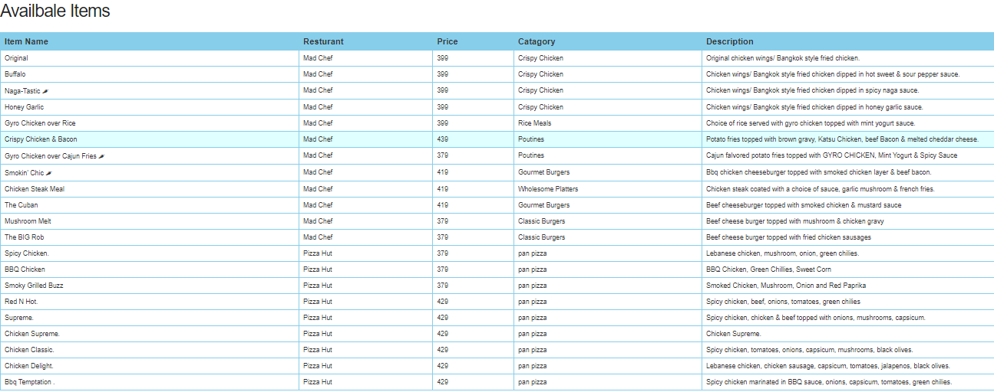

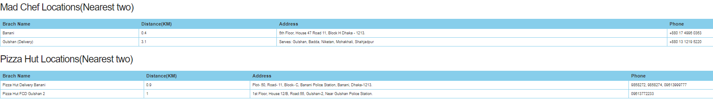

**Postman test for visutalization**

var template **=** `

    <style type="text/css">

        .tftable {font-size:14px;color:#333333;width:100%;border-width: 1px;border-color: #87ceeb;border-collapse: collapse;}

        .tftable th {font-size:18px;background-color:#87ceeb;border-width: 1px;padding: 8px;border-style: solid;border-color: #87ceeb;text-align:left;}

        .tftable tr {background-color:#ffffff;}

        .tftable td {font-size:14px;border-width: 1px;padding: 8px;border-style: solid;border-color: #87ceeb;}

        .tftable tr:hover {background-color:#e0ffff;}

    </style>

    <h3> Availbale Items</h3>

    <table class="tftable" border="1">

        <tr>

            <th>Item Name</th>

            <th>Resturant</th>

            <th>Price</th>

            <th>Catagory</th>

            <th>Description</th>

        </tr>

        {{#each response.item_list}}

            <tr id=row_{{@key}} onClick="handleClick(this.id)">

                <td id={{@key}}>{{item_name}}</td>

                <td>{{resturant}}</td>

                <td>{{price}}</td>

                <td>{{catagory}}</td>

                <td>{{description}}</td>

            </tr>

        {{/each}}

    </table>

    <h3>Mad Chef Locations(Nearest two)</h3>

    <table class="tftable" border="1">

        <tr>

            <th>Brach Name</th>

            <th>Distance(KM)</th>

            <th>Address</th>

            <th>Phone</th>

        </tr>

        {{#each response.madChef_loaction}}

            <tr id=row_{{@key}} onClick="handleClick(this.id)">

                <td id={{@key}}>{{branch_name}}</td>

                <td>{{distance}}</td>

                <td>{{address}}</td>

                <td>{{phone}}</td>

            </tr>

        {{/each}}

    </table>

    <h3>Pizza Hut Locations(Nearest two)</h3>

    <table class="tftable" border="1">

        <tr>

            <th>Brach Name</th>

            <th>Distance(KM)</th>

            <th>Address</th>

            <th>Phone</th>

        </tr>

        {{#each response.pizzahut_locations}}

            <tr id=row_{{@key}} onClick="handleClick(this.id)">

                <td id={{@key}}>{{branch_name}}</td>

                <td>{{distance}}</td>

                <td>{{address}}</td>

                <td>{{phone}}</td>

            </tr>

        {{/each}}

    </table>

`;

pm.visualizer.**set**(template, {

    response: pm.response.json()

});

**JSON**

{

    "item_list": [

        {

            "catagory": "Crispy Chicken",

            "description": "Original chicken wings/ Bangkok style fried chicken.",

            "item_name": "Original",

            "price": 399,

            "resturant": "Mad Chef"

        },

        {

            "catagory": "Crispy Chicken",

            "description": "Chicken wings/ Bangkok style fried chicken dipped in hot sweet & sour pepper sauce.",

            "item_name": "Buffalo",

            "price": 399,

            "resturant": "Mad Chef"

        },

        {

            "catagory": "Crispy Chicken",

            "description": "Chicken wings/ Bangkok style fried chicken dipped in spicy naga sauce.",

            "item_name": "Naga-Tastic 🌶",

            "price": 399,

            "resturant": "Mad Chef"

        },

        {

            "catagory": "Crispy Chicken",

            "description": "Chicken wings/ Bangkok style fried chicken dipped in honey garlic sauce.",

            "item_name": "Honey Garlic",

            "price": 399,

            "resturant": "Mad Chef"

        },

        {

            "catagory": "Rice Meals",

            "description": "Choice of rice served with gyro chicken topped with mint yogurt sauce.",

            "item_name": "Gyro Chicken over Rice",

            "price": 399,

            "resturant": "Mad Chef"

        },

        {

            "catagory": "Poutines",

            "description": "Potato fries topped with brown gravy, Katsu Chicken, beef Bacon & melted cheddar cheese.",

            "item_name": "Crispy Chicken & Bacon",

            "price": 439,

            "resturant": "Mad Chef"

        },

        {

            "catagory": "Poutines",

            "description": "Cajun falvored potato fries topped with GYRO CHICKEN, Mint Yogurt & Spicy Sauce",

            "item_name": "Gyro Chicken over Cajun Fries 🌶",

            "price": 379,

            "resturant": "Mad Chef"

        },

        {

            "catagory": "Gourmet Burgers",

            "description": "Bbq chicken cheeseburger topped with smoked chicken layer & beef bacon.",

            "item_name": "Smokin' Chic 🌶",

            "price": 419,

            "resturant": "Mad Chef"

        },

        {

            "catagory": "Wholesome Platters",

            "description": "Chicken steak coated with a choice of sauce, garlic mushroom & french fries.",

            "item_name": "Chicken Steak Meal",

            "price": 419,

            "resturant": "Mad Chef"

        },

        {

            "catagory": "Gourmet Burgers",

            "description": "Beef cheeseburger topped with smoked chicken & mustard sauce",

            "item_name": "The Cuban",

            "price": 419,

            "resturant": "Mad Chef"

        },

        {

            "catagory": "Classic Burgers",

            "description": "Beef cheese burger topped with mushroom & chicken gravy",

            "item_name": "Mushroom Melt",

            "price": 379,

            "resturant": "Mad Chef"

        },

        {

            "catagory": "Classic Burgers",

            "description": "Beef cheese burger topped with fried chicken sausages",

            "item_name": "The BIG Rob",

            "price": 379,

            "resturant": "Mad Chef"

        },

        {

            "catagory": "pan pizza",

            "description": "Lebanese chicken, mushroom, onion, green chilies.",

            "item_name": "Spicy Chicken.",

            "price": 379,

            "resturant": "Pizza Hut"

        },

        {

            "catagory": "pan pizza",

            "description": "BBQ Chicken, Green Chillies, Sweet Corn",

            "item_name": "BBQ Chicken",

            "price": 379,

            "resturant": "Pizza Hut"

        },

        {

            "catagory": "pan pizza",

            "description": "Smoked Chicken, Mushroom, Onion and Red Paprika",

            "item_name": "Smoky Grilled Buzz",

            "price": 379,

            "resturant": "Pizza Hut"

        },

        {

            "catagory": "pan pizza",

            "description": "Spicy chicken, beef, onions, tomatoes, green chilies",

            "item_name": "Red N Hot.",

            "price": 429,

            "resturant": "Pizza Hut"

        },

        {

            "catagory": "pan pizza",

            "description": "Spicy chicken, chicken & beef topped with onions, mushrooms, capsicum.",

            "item_name": "Supreme.",

            "price": 429,

            "resturant": "Pizza Hut"

        },

        {

            "catagory": "pan pizza",

            "description": "Chicken Supreme.",

            "item_name": "Chicken Supreme.",

            "price": 429,

            "resturant": "Pizza Hut"

        },

        {

            "catagory": "pan pizza",

            "description": "Spicy chicken, tomatoes, onions, capsicum, mushrooms, black olives.",

            "item_name": "Chicken Classic.",

            "price": 429,

            "resturant": "Pizza Hut"

        },

        {

            "catagory": "pan pizza",

            "description": "Lebanese chicken, chicken sausage, capsicum, tomatoes, jalapenos, black olives.",

            "item_name": "Chicken Delight.",

            "price": 429,

            "resturant": "Pizza Hut"

        },

        {

            "catagory": "pan pizza",

            "description": "Spicy chicken marinated in BBQ sauce, onions, capsicum, tomatoes, green chilies.",

            "item_name": "Bbq Temptation .",

            "price": 429,

            "resturant": "Pizza Hut"

        }

    ],

    "madChef_loaction": [

        {

            "address": "5th Floor, House 47 Road 11, Block H Dhaka - 1213.",

            "branch_name": "Banani",

            "phone": "+880 17 4996 0363",

            "distance": 0.4

        },

        {

            "address": "Serves: Gulshan, Badda, Niketan, Mohakhali, Shahjadpur",

            "branch_name": "Gulshan (Delivery)",

            "phone": "+880 13 1219 5220",

            "distance": 3.1

        }

    ],

    "pizzahut_locations": [

        {

            "address": "Plot- 50, Road- 11, Block- C, Banani Police Station, Banani, Dhaka-1213. ",

            "branch_name": "Pizza Hut Delivery Banani",

            "phone": " 9858272, 9858274, 09613999777",

            "distance": 0.9

        },

        {

            "address": "1st Floor, House:12/B, Road:55, Gulshan-2, Near Gulshan Police Station. ",

            "branch_name": "Pizza Hut FCD Gulshan 2",

            "phone": " 09613772233",

            "distance": 1.0

        }

    ]

}