

American International University-Bangladesh (AIUB)  
Department of Computer Science  
Faculty of Science &Technology (FST)  
2020-2021, Spring

Section: C  
Software Quality and Testing

PROJECT TITLE

**Developing a Test Plan for a Banking System**

A Report submitted

By

|  |  |  |
| --- | --- | --- |
| SN | Student Name | Student ID |
| 1 | Shimu, Md. Abusufian | 15-29876-2 |
| 2 | Farajannat, Fahim | 17-35634-3 |
| 3 | Hossan, Md.Sazzat | 18-37445-1 |
| 4 | Hridoy, Abdur Rahman | 17-33706-1 |

Under the supervision of

**ABHIJIT BHOWMIK**

**Department of Computer Science**

**American International University of Bangladesh**

Software Test Plan

for

**A Banking Management System**

Version 1.0 approved

Prepared by

Md. Abusufian Shimu

Fahim Farajannat

Md. Sazzat Hossan

Md. Abdur Rahman Hridoy

Datasoft Systems Bangladesh Limited

Rupayan Shelford, 20th Floor, 23/6 Mirpur Rd, Dhaka 1207

28.04.2021

Table of Contents

Revsion History:………………………………………………………………………………………………....3

1. TEST PLAN IDENTIFIER: RS-MTP01.3 4

**2**.REFERENCES………………………………………………………………………………………………………………………..….5

3. INTRODUCTION 7

Background to the Problem 7

Solution to the Problem 7

4. REQUEIREMNT SPECIFICATION 7

4.1 System Features 7

4.2 System Quality Attributes 8

4.3 System Interface 8

4.4 Project Requirements 8

5. FEATURES NOT TO BE TESTED 9

6. Testing Approach 10

6.1 Testing Levels 10

6.2 Test Tools 11

6.3Meetings 12

7. TEST CASES/TEST ITEMS 13

8. ITEM PASS/FAIL CRITERIA 13

8.1 Unit Test Plan: 13

8.2 Master Test Plan: 13

8.3 Number & severity of defects located: 14

9. TEST DELIVERABLES 14

10. STAFFING AND TRAINING NEEDS 14

11. RESPONSIBILITIES 16

11.1 Project Leader 16

11.2 Software Quality Assurance Project Leader 16

11.3 Test Planner / Controller 16

11.4 Testers 17

11.5 Client 17

11.6 Bookkeeping Support 17

11.7 Technical Support 18

11.8 Software Control Change Board 18

12. TESTING SCHEDULE 18

13. PLANNING RISKS AND CONTINGENCIES 19

14. APROVALS 20

Revision History

|  |  |  |  |
| --- | --- | --- | --- |
| Revision | Date | Updated by | Update Comments |
| 0.1 | 10.01.2021 | Md. Abusufian Shimu | 1st Draft |
| 0.2 | 20.01.2021 | Fahim Farajannat | 2nd Draft |
| 0.3 | 12.02.2021 | Md.Sazzat Hossan | 3rd Draft |
| 0.4 | 20.02.2021 | Abdur Rahman Hridoy | 4th Draft |
| 0.5 | 26.02.2021 | Md. Abusufian Shimu | 5th Draft |
| 0.6 | 29.02.2021 | Fahim Farajannat | 6th Draft |
| 0.7 | 07.03.2021 | Md.Sazzat Hossan | 7th Draft |
| 0.8 | 17.03.2021 | Abdur Rahman Hridoy | 8th Draft |
| 0.9 | 22.03.2021 | Md. Abusufian Shimu | 8th Draft |
| 10 | 29.03.2021 | Fahim Farajannat, | 10th Draft |
| 11 | 06.04.2021 | Md.Sazzat Hossan | Final Draft |

# TEST PLAN IDENTIFIER:RS-MTP01.3

**Datasoft, Inc.** release 0.1 Software Test Plan.

Note, the structure of this document is primarily based on the IEEE 829- 1998 Standard for Software Test Documentation. Additional reference standards include IEEE 1008 (Unit Testing), 1012 & 1059(Validation

& Verification) and 1074 (Software Life Cycle process).

# REFERENCES

TEST PLAN OUTLINE (IEEE 829 FORMAT)

[http://ece.uprm.edu/~icom5047/documents/OtherDocuments/TestPlan.p](http://ece.uprm.edu/~icom5047/documents/OtherDocuments/TestPlan.pdf) [df](http://ece.uprm.edu/~icom5047/documents/OtherDocuments/TestPlan.pdf)

* + The system will confiscate the ATM card if it detects that a lost or stolen card has been inserted by a customer. The system will also display an apology to the customer.
  + The system will allow the customer to enter the correct PIN in no more three attempts. The failure to provide correct PIN in three attempts will result in the confiscation of the ATM card.
  + The system will ask for the transaction type after satisfactory validation of the customer PIN. The customer will be given three options: withdrawal transaction, or query transaction, or transfer transaction.
  + If a customer selects withdrawal transaction, the system will prompt the customer to enter account number and amount to be dispensed.
  + For a withdrawal transaction, the system will determine that sufficient funds exist in the requested account, that the maximum daily limit has not been exceeded, and that there are sufficient funds available at the local cash dispenser.
  + If a withdrawal transaction is approved, the requested amount of cash will be dispensed, a receipt will be printed containing

information about the transaction, and the card will be ejected. The information printed on the receipt includes transaction number, transaction type, amount withdrawn, and account balance.

* + If a customer selects query transaction, the system will prompt the customer to enter account number.
  + If a query transaction is approved, the system will print a receipt and eject the card. The information contained on the receipt includes transaction number, transaction type, and account balance.
  + If a customer selects transfer transaction, the system will prompt the customer to enter from account number, to account number, and amount to be transferred.
  + The system will check if there are enough funds available in the ‘from account’, which are being requested for transfer to the ‘to account’.
  + If the transfer transaction is approved, a receipt will be printed and the card will be ejected. The information printed on the receipt includes transaction number, transaction type, amount type, and account balance.
  + The system will cancel any transaction if it has not been completed if the customer presses the Cancel button.
  + The customer records, account records, and debit card records will all be maintained at the server and will not be the responsibility of the system.
  + The system will enable an ATM operator to shut down or start up an ATM for routine maintenance.
  + The system will enable an ATM operator to add cash to the cash dispenser.
  + The system will not be responsible for opening or closing of accounts, and to create, update, or delete customer and debit card records. These tasks are performed elsewhere by the bank.
  + The system will be linked with the bank server through communication systems, which are beyond the scope of the current system. It is assumed that this facility is always available.
  + The system will not be responsible for the maintenance of the hardware devices of the ATM or network facilities

# INTRODUCTION

## Background to the Problem

The purpose of that system is to give an easiest way of Banking Service. It is system test plan for AIUB Bank limited linked to a central server via a wide area network where the ATM machine is used, a customer's checking or savings account can be used to withdraw cash, query the balance of an account, or transfer funds from one account to another. The aim of that system is to make banking services as simple as possible.

## Solution to the Problem

To create software for dealing with a customer's financial applications in a banking environment in order to meet the needs of a bank customer by allowing customers to conduct banking tasks in a variety of ways. Additionally, to provide extra functionality to the device workspace which are not provided under a conventional banking software.

# REQUEIREMNT SPECIFICATION

## System Features

The major functionalities of the system are as follows:

* 24/7 service.
* Query of Valid account.
* Query of Valid ATM pin.
* Withdrawal of funds.
* Query of account balance.
* Touch screen menu selection.
* Transfer of funds from one bank account to another account in the same bank.
* Limit the number of transaction at the same time
* Changing the ATM pin.
* Prints the receipt automatically.

## System Quality Attributes

* **Correctness**
* **Reliability**
* **Robustness**
* **Maintainability**
* **Readability**
* **Extensibility**
* **Testability**
* **Efficiency**
* **Portability**

## System Interface

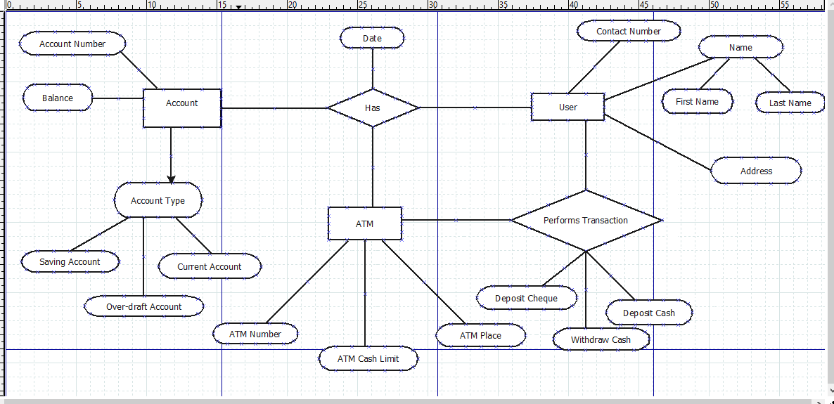

## Project Requirements

This section lists the features not to be included in the testing process.

* Machine accepts card and PIN detail.
* Machine successfully takes out the money.
* Machine takes out the balance printout after the withdrawal.
* Machine logs out of the client session immediately after withdrawal successfully.
* Machine prints out balance inquiry standalone as part of menu operation.
* Machine does not accept Invalid card and PIN.
* Machine finds wrong PIN.
* Machine finds card insertion in wrong way.
* Machine takes 3 invalid PIN attempt.
* Lack of money in the savings account.
* Expired card inserted in the machine.
* Money amount less than 100 entered in the machine.

# FEATURES NOT TO BE TESTED

This section lists the features not to be included in the testing process, identifying the reason behind its exclusion. The reasons are:

* It is used before.
* It is deemed stable and reusable.
* It has low risk.
* No intention of releasing with software.

This section of a Test Plan is directly associated with previous sections; what will and will not be tested is directly affected by levels of acceptable risk within the project. If a feature does not get tested it affects the level of risk of the project.

# Testing Approach

## Testing Levels

This section identifies the strategy for this test plan, differing depending on the level of test plan (Unit, Integration, and Acceptance). The approach stated should be appropriate and in agreement with all higher and lower levels of test plans. The level of detail of this section differs depending on the level of test plan. For example, a Unit test plan will go into much detail on individual unit tests and test data. The bulk of information on testing techniques and methodologies will be included in this section.

* + Collection of metrics.
  + Level of each metric to be collected.
  + Special tools to be used in the testing process.
  + What are those tools?
  + Special training required for the tools.
  + How many different configurations will be tested
  + Configuration management should be handled.
  + Hardware & Software.
  + Combinations of Hardware, Software and other vendor packages.
  + Levels of regression testing will be done.
  + How much testing is needed?
  + Will regression testing be based on severity of defects detected?
  + How will elements in the requirements and design that do not make sense or are untestable be processed?

If this is a master test plan the overall project testing approach and coverage requirements must also be identified.

Specify if there are special requirements for the testing.

* + Only the full component will be tested.

A specified segment of grouping of features/components must be tested together.

## 6.2 Test Tools

One complete, controlled system is required for the testing, setup as per one standard. In order to maintain the integrity of the test environment this network will not be accessible to anybody outside the project. The supporting software also have to currently up-dated and upgradeable if any case the system needs patch, bugs fixed or upgrade.

Hardware components required:

* + 1 Network Controller
  + 1 ATM Machine [With complete requirements]
  + 1 HP LaserJet 4v Printe

Test Environment Software:

Supporting Software:

* + *ATMulator*™ Plus

System Test will be run on the following Software Versions:

* + Windows 7 Operating System
  + Visual Studio 2015
  + MS Office

## 6.3 Meetings

The test team will meet once every two weeks to evaluate progress to date and to identify error trends and problems as early as possible. The test team leader will meet with development and the project manager once every two weeks as well. These two meetings will be scheduled on different weeks. Additional meetings can be called as required for emergency situations.

|  |  |  |  |  |  |
| --- | --- | --- | --- | --- | --- |
| Project Name:  **Test Plan for a Banking System** | | | Test Designed by: Md. Abusufian Shimu | | |
| Test Case ID: FR_1 | | | Test Designed date:22.02.2021 | | |
| Test Priority (Low, Medium, High): Medium | | | Test Executed by: Fahim Farjannat | | |
| Module Name: Login Session | | | Test Execution date:03.03.2021 | | |
| Test Title: verify login with valid username and password | | |  | | |
| Description: Test website login page | | |  | | |
| Precondition (If any): User must have valid username and password | | | | | |
| Test Steps | Test Data | Expected Results | | Actual Results | Status (Pass/Fail) |
| 1. Go to the website 2. Enter username 3. Enter password 4. Click submit | Username: 87056318  Password: 111866 | User should login into the application | | As expected, | Pass |
|  |  |  | |  |  |
| Post Condition: User is validated with database and successfully login to account. The account session details are logged in the database. | | | | | |
|  | | | | | |

# TEST CASES/TEST ITEMS

* Card and PIN information are accepted by the machine.
* The money is successfully taken out by the machine.
* After the withdrawal, the machine prints out the balance printout.
* After a complete withdrawal, the machine automatically logs out of the client session.
* As part of menu service, the machine prints out a balance inquiry.
* Invalid card and PIN are not accepted by the machine.
* The machine detects an incorrect PIN.
* Machine detects incorrect card insertion.
* Machine takes 3 invalid PIN attempt.
* The machine attempts three times with an invalid PIN.
* Expired card inserted in the machine.
* Money amount less than 100 entered in the machine.

# ITEM PASS/FAIL CRITERIA

This section identifies the pass and fail criteria appropriate to this test plan.

## Unit Test Plan:

* All test cases are complete.
* The automated testing tool displays all lines of code that have been tested.

## Master Test Plan:

* All lower level plans are completed.
* A successful Test Plan should specify whether or not a project stage can proceed.

## Number & severity of defects located:

* A flaw is something that has the potential to cause a malfunction but is permissible to leave in the application.
* A failure is caused by a defect that is visible to the user, such as a system crash.

# TEST DELIVERABLES

* Test cases documents
* Test plan
* Testing Strategy
* Test Data
* Test Scripts
* Test trace ability matrix
* Test Summary report
* Configuration guide
* Release notes
* Defect report & corrective steps
* Simulators
* Error logs
* Static & Dynamic generators

# STAFFING AND TRAINING NEEDS

The purpose staffing plan is to make certain the project has sufficient staff with the right skills and experience to ensure a successful project completion. The following is a detailed breakdown of the roles required to execute the project. It includes the project role, the project responsibility of the role, number of staff required fulfilling the role and the duration the staff resource will be needed on the project.

|  |  |  |  |  |
| --- | --- | --- | --- | --- |
| Requirements Analyst | Fahim Farajannat | **25** | Requirements | **01** |
| Software Engineer | Md.Sazzat Hossan | **40** | System Allocation &  Design | **01** |
| Programmer | Abdur Rahman Hridoy | **20** | Implementation | **01** |
| Verification Engineer | Md. Abusufian Shimu | **62** | Requirements, Design,  Implementation, | **01** |
| Software Designer | Fahim Farajannat | **60** | Design | **01** |
| Quality Analyst | Md.Sazzat Hossan | **25** | All (but most work up-front during definition) | **01** |
| Database Engineer | Abdur Rahman Hridoy | **20** | Design,  Implementation, Installation | **01** |
| Configuration Manager | Md. Abusufian Shimu | **20** | All (but most work up-front  During definition) | **01** |

|  |  |  |  |  |
| --- | --- | --- | --- | --- |
| Technical Writer | Fahim Farajannat | **20** | Documentation | **01** |
| Installation Specialist | Abdur Rahman Hridoy | **20** | Installation | **01** |

|  |  |  |  |  |
| --- | --- | --- | --- | --- |
| **Role** | **Name** | **Est. wor king hour s** | **Key project phase** | **Num ber of staff requi red** |
| Project Manager | Md. Abusufian Shimu | **105** | All | **01** |

# RESPONSIBILITIES

## Project Leader

* + Ensure that Phase 1 is completed on time, on budget, and with high quality.
  + Ensure Exit Criteria are achieved prior to System Test Signoff.
  + Check the status of the testing with the Test Planner.
  + Liaise with external groups e.g. New ATM Vendors
  + Raise and manage issues/risks relating to project or outside Teams control.
  + Review & sign off Test approach, plans and schedule.

## Software Quality Assurance Project Leader

* + Ensure that Testing Phase 1 is completed on time, on budget, and with high quality.
  + Regularly review Testing progress
  + Manage issues / risks relating to System Test Team
  + Provide the resources required to complete the system test.

## Test Planner / Controller

* + Ensure Phase 1 is completed on time, on budget, and with high quality.
  + Produce High Level and Detailed test cases
  + Report progress at status reporting meetings
  + Co-ordinate review & signoff of Test Conditions
  + Manage individual test cycles & resolve tester queries/problems.
  + Ensure test systems outages/problems are followed up.
  + Ensure Entrance criteria are achieved prior to System Test start.
  + Ensure Exit criteria are achieved prior to System Test signoff.

## Testers

* + Notify the Testing Supervisor of any problems.
  + Execute Test Conditions and Mark off results (execute test cases- system and UAT)
  + Ensure the traceability of test case requirements
  + Resolve queries arising from remote backup
  + Inform the Testing Coordinator of your progress.

## Client

* + Provide detailed requirements
  + Participate in Business Designing
  + Review and Approve Requirements
  + Create User Acceptance Test Cases
  + Execute UAT

## Bookkeeping Support

* Bookkeeping Integration
* Provide Bookkeeping Technical support, if required.
* Resolve queries, if required.

## Technical Support

* Provide support for hardware environment
* Provide support for Test software
* Promote Software to system test environment

## Software Control Change Board

* Attend the change control meetings
* Follow change control process
* Evaluate and document change

# TESTING SCHEDULE

Time has been allocated within the project plan for the following testing activities. The specific dates and times for each activity are defined in the project plan timeline. The persons required for each process are detailed in the project timeline and plan as well.

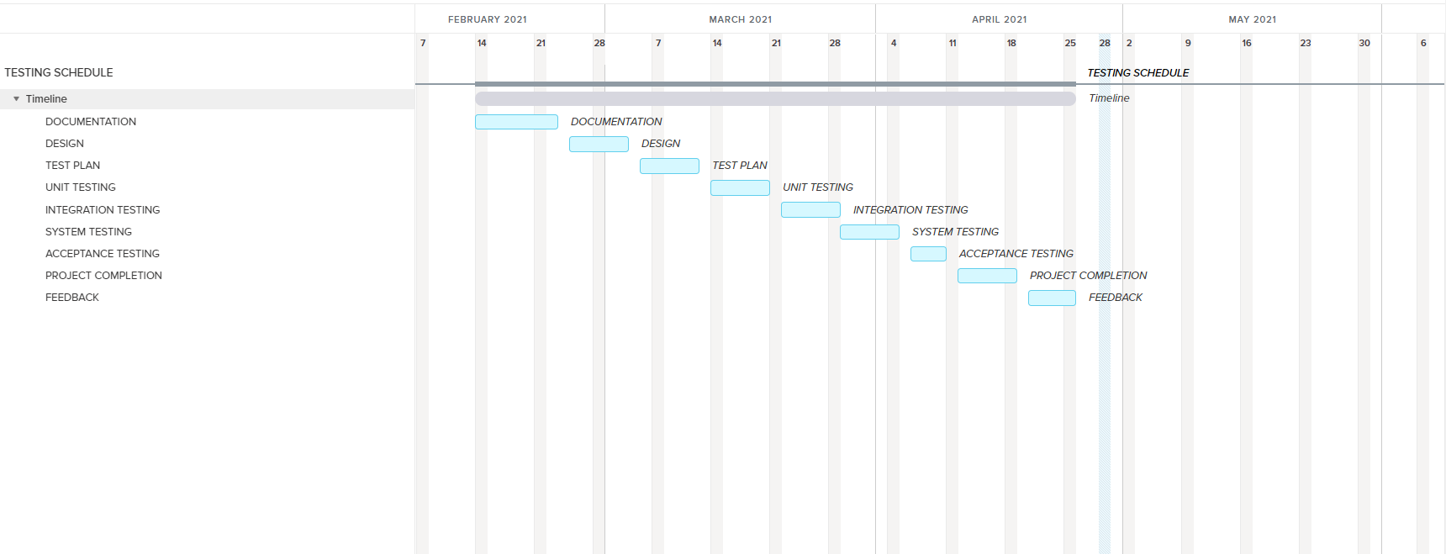

# PLANNING RISKS AND CONTINGENCIES

This section mentions a number of possible risks for the project. Also, actions or measures are described to prevent or to reduce the risks.

* + Break Down in Communication - There is a chance that a break own in communication occurs between the team members, and even between the sponsors. If this occurs, it can result in a loss of ground. It would be difficult to complete tasks on schedule or at all if there was little or no contact. If we lose contact with a teammate, we will make every effort to contact that person. Shall they become unreachable for an extended period; we will redistribute the works, and assume the team members are no longer a member of the team.
  + Hardware Failure - There's a risk the company server could go down before, during, or after our program is deployed. If this occurs and no remedy can be found, we will have to depend on previously acquired hardware. Split test execution into morning and evening shifts such that testing can occur for multiple teams in the someday using the limited hardware.
  + Team Member Leaving/Getting Sick - It's possible that one or more team members will leave or become ill and need to take a long leave of absence. If this happens, we run the risk of falling behind, or being unable to complete the project for our sponsor. Component resources would be divided between existing resources. It is necessary to make the necessary adjustments to the schedule.
  + Not Sufficient Budget for Testing- This is a common complaint. The challenge is to prioritize the plan to test the right things in the given time.
  + Political Interference: In case of strike or any other political interference our workers will work on the weekends or work overtime in the working days to recover the lost time.

# APROVALS

|  |  |
| --- | --- |
| **Position** | **Assigned** |
| Project Sponsor | Md. Abusufian Shimu |
| Development Management | Fahim Farajannat |
| EDI Project Manager | Md. Sazzad Hossan |
| RS Test Manager | Abdur Rahman Hridoy |
| RS Development Team Manager | Md. Abusufian Shimu |
| Reassigned Sales | Fahim Farajannat |
| Order Entry EDI Team Manager | AIUB |

The End