

American International University- Bangladesh

**Software Requirement Engineering**

**Faculty: Abhijit Bhowmik**

**Title: Assignment on Requirement Collection**

**Section:** **A**

**Date:** **12.03.2021**

|  |  |  |
| --- | --- | --- |
| **SL** | **Group Member’s Name** | **ID** |
| **01** | **Fahim Farajannat** | **17-35634-3** |
| **02** | **Arfatur Noor** | **18-39151-3** |
| **03** | **Fatema Tuj Zohora Nusrat** | **18-39165-3** |
| **04** | **Nishat Anjum** | **18-39175-3** |

Our project is to automate their company with an ERP (Enterprise Resource Planning). Description of how a Project Manager can successfully collect full requirements from the company and start development is given bellow: Collecting requirements for a project is a very vital part. In fact, collect requirements process helps to define project scope during scope management. There are some set of tools and techniques to gather project requirements. It seems practical to collect all requirements at the start using a requirement-gathering tool. This should ensure the project deliverable as sought. To designing and building an elegant computer program that solves the wrong problem. That's why it's important to understand what the customer wants before you begin to design and build a computer-based system. The hardest single part of building a software system is deciding what to build. There is no such part of the work so cripples the resulting system if done wrong. No other part is more difficult to rectify later. Many software developers argue that things will become clear as they build, that project stakeholders will be able to understand need only after examining early iterations of the software, that things change so rapidly that any attempt to understand requirements in detail is a waste of time, that the bottom line is producing a working program, and that all else is secondary. Requirements engineering establishes a solid base for design and construction. Without it, the resulting software has a high probability of not meeting customer's needs.

Requirements can be classified into various types, like business requirements, solution requirements, stakeholders’ requirements, transition requirements, quality requirements, etc. Stakeholder's play an essential role in influencing the success of the project as they involve in determining, documenting, and managing the requirements. Requirements are regarded as the foundation of the WBS (Work Breakdown Structure) and for the project managers to work on a particular project would find it difficult without a requirement document because they won’t have anything to work on.

Project Requirements:

The requirement is the expectation of project stakeholders on project outcomes. As per the definition is given by PMI, “Collect Requirements is the process of determining, documenting, and managing stakeholder needs & requirements to meet project objectives."

Requirements are descriptions of the services that a software system must provide and the constraints under which it must operate Requirements can range from high-level abstract statements of services or system constraints to detailed mathematical functional specifications.

**Types of Requirement:**

**User requirement:** User requirements, often referred to as user needs, describe what the user does with the system, such as what activities that users must be able to perform.

**System requirement:**

System requirements are the required specifications a device must have in order to use certain [hardware](https://techterms.com/definition/hardware) or [software](https://techterms.com/definition/software).

**Software requirement:**

The software requirements are description of features and functionalities of the target system. Requirements convey the expectations of users from the software product.

**Functional, non-functional and domain requirement:**

**Functional requirement**:

Functional requirement specify the behaviors the product will exhibit under specific conditions.

* They describes what the developers must implement to enables users to accomplish their tasks (user requirements), thereby satisfying the business requirements.

**Non-functional requirement**:

Non-functional requirements are also known as quality attributes, products requirements that describes a service or performance characteristic of a product.

* Constraints on the services or functions offered by the system such as timing constraints, constraints on the development process, standards etc.

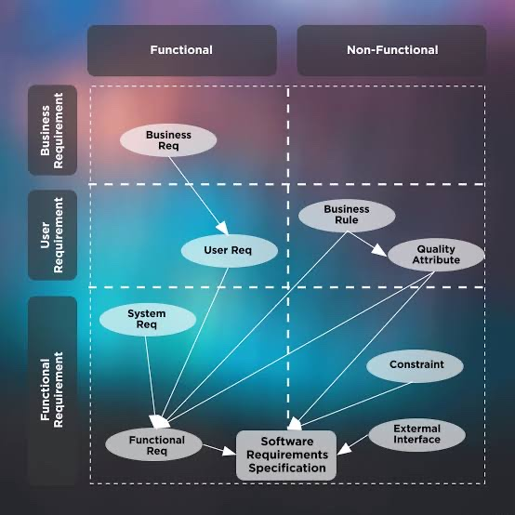

**Domain requirements:**

Requirements that come from the application domain of the system that reflect the characteristics of that domain.

* May be functional or non-functional.

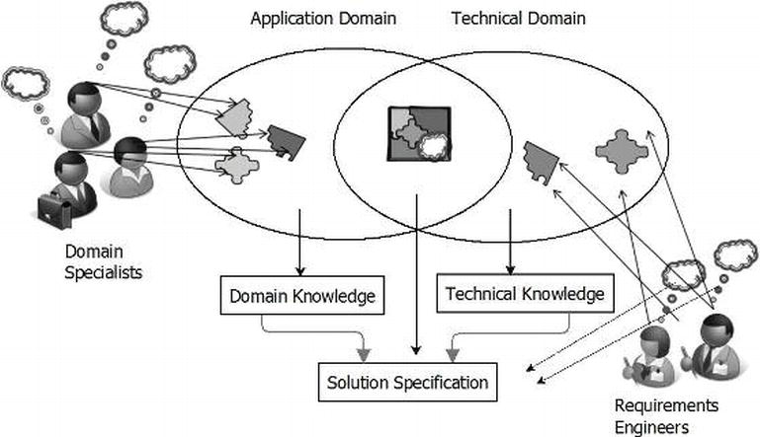

**Requirements document users:**

**System customers:**

Specify the requirements and read them back to check that they meet their needs; specify changes to the requirements.

System requirements is a statement that identifies the functionality that is needed by a system in order to satisfy the customer's requirements

**Development Managers:**

Use the requirements document to plan a bid for the system and to plan the system development process

**Implementation Programmers:**

Use the requirements to understand what system is to be developed. Implementation is the part of the process where software engineers actually program the code for the project. Software testing is an integral and important phase of the software development process. This part of the process ensures that defects are recognized as soon as possible.

**Test programmers:**

Use the requirements to develop validation tests for the system. Testing is the process of evaluating a system or its component(s) with the intent to find whether it satisfies the specified requirements or not. In simple words, testing is executing a system in order to identify any gaps, errors, or missing requirements in contrary to the actual requirements.

**Maintenance programmers:**

Use the requirements to help understand the system and the relationships between its parts.

**Summary:**

Requirements determine the fundamental characteristics of an office  
information system. They are an informal step to systems specification  
and design as they focus on features and characteristics of the  
technical system that will be developed.  
 Here the characteristics of requirements and the requirement analysis is shown.

Requirements analysis encompasses those tasks that go into determining  
the needs or conditions to meet for a new or altered product or project,  
taking account of the possibly conflicting requirements of the various  
stakeholders, analyzing, documenting, validating and managing software  
or system requirements.

Hence, it is necessary to fulfill the requirement to properly in order to get the output.