

American International University-Bangladesh (AIUB)  
**Department of Computer Science  
Faculty of Science &Technology (FST)  
Spring 20- 21**

**“Hospital Management System”**

Software Requirement Engineering

Faculty: **“Abhijit Bhowmik”**

Section: **A**

Project submitted

By

*Nishat Anjum (18-39175-3)*

*Arfatur Noor (18-39151-3)*

*Fatema Tuj Zohora Nusrat (18-39165-3)*

*Fahim Farajannat (17-35634-3)*

1. **PROBLEM DOMAIN**

**1.1 Background to the Problem**

Large segments of the population in developing countries are deprived of a fundamental right: access to basic health care. Without an appropriate and adequate health support and delivery system in place, its adverse effects will be felt in all other sectors of the economy. In simple terms, an ailing nation equates to an ailing economy as manifested in lower income-earning capacity of households and significant productivity losses in those sectors that sustain the economy.

In our country since the population is more and it is only increasing. Number of hospitals in our country is inadequate compared to the number of patients. Also doctor and hospitals and their facilities are not enough to treat the patients and diseases properly. Often many patients do not get the proper hospital facilities due to less number of beds and doctors. Patients in emergency cases suffer most due to such kinds of problematic management. An economic survey of 2018 shows that there will be only one doctor available for every 2039 patients. There are a large number of patients showing up to the hospitals each day. These patients will suffer very long delays by having to wait in long queue to even get a serial number, let alone find consultation with the doctor. This can be very time consuming and also be very inefficient as a process. Time, money and much of energy is wasted.

So in any case, the current system is very inefficient and cumbersome. And as for the root causes, unorganized, unfriendly management and dishonesty of peoples are to blame. For a densely populated country like ours where number of doctors is very inadequate, mentioned problem is very important to consider and come up with a better and efficient solution.

**1.2 Solution to the Problem**

The solution being suggested to cure the problem is a management system for handling doctors, patients, nurse and other staff. In other words a portal that helps doctors in their work, and eases the process of patients to book doctors for appointments and view their medical process. Also there will be options for medical report, facility management, proper service from the nurses, financial records, staff interaction and better management. A search engine will be provided through which users can conveniently find out desired doctors and customize their appointment facilities. Here the system will have the information of doctors, patients, nurses, and accountant, laboratorial and there will be admin for controlling all these tasks. The system allows doctors to manage their booking slots online. Each patient will be allowed to book an empty slot online, and these slots are reserved under their name. A patient can also cancel their booking in case of inconveniences or emergencies. The system will manage the appointment data for multiple doctors for various dates and times. Every time a user visits a doctor, their medical entry is stored in the database by a doctor's assistant. Every time a user logs in, he/she may view their entire medical history when needed, which will no longer require them to carry their old medical documents such as reports and prescriptions. Simultaneously, a doctor may view a patient's medical history every time they visit the aforementioned doctor. This will allow an automated doctor-patient handling system through an online interface.

1. **SOLUTION DESCRIPTION**

**2.1 System Features**

There are several users associated with our system. Different user needs different functionalities.

**Features for all users:**

1.Log in

2.Registration

**Features for Admin-**

1.Can add users

2.Can verify users profile-block/approve Users

**Features for doctor-**

1.Check Appointment

2.Confirm/Cancel Appointment

**Features for Patient-**

1. Search doctor

2. Take appointment of Doctor

3. Can contact system Admin

4. Search Medicine

5. Order Medicine

**Features for Nurse**-

1. Supervise patients

2. Contact doctor in case of emergency

3. Search medicine

**Features for pharmacist-**

1. Input Medicine

2. Checks order

3. Confirm/Cancel order

**Features for Accountant**-

1.Cash

2.Bkash

3.Card

**Features for Laboratories-**

It includes pathologist, radiologist

1.Performing the tests

2.Create report

**2.2 UML Diagrams**

**Use case diagram:**

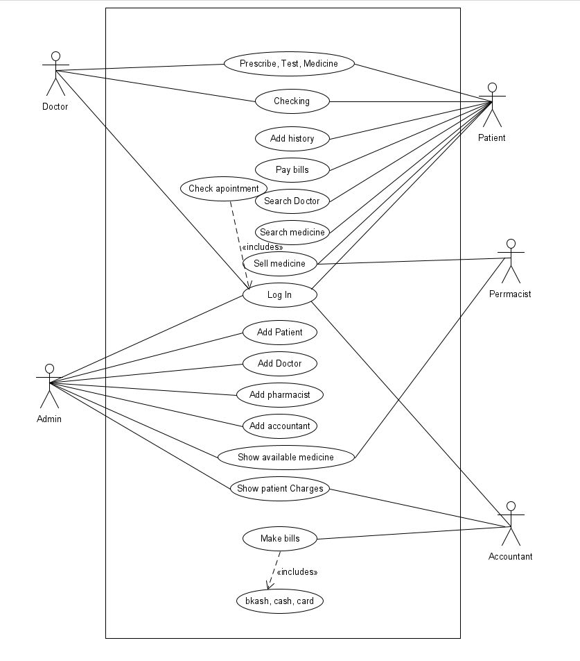

**E-R diagram:**

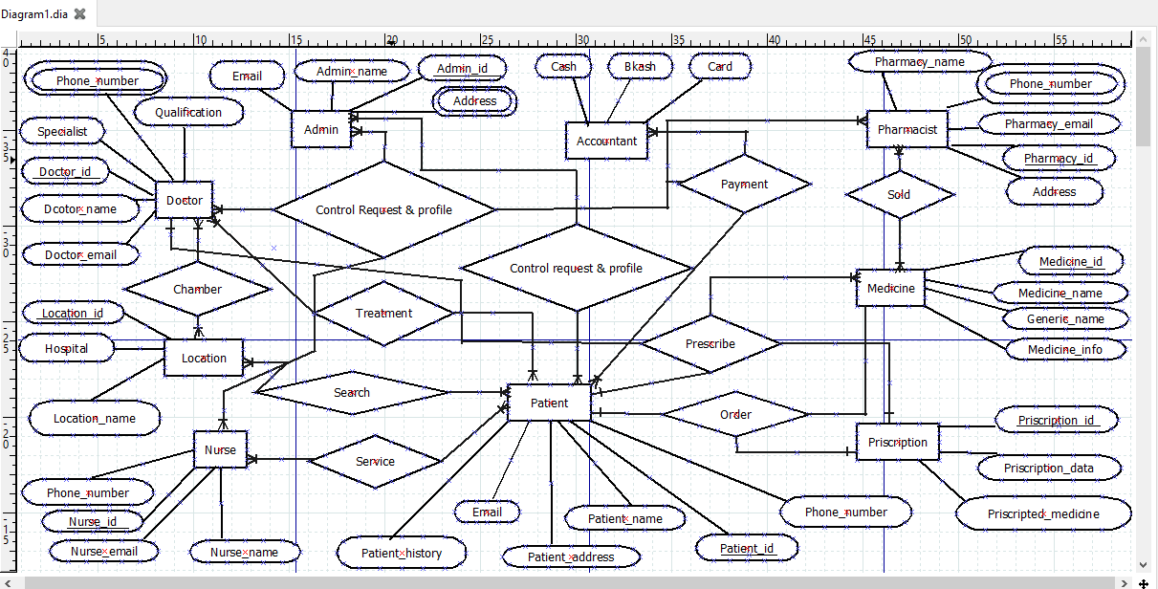

.

1. **Social Impact**

Here we working on a project called Hospital Management System. Now we discuss about social impact of this project in our community/society.

Our main working theme in this project is a management system that includes the whole management system of the hospital and helps to ease the work of doctors, nurses and pharmacists and helps in giving proper service to the patients. A search engine will be provided through which users can conveniently find out desired doctors and customize their appointment facilities. The system allows doctors to manage their booking slots online. Each patient will be allowed to

book slot online, and these slots are reserved under their name. Also the nurses will be able to serve the patients, pharmacists will provide the medicines, and accountant will keep the records for all types of payment and admin will manage all the users.

The health system is one of essential socio-economic activities; therefore, it requires rational and effective management. Hospitals, as the main actors of the health system, generate an essential volume of information, but in most cases, it is dispersed or not available in the necessary time and manner.

In recent years, health information systems have helped improve the quality of life of people in all sectors of our society, so it is inevitable to adhere to this dizzying technological career. Currently, clinical and administrative management of hospitals and health centers is possible through a single platform, with the support of cutting-edge technology, developed to optimize the processes that allow the operation of organizations dedicated to treating patients in any branch of the medicine.

Hospital management systems allows us the ability to optimize and digitize all the processes within the institution, which will help to improve customer service, reduce process costs, streamline the search of medical records, bills, patients, doctors, etc.; thus, having a database of each module implemented.

Therefore, through this system we can easily manage all the facilities and give proper service to the people in general. In Overall discussion we can say that our project gives a good impact in our society. And this gives a better relationship between doctor and patient. This is all about our project impact in our society.

1. **Development Plan**

In our project we will first start with the programming. We need to give proper timing to the programming since our management system is vast. After giving the proper time in coding we can start the testing which will take almost 5 to 6 weeks.

Then, we will call up a meeting and discuss about the requirement between the team members which thing we will go to build. After that we will do the design part then the coding and testing part. After that the release part we will go for documentation part. For development we will project management tool Jira ,which will help in tracing our project easily. We can find our bug easily and also we can assign task to the team member very easily.

**4.1 Meeting**: In the meeting part we will discuss about our idea. In our meeting we will brainstorm and come up with some idea to which thing we will go to implement. In this part we will also collect some requirement from people, doctor and nurse because they will be the users of the system. So by collecting some requirement with questionnaires technique we can get an idea to how our system will be. To collect those requirements we need at least one week. And to select which requirement is important or not, which feature will be implemented and also we need to do brain storming to come up with best idea. So we need at least one week to do meeting and brainstorming, which will require almost 2 weeks.

**4.2 Designing**: In designing part we will design the diagram and modules. We will design use-case diagram, Class diagram, Activity diagram, Sequence diagram, E-r diagram. In this part we need to work so carefully. Because if we do any type of mistake here then we will be in big trouble while implementing the system. So we need more time here to design carefully the diagrams. We will need almost 3 week to design these diagrams. So in this part we will mainly design the diagrams.

**4.3 Coding:** In the coding part we will implement the system. We will code in extreme programming. In our team we are 4 members. So we divide our team in two parts. And we divide our work. In extreme programming, when one programmer writes the code another one observing the code. So when we go for extreme programming we need more time in coding part. So we will try to finish our coding part in 5 weeks.

**4.4 Testing:** In testing part we will test our system is it working properly or not. In the testing we will do white box testing, Black box testing. We will do unit testing, integration testing, regression testing, acceptance testing. We will do all the testing to the system. By this we can say that how perfectly our system work. After starting the coding part we can start the testing part. After 2 week of the coding part start we can start our testing part. In testing part we have to ensure that the system works properly. So we need a huge amount of testing. If we find error, we have to work on it. So in testing part we need at least 5 to 6 week to finish it.

**4.5 Release:** In the release part we will take the preparation for releasing the system. In releasing part we will do the advertisement. And after releasing the version we have to maintain our system. So we need At least 2 week for this job.

**4.6 Documentation:** In documentation part we will document our whole system. Building, planning, testing and releasing will be discussed. We will document all these things in this part. So we need not more than 1 week for this work. In 1 week we will document all the work.

1. **Marketing Plan**

**5.1 Broadcasting:** Broadcasting is a very effective advertisement. It attracts the customer to use the product, when we create an advertisement with our system. If we can give a message that how much worthy this system, the social impact of the system, the importance of the system, how much people will be benefited by using this system, then our customers will be interested and willing to use the system.

**5.2 Seminar:** This is an effectual strategy for gaining influence, particularly with a new set of customers. Offers could also be plain to provide a permanent discount to important groups. For example, you can mark members of an organization that fall within reference market. If goal is to increase client-base within human resources can provide, Society for Human Resource Management chapters a special offer tailored to them. However, we need to monitor the execution of group offers. The revenue may not offset the cost of the current price discount.

**5.3 Advertising:** This includes traditional media like print, television, and radio. Whether it’s billboards on the side of the road or the online ads for a brand, advertising is seen as an indicator of the product or service.

This includes traditional media like print, television, and radio. Whether it’s billboards on the side of the road or the online ads for a brand, advertising is seen as an indicator of the product or service.

**5.4 Public relations:** PR efforts, in general, are active actions that positively build a company’s brand online and offline over the long term. PR teams often execute goals by strategically sharing information with in hand media outlets. A well-executed PR strategy builds over months not days and takings time to succeed.

* 1. **Sales Promotion:** Sales promotion is when a hospital gets more patients to visit the hospital by encouraging them to sign up for health services.

**5.6 Publishing and Promoting Content:** Developing a stream of fresh, applicable content like newsletters, tips or blog posts will result in selected traffic to website, but will also place among the top thought leaders in a field. Easygoing that is posted, updated and archived on a regular basis will provide you great weaponry for long-term nurture campaigns and promote visitors to return.

**5.7 Search Engine Optimization (SEO):** SEO is a continuous marketing strategy that can take several months or long way, but it is important for success because organic search engine traffic has been remuneration to be the best source of B2B leads. Knowing your audience and optimizing your website for keywords and phrases that expected customers would use in their online search is carping to being found on the Internet. SEO is an on-going process and to do it effectively takes time. Businesses should consider engaging skilled, they can trust to keep their website perfect.

**5.8 Social Media:** As a collection of communication channels, social networks can be used to achieve both short-term and long-term strategies and continuous strategy. In a short-term context it can use to monitor and manage your online notoriety. In a continuous context, you can use social media to promote content, support advantage generation activities, and engage in online communities.

The world is on social media. Facebook, Twitter, Instagram, LinkedIn and the likes are the virtual places where you can reach to create brand awareness with potential customers as well as attract good talent. Appearing on social news feeds often will go a long way in keeping you in the mind of the users. Interesting posts keep people interested. And people remember useful tips and their source.

**5.9 Branding:** Brands are a product with a well-defined personality that marketing can seek to convey to a person who may visit the hospital.

Brands are a product with a well-defined personality that marketing can seek to convey to a person who may visit the hospital.

1. **Cost and Profit Analysis**

**6.1 Total Cost**

**Project Team:**

1. Project Manager (1) (8 month) - 5, 20,000 tk.

2. Project Leader (1) (8 month) (per month 35000 taka) - 2,80,000 tk.

3. Programmer (6) (6 month) (per month 38,500 taka) - 13,86,000 tk.

4. Tester (4) (6 month) (per moth 40,000 taka)- 960000 taka

Total = 31,46,000 tk.

**Office Cost**

1) Office rent (1 year and 6 months) – 3, 00,000 tk.

2) Maintenance (1 year) - 1, 30,000 tk.

Total – 4,30,000 tk.

**Marketing Cost:**

1) Broad Casting (5 month) – 1, 00,000 tk.

2) Seminar (8 seminar) – 1, 90,000 tk.

3) PPC – 70,000 tk.

4) public relation – 3,60,000 tk.

5) Publishing and promoting content – 300000 tk.

6) SEO (per month) – 5,75,000 tk.

7) Social Media -3,15,000

8)Advertising and branding-90,000 tk.

Total Marketing Cost**: 2000000** tk.

Total Costing **– 55,76,000** taka.

**6.2 Profit Analysis:**

**By subscription:** Let us fix our subscription rate 800 taka for 2 year. We assume that at least 25000 people will buy our subscription. They will come by our advertisement. So in 2 year we will get 25000 users. In the pandemic situation the importance of hospitals has increased and people need these facilities even more. Therefore, through the management system many people will be benefitted and people will get the services properly without facing any sufferings.

So from that we can earn:

Subscription rate per month – 800 tk.

Users- 25000 person

So total income- (800*25000) = 20000000 tk.

**6.3 Total Profit:**

So in 2 year our total earning will be 20000000.

So our profit will be – (20000000 tk. – 55,76,000 tk.) = 1,44,24,000 tk.

So in 2 years we can make a huge profit from the system. And after 2 years we will reduce our subscription rate gradually. In this way we will gradually run the system and earn the profit.

That's all about our project and we hope that following these steps we will able to reach our goal.