

Course Code: CSE-246

Submitted To:

Dr. Taskeed Jabid

Faculty of sciences and Engineering

Chairperson & Associate Professor  
Department of Computer science and Engineering

Submitted By:

|  |  |
| --- | --- |
| MD FAHIM AREFIN |  |
| SADIA RAHMAN ANI |  |
| MASLINIA SAJNUSH |  |
| SAMIHA MASHRURA SRISTY |  |

Project Summary:

Annie is the mother she lost her child in the park then she complained to the authority but authority had fined that there Is also six same age other girls there. So now what Annie should do to find her daughter? DNA sequence test is the only option left.

So we build a program to help to solve this issue. At first 50 sequence of Annie’s DNA will take as input from file for check:

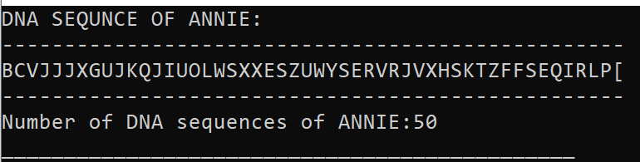

Now our program will take input from will take input of that six children’s DNA sequence accordingly and checked them if the sequence matched with Annie then it will show the Index place from where she can found her baby, if the sequence doesn’t match it will show the output of not matching.

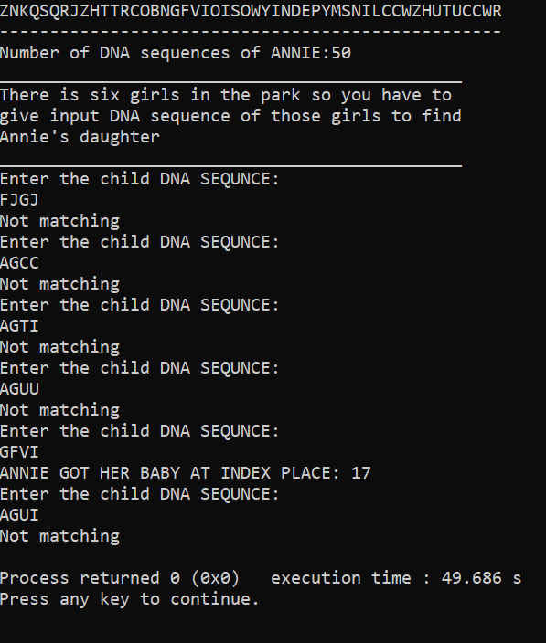

In this way we by checking the DNA sequence with Annie,

Annie will able to get child.

Codes:

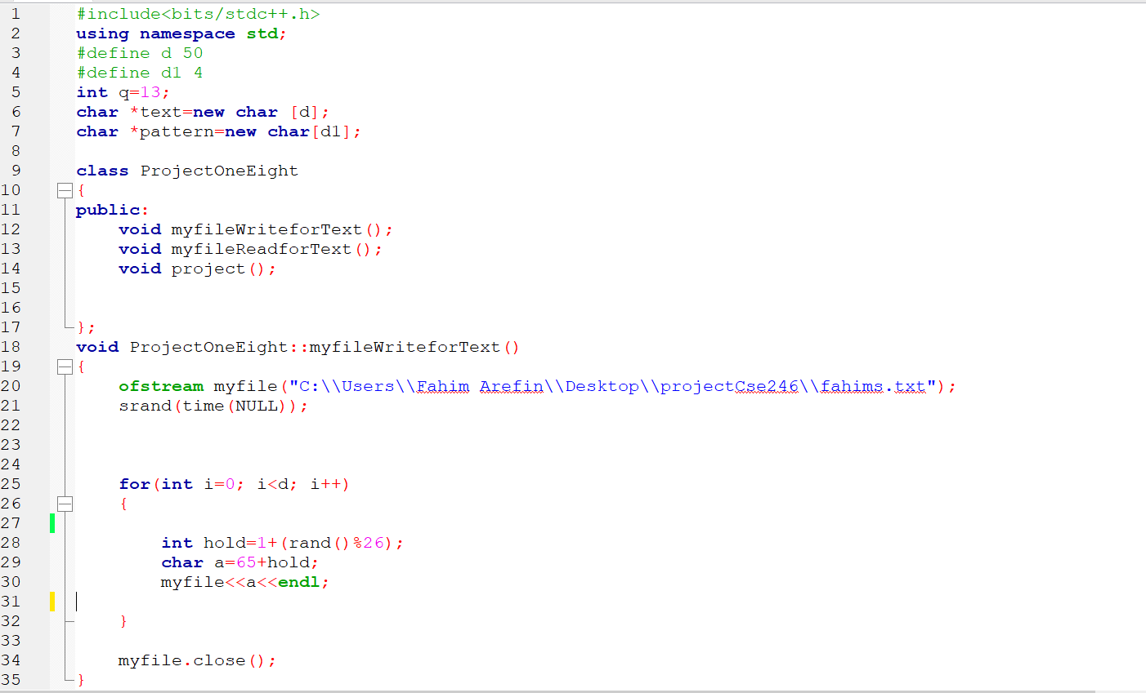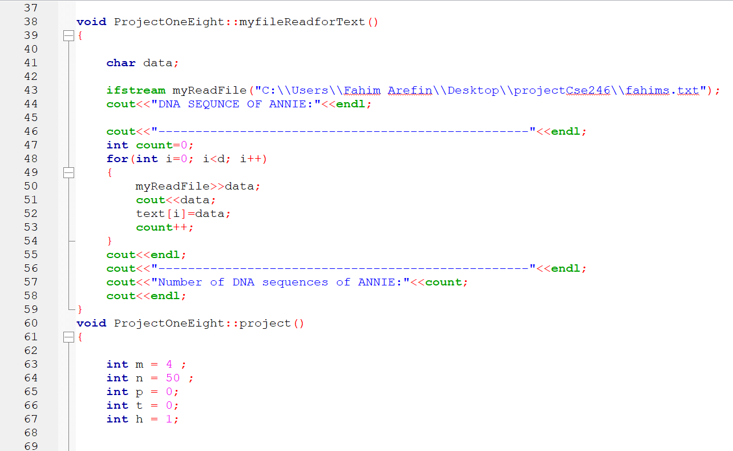

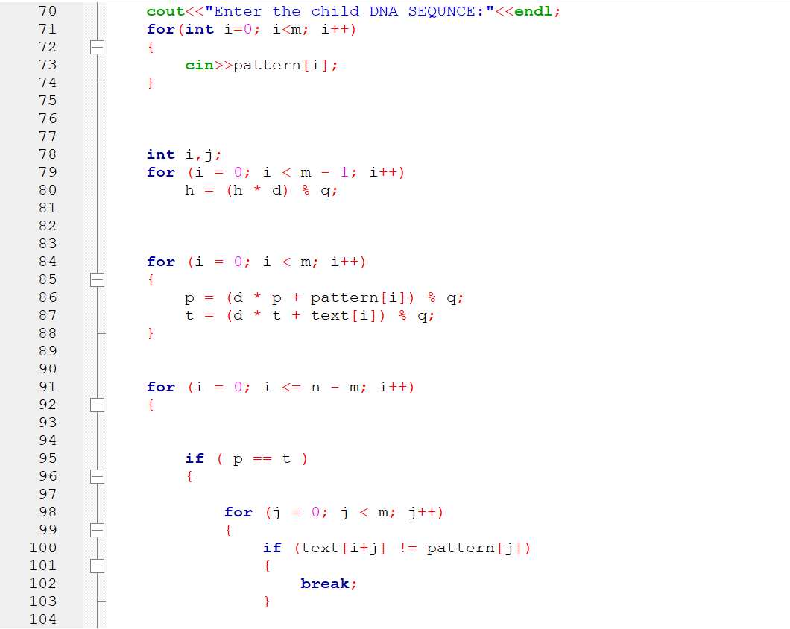

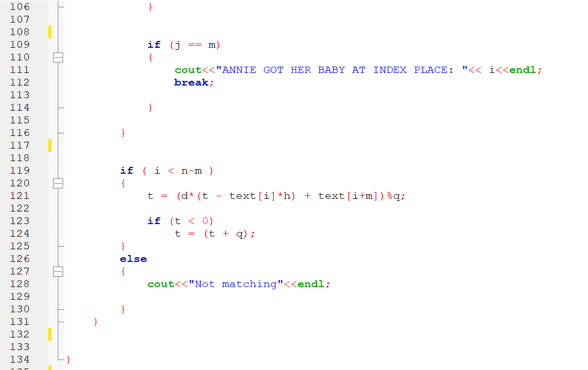

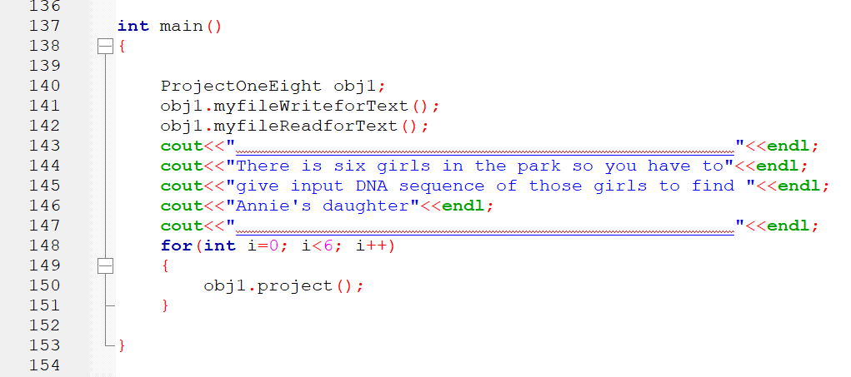

Codes text:

#include<bits/stdc++.h>

using namespace std;

#define d 50

#define d1 4

int q=13;

char *text=new char [d];

char *pattern=new char[d1];

class ProjectOneEight

{

public:

void myfileWriteforText();

void myfileReadforText();

void project();

};

void ProjectOneEight::myfileWriteforText()

{

ofstream myfile("C:\\Users\\Fahim Arefin\\Desktop\\projectCse246\\fahims.txt");

srand(time(NULL));

for(int i=0; i<d; i++)

{

int hold=1+(rand()%26);

char a=65+hold;

myfile<<a<<endl;

}

myfile.close();

}

void ProjectOneEight::myfileReadforText()

{

char data;

ifstream myReadFile("C:\\Users\\Fahim Arefin\\Desktop\\projectCse246\\fahims.txt");

cout<<"DNA SEQUNCE OF ANNIE:"<<endl;

cout<<"--------------------------------------------------"<<endl;

int count=0;

for(int i=0; i<d; i++)

{

myReadFile>>data;

cout<<data;

text[i]=data;

count++;

}

cout<<endl;

cout<<"--------------------------------------------------"<<endl;

cout<<"Number of DNA sequences of ANNIE:"<<count;

cout<<endl;

}

void ProjectOneEight::project()

{

int m = 4 ;

int n = 50 ;

int p = 0;

int t = 0;

int h = 1;

cout<<"Enter the child DNA SEQUNCE:"<<endl;

for(int i=0; i<m; i++)

{

cin>>pattern[i];

}

int i,j;

for (i = 0; i < m - 1; i++)

h = (h * d) % q;

for (i = 0; i < m; i++)

{

p = (d * p + pattern[i]) % q;

t = (d * t + text[i]) % q;

}

for (i = 0; i <= n - m; i++)

{

if ( p == t )

{

for (j = 0; j < m; j++)

{

if (text[i+j] != pattern[j])

{

break;

}

}

if (j == m)

{

cout<<"ANNIE GOT HER BABY AT INDEX PLACE: "<< i<<endl;

break;

}

}

if ( i < n-m )

{

t = (d*(t - text[i]*h) + text[i+m])%q;

if (t < 0)

t = (t + q);

}

else

{

cout<<"Not matching"<<endl;

}

}

}

int main()

{

ProjectOneEight obj1;

obj1.myfileWriteforText();

obj1.myfileReadforText();

cout<<"______________________________________________"<<endl;

cout<<"There is six girls in the park so you have to"<<endl;

cout<<"give input DNA sequence of those girls to find "<<endl;

cout<<"Annie's daughter"<<endl;

cout<<"______________________________________________"<<endl;

for(int i=0; i<6; i++)

{

obj1.project();

}

}