Actual Data Objects:

**Customer:**CustomerID,first_name,last_name,address,phone_Number,email,date_of_birth,age

**Branch**: name, address, asset

**Loan:** loan_Number ,branch_name,amount

**Borrower:** Borrower_No,customer_id, Loan_Number

**Account:** acc_Number, customer_id ,Branch_Name,Balance

**Depositor:** customer_id,acc_Number

**Employee:**employee_Id,first_name,last_name,salary,address,blood_group,phone_number,email,date_of_birth,age

**Customer_Employee:** Customer_id, Employee_Id

Relationship among data objects:

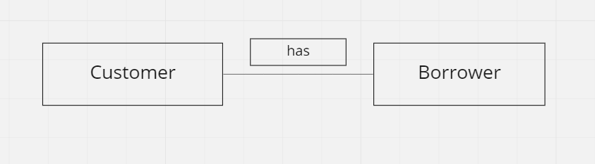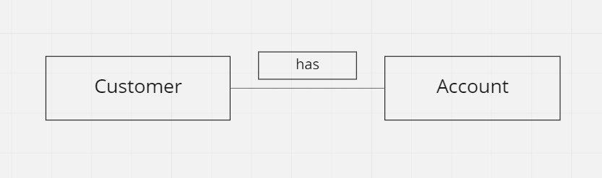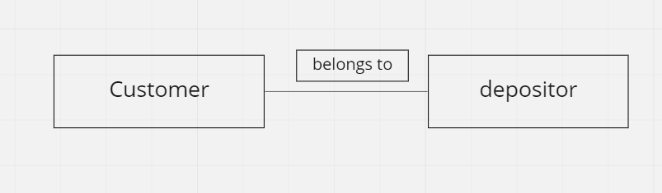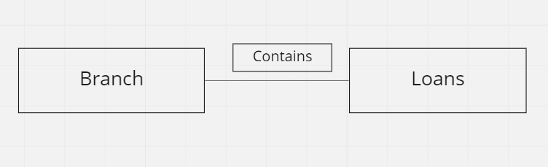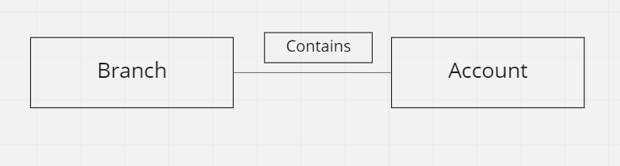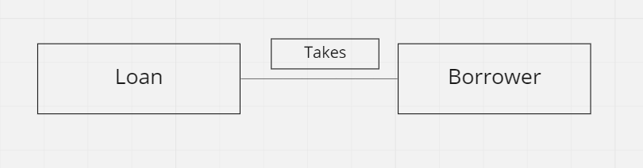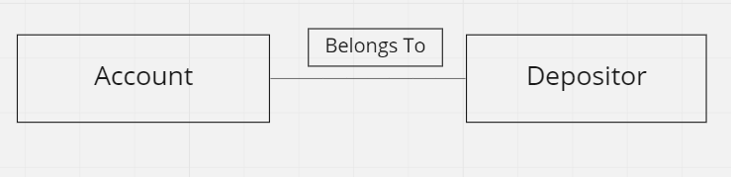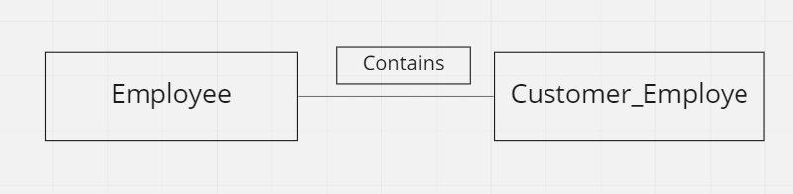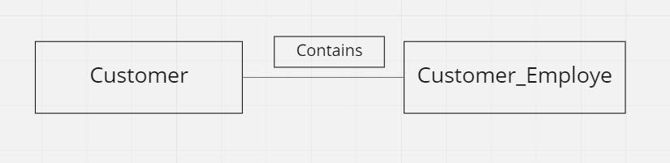

Schema Table:

Key: AI: Auto Incremented ID

Table 1: Schema table for Customer

|  |
| --- |
| Customer |
| |  |  |  | | --- | --- | --- | | Attributes | Types | Size | | customer_id | number | AI | | first_name | varchar | 250 | | last_name | varchar | 250 | | address | varchar | 250 | | Phone_Number | number | 11 | | email | varchar | 250 | | Date_of_birth | Date-time |  | | age | number | 3 | |

Table 2: Schema table for Branch

|  |
| --- |
| Branch |
| |  |  |  | | --- | --- | --- | | Attributes | Types | Size | | name | varchar | 250 | | address | varchar | 250 | | asset | number | AI | |

Table 3: Schema table for Loan

|  |
| --- |
| Loan |
| |  |  |  | | --- | --- | --- | | Attributes | Types | Size | | loan_Number | number | 6 | | branch_name | varchar | 250 | | amount | number | AI | |

Table 4: Schema table for Borrower

|  |
| --- |
| Borrower |
| |  |  |  | | --- | --- | --- | | Attributes | Types | Size | | Borrower_No | number | AI | | customer_id | number | AI | | loan_Number | number | 6 | |

Table 5: Schema table for Account

|  |
| --- |
| Account |
| |  |  |  | | --- | --- | --- | | Attributes | Types | Size | | customer_id | number | AI | | acc_number | number | AI | | Branch_Name | varchar | 250 | | balance | number | AI | |

Table 6: Schema table for Depositor

|  |
| --- |
| Depositor |
| |  |  |  | | --- | --- | --- | | Attributes | Types | Size | | customer_id | number | AI | | acc_Number | number | AI | |

Table 7: Schema table for Employee

|  |
| --- |
| Employee |
| |  |  |  | | --- | --- | --- | | Attributes | Types | Size | | employee_id | number | AI | | first_name | varchar | 250 | | last_name | varchar | 250 | | salary | number | 10 | | address | varchar | 250 | | blood_group | varchar | 250 | | phone_Number | number | 11 | | email | varchar | 250 | | Date_of_birth | Date-time |  | | age | number | 3 | |

Table 8: Schema table for Customer_Employee

|  |
| --- |
| Depositor |
| |  |  |  | | --- | --- | --- | | Attributes | Types | Size | | customer_id | number | AI | | Employee_ID | number | AI | |

**Entity Relation:**

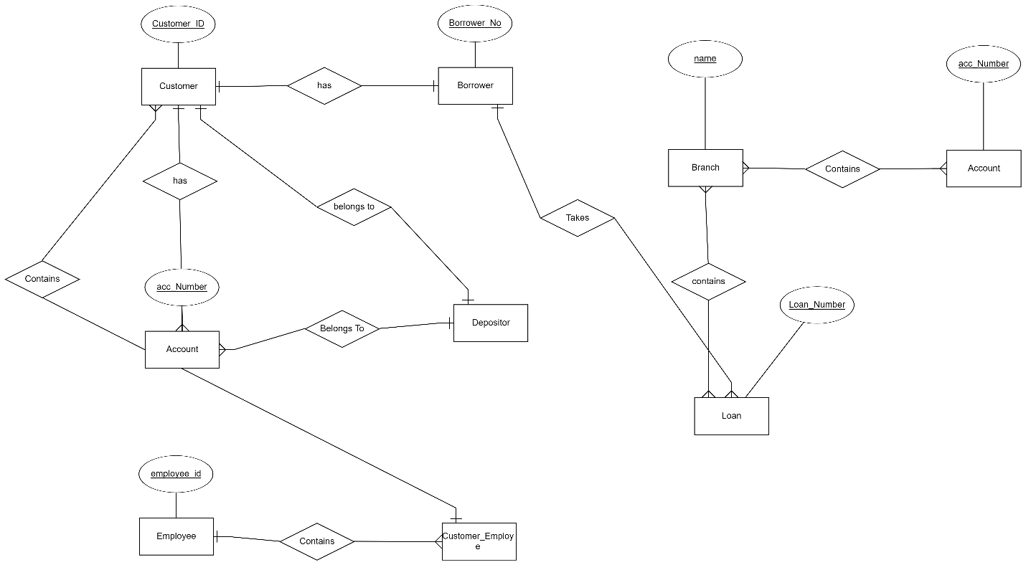

**Database Creation**

**XAMP:**

Creating the database **Banking_manegement** and creating the tables from given ER diagram:

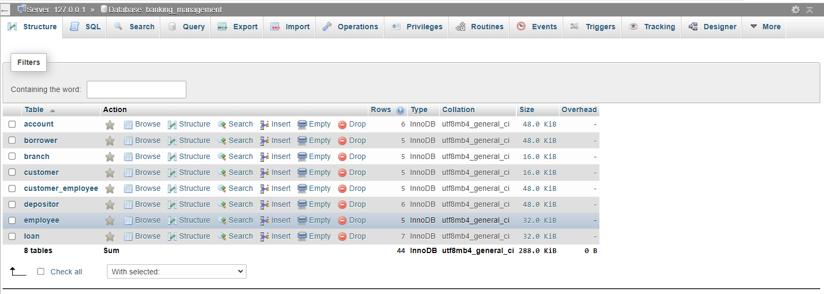

Adding the attributes in table **account** which have four attributes, one primary key and two foreign key:

Primary key(acc_number),foreign key(Customer_id,branch_Name)

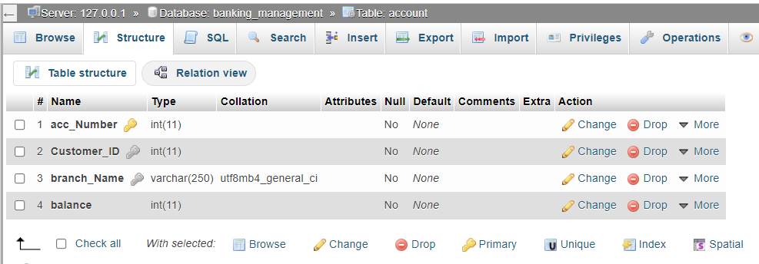

Adding the attributes in table **borrower** which have three attributes one primary key and two foreign key: Primary key(Borrower_No), Foreign Key(Customer_id,loan_Number)

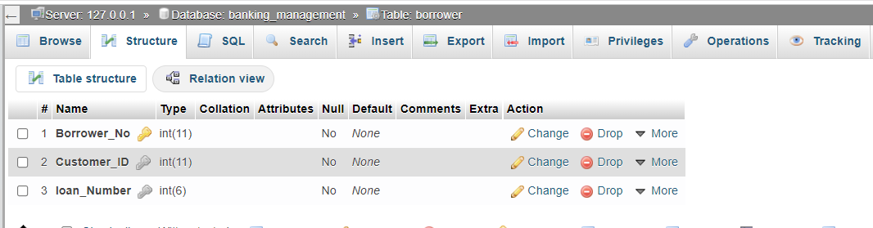

Adding the attributes in table **branch** which have three attributes one primary key:

Primary key(name)

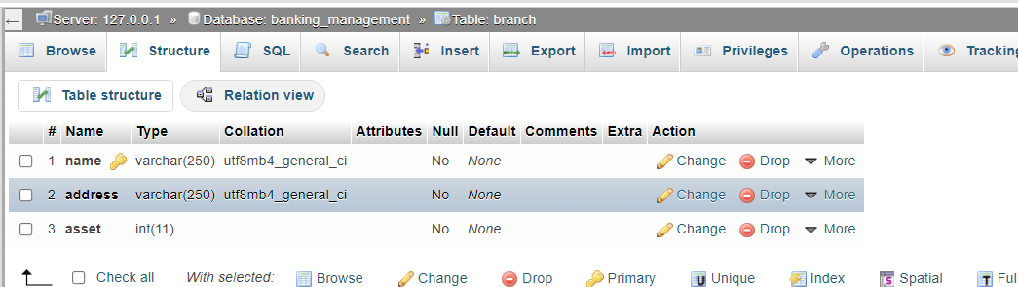

Adding the attributes in table **customer** which have eight attributes one primary key:

Primary key(customer_ID)

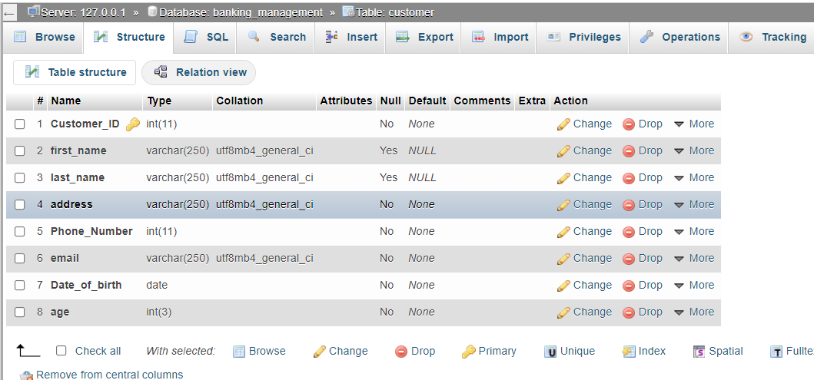

Adding the attributes in table **customer_employee** which have two attributes and both are foreign key:

Foreign key(customer_ID,employee_id)

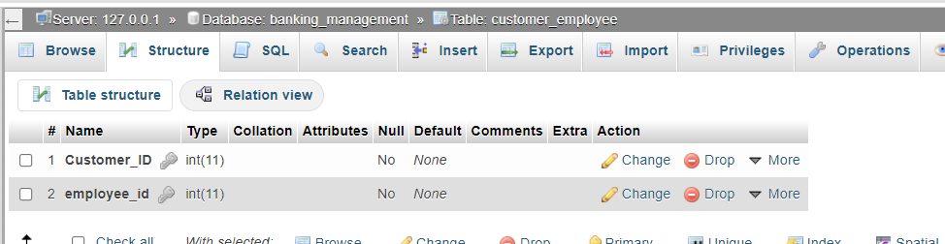

Adding the attributes in table **depositor** which have two attributes and both are foreign key:

Foreign key(customer_ID,acc_Number)

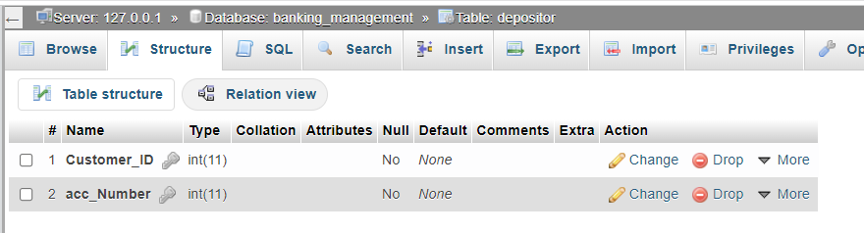

Adding the attributes in table **employee** which have ten attributes one primary key:

Primary key(employee_ID)

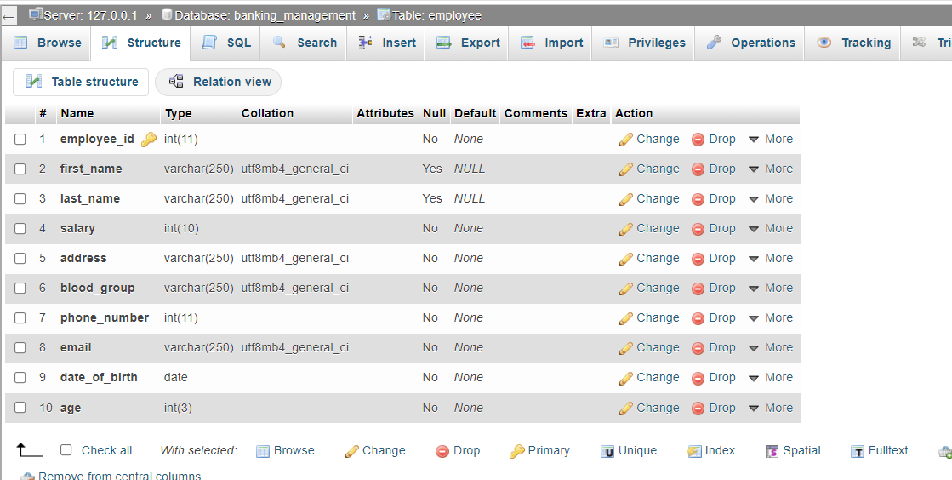

Adding the attributes in table **loan** which have three attributes one primary key and one foreign key:

Primary key(loan_Number), Foreign key(branch_name)

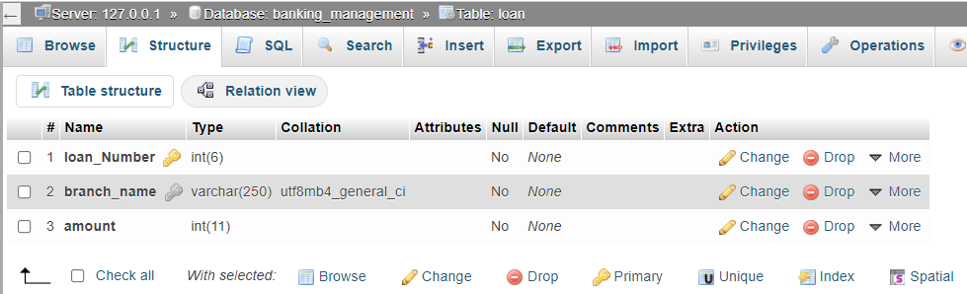

Inserting the values into table **account**:

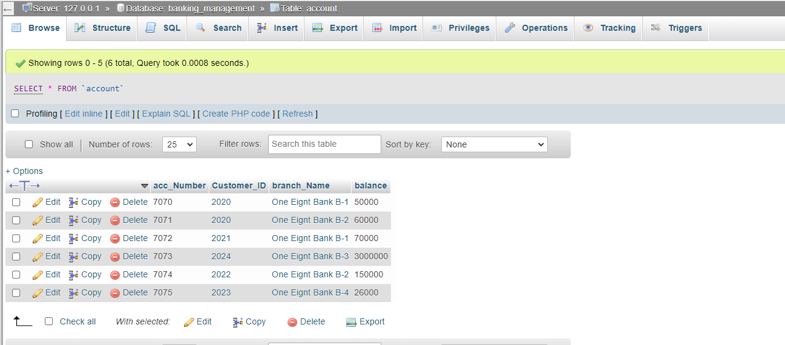

Inserting the values into table **borrower**:

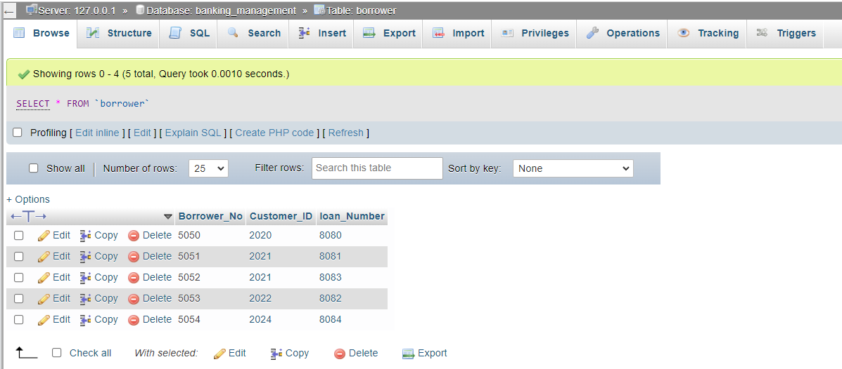

Inserting the values into table **branch**:

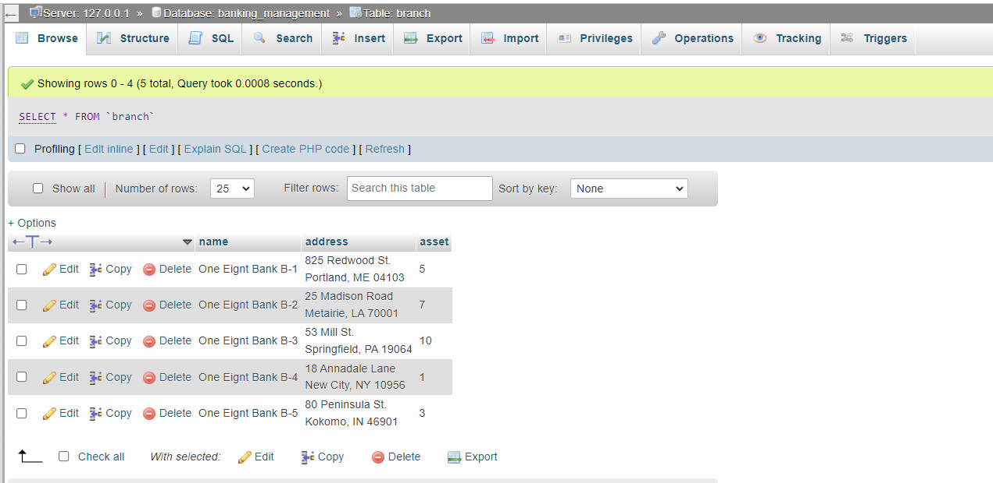

Inserting the values into table **customer:**

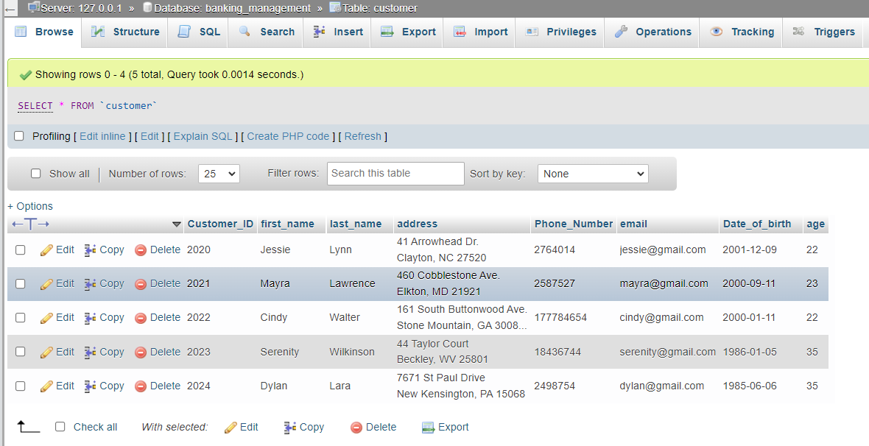

Inserting the values into table **customer_employee**:

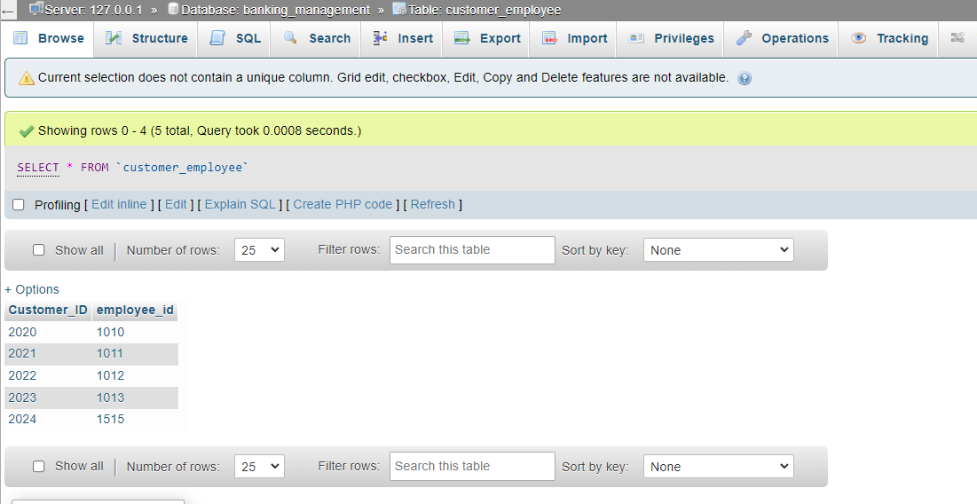

Inserting the values into table **depositor**:

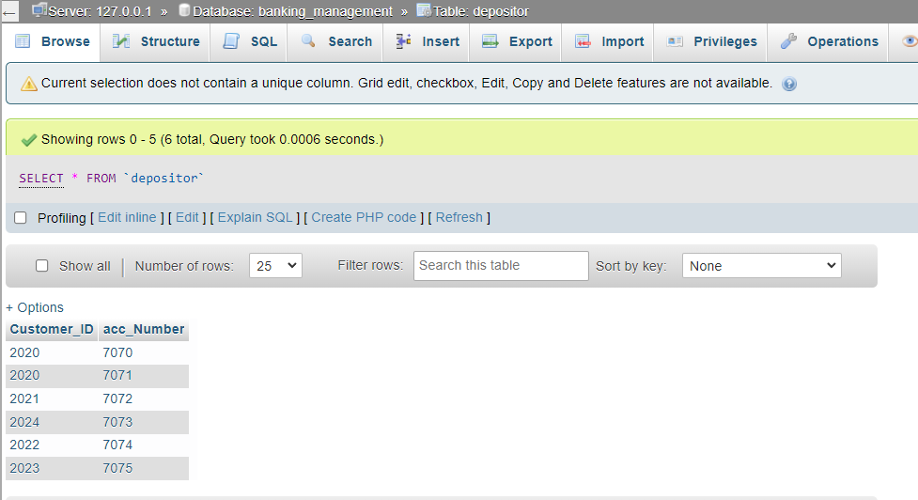

Inserting the values into table **employee**:

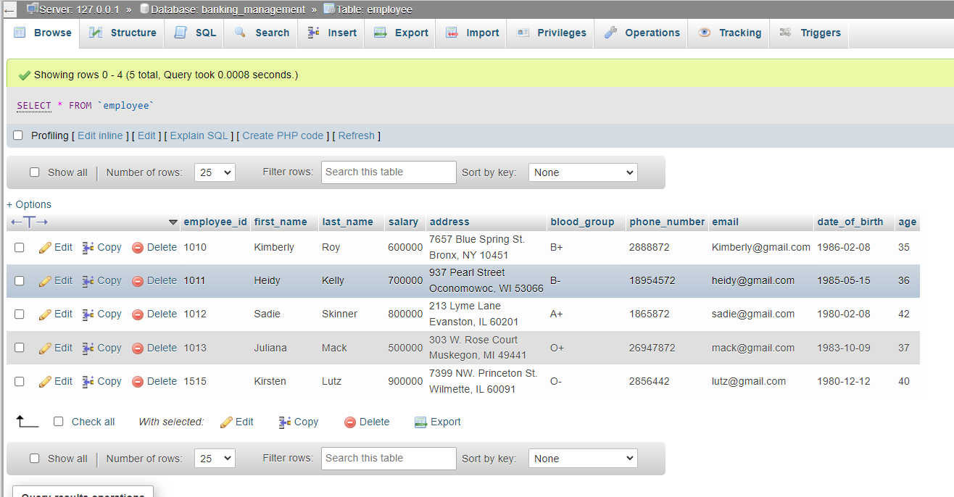

Inserting the values into table **loan**:

