
Heaven’s Light is our guide

Department of Mechatronics Engineering , RUET

EEE 2188
Electronics Sessional
Project report on Line Follower Robot Without Microcontroller

Submitted by:
Group : 01
Roll: | Name:
2008001 | FAHIM FAISAL
2008002 | FAHAD BIN ISLAM
2008003 | NISHAT PERVEZ MEGHOBOTI
2008004 | ARIFUL ISLAM RIAD
2008005 | HOMAYRA MOBESSHIRA HEMU
2008006 | NURUL SAJJAD

Date of Submission: 25 /7 /2023
Name of the Project :Line Follower Robot Without Microcontroller
Introduction :
The concept of line follower robots has been in existence for several decades and has found applications in various industries, including manufacturing, warehousing, and even education. Typically, these robots use infrared sensors or other proximity sensors to detect the contrasting line on the ground and adjust their movement accordingly. The use of microcontrollers, such as Arduino or Raspberry Pi, has been the standard approach to control the robot's motors and interpret sensor data. However, this project delves into an innovative approach that eliminates the reliance on a microcontroller while achieving accurate and reliable line-following capabilities.
Background of study:
The concept of line follower robots has been in existence for several decades and has found applications in various industries, including manufacturing, warehousing, and even education. Typically, these robots use infrared sensors or other proximity sensors in conjunction with Arduino or Raspberry Pi as the controller. But in this project microcontrollers are not being used. Instead, we are using Operational Amplifiers, Transistors, Voltage regulators and required resistors to “Process” the signal from the infrared sensor. As there are no microcontrollers, this is an analogue system that relies on the basic functionality of said electrical components.
Problem Statement:
Line Following Robots or LFR’s are robots that can follow a line on the ground by using sensory inputs from various sensors. But it needs to process that input signal and control the actuators(motors) accordingly. Traditionally this “Processing” is done by a microcontroller such as Arduino or Raspberry Pi. But those require to be programmed beforehand to be able to process signals and control the actuators. That requires a good amount of programming knowledge, which is also a digital approach. But here we intended to achieve this goal by not using such microcontrollers i.e., no programming required, hence called analogue method. For this choice of method, we had to rely on concepts of electronics and crude circuitry.
Objectives of Project:
The objective of this project is to showcase the implementation of electronics in constructing automated machines without the use of programming. Although Electronics and Programming go hand in hand, it is possible to accomplish tasks only by using electronics without any underlying programming. This method is in most cases, is more complex to grasp, but much more reliable or in other words, has high redundancy. Devices made with this method are literally just physical objects operating on the natural phenomenon of current, voltage and resistance. This property makes them reliable, rugged and robust.
Scope of Project:
This project is a testament to the fact that almost any automated machine can be created using only electronics and no conventional programming. This type of device as it is stated previously, has high redundancy and reliability. Because they are not that much sophisticated in comparison with regular devices, even though they have the same functionality. This is somewhat analogous to making fire with a gas lighter and a flintand-steel; sure the lighter is simpler to use but the flint-and-steel never fails to deliver. So due to such reliability this method of construction is suitable for the military, as they obviously require devices that don’t fail easily. It is also useful in other sectors where reliability is paramount. Like in critical safety mechanisms for potentially dangerous infrastructure (Nuclear power plant, ammunition storage etc.
Feasibility of Project:
This approach to assembling devices has its upsides and also downsides. So, feasibility depends on the specific scenario the device is intended to be used. Like In some place’s reliability is more important than looks and design (like military), there this method of assembly is feasible. But similarly, in sectors where portability, looks, sophistication are more important, there conventional method of using electronics and programming is used(like is consumer electronic device industry). So, in the end feasibility boils down to the field of application.

Circuit Diagram :
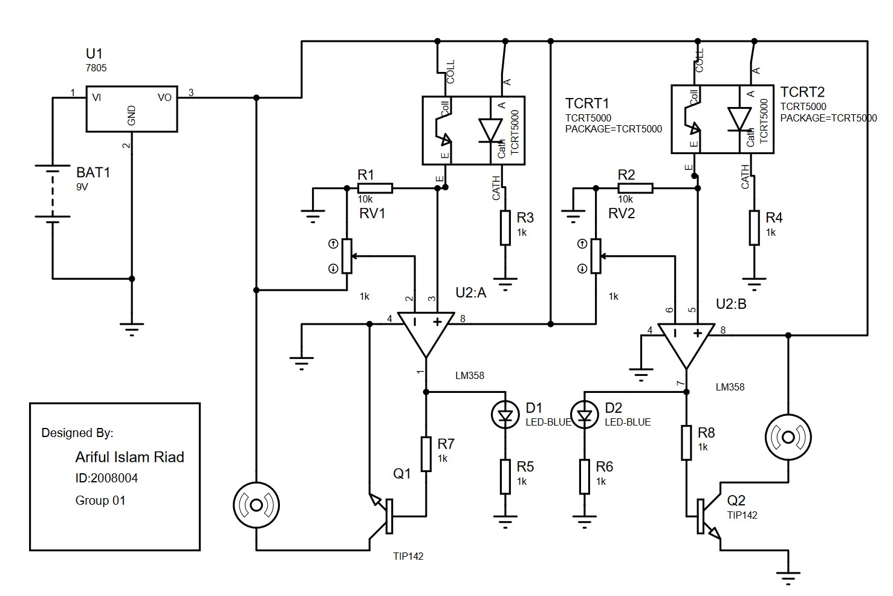
Figure 1 : Circuit diagram of Line Follower Without Microcontroller

List of Components:
- Lm358 IC
- TIP-142 BJT
- TCRT-5000L IR sensor
- 10k potentiometer
- LED
- DC motor
- Resistors
- Li-po Battery

Cost of Project:
Components | Price
Lm358 IC | 30 tk.
TIP-142 BJT | 35x2 = 70 tk.
TCRT-5000L IR sensor | 25x2 = 50 tk.
10k potentiometer | 5x2 = 10 tk.
Lm7805 | 15 tk.
LED | 2x2 = 4 tk.
Resistors | 5 yk.
DC motor | 100x2 = 200 tk.
Li-po Battery | 1300 tk.
 | Total Cost = 1684 tk.

Output:
The expected output of this project is a fully functional line follower robot that successfully navigates a predefined path without utilizing a conventional microcontroller. The robot should demonstrate stable and accurate tracking capabilities, showcasing the feasibility of an innovative approach to line-following robotics.
Conclusion :
The completion of this project provides valuable insights into the development of a line follower robot without the use of a microcontroller. The achievements and challenges faced during the project's implementation will be summarized. This project aims to inspire further research in simplified and cost-effective robotic designs for industrial and educational applications.
Future Recommendations :
While the current project focuses on creating a basic line follower without a microcontroller, there are several avenues for further improvement and exploration. Future recommendations include:
- Incorporating obstacle avoidance mechanisms to enhance the robot's versatility and safety.
- Implementing advanced algorithms for dynamic path planning to navigate complex environments.
- Exploring the integration of wireless communication to enable remote control and monitoring capabilities.
- Investigating power-efficient components and renewable energy sources to extend the robot's operational lifespan.
- Conducting comprehensive field tests and real-world applications to validate the robot's performance in different scenarios.
References
[1]https://www.academia.edu/38662288/Line_Follower_Robot_for_Industrial_Manufacturing_Process.
[2] Colak, I., Yildirim, D.,"Evolving a Line Following Robot to use in shopping centers for entertainment",Industrial Electronics, 2009. IECON '09. 35th Annual Conference of IEEE,pp.3803 - 3807,3-5 Nov. 2009.

