Software Requirement Specification

Project Title

Multimedia-platform video downloader


Submitted by:
Muhammad Fahim

Roll No:
S22BINFT1M01124

Submitted to :
Dr.Musarat Kareem

Department Of Information Technology

Faculty of computing

The islamia University of Bahawalpur

Table of Contents

1. Introduction

1.1. Purpose

1.2. Scope

1.3. Product Perspective

1.4. User Characteristics

1.5. Similar apps and systems/Literature Review

1.6. Proposed Technologies

2. Requirements

2.1. Function Requirements

2.2. Non-Functional Requirements

3. Use Cases and Flow of Processes

3.1. Use Case 1

4. References

Meeting Details

Sr No | Details | Date | Supervisor signatue

1. Introduction:
In the current digital age, users frequently engage with content across various multimedia platforms such
as YouTube, Facebook, TikTok, and Twitter. However, downloading videos from these platforms is often restricted or limited to paid subscriptions, creating accessibility challenges for users who want to store or reuse multimedia content for offline viewing, educational use, or sharing purposes. To address this gap, this project introduces a web-based Multimedia Platform Video Downloader that enables users to download videos from major platforms easily and efficiently.
The system is being developed as an independent solution, not tied to a specific organization. It aims to offer a user-friendly interface where individuals can paste video URLs, choose preferred formats and resolutions, and download the content directly to their devices. The application is particularly useful for educators, students, marketers, and general users who frequently need multimedia resources.
The backend of the application is built using Django, ensuring robust API handling and secure user management. The React frontend offers an interactive and dynamic user experience, while PostgreSQL is used as the relational database to store user data and download history efficiently.
This Software Requirements Specification (SRS) document outlines the scope, functionalities, and technical requirements of the system, providing a comprehensive understanding of the solution to be developed.
1.1 Purpose

The purpose of this project is to develop a web-based Multimedia Platform Video Downloader that allows users to download videos from popular platforms such as YouTube, Facebook, TikTok, and Twitter in a fast, secure, and user-friendly manner. The primary goal is to provide users with a centralized tool that eliminates the need for multiple browser extensions or third-party software to download video content from various social media platforms.

This application aims to:

Enable users to download videos in different resolutions and formats (e.g., MP4, MP3).

Offer support for multiple platforms under one unified interface.

Maintain a download history for registered users to track their downloads.

Provide a secure authentication system for user accounts.

Ensure the performance, scalability, and reliability of the platform for a broad user base.

The project is intended for public use and is not developed for a specific organization. It serves individuals who regularly consume and reuse online video content, including students, educators, content creators, marketers, and everyday internet users.
1.2 Scope
The scope of this project is to design and develop a web-based Multimedia Platform Video Downloader that allows users to download videos from multiple social media and video-sharing platforms including YouTube, Facebook, TikTok, and Twitter. The system will offer a simple interface where users can input video URLs, select the preferred quality and format, and initiate the download process. The platform will also provide user authentication and download history tracking features for registered users.
Modules and features to be developed:
- User Authentication System (Sign Up, Login, Logout)
- Video URL Input and Processing
- Video Download Functionality (supporting multiple formats and resolutions)
- Support for Multiple Platforms (YouTube, Facebook, TikTok, Twitter)
- Download History for Registered Users
- Responsive Frontend built with React
- Backend REST APIs developed using Django
- PostgreSQL Database integration for storing user and download data
Items not included in the current scope:
- Mobile applications (iOS/Android) – only a web platform will be developed.
- Live video streaming or playback within the app – the platform only handles downloads.
- Download from private or restricted videos – the application will support only publicly accessible content.
- Browser extension or desktop application versions – these may be considered in future iterations.
- Built-in video converter (e.g., converting downloaded files to other formats post-download) – only format selection before download will be available.
The project is focused on delivering a lightweight and efficient downloader service with essential features to ensure usability and security, while leaving out complex or heavy modules that are outside the current development goals.

1.3. Product Perspective

The Multimedia Platform Video Downloader is designed as a standalone web application, meaning it functions independently and does not rely on integration with any larger external system. It follows a client-server architecture, where the frontend (React) communicates with the backend (Django REST APIs) to perform all operations such as user authentication, video URL processing, and initiating downloads.

The overall system is divided into three main layers:

Frontend (React): Provides an interactive and responsive user interface where users can register/login, paste video links, choose download options, and view download history.

Backend (Django): Handles all the application logic including video link validation, platform detection (YouTube, Facebook, TikTok, Twitter), video metadata fetching, format/resolution selection, and generating download links.

Database (PostgreSQL): Stores user data, download history, and logs necessary for system operations.

The video downloading functionality will utilize third-party libraries or APIs (e.g., pytube, yt-dlp, or similar tools) to fetch and process videos from supported platforms. These tools will be integrated into the Django backend and wrapped in custom logic to support multiple platforms in a consistent and modular way.

Though it is currently a standalone application, the system is designed with scalability and modularity in mind.
1.4. User Characteristics
The Multimedia Platform Video Downloader will be used by different categories of users, each with varying levels of technical knowledge and access permissions. The main user roles are as follows:

1. Registered Users (Customers):

These are the primary users of the system.

They can sign up, log in, and use the downloader to fetch videos from supported platforms.

Users can select formats and quality options before downloading.

Registered users will have access to their download history.

No technical background is required—simple and user-friendly interface provided.

2. Admins:
- Responsible for managing the overall platform.
- Can manage user accounts, monitor system usage, and view/download logs.
- Can update or configure supported platforms and download-related settings.
- Admins may also manage content moderation or usage policies.
- Requires basic technical or platform management knowledge.

3. Visiter (Optional Role):
- Can access limited functionality (e.g., test downloading without creating an account).
- No access to download history or personalized features.
- Ideal for quick, one-time users who don’t want to register.
Each user role interacts with the system through the web interface, which is designed to be intuitive and responsive for all user types. The system ensures proper access control and permissions based on roles to maintain security and usability.
1.5. Similar apps and systems/Literature Review

Several video downloader tools and applications are available in the market that offer similar functionalities. This section reviews some of the most popular ones, analyzing their features and limitations to identify gaps that the proposed system aims to address.

1. SaveFrom.net

Features: Supports downloading videos from YouTube, Facebook, and a few other platforms; browser extension available.

Shortcomings: Limited support for newer or less common platforms like TikTok; cluttered UI with ads; unstable performance due to external website dependency; download quality and format options are limited.

2. Y2Mate

Features: Easy-to-use interface; allows downloading YouTube videos in various formats (MP3, MP4); no registration required.

Shortcomings: Primarily supports only YouTube; excessive ads/pop-ups; many features are blocked by browsers or antivirus software due to security concerns.

3. SnapSave (formerly SnapTik)

Features: Specializes in downloading TikTok videos without watermark; no account needed; mobile-friendly interface.

Shortcomings: Supports only TikTok; no download history or user account management; lacks support for other platforms like YouTube or Twitter.

4. 4K Video Downloader (Desktop App)

Features: Rich in features; supports multiple platforms; allows downloading entire playlists; supports 4K resolution.

Shortcomings: Requires installation; limited free usage (premium features locked); not web-based; not ideal for mobile users.

5. OnlineVideoConverter

Features: Converts and downloads videos from multiple platforms; supports format conversion.

Shortcomings: Frequent downtime; slow conversion speeds; outdated UI; limited platform compatibility in recent years.

Identified Gaps in Existing Systems

Many tools support only one or two platforms, forcing users to use different tools for different platforms.

Several applications are plagued with advertisements, pop-ups, or security risks.

Most free tools do not provide user accounts or download history.

Many services offer limited format/resolution options.

Mobile responsiveness and cross-platform support are lacking in some tools.

Proposed Improvements

The proposed Multimedia Platform Video Downloader will:

Support multiple platforms (YouTube, Facebook, TikTok, Twitter) under a single, unified interface.

Offer ad-free, secure downloads.

Provide user authentication and download history tracking.

Be entirely web-based, mobile-friendly, and easy to use without needing software installation.

Ensure better scalability, modularity, and maintainability by using Django, React, and PostgreSQL.
1.6. Proposed Technologies
The proposed system is a web-based application that will be developed using modern and scalable technologies for both the frontend and backend, along with a robust database system. The technologies have been carefully chosen to ensure performance, security, scalability, and ease of development.

Frontend Technologies

React.js: A JavaScript library for building fast, interactive, and component-based user interfaces. It ensures a responsive and smooth user experience.

HTML5, CSS3, JavaScript: Core web technologies used in conjunction with React to design the structure, layout, and styling of the user interface.

Axios/Fetch API: For making HTTP requests to the backend API endpoints.

Backend Technologies

Django (Python): A high-level Python web framework used to build secure and maintainable APIs. Django is well-suited for rapid development and clean architecture.

Django REST Framework (DRF): A powerful toolkit used to build RESTful APIs for handling requests from the React frontend.

Database

PostgreSQL: A powerful, open-source, object-relational database system used to store user information, download history, and other application data. Known for its performance, reliability, and scalability.

Third-Party Libraries/Tools

yt-dlp / pytube / youtube_dl: Used to extract video content and metadata from platforms like YouTube, Facebook, TikTok, and Twitter.

Development and Deployment Tools

Git: For version control.

GitHub/GitLab: For source code hosting and collaboration.

These technologies collectively form a modern tech stack capable of handling user interactions, API requests, video processing, and database operations efficiently.
2.1. Functional Requirements

2.1.1 Sign Up

Name: FR001
Purpose: Sign up process is required for a user to create an account and become a registered member of the system.
User(s): General User
Input:

First Name: Actual name of the user.

Last Name: Actual name of the user.

Email: A valid and unique email address.

Password: Must be at least 8 characters long and include numbers and special characters.
- Profile photo: profile photo of the user.
- Output: A new user account is created; the user will be able to log in and access personalized features like download history.

2.1.2 Log In

Name: FR002
Purpose: Allows registered users to log into their accounts.
User(s): General User, Admin
Input:

Email

Password
Output: User is authenticated and redirected to their dashboard.

2.1.3 Submit Video URL for Download

Purpose: Allows the user to input a valid video URL and initiate the download process.
User(s): General User, Guest
Input:

Video URL (from YouTube, Facebook, TikTok, or Twitter)(identify url with domain whether it is tiktok facebook twitter or youtube)
Output: System fetches video metadata and shows download options.

2.1.4 Choose Format and Resolution
Purpose: Lets the user choose the format (e.g., MP4, MP3) and resolution (e.g., 720p, 1080p) of the video before downloading.
User(s): General User, Guest
Input:

Preferred Format

Preferred Resolution
Output: System prepares download link based on selected options.

2.1.5 Download Video
Purpose: Enables the actual download of the selected video content.
User(s): General User, Guest
Input:

None (Triggered after selecting format/resolution)
Output: Video is downloaded to the user's device.

2.1.6 View Download History

Purpose: Allows registered users to view their past downloads.
User(s): General User
Input:

None (Accessed from dashboard)
Output: List of previously downloaded videos with formats.

2.1.7 Admin Dashboard Access

Name: FR007
Purpose: Admins can log in to monitor user activity, manage accounts, and configure platform settings.
User(s): Admin
Input:

Admin Email

Admin Password
Output: Admin is granted access to administrative dashboard and tools.

2.1.8. General user Manage profile

Wher user logged in
Purpose: user can monitor ,manage their own profile(CRUD) every general user can access their own account .
User(s): general user
Input:
Output: user is granted access to perform CRUD operation to their account profile

2.2 Non-Functional Requirements
The system is expected to fulfill several non-functional requirements that ensure its usability, reliability, performance, and maintainability.
- Performance: The application must respond to user actions within 2–3 seconds. Video link processing and download link generation should be efficient, even under high traffic conditions. Background processing (e.g., video conversion) should not block the user interface.
- Scalability: The system should be designed in a scalable manner so it can support a growing number of users and video downloads. Technologies like Django, PostgreSQL, and optional tools like Celery or Docker will support horizontal and vertical scaling.
- Availability and Reliability: The downloader must be highly available, with minimal downtime. Proper error handling should be in place to manage failed downloads or invalid URLs. System logs should capture errors for debugging.
- Security: User data such as login credentials must be securely stored using hashing (e.g., Django's password hashing). The system should prevent unauthorized access to the admin panel and protect against common attacks like SQL injection, CSRF, and XSS.
- Usability: The user interface should be simple, intuitive, and responsive across devices. Even non-technical users should be able to paste a video URL and download it without confusion.
- Compatibility: The platform must be compatible with modern web browsers including Chrome, Firefox, Safari, and Edge. It should also work well on both desktop and mobile devices.
- Maintainability: The system should be well-documented and modular, making it easy for future developers to understand, update, or extend the functionality.
- Legal Compliance: The system will not allow downloads of copyright-restricted videos and will display a disclaimer to ensure users understand the legal limitations of the service.
3. Use Case and Flow of process
👥 Actors (Users)
You can define these based on your app's roles:
- Actor 1: Visitors
- Actor 2: Registered User
- Actor 3: Admin
👤 Visitor
- Sign Up
- Log In
- Paste URL & Download Video
- Select Video Resolution: 360p, 480p, etc.

👤 Registered User (General User)
- Log In
- Paste URL & Download Video
- Select Video Resolution: 360p, 480p, etc.
- View Own Download History
- Delete own Download History
- Manage Own Account (CRUD)
👤 Admin
1. Log In
2. View All Users
3. Manage System Logs
4. Manage Any User Account (CRUD)
5. View All Users' Download Histories
6. Delete Any User's Download History

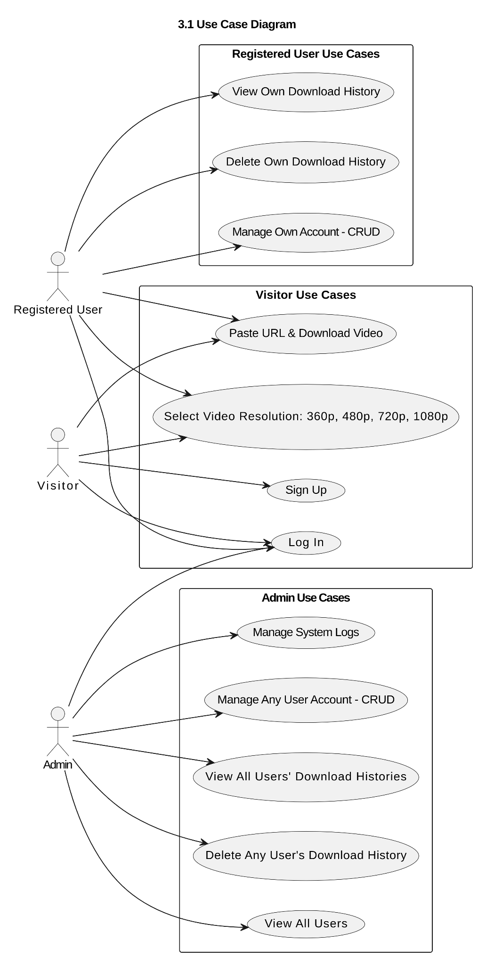

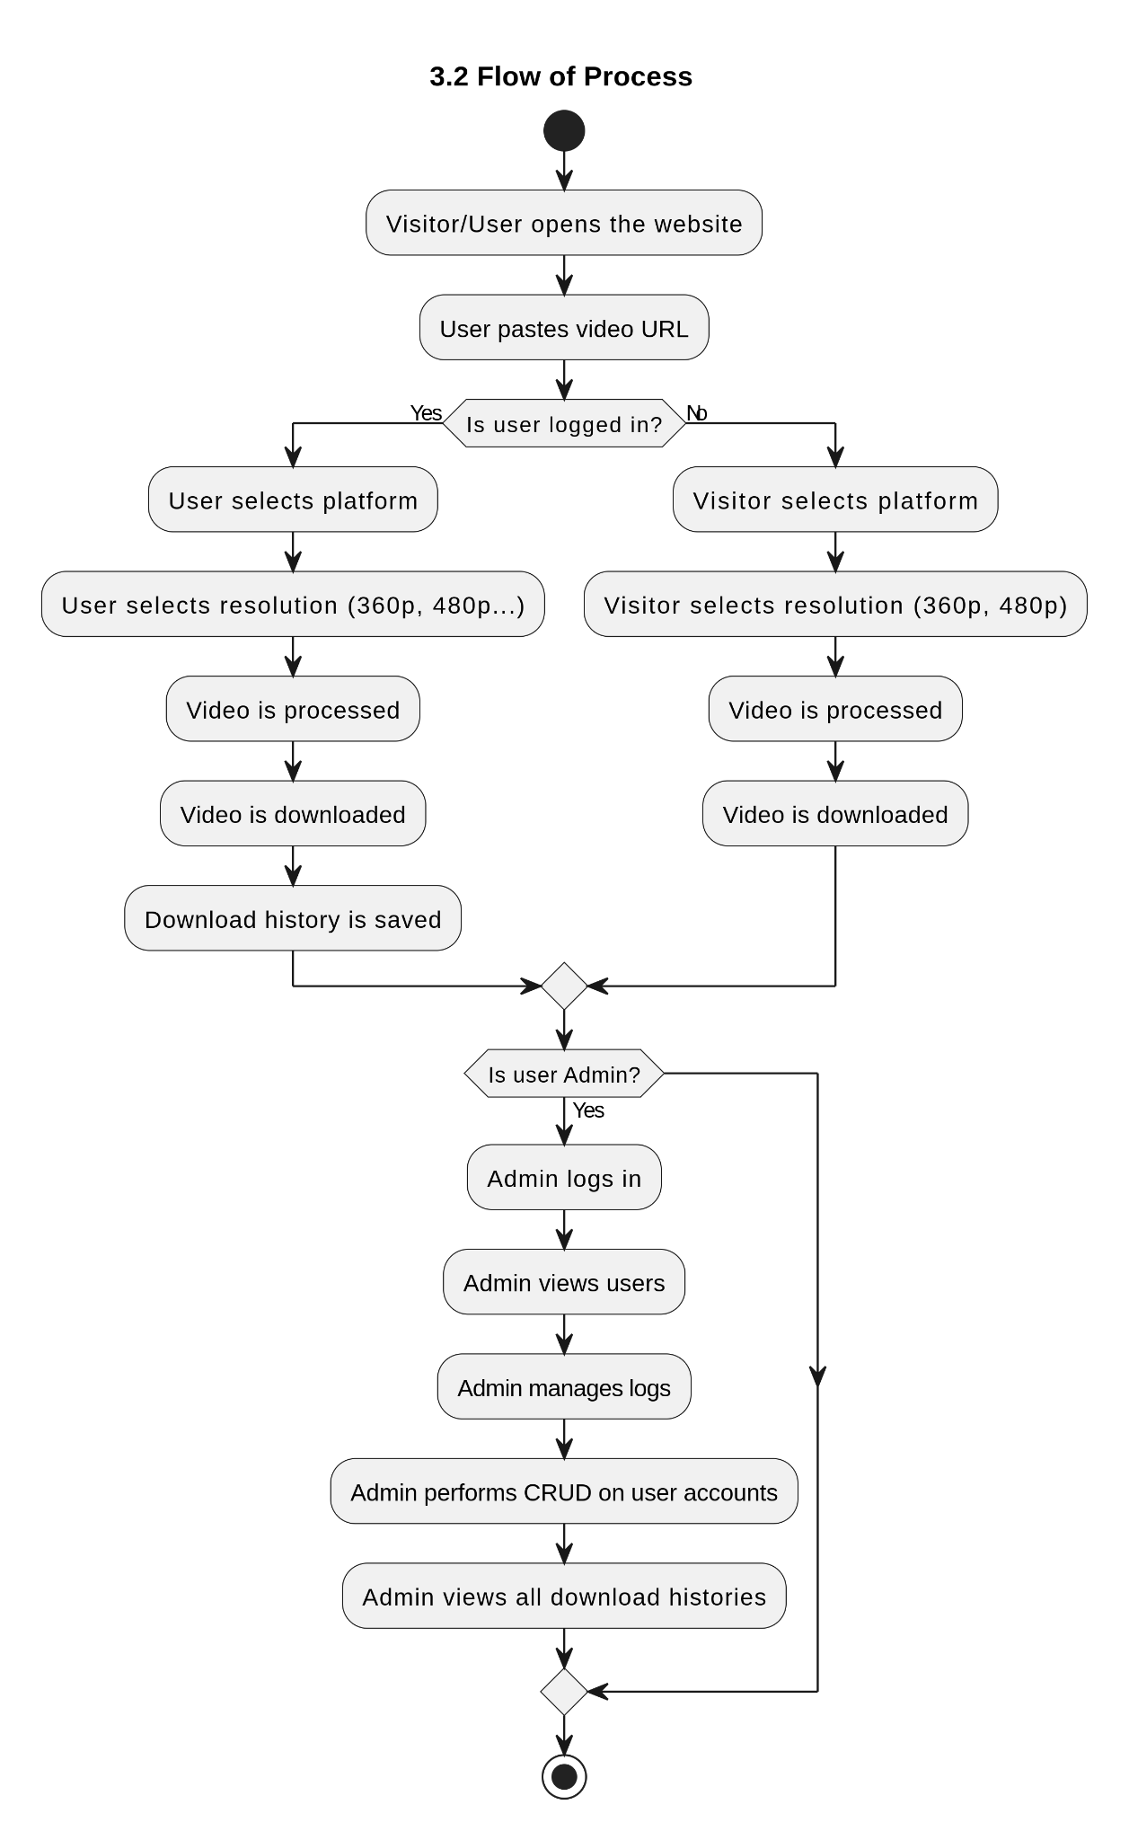

4. References
[1] Django Software Foundation, "Django Web Framework," [Online]. Available: https://www.djangoproject.com/.
[2] ReactJS, "A JavaScript library for building user interfaces," Meta, [Online]. Available: https://reactjs.org/.
[3] PostgreSQL Global Development Group, "PostgreSQL: The World's Most Advanced Open Source Relational Database," [Online]. Available: https://www.postgresql.org/.
[4] YouTube, "YouTube Terms of Service," Google LLC, [Online]. Available: https://www.youtube.com/t/terms.
[5] Facebook, "Facebook Platform Policies," Meta Platforms Inc., [Online]. Available: https://developers.facebook.com/policy/.
[6] TikTok, "TikTok Developer Terms of Service," ByteDance Ltd., [Online]. Available: https://developers.tiktok.com/terms.
[7] Twitter Developer Platform, "Twitter Developer Agreement and Policy," X Corp., [Online]. Available: https://developer.twitter.com/en/developer-terms/agreement-and-policy.

