Software Requirements

Specification

for

<Project>

Version 1.0 approved

Prepared by <author>

<organization>

<date created>

Software Requirements

Specification

for

<Project>

Version 1.0 approved

Prepared by <author>

<organization>

<date created>

Software Requirements

Specification

for

<Project>

Version 1.0 approved

Prepared by <author>

<organization>

<date created>

Software Requirements

Specification

for

<Project>

Version 1.0 approved

Prepared by <author>

<organization>

<date created>

Software Requirements

Specification

for

<Project>

Version 1.0 approved

Prepared by <author>

<organization>

<date created>

**Software Requirements Specifications**

**Company Directory**

Fahim Hasan

8/28/2020

1. **INTRODUCTION**

This document is a response to the brief submitted by Paddy Evans. It presents a high level view of the main system functionality along with some sample screen layouts to facilitate better understanding of the proposed solution. Acceptance of this document by the sponsor will initiate a formal system development project that will be designed and built according to prevailing company standards.

1. **PRODUCT DECRIPTION** 
   1. **SCOPE**

The product is intended to be a standalone, single page application that is designed to be mobile first, but work equally as well on desktops. The application will allow the user to manipulate the database using a simple interface which connects front-end components to server side endpoints to achieve this result. An example of the typical functionality is shown in the diagram below:

HTML page outputs organised result

Code runs SQL query to database through PHP backend

User clicks a particular button or searches to find a result

Figure 1 – Example – please replace with your own.

* 1. **PRODUCT FEATURES**

The application will be developed using the following:

* HTML/CSS/JavaScript (Bootstrap framework)
* PHP (JSON data interchange)
* MariaDB (Create, Read, Edit and Delete).

The wireframe model below demonstrates the proposed layout and functionality:

**Homepage**

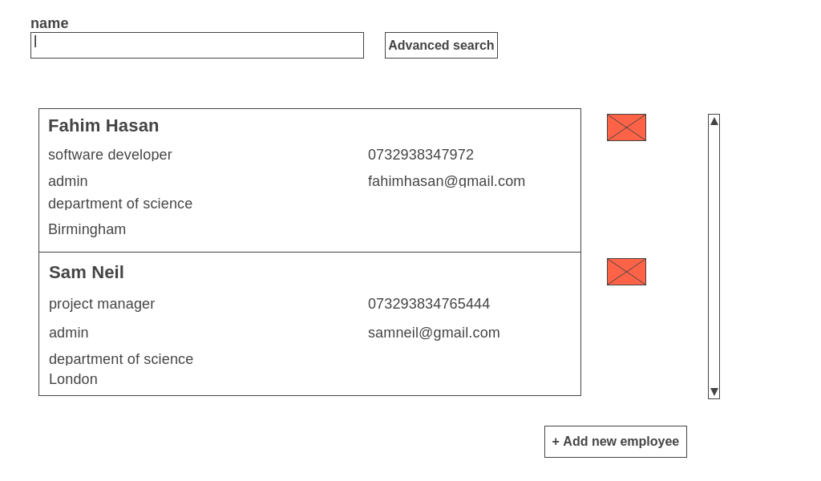

This will be the homepage of the Website, it will list all the employees present in the Database on load.

The User then will be able to:

* Filter the employees by name or by using advanced search
* Edit an employee
* Delete an employee
* Add a new employee

**Advanced Search**

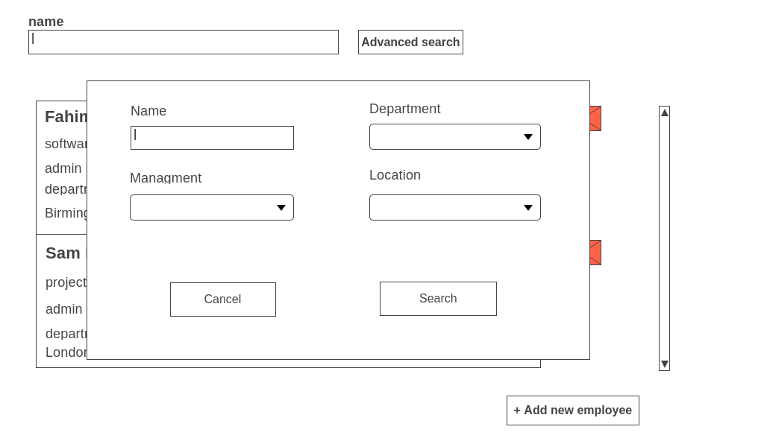

By clicking on the advanced search button the user will be presented with this modal where he will be able to search employees by more options.

**Insert and edit an employee**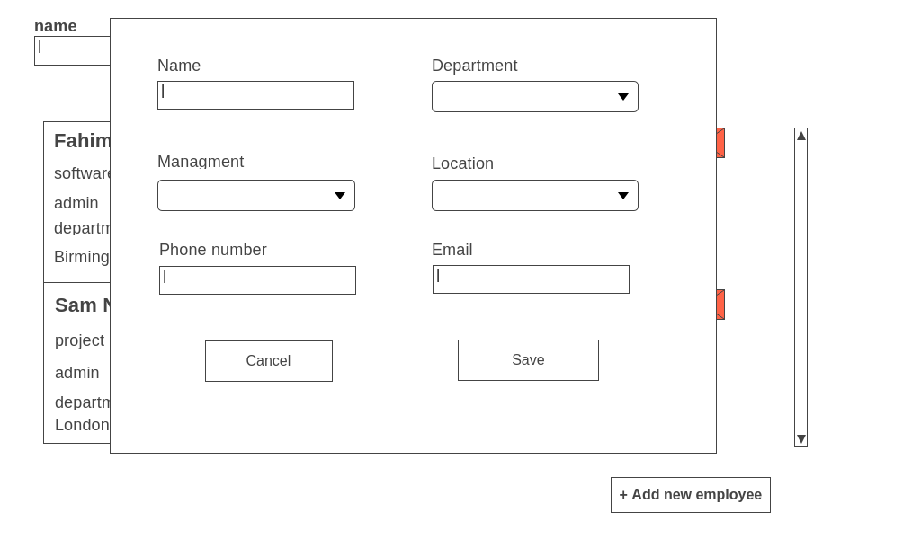

By clicking on an employee or the button add new employee the user will be presented with this modal where he will be able to edit the data of an existing employee or insert the data of a new one.

**Delete an employee**

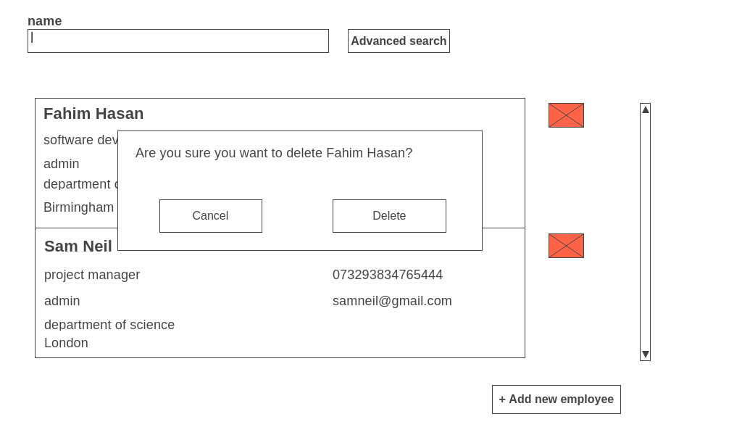

The user will be able to delete employees by clicking on the red delete button present in the side of every employee, after that the user will be presented with this modal to confirm the delete operation, this will avoid any unintentional delete.

Acceptance of this document will initiate the development of the system.

Sign off: Paddy Evans

............................................................................... Date