Oracle Certification Program

IEG has an MOU with Oracle University, for increasing Knowledge of students and also enhance their career opportunities. It is planned to support the student community for pursuing Certification programs by assisting them technically and financially.

Scope in Oracle Technologies:

- DBA (Data base Administrator)
- Application Developer (D2K)
- Backend Developer (Pl/Sql)
- OBI Consultant (Data Warehousing)
- ERP Consultant ( Apps )

Certification Categories:

- OCA
- OCP
- OCM ( DBA Only)

Oracle PL/SQL and Oracle Forms Developer

Oracle Certified Associate

EXAM  (Choose any one)  1Z0-001  Introduction to Oracle: SQL® and PL/SQL™  or  1Z0-007  Introduction to Oracle9i SQL®  or  1Z0-047  Oracle Database SQL Expert  or  1Z0-051  Oracle Database 11g: SQL Fundamentals I |  | EXAM  Program with PL/SQL  1Z0-147 |  |   Oracle PL/SQL Developer  Certified Associate

Oracle Forms Developer Certified Professional

PRIOR CERTIFICATION  Oracle PL/SQL Developer Certified Associate |  | EXAM  Oracle Forms: Build Internet Applications  1Z0-141 |  | Oracle Forms Developer Certified Professional

Oracle Advanced PL/SQL Developer Certified Professional

 | PRIOR CERTIFICATION  Oracle PL/SQL Developer Certified Associate |  | EXAM  Oracle PL/SQL Developer  1Z0-146 |  | Oracle Advanced PL/SQL Developer Certified Professional

OR

EXAM  (Choose any one)  1Z0-001  Introduction to Oracle: SQL® and PL/SQL™  or  1Z0-007  Introduction to Oracle9i SQL®  or  1Z0-047  Oracle Database SQL Expert  or  1Z0-051  Oracle Database 11g: SQL Fundamentals I |  | EXAM  1Z0-101  Develop PL/SQL Program Units  or  1Z0-147  Program with PL/SQL |  | EXAM  Oracle PL/SQL Developer  1Z0-146 |  | Oracle Advanced PL/SQL Developer Certified Professional

Oracle Database 10g Administrator

Oracle Certified Associate

 | EXAM  (Choose any one)  1Z0-001  Introduction to Oracle: SQL® and PL/SQL™  or  1Z0-007  Introduction to Oracle9i SQL®  or  1Z0-047  Oracle Database SQL Expert  or  1Z0-051  Oracle Database 11g: SQL Fundamentals I |  | EXAM  Oracle Database 10g: Administration I  1Z0-042 |  | Oracle Database 10g Administrator Certified Associate

Oracle Certified Professional

TRAINING  Complete one of the approved instructor-led online or in-class courses. |  | EXAM  Oracle Database 10g: Administration II  1Z0-043 |  | FORM  Submit the Hands On Course Requirement Form |  | Oracle Database 10g Administrator Certified Professional

Oracle Certified Master

TRAINING  Complete two advanced instructor-led online or in-class courses |  | EXAM  Oracle Database 10g Certified Master Exam |  | FORM  Submit the Hands On Course Requirement Form |  | Oracle Database 10g Administrator Certified Master

Price List:

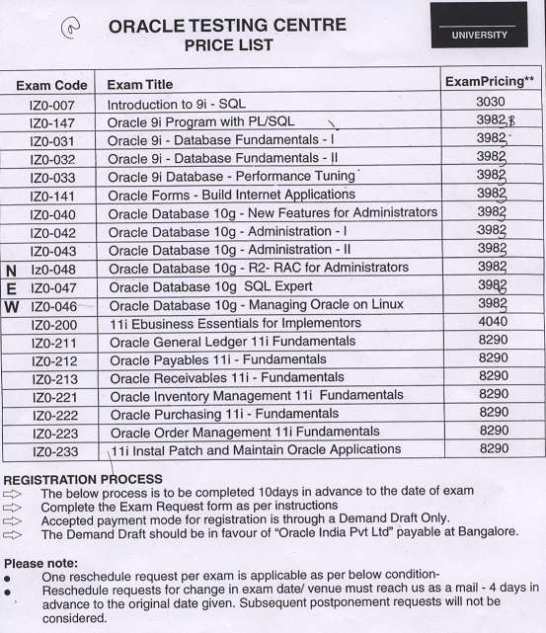

* For any further clarifications kindly contact:-

ieg.oraclecertification@gmail.com
ieg.helponcertification@gmail.com

