Link to remote github repo: https://github.com/fahimmohamed/inf1103-labs/commits/main/INF1103-Lab-2

Docker mount and run:
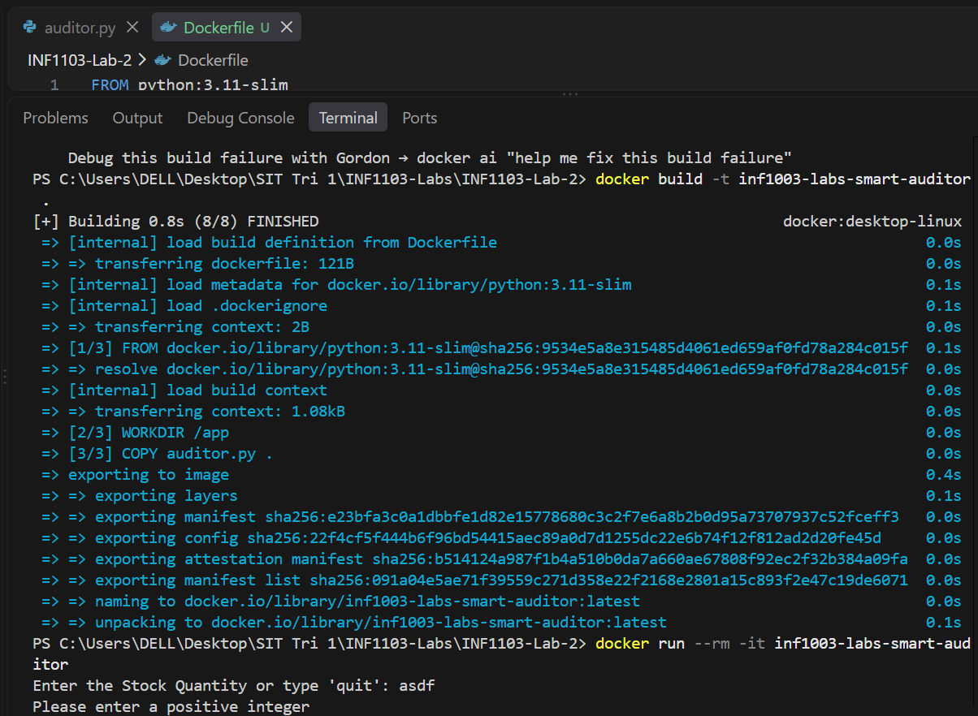

Docker images:
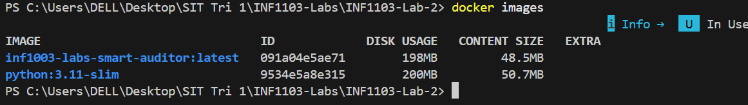

Input 1:
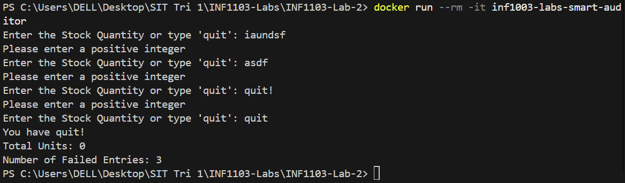
Input 2:
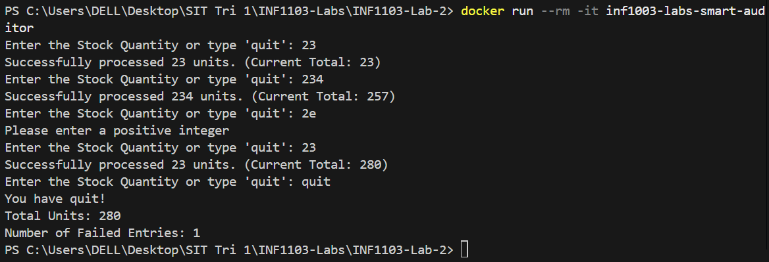

Input 3:
