Link to github repo: https://github.com/fahimmohamed/inf1103-labs/tree/main/INF1103-Lab-4

Docker mount and run:
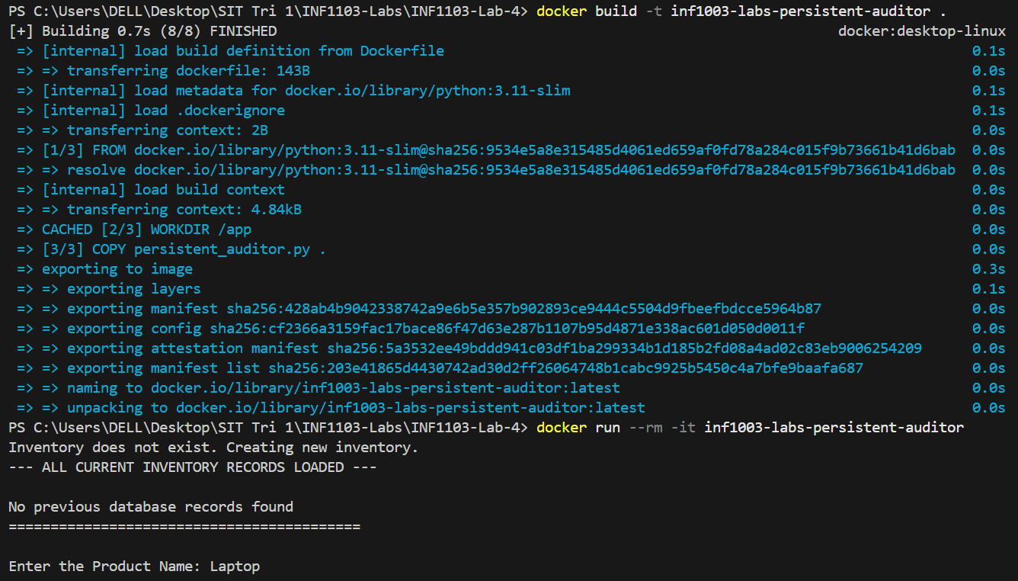

Docker images:
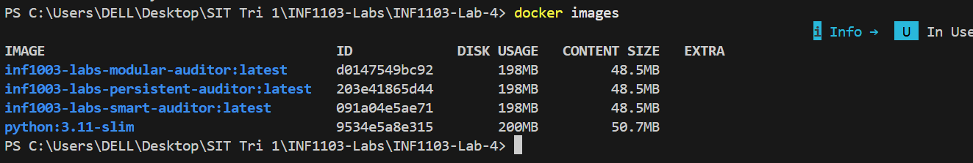

Input 1:
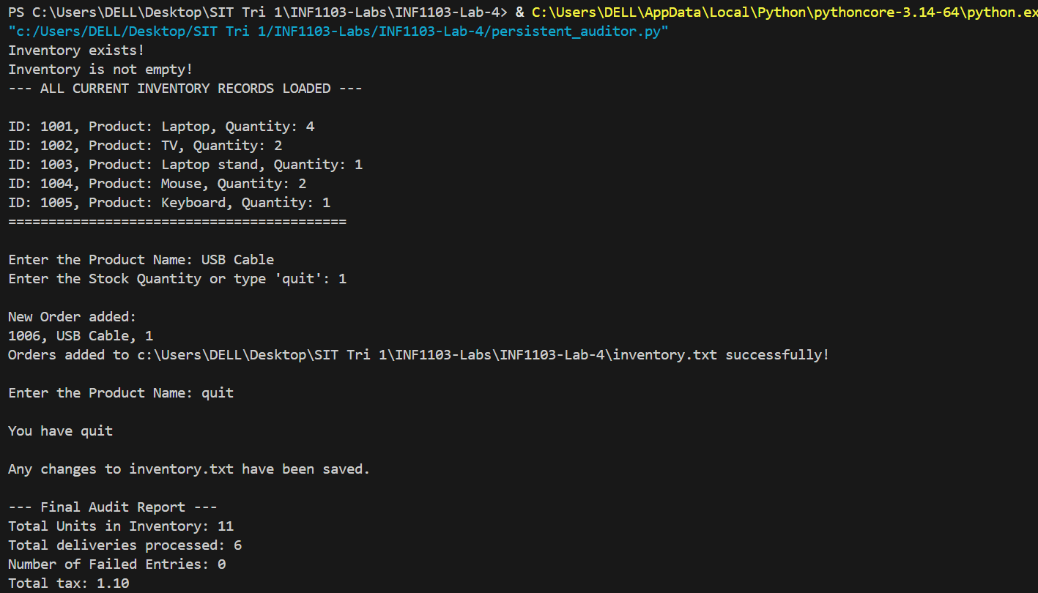

Input 2:
