Github repo
https://github.com/fahimmohamed/inf1103-labs/tree/main/INF1103-Lab-8

Predict first
2.2 – My prediction is that both products still display the supplier since del supplier only deletes the variable and not the object. Each product still stores its own reference to the supplier object. Both products still show the full supplier details after the variable was deleted.

3.3 – My prediction is that the product still works because only the product’s reference is deleted from the inventory list but things like the stock can still be updated. After running, it still works

4.3 – My prediction is that there will be 1 product object but 2 orderline object. This is because “add_order_line” is called once per order so each order gets its own new line. The check with “is” prints false and the “id()” for both values are different.

6.3 – Yes it violates the LSP since this version of DigitalProduct cannot run where the parent class is expected. I would change the subclass as all digital products are expected to have a stock and update stock. Since DigitalProduct cannot update stock, it must be removed and use update_stock() from Product.

7.2 – My prediction is that each product will print the supplier information and whether it is a delivery parcel for physical product or digital product which can be downloaded online

UML class diagram:
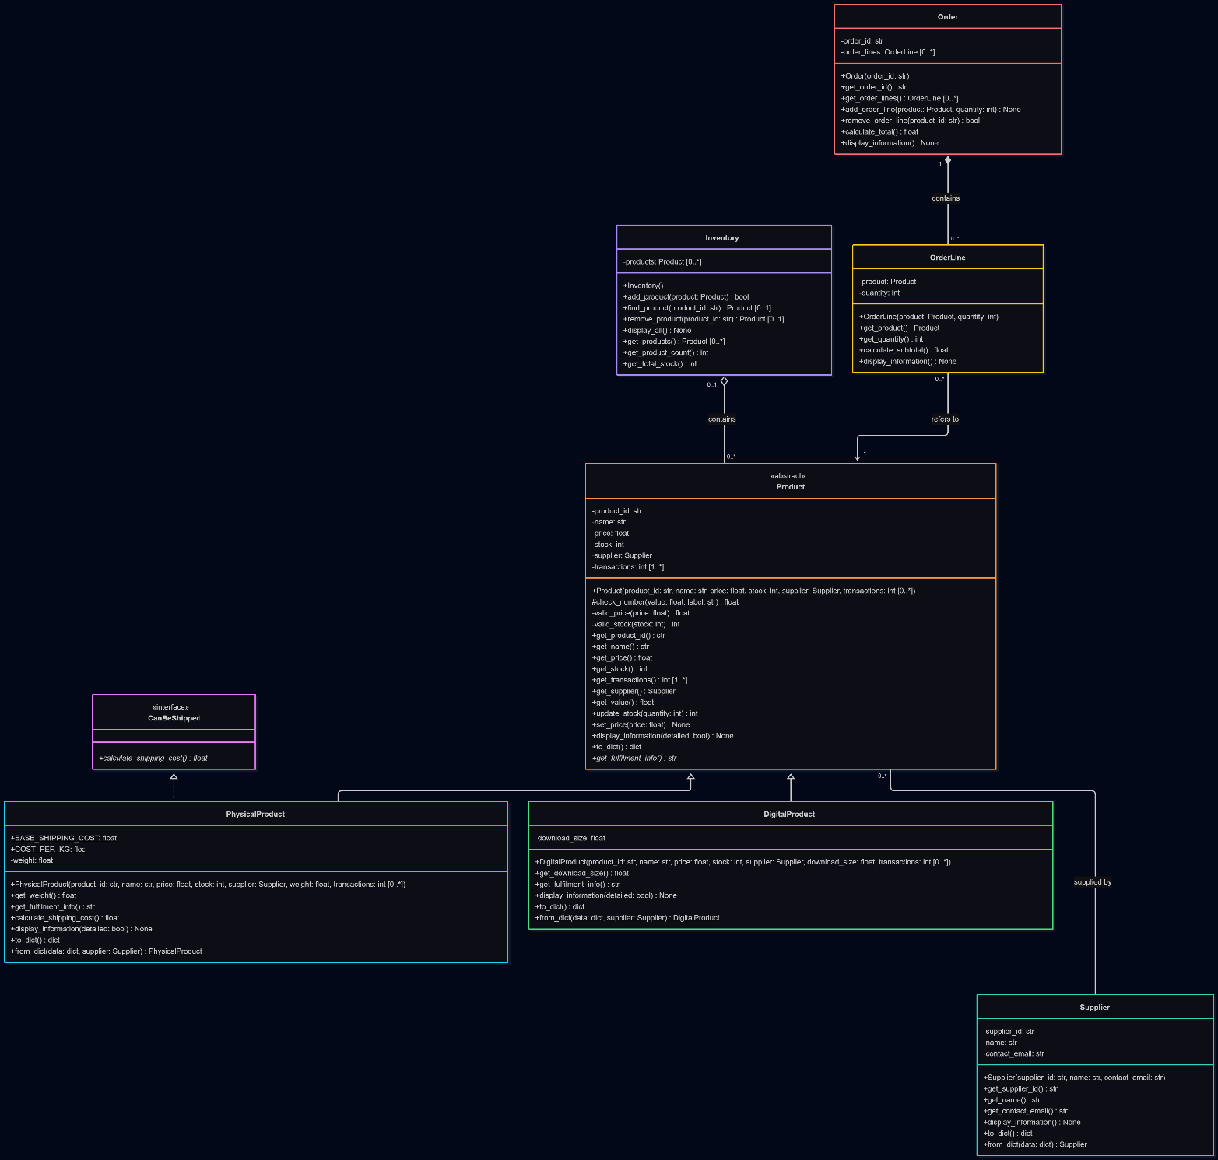

Docker mount and run:
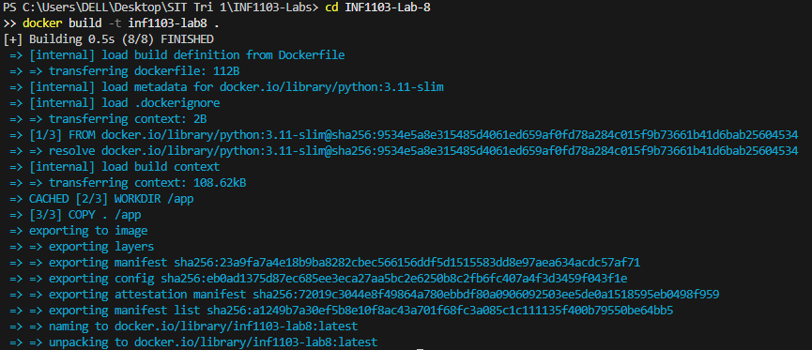

Docker image:
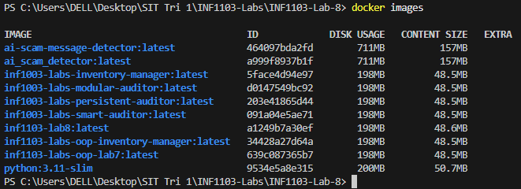

Inputs:


