Github repo
https://github.com/fahimmohamed/inf1103-labs/tree/main/INF1103-Lab-7
UML class diagram:
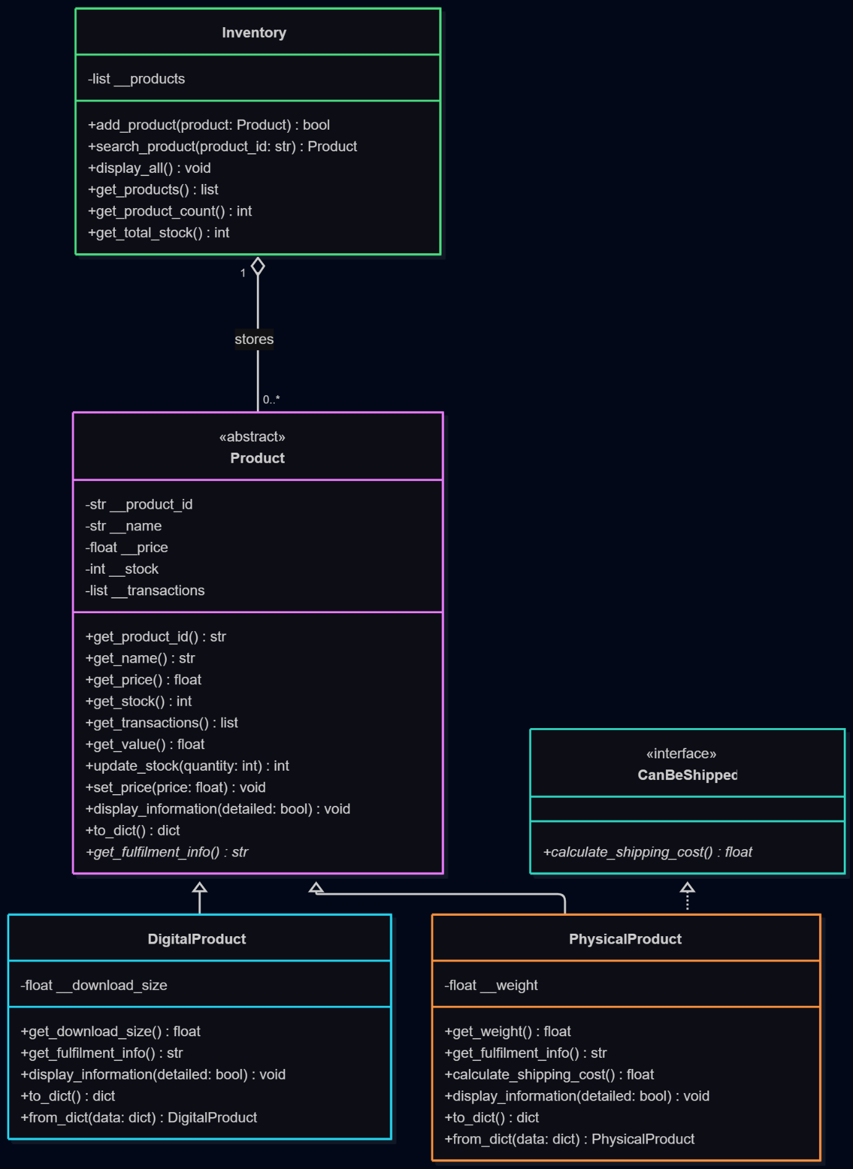
Docker mount and run:
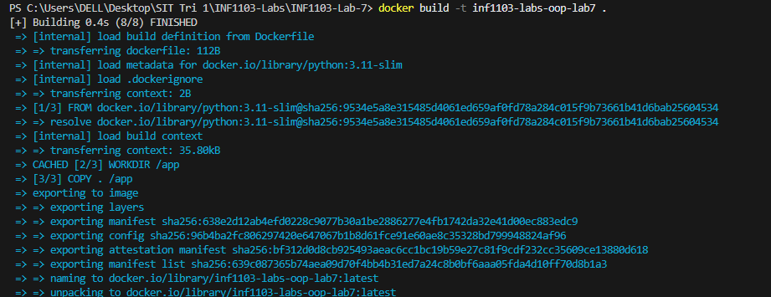
Docker image:
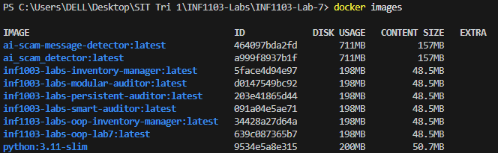
Inputs:


