Abstract



**Created By**

**Fahim Ahmed**

**Taharam Chowdhury**

**Lamyea Hoque**

**Akil Adnan Bhuiyan**

Tourly

“Tourly”” is an online tour booking website in which you can book a tour to different destinations. You will have different options to choose from to take a tour of a destination you like and you can select the number of days you want to be there. Tourly is a complete tourist fully integrated tourism web site. The website covers all the areas required for an including tourism.

"There is no way to succeed in business without the highest ethical standards"

– Jordan Belfort.

As an online business, very important thing here we follows is the **transparency**. To make a good bond between company and client, we have provided the company profile regarding the 5 years of history. And also, the company contact details.

Well use of well secured internal system to improve the **integrity** of the data and calculations for the items and prices for the orders. Websites **secure the customer data** by applying the techniques and make lawful interconnection.

We are providing booking to some of the best destinations in the world like Dubai, Italy, Japan etc.

We provide different packages that can range from basic to premium with first class facilities. There is also different discounts for prople more than 5.

You can also check our reviews from our past customers and that our website has been one of the best online websites for tour bookings for the past three years. You can learn more about our business from the learn more sections.

You will find our website user friendly and easy to use. You can even contact us on different social media sites like Facebook, Twitter and Instagram. Or can call us directly from the phone number on our website.

Hierarchy of the website

HOME

Packages

Check Out

Destinations

Contact

We provide safe and secure payment systems and you can even pay with crypto if you would like. Our payment is secure and easy to use.

**Questions regarding the projects:**

**a. what is your business:** We are providing tour booking website so that people can travel across the world using our website.

**b.what is the business ethos:** We provide different packages in regard to the destination the user chooses and the number of days the user wants the tour to be. We also offer discounts on different occasions.

**c.what do you produce/make/offer/sell:** We provide an easy way for people to choose their destination which may be for their honeymoon, summer break or any occasion. We provide a lot of different places to select from all over the world.

**d.who is your target audience:** People who want to take a tour or visit places all over the world, we provide excellent packages for them.

**e.what are the key motivations of why you expect people to visit your website and how you will attract and motivate people therein:** People all over the world are always looking for travelling across the world and visiting a lot of different beautiful places. So for all those people our website is the go to place to book their dream vacation.

**f.do they want general information/research (such as background on a topic/company), or are they after something specific:** No matter what they want we provide for them on our website in regard to travelling.

**g.are they already familiar with the service or product that you offer or do they need to be introduced to it: ​​**This is a field that is close to people since the Personal Computer was invented. So, there is no effort needed to make it familiar to our clients.

**h. are they looking for time-sensitive information, such as the latest news or updates on a particular topic:** They will have to look for the available dates for certain locations that we provide for them to travel to.

**i. do they want to discover information about a specific product or service to help them decide whether to buy it or not?** We provide different packages and different discounts for the places the want to visit. So they will have a lot of options to choose from.

**j.do they need to contact you? If so, can they visit in person (which might require opening hours and a map)? Or might they need email or telephone contact details?**

Our site has provided Email, Contact Number, Address, and map locations. Customers can contact the company anytime from Monday to Saturday from 8.00 am – 8.00 pm. Or make an appointment through an email to meet our team.

**k. will visitors be familiar with your subject area/brand or do you need to introduce yourself?** If the visitors are not familiar with the places that we offer we also provide a learn about the place section in which they can find why would they need to visit the places and what that place offer.

**l. will they be familiar with the product/service / information you are covering or do they need background information on it?** They wouldn’t need background information. Everything on our website will clear it for them.

**m. what are the most important features of what you are offering?**  We are providing packages on the user needs. Like honeymoon package, family vacation, tour all over the world in 30 days etc. So the user can choose any package they like and they will get specific discounts based on the package the select. Also the packages have a basic, premium and first class options.

n. **what is special about what you offer that differentiates you from other sites that offer something similar:** Many sites provide tour booking websites that are either costly or have only a few packages. We provide tours that are affordable and also have a lot of different packages to select from. Also we provide booking all over a year.

**o. once people have achieved the goal that sent them to your site, are there common questions people ask about this subject area:** Yes there is a common question section in which we provide answers to some of the common questions people ask about our site.

**How to start:**

#home page:

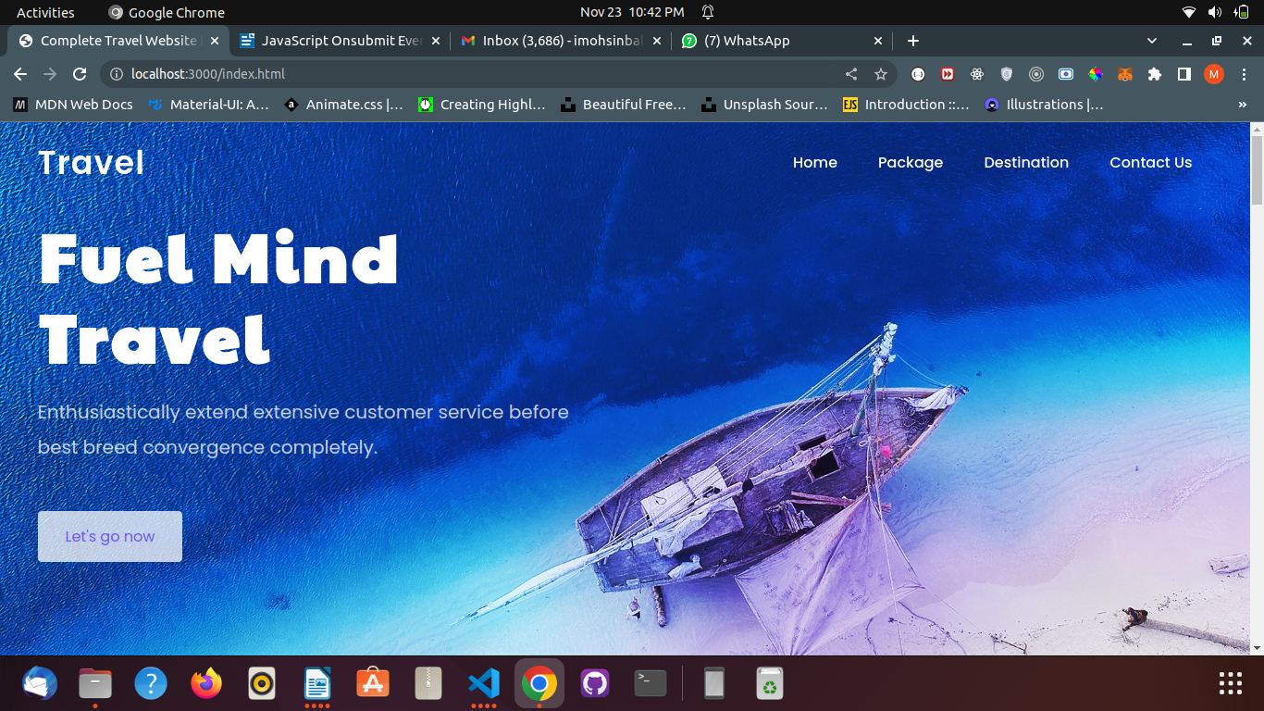

#pakages

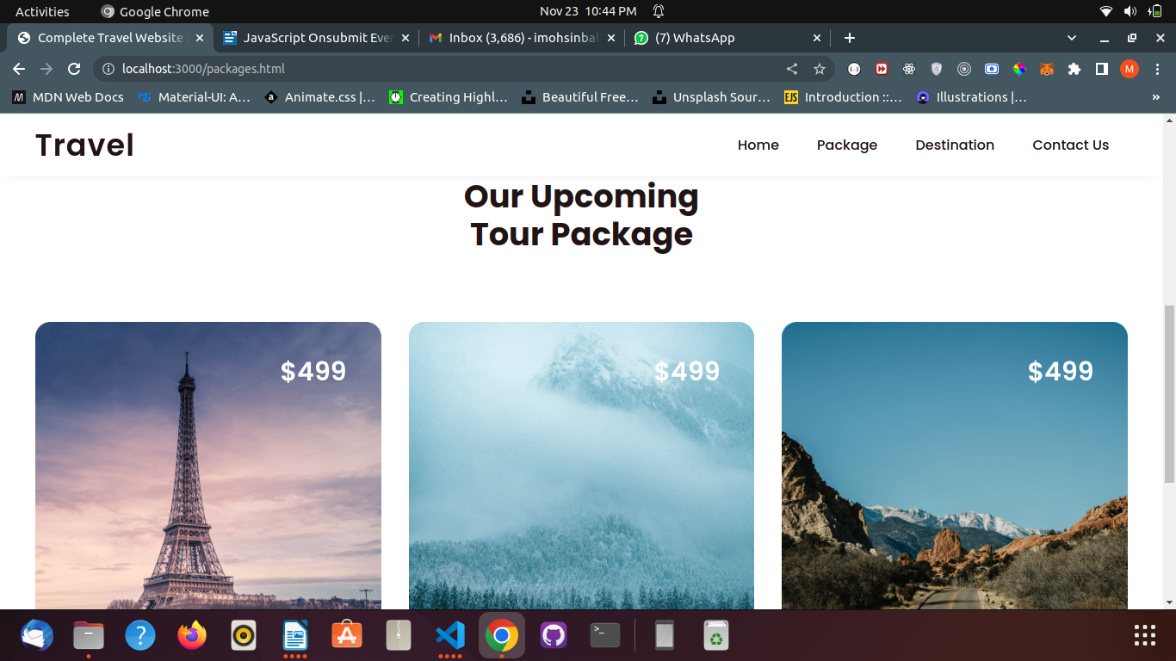

#booking

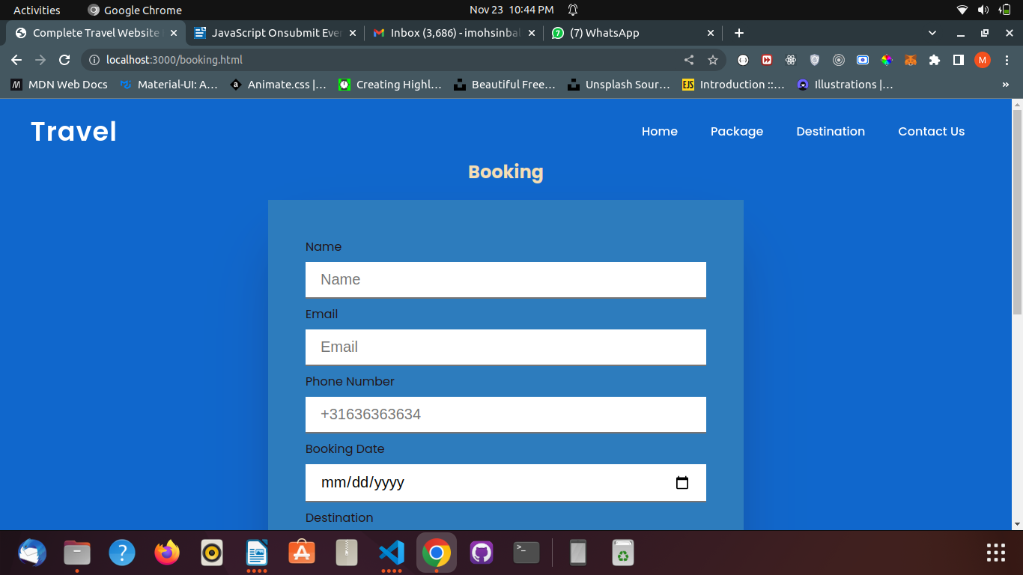

#Database

