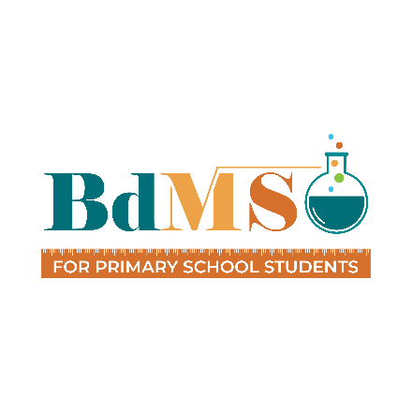
Bangladesh Mathematics and Science Olympiad 2025

Frequently Asked Questions (FAQ)

Organizer
Bangladesh Open Source Network (BdOSN)
Society for the Popularization of Science, Bangladesh (SPSB)

Building# 758, Green City Centre, Sat Masjid Road, Dhanmondi, Dhaka 1209
info.bdmso@gmail.com | facebook.com/imsobd | www.bdmso.org

General Information & Eligibility

Who is eligible to participate in the Olympiad?
BdMSO is open to primary or elementary school students under 13 years old. To participate, students must be enrolled in primary school as of July 1, 2025. Additionally, their birth date should be on or after October 6, 2012.
What subjects can I participate in?
Contestants can participate in Mathematics, Science, or both. There are no categories based on school class or grade level.

Registration Process

How do I register for the National Round?
Participation is confirmed through online registration. Please visit this link to register: https://festive.rocks/sh/bdmso
What is the registration fee for the National Round?
The registration fee is 1000 BDT for a single subject (Mathematics or Science). If participating in both subjects, the combined registration fee is 1500 BDT.
How do I pay the registration fee?
The registration fee is paid by purchasing tickets online through the registration link: https://festive.rocks/sh/ticket
Do I need to keep my ticket?
Yes, you must bring either a hardcopy or a softcopy of your ticket for verification at the event venue.

National Round Details

When and where will the National Round take place?
The BdMSO National Round will be held on August 9, 2025. The specific venue will be announced soon.
Are there regional rounds?
No, there are no regional rounds. BdMSO features a direct National Round.
What is the schedule/format of the National Round event?
The event day includes an Inauguration ceremony, one-hour exams for Mathematics and Science, a Science Experiment Session, a Q&A Session, and experience sharing from IMO and IJSO medalists. There will also be an IMSO Brief Session, a Cultural Session, and a Prize Giving ceremony.

Awards & Recognition

What prizes will be awarded?
Approximately one-fifth of all participants will be awarded gold, silver, and bronze medals in a 1:2:3 ratio per subject. All medalists receive a winner's t-shirt and a Certificate of Achievement. A Champion Trophy is awarded to the top scorer in each subject. Every contestant who attends the National Round will receive a Certificate of Participation.

Can a participant win awards in both subjects?
No. While contestants may register for and participate in both Mathematics and Science, awards will be granted in only one subject category per participant, based on their scores.

Team Selection & International Participation

How are participants selected for the National Camp and IMSO team?
Top scorers from the National Round will be invited to a non residential National Camp. From this camp, Top individuals will proceed to a National Team Selection Test. The top six from each subject based on this test will form the national team to represent Bangladesh at IMSO.

What is the International Mathematics and Science Olympiad (IMSO)?
IMSO is a prestigious annual international competition for primary school students under 13, bringing together young talents from around the world to compete in challenging math and science exams.
How does BdMSO connect to IMSO?
BdMSO serves as Bangladesh's official national qualifying round for IMSO. The national team selected through BdMSO will represent Bangladesh at the 22nd IMSO in Kedah, Malaysia, this October.
What is the format of the IMSO competition?
IMSO consists of both theoretical and experimental/exploration components. All questions and instructions are provided in English, and answers must be written in English.
What costs are involved for IMSO participation?
Participants selected as national delegates for IMSO are required to pay a registration fee to the local organizer, covering comprehensive costs including travel, visa processing, accommodation, and local travel during the Olympiad.

Can a parent accompany a participant to IMSO?
Yes, it is encouraged for one parent to accompany each participant. The accompanying parent will need to pay an additional fee (approximately $650 USD, payable directly to the IMSO Organizers in Malaysia).

What kind of support will the National Team receive during IMSO?
The Bangladesh National Team will be accompanied by one team leader and one tutor for each subject who will provide comprehensive guidance, support, and supervision throughout the IMSO event, including travel, competition days, and recreational activities.
What is the duration of the IMSO trip to Malaysia?
The exact duration of the IMSO trip, including travel days, will be communicated to the selected national delegates once the detailed itinerary from the IMSO organizers is finalized. Typically, it spans approximately 7-10 days.

Preparation
How should I prepare for the National Round?
Participants should follow the official BdMSO syllabus. It is recommended to solve elementary-level creative Mathematics and Science problems and study sample questions from IMSO for better preparation. Syllabus Link
What books can participants follow?
Participants can follow elementary-level Mathematics and Science textbooks, as well as sample questions and past papers.

Contact & Support
How can I get further assistance or information?
You can reach us via email at info.bdmso@gmail.com. You can also find more information and updates on our official Facebook page (facebook.com/imsobd) and website (www.bdmso.org).

