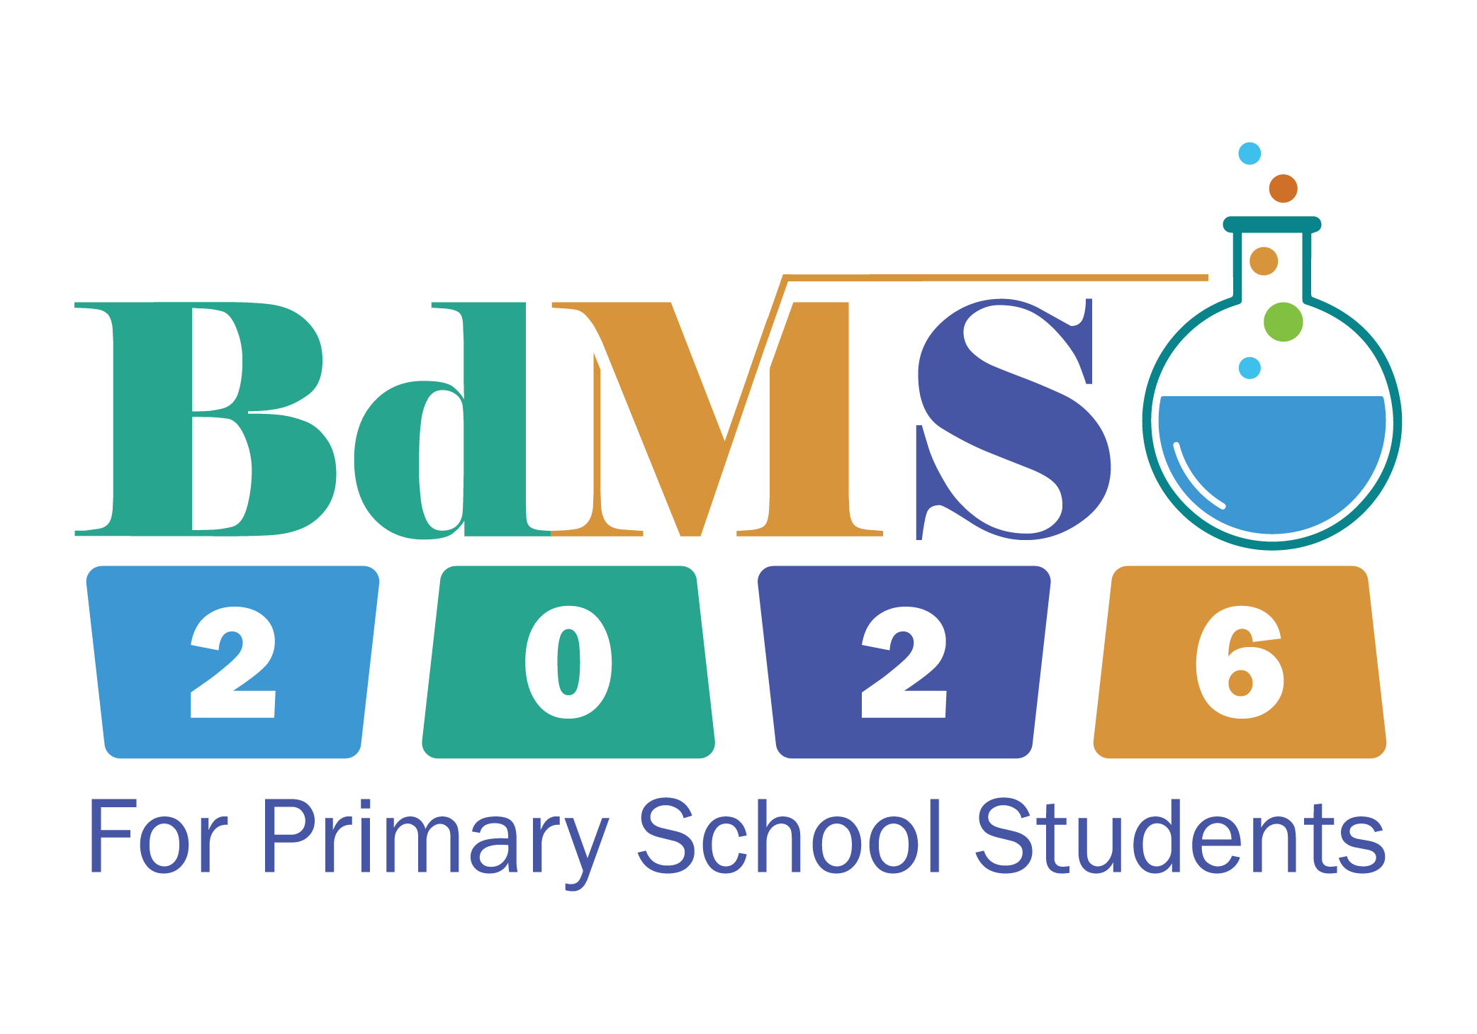

Bangladesh Mathematics and Science Olympiad

BdMSO Syllabus 2026

Organizer
Society for the Popularization of Science, Bangladesh (SPSB)
Bangladesh Open Source Network (BdOSN)

Building# 758, Green City Centre, Sat Masjid Road, Dhanmondi, Dhaka 1209
info.bdmso@gmail.com | facebook.com/imsobd | www.bdmso.org

BdMSO SYLLABUS: MATHEMATICS

1. Arithmetic and Number Theory
 | A. | Whole & Rational Numbers | Absolute Value, understanding fractions, decimals, and percentages, and converting between them,
 | B. | Properties of Numbers | Even and odd integers, prime and composite numbers.
 | C. | Factors and Multiples | Greatest Common Divisor (GCD) and Least Common Multiple (LCM).
 | D. | Divisibility & Sequences | Divisibility rules, remainders, cyclic patterns, ordering of numbers, and evaluating complex arithmetic & geometric sequences.
 | E. | Ratio and Proportion | Solving real-world problems using ratios and direct/inverse proportions.
2. Geometry and Spatial Sense
 | A. | Polygons & Circles | Angle relationships, properties of triangles, quadrilaterals, parallelograms, trapeziums, and circles.
 | B. | Measurements | Calculating angles, area, and perimeter of various 2D shapes.
 | C. | Coordinate & Transformational Geometry | Basics of the Cartesian plane, plotting points, grid distances, and spatial transformations: symmetry, reflection, rotation, similarity, and proportion.
 | D. | 3D Geometry | Properties of solid figures, cubes, parallelepipeds.
 | E. | Spatial Visualization | Understanding and solving problems involving the nets of 3D shapes.
3. Algebra and Pattern Recognition
 | A. | Pattern Recognition | Identifying and predicting terms in numeric and geometric sequences.
 | B. | Basic Algebra | Evaluating algebraic expressions, variables as unknowns, and solving simple linear equations.
 | C. | Advanced Expressions | Introduction to quadratic expressions and basic factorization
4. Data Analysis, Statistics, and Measurement
 | A. | Data Representation | Reading and interpreting tables, bar charts, pie charts, line graphs, and scatter plots.
 | B. | Statistical Averages | Mean, Median, and Mode.
 | C. | Advanced Averages | Understanding how changing individual values in a dataset affects the overall average
5. Combinatorics and Probability
 | A. | Counting Techniques | Systematic counting, finding the number of possible ordered pairs, and basic permutations/combinations, and the Inclusion-Exclusion principle.
 | B. | Probability | Calculating the likelihood of specific outcomes in random events, understanding independent and dependent events.
6. Recreational Mathematics
 | A. | Mathematical Puzzles | Logic grids, parity, magic squares, and critical thinking brainteasers.

BdMSO SYLLABUS: SCIENCE

1. Scientific Method and Experimental Reasoning
 | A. | Scientific Thinking | Observation, forming hypotheses, and drawing conclusions based on evidence.
 | B. | Measurements | Understanding units, length, mass, time, temperature, volume
 |  |  | Using scientific instruments, Accuracy, precision, and estimation.
 | C. | Experimental Design & Data Interpretation | Fair testing, identifying variables, independent, dependent, controlled.
 |  |  | Organizing data in tables, interpreting experimental diagrams. Analyzing graph-based reasoning problems.
2. Life Science
 | A. | The Basics of Life | Characteristics of living vs. non-living things, The cell as the basic unit of life, movement of materials in/out.
 | B. | Plant Science | Photosynthesis, respiration, seed germination, pollination, tissue systems, and basic hormone regulation.
 | C. | Human Anatomy & Organ Systems | Support & Movement, Skeleton, joints, and muscles.
 |  |  | Control & Coordination, Brain, spinal cord, nerves, reflex actions.
 |  |  | Sense Organs, Eyes, Ears, Nose.
 |  |  | Circulation & Respiration, Blood components, heart, lung function, gas exchange.
 |  |  | Digestion & Excretion, Nutrient absorption, renal system, kidneys, waste removal.
 | D. | Health & Metabolism | General health, nutrition, release of energy from food, common diseases, prevention, and hygiene.
 | E. | Microbiology & Genetics | Beneficial vs. harmful bacteria, viruses, antibiotic resistance, microbes, Basic DNA structure, inheritance, family traits, and an introduction to Punnett Squares, evolution.
 | F. | Ecology & Animal Behavior | Habitats, food chains, food webs, ecosystems.  Animal behavior, migration, hibernation, fixed action patterns.
 |  |  | Classifying organisms based on anatomy, diet, and reproduction.
3. Physical Science
 | A. | Chemistry Fundamentals | Atoms and molecules, mole, common elements, simple chemical formulas, carbon as the building block of life, and chemical reactions in everyday life.
 | B. | Matter & Fluids | States of matter, physical & chemical transformation.  Motion, speed, density.  Properties of static fluids and gases.
 | C. | Forces & Motions | Gravitational, magnetic, elastic, and frictional forces.  Changes in shape due to force.
 | D. | Energy & Thermal Properties | Kinetic/potential energy, energy conversion.  Temperature, heat transfer, conduction, convection, radiation.
 | E. | Light & Sound | Properties of light, color, vision.  The mechanics of sound/vibration.
 | F. | Electricity & Magnetism | Basic applications and models.
4. Earth and Space Science
 | A. | The Solar System & Earth | The Sun, planets, asteroids, comets. Earth's rotation/revolution, Earth-Moon system, phases of the moon, eclipses. Natural and artificial satellites.
 | B. | Earth System & Weather | Structure of the Earth: crust, mantle, core. Composition of air, weather, climate, wind formation, and the water cycle.
 | C. | Natural Calamities | Understanding extreme natural events including Earthquakes, Tsunamis, and weather patterns like El Niño and La Niña.
5. Geography and Environmental Science
 | A. | Global Geography & Biomes | Continents, oceans, major biomes, deserts, rainforests, tundras.
 |  |  | understanding basic maps, latitude, and longitude.
 | B. | Geography & Bangladesh | Understanding the Bengal Delta and how it was formed, the major river networks, the Haor basin, the Sundarbans, and the significance of monsoons.
 | C. | Environmental Chemistry & Issues | Greenhouse gases, the science of the ozone layer, acid rain, methods of water purification and pollution management.
 | D. | Conservation & Climate Action | Protecting local ecosystems, human-wildlife relations and conflict.
 |  |  | Deforestation, Climate Change, saving Bangladesh's rivers, wetlands and forests.
6. Biotechnology
 | A. | Biotechnology Basics | Simple fermentation, basics of genetic engineering/cloning, and the role of GMOs in food security.
 | B. | Modern Application | Understanding how emerging scientific fields impact the world and environment

