title: Existing customer assignment on new inbound conversation

description: Automatically identify and link existing Dynamics 365 customer records to Contact Center inbound conversations using JavaScript and CE Web API.

keywords: Dynamics 365, Omnichannel/ Contact Center, inbound call, customer assignment, CE Web API, contact center ms.

service: dynamics-365 ms.

topic: conceptual ms.

subservice: guidance ms.

custom: bap-template

author: fahmeedayaseen86-png

date: 02/02/2026

Existing customer assignment on new inbound conversation
This solution demonstrates how Dynamics 365 Contact Center for Customer Service can automatically identify and assign existing customer records to new inbound conversations using JavaScript and the CE Web API. Agents can see customer information immediately in the conversation pop-up, improving efficiency and response times.

Architecture
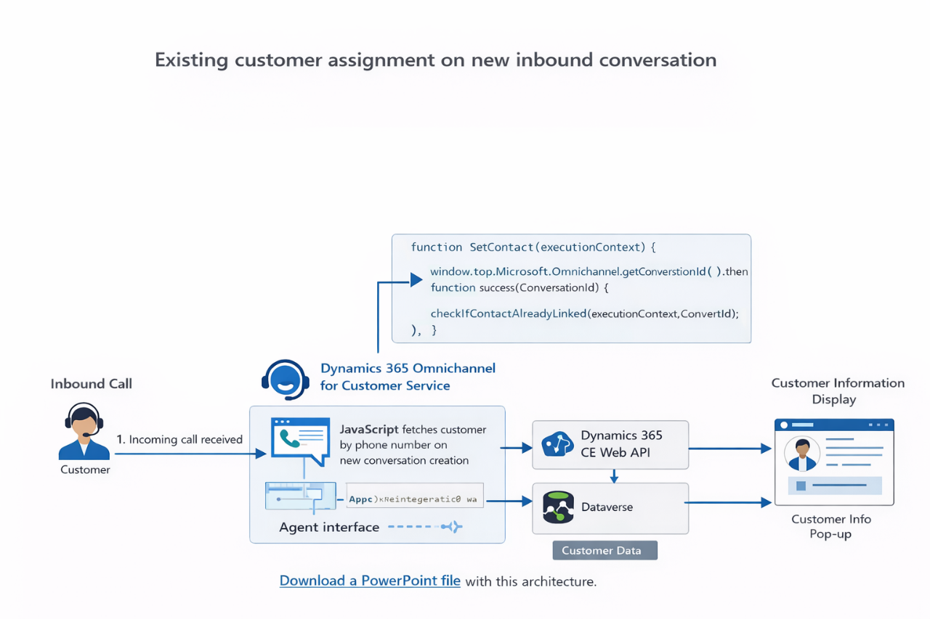

Dataflow
- A customer places an inbound call to the contact center.
- Dynamics 365 Contact Center generates a new conversation and displays the active conversation pop-up.
- A JavaScript function executes to fetch the conversation ID and check if inbound call phone number is populated.
- The JavaScript code extracts the phone number from the conversation.
- Using the Dynamics 365 CE Web API, the system queries Dataverse for an existing customers matching the phone number.
- If a matching customer exists, it is automatically linked to the conversation.
- The agent interface updates, and customer details are displayed in the conversation pop-up.

Components
- Dynamics 365 Contact Center for Customer Service
Handles inbound call routing, live conversations, and agent interface.
- Dataverse
Stores contact and customer data as well as live work items.
- Dynamics 365 CE Web API
Queries existing customer records based on the phone number.
- JavaScript client-side logic
Fetches conversation ID, retrieves customer data, and links records to conversations.

Scenario details
Inbound calls to contact centers often show only the caller's phone number in the agent interface. Without automatic linking, agents must manually search for the customer, slowing down service and similarly, increase the steps for the agent, search the customer and link to the conversation. This solution enables real-time detection of existing customers using the phone number as the key, automatically linking the customer record to the conversation.

Potential use cases
- Retail: Quickly display returning customer details and purchase history.
- Finance: Show account information immediately for faster call resolution.
- Healthcare: Identify patients efficiently for better service.
- Telecommunications: Surface subscriber information instantly to agents.
Applicable across industries where inbound call handling and rapid customer identification are critical.

Sample implementation
Git Repo Location: https://github.com/fahmeedayaseen86-png/ContactCenterSolutionIdeas.git
//Automatically identify and link existing Dynamics 365 customer records to C Contact Center inbound conversations using JavaScript and CE Web API
//Register method against onload event of conversation record.
function SetContact(executionContext) {
try {
window.top.Microsoft.Omnichannel.getConversationId().then(

function success(ConversationId) {

if (ConversationId != null) {
debugger;
checkIfContactAlreadyLinked(executionContext, ConversationId);
}
},
function error(err) {
debugger;
console.log("Error in Getting Conversation ID. " + err);
}
);
}
catch (excep) {
console.log(excep)
}
}

function wait(ms) {

var start = new Date().getTime();

var end = start;

while (end < start + ms) {

end = new Date().getTime();

}

Xrm.Utility.closeProgressIndicator();

}

//Checked is contact is already exist.

function checkIfContactAlreadyLinked(executionContext, ConversationId) {

Xrm.WebApi.online.retrieveMultipleRecords("msdyn_ocliveworkitem", "?$select=_msdyn_customer_value&$filter=msdyn_ocliveworkitemid eq '" + ConversationId + "'").then(

function success(data) {
debugger;
if ((data !== null) && (data.entities !== null) && (data.entities.length > 0) && data.entities[0]._msdyn_customer_value == null) {

createContactLinkContact(ConversationId, executionContext);

}

else {
debugger;
console.log("Omnichannel: Contact Already Created and Linked ",);

}
debugger;
console.log("2 GUID: ",);

}

);

}

//Link customer with the conversation
function createContactLinkContact(ConversationId, executionContext) {
debugger;

var phone;

var req = new XMLHttpRequest();
req.open("GET", Xrm.Utility.getGlobalContext().getClientUrl() + "/api/data/v9.2/msdyn_ocliveworkitems(" + ConversationId + ")?$select=subject", false);
req.setRequestHeader("OData-MaxVersion", "4.0");
req.setRequestHeader("OData-Version", "4.0");
req.setRequestHeader("Content-Type", "application/json; charset=utf-8");
req.setRequestHeader("Accept", "application/json");
req.setRequestHeader("Prefer", "odata.include-annotations=*");
req.send();
if (req.status === 200) {
var result = JSON.parse(req.response);
console.log(result);
// Columns
var activityid = result["activityid"]; // Guid
var subject = result["subject"]; // Text
var _phone = subject.split(':');
// phone = _phone[0];
phone = _phone[0].replace('+', '');
GetCustomerDetails(executionContext, ConversationId, phone);
}
else {
console.log(req.responseText);
}
}

//get customer details in the base of phone number
function GetCustomerDetails(executionContext, conversationId, PhoneNumber) {
debugger;

var req = new XMLHttpRequest();
req.open("GET", Xrm.Utility.getGlobalContext().getClientUrl() + "/api/data/v9.2/contacts?$select=firstname,fullname,lastname&$filter=(contains(telephone1,'" + PhoneNumber + "') or contains(address1_telephone1,'" + PhoneNumber + "'))", false);
req.setRequestHeader("OData-MaxVersion", "4.0");
req.setRequestHeader("OData-Version", "4.0");
req.setRequestHeader("Content-Type", "application/json; charset=utf-8");
req.setRequestHeader("Accept", "application/json");
req.setRequestHeader("Prefer", "odata.include-annotations=*,odata.maxpagesize=1");
req.send();

if (req.status === 200) {
var result = JSON.parse(req.response);

if (result.value && result.value.length > 0) { // Ensure data exists
var contact = result.value[0]; // Get first contact
var contactid = contact.contactid; // Guid
var fullname = contact.fullname; // Text

Microsoft.Omnichannel.linkToConversation("contact", contactid, conversationId).then((response) => {
// Refreshing the tab UI
Microsoft.Apm.getFocusedSession().getFocusedTab().refresh();
}, (error) => {
console.log(error);
});
} else {
console.log("No matching contact found.");
}
} else {
console.log(req.responseText);
}
}

Contributors
This article is maintained by Microsoft. It was originally written by the following contributors.
Principal authors:
- Author Name | Cloud Solution Architect

Next steps
- Explore Dynamics 365 Omnichannel/Contact Center documentation.
- Learn about client-side extensibility with Power Apps component framework.
- Reference Dataverse Web API for querying records.

Related resources
- Omnichannel/Contact Center extensibility overview
- Customer Service reference architectures

