Student Hands

Higher technical education system

[اسم الشركة] |[عنوان الشركة]

‏1439

# 1. INTRODUCTION

## 1.1 Purpose

The purpose of this document is to collect, analyze and define system requirements of the Student Hands System (SHs). It focuses on the capabilities needed by the stakeholders, and the users, and why these needs exist. This document will be used by the development team as a reference and it will be helpful in implementing this system.

## 1.2 Scope

This system design description document applies to Higher Technical Education (HTE). The system will be initially developed to be system and it will be used to manage the higher technical education information in general including student, Teachers, Chairman, Register and IT Administrator.

## 1.3 Definitions, Acronyms and Abbreviations

**SHs:** Student Hands System

**HTE:** Higher Technical Education

## 1.4 References

None

## 1.5 Overview

The document starts by an overall description of (SH) Student Hands to show the main modules of the system and then the document will list the specific requirements of (SHs) Student Hands System.

# 2. Overall Description

## 2.1 Website perspective

Student Hands is a system of study for the Higher Technical Education Direction. which can help facilitate registration and admission process, monitoring the grades of students, helping students to know their grades and facilitating administrative processes in the Higher Technical Education Direction.

## 2.2 Website Features

* Manage Student’ personal records
* Manage and monitor students' grades
* Manage Teacher and users accounts records
* Enforce user authorization and authentication
* Allow backup of the system’s database
* Arabic / English User Interface
* Multiple User Interface based on User Type

## 2.3 User characteristics

|  |  |
| --- | --- |
| **User** | **Description** |
| **IT Administrator** | A casual user that will user records accounts for teachers and students. |
| **Chairman** | A casual user of the system with managerial features like Such as the addition of teachers, the addition of subjects and the registration of students from level to level. |
| **Register** | An official user will inquire about the students in any department and level. He will also inquire about students' grades by level and block, and will add new students. |
| **Teachers** | A casual user that will user records score for students and show subject. |
| **Students** | A casual user only for query for score. |

## 2.4 Constraints

The system must be developed within one year.

## 2.5 Assumptions and dependencies

N/A

# 3. Specific Requirements

## 3.0 Requirements List

1. Chairman
2. Add Teacher Record.

System shall allow the Chairman to register new Teacher by making new file in the system database that will hold Teacher personal information, work information.

1. View Teacher Record

System shall allow the Chairman to view Teacher’ record.

1. Modify Teacher Record

System shall allow the Chairman to modify Teacher’ record.

1. Delete Teacher Record

System shall allow the Chairman to delete Teacher’ record

1. Add Subject.

System shall allow the Chairman to add Subject. The information is: Name of Subject, time Subject.

1. Delete Subject

System shall allow the Chairman to cancel Subject.

1. View Record Subject of the Teacher

System shall allow the Chairman to show Subject that are taught to each Teacher.

1. View Subject

System shall allow the Chairman to view Subject.

1. Add Subject of the Teacher

System shall allow the Chairman to add new Subject to a teacher record.

1. Students Move To Block.

System shall allow the Chairman to Move students to bluck.

1. Register
2. Add New Student

System shall allow the Register add new student by making new file in the system database that will hold identifying and personal information.

1. View student record

System shall allow the Register to View student personal files.

1. View student Record According to the Department and Level

System shall allow the Register to show a selected student’ record.

1. View student Score

System shall allow the Register to show student Score.

1. View The Annual Record of student Score According to the Level

System shall allow the Register to show The Annual Record of student Score According to the Level to the system.

1. View student to Added New

System shall allow the Register to show any selected student to the system Added.

1. Students Move to Level.

System shall allow the Chairman to Move students to level.

1. IT Administrator
2. Add New User

System shall allow the Administrator to add new users.

1. Remove User

System shall allow the Administrator to remove any user.

1. Block User

System shall allow the Administrator to Block users.

1. Change User Type

System shall allow the Administrator to change user's type.

1. Rest User Password

The system should allow the administrator to rest the user's password.

1. Database Backup

The System should allow the admin to back up the database

1. Teacher
2. View Teacher profile

System shall allow the Teacher to view information’ record his.

1. View Teacher Subjects

System shall allow the teacher to show subject’ record.

1. List of Students in each Subject

System shall allow the Teacher t to show all Student’ record, which are added to subject.

1. Add Score for Students.

System shall allow the Teacher to add student score’ which are added to subject.

1. Student
2. View Student profile

System shall allow the Student to view information’ record his.

1. View student courses

System shall allow the student to show subject’ record his.

1. View student Score

System shall allow the Student to show Score’ record, which are added to subject.

## 3.1 Receptionist

### 3.1.0 Chairman

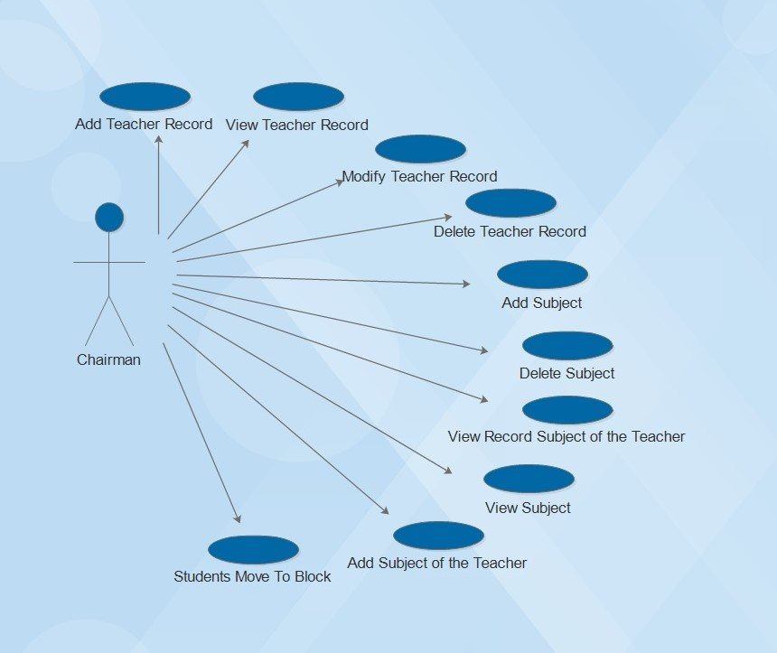

#### 3.1.0.1 Add Teacher Record

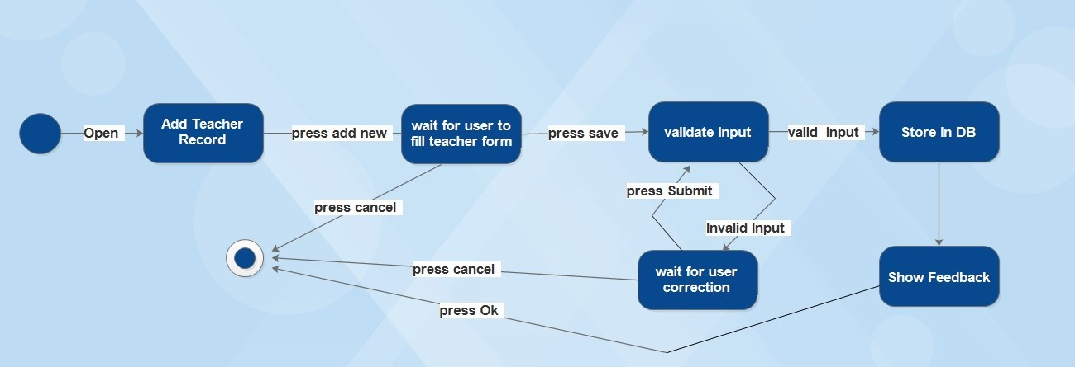

#### 3.1.0.2 View Teacher Record

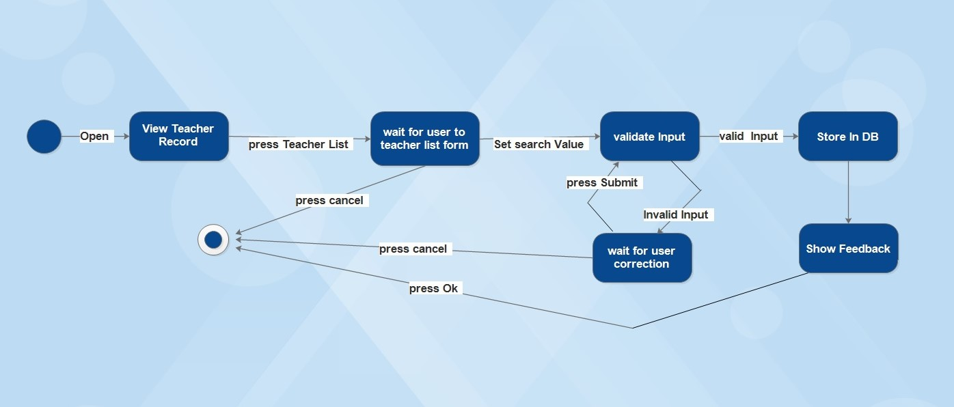

#### 3.1.0.3 Modify Teacher Record

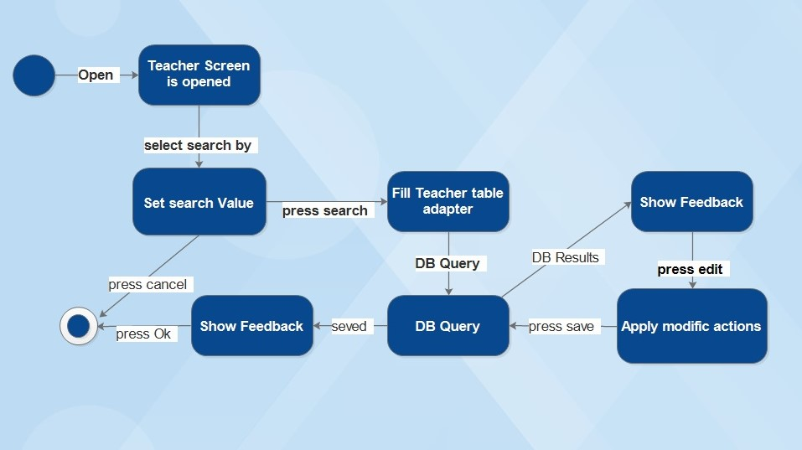

#### 3.1.0.4 Delete Teacher Record

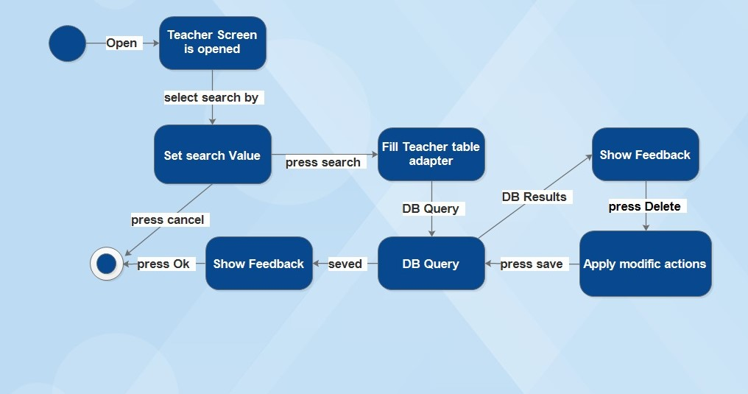

#### 3.1.0.5 Add Subject

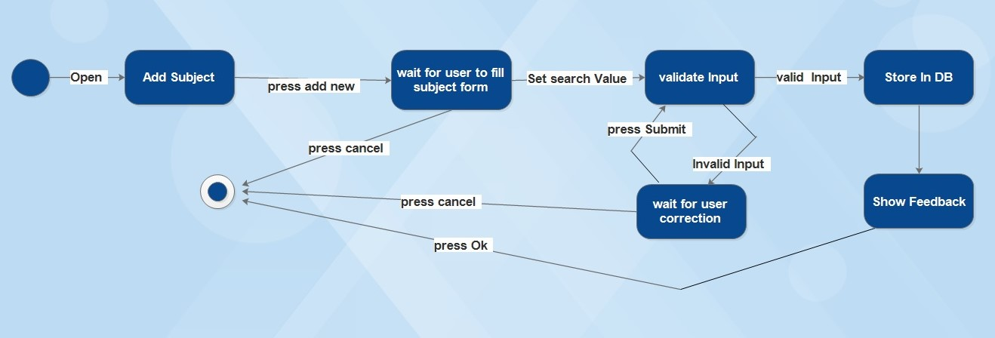

#### 3.1.0.6 Delete Subject

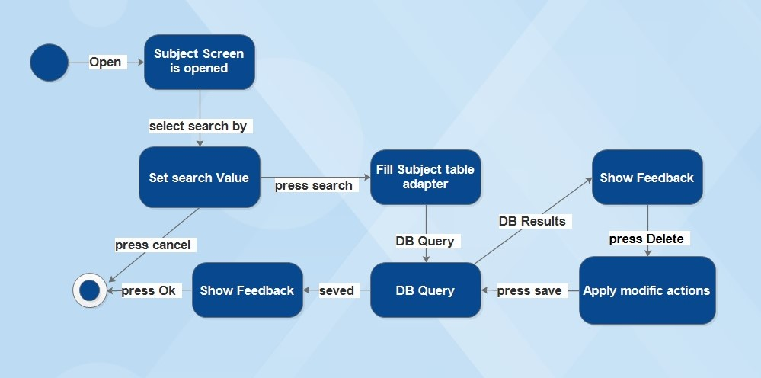

#### 3.1.0.7 View Record Subject of the Teacher

#### C:\Users\Mony\Desktop\New folder (9)\c\6.jpg

#### 3.1.0.8 View Subject

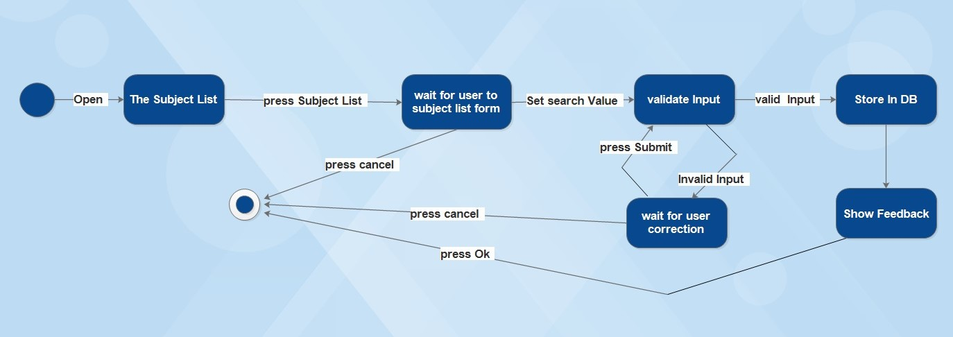

#### 3.1.0.9 Add Subject of the Teacher

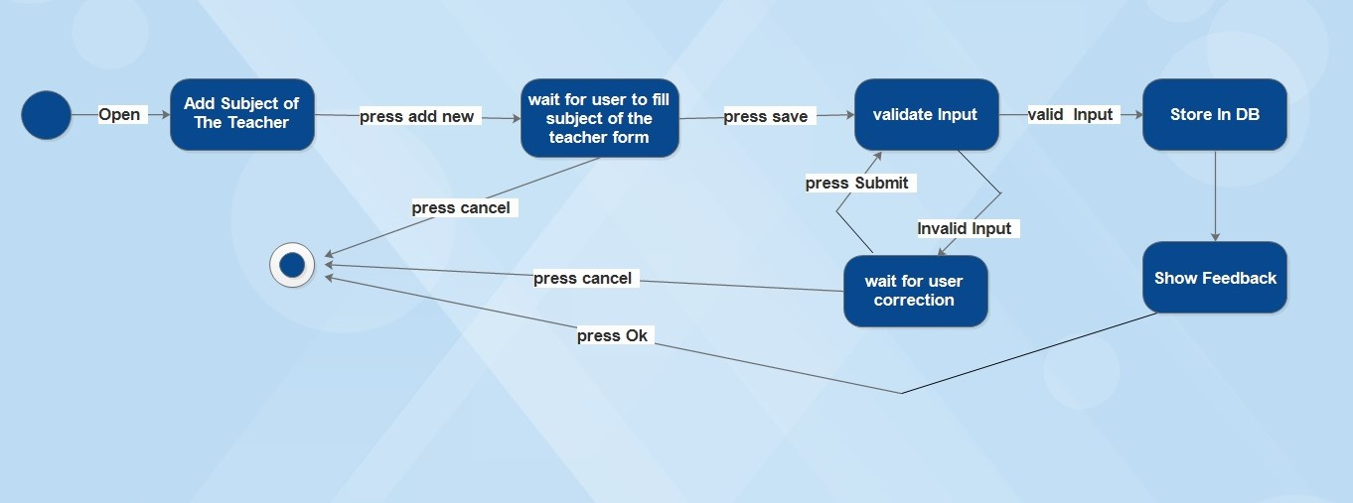

#### 3.1.0.10 Students Move To Block

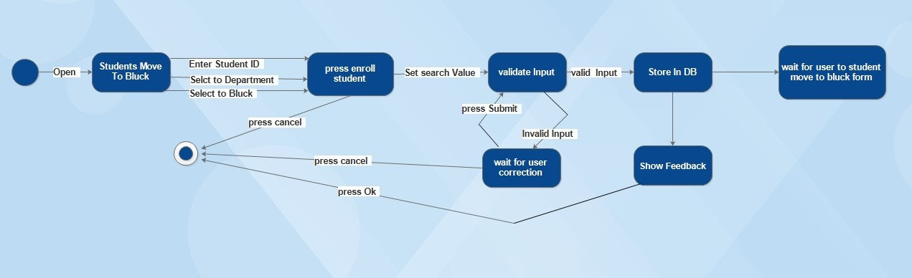

### 3.1.1 Register

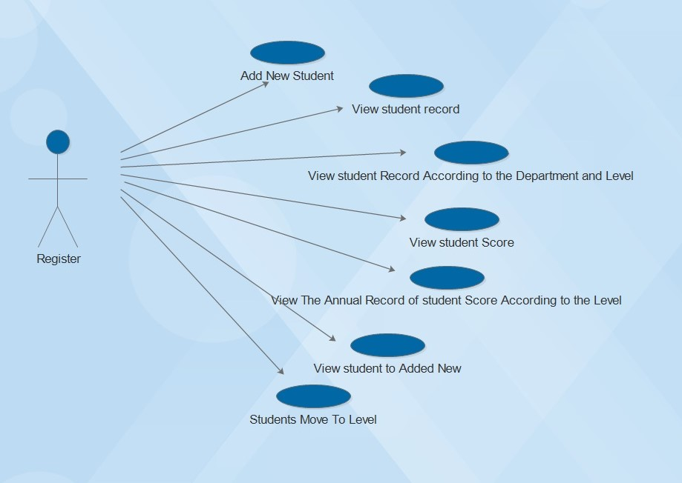

#### 3.1.1.0 Add New Student

#### C:\Users\Mony\Desktop\New folder (9)\R\1.jpg

#### 3.1.1.1 View student record

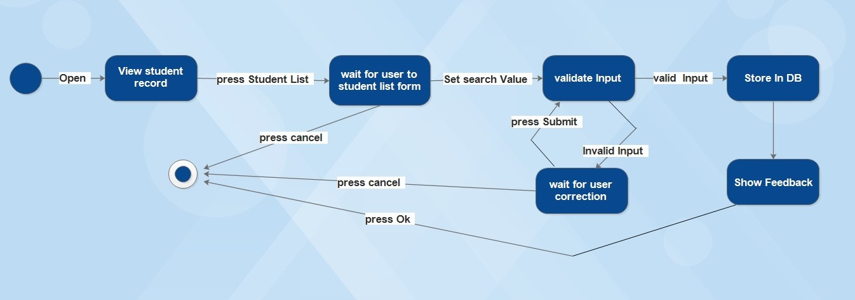

#### 3.1.1.2 View student Record According to the Department and Level

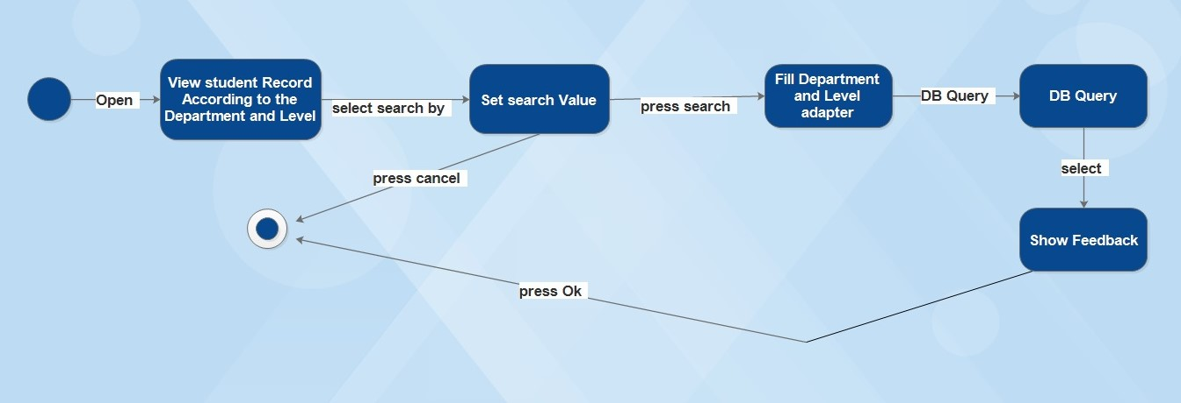

#### 3.1.1.3 View student Score

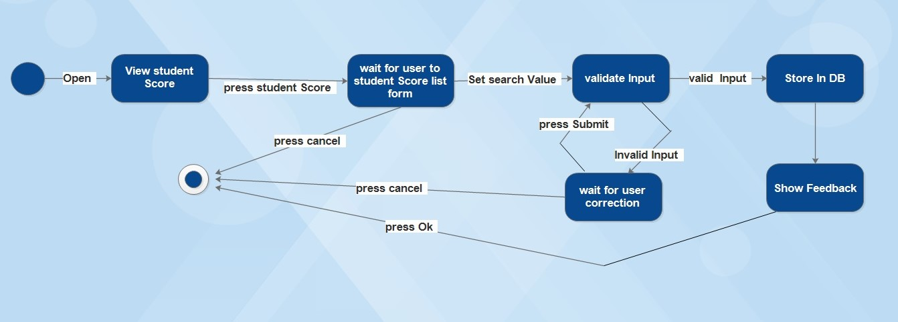

#### 3.1.1.4 View The Annual Record of student Score According to the Level

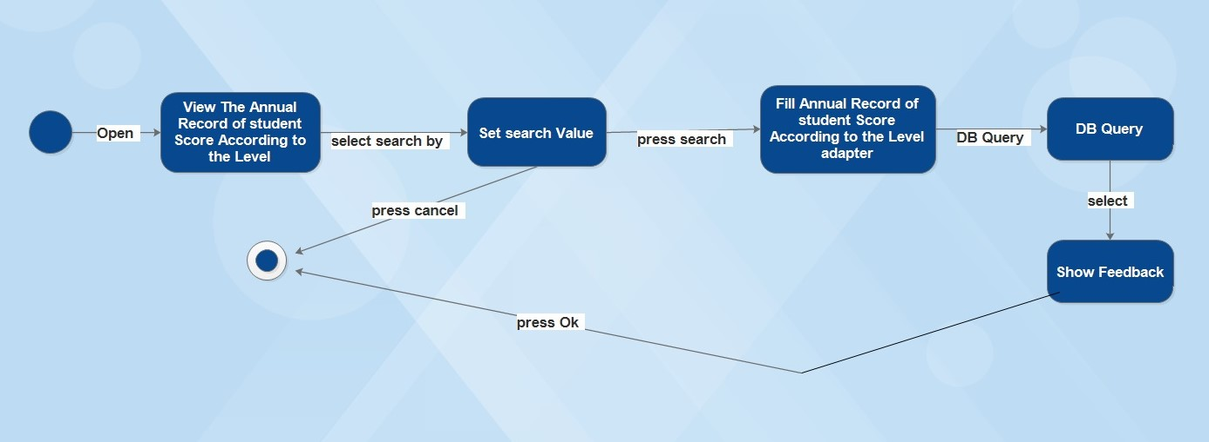

#### 3.1.1.5 View student to Added New

#### C:\Users\Mony\Desktop\New folder (9)\R\6.jpg

#### 3.1.1.6 Students Move To Level

#### 

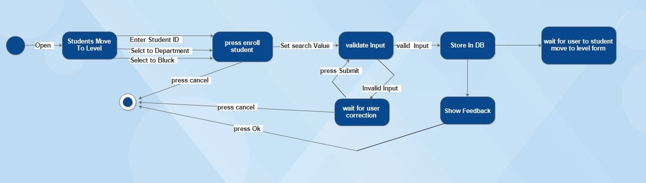

### 3.1.2 IT Administrator

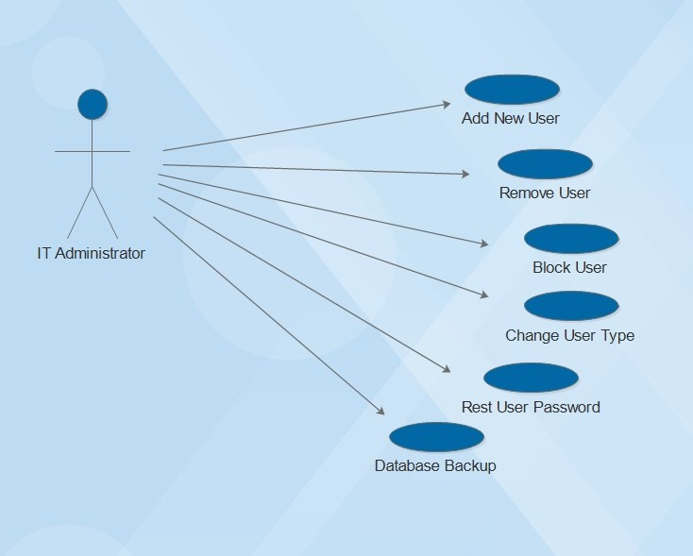

#### 3.1.2.0 Add New User

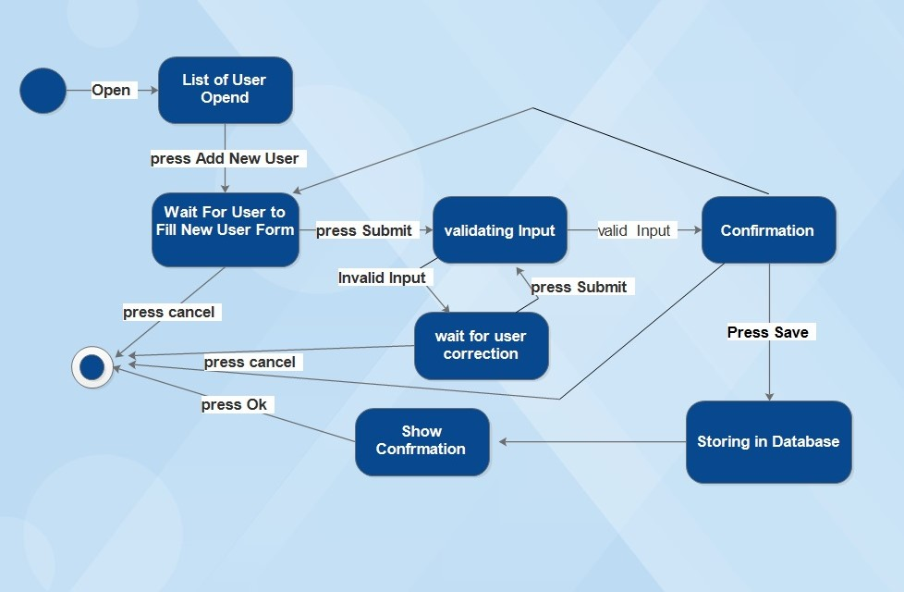

#### 3.1.2.1 Change User Type

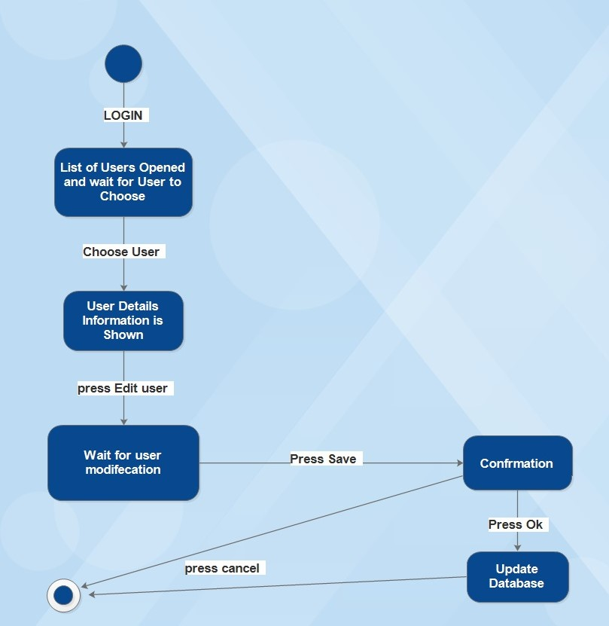

#### 3.1.2.2 Database Backup

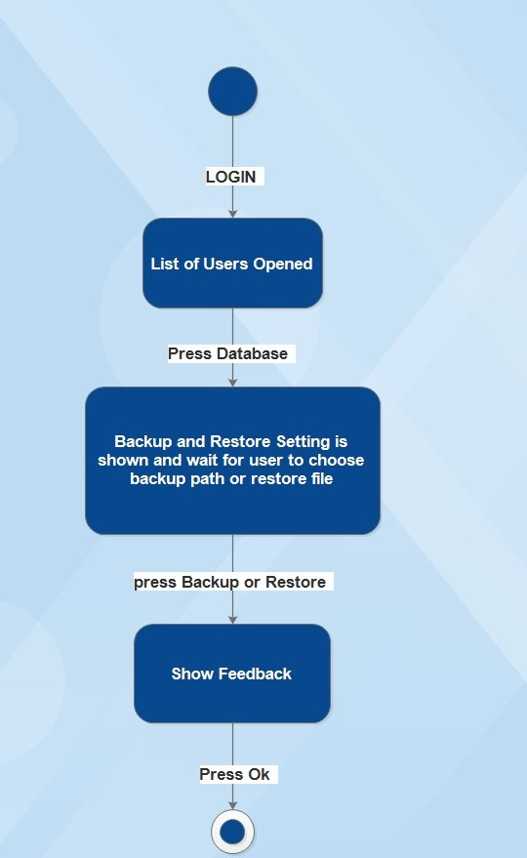

### 3.1.3 Teacher

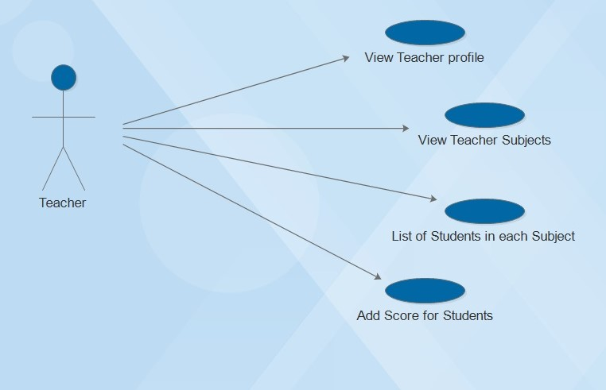

#### 3.1.3.0 View Teacher profile

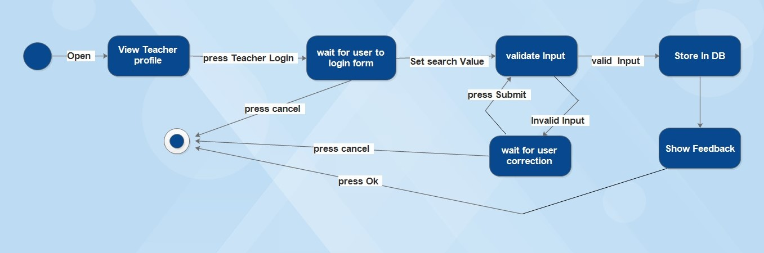

#### 3.1.3.1 View Teacher Subjects

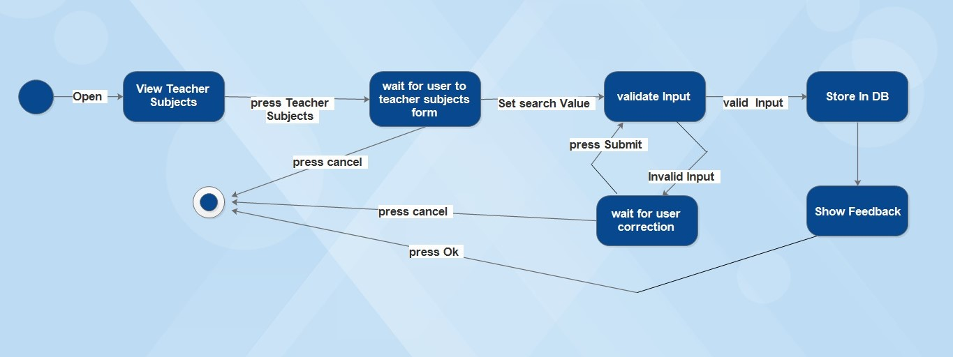

#### 3.1.3.2 List of Students in each Subject

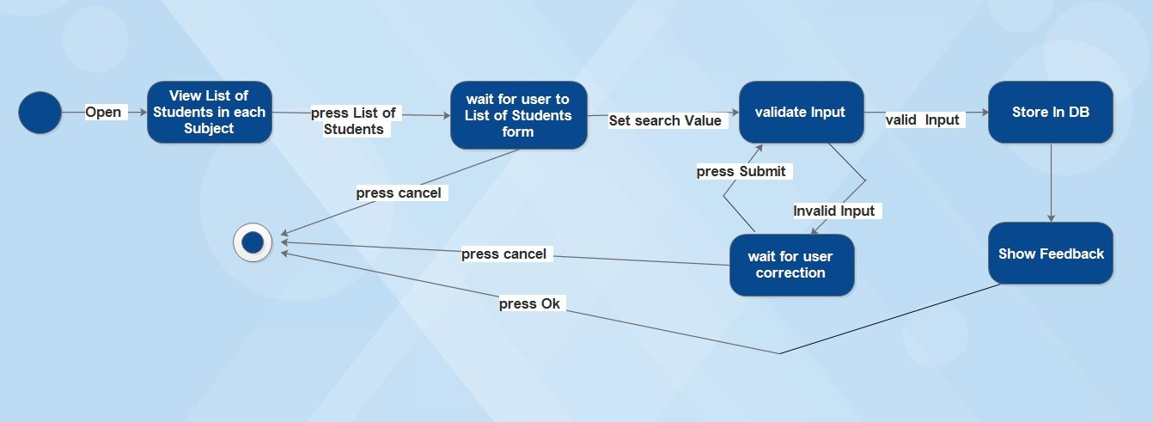

#### 3.1.3.3 Add Score for Students

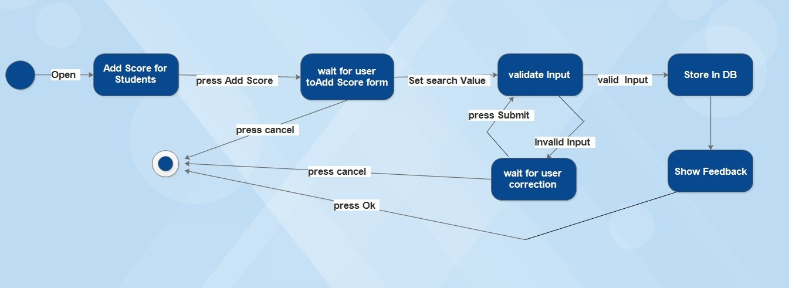

### 3.1.4 Student

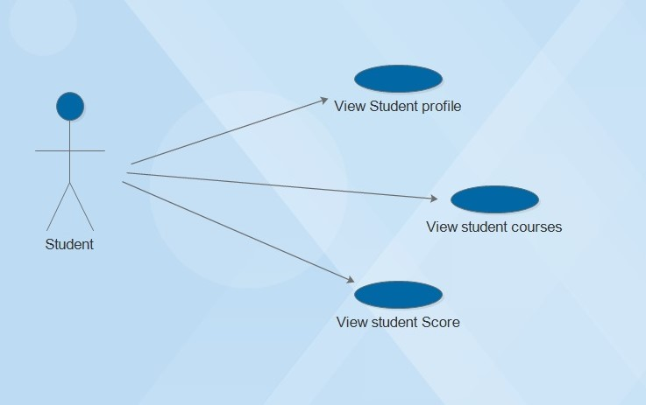

#### 3.1.4.0 View Student profile

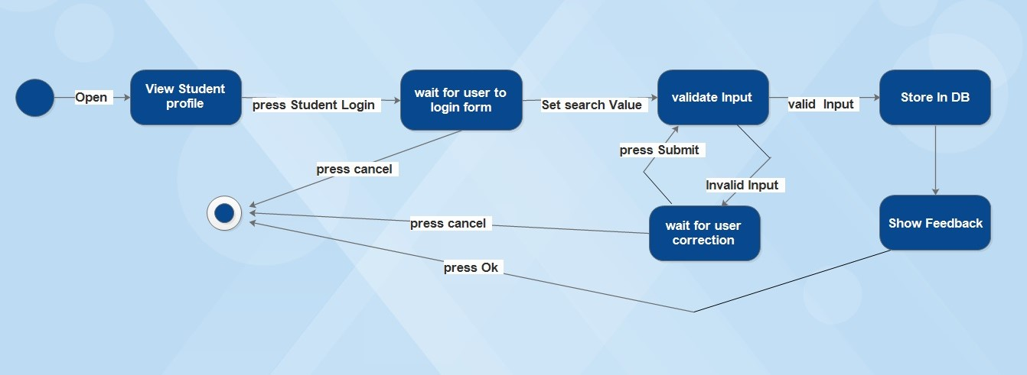

#### 3.1.4.1 View student courses

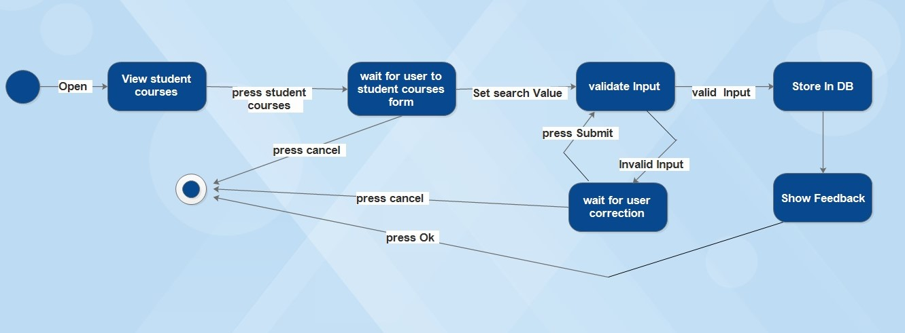

#### 3.1.4.2 View student Score

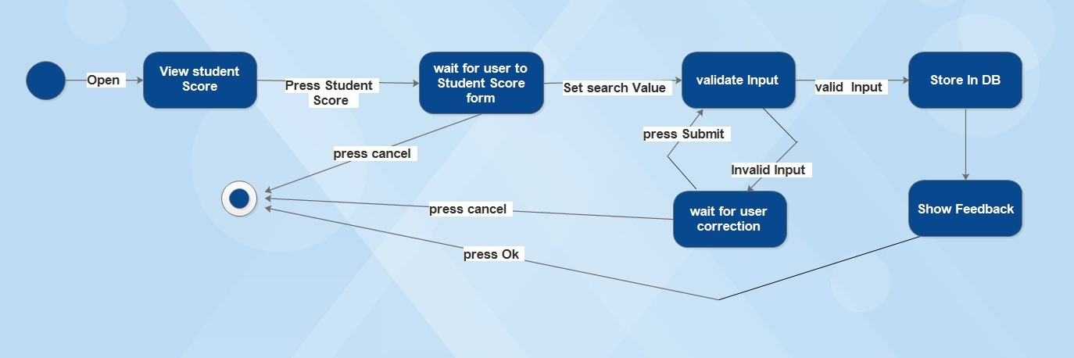

## 3.2 Usability

The normal users who do not have the required level of computer knowledge will need only basic system training because of the system GUI website is the same of standards GUI of Microsoft for Windows. System administrators, who are responsible for users of the system, database synchronization and database backup, will have training time and effort than normal user.

## 3.3 Reliability

Under normal working conditions, the system will be available at all times. But the system needs maintenance from time to time. These periods have to be announced and it's at out of working time.

## 3.4 Performance

### 3.4.1 Response Time

The average response time for each transaction should be around 1 second.

The maximum allowed time for a transaction must be less than 6 seconds.

### 3.4.2 Throughput

The system should be capable to perform 50 or more transactions per second.

### 3.4.3 Capacity

The system should be capable to handle more than 50 users simultaneously.

### 3.4.4 Resource Utilization

The system should run on a Pentium 4 processor with more than 5 GB as free memory with a minimum connection speed of a dial-up connection.

## 3.5 Design Constraints

N/A

## 3.6 Online User Documentation and Help System Requirements

N/A

## 3.7 Purchased Components

There will be no purchased components. The work will be done using the available resources given.

## 3.8 Interfaces

### 3.8.1 User Interface

The system should be in English. The application should be GUI based interface.

The following is the screen layout of the system:

### 3.8.2 Hardware Interfaces

The system should run on any hardware that supports Windows or any later versions or any system.

### 3.8.3 Software Interfaces

The system will interface with Microsoft SQL Server and webserver.

### 3.8.4 Communications Interfaces

The communication will be using a internet network.

## 3.9 Licensing Requirements

N/A

## 3.10 Legal, Copyright and Other Notices

N/A

Student Hands

Higher technical education system

‏1439

# 1. INTRODUCTION

## 1.0 Purpose

The purpose of this document is to analyze and define software detailed design of Student Hands System (SHs). It focuses on how the capabilities needed by the stakeholders, and the users will be implemented in design. This document will be used by the development team as a reference and it will be helpful in implementing this system.

## 1.1 Scope

This software design description document applies to Higher Technical Education System (HTE). The system will be initially developed to be self-contained system and it will be used to manage the information in general including Students and Teacher’ information and students’ score.

## 1.2 Definitions, Acronyms and Abbreviations

SHs: Student Hands System

SRS: Software Requirement Specification

## 1.3 References

1. SHs Software Requirement Specification document (SRS).
2. IEEE Recommended Practice for Software Design Descriptions

## 1.4 Overview

This document contains all needed information regarding the software design for SHs starting with an overall description of it then moving towards detailed design then user interface design will be described.

# 2. SYSTEM ARCHITECTURE



## 2.0 Data Detailed Design

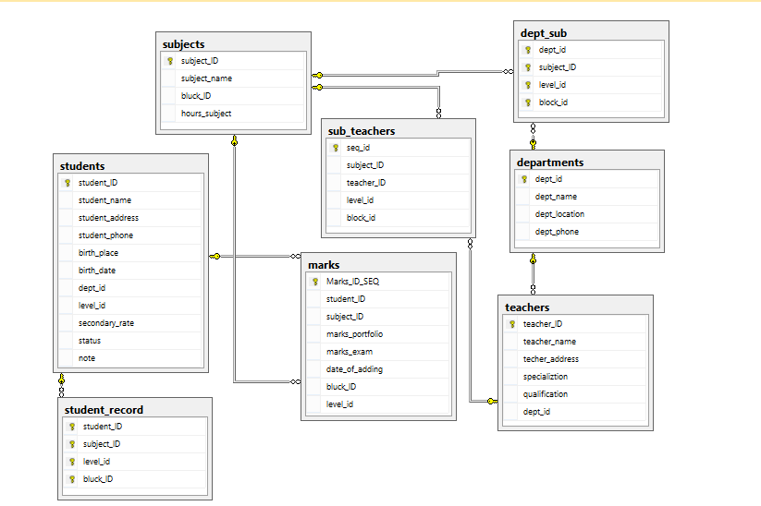

Student Hands

Higher technical education system

‏1439

# 1. Introduction

This User Manual document describes the operation of The SHs (Student Hands System) software to be delivered to Higher Technical Education (HTE).

## 1.0 Description

1. Functional architecture

The Student Hands System (SHs) is a PC-based program, which provides for the following functions:

* Administration of the users of the system.
* Management of the center Teacher and their information.
* Management of the Students and their information.

The program has the following features:

* It has a Microsoft Windows-based graphical user interface;
* The program will be deployed on several workstations attached to the Network Internet.

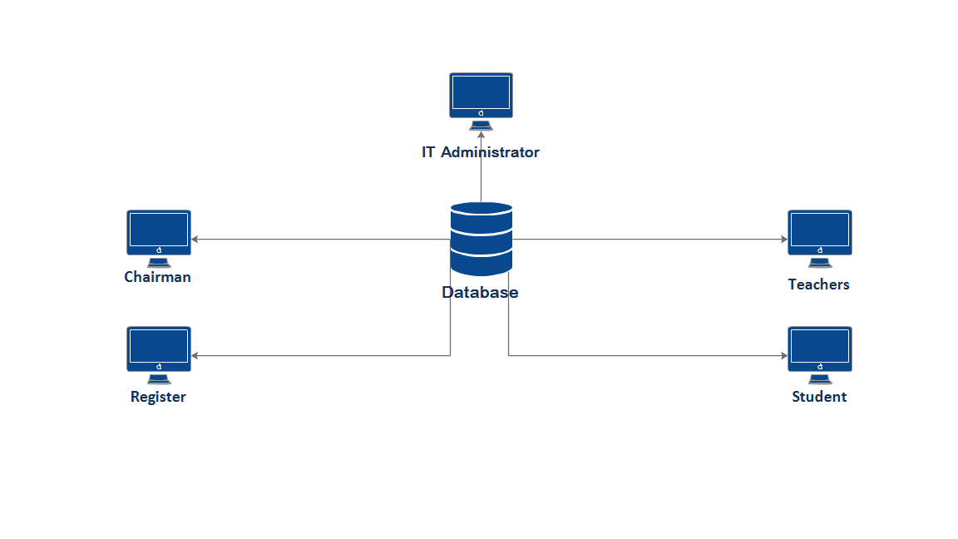

# 2. Student Hands System

**1. The infrastructure of the students' hands system**

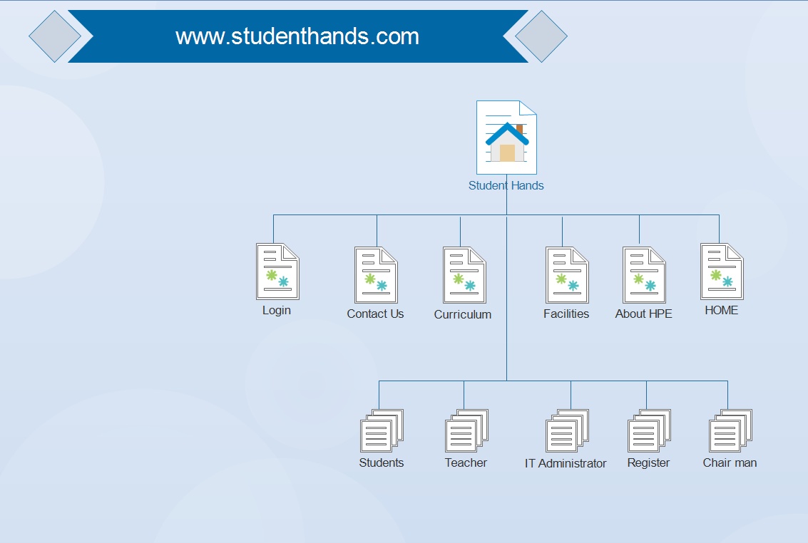

صور عامه للموقع

**2. Startup**

After startup of the SH website, the following dialogue will appears.

صورة login

The User will write his own user name and password then press ok button the system will open the form that is related to the Admin only.

صورة لتعبه بيانات تسجيل الدخول

## 2.0 Chairman

صورة لصفحة رئيس القسم

1. Manage Teachers

A list of Teacher and add new Teacher will be displayed first in the stuff tag. When you need to add new Teacher, first just press add new symbol and then fill the fields that are shown in the stuff tag and then press save button. When you need to list of Teacher, first just press list of Teacher and in search value.

صورة

1. Mange Courses

A list of Subject and add new Subject will be displayed first in the stuff tag. When you need to add new Subject, first just press add new symbol and then fill the fields that are shown in the stuff tag and then press save button. When you need to list of Subject, first just press list of Subject and in search value.

صورة

1. Assing Courses To Teacher

A list of The Teacher Subject and Add New Teacher into Subject will be displayed first in the stuff tag. When you need to add new Subject, first just press add new symbol and then fill the fields that are shown in the stuff tag and then press save button. When you need to list of The Teacher Subject, first just press list of Subject and in search value.

صورة

1. Score Update

A score Update students, first just press add to student ID, in search value and press button search.

صورة

1. Students Move To Block

A Students Move To Bluck , When you need to Moving the student from Bluck to Bluck enter the students ID, then press department, level and level then show the student file. Then and press enter student ID and press the enroll student.

صورة

## 2.1 Register

صورة لصفحة المسجل

1. Manage Students

A student form list and add new student will be student displayed first in the stuff tag. When you need to add new student, first just press add new symbol and then fill the fields that are shown in the stuff tag and then press save button. When you need to student form list, first just press student form list and in search value then press search button, then show student profile. When you need to edit, first just press the edit symbol and then fill the fields that are show in the stuff tag and then press save button.

صور

1. Student Move TO Level

A Students Move To level, when you need to Moving the student from level to level enter the students ID, then press department, level and level then show the student file. Then and press enter student ID and press the enroll student.

صورة

1. Students Transcript

A Students Transcript will be displayed first in the stuff tag. First, just press enter student ID and level when press search button show the student scores.

صورة

## 2.2 IT Administrator

صورة لصفحة الادمن

1. Listing User's Accounts of the System:

1. When you want to list the Chairman of the system, press Chairman Button in the Users tap.
2. When you want to list the Register users, press Register button in the Users tap.
3. When you want to list the Teachers user, press Teachers button in the Users tap.
4. When you want to list the Students users, press Students button in the Users tap.
5. When you want to list the all Admin users, press Admin button in the Users tap.
6. Searching in Users Account
   1. First Choose the search filed from search filed drop down list. You can search in users using either User ID or User Name.
   2. Write the search value in Search Value text box. If the search value is User ID, you need to write all the user ID not just part of it. If the search value is User Name just write substring of the user name and all matches will be retrieved.
   3. Press Search Button to see the result in the user accounts grid.
7. Add New User Account

* 1. Just press add new symbol or New User button.
  2. Choose user from the user combo box. If the user already has accounts all his account will be listed in the grid.
  3. Fill the fields that are shown in the User tap and then press save button.

1. Edit User Account
   1. Choose the user account from the user's accounts grid.
   2. Press Edit user button.
   3. The user information will be shown in the user information at the bottom. Change what you want to edit.
   4. Press save button on the left.
2. Delete User
   1. Choose the user account from user's account grid or try search for it if it is not visible.
   2. Press Delete User button.
   3. Press Save button.
3. Reset User Password
4. Choose the user from user account grid by pressing once on it. If the user account is not visible, try to search first to find it.
5. Press Reset Password button in the user information at the bottom. 3- Press save button. The user then can access the system using 'adcs' as his password.

## 2.3 Teachers

صورة لصفحة المدرس

1. Teacher Profile

A Teacher Profile, when recording the login show the teacher profile.

صورة

1. Manage Score

A list of The Scores and Add New Score will be displayed first in the stuff tag. When you need to add Score, first just press add Score symbol and then fill the fields that are shown in the stuff tag and then press insert button. When list of The Scores, first just press scores list and then show list of the Scores.

صور

1. courses Details

Courses Details, when the teacher press courses details, show courses Details then, press select show all the students additional to courses.

صورة

## 2.4 Students

صورة بصفحة الطالب

1. Students Profile

A Student Profile, when recording the login show the Student profile.

صورة

1. Students' Scores

A Students' Scores will be displayed first in the stuff tag. First, just press enter student ID and level when press search button show the student scores.

صورة

1. Student Subject

Student Subject, when the student press Student Subject, show the Student courses Details then, press select show the subject scores.

صورة