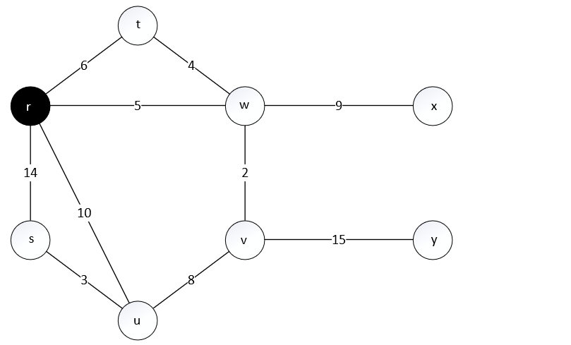

Prim Algorithm

|  |  |  |
| --- | --- | --- |
| Vertex | Key | Parent |
| R | **0** | **-** |
| S | 14 | R |
| T | 6 | R |
| U | 10 | R |
| V |  |  |
| W | **5** | **R** |
| X |  |  |
| Y |  |  |

1. 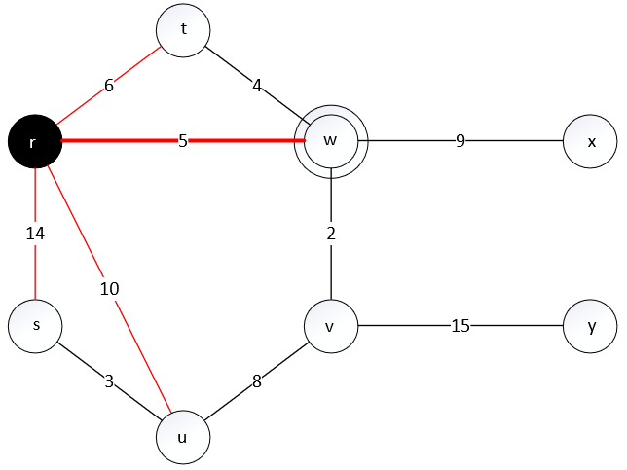

|  |  |  |
| --- | --- | --- |
| Vertex | Key | Parent |
| R | **0** | **-** |
| S | 14 | R |
| T | 4 | W |
| U | 10 | R |
| V | **2** | **W** |
| W | **5** | **R** |
| X | 9 | W |
| Y |  |  |



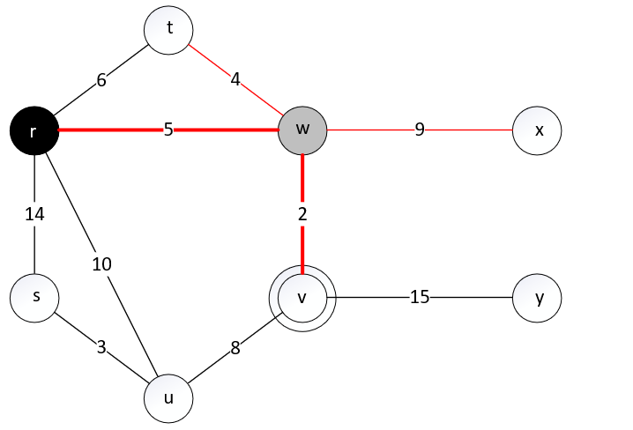

|  |  |  |
| --- | --- | --- |
| Vertex | Key | Parent |
| R | **0** | **-** |
| S | 14 | R |
| T | **4** | **W** |
| U | 8 | V |
| V | **2** | **W** |
| W | **5** | **R** |
| X | 9 | W |
| Y | 15 | V |

1. 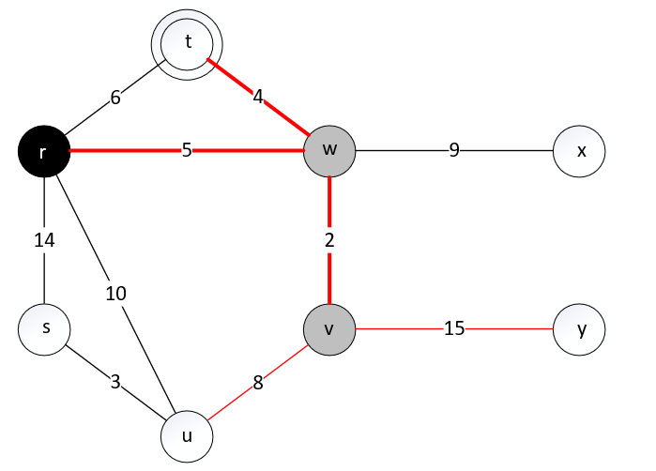

|  |  |  |
| --- | --- | --- |
| Vertex | Key | Parent |
| R | **0** | **-** |
| S | 3 | U |
| T | **4** | **W** |
| U | **8** | **V** |
| V | **2** | **W** |
| W | **5** | **R** |
| X | 9 | W |
| Y | 15 | V |

1. 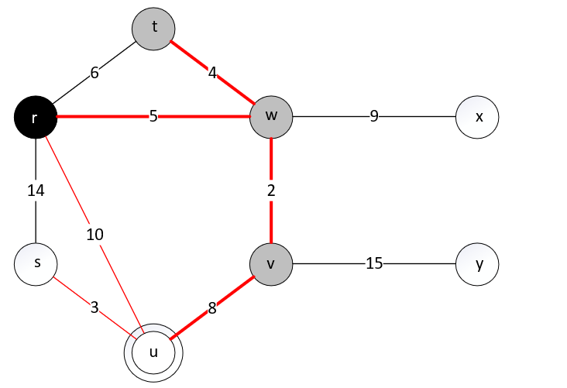

|  |  |  |
| --- | --- | --- |
| Vertex | Key | Parent |
| R | **0** | **-** |
| S | **3** | **U** |
| T | **4** | **W** |
| U | **8** | **V** |
| V | **2** | **W** |
| W | **5** | **R** |
| X | 9 | W |
| Y | 15 | V |

1. 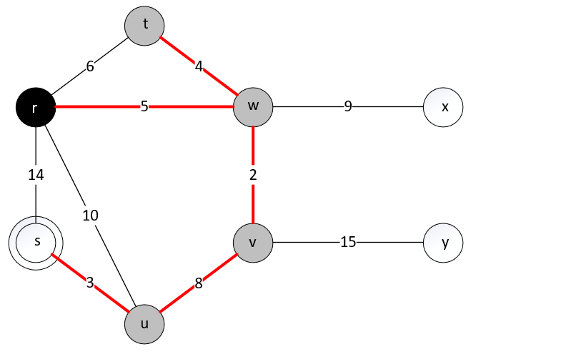

|  |  |  |
| --- | --- | --- |
| Vertex | Key | Parent |
| R | **0** | **-** |
| S | **3** | **U** |
| T | **4** | **W** |
| U | **8** | **V** |
| V | **2** | **W** |
| W | **5** | **R** |
| X | **9** | **W** |
| Y | 15 | V |

1. 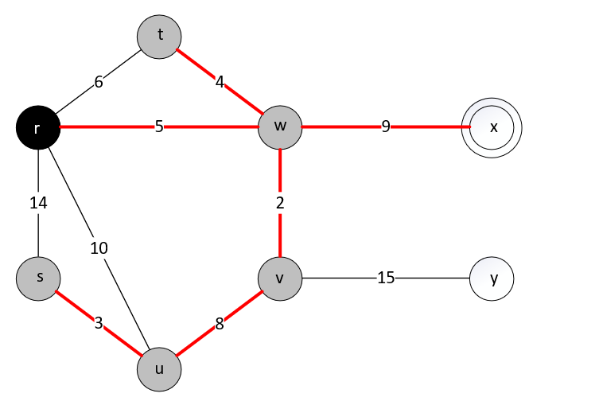

|  |  |  |
| --- | --- | --- |
| Vertex | Key | Parent |
| R | **0** | **-** |
| S | **3** | **U** |
| T | **4** | **W** |
| U | **8** | **V** |
| V | **2** | **W** |
| W | **5** | **R** |
| X | **9** | **W** |
| Y | **15** | **V** |

1. 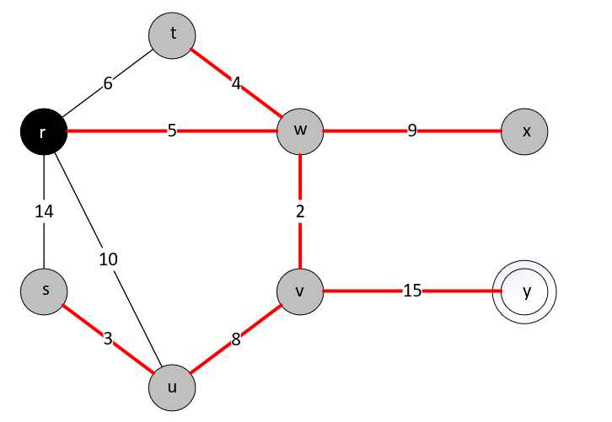
2. Result

