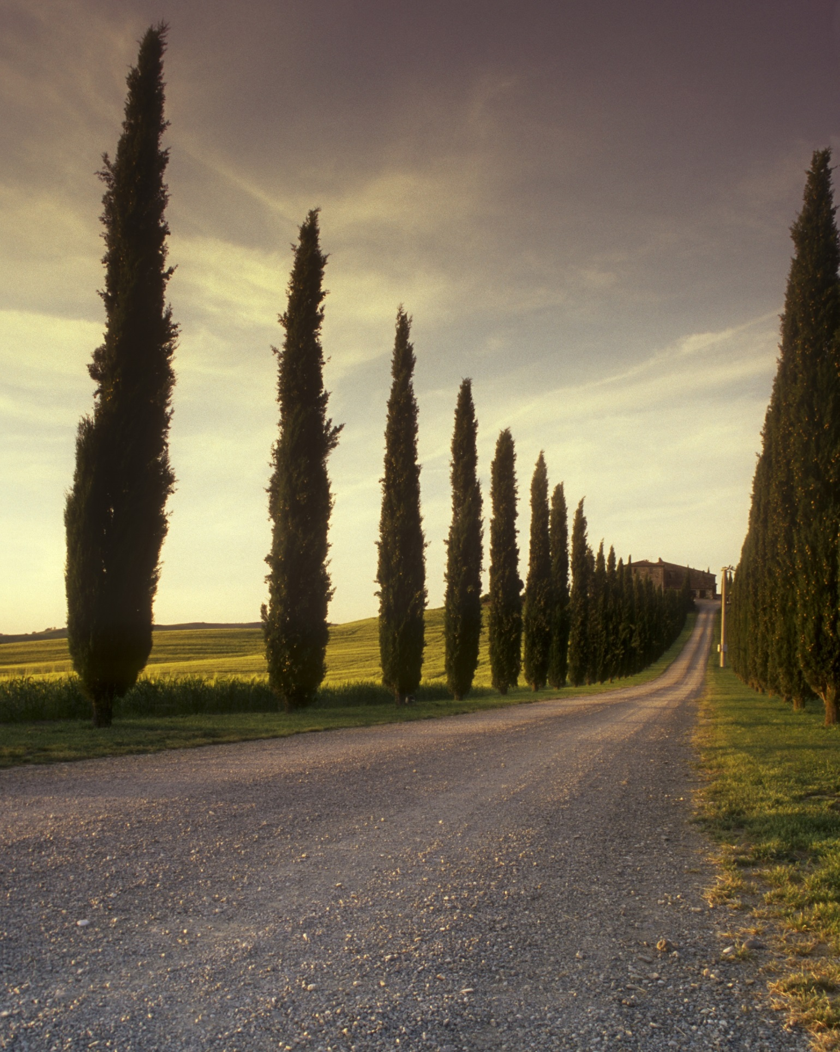 | Groups names:  Fahmida,  Saira,  Zara  SapID:5000000393  SapID:5000000374  SapID:5000000396  Database: assignment 01.  Dept. mmg.

