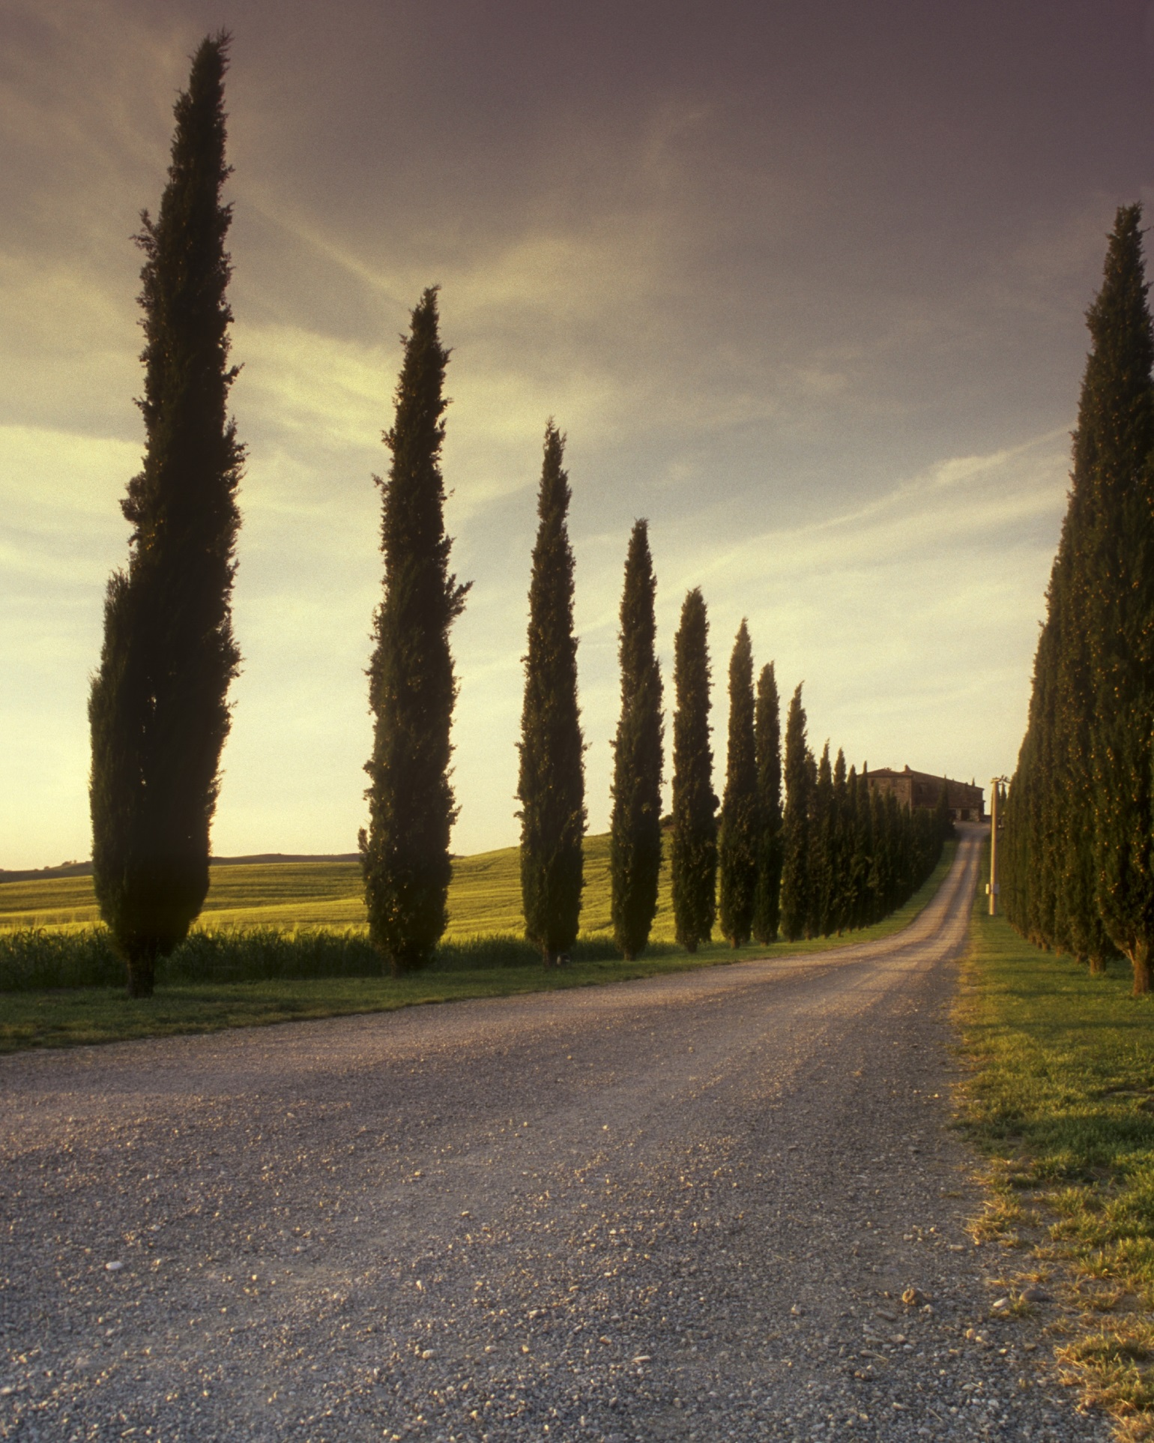 | LAB 03  Database system  name fahmida  sap _id 5000000393  dept :mmg

- UPPER() Function
Task 01
Convert all first names to uppercase.
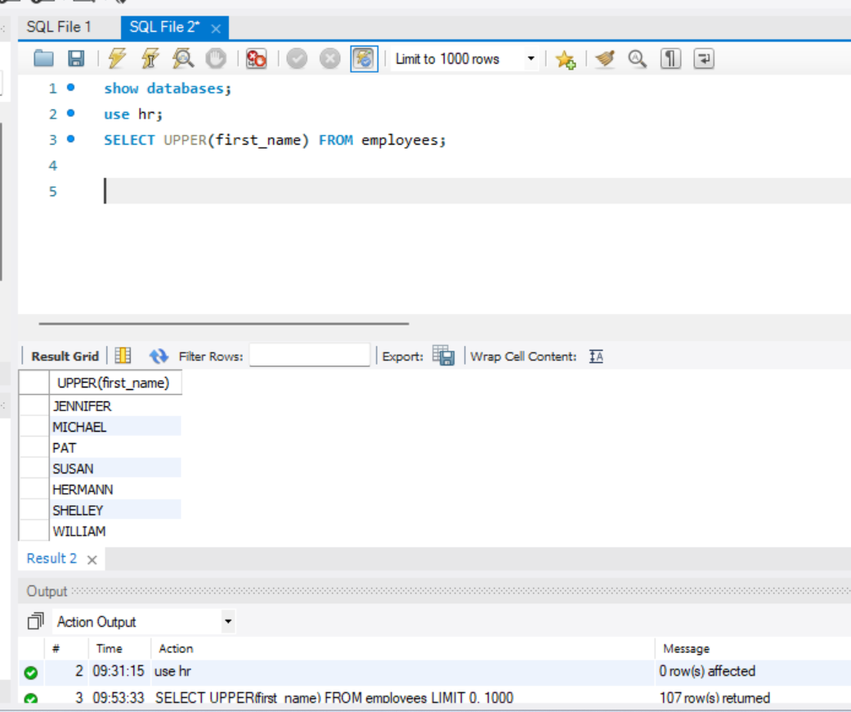

Task 02
Show employee full name in uppercase.
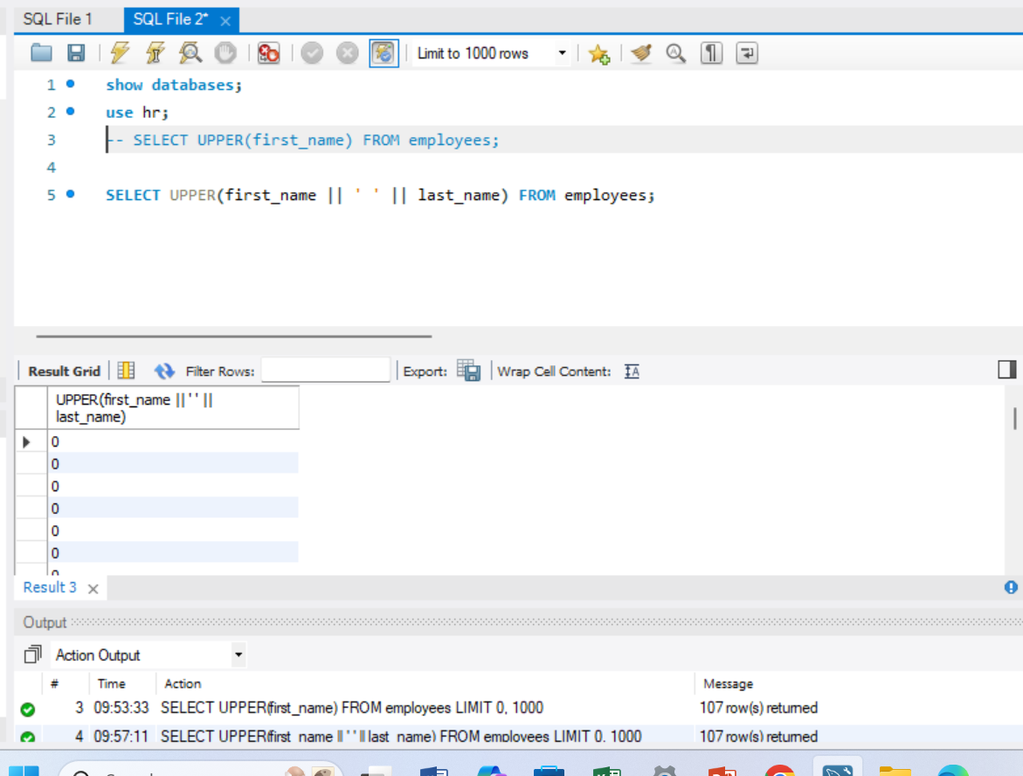

Task 03.
Display uppercase department names
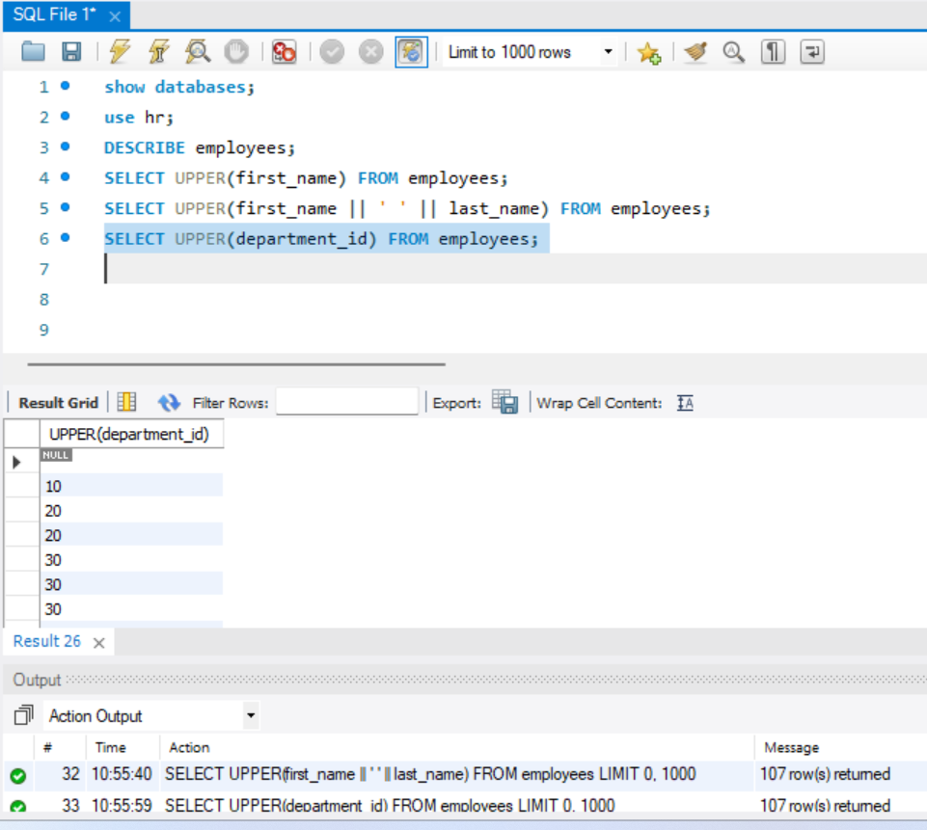

Task 04.
Find employees whose uppercase department is ‘SALES’


Task 05.
Convert email IDs to uppercase
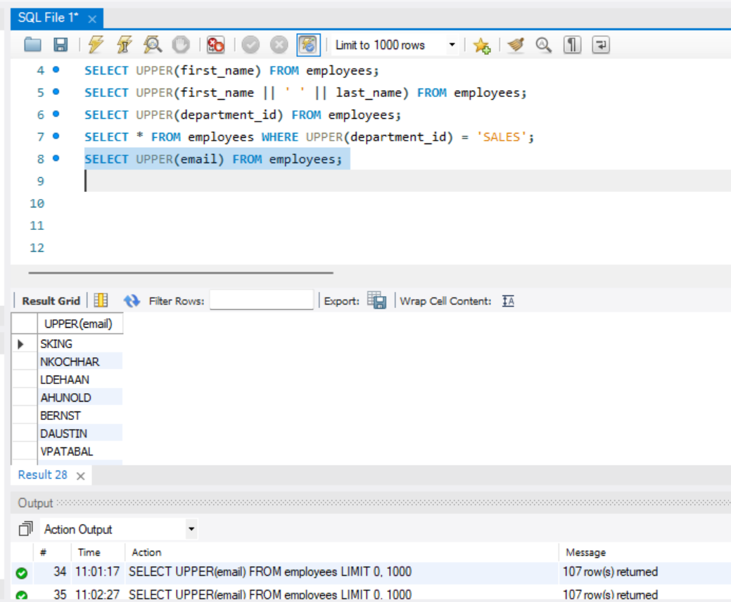

Task 06
6. Compare department ignoring case
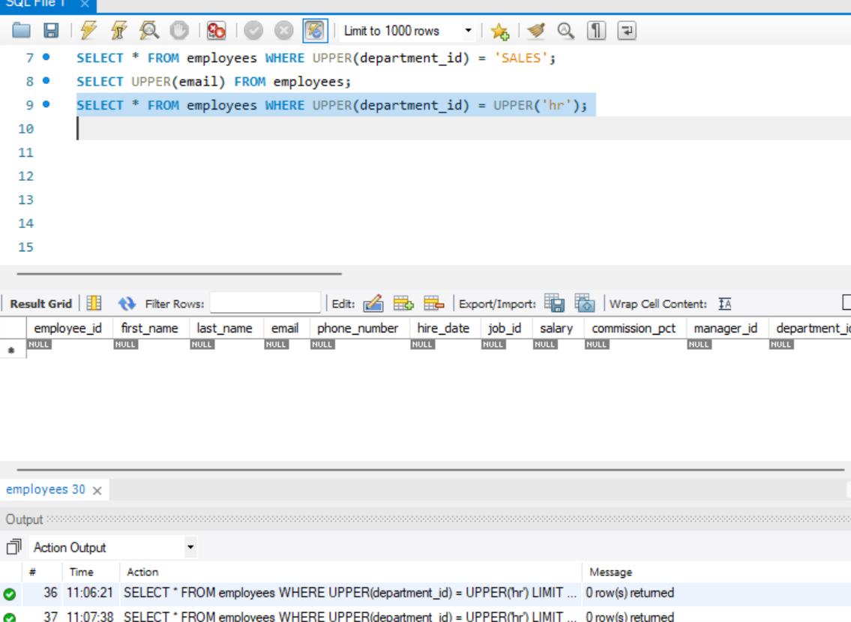

Task 07.
Display uppercase last names ordered alphabetically
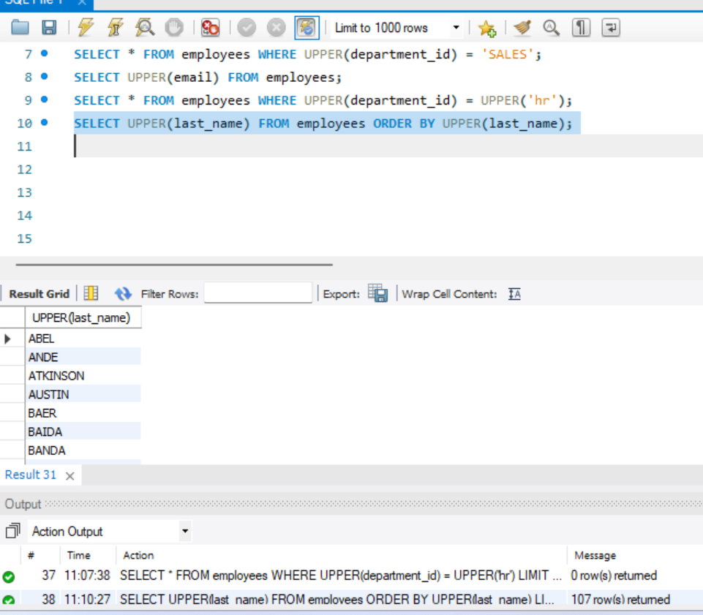

Task 08.
Show uppercase first names for employees with salary > 50000
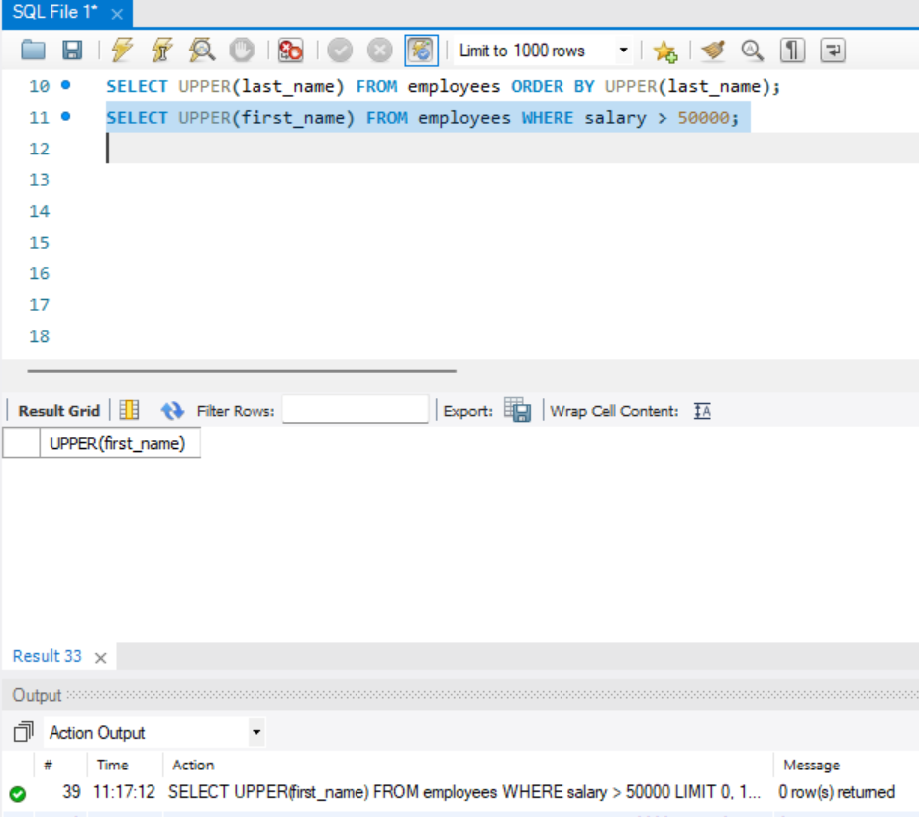
Task 09
9. Replace mixed case department values with uppercase
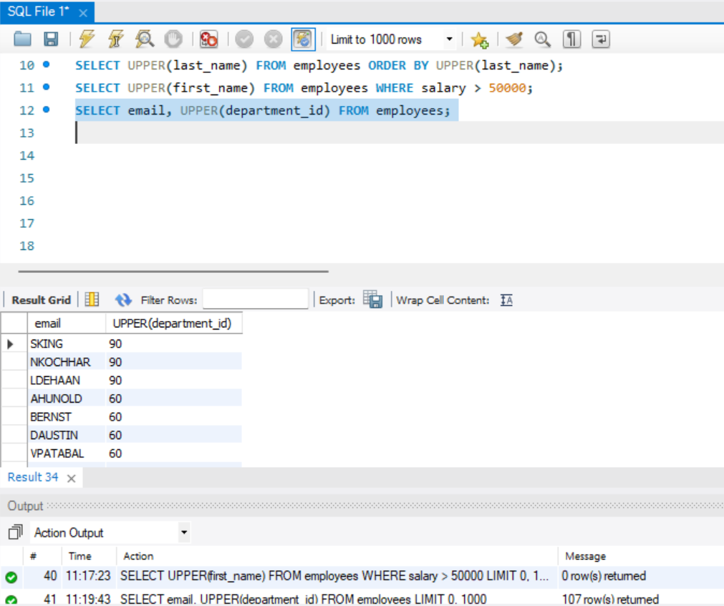

Task 10.
Count employees per uppercase department
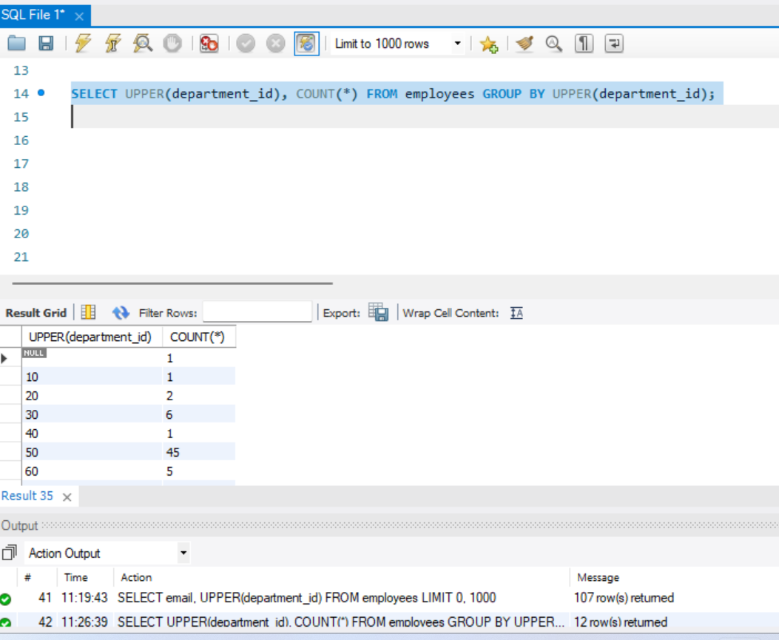

- LOWER() Function
Task 01
- Convert all last names to lowercase

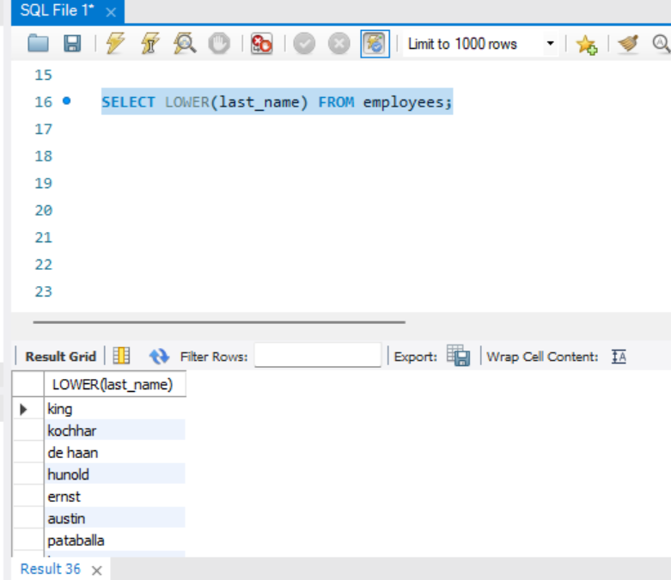

Task 02
Display emails in lowercase
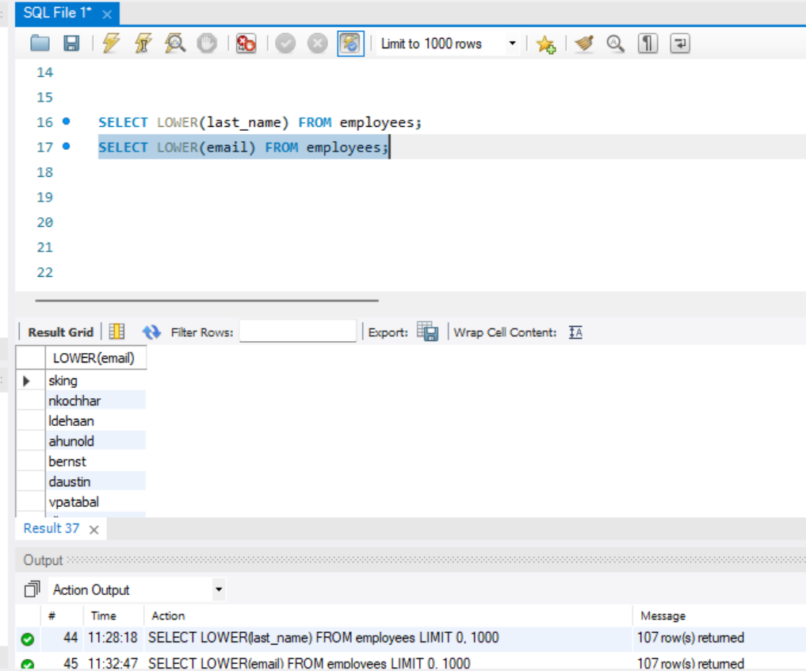

Task 03
- Compare department names case-insensitively
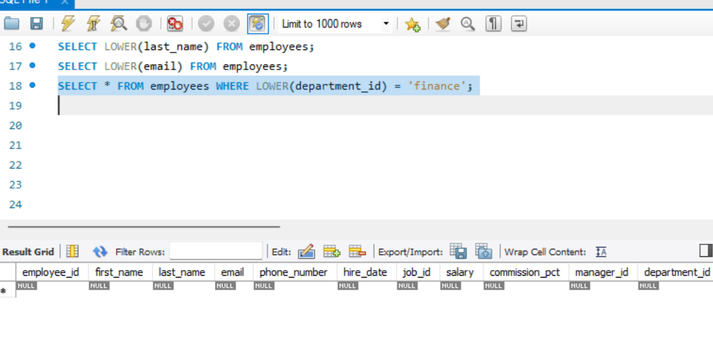

Task 04.
Show lowercase full names
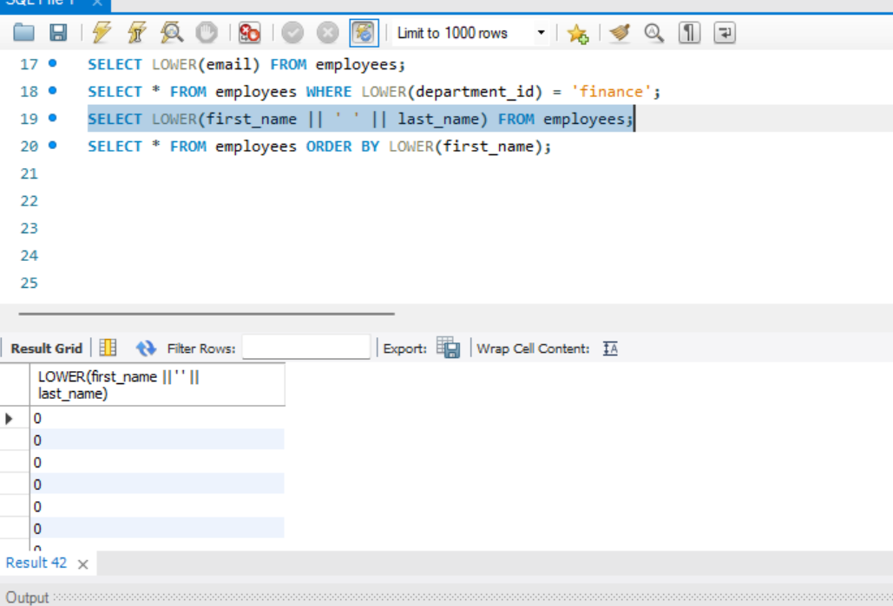
Task 05
- Order employees by lowercase first name
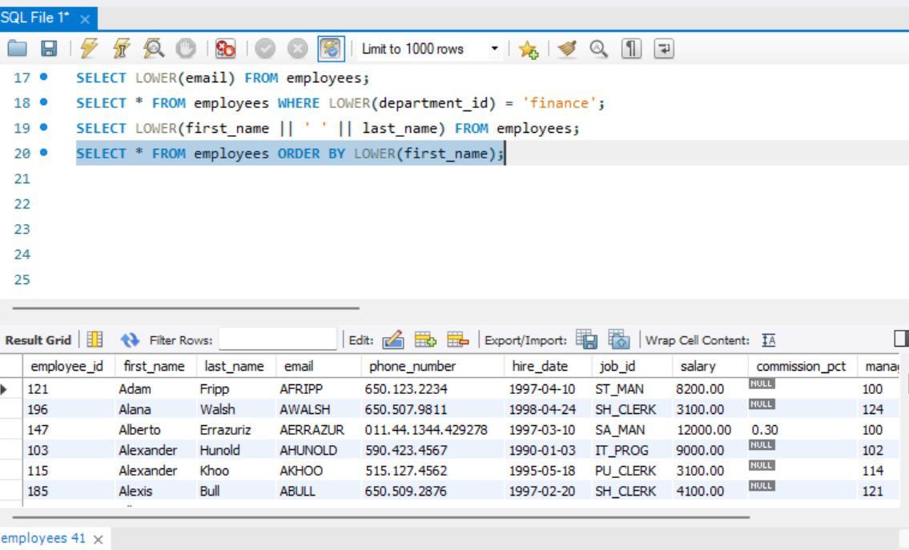

3.LENGTH() Function
Task 01
- Find length of each first name
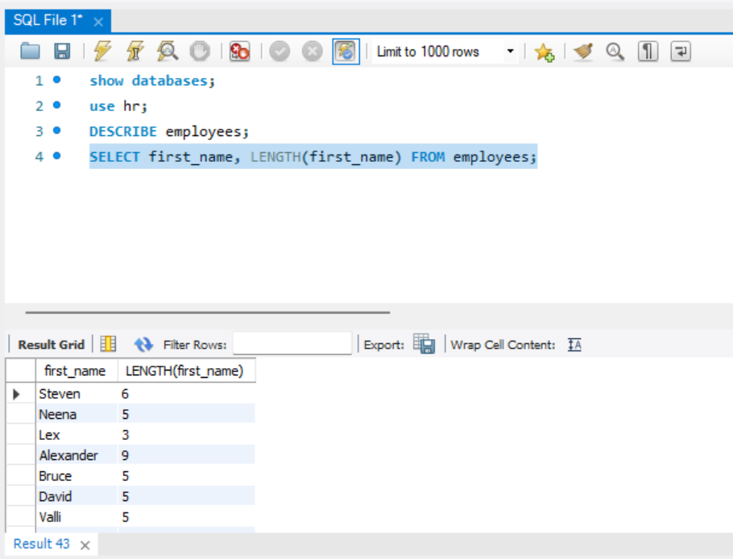

Task 02
- Show employees with last name longer than 6 characters
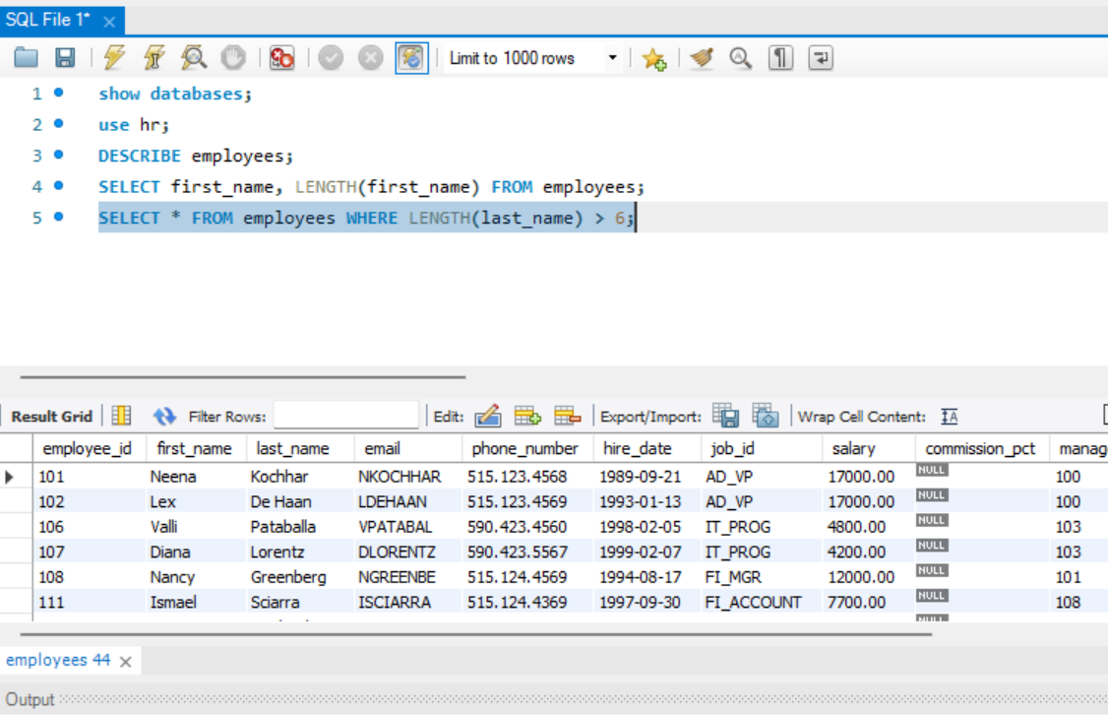

Task 04
- Find employees whose department name length is 5
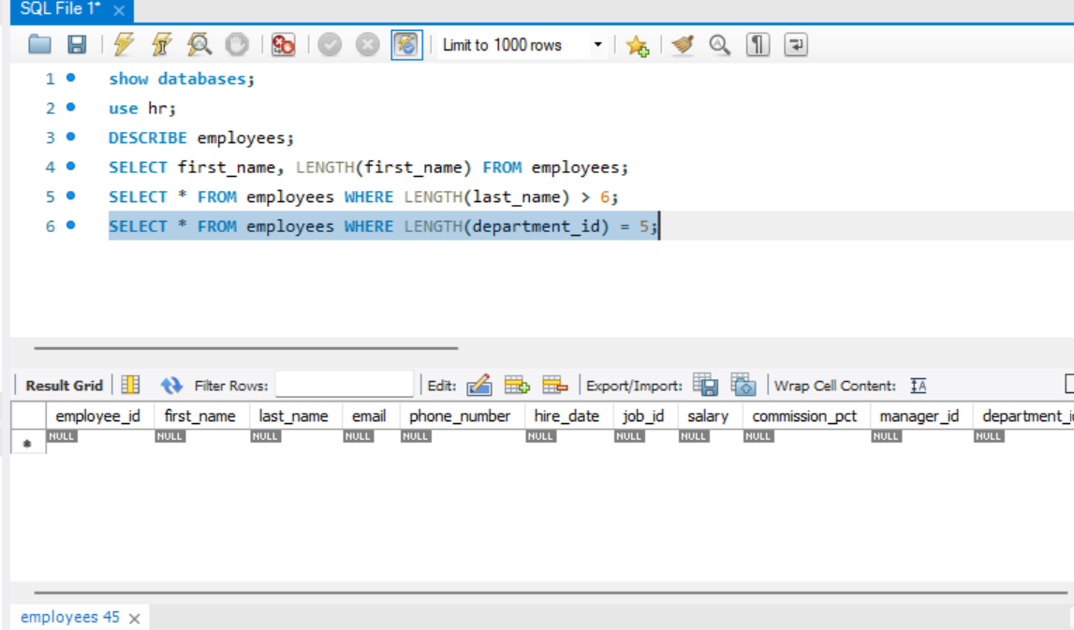

Task 06
6.Count employees with first name length > 4
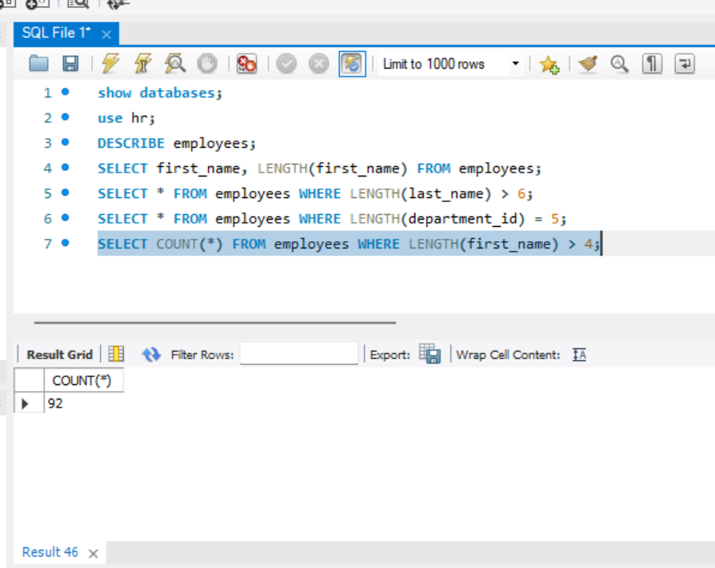

4.SUBSTRING() / SUBSTR() Function.
Task 01
- Extract first 3 characters of first name
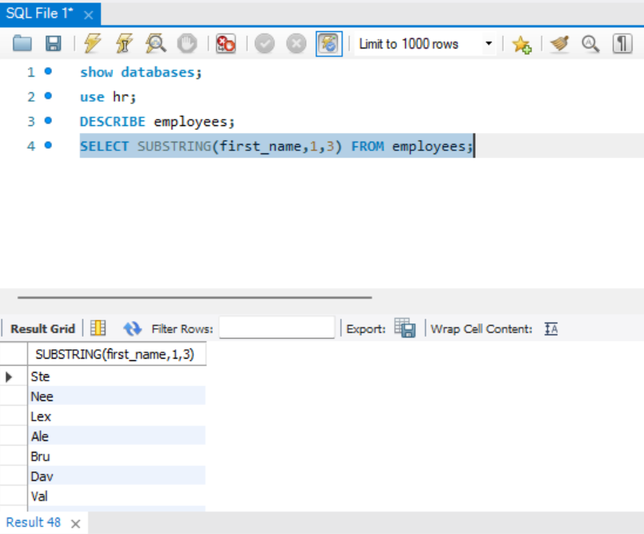

Task:02
- Get domain name from email
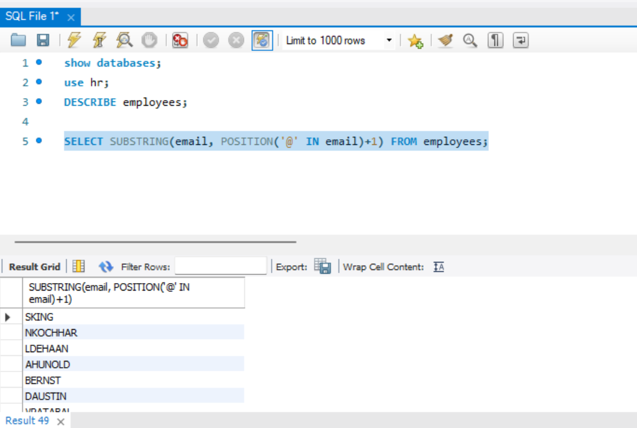

Task: 04
4. Display first letter of last name
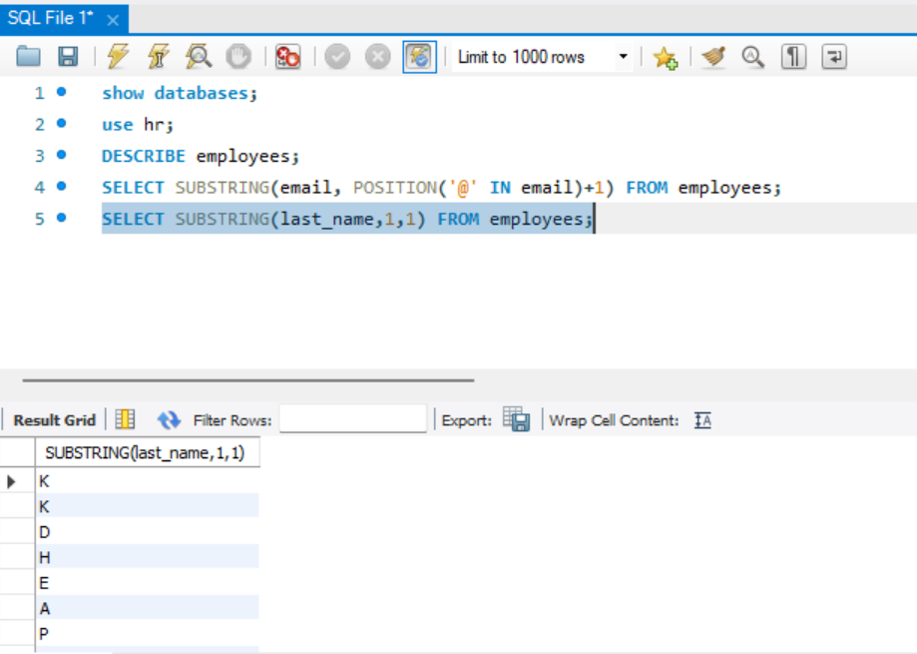

Task: 05
- Extract first 5 characters of department
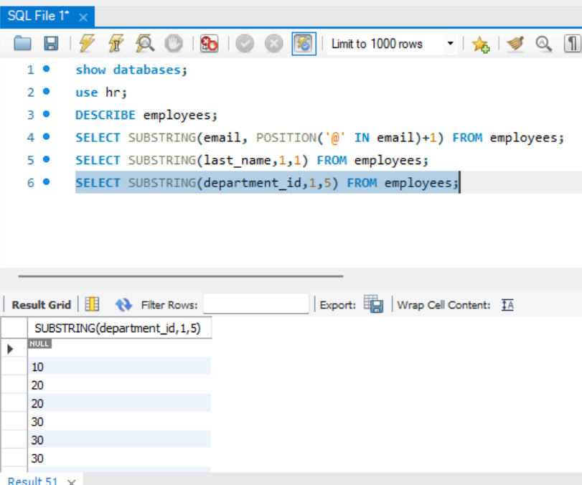

Task 07.
7. Extract characters from position 2 to 4 in first name
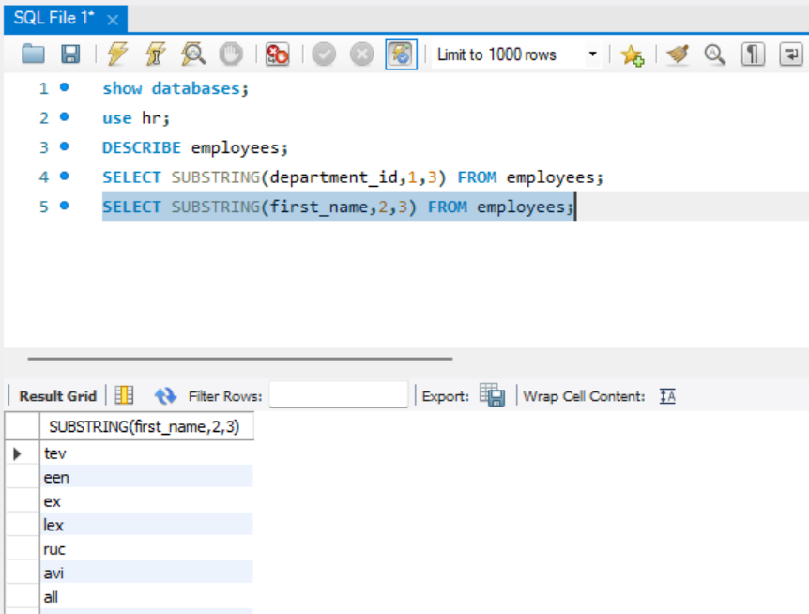
- ROUND() Function
Task: 01
- Round salary to nearest integer
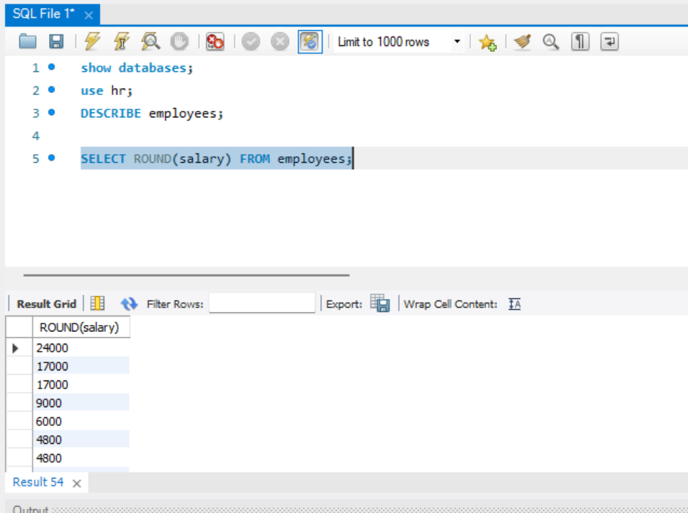

Task 02.
- Round salary to 2 decimal places

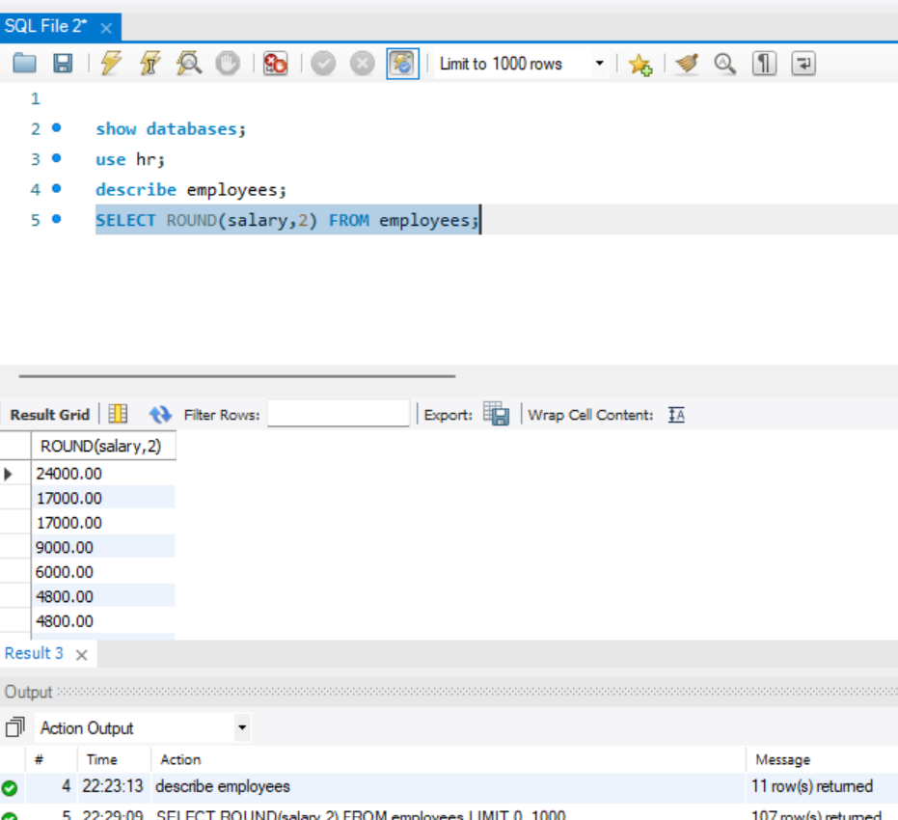
Task 03
- Increase salary by 10% and round
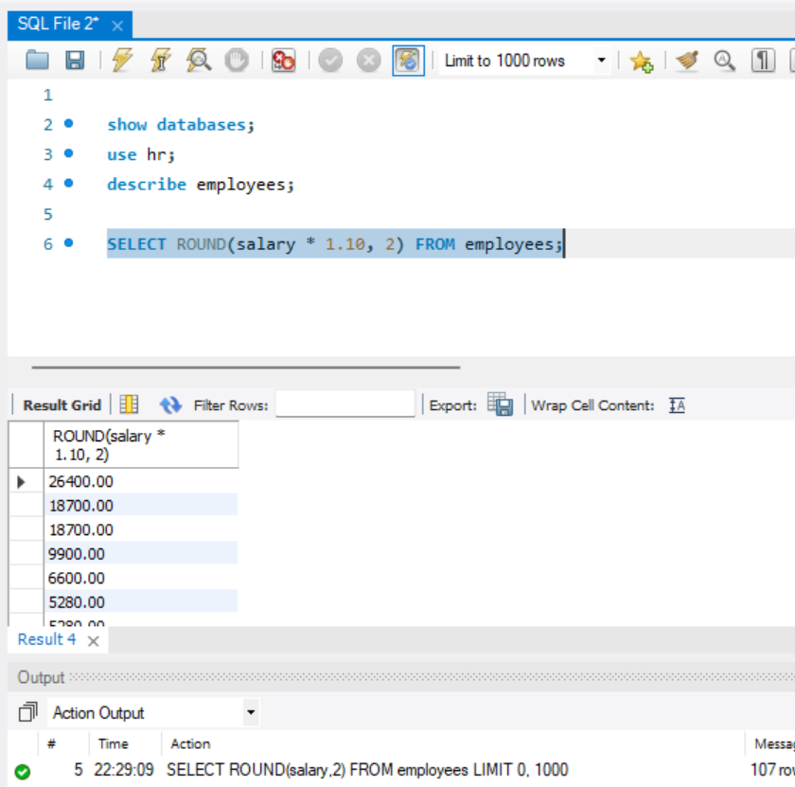

Task 04
- Round average salary
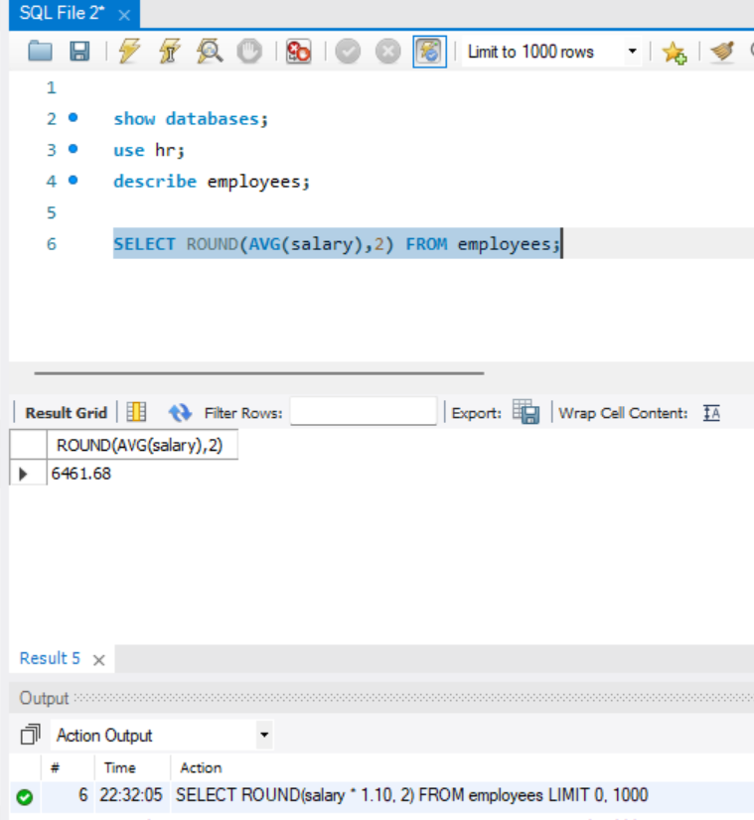

Task 05
- Round salary divided by 3
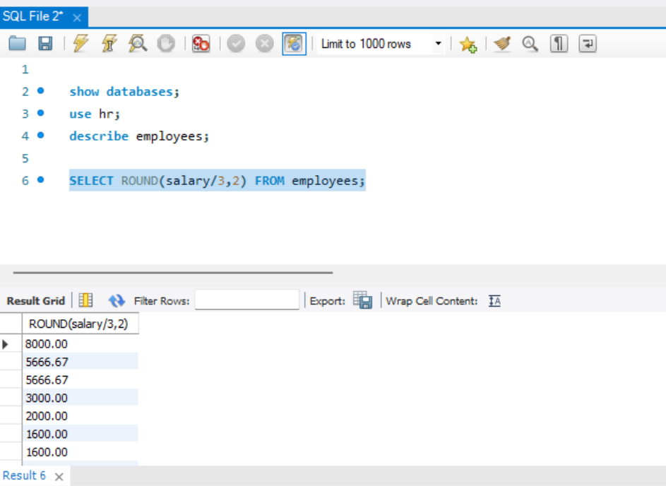

- COUNT() Function.
Task 01
- Count total employees
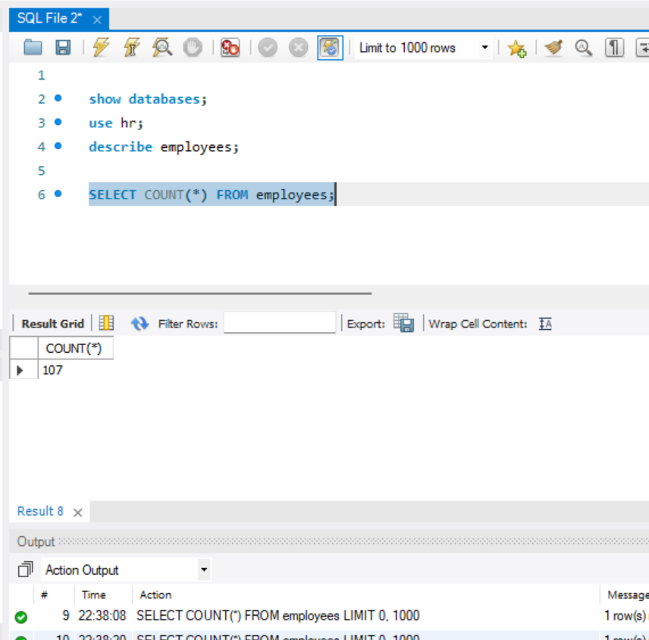

Task 02
- Count employees per department
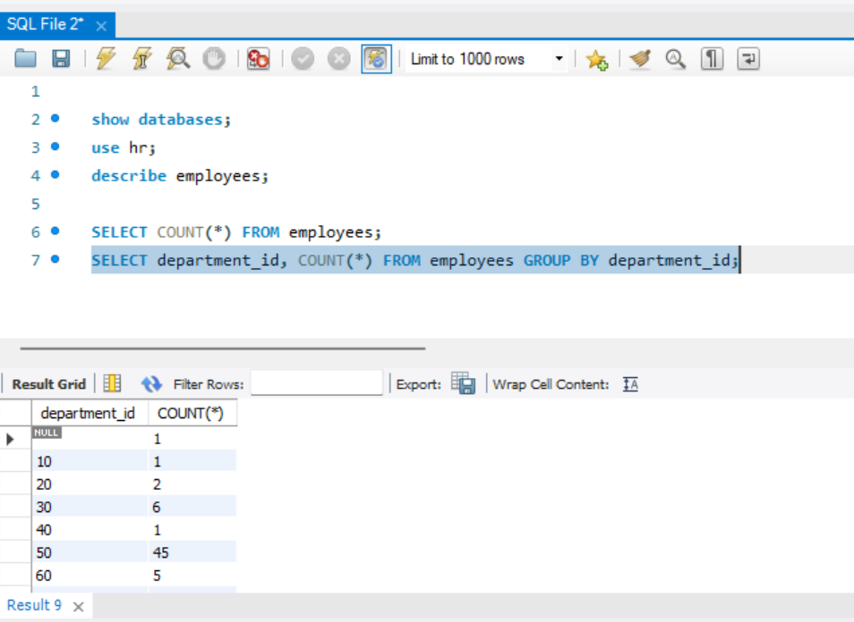

Task 03
- Count employees with salary > 60000
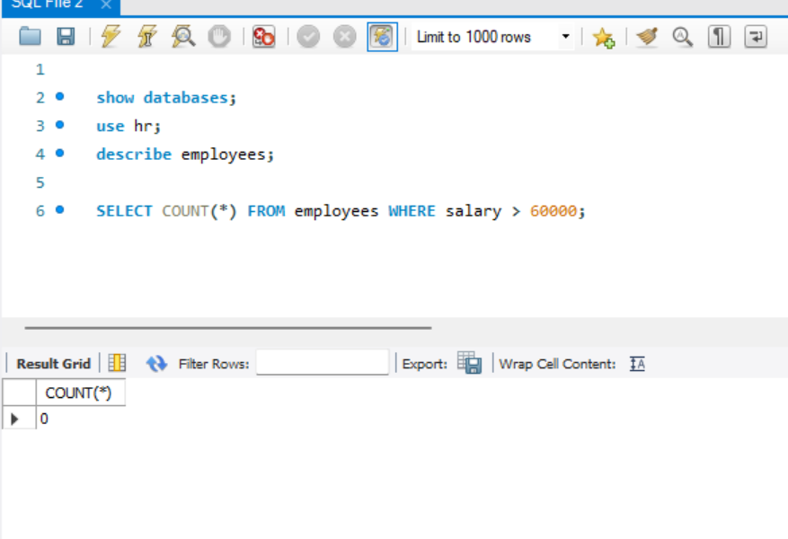
Task 04
- Count distinct departments
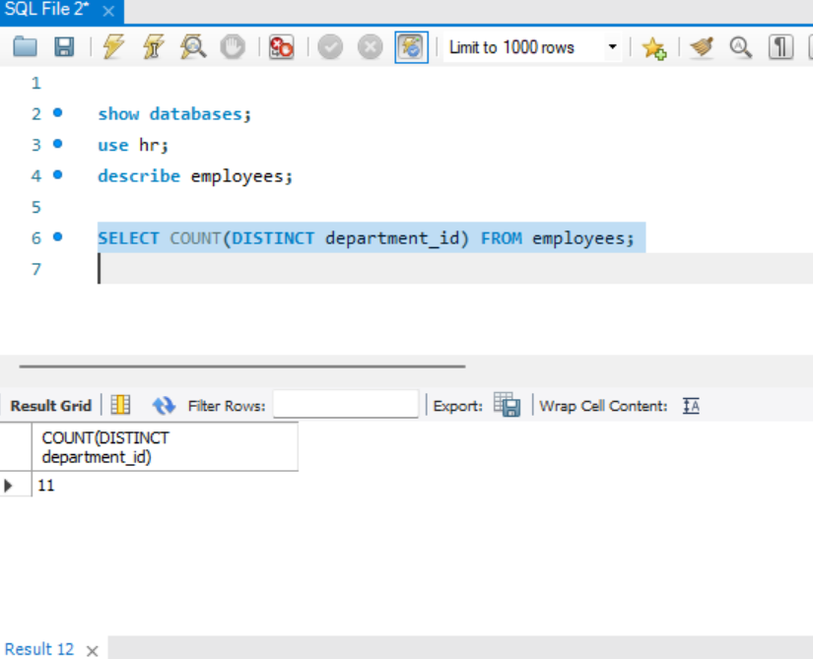

Task 05
- Count employees hired after 2020
