 | LAB 07  DATABASE SYSTEM  NAME : FAHMIDA  SAP_ID 5000000393  DEPT: MMG

Types of Subqueries
1. Single-row subquery
A single-row subquery returns one value and is used with operators like =, >, <, >=.
1. Calculate average salary from employees.
2. Compare each employee salary with the result.
3. Display matching records.
Grater then
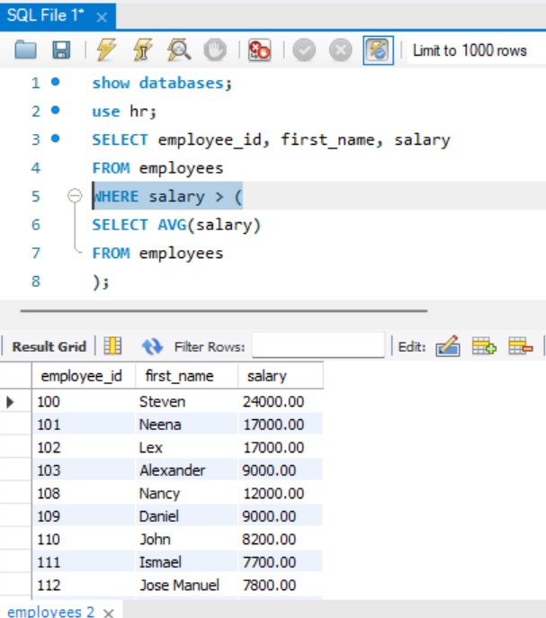

Equal
Less then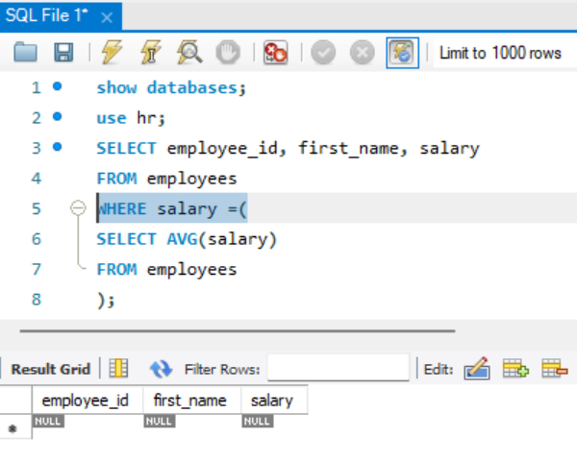

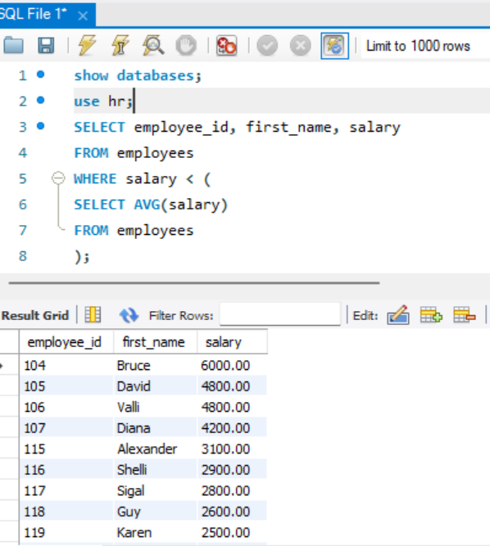
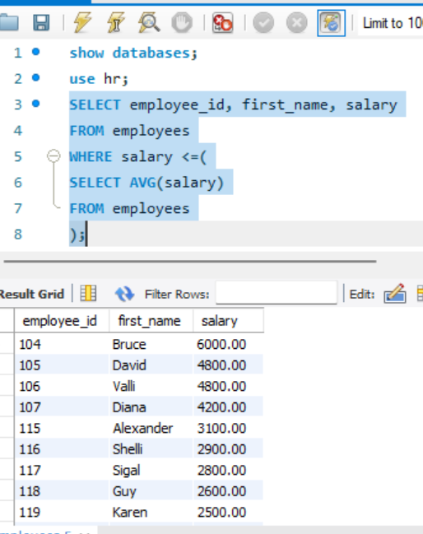
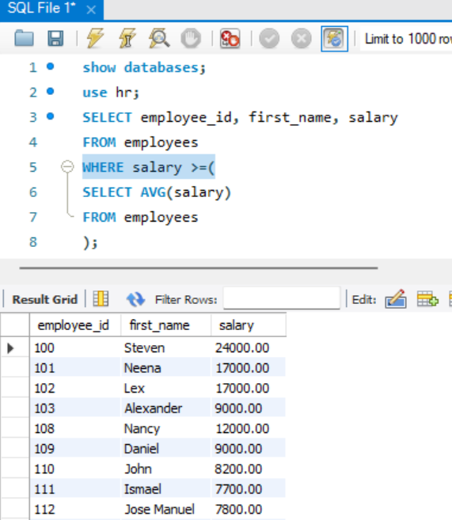

2: Multiple Row Subquery (IN, ANY, ALL)
1. Retrieve department_id of IT department.
2. Match employees whose department_id exists in that result.
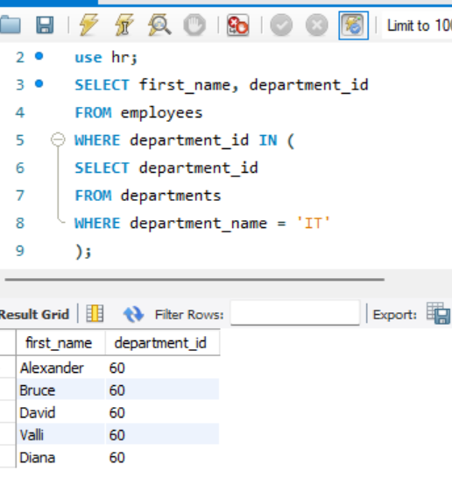
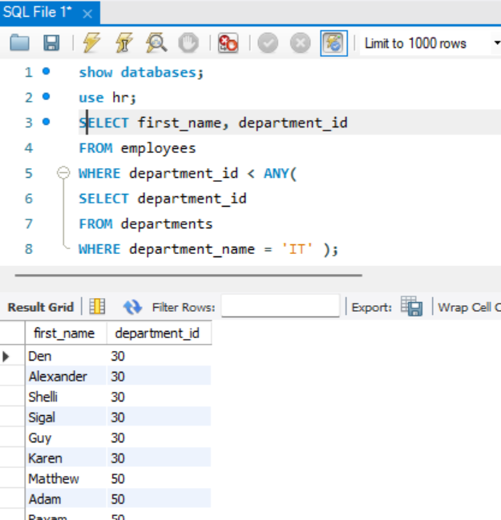
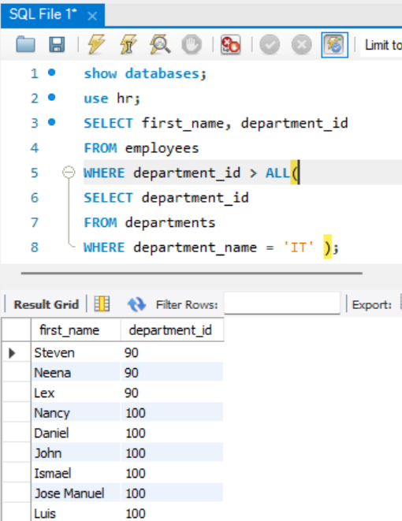
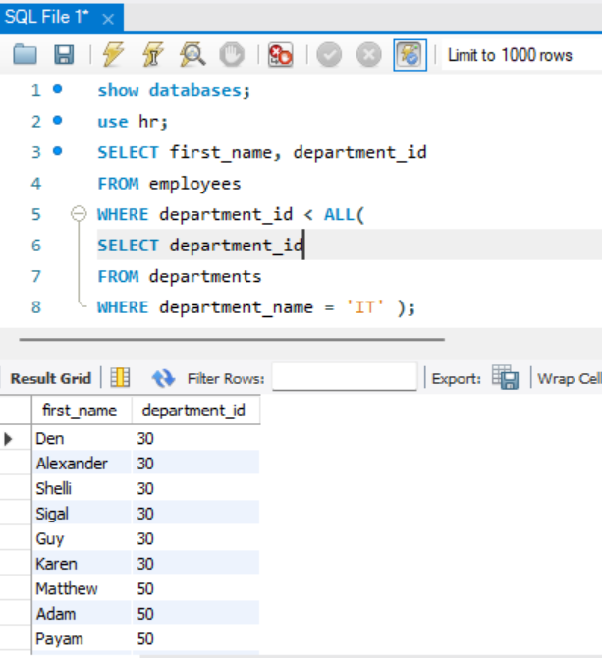

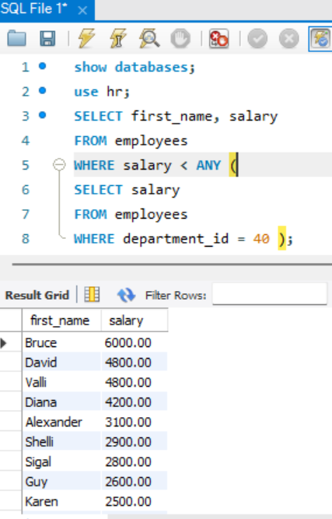

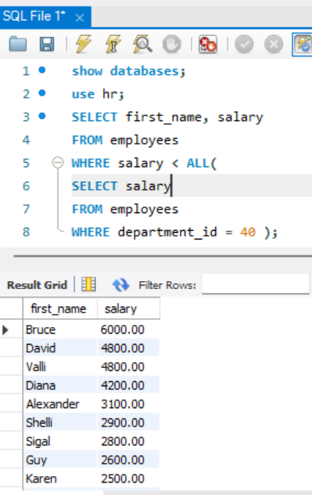
3: Correlated Subquery
1. For each employee, calculate department average salary.
2. Compare employee salary with department average.
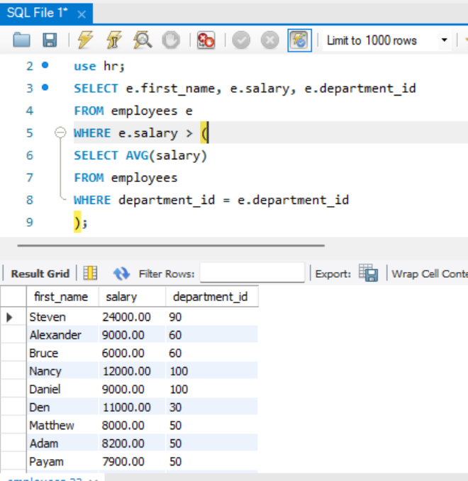

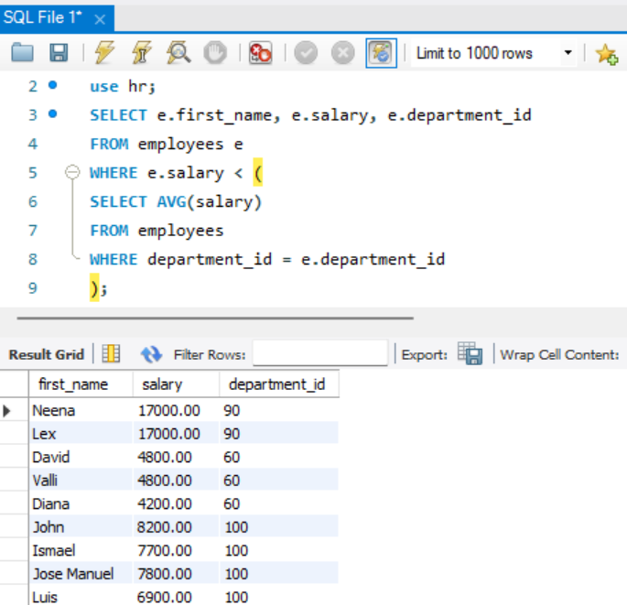

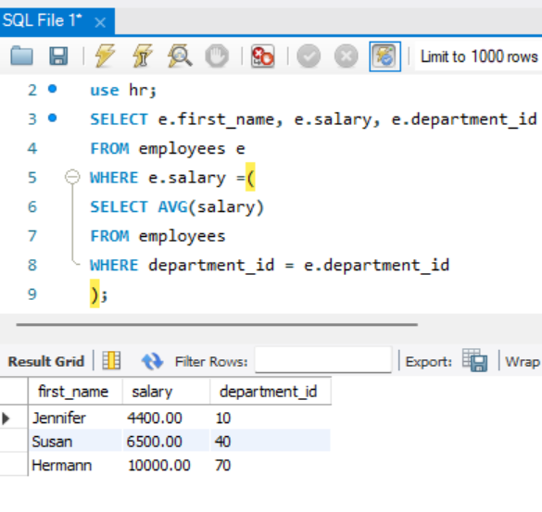

4: EXISTS Subquery
1. Check if department has employees.
2. Display only such departments.
