 | lab 06  Database system  name: fahmida  sap_id 5000000393  dept: mmg

Lab task 01
Task 01. Display employee name and job title.
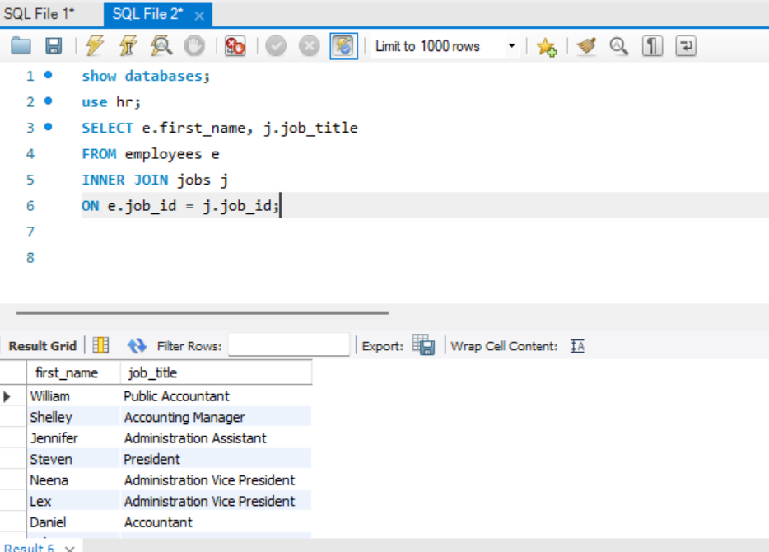
Task 02. Display department name and city. 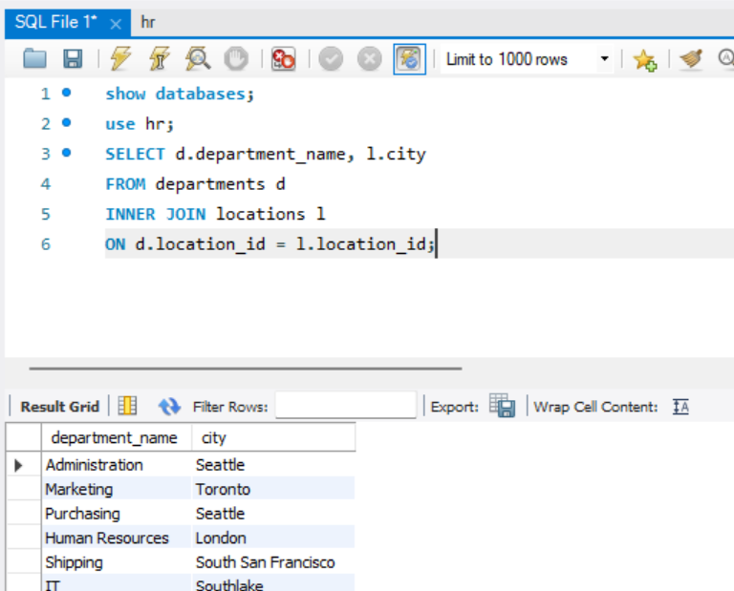

Task: 03 List employees with salary greater than 5000 along with department name.
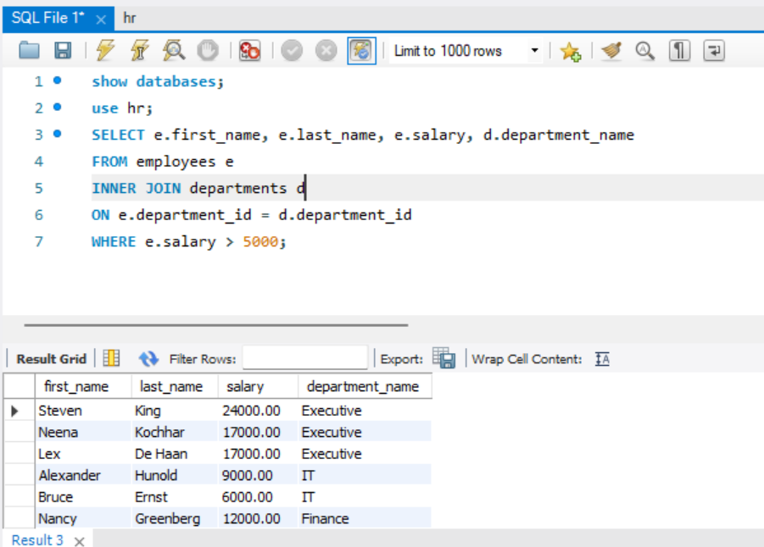

Lab Task 2
- Show all departments and employees working in them.
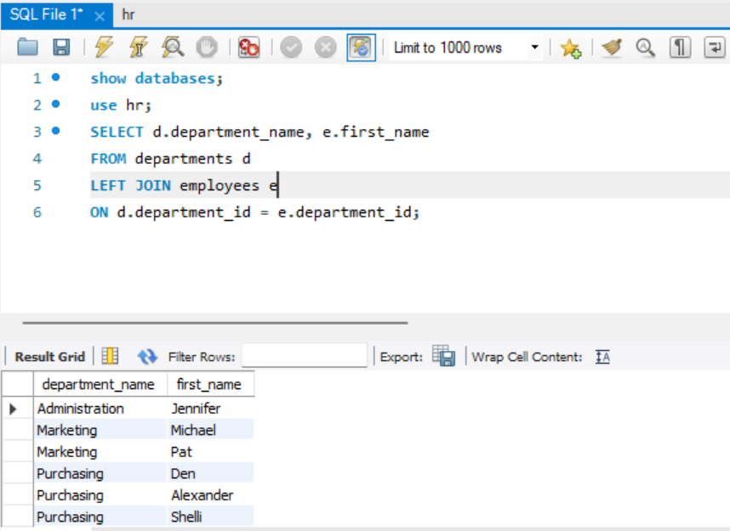
2. Display all employees and their manager names (if assigned).
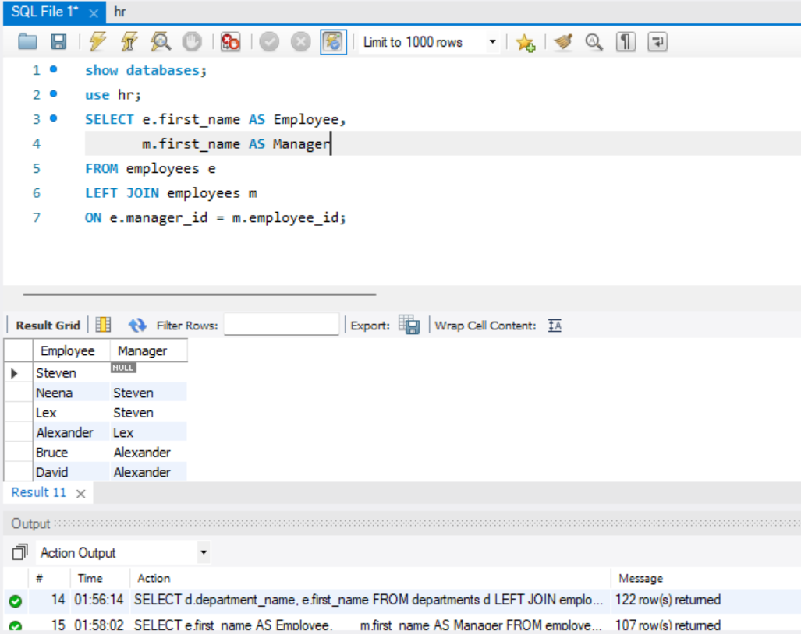
Lab Task 3
1. Show all locations and departments operating in them.
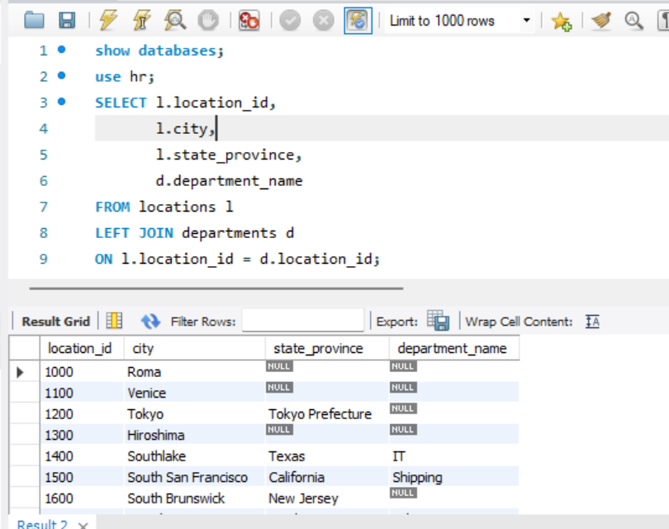
- Display all jobs and employees assigned to them.
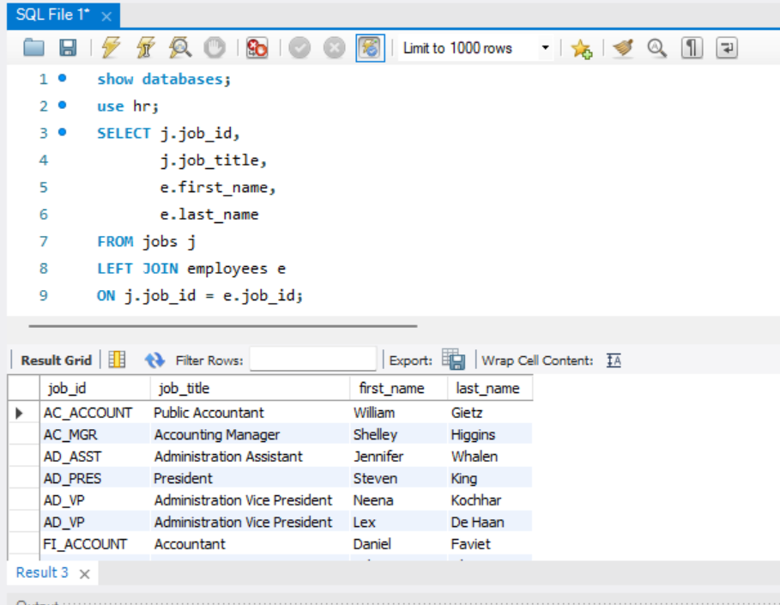

Lab Task 4
- Perform FULL OUTER JOIN between departments and locations.
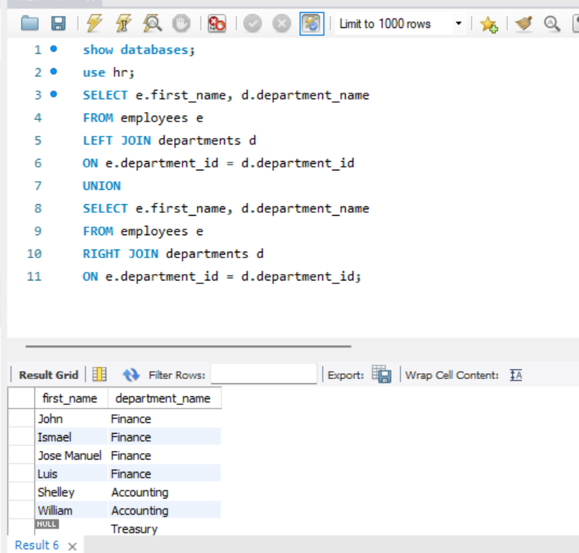

- Display all employees and all jobs (matched and unmatched).
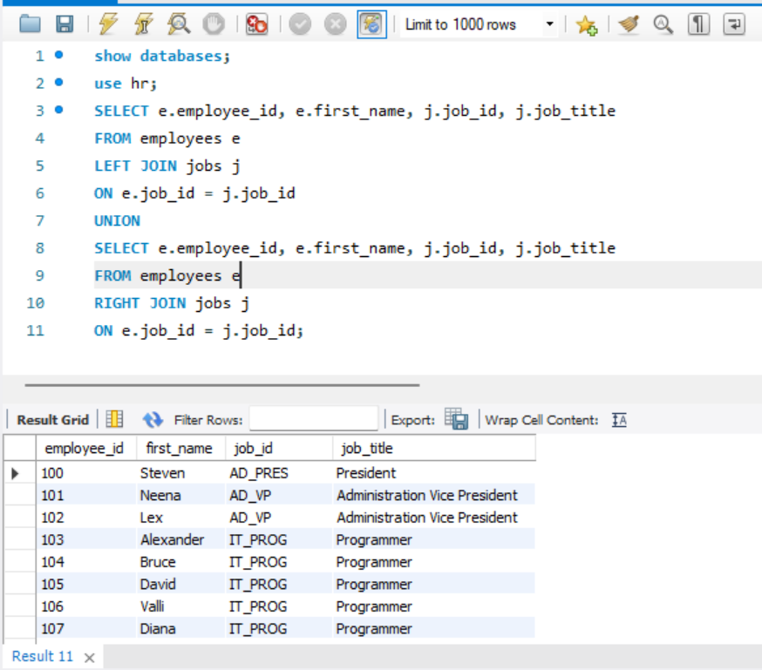

Lab Task 5
- Display employee name, manager name, and manager salary.
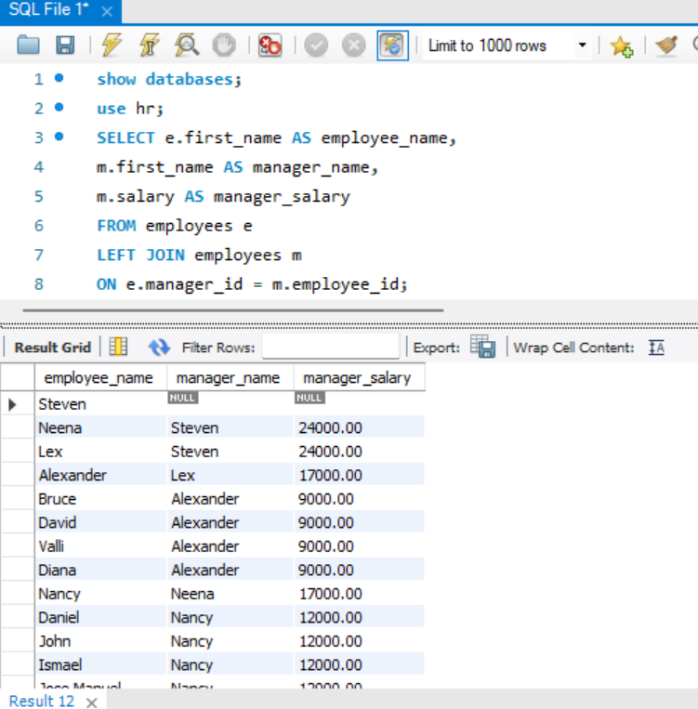

- Find employees who work under the same manager.
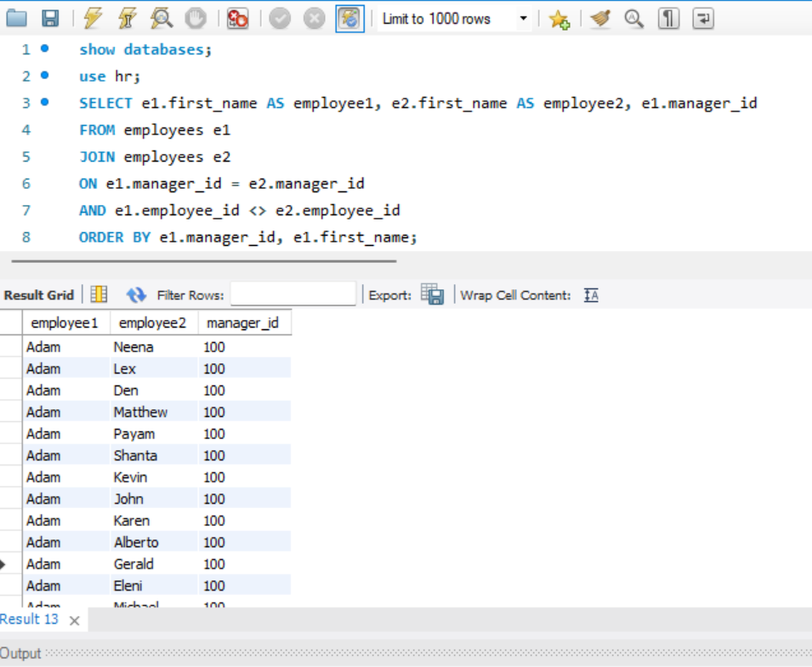

- Display hierarchy up to two levels.
