E DATABASE PROJECT SUBMISSION WORKSHEET | Student Copy
DATABASE PROJECT
SUBMISSION WORKSHEET
Phase 2: Full Implementation & Documentation
Project Name | Blood Bank & Donor Registry Management System
Member 1 | Tahira 5000000389
Member 2 | Tooba 5000000375
Member 3 | Zara 5000000396
Member 4 | Jahangir 5000000380
Class / Batch | Multi Media and Gaming
Submission Date | 19-04-2026
Instructor | Engr.Arifa

PROJECT SUBMISSION CHECKLIST
Tick each item once completed. Incomplete submissions will not be accepted.
# | Deliverable / Task | Marks / Status
□ | 1. Cover Page with all member details filled | __ / 5
□ | 2. Database Schema Diagram (ERD) | __ / 10
□ | 3. Normalization — 1NF, 2NF, 3NF explained | __ / 15
□ | 4. DDL Queries (CREATE, ALTER, DROP) | __ / 15
□ | 5. DML Queries (INSERT, UPDATE, DELETE) | __ / 15
□ | 6. DQL Queries — minimum 10 SELECT queries | __ / 20
□ | 7. Database Backup (.sql dump file attached) | __ / 10
□ | 8. Report Document (this worksheet completed) | __ / 10

Page 1 of 14
DATABASE PROJECT SUBMISSION WORKSHEET | Student Copy
PART 1 — DATABASE SCHEMA DIAGRAM
Draw or paste your Entity-Relationship Diagram (ERD) / Schema Diagram below. You may also attach a printed/digital copy of your diagram as an appendix.
Required elements in the diagram: All tables, Primary Keys (PK), Foreign Keys (FK), cardinality (1:1 / 1:N / M:N), and attribute data types.
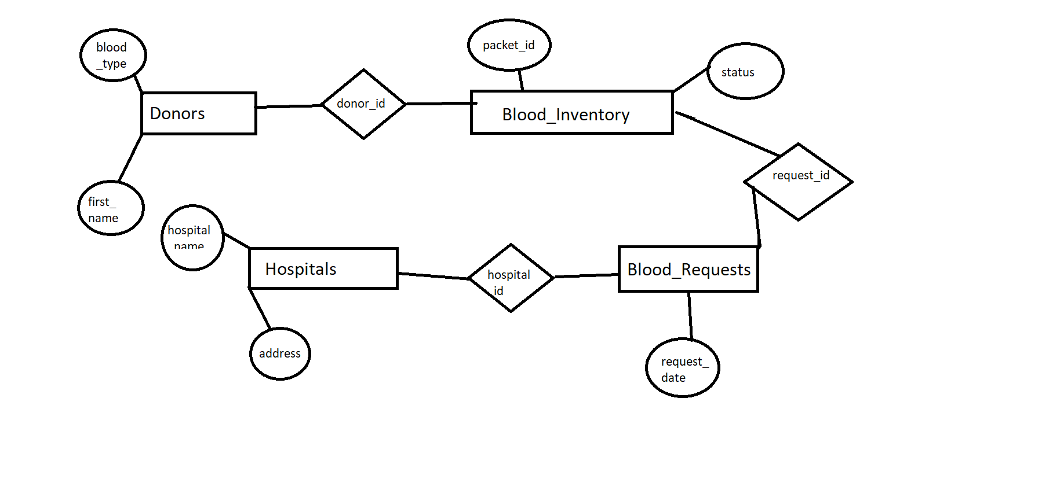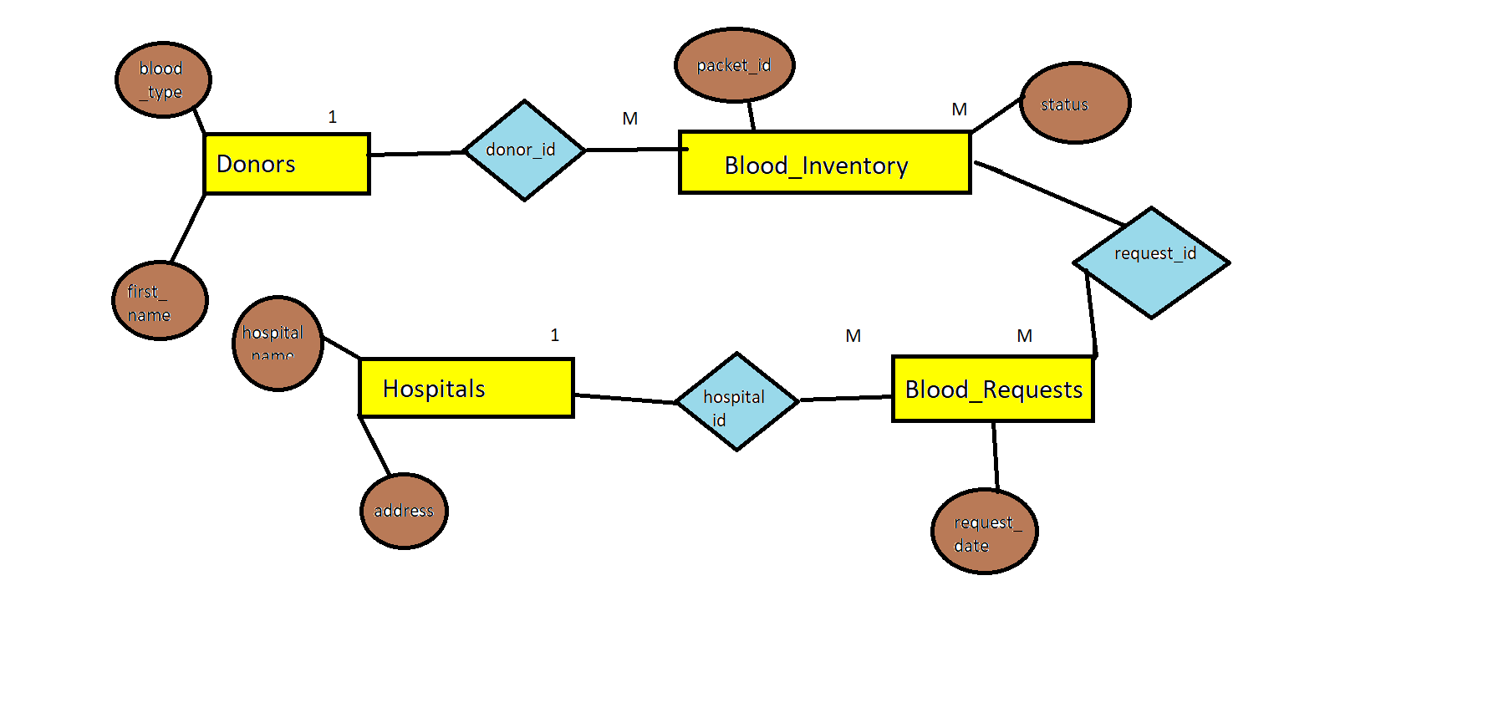[ Attach / Draw ERD / Schema Diagram Here ]

Table List — Write all table names in your database:
1. Donors
2. Hospitals
3. Blood_Requests
4. Blood_Inventory
5. Compatibility_Matrix
________________________________________________________________________________
Brief description of each table and its purpose:
1. Donors → Stores donor personal info + blood type + last donation date (core entity)
2. Hospitals → Stores hospital details who request blood (clients)
3. Blood_Requests → Records blood requests from hospitals with urgency
4. Blood_Inventory → Tracks actual blood packets with expiry & status
5. Compatibility_Matrix → Reference table for blood type compatibility rules (brain of system)
__________________________________________________________________________________________Page 2 of 14
DATABASE PROJECT SUBMISSION WORKSHEET | Student Copy
PART 2 — DATABASE NORMALIZATION
Demonstrate that your database satisfies all three normal forms. Answer each section for at least ONE table in your project (you may repeat for all tables).
2.1 — First Normal Form (1NF)
Rule: Each column must contain atomic (indivisible) values. No repeating groups.
State which table you are normalizing to 1NF:
Table: Donors
__________________________________________________________________
Explain how your table satisfies 1NF (no multi-valued attributes, each cell has one value): Example: The 'Orders' table has no repeating groups. Each product is stored in a separate row.

Every column contains atomic values. No repeating groups. Each cell has single value (e.g., blood_type = 'O-' only, not multiple types). Phone and email are single values.
______________________________________________________________________________________
If modifications were required for 1NF, describe what changed:
No modifications required.
______________________________________________________________________________________
2.2 — Second Normal Form (2NF)
Rule: Must be in 1NF AND every non-key attribute must be fully functionally dependent on the entire primary key (no partial dependency).
Identify the primary key for the table:
Primary Key: donor_id (single column PK)
___________________________________________________________________________________
Explain why there is no partial dependency in your table:
Example: In 'OrderItems', every attribute depends on the composite key (order_id, product_id) — not just one part. __
All non-key attributes (first_name, last_name, blood_type, etc.) are fully dependent on donor_id. No partial dependency possible because PK is single column.
_____________________________________________________________________________________
If partial dependencies existed, describe how you resolved them (e.g., split into new table):
No partial dependencies existed.
____________________________________________________________________________
2.3 — Third Normal Form (3NF)
Page 3 of 14
DATABASE PROJECT SUBMISSION WORKSHEET | Student Copy
Rule: Must be in 2NF AND no transitive dependencies (non-key attribute should not depend on another non-key attribute).
Check your table for transitive dependencies:
No transitive dependencies: email does not depend on phone, blood_type does not depend on last_name, everything depends only on donor_id (PK).
______________________________________________________________________________________
Explain how your table satisfies 3NF:
Example: 'city' does not depend on 'zip_code'; each attribute depends only on the primary key.
No transitive dependencies existed → already in 3NF.
______________________________________________________________________________________
If transitive dependencies existed, describe the fix:
________________________________________________________________________________________ _____________________________________________________________

Page 4 of 14
DATABASE PROJECT SUBMISSION WORKSHEET | Student Copy
PART 3 — DATA DEFINITION LANGUAGE (DDL)
Write all DDL queries used to build your database structure. Include the actual SQL you executed. Required: CREATE DATABASE, USE, CREATE TABLE (with constraints), ALTER TABLE, and DROP TABLE.
3.1 — Create Database & Use
Write your CREATE DATABASE and USE statement:
e.g. CREATE DATABASE school_db; USE school_db;

CREATE DATABASE blood_bank;
USE blood_bank;

______________________________________________________________________________________

3.2 — Create Tables (with Constraints)
Write CREATE TABLE statements for ALL tables in your project. Include constraints: PRIMARY KEY, FOREIGN KEY, NOT NULL, UNIQUE, DEFAULT, CHECK, AUTO_INCREMENT.
Table 1 — CREATE TABLE:
CREATE TABLE Donors (
donor_id INT AUTO_INCREMENT PRIMARY KEY,
first_name VARCHAR(50) NOT NULL,
last_name VARCHAR(50),
blood_type VARCHAR(5) NOT NULL,
phone VARCHAR(15),
email VARCHAR(100) UNIQUE,
last_donation_date DATE
);
Table 2 — CREATE TABLE:

CREATE TABLE Hospitals (
hospital_id INT AUTO_INCREMENT PRIMARY KEY,
hospital_name VARCHAR(100),
address TEXT,
emergency_contact VARCHAR(20)
);

Table 3 — CREATE TABLE:
CREATE TABLE Blood_Requests (
request_id INT PRIMARY KEY,
hospital_id INT,
required_blood_type VARCHAR(5),
quantity_requested INT,
request_date INT, -- stored as Excel serial date
urgency_level VARCHAR(20)
);
Table 4— CREATE TABLE
CREATE TABLE Blood_Inventory (
packet_id INT AUTO_INCREMENT PRIMARY KEY,
donor_id INT,
donation_date DATE,
expiry_date DATE,
status ENUM('Available','Requested','Used','Expired'),
storage_location VARCHAR(50),
FOREIGN KEY (donor_id)
REFERENCES Donors(donor_id)
ON DELETE CASCADE
ON UPDATE CASCADE
) ENGINE=InnoDB;

Table 5 — CREATE TABLE (add more as needed):
CREATE TABLE Compatibility_Matrix (
donor_type VARCHAR(5),
recipient_type VARCHAR(5),
PRIMARY KEY (donor_type, recipient_type)

);

______________________________________________________________________________________
3.3 — ALTER TABLE
Write at least 2 ALTER TABLE statements (ADD column, MODIFY column, ADD CONSTRAINT, DROP COLUMN, etc.)
ALTER TABLE statements:
e.g. ALTER TABLE users ADD COLUMN profile_pic VARCHAR(255);
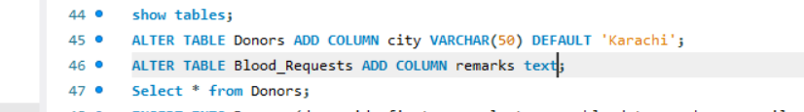

______________________________________________________________________________________
3.4 — View Table Structure
Write DESCRIBE / SHOW COLUMNS statements for each table:
e.g. DESCRIBE users; SHOW COLUMNS FROM orders;
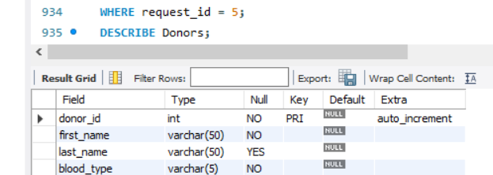
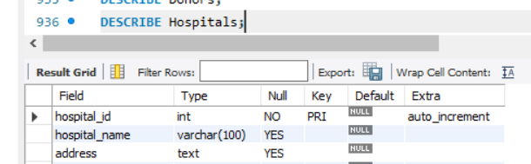

______________________________________________________________________________________
3.5 — DROP TABLE (Test Only)
Write a DROP TABLE statement (used only during testing — do NOT drop final tables): e.g. DROP TABLE IF EXISTS temp_log;
DROP TABLE IF EXISTS temp_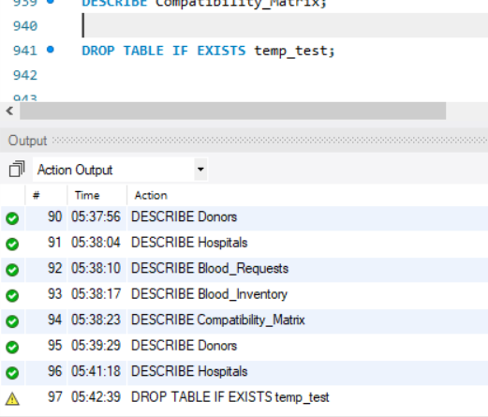

______________________________________________________________________________________
Page 6 of 14
DATABASE PROJECT SUBMISSION WORKSHEET | Student Copy
PART 4 — DATA MANIPULATION LANGUAGE (DML)
Write all DML queries. You must INSERT at least 5 rows per table, perform at least 3 UPDATE operations, and at least 2 DELETE operations.
4.1 — INSERT Statements
Insert sample/test data into ALL tables. Use realistic values related to your project.
INSERT INTO — Table 1 (minimum 5 rows):
e.g. INSERT INTO users (name, email, role) VALUES ('Ali', 'ali@email.com', 'admin');

INSERT INTO Donors (first_name, last_name, blood_type, phone, email, last_donation_date)
VALUES
('Ahmed','Sheikh','O-','03511861060','ahmed1@gmail.com','2025-07-21'),
('Ayesha','Butt','A+','03713995719','ayesha2@gmail.com','2025-11-18'),
('Noor','Hussain','B+','03302629814','noor3@gmail.com','2025-06-21'),
('Zara','Butt','O+','03990027820','zara4@gmail.com','2025-12-13'),
('Ayesha','Malik','A+','03449063746','ayesha5@gmail.com','2025-07-14');
______________________________________________________________________________________
INSERT INTO — Table 2 (minimum 5 rows):

INSERT INTO Hospitals (hospital_id, hospital_name, address, emergency_contact) VALUES
('1','City Hospital', 'Karachi', '0211111111'),
('2','National Hospital', 'Lahore', '0422222222'),
('3','General Hospital', 'Islamabad', '0513333333'),
('4', 'Hira Hospital', 'Sukkur', '0454924935'),
('5', 'Jinnah Hospital', 'Karachi', '3048894892');

______________________________________________________________________________________
INSERT INTO — Table 3 (minimum 5 rows):

INSERT INTO Compatibility_Matrix (donor_type, recipient_type) VALUES
('A+','A+'),
('A+','A-'),
('A+','B+'),
('A+','B-'),
('A+','AB+'),
('A+','AB-'),

______________________________________________________________________________________

INSERT INTO — Table 4 (minimum 5 rows):

INSERT INTO Blood_Requests (request_id, hospital_id, required_blood_type, quantity_requested, request_date, urgency_level) VALUES
(1,6,'AB-',2,'2025-03-17','Critical'),
(2,32,'O+',5,'2025-08-12','Normal'),
(3,9,'B+',5,'2025-02-09','Critical'),
(4,30,'A+',3,'2025-01-03','Normal'),
(5,41,'O+',1,'2025-10-20','Critical'),
(6,15,'B-',5,'2025-05-22','Normal'),
(7,42,'B-',3,'2025-04-02','Critical'),
(8,60,'B+',1,'2025-10-29','Urgent'),

INSERT INTO — Remaining Tables:
INSERT INTO Blood_Inventory (donor_id, donation_date, expiry_date, status, storage_location)
VALUES
(1, '2025-08-10', '2025-09-21', 'Available', 'Fridge A'),
(2, '2025-08-11', '2025-09-22', 'Used', 'Fridge B'),
(3, '2025-08-12', '2025-09-23', 'Requested', 'Fridge C'),
(4, '2025-08-13', '2025-09-24', 'Available', 'Fridge A'),
(5, '2025-08-14', '2025-09-25', 'Expired', 'Fridge B'),
(1, '2025-08-15', '2025-09-26', 'Available', 'Fridge C'),

______________________________________________________________________________________
4.2 — UPDATE Statements
Write at least 3 UPDATE queries. Use WHERE clause correctly to avoid updating all rows accidentally.
UPDATE statements (minimum 3):
e.g. UPDATE products SET price = 1500 WHERE product_id = 3;
UPDATE Donors SET last_donation_date = '2026-04-01' WHERE donor_id = 1;
UPDATE Blood_Requests SET urgency_level = 'Critical' WHERE request_id = 1;
UPDATE Blood_Inventory SET status = 'Available' WHERE packet_id = 1;
______________________________________________________________________________________
4.3 — DELETE Statements
Write at least 2 DELETE queries. Always use WHERE clause.
DELETE statements (minimum 2):
e.g. DELETE FROM orders WHERE status = 'cancelled' AND order_date <'2023-01-01';

DELETE FROM Blood_Requests WHERE urgency_level = 'Normal' AND request_date < '2025-01-01';
DELETE FROM Donors WHERE donor_id = 500; -- test donor
_____________________________________________________________________________________

Page 8 of 14
DATABASE PROJECT SUBMISSION WORKSHEET | Student Copy
PART 5 — DATA QUERY LANGUAGE (DQL)
Write at least 10 SELECT queries that extract meaningful data from your database. Cover all the categories listed below.
5.1 — Basic SELECT Queries
Query 1: Select ALL records from any table:
e.g. SELECT * FROM users;

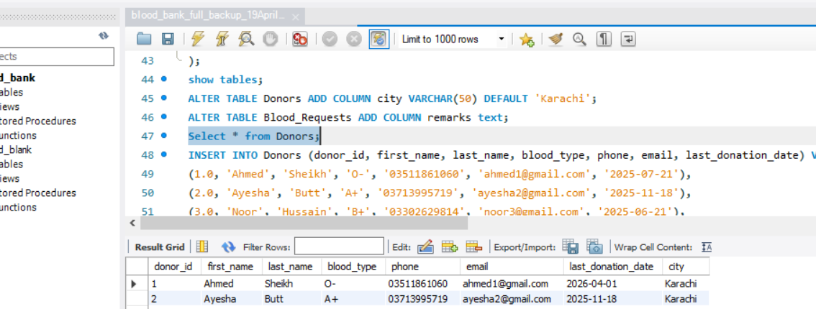
______________________________________________________________________________________
Query 2: Select SPECIFIC columns:
e.g. SELECT name, email FROM users;

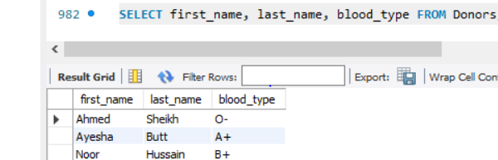
______________________________________________________________________________________
Query 3: SELECT with WHERE condition:
e.g. SELECT * FROM products WHERE category = 'Electronics';

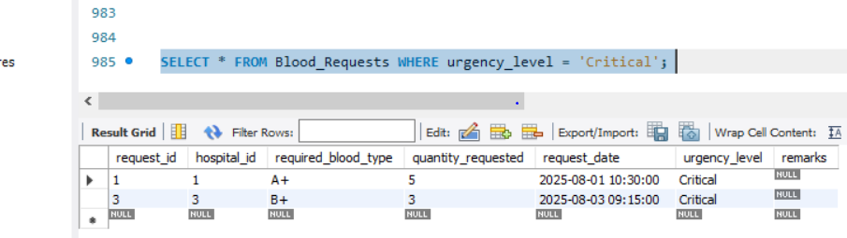
______________________________________________________________________________________
5.2 — Sorting & Filtering
Query 4: SELECT with ORDER BY:
e.g. SELECT * FROM products ORDER BY price DESC;

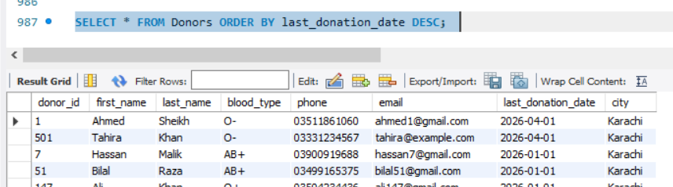
______________________________________________________________________________________
Query 5: SELECT with LIMIT:
e.g. SELECT * FROM orders ORDER BY created_at DESC LIMIT 10;
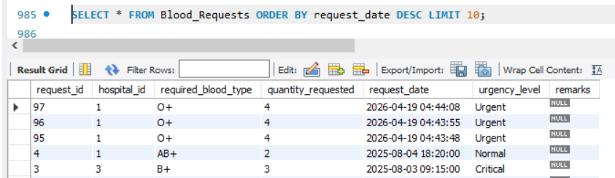
______________________________________________________________________________________
Query 6: SELECT with LIKE / pattern matching:
e.g. SELECT * FROM customers WHERE name LIKE 'A%';

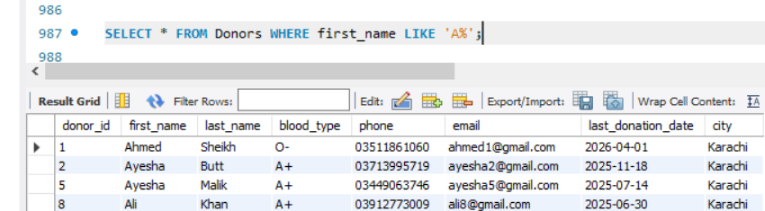
________________________________________________________________________________________5.3 — Aggregate Functions
Query 7: COUNT, SUM, AVG, MIN, or MAX:
e.g. SELECT COUNT(*) AS total_orders FROM orders;

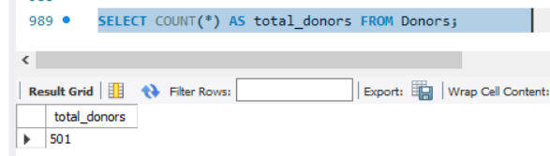
______________________________________________________________________________________
Query 8: GROUP BY with aggregate function:
e.g. SELECT category, COUNT(*) AS total FROM products GROUP BY category;
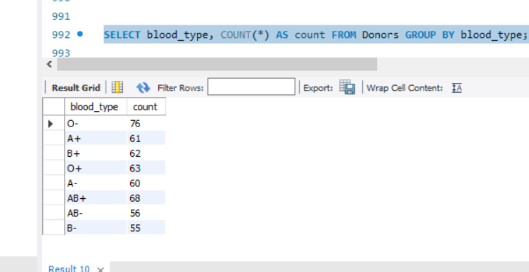
______________________________________________________________________________________
Query 9: GROUP BY with HAVING clause:
e.g. SELECT customer_id, SUM(amount) AS total FROM orders GROUP BY customer_id HAVING total > 5000;
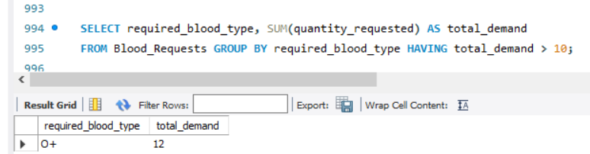
______________________________________________________________________________________5.4 — JOIN Queries
Query 10: INNER JOIN between two tables:
e.g. SELECT u.name, o.order_date FROM users u INNER JOIN orders o ON u.id = o.user_id;

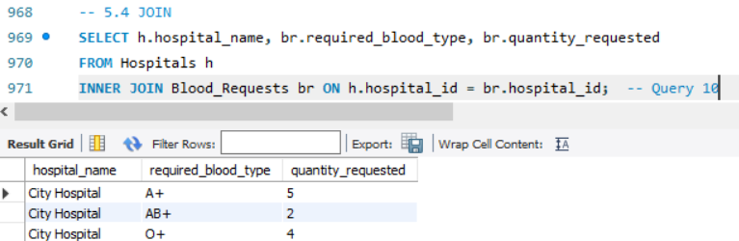
______________________________________________________________________________________
Query 11: LEFT JOIN (or RIGHT JOIN):
e.g. SELECT u.name, o.amount FROM users u LEFT JOIN orders o ON u.id = o.user_id;
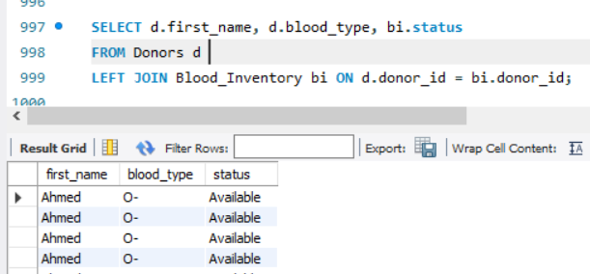

______________________________________________________________________________________
Query 12 (Bonus): Subquery or Nested SELECT:
e.g. SELECT name FROM users WHERE id IN (SELECT user_id FROM orders WHERE amount > 1000);

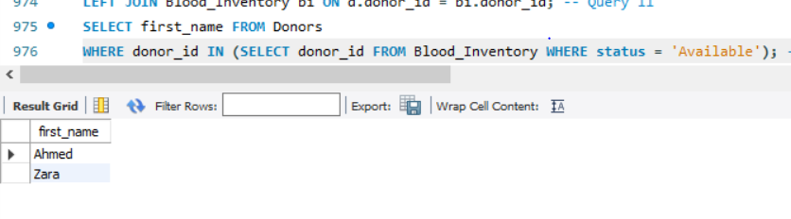
______________________________________________________________________________________

DATABASE PROJECT SUBMISSION WORKSHEET | Student Copy
5.5 — Results Screenshot / Output
Paste a screenshot OR write the output of at least 3 queries in the space below.
[ Paste Query Output Scree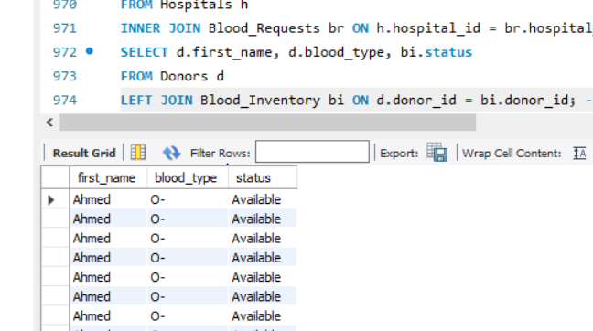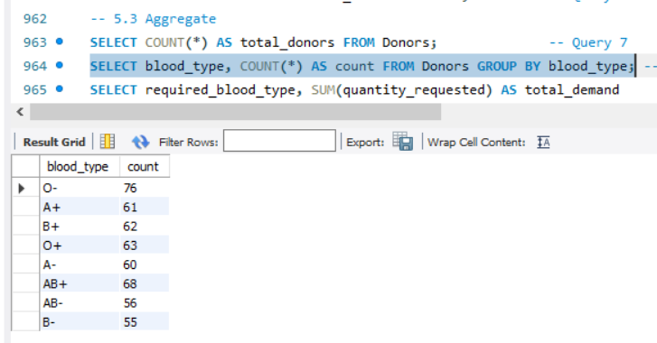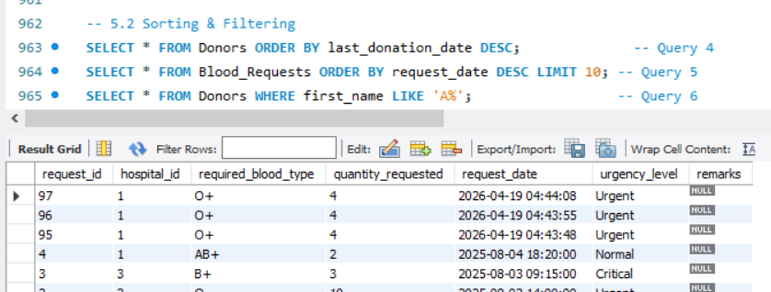nshots Here ]

PART 6 — DATABASE BACKUP
You must take a complete backup of your database and attach the .sql dump file with your submission.
6.1 — How to Take a Backup (MySQL)
Follow the steps below to create your database backup using mysqldump.
Step 1 | Open Terminal / Command Prompt on your machine.
Step 2 | Type the following command (replace 'your_db_name' and 'username'):
Step 3 | mysqldump -u username -p your_db_name > project_backup.sql
Step 4 | Press Enter. You will be prompted for your MySQL password.
Step 5 | A file named project_backup.sql will be created in your current directory.
Step 6 | Attach this .sql file with your project folder / ZIP submission.

6.2 — Backup Confirmation
Write the exact command you used to take the backup:
Copy the command from your terminal here.
mysqldump-u root -p blood_bank > blood_bank_full_backup_19April2026.sql
_____________________________________________________________________________________
Write the name of the backup file you are attaching:
e.g. library_db_backup.sql
blood_bank_full_backup_19April2026.sql
______________________________________________________________________________________
Describe what the backup file contains (tables, rows of data):
e.g. The backup contains 5 tables: users, orders, products, categories, reviews. Total ~200 rows.
Contains 5 tables (Donors, Hospitals, Blood_Requests, Blood_Inventory, Compatibility_Matrix) with 500+ donors, 100 hospitals, 500 requests and full data.
______________________________________________________________________________________
6.3 — Restore Command (Bonus)
Write the command to RESTORE the database from the backup file:
e.g. mysql -u username -p new_db_name < project_backup.sql

mysql -u root -p blood_bank < blood_bank_full_backup_19April2026.sql
______________________________________________________________________________________

PART 7 — REFLECTION & LEARNINGS
What challenges did your group face during this project?
Importing 500 rows from Excel was time-consuming, handling date formats in last_donation_date, ensuring Compatibility_Matrix had all 64 combinations.
______________________________________________________________________________________
What did you learn from designing and implementing this database?
Understood real-world normalization, importance of foreign keys for data integrity, how JOIN queries solve complex blood matching, and backup importance.
______________________________________________________________________________________
If you were to improve this project further, what features would you add?
Add donor eligibility check (age, health), SMS notification for requests, dashboard with charts, auto-expiry update using events.
______________________________________________________________________________________

Individual Contribution
Member Name | Role / Contribution | Signature
Tahira | Performed debugging, removed errors, and refined the complete project to ensure proper working of the Blood Bank Management System in MySQL.
Tooba | Helped in collecting and organizing the dataset in Excel format and contributed to the development of the database schema.
Zara | Created the Entity Relationship (ER) Diagram for the Blood Bank Management System project.
Jahangir | Assisted in preparing the dataset in Excel and supported in designing the database schema.

PART 8 — INSTRUCTOR MARKING RUBRIC
Section | Max Marks | Marks Awarded | Comments
1. Schema Diagram (ERD) | 10
2. Normalization (1NF, 2NF, 3NF) | 15
3. DDL Queries | 15
4. DML Queries | 15
5. DQL Queries (10+ queries) | 20
6. Query Output / Screenshots | 5
7. Database Backup (.sql file) | 10
8. Reflection & Presentation | 10
TOTAL | 100

Instructor Signature:
__________________________________________________________________________________________ __________________________________________________________________________________________
General Feedback:
__________________________________________________________________________________________ __________________________________________________________________________________________ __________________________________________________________________________________________ __________________________________________________________________________________________

