1-Sum of Biggest Neighbor *(required time:30min)*

*this question should be answered with c#*

Your program is receiving array A which consists of N integers where N>=2.

Each element of the array X is repeated maximum M times.

Find the biggest combination of two neighboring elements of array X where array X is made of the elements of array A, repeated at least M-1 times.

Write the program in the most efficient way you can. Can you tell what is your solution complexity? Is it O(n)?

# example 1:

input: [1,2,1,5,5,3,3,3,4]

output: 10

## explanation:

number 1 is repeated 2 times,

number 2 is repeated 1 time,

number 3 is repeated 3 times,

number 4 is repeated 1 time

number 5 repeated 2 times,

so, the **M** is equal to 3, so we need to filter all the input with at least the **M-1** repeat that would be

[1,1,5,5,3,3,3].

the biggest combination of neighbor element that can be found is 10

# example2:

input: [1,6,1,2,6,1,6,6]

output: 12

## explanation:

the M is equal to 4, so the element that repeated at least M-1 is [1,6,1,6,1,6,6] the biggest two neighbor elements [6,6]. the result is the sum of those, equal to 12.

#### You can’t change the Challenge function signature and output.

|  |
| --- |
| public int **Challenge**(int[] input){  *//your code here*  } |

2-User Class *(required time:10min)*

*this question should be answered with c#*

implement the **User** class

please note that you are not allowed to change below code and you are not allowed to use any database or persistent data storage. The data is good to be available as long as the program is running.

#### You can’t change the code below.

|  |
| --- |
| private static void **Main**(string[] args)  {  while (true)  {  var user = new User();  Console.**WriteLine**("please enter the username, or q to exit");  var userName = Console.**ReadLine**();  if (userName == "q")  {  break;  }  user.**Add**(userName);  Console.**WriteLine**($"number of addedUser {user.**GetUsersCount**()}");  }  } |

Output of your program should be as bellow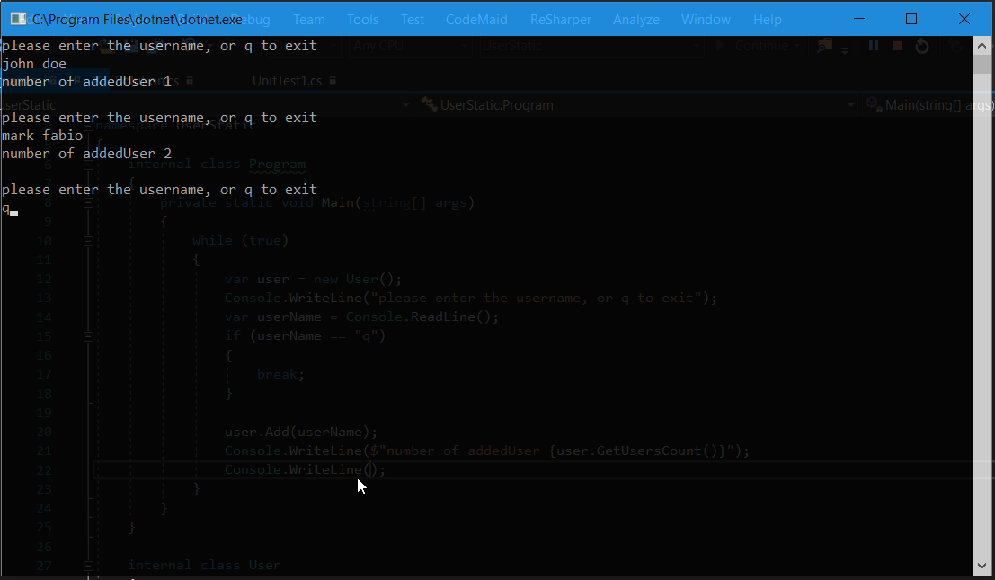

3-John the Robot *(required time:15min)*

*this question should be answered with c#*

Our technical team made a new robot. You are given a task to write a program to let the robot learn and show the new skills. Below is the code that your boss gave you and you are going to implement **Humanoid** class to return a result as shown in the picture below.

#### You can’t change the code below.

|  |
| --- |
| private static void **Main**(string[] args)  {  var john = new Humanoid(new Dancing());  Console.**WriteLine**(john.**ShowSkill**()); *//print dancing*  var alex = new Humanoid(new Cooking());  Console.**WriteLine**(alex.**ShowSkill**());*//print cooking*  var bob = new Humanoid();  Console.**WriteLine**(bob.**ShowSkill**());*//print no skill is defined*  } |

Output of your program should be as bellow

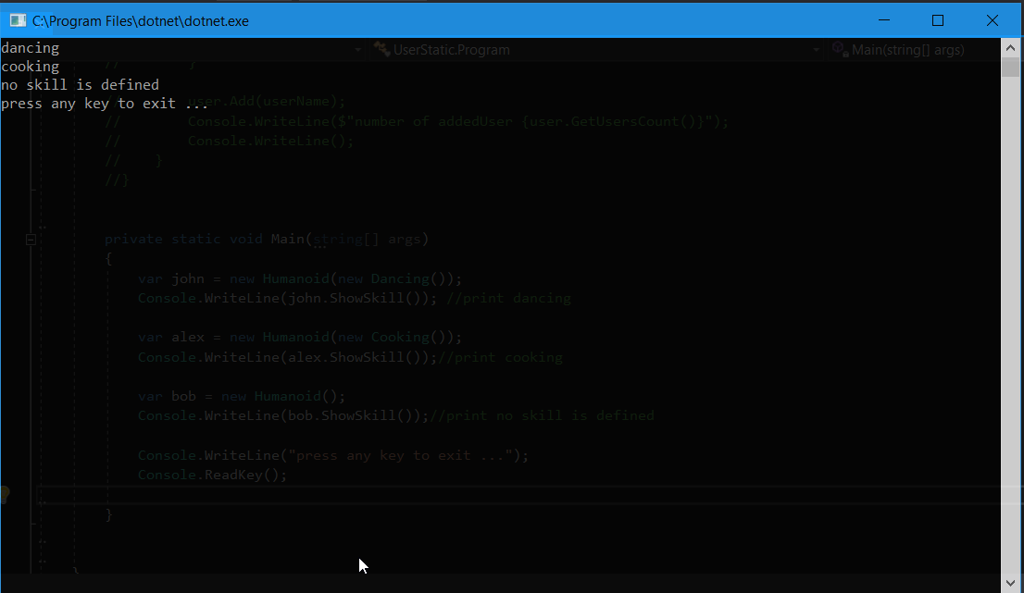

4-Alexa Settings *(required time:15min)*

*this question should be answered with c#*

Your team is creating a home management system for Alexa, they want to be able to configure Alexa settings through the code. your boss passes you this code and ask you to complete it.

#### You can’t change the code below.

|  |
| --- |
| private static void **Main**(string[] args)  {  var alexa = new Alexa();  Console.**WriteLine**(alexa.**Talk**()); *//print hello, i am Alexa*  alexa.**Configure**(x =>  {  x.GreetingMessage = "Hello {OwnerName}, I'm at your service";  x.OwnerName = "Bob Marley";  });  Console.**WriteLine**(alexa.**Talk**()); *//print Hello Bob Marley, I'm at your service*  Console.**WriteLine**("press any key to exit ...");  Console.**ReadKey**();  } |

The output looks like this

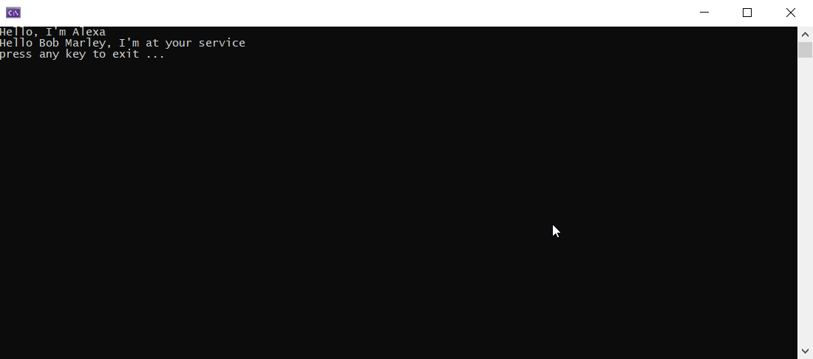

5- Method Signature *(required time:2min)*

*this question should be answered with c#*

your colleague wrote a function to calculate something, you need to find the function in a project and you have only notepad in your machine, so you need to guess how the function look like. Write your guess, how the function “SomeCalculation” should look like (return type and method signature)?

|  |
| --- |
| var (averageSalary, numberOfEmployee) = await **SomeCalculation**(0L, 10, 0L == 10L); |

6- Construction Game*(required time:15min)*

*this question should be answered with c#*

You are writing a construction game, you want to let the user configure as many things as they want, with any order. Your boss comes up with a code that let the user add and configure as many things as they want. But it will build the building when the user call the “.Build()”. Here is the code:

#### You can’t change the code below.

|  |
| --- |
| private static void **Main**(string[] args)  {  var myHouse = new Building()  .**AddKitchen**()  .**AddBedroom**("master")  .**AddBedroom**("guest")  .**AddBalcony**();  var normalHouse= myHouse.**Build**();  *//kitchen, master room, guest room, balcony*  Console.**WriteLine**(normalHouse.**Describe**());  myHouse.**AddKitchen**().**AddBedroom**("another");  var luxuryHouse = myHouse.**Build**();  *//it only shows the kitchen after build*  *//kitchen, master room, guest room, balcony, kitchen, another room*  Console.**WriteLine**(luxuryHouse.**Describe**());  } |

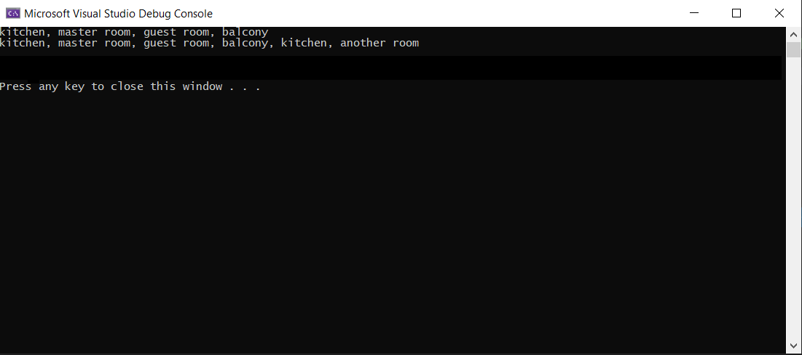

7- ES6 Import

you have two types of import syntax. you need to guess what is the correct implementation of the **app.js**

the imports look like this.

**type 1:**

#### You can’t change the code below.

|  |
| --- |
| import {Car} from "app.js"; |

**type2:**

#### You can’t change the code below.

|  |
| --- |
| import Car from "app.js"; |

the implementation of the **app.js** look like below. for each of the import types choose the right implementation. you can choose more than one answer for each import type.

**answer1:**

#### You can’t change the code below.

|  |
| --- |
| *//app.js*  export function **Car**(){  return "lamborghini";  } |

**answer2:**

#### You can’t change the code below.

|  |
| --- |
| *//app.js*  export default function **Car**(){  return "lamborghini";  } |

**answer3:**

#### You can’t change the code below.

|  |
| --- |
| *//app.js*  function **Car**(){  return "lamborghini";  } |

**answer4:**

#### You can’t change the code below.

|  |
| --- |
| *//app.js*  function **Car**(){  return "lamborghini";  }  export default Car; |

**answer5:**

#### You can’t change the code below.

|  |
| --- |
| *//app.js*  function **Car**(){  return "lamborghini";  }  export Car; |

8- (optional) Typescript Mastery

*this question isn’t required but it has a high score.*

your team decided to implement a class that have a **addOne** method that always add 1 to any number it receives. but you want to be able to programatically change the result of that function without modifying the function. your senior developer describe to you that the class should look like below code.

he gives you a sample code and a result. the code below should return 5.

the class receive 2, add one to it (3), then multiply it by 2 (6), then subtract 1 from it (5).

((2+1)*2)-1 =5

implement the **@subtract** and **@multiply** in typescript.

#### You can’t change the code below.

|  |
| --- |
| class **MathClass**{    **@subtract**(1)  **@multiply**(2)  **addOne**(number:number) {  return number+1;  }  }    console.**log**(new MathClass().**addOne**(2)) *//should print 5* |