# 3. Rack Location Unit

Data center yang kami miliki terdiri dari 2 jenis *Rack Location Unit* (RLU) yaitu Application Server dan Storage. Kedua RLU tersebut memiliki spesifikasi sebagai berikut:

## 3.1. Application Server RLU

Spesification : IBM X3850 X5 7143-B1A  
Power : 19750 W  
Cooling : 67,545 BTU  
Physical Space : 60cm x 120 cm, 641 KG  
Bandwidth : 4 Cat 5e  
Functional Capacity : Intel Xeon 120 core, RAM 80GB

RLU ini akan berisi :

***Rack Server***

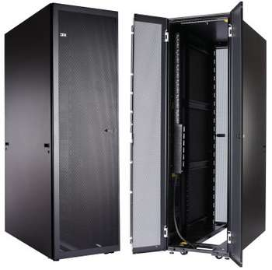

**Type**            : IBM 42u 1200mm deep static rack

**Capacity Server** : 42u  
    **Dimension**         : 60cm x 120 cm x 200 cm

**Weight**     : 141 kg

**Max Weight**        : 953 kg

**Features**        : Designed for high availability IBM System x® and BladeCenter® environments, Rear cable management channels, Front cable access portals and a large rear adjustable opening provide improved overhead cable management, Lockable doors and side panels provide a more secure environment for equipment and data, Backed by a three-year limited warranty

**Price**         : $1,830.27 / Rp.23.790.000 (kurs Rp 13000

***Server for Application***

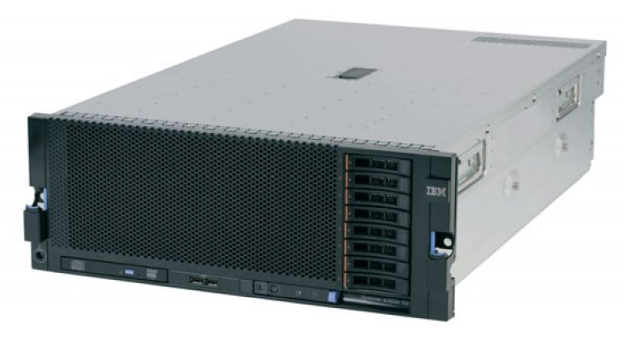

**Type          :** IBM X3850 X5 7143-B1A

**Capacity Storage    :** 146GB 10K HS 2.5in SAS

**Capacity RAM    :** 2x4GB

**Proccessor        :** 2 x Intel Xeon 6C E7-4807 95W 1.86GHz/18MB L3

**Size            :** 4U

**Power            :** 1975W p/s

**Weight        :** Minimum configuration: 35.4 kg (78 lb), maximum configuration: 49.9 kg (110 lb)

**Features        :** Memory MirroringTM and sparing / Optional Optical Drive / Eight 2.5in HS SFF SAS HDD / RAID 0, 1 (optional RAID 5) / 7 total PCI-Express: One PCI-Express 2nd Gen x16 slot / Three PCI-Express 2nd Gen x8 slots full length / Three PCI-Express 2nd Gen x8 slots half length / 5 USB (2.0) / Two Gigabit Ethernet ports Broadcom® 5709C / Emulex 10Gb Virtual Fabric Ethernet adapter / SVGA Matrox G200eV 16MB

**Price            :** $10,645.00 = Rp 138,464,178.79

***Switch***

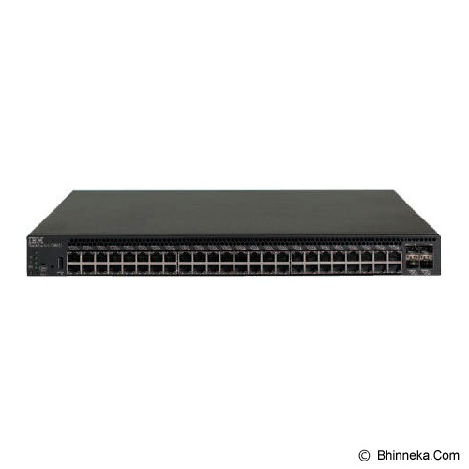

**Features** : Switch Managed, 48 x 10/100/1000Mbps + 4 x 10Gb SFP+ ports, Rear to Front Cooling

**Price :** Rp 102,815,900

**TOTAL PRICE RLU Server :** Rp 1,511,247,680

## 3.2. Storage RLU

Spesification : SEAGATE Business Storage 4-Bay RackMount NAS  
Power : 5400 W  
Cooling : 18,360 BTU  
Physical Space : 60cm x 90 cm, 790 KG  
Bandwidth : 4 Cat 5.e  
Functional Capacity : 216TB

RLU ini akan berisi:

**Storage Rack**

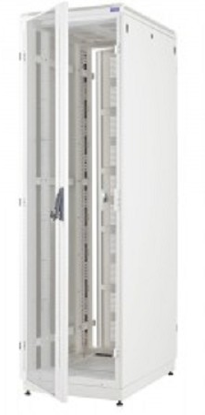

**Type**            : Abba rack Abba rack 19 Closed Rack 30U (900mm)

**Capacity Server** : 30u  
    **Dimension**         : 60cm x 90cm x 108cm

**Weight**     : 100 kg

**Price :** Rp 7,986,000

**Storage Server**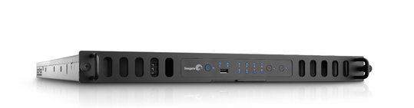

# Type          : Seagate Business Storage NAS 8-Bay Rackmount 8TB

**Capacity Storage    :** 8TB

**Capacity RAM    :** 2GB

**Proccessor        :** Intel Atom 2.13 GHz Dual

**Size            :** 1U

**Power            :** 180W

**Weight        :** 23 KG

**Features        :** Built-in support for iSCSI enables maximum performance and compatibility for virtualized environments. Seagate Business Storage 8-bay Rackmount NAS 8TB includes 4 x 2TB HDD and is a "half-populated" drive and ships with 4 empty bays,

**Price            :** Rp. 20.765.400 Top of Form

Bottom of Form

***Switch***

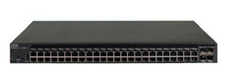

**Features** : Switch Managed, 48 x 10/100/1000Mbps + 4 x 10Gb SFP+ ports, Rear to Front Cooling

**Price :** Rp 102,815,900

**TOTAL PRICE RLU Server :** Rp 712,998,500

## 3.3. RLU Analysis

Data center yang akan dibangun akan berisi 3 RLU *application server* dan 3 RLU *storage server*, sehingga total RLU menjadi seperti ini:

|  |  |  |  |
| --- | --- | --- | --- |
| Specification | 3 x RLU Storage | 3 x RLU Server | Total |
| Weight | 2,370 KG | 1,923 KG | 4,294 KG |
| Power | 16200 W | 59,250 W | 75,450 W |
| Cooling | 55,080 BTU/h | 201,450 BTU/h | 256,530 BTU |
| Physical Space | 5400cm2 | 21600 cm2 | 27000 cm2 |
| Bandwith | 4 Cat 5.e | 4 Cat 5.e | 8 Cat 5.e |
| Functional Capacity | 648 TB | Intel Xeon 360 Cores, Ram 240 GB |  |
| Price | Rp 2,138,995,500 | Rp 4,533,743,040 | Rp 6,672,738,540 |