BPMN 1.0 User-Guide INS

Author:  Created:  Updated: | Ivan Stanev  5 September 2008  08 September 2008

Content

1. Minimal Set of Nodes 2
2. BP Extended Set of Nodes 3
2.1. Task Types 3
2.2. Sub-Process Types 4
2.3. Event Types 4
2.4. Gateway Types 7
3. BP Connectors 10
4. BP Artifacts 10
5. BP Groups 11

Minimal Set of Nodes
Node Type | Node Notation | Node Definition
Task |  | Atomic activity included in the process, performed from End-User and/or application. Every task (doesn’t matter its type) has only one input, and one output.
Standard Loop Task | 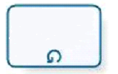 | End-User and/or application atomic activity included in the process, performed till attached to the Loop task Boolean expression accepted value false if the Boolean expression is situated before Loop Task (While Loop Task), or accepted value True if the Boolean expression is situated after Loop Task (Until Loop Task).
Multiple Instance Task |  | End-User and/or application atomic activity included in the process, performed preliminary defined number of repetitions (For Loop Task).
Sub-Process |  | Sub-Process is a graph including as BP nodes tasks, sub-processes, gateways, and events, and as arrows BP connectors. All process data are visible for the sub-process. All sub-process data are not visible for the process. Every Sub-Process (doesn’t matter its type) has only one input and one output.
Loop Sub-Process |  | Same as Loop Task for the defined in the node sub-process. (While or Until Loop Sub-Process)
Multiple Instance Sub-Process |  | Same as Multiple Instance Task for the defined in the node sub-process. (For Loop Sub-Process).
Ad-Hoc Sub-Process |  | An Ad Hoc Sub-Process is a group of activities that have no pre-definable sequence relationships. A set of activities can be defined for the Process, but the sequence and number of performances for the activities is completely determined by the performers of the activities and cannot be defined beforehand.
Transaction |  | The Transaction is a contract between all involved in the Sub-Process parties, that the operations included in the transaction will finish successfully, or will be canceled, and all involved in the Sub-Process resources will be returned in its state before the start of the transaction. The Transaction is a Sub-Process, and may include all BPMN components, included in other processes or sub-processes.
Start Event |  | Start event is this event after which happening the Business Process starts. Every Start Event has no input and one output arrows.
Intermediate Event |  | Intermediate event is this event after which happening the Business Process continue through event output arrow. Every Intermediate Event has one input and one output arrows.
End Event |  | End event is this event after which happening the Business Process stops. Every Intermediate Event has one input and no output arrows.
Decision Gateway |  | Decision Gateway is a process node that splits one process branch to several different process branches. Decision Gateway equips every different output branch of the Decision Gateway with an own token. This token must be moved through this branch of the process till the achieving a Merge Gateway. Merge Gateway role is to close this branch according the rules attached to the particular Merge Gateway type. Every Decision Gateway has one input and several output arrows.
Merge Gateway |  | Merge Gateway is a process node that merges several process branches to one. Every Merge Gateway has several input and one output arrows.

BP Extended Set of Nodes

Task Types
Task Type | Task Notation | Task Definition
User Task | 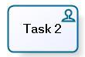 | Task realised as dialogue between Actor and software application.
Service Task | 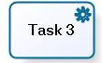 | Fully automated Web Service or Software Component with clearly defined input and output data (typically without history of the computation process and data).
Receive Task | 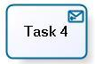 | Task which can be completed only after the performance of all the specified in the task activities and obligatory the last operation of the task must be the receiving of specified in the task an external for the task message.
Send Task | 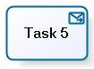 | Task which can be completed only after the performance of all the specified in the task activities and obligatory after the sending of specified in the task message addressee to an external task, process or actor.
Script Task | 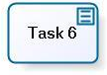 | Task performed by the BP Engine, written at low level language, which the BP Engine can interpret (for instance Java).
Manual Task | 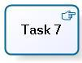 | Task fully performed by End User, and not performed by application. This task must have specified an event, after which happening the task performance must be finalized.
Reference Task | 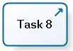 | This task plays the call of other task (usually reusable service or sub-process) situated to different place in the set of Business Processes. This activity must have the same behavior as the required from the reference task. After the end of the performance of the called activity the activity which is next after the reference task must be performed.

Sub-Process Types
Sub-Process Type | Sub-Process Notation | Sub-Process definition
Embedded Sub-process |  | This process is invoked by a parent process. All resources visible for the parent process are visible for the embedded process. All resources of the embedded process are not visible for the parent process. The parent process node situated after the embedded process will be performed after the end of the embedded process.
Reusable Sub-process |  | This process is invoked by the parent process where is situated the reusable sub-process node. Reusable sub-process can be described in details in other process, or as independent process. All resources visible for the parent process are not visible for the reusable sub-process. The resources required for the work of the reusable sub-process must be delivered from / to parent process to reusable sub-process.
Reference Sub-Process |  | This sub-process plays the call of other task (usually reusable service or sub-process) situated to different place in the set of Business Processes. This activity must have the same behavior as the required from the reference sub-process. After the end of the performance of the called sub-process the node which is next after the reference sub-process must be performed.

Event Types
Event Type | Start Event | Intermediate Event | End Event | Event Definition
Message |  |    |  | A trigger mapped to the event will be flagged when the specified message is throw / catches. When trigger is flagged the next process node will be performed. If the event is attached to task / sub-process the attached to the event task is for exception treat.
Timer |  |  | n.a. | In normal flow timer acts as time delay till the specified time – date or till the periodically repeated time – date. If timer catches exception (attached to task / sub-process) the normal flow will be changed by exception flow.
Error | n.a. |  |  | This event can be realised only as exception handler (attached to task / sub-process). If exception catches in the task / sub-process the exception treatment flow will be followed.
Conditional (Rule) |  |  | n.a. | If the Rule is used in the normal flow the next node will be performed when the event trigger receive value TRUE. If the Rule is used exception catches (attached to Task / Sub-Process) Exception handling flow will be activated when the condition will receive value FALSE. When the next node or exception are activated the condition value must be automatically reversed.
Link |  |  |  | This event will be used as link for modelling level of Long sequences, GoTo new page, or other process breaks. The event will be used at Process level as operator GoTo, or for the realisation of non task / sub-process loops. (The last option is not recommended). This event can be used only at one and same level of the process. It can not be link between process and task or process and sub-process. Source and Target Link events must have one, and same named markers.
Multiple |  |    |  | The Multiple event is equipped by several triggers connected to different conditions, or events. If we use the event in normal flow we can use it as throw event – equipped with triggers, and performing the next node when all triggers are flagged, or as catch event, where only one trigger is enough for the performance of the next node. If we use the event with task / sub-process we only can use the event as Catch mechanism activated after flagging of one trigger.
Cancel | n.a. |  |  | This event can be attached only to task / sub-process which is a transaction. There is possible we have more than one triggers, and we will cancel the transaction when the triggers are flagged.
Compensation | n.a. |  |  | In the Normal flow the compensation can be used with activity identifier (then will be compensated only the mentioned activity), or without identifier (then will be compensated all main process and all sub-process activities). If we use Event attached to the task / sub-process.
Signal |  |    |  | If the event is used in Normal flow it can also send (throw) a signal. The signal is different from the message because it has not specific addressee. The event will send signal only when the specified in the event condition is happen. If the event is used in Task / sub-process it can receive (catch) signal with specified name from unidentified source.
Terminate | n.a. | n.a. |  | We terminate the process (sub-process, task) when we haven’t more active activities, we haven’t possibility to activate new activities, and the process is not in deadlock.

Gateway Types

Gateway Name | Gateway Notation | Decision Gateway | Merge Gateway | Gateway Definition
Data Based Exclusive Gateway |  | 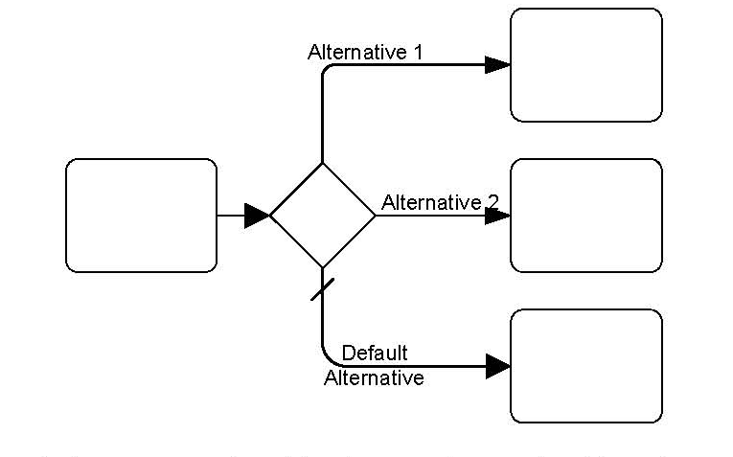 | 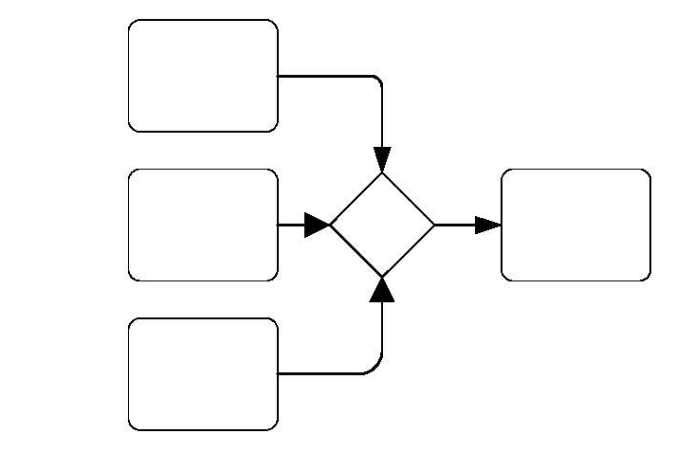 | Every output way is equipped with unique condition. During runtime will be performed only this output way which condition first will be set TRUE.
Event Based Exclusive Gateway |   () | 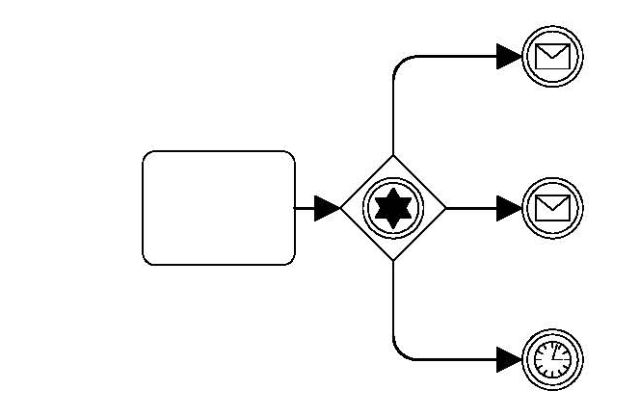 | n.a. | Every output way is equipped with unique event. During runtime only one from output ways will be performed – this which event will be realized first.
Inclusive Gateway |  | 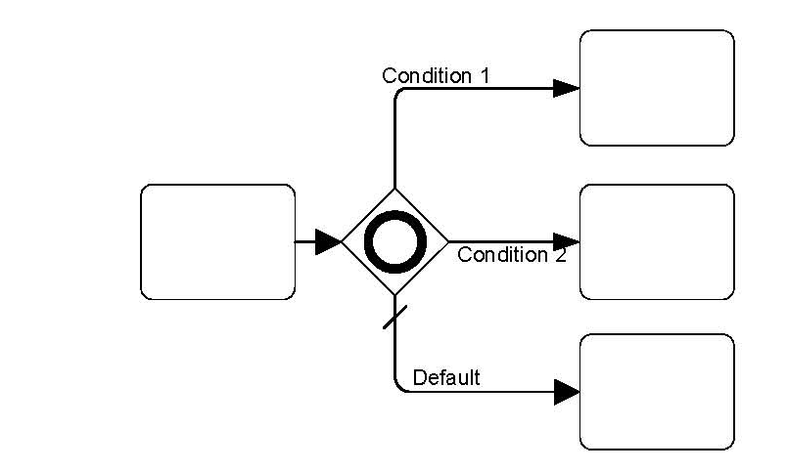 | 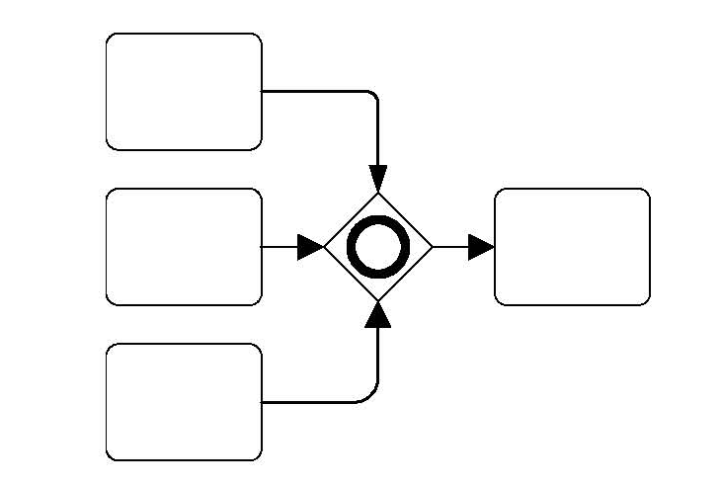 | Every output way is equipped with one condition. During Runtime (used as decision) will be performed all output ways which conditions are TRUE, at the moment of the inclusive gateway performance. During Runtime (used as Merge) will be synchronized these input ways (after receiving the tokens for every started way) which were started as output ways from the equivalent decision inclusive gateway.
Complex Gateway |  | 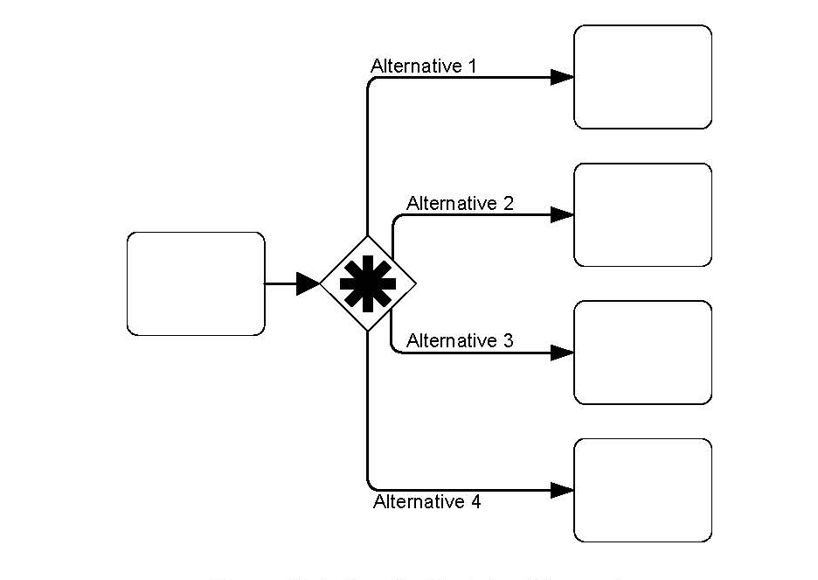 | 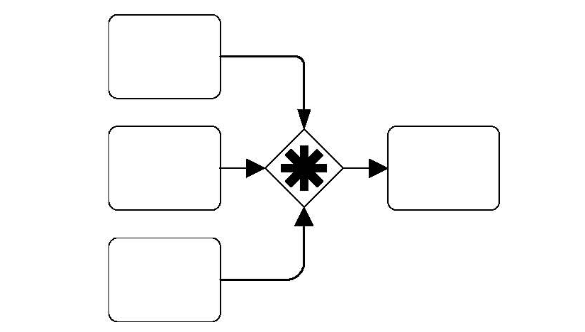 | Same as Inclusive Gateway, but with possibility to use more complex conditions, which express when necessary the combination from different combinations from Gateways.
Parallel Gateway |  | 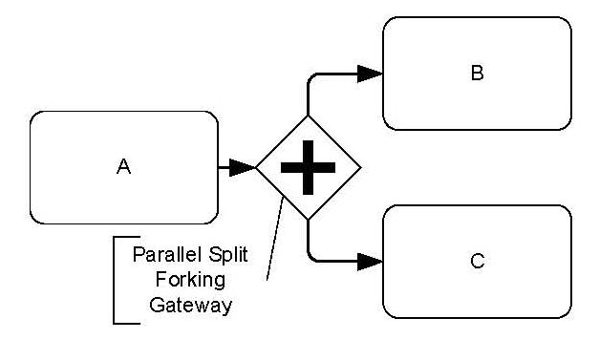 | 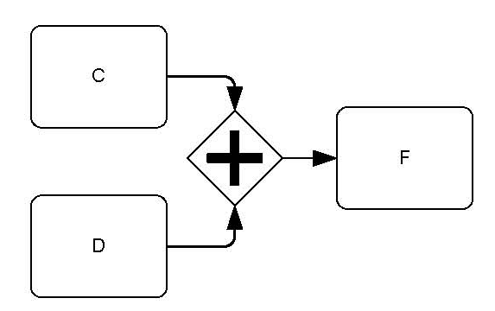 | If this Gateway has more tan one incoming ways the outcoming way will be performed after the performance of all incoming ways. If this Gateway has more than one outcoming ways all ways will be started in parallel after the performance of the Gateway.

BP Connectors

Connector Name | Connector Notation | Connector Definition
Uncontrolled Flow | 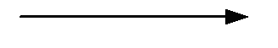 | Unconditional performance of the node at the end of the Arrow.
Conditional Flow | 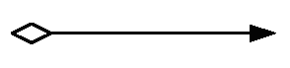 | Performance of the node at the end of the Arrow if the condition included in the diamond of the arrow is TRUE.
Default Flow | 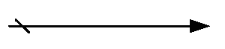 | For Data-Based Exclusive Decisions or Inclusive Decisions, one type of flow is the Default condition flow. This flow will be used only if all the other outgoing conditional flow is not true at runtime. These Sequence Flow will have a diagonal slash will be added to the beginning of the line (see the figure to the right).
Message Flow | 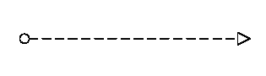 | A Message Flow is used to show the flow of messages between two entities that are prepared to send and receive them. In BPMN, two separate Pools in the Diagram will represent the two entities.
Association |  | An Association is used to associate information with Flow Objects. Text and graphical non-Flow Objects can be associated with the Flow Objects.

BP Artifacts
Artifact Type | Artifact Notation | Artifact Definition
Data Object |  | Data Objects are considered Artifacts because they do not have any direct effect on the Sequence Flow or Message Flow of the Process, but they do provide information about what activities require to be performed and/or what they produce.
Text Annotation |  | Text Annotations are a mechanism for a modeller to provide additional information for the reader of a BPMN Diagram.

BP Groups
Group Type | Group Notation | Group Definition
Pool | 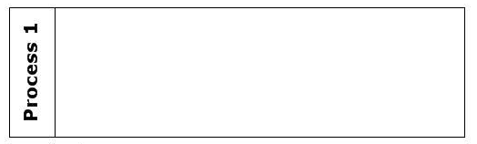 | Pool groups logically closed processes or businesses.
Lane | 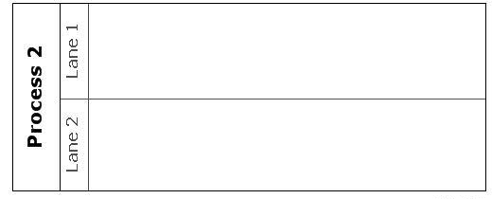 | Line groups all activities connected to one actor (usually name of the Line is name of the actor).
Group |  | Group includes logically closed activities situated in different pools, or lines.

