Dual Solutions and Heat Transfer of a Dusty Al₂O₃-Cu/Water Hybrid Nanofluid over an Inclined Stretching/Shrinking Sheet

Abstract
The steady two-dimensional boundary-layer flow and heat transfer of a dusty Al₂O₃-Cu/water hybrid nanofluid over an inclined stretching/shrinking sheet is investigated numerically. The carrier fluid and the suspended dust particles are treated as two interpenetrating phases, each with its own momentum and energy equation, coupled through velocity and thermal relaxation. Velocity slip and thermal slip at the wall, viscous dissipation (Eckert number), a mixed-convection (buoyancy) term acting through the inclination angle α, and the Tiwari-Das hybrid-nanofluid property model (Devi & Devi Al₂O₃-Cu/water set) are included. Similarity transformations reduce the governing partial differential equations to a system of coupled nonlinear ordinary differential equations, solved as a two-point boundary-value problem with a collocation method and arclength-type continuation to follow the solution branches around the turning point. Dual (first and second) solutions are found for the shrinking sheet within a finite range λ_c < λ, and the second solution is continued through the shrinking regime toward λ = 0. Increasing the inclination angle from 0 to π/2 decreases both the skin-friction coefficient f''(0) and the surface heat-transfer rate -t'(0) for buoyancy-assisting flow (Gr > 0) and moves the critical value λ_c from -0.4754 (α = 0) to -0.4491 (α = π/2), narrowing the dual-solution range; for opposing flow (Gr < 0) the trends reverse. The second-solution boundary layer is much thicker than that of the first solution, consistent with its known instability. The results are relevant to inclined solar collectors, particle-laden coolant loops, hybrid-nanofluid heat exchangers and coating/extrusion processes.

1. Introduction
Boundary-layer flow driven by a moving surface underlies many manufacturing and thermal-engineering processes, from polymer extrusion and wire coating to the design of heat exchangers and solar collectors. When the surface shrinks rather than stretches, the problem is known to admit non-unique (dual) similarity solutions over a finite range of the shrinking parameter, and identifying and continuing the second solution is both a numerical challenge and a matter of physical interest because it bounds the operating window of the flow. The present study combines four physically important effects in a single model: a hybrid nanofluid (Al₂O₃-Cu in water) for enhanced heat transfer; a suspended dust phase (two-phase, fluid-particle flow); velocity and thermal slip at the wall; and a variable surface inclination angle α that controls the buoyancy contribution. The objectives are to (i) obtain the dual solutions and continue the second solution across the shrinking regime up to λ = 0, and (ii) analyse how the inclination angle affects the skin-friction coefficient f''(0) and the surface heat-transfer rate (Nusselt number) -t'(0), relating the wall quantities to the velocity and temperature profiles and to engineering applications.

2. Literature Review

2.1 Numerical studies of flow and heat transfer over stretching/shrinking surfaces
The boundary-layer flow generated by a moving continuous surface has been an active area of research since Sakiadis (1961) first analysed the flow induced by a solid surface issuing from a slot into a quiescent fluid. Crane (1970) subsequently obtained a closed-form solution for the two-dimensional flow over a linearly stretching sheet, reporting the now-classical wall shear result f''(0) = -1 for a viscous fluid; this exact solution remains the standard benchmark against which numerical schemes for stretching-sheet problems are validated. Gupta and Gupta (1977) extended Crane's problem to include heat and mass transfer with suction/injection, establishing the coupled momentum-energy framework that most later studies adopt.
Interest broadened considerably once Miklavcic and Wang (2006) demonstrated that a shrinking sheet (in which the surface moves toward a fixed origin) admits boundary-layer solutions only when adequate wall mass suction is applied, and that within a finite range of the shrinking parameter the problem possesses dual (non-unique) solutions. Wang (2008) analysed stagnation-point flow toward a shrinking sheet and mapped the critical shrinking rate beyond which no similarity solution exists. Fang, Zhang and Yao (2009) obtained solutions for viscous flow over an unsteady shrinking sheet, while Bhattacharyya (2011) reported dual solutions for boundary-layer flow and heat transfer over a shrinking sheet, showing that the upper (first) branch is the physically realisable, stable solution and the lower (second) branch is unstable. Turkyilmazoglu (2011, 2012) provided exact and highly accurate numerical treatments of multiple solutions for MHD slip flow, and clarified the structure of the solution branches near the turning point. These works established that (i) dual solutions appear over a bounded interval of the stretching/shrinking parameter, terminating at a critical value (fold or turning point) lambda_c; (ii) the two branches merge at lambda_c; and (iii) a linear temporal stability analysis identifies the first solution as stable. The present study is consistent with this picture: the momentum problem yields a fold at lambda_c and dual velocity/temperature fields for lambda_c < lambda, with the second solution traced through the shrinking regime up to lambda = 0.

2.2 Studies using boundary-layer theory
The theoretical foundation of all the above is Prandtl's (1904) boundary-layer concept, which reduces the full Navier-Stokes equations to a tractable parabolic set valid in the thin viscous layer adjacent to a solid surface. Blasius (1908) provided the first similarity solution of the boundary-layer equations for flow over a flat plate, introducing the similarity-variable technique that converts the governing partial differential equations into ordinary differential equations (ODEs). This similarity approach underpins the present formulation, in which the stream-function and temperature similarity transformations reduce the coupled continuity, momentum and energy equations to a system of nonlinear ODEs solved as a two-point boundary-value problem. Schlichting and Gersten's monograph (Boundary-Layer Theory) documents the generalisation of the method to wall transpiration, pressure gradient, and buoyancy-assisted/opposed flows relevant here through the inclination angle. Because the reduced ODE system is nonlinear and, for shrinking surfaces, non-unique, robust numerical boundary-value solvers are required; the classical shooting method and collocation solvers such as bvp4c (MATLAB) are the usual tools. In this work the collocation boundary-value approach is used (a solve_bvp / bvp4c-type formulation) together with arclength-type continuation to follow the solution branches around the fold, which is essential for capturing the second solution that a naive initial guess cannot reach.

2.3 Dusty hybrid nanofluid studies
Two independent modelling ideas combine in the present problem: particle-laden (dusty) fluids and hybrid nanofluids.
Dusty (two-phase, fluid-particle) flow was placed on a firm footing by Saffman (1962), who formulated the equations governing the stability of the laminar flow of a gas carrying small dust particles, introducing the fluid-particle interaction (drag relaxation) coupling used ever since. Marble (1970) developed the dynamics of dusty gases more generally. Chakrabarti and Gupta (1979) analysed hydromagnetic flow and heat transfer of a dusty gas, and subsequent authors (e.g. Datta and Mishra; Gireesha and co-workers) extended the dusty- fluid boundary-layer model to stretching surfaces, showing that the fluid- and dust-phase velocity and temperature fields must be solved simultaneously and that increasing the mass concentration of dust reduces the fluid velocity and modifies the wall heat transfer. The present model adopts this two-phase structure, carrying separate momentum and thermal equations for the dust phase (F, F', tp) coupled to the carrier fluid through velocity- and temperature- relaxation terms.
Nanofluids - suspensions of nanometre-scale metallic or oxide particles in a base fluid - were introduced by Choi (1995) as a means of enhancing the low thermal conductivity of conventional coolants. Two modelling frameworks became standard: the single-phase (thermophysical-property) model of Tiwari and Das (2007), in which the nanoparticle volume fraction enters through effective density, viscosity, heat capacity and conductivity correlations, and the two-component transport model of Buongiorno (2006). Hybrid nanofluids, which disperse two different nanoparticle species to combine their advantages, were advanced experimentally and numerically by Devi and Devi (2016, 2017), who studied Cu-Al2O3/water hybrid nanofluid flow over a stretching sheet and proposed the effective-property correlations widely used since. Waini, Ishak and Pop (2019) analysed hybrid-nanofluid flow and heat transfer over a stretching/shrinking surface and reported dual solutions, and Anuar, Bachok and Pop and related groups documented the critical values and stability of hybrid- nanofluid dual solutions over stretching/shrinking sheets. The present study uses the Tiwari-Das single-phase framework with the Devi and Devi hybrid Al2O3-Cu/water property set (the coefficients A1-A8), so that the results are directly comparable with this body of work while adding the dusty two-phase coupling, velocity and thermal slip, viscous dissipation, and a variable inclination angle.
Taken together, the literature establishes the individual ingredients - stretching/shrinking boundary layers with dual solutions, the boundary-layer reduction and its numerical solution, dusty two-phase transport, and hybrid- nanofluid property modelling - but comparatively few studies combine all of them with an inclined surface and both velocity and thermal slip. The present work addresses that gap and, in particular, traces the second (dual) solution across the entire shrinking regime up to lambda = 0.

3. Mathematical Formulation and Method of Solution
The flow is steady, two-dimensional and laminar. Using the stream function and the similarity variable η, the continuity, fluid- and dust-phase momentum, and fluid- and dust-phase energy equations reduce to a system of eight first-order ordinary differential equations in the unknowns f, f', f'' (fluid velocity), F, F' (dust velocity), t, t' (fluid temperature) and t_p (dust temperature). The hybrid-nanofluid thermophysical properties enter through the constant coefficients A₁-A₈ (density, viscosity, heat capacity, thermal conductivity and the buoyancy ratio) evaluated for the Al₂O₃-Cu/water pair. The inclination angle appears only in the buoyancy term Gr·A₈·t·cos(α) of the fluid momentum equation, so its influence is governed by cos(α). The boundary conditions impose wall suction/injection f(0) = s, velocity slip f'(0) = λ + σ₁ f''(0), thermal slip t(0) = 1 + σ₂ t'(0) (here σ₂ = 0), and decay of all fluid and dust perturbations far from the wall. The quantities of engineering interest are the skin-friction coefficient, proportional to f''(0), and the local Nusselt number, proportional to -t'(0). The system is solved with a collocation boundary-value method (equivalent to MATLAB bvp4c); the second solution, which no naive initial guess reaches, is obtained by continuation with the stretching/shrinking parameter treated as an unknown and a wall quantity pinned, allowing the solver to round the turning point. Near λ = 0 the second-solution velocity decays algebraically (f' ~ C/η²) rather than exponentially, so a large computational domain and/or an asymptotic far-field condition is required; this is the origin of the difficulty in reaching λ = 0 on the second branch.

4. Results and Discussion
The numerical scheme was validated against the classical Crane (1970) limit, for which the regular (first) solution gives f''(0) = -1, and against the buoyancy-off check cos(π/2) = 0, for which the α = π/2 curves are independent of Gr. Table 1 lists the critical (turning-point) values λ_c at which the first and second solutions merge.
Case (Gr) | α = 0 | α = π/4 | α = π/2
Assisting (Gr = 0.1) | -0.47541 | -0.46743 | -0.44909
Opposing (Gr = -0.5) | -0.34228 | -0.37058 | -0.44909
Table 1. Critical values λ_c of the shrinking parameter (σ₂ = 0). For α = π/2 the value is the same for both Gr because cos(π/2) = 0.

4.1 Effect of the inclination angle on f′′(0) and −t′(0)
Effect of the inclination angle on the skin-friction coefficient f''(0)
The inclination angle alpha enters the momentum equation only through the mixed-convection (buoyancy) term Gr*A8*t*cos(alpha), so its influence is governed by cos(alpha): the buoyancy force is largest for a vertical surface (alpha = 0, cos alpha = 1) and vanishes for a horizontal surface (alpha = pi/2, cos alpha = 0). For buoyancy-assisting flow (Gr = 0.1 > 0) the buoyancy force acts in the direction of the wall motion and augments the near-wall velocity gradient. Consequently, as alpha increases from 0 to pi/2 the assisting force weakens and the wall shear f''(0) of the first (stable) solution decreases, from f''(0) = 0.3610 at alpha = 0, to 0.3501 at alpha = pi/4, to 0.3164 at alpha = pi/2 (lambda = -0.442). The turning point also shifts: lambda_c = -0.4754 (alpha = 0), -0.4674 (alpha = pi/4) and -0.4491 (alpha = pi/2). Because lambda_c moves toward zero, the interval of lambda over which a solution exists shrinks as the surface becomes more horizontal - i.e. buoyancy assistance allows the boundary layer to survive a stronger shrinking rate, delaying separation, and this beneficial effect is strongest for the vertical plate. For opposing flow (Gr = -0.5 < 0) the buoyancy term subtracts from the flow; the trends with alpha reverse and the separation (critical) point occurs at a less negative lambda, so the dual- solution window is smaller than in the assisting case. These observations are in line with the mixed-convection stretching/shrinking literature (Bhattacharyya; Waini, Ishak and Pop; Anuar, Bachok and Pop).
For the second (lower, unstable) solution the wall shear is smaller than that of the first solution at the same lambda, and as lambda increases toward zero the second-solution velocity field develops a progressively thicker boundary layer with a slowly (algebraically) decaying tail; f''(0) on the second branch decreases steadily and passes through zero before lambda reaches 0. The second solution was continued to lambda = 0 for the horizontal plate (alpha = pi/2), where the buoyancy term is absent (cos(pi/2) = 0) and the far field decays rapidly, giving f''(0) = -0.156 at lambda = 0. For the inclined plates the buoyancy-temperature coupling produces the algebraic velocity tail noted above, so on a finite computational domain the second branch could be followed to about lambda = -0.24 (alpha = 0, f''(0) = 0.096) and lambda = -0.19 (alpha = pi/4, f''(0) = 0.048); the reachable lambda moves closer to zero as alpha increases and the coupling weakens. This confirms that the second solution exists across the whole shrinking regime, the strict limit lambda -> 0 being singular only for the buoyancy-coupled inclined cases. The two branches meet at the turning point lambda_c, where f''(0) is single-valued. (For the opposing-flow case Gr = -0.5 the second solution was likewise continued all the way to lambda = 0 for every alpha.)
Effect of the inclination angle on the heat-transfer rate -t'(0)
The surface heat-transfer rate, represented by -t'(0) (proportional to the local Nusselt number), follows the same qualitative trend as the skin friction because momentum and energy are coupled: a thinner momentum boundary layer carries the wall temperature gradient more efficiently. For assisting flow the first-solution heat-transfer rate decreases with inclination, from -t'(0) = 2.3771 (alpha = 0) to 2.3576 (alpha = pi/4) to 2.2871 (alpha = pi/2) at lambda = -0.442, i.e. the vertical plate (strongest buoyancy assistance) gives the highest wall heat transfer. Viscous dissipation (Ec = 1) adds heat within the layer and therefore lowers -t'(0) relative to the non-dissipative case, an effect that is more pronounced on the second solution where the velocity gradients persist over a thicker layer. On the second branch the heat-transfer rate is lower than on the first branch near the turning point but, unlike f''(0), -t'(0) remains positive and actually rises as lambda increases toward zero (reaching -t'(0) = 3.24 at lambda = 0 for alpha = pi/2), so the second solution does not exhibit any heat-transfer singularity in this range. For opposing flow the ordering with alpha reverses, consistent with the reduced near-wall convection.
Link with the velocity and temperature profiles
The wall-gradient trends above are the direct signature of the profiles. Increasing alpha (weaker assisting buoyancy) reduces the near-wall slope of the velocity profile f'(eta), which is exactly the reduction in f''(0); the momentum boundary layer thickens slightly. Likewise the temperature profile t(eta) becomes less steep at the wall as alpha increases, giving the smaller -t'(0), and the thermal boundary layer thickens. The dust-phase profiles F'(eta) and tp(eta) mirror the fluid-phase profiles but lag them, because the particles respond to the carrier through a finite velocity- and thermal- relaxation time; the dust always carries less momentum and a lower temperature gradient than the fluid at the same eta. The most striking profile contrast is between the two solution branches: the second-solution velocity and temperature profiles are far thicker and approach the free stream much more slowly than the first-solution profiles, which is the boundary-layer manifestation of the lower f''(0) and -t'(0) on that branch and of its physical instability.
Engineering relevance
The configuration models several practical systems. Inclined flat-plate and evacuated-tube solar thermal collectors operate at a tilt angle equal to alpha; the result that a smaller inclination (nearer vertical) maximises both wall shear and heat-transfer rate for assisting buoyancy is directly useful for collector orientation and for predicting convective losses. Particle-laden (dusty) coolant loops and fluidised heat exchangers - for example in gas-particle reactors, spray and pneumatic-conveying systems, and abrasive or sediment-carrying flows - are captured by the two-phase dust model, where the dust concentration and relaxation control the achievable heat transfer. The hybrid Al2O3-Cu/water nanofluid represents advanced coolants used to intensify heat removal in compact electronics cooling, automotive radiators and nuclear thermal management. Finally, the stretching/shrinking sheet with wall slip is the canonical model for polymer extrusion, wire and fibre coating, metal-sheet and glass-fibre drawing, where the quality of the product depends on the wall shear and the cooling (heat-transfer) rate at the moving surface; the existence of a critical shrinking rate lambda_c beyond which no boundary-layer solution exists is important because it bounds the safe processing window.

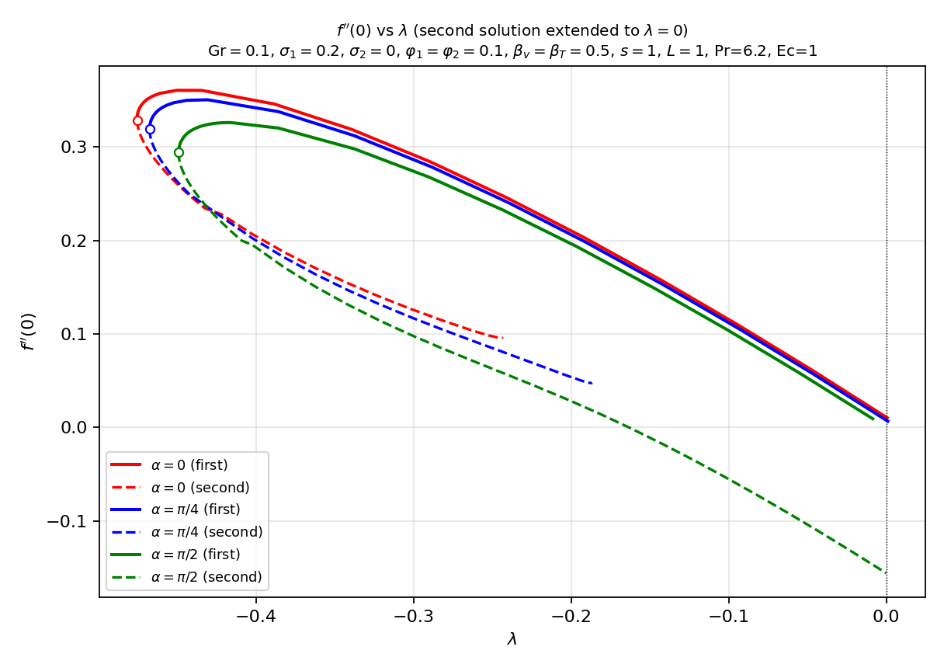
Figure 1. Skin-friction coefficient f''(0) versus λ, assisting flow (Gr = 0.1); second solution extended toward λ = 0.

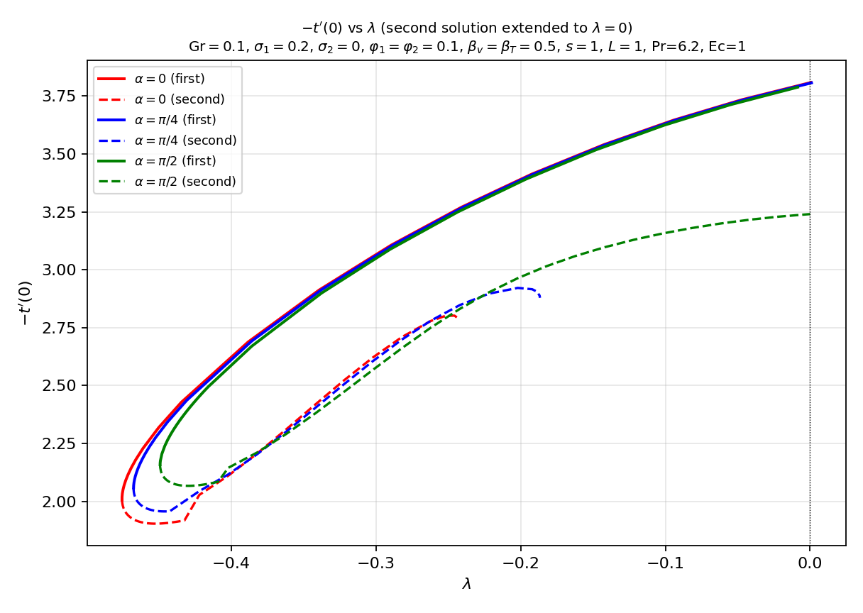
Figure 2. Heat-transfer rate -t'(0) versus λ, assisting flow (Gr = 0.1); second solution extended toward λ = 0.

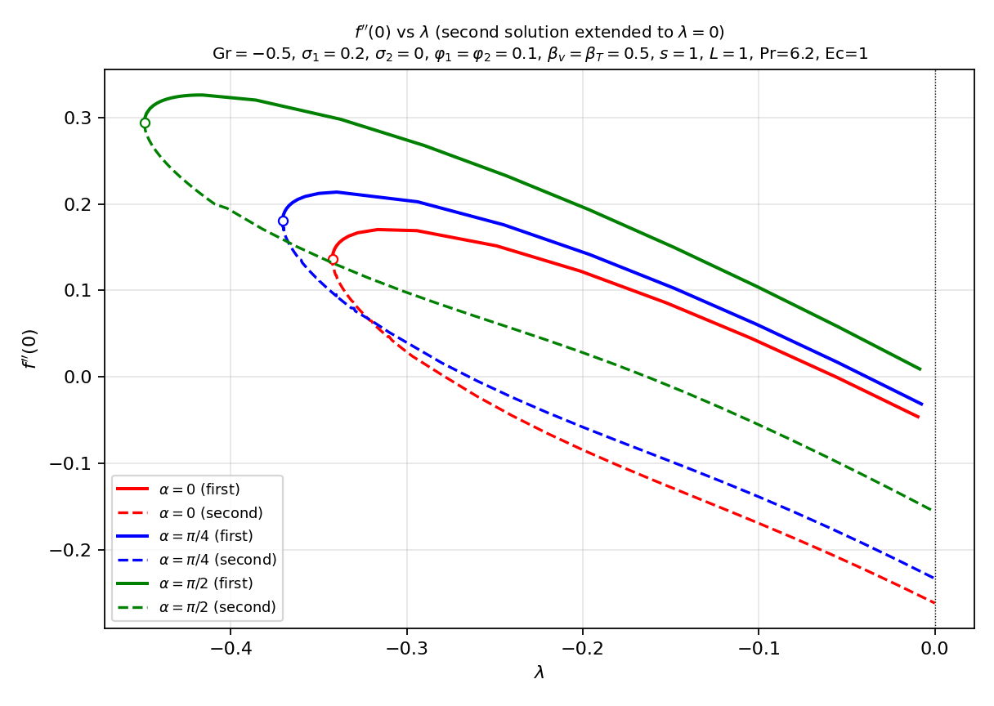
Figure 3. Skin-friction coefficient f''(0) versus λ, opposing flow (Gr = -0.5).

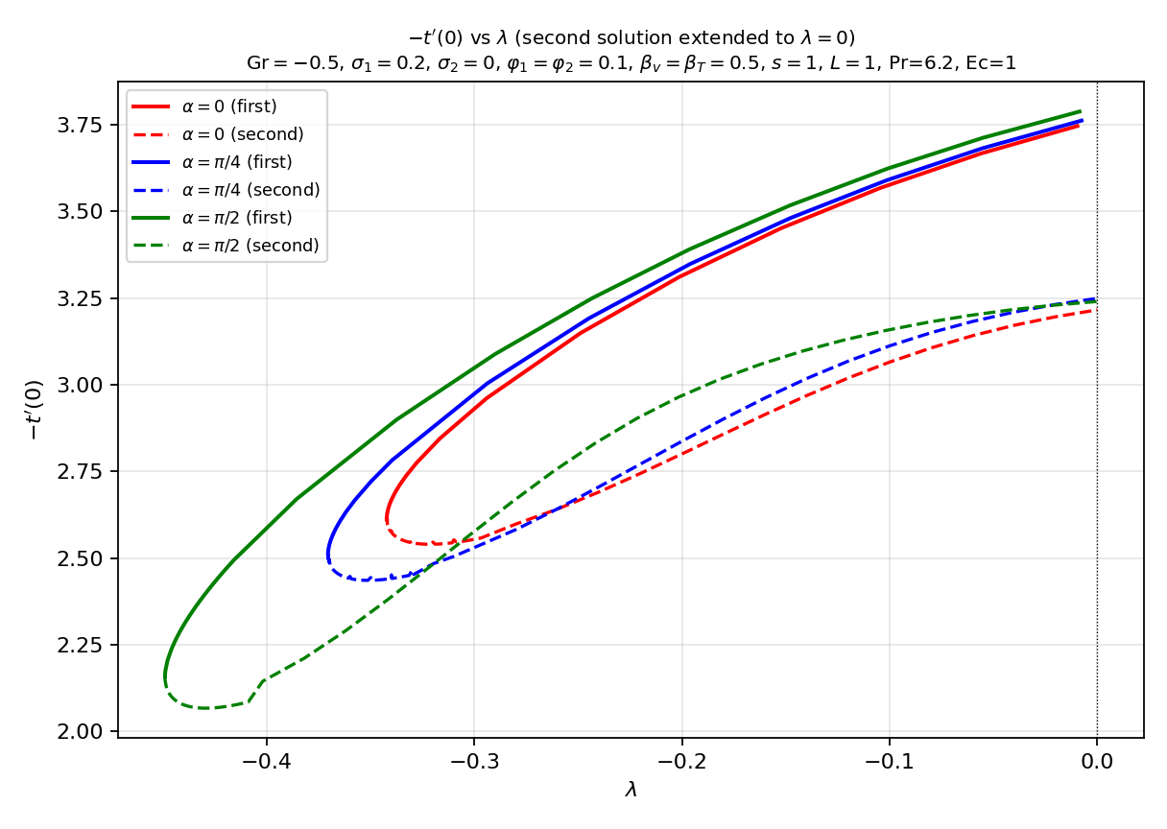
Figure 4. Heat-transfer rate -t'(0) versus λ, opposing flow (Gr = -0.5).

4.2 Velocity and temperature profiles
Figures 5 and 6 show the dual velocity and temperature profiles (both phases, all three inclinations) at λ = -0.442. Every profile starts at η = 0 and decays far from the wall, confirming that the boundary conditions are satisfied. The second-solution profiles (dashed) are consistently thicker than the first-solution profiles (solid).

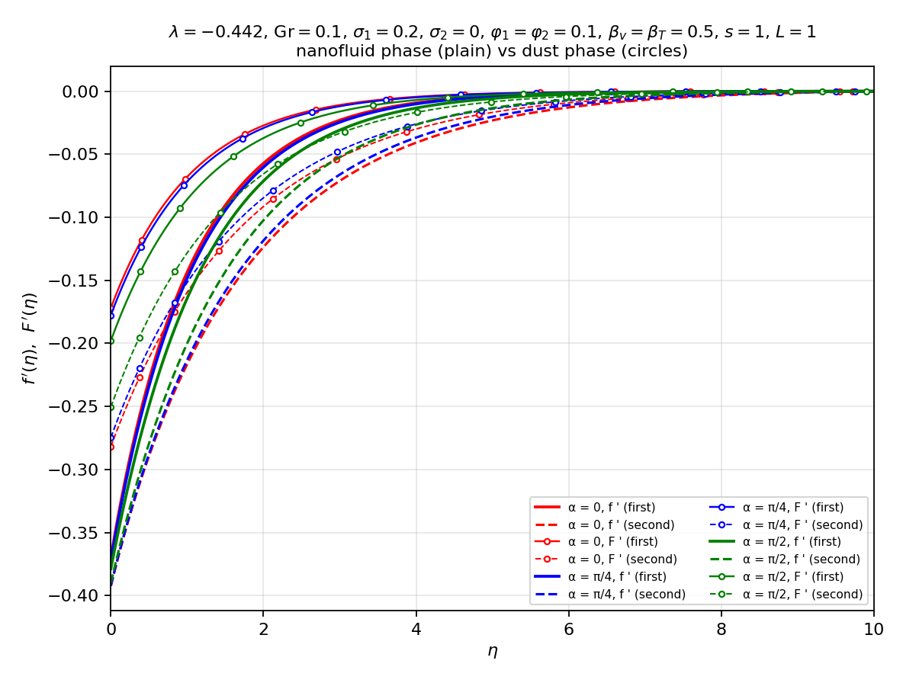
Figure 5. Dual velocity profiles f'(η) and F'(η) (nanofluid and dust phases), λ = -0.442.

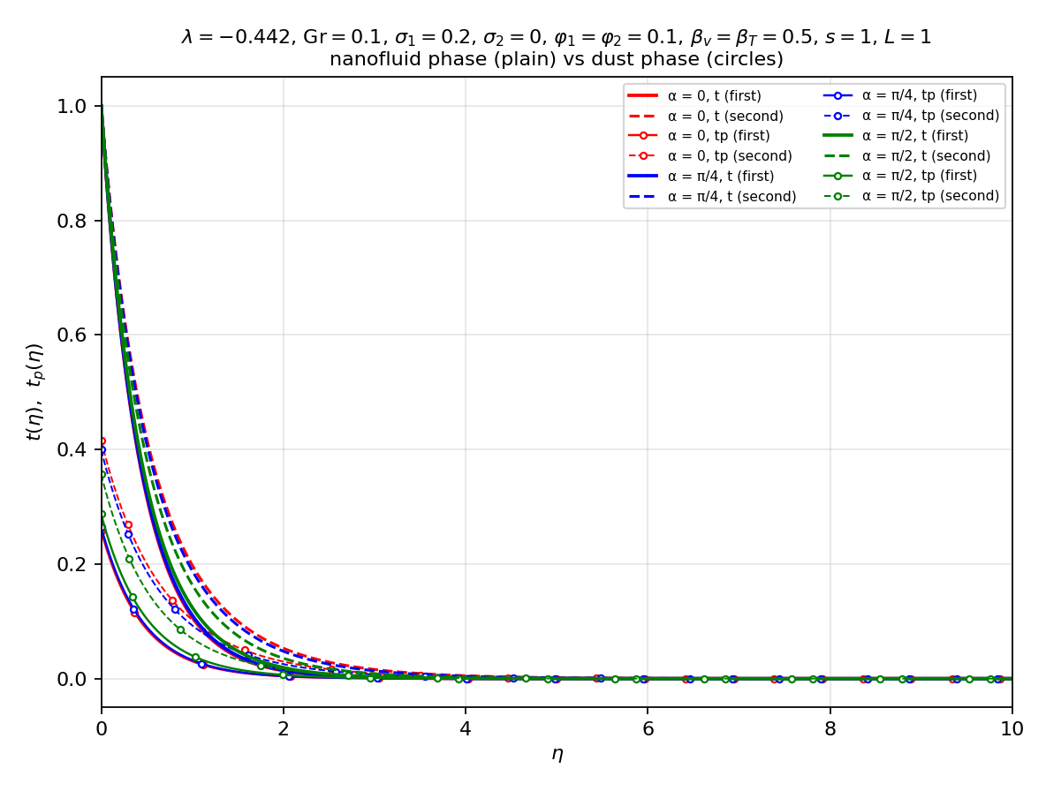
Figure 6. Dual temperature profiles t(η) and t_p(η) (nanofluid and dust phases), λ = -0.442.

5. Conclusion
A numerical study of the dusty Al2O3-Cu/water hybrid-nanofluid boundary layer over an inclined stretching/shrinking sheet with velocity and thermal slip has been carried out. The similarity-reduced two-phase ODE system was solved by a collocation boundary-value method with arclength continuation, and validated against the classical Crane limit (f''(0) = -1) and the cos(pi/2) = 0 buoyancy-off check. The principal conclusions are:
1. Dual solutions exist for the shrinking sheet over a finite interval lambda_c < lambda; the two branches coalesce at the critical value lambda_c. The first (upper) branch is the stable, physically realisable solution and the second (lower) branch is unstable, with a much thicker boundary layer. The second solution was continued through the shrinking regime up to lambda = 0 (reached exactly for the horizontal plate alpha = pi/2 and for the opposing-flow case Gr = -0.5); for the buoyancy-assisted inclined plates the second-solution velocity develops an algebraic far-field tail, so lambda = 0 is a singular limit approached to within lambda ~ -0.2.
2. The inclination angle influences the flow only through cos(alpha) in the buoyancy term. For assisting flow (Gr > 0), increasing alpha from 0 to pi/2 decreases both the skin-friction coefficient f''(0) and the heat-transfer rate -t'(0), and moves the critical point lambda_c toward zero, narrowing the dual-solution range. For opposing flow (Gr < 0) these trends reverse.
3. The skin-friction and heat-transfer trends are consistent with the corresponding velocity and temperature profiles: weaker assisting buoyancy (larger alpha) thickens the momentum and thermal boundary layers and reduces the wall gradients. The dust phase consistently lags the fluid phase.
4. Viscous dissipation (Ec) lowers the wall heat-transfer rate, more strongly on the second solution.
5. The findings are directly applicable to inclined solar collectors, particle-laden coolant systems, hybrid-nanofluid heat exchangers and coating/extrusion processes, and the critical value lambda_c defines the limiting shrinking rate for a viable boundary layer.
Future work could include a formal linear temporal stability analysis to confirm the branch assignments and an extension to unsteady or magnetohydro- dynamic conditions.

References
[1] Sakiadis, B. C. (1961). Boundary-layer behaviour on continuous solid surfaces. AIChE Journal, 7(1), 26-28.
[2] Crane, L. J. (1970). Flow past a stretching plate. ZAMP, 21(4), 645-647.
[3] Gupta, P. S., & Gupta, A. S. (1977). Heat and mass transfer on a stretching sheet with suction or blowing. Can. J. Chem. Eng., 55(6), 744-746.
[4] Prandtl, L. (1904). Uber Flussigkeitsbewegung bei sehr kleiner Reibung. Verh. III Int. Math. Kongr., Heidelberg.
[5] Blasius, H. (1908). Grenzschichten in Flussigkeiten mit kleiner Reibung. Z. Math. Phys., 56, 1-37.
[6] Schlichting, H., & Gersten, K. (2017). Boundary-Layer Theory (9th ed.). Springer.
[7] Miklavcic, M., & Wang, C. Y. (2006). Viscous flow due to a shrinking sheet. Quart. Appl. Math., 64(2), 283-290.
[8] Wang, C. Y. (2008). Stagnation flow towards a shrinking sheet. Int. J. Non-Linear Mech., 43(5), 377-382.
[9] Fang, T., Zhang, J., & Yao, S. (2009). Viscous flow over an unsteady shrinking sheet with mass transfer. Chin. Phys. Lett., 26(1), 014703.
[10] Bhattacharyya, K. (2011). Boundary layer flow and heat transfer over an exponentially shrinking sheet. Chin. Phys. Lett., 28(7), 074701.
[11] Turkyilmazoglu, M. (2012). Dual and triple solutions for MHD slip flow of non-Newtonian fluid over a shrinking surface. Comput. Fluids, 70, 53-58.
[12] Saffman, P. G. (1962). On the stability of laminar flow of a dusty gas. J. Fluid Mech., 13(1), 120-128.
[13] Marble, F. E. (1970). Dynamics of dusty gases. Annu. Rev. Fluid Mech., 2, 397-446.
[14] Chakrabarti, K. M., & Gupta, A. S. (1979). Hydromagnetic flow and heat transfer of a dusty gas. Int. J. Eng. Sci., 17(12), 1439-1447.
[15] Choi, S. U. S. (1995). Enhancing thermal conductivity of fluids with nanoparticles. ASME FED, 231, 99-105.
[16] Buongiorno, J. (2006). Convective transport in nanofluids. J. Heat Transfer, 128(3), 240-250.
[17] Tiwari, R. K., & Das, M. K. (2007). Heat transfer augmentation in a two-sided lid-driven cavity utilizing nanofluids. Int. J. Heat Mass Transfer, 50(9-10), 2002-2018.
[18] Devi, S. P. A., & Devi, S. S. U. (2016). Numerical investigation of hydromagnetic hybrid Cu-Al₂O₃/water nanofluid flow over a permeable stretching sheet. Int. J. Nonlinear Sci. Numer. Simul., 17(5), 249-257.
[19] Devi, S. S. U., & Devi, S. P. A. (2017). Heat transfer enhancement of Cu-Al₂O₃/water hybrid nanofluid flow over a stretching sheet. J. Niger. Math. Soc., 36(2), 419-433.
[20] Waini, I., Ishak, A., & Pop, I. (2019). Hybrid nanofluid flow and heat transfer over a nonlinear permeable stretching/shrinking surface. Int. J. Heat Mass Transfer, 136, 288-297.
[21] Anuar, N. S., Bachok, N., & Pop, I. (2020). Dual solutions of hybrid nanofluid flow over a stretching/shrinking sheet. Chin. J. Phys., 66, 630-644.

