Report

Overview
A new pharmaceutical company that specializes in anti-cancer medications. Recently, it began screening for potential treatments for squamous cell carcinoma (SCC), a commonly occurring form of skin cancer.
As a senior data analyst at the company, I have been given access to the complete data from their most recent animal study.
In this study, 249 mice who were identified with SCC tumors received treatment with a range of drug regimens. Over the course of 45 days, tumor development was observed and measured.
The purpose of this study was to compare the performance of Pymaceuticals’ drug of interest, Capomulin, against the other treatment regimens.
Data Analysis
The executive team has tasked you with generating all of the tables and figures needed for the technical report of the clinical study. They have also asked you for a top-level summary of the study results.

Data Analysis

First of all we start by reading our Database “ the mouse data and the study results”,Combining the data into a single DataFrame and finaly claining the data . we found 1 duplicated mice so the last number of mice is 248 .

second we generate a summary statistics table of mean, median, variance, standard deviation, and SEM of the tumor volume for each regimen

summary statistics table

Drug Regime Mean Median Variance Std Dev SEM
Capomulin 40.67 41.55 24.947764 4.994774 0.329346
Ceftamin 52.59 51.77 39.290177 6.268188 0.469821
Infubinol 52.884795 51.820584 43.128684 6.567243 0.492236
Ketapril 55.235638 53.698743 68.553577 8.279709 0.603860
Naftisol 54.331565 52.509285 66.173479 8.134708 0.596466
Placebo 54.033581 52.288934 61.168083 7.821003 0.581331
Propriva 52.320930 50.446266 43.852013 6.622085 0.544332
Ramicane 40.216745 40.673236 23.486704 4.846308 0.320955
Stelasyn 54.233149 52.431737 59.450562 7.710419 0.573111
Zoniferol 53.236507 51.818479 48.533355 6.966589 0.516398

thirt we visualise the total number of rows (Mouse ID/Timepoints) for each drug regimen

# Generate a bar plot showing the total number of rows (Mouse ID/Timepoints) for each drug regimen using Pandas.
# Group data by drug regimen and count the number of rows in each group

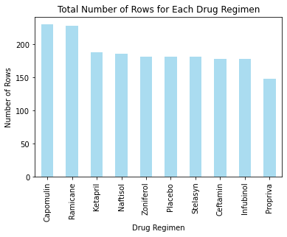

# Count the distribution of female and male mice

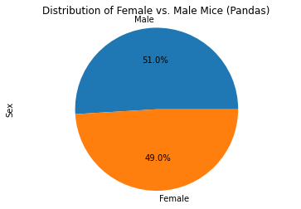

Analysis
the distribution of Male is 51% more greather than the distribution of female 49%

Calculate the final tumor volume of each mouse across four of the most promising treatment regimens: Capomulin, Ramicane, Infubinol, and Ceftamin. Then, calculate the quartiles and IQR, and determine if there are any potential outliers across all four treatment regimens

Capomulin's potential outliers: Series([], Name: Tumor Volume (mm3), dtype: float64)

Ramicane's potential outliers: Series([], Name: Tumor Volume (mm3), dtype: float64)

Infubinol's potential outliers: 31 36.321346 Name: Tumor Volume (mm3), dtype: float64

Ceftamin's potential outliers: Series([], Name: Tumor Volume (mm3), dtype: float64)

# Generate a box plot that shows the distrubution of the tumor volume for each treatment group.
# Create a boxplot

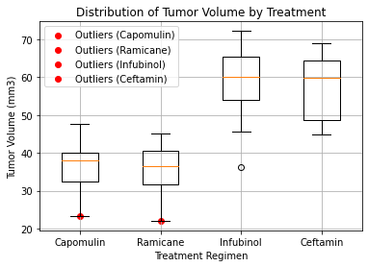

Analysis
when we look in the distrubution of the tumor volume for each treatment group we can localise easily the potential outliers across all four treatment regimens

# Generate a line plot of tumor volume vs. time point for a single mouse treated with Capomulin we choose the mice Id l509
mouse_id = "l509"
treatment = "Capomulin"

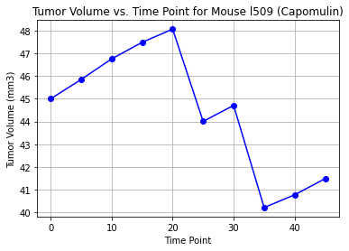

Analysis
we see that the tumor volume increase durant the 20 day of traitement after that it decrease so we have the best result in 35 day of Capomulin traitement ,
so the period optimum for this traitement is 35 days

Generate a scatter plot of mouse weight vs. the average observed tumor volume for the entire Capomulin regimen

# Generate scatter plot

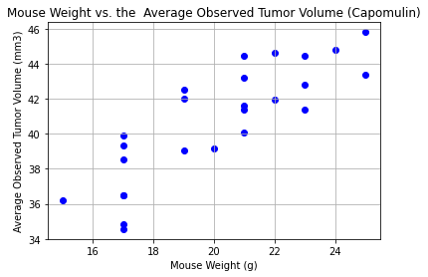

Analysis

we can observe that they are a relation between the mouse weight and the average observed tumor volume for the entire Capomulin regimen ,so it s better to decrease the weight for the best result for this Capomulin regimen

## Correlation and Regression

# Calculate the correlation coefficient and a linear regression model for mouse weight and average observed tumor volume for the entire Capomulin regimen

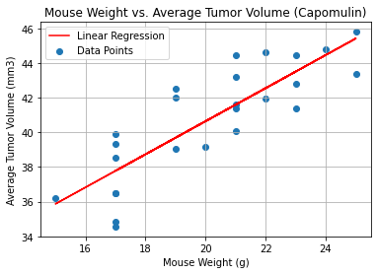

Analysis
we have a good correlation between the Mouse Weight and the Average tumor Volume also we have a positif regression

