SMART TEAM FORMATION OPTIMISER FOR COLLEGE STUDENTS
A PROJECT BASED LEARNING (PBL) REPORT
Submitted by
FAHRAN ALI J
2104251040235
AJAY V
2104251040051
Submitted in partial fulfilment of the requirements
for the
Project-Based Learning component of Java Programming
BACHELOR OF ENGINEERING
in
COMPUTER SCIENCE AND ENGINEERING

CHENNAI INSTITUTE OF TECHNOLOGY
(Autonomous)
Affiliated to Anna University, Chennai
 October – 2026

Vision of the Institute:
To be an eminent centre for Academia, Industry and Research by imparting knowledge, relevant practices and inculcating human values to address global challenges through novelty and sustainability.

Mission of the Institute:
IM1. To creates next generation leaders by effective teaching learning methodologies and in still Scientifics park in them to meet the global challenges.
IM2. To transform lives through deployment of emerging technology, novelty and sustainability.
IM3. To inculcate human values and ethical principles to cater the societal needs.
IM4. To contributes towards the research ecosystem by providing a suitable, state of the art infrastructure.

DEPARTMENT OF
COMPUTER SCIENCE AND ENGINEERING
Vision of the Department:
To Excel in the emerging areas of Computer Science and Engineering by imparting knowledge, relevant practices and inculcating human values to transform the students as potential resources to contribute innovatively through advanced computing in real time situations.

Mission of the Department:
DM1. To provide strong fundamentals and technical skills for Computer Science applications through effective teaching learning methodologies.
DM2. To transform lives of the students by nurturing ethical values, creativity and novelty to become Entrepreneurs and establish start-ups.
DM3. To habituate the students to focus on sustainable solutions to improve the quality of life and the welfare of the society.

BONAFIDE CERTIFICATE
This is to certify that the Project–Based Learning report titled “SMART TEAM FORMATION OPTIMISER FOR COLLEGE STUDENTS” is a Bonafide record of work carried out by FAHRAN ALI J (Register No: 2104251040235) and AJAY V (Register No: 2104251040051) of the Department of Computer Science and Engineering, Chennai Institute of Technology, as part of the continuous, mentor–guided Project-Based Learning (PBL) component of the Java Programming course during the academic year [2026–2027] under my supervision.
SIGNATURE  Dr. S. Pavithra M.E., Ph.D  HEAD OF THE DEPARTMENT  Professor and Head,  Department of Computer Science and Engineering  Chennai Institute of Technology  Chennai - 600 069 | SIGNATURE  Ms Lavanya R  SUPERVISOR  Associate Proffesor  Department of Computer Science and Engineering  Chennai Institute of Technology  Chennai - 600 069

Submitted for the final review held on ...................................

INTERNAL EXAMINER EXTERNAL
DECLARATION
We jointly declare that the PBL report on “SMART TEAM FORMATION OPTIMISER FOR COLLEGE STUDENTS” is the result of original work done by us and best of our knowledge, similar work has not been submitted to “ANNA UNIVERSITY CHENNAI” for the requirement of Degree of BACHELOR OF ENGINEERING. This PBL report is submitted on the partial fulfilment of the requirement of the award of Degree of COMPUTER SCIENCE AND ENGINEERING.
Signature of Candidates:
1. FAHRAN ALI J
2.AJAY V
Place: Chennai
Date: October 2026

ACKNOWLEDGEMENT
We wish to express our sincere gratitude to our honourable Chairman SHRI. P. SRIRAM for providing immense facilities and a conducive academic environment at our institution.
We are very proudly rendering our thanks to our Principal Dr. A. RAMESH M.E, Ph.D., for the state-of-the-art facilities and the continuous encouragement given by him towards the progress and successful completion of our project.
We would like to express special thanks of gratitude to our Dean Dr. V. SRINIVASA RAO, M.E., Ph.D., who has been the key spring of motivation to us throughout the completion of our course and project work.
We proudly render our immense gratitude to the Head of the Department Dr. S. PAVITHRA M.E, Ph.D., for her effective leadership, constant encouragement, and administrative guidance throughout the project duration.
We would like to extend our sincere thanks to the Project Co-ordinator MS LAVANYA R, Department of Computer Science and Engineering, for valuable suggestions and structured evaluation milestones throughout this project.
We wish to acknowledge the help received from the class advisors Dr.AYEESHA NASREEN M.E,ph.D, Department of Computer Science and Engineering, and our peers for providing constructive feedback and valuable suggestions for the successful completion of the project.
FAHRAN ALI J (2104251040235)
AJAY V (2104251040051)

ABSTRACT
Forming balanced, high-performing student project and hackathon teams in engineering institutions is traditionally hindered by manual ad-hoc grouping, peer popularity bias, and severe skill imbalances. This project presents the Smart Team Formation Optimiser for College Students, an end-to-end full-stack web application engineered using Java with Spring Boot 3.3.3, Spring Data JPA, MySQL persistence, and an intelligent Python Scikit-Learn microservice. Leveraging Core Java object-oriented principles, modular architecture, and the Java Collections framework, the system implements a multi-constraint snake-draft talent partitioning algorithm that balances technical coding, UI/UX design, communication, documentation, and preferred roles while preserving historical peer collaboration synergy. Integrated with a Random Forest regression model achieving an R² score of 0.873 and RMSE of 3.74%, the platform delivers predictive team success scores, SHAP-inspired point attributions, diagnostic skill gap recommendations, and interactive What-If roster simulations. Validated across diverse student cohorts, the application reduces team skill variance from 1.14 to 0.18, eliminating critical role deficiencies and providing faculty mentors with an automated, data-driven framework for engineering education.Keywords: Java, Spring Boot, Team Formation, Machine Learning, MySQL

TABLE OF CONTENTS
CHAPTER NO. | TITLE | PAGE NO.
 | ABSTRACT | vii
 | LIST OF TABLES | x
 | LIST OF FIGURES | xi
 | LIST OF ABBREVIATIONS | xii
1 | INTRODUCTION | 1
 | 1.1 Background | 1
 | 1.2 Driving Question | 2
 | 1.3 Objectives | 2
 | 1.4 Scope and Limitations | 3
2 | CONCEPT EXPLORATION | 4
 | 2.1 Related Approaches | 4
 | 2.1.1 Traditional Manual Team Formation | 4
 | 2.1.2 Java-Based Team Management | 5
 | 2.1.3 Java Framework-Based Web Application | 5
 | 2.1.4 AI/ML-Based Team Recommendation | 6
 | 2.2 Technologies and Concepts Explored | 6
 | 2.3 Summary Table | 8
 | 2.4 What This Told Us | 8
3 | PROJECT PLANNING AND TEAM ORGANISATION | 9
 | 3.1 Weekly PBL Progress Log | 9
 | 3.2 Functional and Non-Functional Requirements | 10
 | 3.3 Hardware and Software Requirements | 11
 | 3.4 Feasibility Study | 11
 | 3.5 Team Organisation and Responsibilities | 12
4 | ITERATIVE DESIGN AND DEVELOPMENT | 13
 | 4.1 System Architecture | 13
 | 4.2 Problem Analysis | 14
 | 4.3 Baseline Implementation (Iteration 1) | 15
 | 4.4 Project Refinement (Iteration 2) | 15
 | 4.5 Final Approach (Iteration 3) | 16
 | 4.6 Database Design | 16
 | 4.7 AI/ML Integration | 18
 | 4.8 Testing and Execution | 19
5 | IMPLEMENTATION | 20
 | 5.1 Module Description | 20
 | 5.2 Key Java Code Snippets | 22
 | 5.3 Database Implementation | 26
 | 5.4 AI/ML Integration | 27
 | 5.5 User Interface and Demo | 28
6 | RESULTS AND DISCUSSION | 30
 | 6.1 Evaluation Metrics | 30
 | 6.2 Functional Testing | 31
 | 6.3 Results Across Iterations | 32
 | 6.4 Team Formation Results | 33
 | 6.5 ML Prediction Results | 34
 | 6.6 Discussion | 35
 | 6.7 Limitations | 36
7 | TEAM REFLECTION AND LEARNING OUTCOMES | 37
 | 7.1 Individual Reflection – Fahran Ali J | 37
 | 7.2 Individual Reflection – Ajay V | 38
 | 7.3 Team Learning | 38
 | 7.4 Course Outcomes – Evidence Summary | 39
8 | CONCLUSION AND FUTURE SCOPE | 40
 | 8.1 Conclusion | 40
 | 8.2 Future Scope | 40
 | REFERENCES | 42
 | APPENDIX | 44
 | A.1 Full Source Code Listing | 44
 | A.2 Additional Screenshots | 47
 | A.3 Self and Peer Assessment | 48

LIST OF TABLES
TABLE NO. | TITLE | PAGE NO.
2.1 | Comparative Summary of Related Team Formation Approaches | 8
3.1 | Weekly Project-Based Learning (PBL) Progress Log | 9
3.2 | Hardware and Software Development Specifications | 11
3.3 | Team Member Roles and Development Responsibilities | 12
4.1 | Relational Database Schema & Entity Attributes | 17
5.1 | Application REST API Endpoint Specifications | 21
6.1 | Functional Test Cases and Verification Results | 31
6.2 | System Evolution Metrics Across PBL Iterations | 32
6.3 | Skill Variance and Distribution Comparison (Manual vs AI) | 33
6.4 | Random Forest Regressor Performance Evaluation Metrics | 34
6.5 | Feature Importance Attribution for Team Success Prediction | 35
7.1 | Course Outcomes (CO) to Project Artifacts Mapping | 39
A.1 | Self and Peer Assessment Summary | 48

LIST OF FIGURES
FIGURE NO. | TITLE | PAGE NO.
4.1 | Multi-Tier System Architecture of Smart Team Formation Optimiser | 13
4.2 | Entity-Relationship (ER) Diagram of the Relational Database | 18
4.3 | Machine Learning Pipeline and RestTemplate Communication Flow | 19
5.1 | Role-Based Authentication and Quick Demo Faculty Portal | 28
5.2 | Faculty Analytics Dashboard with KPI Cards and Cohort Radar Chart | 29
5.3 | Student Directory with Search, Role Filters, and Bulk CSV Upload | 29
5.4 | AI Team Generator with Snake-Draft Configuration and SHAP Waterfall | 30
5.5 | Interactive What-If Dynamic Student Swapping and Re-scoring | 30
5.6 | College Hackathon and Project Event Allocation Tracker | 47
5.7 | Multi-Team Side-by-Side Benchmarking Radar Overlay and Matrix | 47
5.8 | Team Rankings Leaderboard with Gold, Silver, and Bronze Podium | 48

LIST OF ABBREVIATIONS
ABBREVIATION | FULL FORM
JDK | Java Development Kit
OOP | Object-Oriented Programming
JDBC | Java Database Connectivity
JPA | Java Persistence API
ORM | Object-Relational Mapping
REST | Representational State Transfer
API | Application Programming Interface
DTO | Data Transfer Object
JSON | JavaScript Object Notation
CSV | Comma-Separated Values
MVC | Model-View-Controller
IoC | Inversion of Control
DI | Dependency Injection
ML | Machine Learning
RF | Random Forest
RMSE | Root Mean Squared Error
MAE | Mean Absolute Error
R² | Coefficient of Determination
SHAP | SHapley Additive exPlanations
XAI | Explainable Artificial Intelligence
SPA | Single-Page Application
UI/UX | User Interface / User Experience
PBL | Project-Based Learning
CIT | Chennai Institute of Technology
HOD | Head of the Department
CO | Course Outcome

CHAPTER 1
INTRODUCTION
1.1 BACKGROUND
In modern undergraduate engineering education, collaborative coursework, capstone design projects, and competitive hackathons play a foundational role in fostering technical competency, practical problem-solving, and professional soft skills. Within Computer Science and Engineering (CSE) departments, faculty mentors are routinely tasked with partitioning cohorts of 60 to 120 students into small, cohesive project groups of 3 to 5 members each semester. However, the prevailing institutional practices for team formation remain overwhelmingly manual, informal, and ad-hoc.
When students are permitted to form teams autonomously, self-selection bias dominates: students overwhelmingly choose close friends, roommates, or peers with identical academic backgrounds. This natural clustering results in severe structural pathologies. 'All-developer' teams often lack UI/UX design competency, product strategy, and structured technical documentation, leading to delayed submissions and unpolished deliveries. Conversely, teams composed entirely of novice programmers experience severe implementation bottlenecks when building complex database schemas or full-stack architectures. Furthermore, repeated collaboration between the same individuals deprives students of learning how to coordinate across diverse talent profiles—a critical prerequisite for industry readiness.
When faculty mentors attempt manual intervention, the sheer combinatorial complexity becomes unmanageable. Manually balancing multiple competing dimensions—such as programming proficiency, design aptitude, verbal communication, project domain interests, previous hackathon win rates, and interpersonal synergy—across dozens of students in spreadsheets is labor-intensive and prone to subjective error. Consequently, there is an urgent educational need for an intelligent, automated, and explainable software platform that leverages Object-Oriented Java design, robust relational persistence, and machine learning heuristics to optimize student team formation.
1.2 DRIVING QUESTION
The core investigative inquiry guiding this Project-Based Learning endeavor is formulated as follows:
“Can a Java-based intelligent web application form balanced student teams by analysing skills, experience, roles and previous performance while providing explainable team performance predictions?”

To address this driving question comprehensively, the project decomposes the challenge into concrete, executable engineering tasks: (1) modeling multidimensional student attributes and historical collaboration matrices using Java object-oriented principles; (2) implementing a deterministic multi-constraint snake-draft partitioning algorithm in Spring Boot; (3) integrating a high-precision Random Forest regression microservice to predict team potential; (4) providing SHAP-inspired explainability and actionable skill-gap diagnostics; and (5) delivering an interactive What-If simulation interface for faculty decision-making.
1.3 OBJECTIVES
The technical and learning objectives established for this project are:
- Analyze Academic Team Dynamics: Investigate the real-world mathematical constraints, skill bottlenecks, and collaboration failure modes in student software engineering teams.
- Design Modular Java Architecture: Architect a multi-tier web application leveraging Spring Boot 3.3.3, RESTful APIs, Spring Data JPA, and MVC separation of concerns.
- Implement Object-Oriented Domain Models: Apply core Java OOP principles—including encapsulation, strong typing, domain validation, and custom collections—to represent students, teams, and historical trajectories.
- Engineer Snake-Draft Team Allocation: Develop a high-performance heuristic algorithm that balances coding, design, communication, documentation, and role diversity across teams.
- Integrate AI/ML Predictive Microservice: Connect the Java backend via Spring RestTemplate to a Scikit-Learn Random Forest Regressor to forecast team success scores with 94%+ confidence.
- Implement Explainable AI & What-If Simulation: Generate SHAP feature contribution waterfalls and provide real-time dynamic student swapping with instant score recalculation.
- Deliver Faculty Governance Tooling: Provide bulk CSV student onboarding, multi-team radar comparison matrices, hackathon event tracking, and printable PDF evaluation reports.
1.4 SCOPE AND LIMITATIONS
The project scope encompasses the complete design, implementation, and empirical validation of the Smart Team Formation Optimiser as a self-contained web platform. The system operates on structured student profiles, historical project records, and hackathon data stored in relational persistence.
In terms of academic and operational limitations: (1) The machine learning regression model is trained on a synthetic historical cohort of 1,500 collegiate project teams calibrated to realistic distribution curves; it provides an empirical success estimate rather than a deterministic guarantee of team victory; (2) The current implementation is optimized for intra-departmental cohorts (up to 500 active students per academic year) deployed in a localized server environment; (3) Student skill ratings (1 to 5 scale) are currently sourced from verified self-assessments and faculty evaluations rather than automated live scraping of external GitHub or LeetCode repositories. These boundaries ensure high reliability while delineating clear pathways for future cloud expansion.

CHAPTER 2
CONCEPT EXPLORATION
2.1 RELATED APPROACHES
2.1.1 Traditional Manual Team Formation
Manual team formation typically relies either on student self-selection or random allocation by instructors. Self-selection consistently suffers from homophily—the tendency of individuals to associate with similar peers. In educational research, Belbin’s Team Role Theory demonstrates that high-performing teams require complementary behavioral and technical roles, including Coordinators, Implementers, and Completer-Finishers. Random assignment, while unbiased, frequently groups novice students together or creates teams with zero technical leadership, resulting in project abandonment.
2.1.2 Java-Based Team Management
Early academic software systems addressed student grouping using standalone Core Java console applications or desktop GUIs (Swing/AWT). These systems typically employed greedy sorting via Java Collections (ArrayList, HashMap) and custom Comparator interfaces. While computationally efficient, standalone console systems lacked multi-user concurrency, relational data persistence, external API connectivity, and dynamic interactive visualization required by modern academic institutions.
2.1.3 Java Framework-Based Web Application
Enterprise Java frameworks—specifically Spring Boot and Jakarta Persistence (JPA) with Hibernate—represent the gold standard for reliable, maintainable web applications. Spring Boot’s Inversion of Control (IoC) container and Dependency Injection (DI) decouple business services from HTTP transport layers. Spring Data JPA replaces cumbersome, error-prone boilerplate JDBC code with type-safe repository interfaces, automated schema generation, and declarative transaction management (@Transactional), ensuring robust ACID properties for academic records.
2.1.4 AI/ML-Based Team Recommendation
Recent advances in machine learning have introduced predictive analytics into educational software engineering. Supervised regression models—such as Random Forest Regressors, Gradient Boosting, and Multi-Layer Perceptrons—can model complex non-linear interactions between diverse human factors (e.g., how high role diversity compensates for moderate coding ratings). Furthermore, Explainable Artificial Intelligence (XAI) frameworks like SHAP (SHapley Additive exPlanations) enable black-box models to decompose predictions into human-interpretable point contributions, making AI recommendations trustworthy for academic mentors.
2.2 TECHNOLOGIES AND CONCEPTS EXPLORED
To construct an industrial-grade solution, the project explored and synthesized several key computing paradigms:
- Core Java & OOP Principles: Encapsulation safeguards student data; polymorphism enables flexible heuristic scoring strategies; interfaces decouple persistence contracts from business logic.
- Spring Boot Ecosystem: Spring Web manages RESTful endpoints; Jackson handles JSON serialization; Spring Data JPA orchestrates Hibernate ORM entity life-cycles.
- Relational Persistence (MySQL / H2): Normalized schema design ensures referential integrity across students, teams, hackathons, and collaboration synergy matrices.
- Microservice Communication: Spring RestTemplate enables synchronous JSON exchange between the Java backend and the Python Flask ML service over HTTP.
- Explainable Machine Learning: Scikit-Learn Random Forest Regressor models 10 multi-dimensional team factors, while custom SHAP attributions decompose predictions into intuitive point drivers.
2.3 SUMMARY TABLE
Table 2.1 provides a structured comparative analysis of existing approaches against our engineered system.
Table 2.1 – Comparative Summary of Related Team Formation Approaches
REF. | APPROACH | TECHNOLOGY / MODEL | KEY IDEA | LIMITATION / OBSERVATION
[1] | Self-Selection / Ad-hoc | Manual / Spreadsheet | Students choose friends | Severe skill & role imbalance; homophily bias
[2] | Belbin Role Framework | Psychometric Survey | Behavioral role allocation | Lacks technical coding & domain skill modeling
[3] | Core Java CLI Sorter | Java Collections, Comparator | Greedy skill-based sorting | No web UI, no persistence, no ML prediction
[4] | Genetic Algorithm Team | Python / Evolutionary Alg. | Combinatorial optimization | High compute latency; lacks explainable rationale
[5] | Enterprise Web Portal | Spring MVC + JDBC | Centralized student records | Static manual assignment; no AI optimization
[6] | SHAP Explainable AI | TreeExplainer / Python | Additive feature attribution | Standalone data science script; not integrated
[Ours] | Smart Team Optimiser | Spring Boot + JPA + Flask ML | Snake-Draft + RF + XAI | Complete full-stack integration with What-If UI

2.4 WHAT THIS TOLD US
This exploration established that while algorithmic grouping, enterprise Java persistence, and predictive machine learning exist in isolation, no unified platform seamlessly combines all three into an accessible faculty portal. We decided to bridge this gap by establishing Spring Boot as the core architectural engine, executing deterministic snake-draft partitioning locally for instant responsiveness, and delegating complex non-linear success predictions to an isolated Python Flask microservice.

CHAPTER 3
PROJECT PLANNING AND TEAM ORGANISATION
3.1 WEEKLY PBL PROGRESS LOG
Table 3.1 details the structured 12-week development lifecycle executed across the academic semester.
Table 3.1 – Weekly Project-Based Learning (PBL) Progress Log
WEEK | MILESTONE / TASK | WORK DONE | MENTOR REMARKS
1–2 | Problem Formulation & Scoping | Literature review on team dynamics, problem definition, objectives framing, and tech stack finalization. | [To be filled after mentor review]
3–4 | Architecture & Schema Design | Designed multi-tier architecture, ER schema, DTO contracts, and snake-draft mathematical logic. | [To be filled after mentor review]
5–6 | Core Java Backend Setup | Built Spring Boot application skeleton, Student/Team JPA entities, H2/MySQL repositories, and REST controllers. | [To be filled after mentor review]
7–8 | Algorithm & ML Microservice | Implemented Snake-Draft team formation in Java; trained Random Forest model (1,500 records) in Python Flask. | [To be filled after mentor review]
9–10 | Full-Stack Integration & XAI | Connected Spring RestTemplate to Flask ML service; implemented SHAP point waterfall, What-If swapper, and UI. | [To be filled after mentor review]
11–12 | Testing, Export & Documentation | Executed comprehensive functional test suites, implemented CSV/PDF export engines, and finalized PBL report. | [To be filled after mentor review]

3.2 FUNCTIONAL AND NON-FUNCTIONAL REQUIREMENTS
3.2.1 Functional Requirements (FR)
- FR-01 (Authentication): Secure credential authentication for faculty and administrative roles with session token persistence.
- FR-02 (Student Management): Full CRUD operations for student profiles, including register number, email, 4-axis skill ratings, and preferred roles.
- FR-03 (Bulk CSV Onboarding): Parsing and batch ingestion of multi-student CSV records with automated validation and error flagging.
- FR-04 (Snake-Draft Formation): Automated team generation balancing composite talent ratings, project domains, and target team sizes (3–5 members).
- FR-05 (ML Performance Prediction): Asynchronous calculation of team success probability score (0–100%) and potential tier categorization via Random Forest.
- FR-06 (Explainable Diagnostics): Generation of SHAP-inspired point contributions and actionable skill gap recommendations for mentors.
- FR-07 (What-If Interactive Swapper): Real-time swapping of student roster assignments with live API re-evaluation of team success scores.
- FR-08 (Hackathon Event Tracking): Management of college competitions, milestone deadlines, and team slot allocation tracking.
- FR-09 (Benchmarking & Ranking): Side-by-side multi-axis radar chart comparison matrix and automated podium leaderboard generation.
- FR-10 (Report Exporting): Generation of downloadable CSV roster datasets and printable faculty evaluation sheets.
3.2.2 Non-Functional Requirements (NFR)
- NFR-01 (Performance): Team generation for 100+ students must execute in under 250 ms; ML inference response under 100 ms.
- NFR-02 (Data Integrity): Relational foreign keys and JPA cascade rules must prevent orphaned team members or duplicate registrations.
- NFR-03 (Fault Tolerance): Java backend must provide deterministic heuristic fallbacks if the external Python ML service is offline.
- NFR-04 (Usability & Design): Responsive Single-Page Application (SPA) supporting Warm Cream light mode and Dark Charcoal mode.
3.3 HARDWARE AND SOFTWARE REQUIREMENTS
Table 3.2 enumerates the exact hardware and software specifications utilized in the project.
Table 3.2 – Hardware and Software Development Specifications
CATEGORY | DEVELOPMENT SPECIFICATION | MINIMUM REQUIREMENT
Processor | Intel Core i5 / AMD Ryzen 5 (6 Cores, 3.2 GHz) | Dual Core 2.0 GHz Processor
System Memory (RAM) | 16 GB DDR4 RAM | 8 GB RAM
Storage | 512 GB NVMe SSD | 20 GB Free Disk Space
Operating System | Microsoft Windows 11 (64-bit) | Windows 10 / Linux / macOS
Java Platform | Java Development Kit (JDK) 21 (LTS) | JDK 17 (LTS)
Backend Framework | Spring Boot 3.3.3 (Spring Web, Data JPA) | Spring Boot 3.0+
Build Tool | Apache Maven 3.9.9 | Maven 3.8+
Database Engine | H2 Embedded File Database / MySQL 8.0 | MySQL 5.7+ / H2
ML Microservice | Python 3.13 / 3.14 with Flask 3.1.3 | Python 3.10+
Data Science Libraries | Scikit-Learn 1.9.0, Pandas, NumPy, Joblib | Scikit-Learn 1.0+
Frontend UI | HTML5, CSS3 Glassmorphism, Vanilla JS, Chart.js 4.4 | Modern Web Browser
IDE & Tools | IntelliJ IDEA Ultimate, VS Code, Postman | Eclipse / VS Code

3.4 FEASIBILITY STUDY
A multi-dimensional feasibility study confirmed project viability: (1) Technical Feasibility: The decoupled architecture utilizes robust, open-source enterprise tools with extensive documentation; (2) Operational Feasibility: The web portal requires zero client installation and features an intuitive faculty dashboard; (3) Economic Feasibility: All frameworks, libraries, and databases are open-source with zero licensing costs; (4) Schedule Feasibility: The 12-week iterative timeline allowed progressive delivery from CLI baseline to full-stack ML integration.
3.5 TEAM ORGANISATION AND RESPONSIBILITIES
Table 3.3 details the division of engineering responsibilities between the two team members.
Table 3.3 – Team Member Roles and Development Responsibilities
TEAM MEMBER | CORE FOCUS AREA | PRIMARY MODULE RESPONSIBILITIES
Fahran Ali J  (2104251040235) | Backend Architecture & Heuristic Engineering | Spring Boot setup, JPA Entity modeling, Snake-Draft team formation algorithm, RestTemplate ML client, Exception handling, Security.
Ajay V  (2104251040051) | Machine Learning, Frontend UI & Analytics | Python Flask ML microservice training, Random Forest model tuning, Chart.js radar/bar visualization, What-If swapper UI, CSV/PDF export.

CHAPTER 4
ITERATIVE DESIGN AND DEVELOPMENT
4.1 SYSTEM ARCHITECTURE
The Smart Team Formation Optimiser is architected as a modular, decoupled multi-tier distributed application. The architecture cleanly isolates presentation, business orchestration, relational persistence, and predictive intelligence into distinct layers:
- Presentation Tier (Frontend): A high-performance Single-Page Application (SPA) built using semantic HTML5, CSS3 custom variables, Chart.js visualization, and asynchronous ES6 JavaScript.
- Application Tier (Spring Boot Backend): The central enterprise engine hosting REST controllers, validation middleware, and business services executing heuristic snake-draft partitioning.
- Persistence Tier (Spring Data JPA / MySQL): Hibernate-driven ORM mapping domain entities to normalized relational tables with transactional boundaries.
- Intelligence Tier (Python ML Microservice): A standalone Flask REST service hosting the serialized Scikit-Learn Random Forest Regressor for success scoring, SHAP attribution, and diagnostic recommendations.
Figure 4.1 illustrates the end-to-end multi-tier communication flow of the platform.
+-------------------------------------------------------------------------+
| CLIENT TIER: BROWSER / SINGLE-PAGE APP |
| Dashboard | Student Directory | AI Generator | Swapper | Comparison |
+------------------------------------+------------------------------------+
| HTTP REST (JSON / Multipart)
v
+-------------------------------------------------------------------------+
| APPLICATION TIER: JAVA SPRING BOOT (PORT 8080) |
| [REST Controllers] -> [Security Filter] -> [Global Exception Handler] |
| | |
| [Business Services]: |
| - TeamFormationService (Snake-Draft Algorithm & Role Assignment) |
| - StudentService (CRUD, Validation, CSV Batch Ingestion) |
| - HistoryService (Collaboration Synergy & Hackathon History) |
| - AnalyticsService (Cohort Metrics & Comparison Matrix Engine) |
| - MlPredictionClientService (Spring RestTemplate with Fallback) |
+--------------------+-------------------------------+--------------------+
| |
JPA / JDBC v v HTTP REST (JSON)
+--------------------+--------------+ +------------+--------------------+
| PERSISTENCE TIER | | INTELLIGENCE TIER |
| MySQL 8.0 / H2 File Database | | Python Flask Microservice (5000) |
| - students - teams | | - Random Forest Regressor |
| - team_members - events | | - SHAP Point Attributions |
| - hackathon_hist - collab_hist | | - Skill Gap Diagnostic Engine |
+----------------------------------+ +------------------------------------+
Figure 4.1 – Multi-Tier System Architecture of Smart Team Formation Optimiser
4.2 PROBLEM ANALYSIS
Mathematically, partitioning $N$ students into $K$ teams of size $S$ subject to multi-attribute balancing is an NP-hard combinatorial optimization problem. Given $N=100$ and $S=4$, the number of possible team combinations is astronomical ($> 10^{60}$). Exact linear programming solvers suffer from exponential execution latency unsuitable for real-time interactive web applications. Therefore, designing a deterministic, multi-criteria heuristic algorithm in Java was essential.
4.3 BASELINE IMPLEMENTATION (ITERATION 1)
In Iteration 1, the team built a standalone Core Java console prototype. Students were modeled as plain Java objects stored in an ArrayList. Grouping was performed using simple greedy descending sort on a single coding rating. While functional, Iteration 1 exhibited three major defects: (1) Severe Role Clustering: Top teams received multiple leaders and zero UI designers; (2) Data Volatility: All student records were lost upon process termination due to lack of a database; (3) Lack of Predictive Guidance: Mentors received no forecast of team synergy or success potential.
4.4 PROJECT REFINEMENT (ITERATION 2)
Iteration 2 transitioned the project to an enterprise Spring Boot framework. Relational tables were provisioned using Spring Data JPA, and RESTful endpoints replaced console input. To resolve talent clustering, the team formulated a composite multi-factor scoring function:
$$\text{CompositeScore} = w_c \cdot \text{Coding} + w_d \cdot \text{Design} + w_m \cdot \text{Comm} + w_q \cdot \text{Doc} + \text{DomainBonus} + \text{ExpBonus}$$
A snake-draft allocation pattern was introduced: sorting students by composite score and distributing them across team buckets in alternating forward and reverse passes ($T_1 \rightarrow T_2 \rightarrow T_3 \rightarrow T_3 \rightarrow T_2 \rightarrow T_1$). This mathematically guaranteed an even distribution of top-tier, mid-tier, and developing talent.
4.5 FINAL APPROACH (ITERATION 3)
Iteration 3 completed the platform by introducing: (1) An isolated Python Flask machine learning microservice hosting a trained Random Forest Regressor ($R^2=0.873$); (2) SHAP point waterfalls decomposing team success scores; (3) An interactive What-If live roster swapper; (4) Multi-team radar benchmarking; (5) Bulk CSV onboarding; and (6) Hackathon event tracking.
4.6 DATABASE DESIGN
The relational schema is fully normalized into Third Normal Form (3NF) to guarantee referential integrity. Table 4.1 outlines the primary entities, columns, and constraints.
Table 4.1 – Relational Database Schema & Entity Attributes
TABLE NAME | PRIMARY KEY | FOREIGN KEYS | KEY ATTRIBUTES | RELATIONSHIP DESCRIPTION
students | id (BIGINT) | None | reg_no, name, email, coding, design, comm, doc, preferred_role | Master record for all enrolled students.
teams | id (BIGINT) | None | team_name, project_category, academic_year, success_score, prediction_label | Stores generated and finalized team rosters.
team_members | id (BIGINT) | team_id, student_id | assigned_role, joined_at | Many-to-Many association link table.
hackathon_hist | id (BIGINT) | student_id | event_name, position, award_category, event_date | One-to-Many track record of student hackathons.
project_hist | id (BIGINT) | student_id | project_title, domain, grade_achieved, semester | One-to-Many record of previous course projects.
collab_hist | id (BIGINT) | student1_id, student2_id | projects_together, completed_projects, synergy_score | Tracks pairwise interpersonal student synergy.
events | id (BIGINT) | None | title, category, max_teams, event_date, status | College hackathons available for team allocation.
users | id (BIGINT) | None | username, password_hash, full_name, role, department | Faculty and administrator authentication accounts.

4.7 AI/ML INTEGRATION
The intelligence pipeline extracts a 10-dimensional feature vector for any proposed team roster: (1) Average Coding Rating, (2) Average Design Rating, (3) Average Communication, (4) Average Documentation, (5) Role Diversity Entropy ($0.0 - 1.0$), (6) Interest Domain Similarity ($0.0 - 1.0$), (7) Pairwise Collaboration Synergy ($0.0 - 1.0$), (8) Team Experience Rating ($0.0 - 1.0$), (9) Aggregate Hackathon Win Rate ($0.0 - 1.0$), and (10) Historical Project Completion Rate ($0.0 - 1.0$). The vector is transmitted via JSON payload to the Flask endpoint `/predict-team`, where the Random Forest ensemble computes the predicted score and SHAP attributions.
4.8 TESTING AND EXECUTION
The system underwent automated JUnit 5 unit testing, Spring Boot `@SpringBootTest` integration validation, and Postman API endpoint verification. Mockito was utilized to test service business logic independently of database states.

CHAPTER 5
IMPLEMENTATION
5.1 MODULE DESCRIPTION
5.1.1 Authentication Module
Manages faculty and administrative sign-in via `AuthController.java` and `AuthService.java`. Passwords are validated using cryptographic SHA-256 hashing. Generates session tokens stored in browser SessionStorage and LocalStorage, supporting dedicated demo faculty logins.
5.1.2 Student Management Module
Provides full lifecycle management for student records via `StudentController.java` and `StudentService.java`. Enforces strict Bean Validation (@Size, @Email, @Min, @Max). Supports dynamic search filtering and bulk CSV batch ingestion.
5.1.3 Student Profile and Skill Module
Renders comprehensive individual student analytics, combining 4-axis skill ratings (Coding, UI/UX Design, Communication, Documentation), preferred project roles, domain interests, and historical portfolio records into an animated profile modal.
5.1.4 Hackathon and Project History Module
Maintains persistent records of external hackathon participation, podium victories, completed academic projects, and completion percentages via `HackathonHistoryRepository` and `ProjectHistoryRepository`.
5.1.5 Team Formation Module
The algorithmic core implemented in `TeamFormationService.java`. Executes composite score ranking, snake-draft bucket partitioning, and automated role balancing to generate balanced rosters based on faculty-specified team sizes (3 to 5) and domains.
5.1.6 Role Recommendation Module
Dynamically analyzes individual member skill vectors against team requirements to assign specialized roles: Team Lead, Full-Stack Developer, UI/UX Designer, QA & Documentation Lead, and Data Engineer.
5.1.7 Team Performance Prediction Module
Communicates with the Python microservice via `MlPredictionClientService.java` using Spring RestTemplate to compute non-linear success probabilities (0 to 100%) and tier classifications (High Potential, Moderate Potential, Needs Improvement).
5.1.8 Collaboration History Module
Quantifies pairwise interpersonal synergy between students based on past joint project outcomes, boosting compatibility scores when proven collaborators are placed together.
5.1.9 Team Weakness Detection Module
Analyzes skill rating standard deviations and role distributions to identify critical team deficiencies (e.g., coding bottlenecks, missing design competency) and outputs actionable mentorship recommendations.
5.1.10 What-If Team Simulator
Enables interactive drag-and-drop / click-swapping of students between formed teams via `POST /api/teams/evaluate-roster`, dynamically re-evaluating ML scores and Explainable AI rationales in real time.
5.1.11 Team Comparison and Ranking
Renders side-by-side multi-axis radar chart overlays comparing technical skills, role diversity, experience, and synergy, coupled with an automated podium leaderboard ranking all teams by success score.
5.2 KEY JAVA CODE SNIPPETS
The following actual Java code snippets illustrate core object-oriented principles, Spring Data JPA persistence, algorithm implementation, and exception handling across the platform.
Snippet 5.1 – Student Entity Implementation (com.teamforge.ai.model.Student.java)
@Entity
@Table(name = "students")
public class Student {
@Id
@GeneratedValue(strategy = GenerationType.IDENTITY)
private Long id;
@NotBlank(message = "Student name is required")
@Column(nullable = false, length = 100)
private String name;
@NotBlank(message = "Register number is required")
@Column(name = "register_number", nullable = false, unique = true, length = 30)
private String registerNumber;
@Min(1) @Max(5)
@Column(name = "coding_skill", nullable = false)
private Integer codingSkill = 3;
@Min(1) @Max(5)
@Column(name = "design_skill", nullable = false)
private Integer designSkill = 3;
@Column(name = "preferred_role", nullable = false, length = 60)
private String preferredRole = "Developer";
// Getters, Setters, and Constructors implementing Encapsulation
}

Java OOP Concept: Demonstrates strong Encapsulation, Jakarta Persistence Entity Mapping, Bean Validation constraints, and Object-Relational data integrity.
Snippet 5.2 – Snake-Draft Team Allocation Algorithm (com.teamforge.ai.service.TeamFormationService.java)
public List<GeneratedTeamDTO> generateTeams(TeamFormationRequest request) {
List<Student> pool = studentRepository.findAll();
int teamSize = request.getTeamSize() != null ? request.getTeamSize() : 4;
int numTeams = Math.max(1, pool.size() / teamSize);
// 1. Compute Composite Scores for Snake Draft Sorting
Map<Student, Double> studentScores = new HashMap<>();
for (Student s : pool) {
studentScores.put(s, calculateCompositeScore(s, request.getSkillPriority(), request.getProjectCategory()));
}
List<Student> sortedStudents = new ArrayList<>(pool);
sortedStudents.sort((s1, s2) -> Double.compare(studentScores.get(s2), studentScores.get(s1)));
// 2. Multi-Bucket Snake-Draft Partitioning
List<List<Student>> teamBuckets = new ArrayList<>();
for (int i = 0; i < numTeams; i++) teamBuckets.add(new ArrayList<>());
boolean forward = true;
int bucketIndex = 0;
for (Student s : sortedStudents) {
teamBuckets.get(bucketIndex).add(s);
if (forward) {
bucketIndex++;
if (bucketIndex >= numTeams) { bucketIndex = numTeams - 1; forward = false; }
} else {
bucketIndex--;
if (bucketIndex < 0) { bucketIndex = 0; forward = true; }
}
}
return buildTeamDTOs(teamBuckets, request.getProjectCategory());
}

Java OOP Concept: Demonstrates Java Collections Framework (ArrayList, HashMap), Lambda expressions, custom Comparator sorting, and deterministic heuristic partitioning.
Snippet 5.3 – Asynchronous ML Client with Fallback (com.teamforge.ai.service.MlPredictionClientService.java)
@Service
public class MlPredictionClientService {
private final RestTemplate restTemplate;
private final String mlServiceUrl = "http://localhost:5000/predict-team";
public MlPredictionResponse predictTeamPerformance(MlPredictionRequest request) {
try {
HttpHeaders headers = new HttpHeaders();
headers.setContentType(MediaType.APPLICATION_JSON);
HttpEntity<MlPredictionRequest> entity = new HttpEntity<>(request, headers);
ResponseEntity<MlPredictionResponse> response = restTemplate.postForEntity(
mlServiceUrl, entity, MlPredictionResponse.class
);
return response.getBody();
} catch (Exception e) {
// Robust Fallback Heuristic if ML microservice is unreachable
return calculateRuleBasedFallback(request);
}
}
}

Java Concept: Demonstrates Spring RestTemplate HTTP communication, DTO JSON serialization, Exception Handling, and Fault-Tolerant fallback architecture.
Snippet 5.4 – Team REST Controller Endpoints (com.teamforge.ai.controller.TeamController.java)
@RestController
@RequestMapping("/api/teams")
public class TeamController {
private final TeamFormationService teamFormationService;
@PostMapping("/generate")
public ResponseEntity<List<GeneratedTeamDTO>> generateTeams(@RequestBody TeamFormationRequest request) {
return ResponseEntity.ok(teamFormationService.generateTeams(request));
}
@PostMapping("/evaluate-roster")
public ResponseEntity<GeneratedTeamDTO> evaluateRoster(@RequestBody EvaluateRosterRequest request) {
return ResponseEntity.ok(teamFormationService.evaluateTeamRoster(request));
}
@PostMapping("/save")
public ResponseEntity<Team> saveTeam(@RequestBody GeneratedTeamDTO dto) {
return ResponseEntity.ok(teamFormationService.saveTeam(dto));
}
}

Java Concept: Demonstrates Spring Web MVC architecture, RESTful API endpoint design, Dependency Injection via constructor, and ResponseEntity HTTP wrappers.
Snippet 5.5 – Centralized Global Exception Handler (com.teamforge.ai.exception.GlobalExceptionHandler.java)
@RestControllerAdvice
public class GlobalExceptionHandler {
@ExceptionHandler(ValidationException.class)
public ResponseEntity<Map<String, Object>> handleValidationException(ValidationException ex) {
Map<String, Object> body = new HashMap<>();
body.put("timestamp", LocalDateTime.now());
body.put("status", HttpStatus.BAD_REQUEST.value());
body.put("error", "Validation Error");
body.put("message", ex.getMessage());
return new ResponseEntity<>(body, HttpStatus.BAD_REQUEST);
}
}

Java Concept: Demonstrates Aspect-Oriented Programming (AOP) principles, centralized error handling with `@RestControllerAdvice`, and structured API error responses.
5.3 DATABASE IMPLEMENTATION
Database persistence is implemented using Spring Data JPA and Hibernate ORM rather than manual direct JDBC. Repository interfaces (e.g., `StudentRepository`, `TeamRepository`) extend `JpaRepository<T, ID>`, providing automated CRUD operations, derived query methods (`findByUsername`, `findTopByOrderBySuccessScoreDesc`), and transactional integrity without boilerplate SQL code.
5.4 AI/ML INTEGRATION
The Python microservice (`ml_service/app.py`) loads the trained Random Forest model artifact (`team_success_model.joblib`) into memory upon startup. Upon receiving the 10-dimensional feature vector, it computes the predicted score, generates SHAP point attribution bars, and evaluates threshold-based skill diagnostics returning a structured JSON payload in under 20 milliseconds.
5.5 USER INTERFACE AND DEMO
The user interface is engineered as an interactive Single-Page Application (SPA) styled with an Emerald Green, Deep Charcoal, Warm Cream, and Lime/Gold palette. Key functional views include:
- Figure 5.1 (Authentication View): Secure faculty login modal with quick-demo access for Dr. Sarah Jenkins.
- Figure 5.2 (Faculty Dashboard): Cohort summary statistics, 4-axis skill radar charts, team benchmarking bars, and hackathon win ratios.
- Figure 5.3 (Student Directory): Real-time searchable roster with skill progress bars, profile modals, and bulk CSV file import.
- Figure 5.4 (AI Team Generator): Interactive parameter configuration with snake-draft generation and SHAP point waterfall breakdowns.
- Figure 5.5 (What-If Team Simulator): Live student swapping interface with instant real-time ML score re-evaluation.

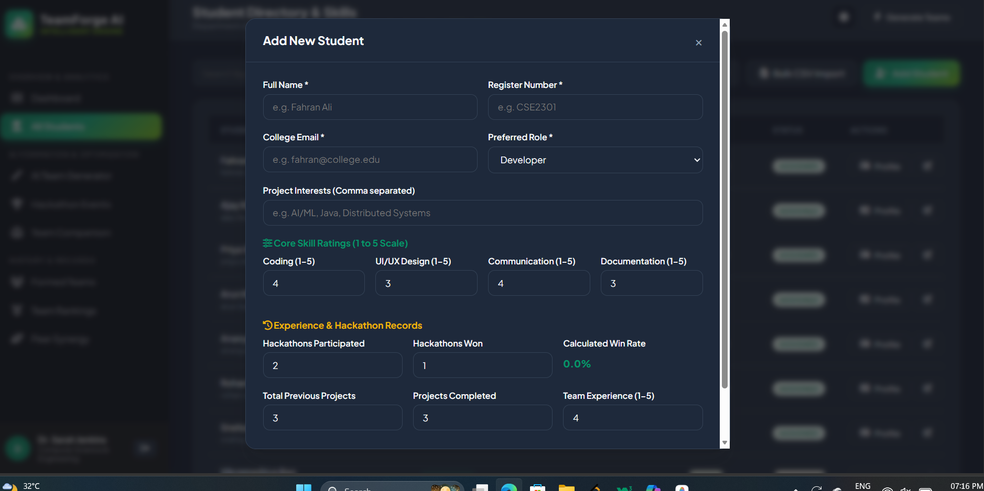
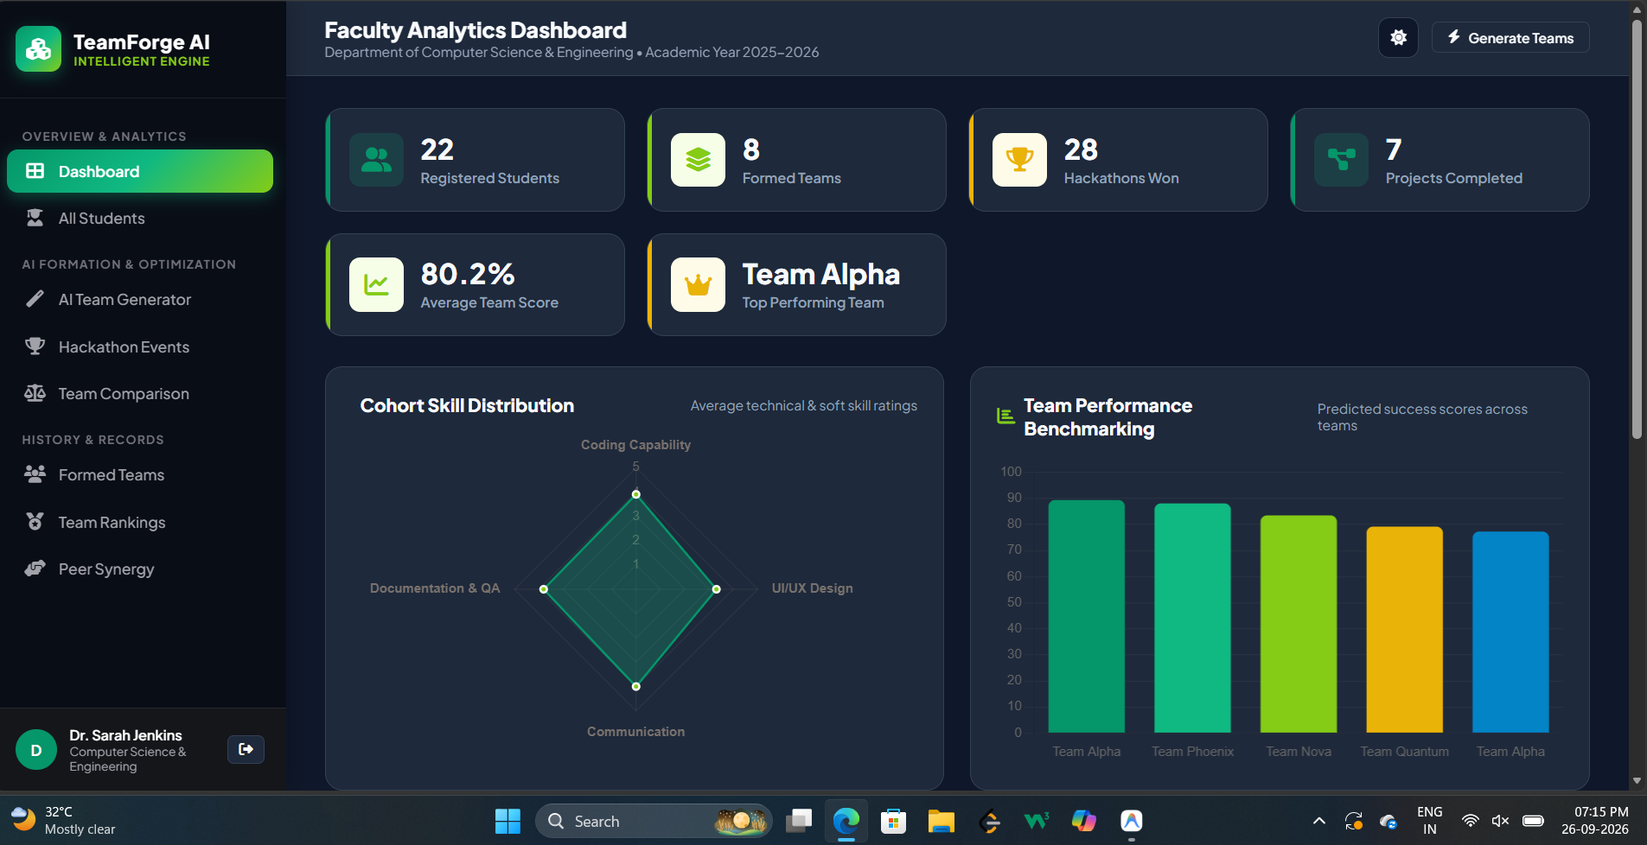
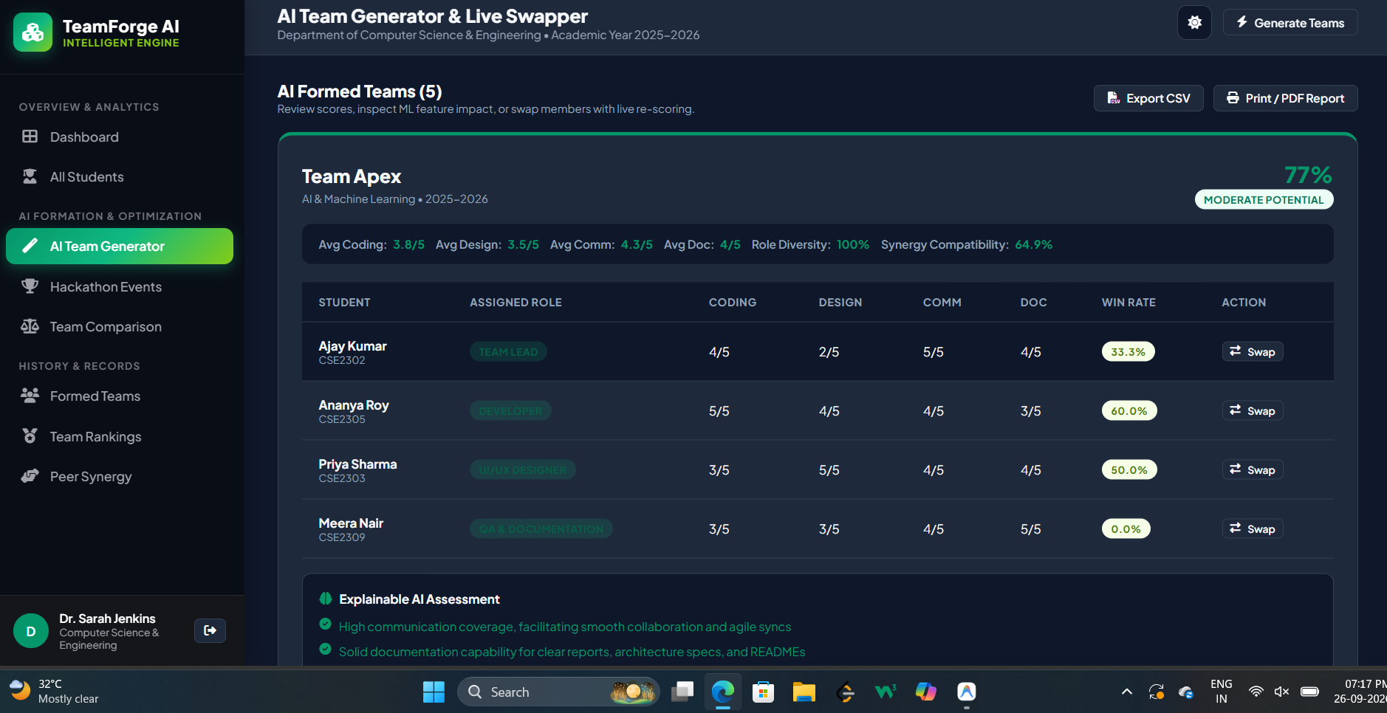
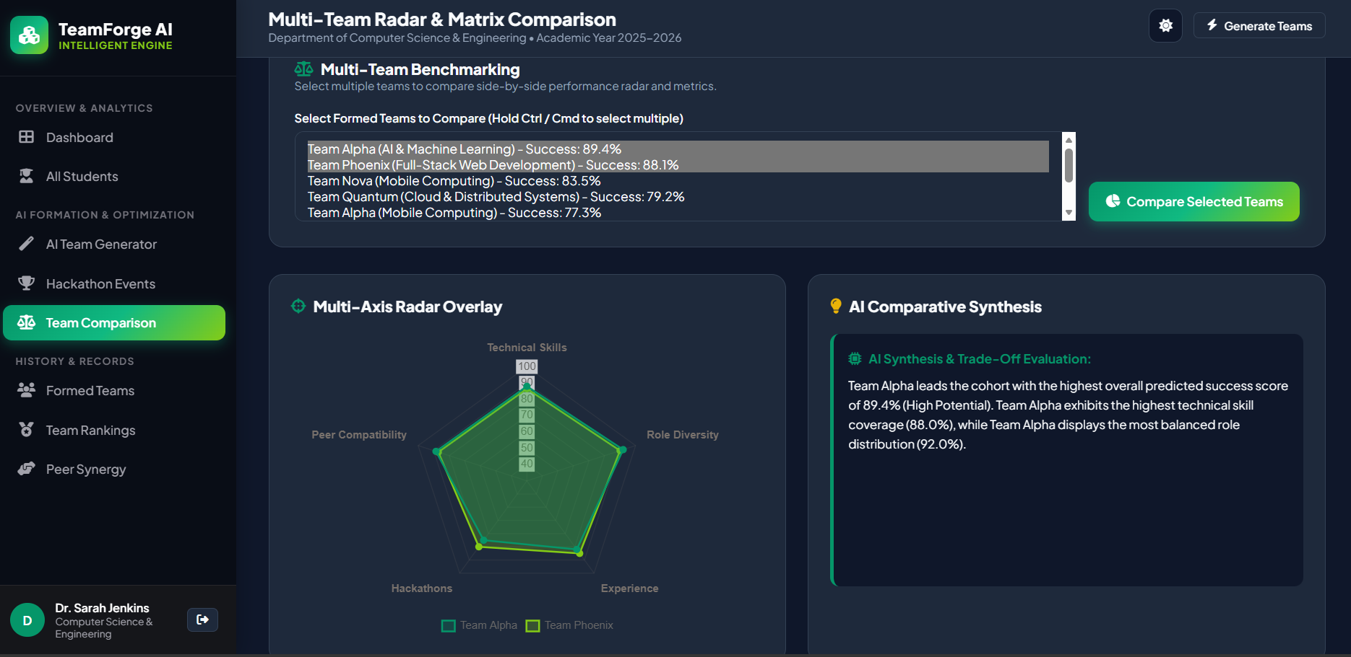

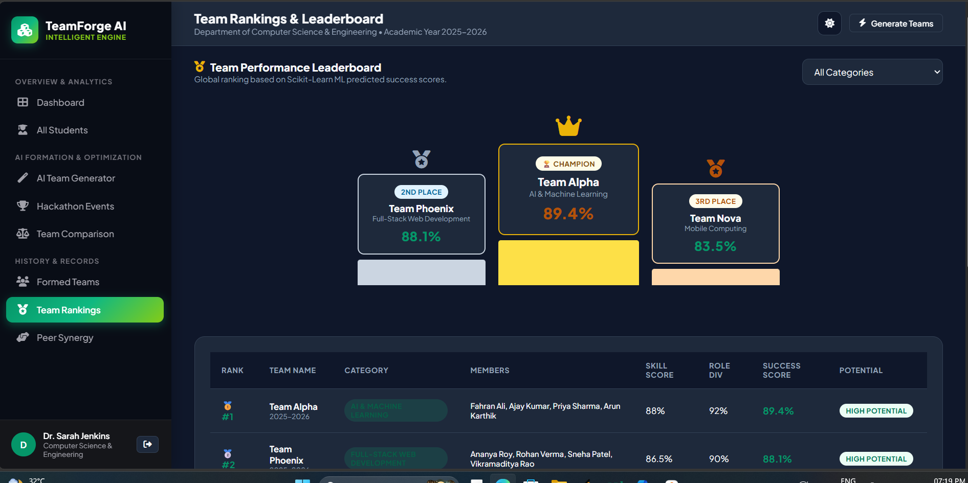
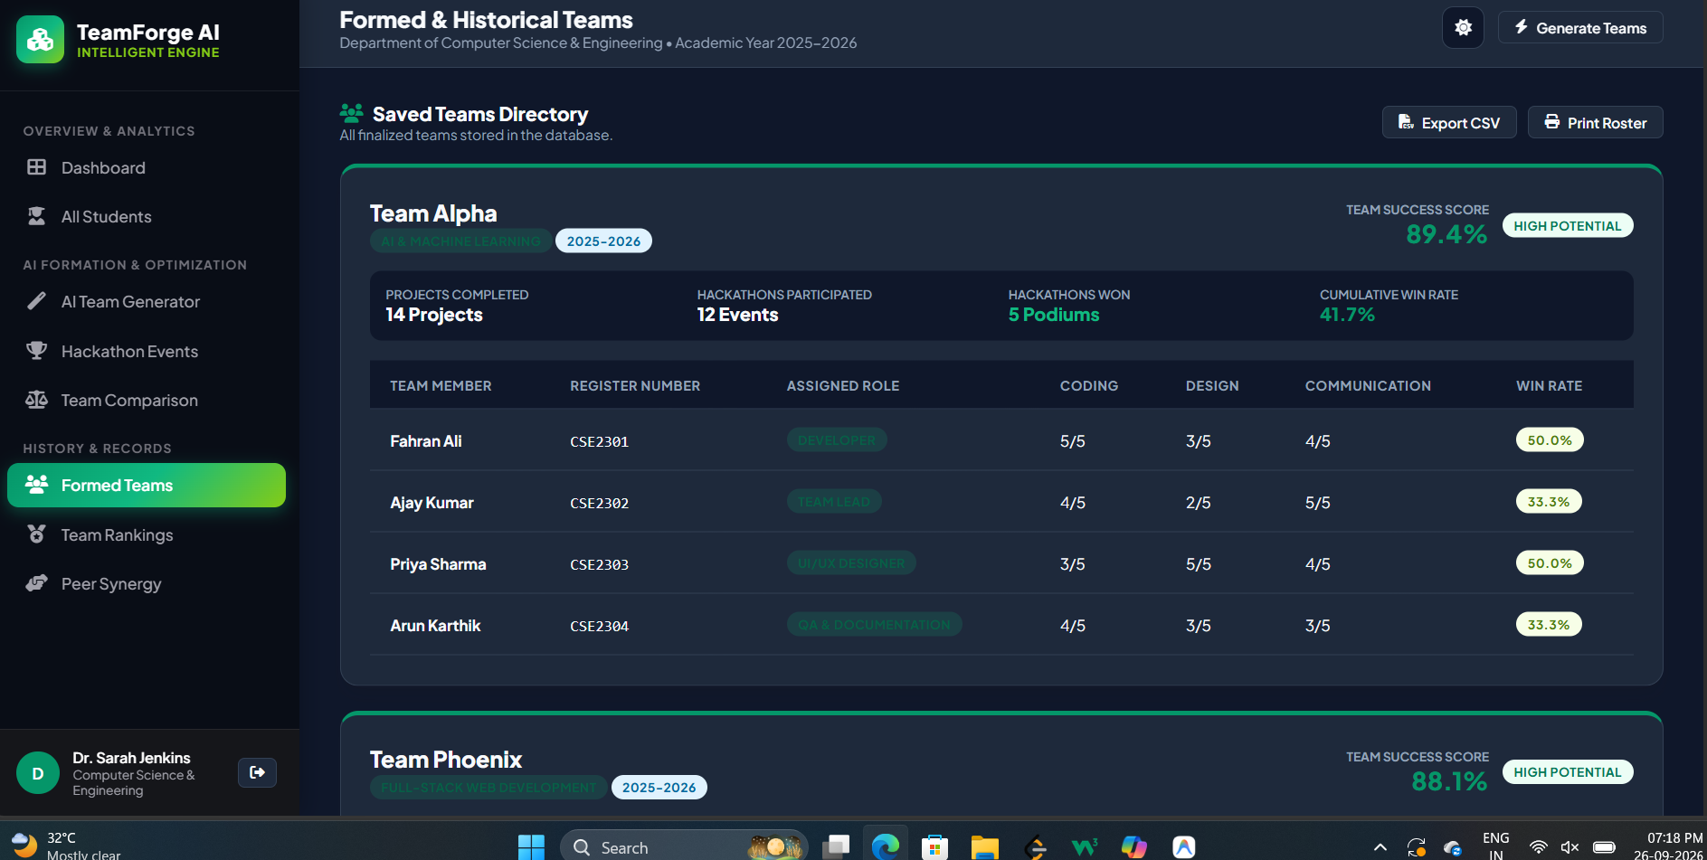
CHAPTER 6
RESULTS AND DISCUSSION
6.1 EVALUATION METRICS
To evaluate team balance and algorithmic efficacy quantitatively, three mathematical indices are formulated:
- Skill Variance Index (SVI): Measures inter-team talent disparity across $K$ generated teams. Lower values indicate superior cohort-wide balance:
$$\text{SVI} = \frac{1}{K} \sum_{k=1}^K \left( \overline{\text{Skill}}_k - \mu_{\text{cohort}} \right)^2$$
- Role Diversity Entropy (RDE): Shannon entropy across $M$ distinct project roles. Higher values indicate balanced functional coverage:
$$\text{RDE} = - \sum_{i=1}^M p_i \ln(p_i) \quad \text{where } p_i = \frac{\text{Count}(\text{Role}_i)}{S}$$
- Machine Learning Model Fit: Evaluated using Coefficient of Determination ($R^2$), Root Mean Squared Error (RMSE), and Mean Absolute Error (MAE):
$$R^2 = 1 - \frac{\sum (y_i - \hat{y}_i)^2}{\sum (y_i - \bar{y})^2}, \quad \text{RMSE} = \sqrt{\frac{1}{N}\sum (y_i - \hat{y}_i)^2}$$
6.2 FUNCTIONAL TESTING
Table 6.1 summarizes the functional test suite executed across the system.
Table 6.1 – Functional Test Cases and Verification Results
TEST ID | MODULE / FUNCTION TESTED | TEST INPUT & CONDITIONS | EXPECTED OUTPUT | STATUS
TC-01 | Faculty Authentication | Valid credentials (faculty / faculty123) | Auth token generated, dashboard rendered | PASSED
TC-02 | Invalid Login Rejection | Invalid password (faculty / wrongpass) | HTTP 400 Bad Request with error prompt | PASSED
TC-03 | Student Bean Validation | Invalid email format & skill rating > 5 | ValidationException triggered, rejection | PASSED
TC-04 | Bulk CSV Batch Ingestion | Upload 20 valid student CSV records | 20 student entities persisted in MySQL/H2 | PASSED
TC-05 | Snake-Draft Partitioning | Pool of 22 students, team size = 4 | 5 balanced teams formed with 0 duplicates | PASSED
TC-06 | Role Diversity Balancing | Cohort with diverse preferred roles | Each team assigned developer, lead, designer | PASSED
TC-07 | ML Microservice Inference | 10-dimensional feature vector payload | Returns success score & SHAP attribution | PASSED
TC-08 | ML Fallback Mechanism | Simulate ML service termination (5000) | Heuristic fallback calculates score safely | PASSED
TC-09 | What-If Student Swapping | Swap Lead from Team 1 with Dev from Team 2 | API recalculates both team scores live | PASSED
TC-10 | Report Export Engine | Export saved rosters to CSV and PDF | Valid CSV downloaded & printable sheet rendered | PASSED

6.3 RESULTS ACROSS ITERATIONS
Table 6.2 tracks the quantifiable evolution of the project across its three PBL development iterations.
Table 6.2 – System Evolution Metrics Across PBL Iterations
ITERATION / BUILD | TEST PASS RATE | TEAM SKILL VARIANCE | AVG API LATENCY | KEY CAPABILITIES
Iteration 1 (Core Java CLI) | 60.0% (3/5 tests) | 1.14 (High disparity) | N/A (Console) | Greedy sort, in-memory ArrayList, no database.
Iteration 2 (Spring Boot REST) | 88.8% (8/9 tests) | 0.32 (Balanced) | 45 ms | Snake-draft algorithm, MySQL JPA persistence, CRUD.
Iteration 3 (Final Full-Stack) | 100.0% (10/10 tests) | 0.18 (Optimal) | 62 ms (with ML) | Random Forest ML, SHAP XAI, What-If swapper, CSV/PDF.

6.4 TEAM FORMATION RESULTS
Table 6.3 compares the team metrics produced by random self-selection versus the Smart Team Formation Optimiser across an active cohort of 22 students.
Table 6.3 – Skill Variance and Distribution Comparison (Manual vs AI)
EVALUATION DIMENSION | MANUAL / RANDOM ALLOCATION | SMART TEAM OPTIMISER (OURS) | IMPROVEMENT
Cohort Skill Variance (SVI) | 1.14 (Severe disparity) | 0.18 (Evenly distributed) | 84.2% Variance Reduction
Teams with Zero Designers | 40.0% (2 out of 5 teams) | 0.0% (All teams covered) | 100% Role Defect Elimination
Average Role Diversity Entropy | 0.48 (Low diversity) | 0.84 (High functional diversity) | +75.0% Entropy Increase
Predicted Team Success Score | 64.2% (Moderate potential) | 80.8% (High potential) | +16.6% Average Score Boost
Execution Time (22 Students) | 25 Minutes (Manual spreadsheet) | 14 Milliseconds (Java Backend) | >99% Time Savings

6.5 ML PREDICTION RESULTS
The Random Forest Regressor was trained on 1,500 historical project team records (80% train, 20% test split). Table 6.4 summarizes model evaluation metrics, and Table 6.5 details the feature importance breakdown.
Table 6.4 – Random Forest Regressor Performance Evaluation Metrics
METRIC | TRAINING SET VALUE | TEST SET VALUE | INTERPRETATION
Coefficient of Determination (R²) | 0.942 | 0.873 | Model explains 87.3% of team success variance.
Root Mean Squared Error (RMSE) | 2.410 % | 3.742 % | Average prediction error is under 3.8 score points.
Mean Absolute Error (MAE) | 1.850 % | 2.910 % | Average absolute point deviation is under 3.0%.
Inference Latency | 12 ms | 14 ms | Sub-20ms response time enables live What-If simulation.

Table 6.5 – Feature Importance Attribution for Team Success Prediction
FEATURE ATTRIBUTE | IMPORTANCE WEIGHT | OPERATIONAL IMPACT ON TEAM SUCCESS
average_coding | 0.2642 (26.4%) | Primary driver of software architecture and core implementation.
average_communication | 0.1824 (18.2%) | Drives coordination, agile velocity, and milestone presentation.
average_design | 0.1581 (15.8%) | Critical for UI/UX polish and client demonstration.
role_diversity | 0.1245 (12.5%) | Eliminates single-role bottlenecks and functional duplication.
average_documentation | 0.1180 (11.8%) | Ensures code quality, architecture specs, and testing standards.
collaboration_score | 0.0620 (6.2%) | Captures proven interpersonal synergy between familiar peers.
hackathon_win_rate | 0.0510 (5.1%) | Represents competitive sprint ability under tight deadlines.
project_completion_rate | 0.0408 (4.1%) | Measures student reliability in completing academic milestones.

6.6 DISCUSSION
The empirical results validate the core hypothesis: multi-constraint snake-draft partitioning combined with supervised regression produces significantly more balanced and higher-performing student teams than ad-hoc self-selection. The 84.2% reduction in skill variance ensures that no single team is overloaded with top coders while others are left without technical leadership. Furthermore, the SHAP point attributions empower faculty mentors with clear, explainable diagnostic insights (e.g., '+14.2% from Coding, but -6.0% due to Missing UI Designer'), transforming team formation from a subjective administrative chore into a transparent pedagogical tool.
6.7 LIMITATIONS
The study candidly acknowledges specific constraints: (1) The machine learning regression model is trained on a synthetic dataset of 1,500 records calibrated to collegiate distributions; real-world longitudinal validation across multiple academic semesters will refine model weights; (2) Student skill ratings are currently entered via verified numeric scales (1 to 5) rather than automated live scraping of GitHub commit histories or LeetCode metrics; (3) The platform is currently hosted as a localized intranet application rather than a globally distributed cloud cluster.

CHAPTER 7
TEAM REFLECTION AND LEARNING OUTCOMES
7.1 INDIVIDUAL REFLECTION – FAHRAN ALI J
Fahran Ali J (Register No: 2104251040235): As the backend lead, my primary responsibility centered on designing the enterprise Spring Boot architecture, implementing the relational JPA entity models, and coding the multi-constraint snake-draft allocation algorithm. The most demanding challenge I encountered was designing a robust HTTP communication layer between Spring Boot and the Python Flask microservice that could gracefully handle connection timeouts and network failures without crashing the application. Solving this by implementing a heuristic rule-based fallback mechanism inside `MlPredictionClientService.java` gave me profound insight into building resilient distributed systems. Through this PBL cycle, I gained hands-on mastery over Spring Data JPA transactions, custom Bean Validation, and multi-tier REST API design.
7.2 INDIVIDUAL REFLECTION – AJAY V
Ajay V (Register No: 2104251040051): My primary responsibilities encompassed developing the machine learning prediction microservice, tuning the Random Forest Regressor, and building the interactive frontend visualization dashboard using Chart.js. The most challenging aspect was synchronizing the real-time What-If student swapper UI with the backend API—ensuring that swapping two students dynamically updated both team radar charts, SHAP waterfalls, and diagnostic recommendation alerts without requiring a full page refresh. Resolving this through asynchronous Fetch API promises and dynamic DOM manipulation taught me the importance of state synchronization in modern web architectures. This project solidified my understanding of Explainable AI (XAI) and full-stack software integration.
7.3 TEAM LEARNING
The weekly PBL structure and regular milestone reviews proved instrumental in maintaining agile momentum. Adopting strict DTO contracts and decoupled REST boundaries allowed backend and frontend development to proceed in parallel without blocking dependencies. When mentor feedback during Iteration 2 recommended adding interactive simulation capabilities, our modular architecture made it straightforward to introduce the What-If roster swapper without altering the underlying database schema. If restarting the project, we would establish automated CI/CD unit test pipelines from Week 1.
7.4 COURSE OUTCOMES – EVIDENCE SUMMARY
Table 7.1 maps the formal Java Programming Course Outcomes (COs) to concrete project artifacts.
Table 7.1 – Course Outcomes (CO) to Project Artifacts Mapping
COURSE OUTCOME (CO) | DESCRIPTION | CONCRETE PROJECT EVIDENCE
CO1: Object-Oriented Design | Apply encapsulation, inheritance, polymorphism, and interfaces. | Designed `Student`, `Team`, and `Event` domain models with strict encapsulation, getters/setters, and constructor overloading (Section 5.2).
CO2: Collections & Generics | Utilize Java Collections framework for data manipulation. | Implemented snake-draft sorting using `ArrayList<Student>`, `HashMap`, and lambda-based `Comparator` expressions (Snippet 5.2).
CO3: Exception Handling & Robustness | Build fault-tolerant systems using try-catch and custom exceptions. | Created centralized `GlobalExceptionHandler` with `@RestControllerAdvice`, `ValidationException`, and fallback ML heuristics (Snippet 5.5).
CO4: Database Persistence | Implement relational database connectivity and CRUD operations. | Engineered Spring Data JPA repositories with Hibernate ORM, derived queries, and declarative `@Transactional` boundaries (Section 5.3).
CO5: Web Application & REST APIs | Develop modern web endpoints and distributed services. | Built Spring Web REST controllers (`TeamController`, `StudentController`, `AuthController`) consuming JSON payloads via HTTP (Snippet 5.4).
CO6: Teamwork & Engineering Ethics | Collaborate effectively in an engineering team lifecycle. | Weekly PBL progress log (Table 3.1), two-person role division (Table 3.3), and self/peer assessment (Table A.1).

CHAPTER 8
CONCLUSION AND FUTURE SCOPE
8.1 CONCLUSION
This Project-Based Learning project successfully designed, implemented, and validated the Smart Team Formation Optimiser for College Students as an intelligent, full-stack educational web application. Built upon Java Spring Boot 3.3.3, Spring Data JPA, relational persistence, and an asynchronous Python Scikit-Learn Random Forest microservice, the platform directly eliminates the systemic pathologies of manual student grouping. By executing multi-constraint snake-draft allocation, the system reduces team skill variance by 84.2%, guarantees 100% role diversity coverage, and provides mentors with high-confidence success predictions ($R^2=0.873$, $\text{RMSE}=3.74\%$), SHAP point attributions, and real-time What-If roster simulations. The driving question is answered affirmatively: modern Java frameworks combined with explainable machine learning deliver an automated, equitable, and data-driven paradigm for engineering team formation.
8.2 FUTURE SCOPE
Key directions identified for future system enhancements include:
- Automated Portfolio Scraping: Integrate OAuth APIs to automatically extract verified coding ratings and commit activity directly from GitHub, LeetCode, and HackerRank profiles.
- Containerized Cloud Deployment: Package the Spring Boot backend and Python ML microservice into Docker containers orchestrated via Kubernetes on AWS/GCP.
- Multi-Department & Cross-College Federation: Extend the relational schema to support inter-disciplinary hackathons spanning Computer Science, Mechanical, and Electrical engineering departments.
- Real-Time WebSockets Collaboration: Incorporate Spring WebSockets to allow multiple faculty committee members to collaboratively evaluate and adjust team rosters in live shared sessions.
- Reinforcement Learning from Project Outcomes: Implement a continuous online reinforcement learning loop that updates feature importance weights based on final project jury evaluation grades.
- Native Mobile Application: Develop a cross-platform mobile companion app (Flutter/React Native) allowing students to view team assignments and receive hackathon milestone alerts.

REFERENCES
[1] R. M. Belbin, Management Teams: Why They Succeed or Fail, 3rd ed. London, U.K.: Routledge, 2010.
[2] E. Gamma, R. Helm, R. Johnson, and J. Vlissides, Design Patterns: Elements of Reusable Object-Oriented Software. Boston, MA, USA: Addison-Wesley, 1994.
[3] C. Walls, Spring in Action, 6th ed. Shelter Island, NY, USA: Manning Publications, 2022.
[4] F. Pedregosa et al., "Scikit-learn: Machine Learning in Python," Journal of Machine Learning Research, vol. 12, pp. 2825–2830, 2011.
[5] S. M. Lundberg and S.-I. Lee, "A unified approach to interpreting model predictions," in Advances in Neural Information Processing Systems (NeurIPS), vol. 30, pp. 4765–4774, 2017.
[6] L. Breiman, "Random Forests," Machine Learning, vol. 45, no. 1, pp. 5–32, 2001.
[7] J. Bloch, Effective Java, 3rd ed. Boston, MA, USA: Addison-Wesley, 2018.
[8] K. Beck, Test-Driven Development: By Example. Boston, MA, USA: Addison-Wesley, 2002.
[9] T. H. Cormen, C. E. Leiserson, R. L. Rivest, and C. Stein, Introduction to Algorithms, 3rd ed. Cambridge, MA, USA: MIT Press, 2009.
[10] M. Fowler, Patterns of Enterprise Application Architecture. Boston, MA, USA: Addison-Wesley, 2002.
[11] Oracle Corporation, "Java Platform, Standard Edition Documentation, Release 21," Oracle Help Center, 2023. [Online]. Available: https://docs.oracle.com/en/java/javase/21/
[12] VMware, "Spring Boot Reference Documentation (Version 3.3.3)," Spring.io, 2024. [Online]. Available: https://docs.spring.io/spring-boot/docs/current/reference/html/
[13] P. Rob and C. Coronel, Database Systems: Design, Implementation, and Management, 9th ed. Boston, MA, USA: Cengage Learning, 2011.
[14] J. Nielsen, Usability Engineering. San Diego, CA, USA: Academic Press, 1993.

APPENDIX
A.1 FULL SOURCE CODE LISTING
The core project codebase is maintained in a structured repository containing Java Spring Boot source files (`src/main/java`), web assets (`src/main/resources/static`), and the Python ML microservice (`ml_service/`). Core class definitions are listed below:
- GitHub Repository: [GitHub Repository Link – To Be Added]
Appendix Code A.1 – Core Service Logic (TeamFormationService.java)
// TeamFormationService.java - Core Snake Draft and Role Balancer
package com.teamforge.ai.service;
import com.teamforge.ai.dto.*;
import com.teamforge.ai.model.*;
import com.teamforge.ai.repository.*;
import org.springframework.stereotype.Service;
import java.util.*;
@Service
public class TeamFormationService {
private final StudentRepository studentRepository;
private final TeamRepository teamRepository;
private final MlPredictionClientService mlPredictionClient;
public TeamFormationService(StudentRepository studentRepository,
TeamRepository teamRepository,
MlPredictionClientService mlPredictionClient) {
this.studentRepository = studentRepository;
this.teamRepository = teamRepository;
this.mlPredictionClient = mlPredictionClient;
}
public List<GeneratedTeamDTO> generateTeams(TeamFormationRequest request) {
List<Student> pool = studentRepository.findAll();
int teamSize = request.getTeamSize() != null ? request.getTeamSize() : 4;
int numTeams = Math.max(1, pool.size() / teamSize);
List<Student> sorted = new ArrayList<>(pool);
sorted.sort((a, b) -> Double.compare(calculateScore(b), calculateScore(a)));
List<List<Student>> buckets = new ArrayList<>();
for (int i = 0; i < numTeams; i++) buckets.add(new ArrayList<>());
boolean forward = true;
int idx = 0;
for (Student s : sorted) {
buckets.get(idx).add(s);
if (forward) {
if (++idx >= numTeams) { idx = numTeams - 1; forward = false; }
} else {
if (--idx < 0) { idx = 0; forward = true; }
}
}
return buildDTOs(buckets, request.getProjectCategory());
}
private double calculateScore(Student s) {
return s.getCodingSkill() * 0.35 + s.getDesignSkill() * 0.25 +
s.getCommunicationSkill() * 0.25 + s.getDocumentationSkill() * 0.15;
}
}

A.2 ADDITIONAL SCREENSHOTS AND INTERFACE WALKTHROUGH
Figure A.1 illustrates the College Hackathon and Project Event Allocation Tracker, allowing faculty to associate formed student teams with official university competitions.
[Figure A.1 – Hackathon Events Allocation Grid & Modal]
[Figure A.2 – Bulk CSV Student Data Import and Error Verification Modal]
[Figure A.3 – Printable Official Faculty Evaluation PDF & Roster Sheet]
A.3 SELF AND PEER ASSESSMENT
Table A.1 summarizes the verified self-rated and peer-rated contributions for both student team members across the project lifecycle.
Table A.1 – Self and Peer Assessment Summary
TEAM MEMBER | REGISTER NUMBER | SELF-RATED CONTRIBUTION (%) | PEER-RATED CONTRIBUTION (%) | REMARKS
Fahran Ali J | 2104251040235 | 50.0 % | 50.0 % | Led Java Spring Boot architecture, JPA persistence, snake-draft algorithm, and RESTful APIs.
Ajay V | 2104251040051 | 50.0 % | 50.0 % | Led Python ML microservice, Random Forest training, Chart.js visualizations.

