Introduction
This manual is edited to help researchers interested in using magnetic resonance imaging (MRI) data in MEG source modeling. We will specifically use two software packages.

- FreeSurfer
An open source software suite for processing and analyzing (human) brain MRI images. For more information, please check
https://surfer.nmr.mgh.harvard.edu/

- MNE toolbox
MNE is a software package for processing magnetoencephalography (MEG) and electroencephalography (EEG) data. It can integrate anatomical MRI data processed by FreeSurfer to generate cortically constrained neuronal current estimates. For more information, please check
http://martinos.org/mne/stable/index.html

Environment setup

Login
- Open a SSH session
- Login to server

%ssh 140.119.165.24 -l megtraining_15 -Y

(%ssh -o TCPKeepAlive=no -o ServerAliveInterval=15 140.119.165.24 -l megtraining_15 –Y)

- Goto your working directory

> cd /space/maki5/1/users/megtraining_15

- Prepare environment

> source /space/maki/1/pubsw/bme-dev-env-new_mne.csh

> setenv SUBJECTS_DIR /space/maki5/1/users/megtraining_15/subjects

Raw data exploration

Load raw data into a viewer
- Appropriately set your environment.
- Launch the viewer program “mne_browse_raw”.

> cd /space/maki5/1/users/megtraining_15/data/

mne_browse_raw

- Locate the raw fiff (Pure_tone_Oddball_raw.fif) file and load it in the viewer.

Explore raw data
- How long were the data shown in your window? What is the duration between two vertical tick lines?
- Data from which sensor are you reading?
- What is the typical range of the MEG?
- Locate EKG data
- Locate EOG data
- Locate triggers
- Switch the selected sensors to occipital lobe, frontal lobe, left temporal lobe, right temporal lobe, and parietal lobe.
- Move the viewer duration to the next 5 seconds. Check how MEG data, EKG, EOG, and trigger signal change.
- Can you find the spontaneous alpha rhythm (~10 Hz)? Where are they?
- Can you find the eye blinking? How are the data in the frontal lobe during eye blinking?
- Did you find any “strange” signals?

Evoked data preparation

Prepare the scripts for average data
- Read the MNE user manual about the preparation of your evoked response
- Change working directory

>cd /space/maki5/1/users/megtraining_15/analysis

- Do you know which triggers you are going to average? If you don’t know them, can you get a list of all triggers in your raw fiff file? (hint: use “mne_process_raw”).

>mne_process_raw --raw Pure_tone_Oddball_raw.fif --eventsout Pure_tone_Oddball_event

(you can check the content of triggers by the following command:
rolle7:/space/maki5/1/users/megtraining_15/data> cat Pure_tone_Oddball_event | more)

- Create both evoked responses and noise covariance matrix offline. This is for subsequent MNE source analysis

>mne_process_raw --raw Pure_tone_Oddball_raw.fif --projon --ave Pure_tone_Oddball.ave

>mne_process_raw --raw Pure_tone_Oddball_raw.fif --projon --cov Pure_tone_Oddball.cov

Evoked data exploration

Load the viewer for evoked data
- Appropriately set your environment.
- Launch the viewer program “xplotter” .

[megtraining_15@black data]$ /neuro/bin/vue/xplotter&

- Locate the evoked fiff file (Pure_tone_Oddball_avg.fif) and load it in the viewer.

- Select the appropriate category (trigger) of the evoked data.

Explore evoked data
- How many sensors do you see? Are they gradiometers or magnetometers? Where is most likely to have some “response”?
- Zoom-in the area showing prominent responses.
- Show the zero-line and the onset of the trigger (time = 0).
- Find the “first peak” of the evoked response. Which sensor are you checking? What is the peak timing? Are you checking a gradiometer or magnetometer?
- Explore neighboring sensors. Do you see similar timing to peak? Are they identical to the peak timing you found above?
- Try to change the layout to show i) only magnetometer, ii) only gradiometers, and iii) both magnetometers and gradiometers.
- Try to explore the evoked data in the other hemisphere. Are they similar to what you found in the original hemisphere?
- Overlay the evoked data from the other trigger.
- Compare the evoked responses from both triggers. Select one prominent sensor. Do they have the same peak timing? What are peak values?

MRI exploration by mne_analyze

Launch mne_analyze
- Setup environment
- Launch mne_analyze

> mne_analyze &

Explore MRI surfaces
- Load subjects (File → Load surfaces). Choose ‘subj01’.
- Explore pial and inflated surfaces
- You can try the button “L”, “R”, and “B” in the “Adjust view” panel to show either/both hemisphere(s). Use four arrows buttons to rotate the surface for different views. Try the “view list” (containing Lat, Med, Ven, Occ options).
- Images can be exported by clicking the “img” button
- What are dark/light gray areas on the surfaces?
- Check the correspondence between “folded” and “inflated” surfaces.
- Change the subject to “fsaverage” and explore.

Loading parcellation
- Load subjects (Labels → Load parcellations). Choose ‘aparc’.
- Explore different gyri and sulci
- Choose Brodmann’s area parcellation ‘BA’
- Explore different BA’s
- Change the subject between ‘subj01’ and ‘fsaverage’. Explore how parcellation changes.

MRI exploration by mrilab

prepare MRI
- Convert the MRI data into fiff format using “mne_setup_mri”.

> mne_setup_mri --subject subj01 --overwrite

Load the viewer for MRI
- Appropriately set your environment.
- Launch the viewer program “mrilab” .

$ cd /space/maki5/1/users/megtraining_15/data
$ /neuro/bin/vue/mrilab&

- Locate the MRI fiff file (/space/maki5/1/users/megtraining_15/subjects/subj01/mri/T1-neuromag/sets/COR.fif) and load it in the viewer.

Explore MRI data
- Adjust the contrast and brightness
- Change different slices in three viewing windows.
- Do you know the relative positions of the head and the MEG sensors?

Registration between MEG data and MRI

Manual registration between MEG and MRI
- Open the fiff file (File→ Import→ Isotrak data:
/space/maki5/1/users/megtraining_15/data/Pure_tone_Oddball_raw.fif) containing the MEG sensor location information.
- Show the locations of auxiliary “points”. (click the “Make point” button in the “You got points” window).
- Open the window of anatomical marker (Windows → Landmarks).
- Check the location of “LPA”, “RPA”, and “nasion”. Are they correctly located?
- Move “LPA”, “RPA”, and “nasion” the appropriate location. Note: you may want to do this one by one. Do not forget to “apply” the chosen location.
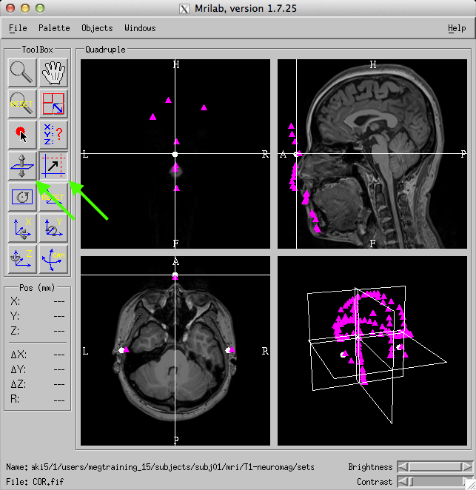
- Check if you are happy with the location of auxiliary “points” after your manual registration? If yes, please save the your MRI data as another fiff file.

automatic registration between MEG and MRI
- Use the following command to do automatic registration

[Please check the MNE manual].
- Load digitizer data
- Adjust → Coordinate alignment
- Define LPA, nasion, RPA
- Align using fiducials
- ICP align
- Save MRI set

- Load the fiff MRI data file containing the correct MEG-head registration. Show the location of auxiliary points after registration.

Distributed source modeling using MEG and MRI data

Setup the environment
source /space/maki/1/pubsw/bme-dev-env-new_mne.csh
setenv SUBJECTS_DIR /space/maki5/1/users/megtraining_15/subjects/
setenv SUBJECT subj01

prepare source space

mne_setup_source_space --subject subj01 --spacing 5 --overwrite

prepare boundary element model

mne_watershed_bem --overwrite (this step takes a while…)
ln -s $SUBJECTS_DIR/$SUBJECT/bem/watershed/$SUBJECT'_inner_skull_surface' $SUBJECTS_DIR/$SUBJECT/bem/inner_skull.surf
ln -s $SUBJECTS_DIR/$SUBJECT/bem/watershed/$SUBJECT'_outer_skull_surface' $SUBJECTS_DIR/$SUBJECT/bem/outer_skull.surf
ln -s $SUBJECTS_DIR/$SUBJECT/bem/watershed/$SUBJECT'_outer_skin_surface' $SUBJECTS_DIR/$SUBJECT/bem/outer_skin.surf

mne_setup_forward_model --surf --ico 4 (this step takes even longer …)

locate the MRI fiff file including the correct MEG-head registration

check Registration between MEG data and MRI section. Locate the fiff file with correct MEG-MRI co-registration. (/space/maki5/1/users/megtraining_15//subjects/subj01/mri/T1-neuromag/sets/COR-fhlin-140129.fif).

calculate the forward solution
(*make sure that your current working directory is /space/maki5/1/users/megtraining_15/analysis)
mne_do_forward_solution --subject subj01 \
--src /space/maki5/1/users/megtraining_15/subjects/subj01/bem/subj01-5-src.fif \
--meas /space/maki5/1/users/megtraining_15/data/Pure_tone_Oddball_raw.fif \
--fwd ./Pure_tone_Oddball_raw-5-fwd.fif \
--mricoord \
--bem /space/maki5/1/users/megtraining_15/subjects/subj01/bem/subj01-5120-5120-5120-bem.fif \
--megonly \
--mri /space/maki5/1/users/megtraining_15/subjects/subj01/mri/T1-neuromag/sets/COR-fhlin-140129.fif

calculate the MNE inverse solution

calculate inverse operator

mne_do_inverse_operator --subject $SUBJECT --fwd ./Pure_tone_Oddball_raw-5-fwd.fif --senscov ../data/Pure_tone_Oddball-cov.fif --meg --inv ./Pure_tone_Oddball_raw-inv.fif

calculate source estimates

mne_make_movie --inv ./Pure_tone_Oddball_raw-inv.fif \
--subject subj01 \
--bmin -100 --bmax 0 \
--stc stc/Pure_tone_Oddball_raw-ave_set1 \
--meas ../data/Pure_tone_Oddball_offline-ave.fif \
--spm

visualize the MNE source estimates using mne_analyze

Launch mne_analyze
- Setup environment
- Launch mne_analyze

> mne_analyze &

Load anatomical surface
- Load subjects (File → Load surfaces). Choose ‘subj01’.
- Load inflated surfaces

Load source estimates
- Load subjects (File → Manage overlays). Choose “load STC” button.
- Get the STC files (stc/Pure_tone_Oddball_raw-ave_set1)
- Explore the source
  - Click the auditory cortex in the viewer
  - Select the time showing max amplitude
  - Explore the evoked auditory response

Dipole fitting

Load the MEG data and define the conductor model
- Launch the “xfit” program.

$ cd /space/maki5/1/users/megtraining_15/data
$ /neuro/bin/vue/xfit&

- Locate the MEG fiff file (/space/maki5/1/users/megtraining_15/data/ Pure_tone_Oddball_avg.fif).
- Define conductor model: Sphere
Define origin: e.g., 5.4, 15.1, 37.1 for x, y, z in mm
- Process → Apply filters

Dipole estimation
- In the Signal waveform window, place cursor on the peak time point and click the Fit button. 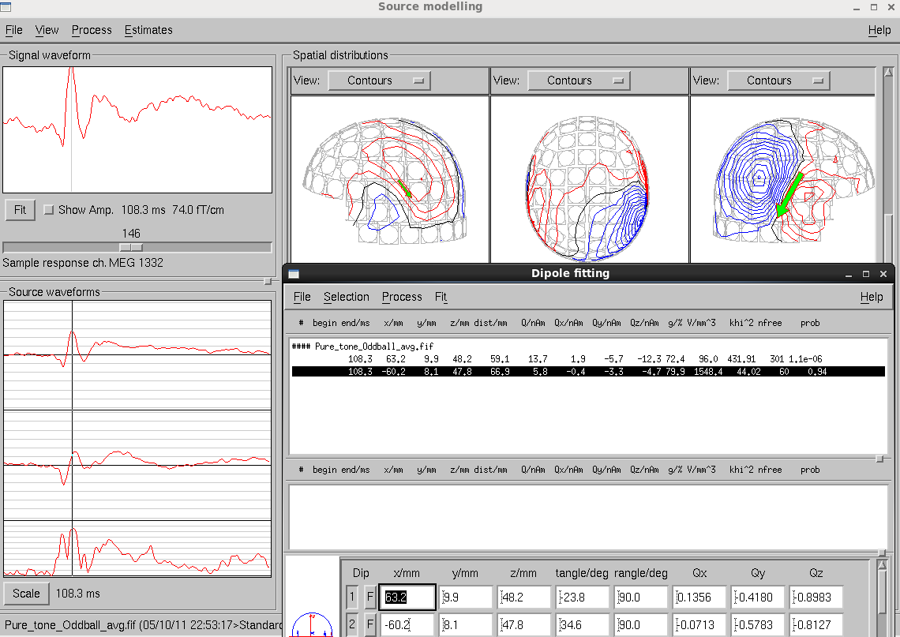

- View → Full view, use the right mouse button to select channels on the left hemisphere, then click on Fit again.
- In Estimates, Dipole Estimation, Multi window, activate the 1 button.
- Right click to select the first dipole, then select “→ Multi”.
- Repeat step 7 and 8 for the second dipole.
- View → Full view, Enable All.
- Estimate → Dipole Estimation → Fit → Fixed dipoles (manual).
- In the Source waveforms window, right click to Save (text) to save dipole waveforms as ASCII text.

Here I use “megtraining_15” as the example. We have “megtraining_01” to “megtraining_15” total 15 independent training accounts. Choose yours and ONLY WORK ON YOUR OWN ACCOUNT. Importantly, in the subsequent command, you should replace “megtraining_15” to your chosen account accordingly.
fiff file format is a proprietary file format of Neuromag MEG system. It is the file format used for not only MEG but also MRI data processing in the MNE tool. However, there are open source packages to read/write them in Matlab. Please check MNE user manual for further detail
This is a proprietary software by Neuromag. You have to SSH to the following server to use it. rolle7:/space/maki5/1/users/megtraining_15/data> ssh black.bme.ntu.edu.tw -Y
This is a proprietary software by Neuromag. You have to SSH to the following server to use it. rolle7:/space/maki5/1/users/megtraining_15/data> ssh black.bme.ntu.edu.tw -Y
This is a proprietary software by Neuromag. You have to SSH to the following server to use it. rolle7:/space/maki5/1/users/megtraining_15/data> ssh black.bme.ntu.edu.tw -Y

