Introduction
This manual is edited to help researchers to analyze fMRI data to localize activated brain areas subserving specific tasks. Particularly, we are analyzing the data using General Linear Model (GLM).

The GLM analysis basically involves the following steps:
- Prepare a 2D data matrix consisting of the time series of all voxels
- Prepare the experiment paradigm
- Perform the GLM of the data
- Show the spatial distribution of GLM results
These procedures are basically running Matlab scripts in a terminal (pure text) command window without evoking the graphic user interface. However, we encourage you to check results of every step of processing by generating appropriate images/plots to make sure that the analysis is reasonable.
Here we assume that DICOM images from EPI scans have been previously processed. This may include motion correction, slice timing correcting, and spatial smoothing. Please refer to the other manual for these pre-processing steps.

Environment setup

Login
- Open a SSH session
- Login to server

%ssh 140.119.165.24 -l username -Y

(%ssh -o TCPKeepAlive=no -o ServerAliveInterval=15 140.119.165.24 -l username –Y)

- Goto your working directory

> cd /space/maki5/1/users/fhlin/ini_vm_nccu/10102012_ChangCI/epi_analysis

- Prepare environment

> source /space/maki/1/pubsw/bme-dev-env-dev.csh

- Set the environment variable $SUBJECTS_DIR

> setenv SUBJECTS_DIR /space/maki5/1/users/fhlin/ini_resting_nccu/subjects/

- Start Matlab

> matlab -nojvm

- Make sure that “fhlin_toolbox” and “NIFTI_20110921” tool boxes are now included in the path. Include them by the “addpath” command in Matlab if they are not included yet.

>> path

MATLABPATH

…
/space/home/fhlin/matlab/toolbox/fhlin_toolbox
/space/home/fhlin/matlab/toolbox/NIFTI_20110921

…

• Prepare a 2D data matrix consisting of the time series of all voxels

Prepare “datamat_epi.m”
Here you only need to specify the location of all processed EPI data files. You may find the following line in datamat_epi.m:

…
datafile={
'../epi_data/bold/004/fmcprstcs.nii';
};
…

Here it lists the relative file path of the data file fmcprstcs.nii in NifTI format. You may include multiple runs of EPI data, all of which have the same resolution, FOV, and the number of slice, into the datafile variable, as listed below:

…
datafile={
'../epi_data/bold/004/fmcprstcs.nii';
'../epi_data/bold/005/fmcprstcs.nii';
'../epi_data/bold/006/fmcprstcs.nii';
'../epi_data/bold/007/fmcprstcs.nii';
};
…

Now it includes 4 runs of pre-processed EPI data, which are called fmcprstcs.nii in 4 different folders.

Run “datamat_epi.m”
Simply run the “datamat_epi.m” script to generate the data matrix, which is a 2D matrix includes the time series of all voxels.

Note: if you allow the graphic output of Matlab to be forwarded to your X11 environment, a 2D images consisting of mosaic of EPI data (averaged across time) will be displayed.

>> datamat_epi
current directory: [/autofs/space/maki5_001/users/fhlin/ini_vm_nccu/10102012_ChangCI/epi_analysis]
generating datamat...
making the coords vector
total pixels for a row:30459
datamat filtered!

elapsed time : 6.540261
>>

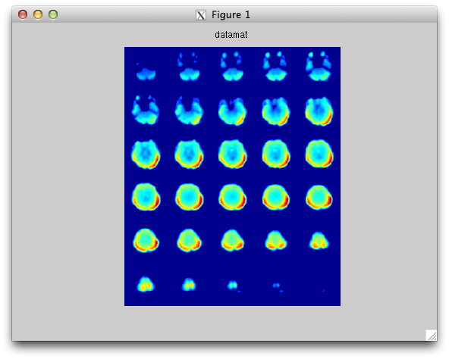

Now you should have a file called datmat_epi.mat created with the following variables:

>> ls -al *.mat
-rw-rw-r-- 1 fhlin fhlin 12594610 Apr 24 22:46 datamat_epi.mat

Name Size Bytes Class Attributes

Cords 1x30459 243672 double
Datamat 120x30459 29240640 double
slices 1x1 8 double
subjects 1x1 8 double
tasks 1x1 8 double
timepoints 1x1 8 double
x 1x1 8 double
y 1x1 8 double
z 1x1 8 double

Here are the meanings of these variables:

x: the number of voxels in the x direction
y: the number of voxels in the y direction
z: the number of slice
slices: the number of slice
subjecs: the number of subjects. (Typically it should be 1).
Tasks: the number of run of your EPI data.
coords: 1D vector including the indices of all voxels included for subsequent analysis. You may use the following commands to check these indices:

>> a=zeros(x,y,z);
>> a(coords)=1;
>> fmri_mont(a);

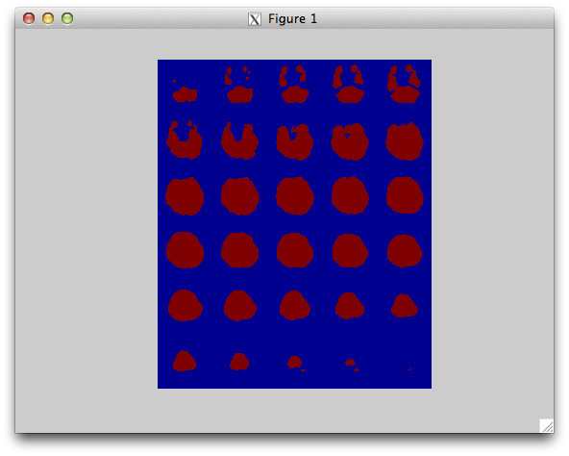

datamat: a 2D matrix including all time series from all included voxels (columns of the matrix). In this example, there are 120 time points in this fMRI acquisition session.

• Prepare the experiment paradigm

Here we prepare the paradigm file, which includes the indices of each fMRI

>pwd
/autofs/space/maki5_001/users/fhlin/ini_vm_nccu/10102012_ChangCI/epi_data

Here I use “user_name” as the example.
Here the working directory is /space/maki5/1/users/fhlin/ini_vm_nccu/10102012_ChangCI/epi_data. You should change that accordingly in your own analysis. The third footnote here?
The “-nojvm” option is used here to keep running the Matlab in a terminal window without showing the graphic user interface. You may ignore it if you want to have a Matlab session in the graphic user interface.
This toolbox is essential for all subsequent processing. It includes multiple functions to be used later.
This toolbox is essential for reading data in the NifTI file format.

