**MR group seminars at SRI  
Monthly on Wednesdays at 1 PM**

**Please kindly send back this form (ideally, 1-2 weeks ahead of your presentation date) with the following 5 questions filled out:**

**Name of Speaker(s): Seyed Ali Jalalifar**

**1.** Presentation date – which Wednesday(s) will you be available?

**September 15th – September 22nd**

**2.** Presentation title:

**Predicting the Outcome of Stereotactic Radiotherapy in Brain Metastasis using AI and MRI**

**3.** Short description of your presentation (a few sentences):

**Early prediction of therapy outcome can facilitate treatment adjustment for individual cancer patients and enhance their prognosis. This is especially crucial for patients diagnosed with brain metastasis as these patients usually suffer from poor prognosis with a short median survival. In this talk, the application of state-of-the-art AI algorithms, such as 3D attention-guided deep network architectures will be presented for early prediction of radiotherapy outcome in brain metastasis. A framework for visualizing the basis of network’s decisions is also presented which provides insights into how the network predicts the therapy outcome using the MRI.**

**4.** About yourself – short bio and/or photo (optional)

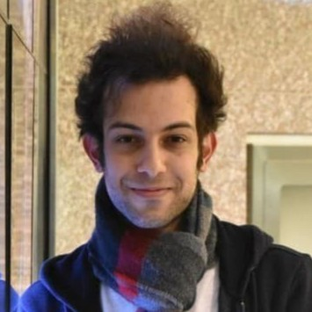

**I am a fourth-year Ph.D. student of Computer Science at York University working under supervision of Dr. Ali Sadeghi-Naini on applications of machine learning in the field of medical imaging. More specifically, I develop state-of-the-art deep learning architectures to analyze MRI data for personalized management of brain tumours.**

**5.** Recording – organizers have arranged as an option to allow speakers to share your presentation on YouTube, if you wish. Please select one of the following options below:

**A)** I agree that the content of my talk can be recorded and made available on the Internet.

**B)** I agree that the content of my talk can be recorded and made available on the Internet but only to people with explicit link (Note: still viewable by anyone who has the link).

**C)** I do not prefer for my presentation to be recorded.

**Option (A, B or C): C**