{
"source": "whatsapp",
"guest_name": "Rahul Sharma",
"message": "Is the villa available from April 20 to 24?",
"timestamp": "2026-05-05T10:30:00Z",
"booking_ref": "NIS-2024-0891",
"property_id": "villa-b1"
}
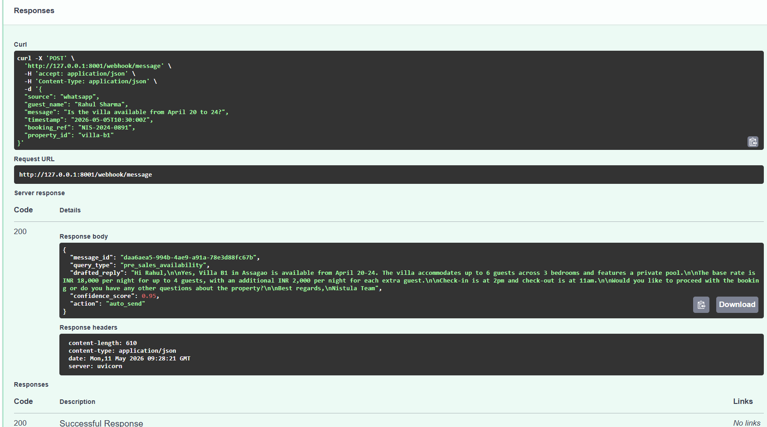

{
"source": "direct",
"guest_name": "Priya Nair",
"message": "What is the total rate for 5 guests for 3 nights?",
"timestamp": "2026-05-05T11:00:00Z",
"booking_ref": "NIS-2024-0901",
"property_id": "villa-b1"
}
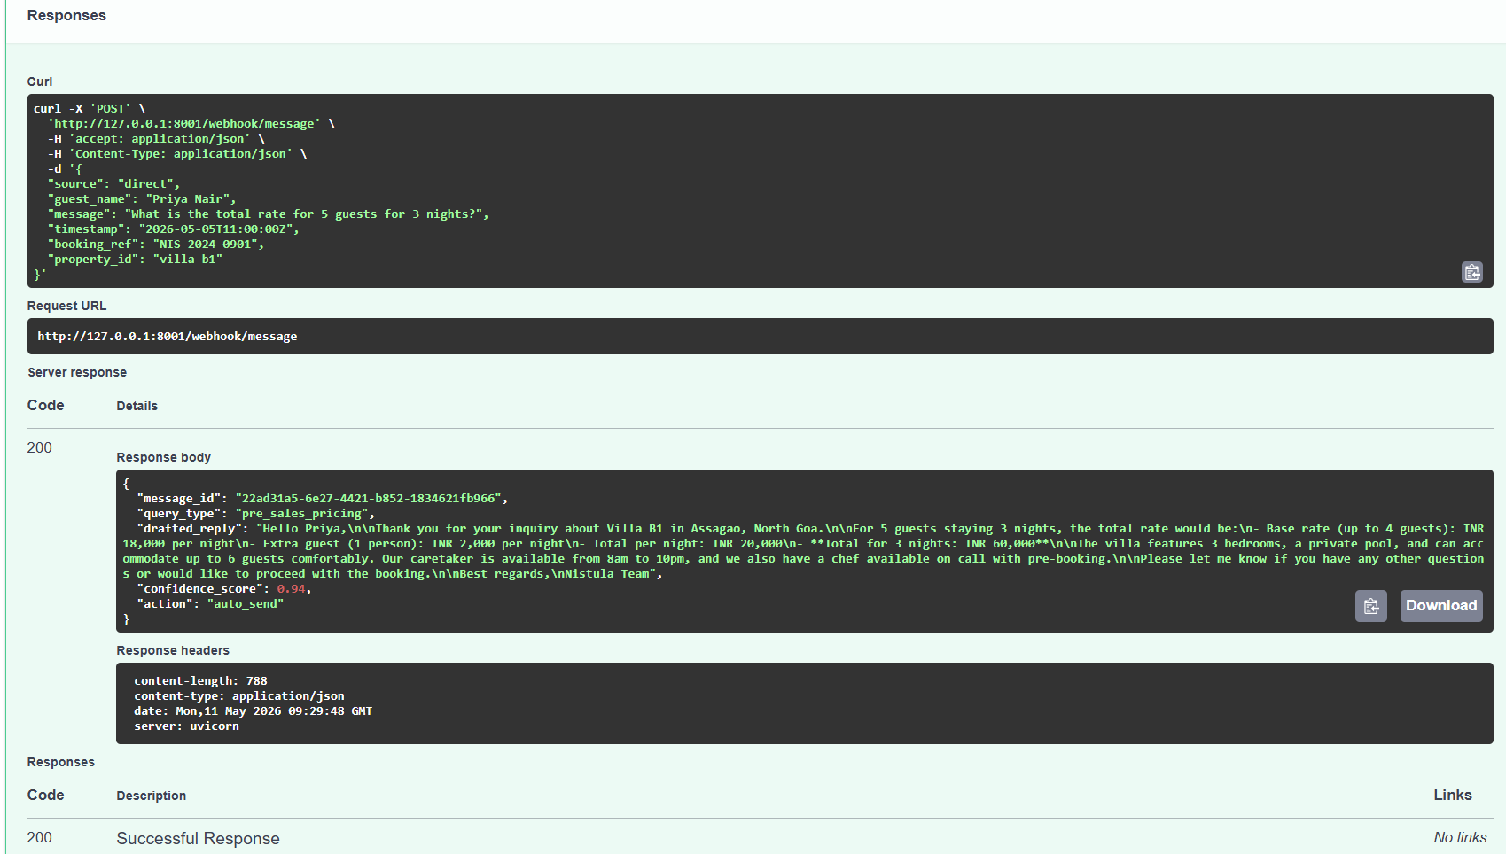

{
"source": "airbnb",
"guest_name": "Ananya Mehta",
"message": "What time can we check in and what is the WiFi password?",
"timestamp": "2026-05-05T12:15:00Z",
"booking_ref": "NIS-2024-0999",
"property_id": "villa-b1"
}
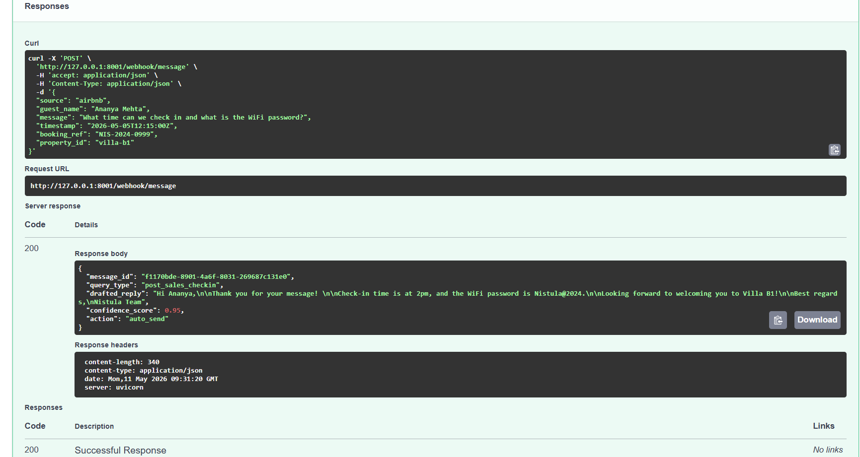

{
"source": "instagram",
"guest_name": "Meera Kapoor",
"message": "Can you arrange a chef for dinner during our stay?",
"timestamp": "2026-05-05T16:45:00Z",
"booking_ref": "NIS-2024-1120",
"property_id": "villa-b1"
}
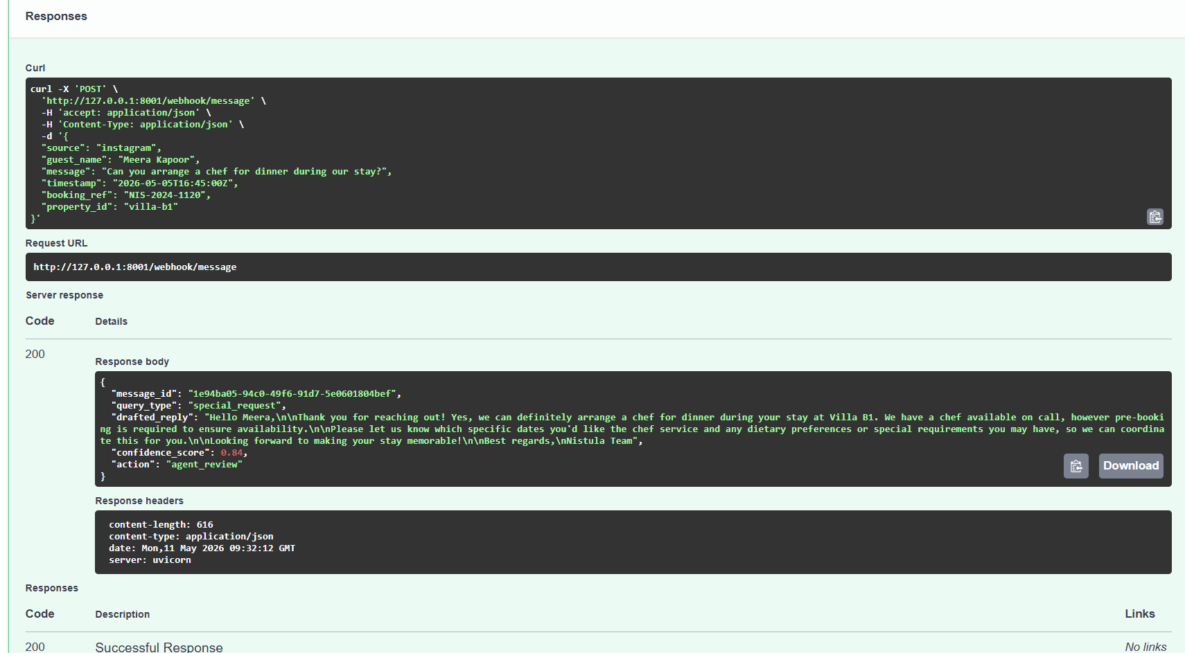

{
"source": "booking_com",
"guest_name": "Vikram Rao",
"message": "The AC is not working and I am not happy with the property.",
"timestamp": "2026-05-05T14:20:00Z",
"booking_ref": "NIS-2024-1012",
"property_id": "villa-b1"
}
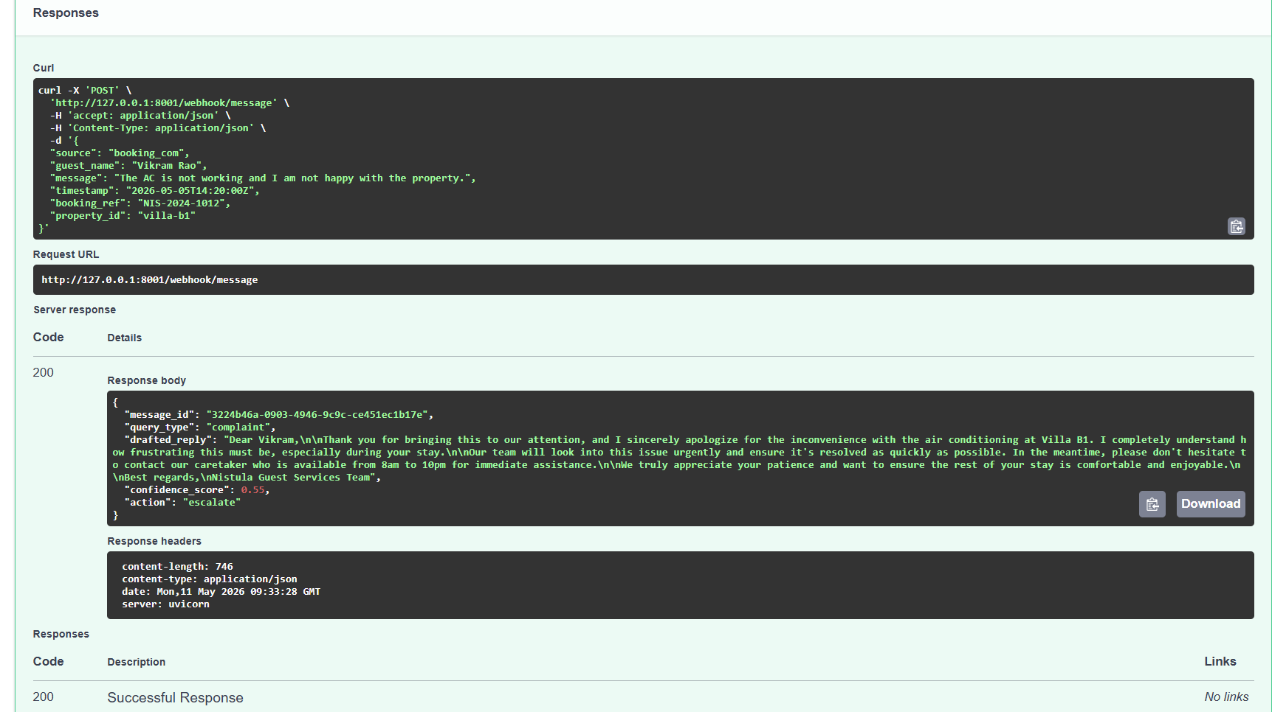

{
"source": "whatsapp",
"guest_name": "Aman Verma",
"message": "Do you allow pets at the villa?",
"timestamp": "2026-05-05T18:10:00Z",
"booking_ref": "NIS-2024-1188",
"property_id": "villa-b1"
}
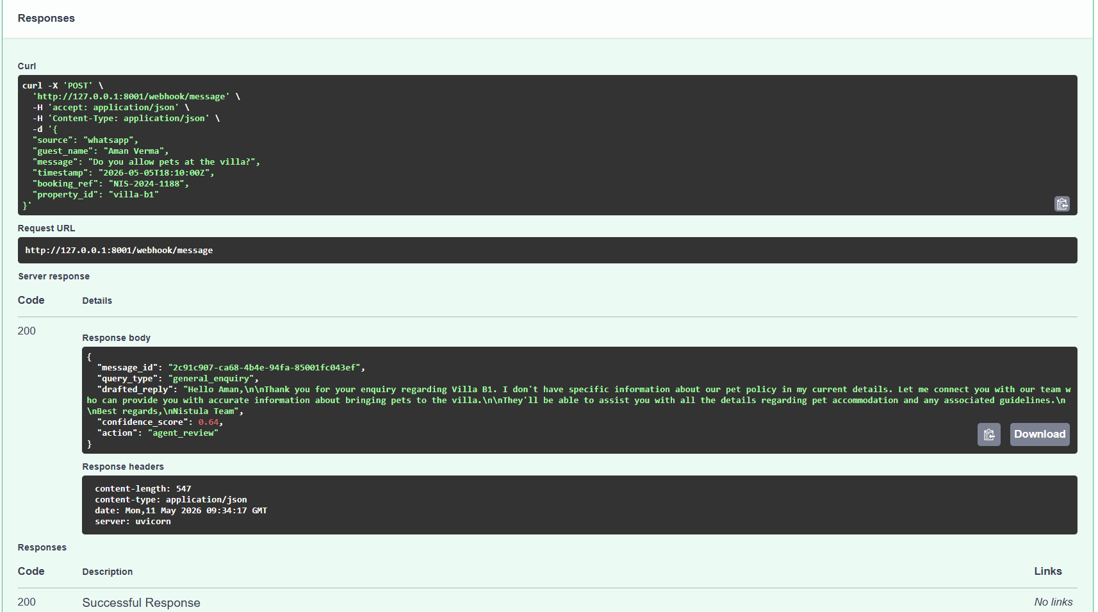

{
"source": "sms",
"guest_name": "Test User",
"message": "Is the villa available?",
"timestamp": "2026-05-05T10:30:00Z",
"booking_ref": "NIS-2024-0001",
"property_id": "villa-b1"
}