Project: Store inventory system

Description: A project was initiate during software engineer bootcamp to create a inventory system for shoe store, it is a OOP focus coding practice and manage data from external source.

Installation: Open any IDE capable for opening Python file (.py) like PyCharm or VS Code.

About system:

1. To run the system, have to make sure both “inventory.py” and “inventory.txt” file are under the same fold.
2. Open “inventory.py” with proper IDE and run it directly, the console view will pop up the system menu for action.

1. Input the respective number listed as an operator command and system will response to it’s action.

For example insert “1” to view the shoes stock, then the result will be populated.

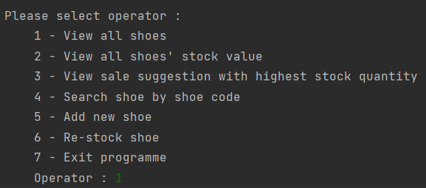

1. Each action of system are representing the following function.

1 - View all shoes : the system will look into data source file and population all result in a predefined format.

2 – View all shoes’ stock value : system do the calculation of all kind of shoes with it total value in dollar by checking the stock quantity and value of each.

3 – View sale suggestion with highest stock quantity : system will find out the kind of shoe with the highest quantity then sales would know which shoe require promotion for selling.

4 – Search shoe by shoe code : system able to find out the detail of particular shoe by giving a match SKU code.

5 – Add new shoe : A new shoe entry will be added to data source if all detail are giving by the user.

6 – Re-stock shoe : This action offering the general stock keeper feature to update the quantity when restock.

7 – Exit programme : system will exit properly.