|  |  |  |  |  |  |
| --- | --- | --- | --- | --- | --- |
| day | person | person 1 | person2 | person 3 | person 4 |
| Day 2 | | **server:**created model(usermodel.js) | **server:** Routes, Hash password for security. | **Login:**  client/login | Home page design |
| Day 3 | | To login then go to home page(protected route) Frontend and backend | State management  Redux loaderslice | Home page layout design |  |
|  | |  |  |  |  |
|  | |  |  |  |  |

**Person 1:**

BackEnd:

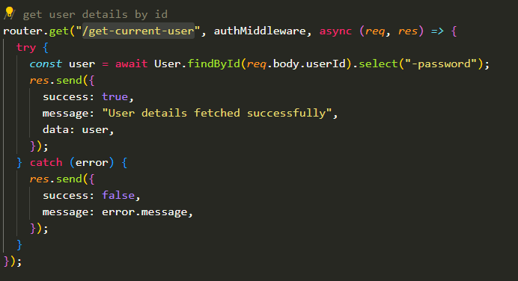

FrontEnd:

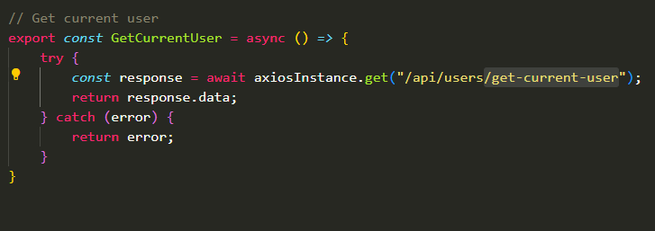

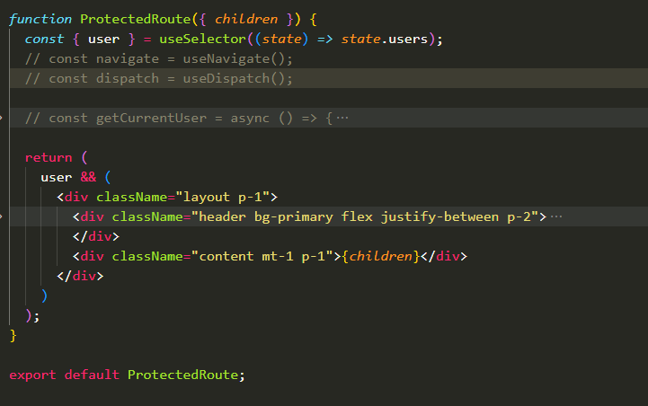

**Person 2:**

Redux=> loaderSlice.js

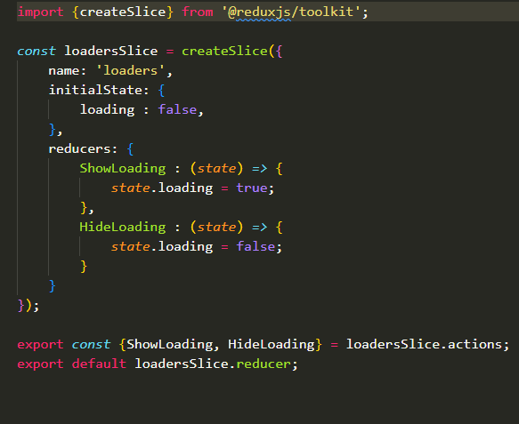

Css of loader

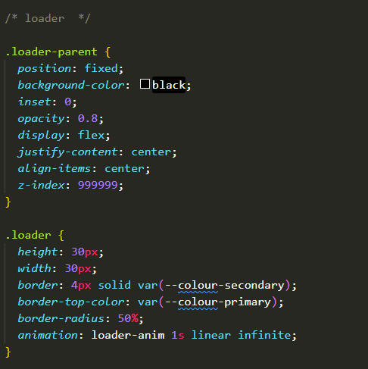

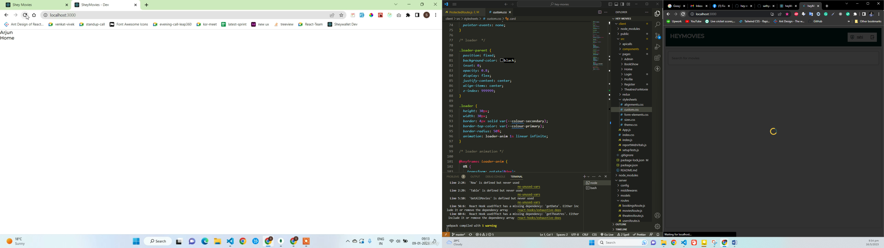

**Person 3:**

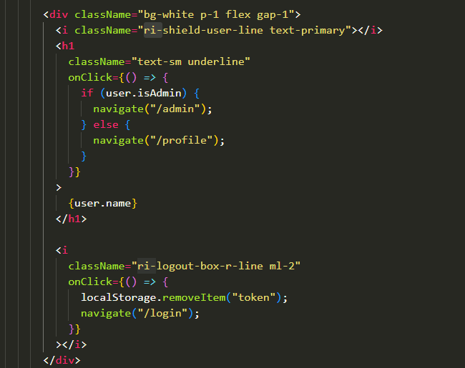

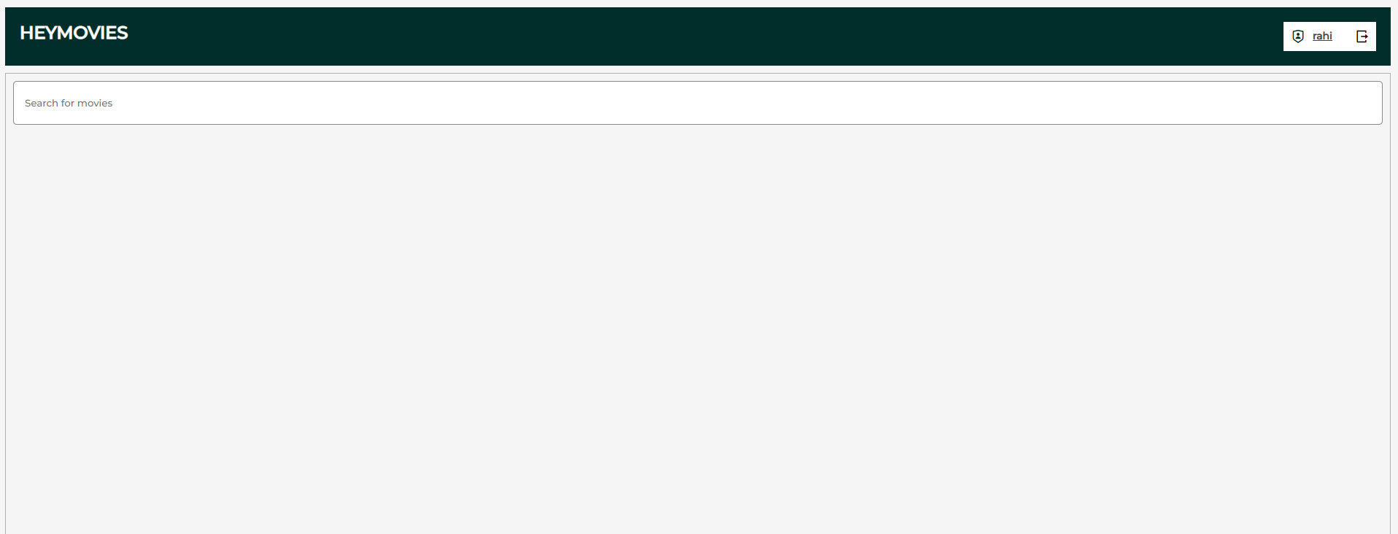

Person 4:

Src=> pages => admin=> index.js

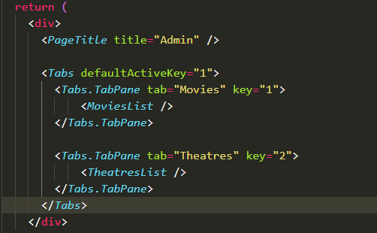

MovieList.js

