University of Derby
Department of Electronic, Computing & Mathematics

A project completed as part of the requirements for BSc (Hons) Computer Science

entitled
Need for Speed: A container-based performance analysis of C#, Java, and Python

by
Louis Wright
l.wright18@unimail.derby.ac.uk
April 2019

Abstract
Fast applications can be the key to a lot of benefits for both individuals and organisations. With a recent move into a more cloud-focused technology world, more time processing data can cost more, and so being able to process the same amount of data in less time can be beneficial. This study reviews the performances of implementations of C#, Java, and Python at handling many collections (e.g. Stacks and Queues) and their primary methods and operations. The tests were run with differing levels of processing required with collections containing from 1 to 10000 (1, 10, 1000, 10000) items of primitive or object type. The results found that C#’s .NET Core was the best performing out of all the implementations tested between the three languages. Despite this, recommendations were made at the end of the study that advised considering other factors depending on each individual scenario before making a decision based on the outcome of the testing.
Acknowledgements
Is this a real section? Do I just put witty stuff here?

Table of Contents
Abstract 1
Acknowledgements 2
Table of Contents 3
1. Introduction 5
1.1. Project Rationale 5
1.2. Project Aim and Objectives 5
2. Literature Review 6
2.1. Introduction 6
2.2. Primitive Types 6
2.3. Language Implementations 8
2.3.1. C# – .NET Framework, .NET Core, Mono 8
2.3.2. Java – OpenJDK, Visual J++, GCJ, Apache Harmony 9
2.3.3. Python – CPython, IronPython, Jython, and PyPy 10
2.4. Collection Comparisons 12
2.5. Conclusions 13
2.5.1. Key Issues 14
3. Testing Methodology 15
3.1. Introduction 15
3.2. Clocks, Collections, and Configurations 15
3.2.1. C# 16
3.2.2. Java 18
3.2.3. Python 20
3.3. Hardware and Operating Systems 22
3.4. Designing the Tests 22
3.5. Limitations 23
3.6. Conclusions 23
4. Results 23
4.1. Introduction 23
4.2. C# 24
4.3. Java 28
4.4. Python 31
4.5. Best of the Best 34
4.6. Conclusion 38
5. Conclusion and Recommendations 39
5.1. Conclusions 39
5.1.1. Future Works 40
5.2. Recommendations 41
5.2.1. Applying this Data 42
5.2.2. Final Thoughts - Consider Everything 42
6. Bibliography 43

Introduction

Project Rationale
During software development, it may not be immediately clear whether one language implementation is simply better, performance-wise, than another language. The same can be said when using different collections/containers.
While some studies have compared the performance of languages and their implementations on higher levels such as how quickly they can process different algorithms, there is a lack of research that covers the performances of languages on a level such as collections.
Because of the lack of research in this area, a study such as this could be instrumental for making decisions regarding the usages of different collections and language implementations in a variety of situations. One such application for the results of this study could be in the development of performance-critical applications when it is vital to get the most performance possible from an application. Another possible application could be for applications whose costs depend on the time taken to process some data (using a cloud provider for example), and so it would be ideal to be able to do the same amount of processing in the least time possible. Another possible application could be in scenarios where it is important to keep the resource usage lower while still achieving decent performance is required.
This study will document when a language and collection outperform others at some operations in various scenarios. For example, when developing performance-critical software, and getting the most performance as is possible, the results of this study could be critical for deciding on a certain language or collection.

Project Aim and Objectives
The aim of this project is to determine and document the most performance efficient container/collection in several operations in C#, Java, and Python by benchmarking each operation and analysing the time taken to complete each test. This aim will be supported by the objectives of this project which are to compare the existing literature of performance comparisons in C#, Java, and Python, then with that information, build a comprehensive testing suite to generate data regarding the performance of several of C#’s, Java’s, and Python’s collections operations in various scenarios, and finally analyse the data to document which language and collection performance best in each scenario.

Literature Review

Introduction
As a result of the lack of existing research in this area, this chapter will aim to evaluate the performance differences that exist between languages and collections in different ways by exploring the aspects on which collections are dependent. The first aspect that will be examined will be several primitive types in each language and how the performances compare in different operations. Secondly, the performance of many language implementations, compilers, and runtimes will be analysed to find which performs best and when. Lastly, the differences between several collections will be examined to see which collections perform the best at certain operations. After all these aspects have been analysed, their results will be summarised to show the absence of research in this area and prove the necessity of the output of this study.
Because the performance of software is dependent on several factors such as software architecture (Williams and Smith, 1998) (Smith and Williams, 2000), systems running the software, and the software runtime/framework (Toub, 2017) (Balliauw, 2018). The performance of collections can be viewed very similarly, though instead of software architecture, it is the underlying data types that affect the performance.

Primitive Types
Primitive data types are the most basic types available to use. These types are so useful to languages that they are included with the language as a feature (Sale, 1977). These types serve as the building blocks for programs, so any non-primitive type requires the use primitive data types to build their functionality. Because of this, it can be said that the performance of non-primitive types will rely considerably on the performance of the supporting primitive types.
In a review by Peter Sestoft, comparisons were made between C (gcc), C# (.NET runtime [version 4.0 and compiler version 4.0.21006.1]) and Mono [version 2.6]), and Java (Sun Hotspot 1.6.0-17) in the following performance testing applications: matrix multiplication, division-intensive loops, polynomial evaluation, and distribution function evaluation (Sestoft, 2010). Despite the amount of testing carried out in this study, the results are of questionable confidence because of two main faults. Firstly, the tests were only executed on a single machine with the only difference being that different Operating Systems (OS) were used (Mac OS X 10.6.2 and Windows XP SP3). Furthermore, even though a different OS was used, the secondary OS was acquired through platform virtualisation software to create a Virtual Machine (VM) running the OS. Given that applications built using .NET Framework are unable to run natively on Mac OS and Linux without the usage of Mono, the results lack the confidence that could have been achieved by running the tests on a machine running Windows instead of through a VM. Although not a fault of the study itself, the performance of complex object types such as collections cannot be reliably predicted based on the results of the numerical tests demonstrated in this study. This is exacerbated by the fact that there is no configuration that consistently outperforms the competition in the tests.
Similar tests to above, tests have been carried out pitting various languages from Ada to TypeScript against each other at running applications such as Mandelbrot, Fasta, and number tests (Chen, 2010) that are built to gauge how efficiently and quickly a language implementation can run such applications (Computer Languages Benchmark Game, n.d.). The tests record the times taken to execute a program and some record other statistics such as memory consumption and CPU usage. While these benchmarks provide an excellent amount of data yielded from test results from 27 languages (Computer Languages Benchmark Game, n.d.) and statistics collecting during the running of the tests, there are various faults with the confidence of the results. Again, like the above test results, the tests were only run on a single machine and each language with a single configuration (Computer Languages Benchmark Game, n.d.) and also include the benchmarking of applications whose contents use collections but do not focus on a single aspect of the applications’ contents but instead the application as a whole. Additionally, because of the way the programs measure the time taken for a test to be complete, the startup time of each application gets included in the result (Computer Languages Benchmark Game, n.d.) which introduces a new variable into the benchmarks that, albeit small (Computer Languages Benchmark Game, n.d.), influenced the times. Lastly, while a lot of language implementations were tested, a lot more have stopped being tracked including Mono C# and some Java implementations (Computer Languages Benchmark Game, n.d.).
Although data from the aforementioned tests and reviews show some level of differences in performance, the present downfalls require more research to be carried out to produce data that is an accurate representation of the performance of just collections by testing on multiple machines and under different configurations. Furthermore, for the testing, the startup time of each application will not be included in the final benchmark time so as to get the most accurate result possible. This way, the resulting data will be more reliable because of the elimination of issues of a certain machine or configuration skewing the results.

Language Implementations
Because languages are notations for writing programs (Aaby, 1998), and not machine-readable code, they cannot immediately be understood by computers (The Linux Information Project, 2006). For high-level code to be understood by a computer, compilers and interpreters are used to convert the code into an executable form – compilers convert code into machine code and interpreters execute the code directly (Mogensen, 2010). As it is the machine code that will be executed (Mogensen, 2010), how the compiler converts the high-level code and what it compiles the code to will affect the performance of the code. For these reasons, the performance of language implementations and runtimes (and subsequently their compilers) will be analysed.

C# – .NET Framework, .NET Core, Mono
Although .NET applications primarily use the .NET compiler named Roslyn (.NET Foundation, 2018), .NET Core uses a resigned Common Language Runtime (CLR) named CoreCLR (with CoreFX) (Mindfire Solutions, 2017) which means that applications start with fewer libraries in .NET Core applications and so can lead to performance improvements. Because of these improvements outside of the compilation, the performance of .NET Framework and .NET Core applications will be analysed.
Mono is an open-source project that has its own C# compiler and CLR (Mono, 2018) and can run on platforms such as macOS, Linux, and Windows (Mono, 2018) and is used in software such as Unity (Mono, 2018).
Some surface level tests have been run that compared .NET Framework and .NET Core (Toub, 2017). Despite some considerable performance differences being seen, the tests were only run on a single machine under one configuration and so the results lack a level of confidence that would be provided by a number of different machines and configurations being used. Additionally, when looking at collection-based tests that were used, the collections used (Queue, ConcurrentQueue, SortedSet, List, and ConcurrentBag) did not cover collections which are recommended for other purposes such as dictionary types and others.
.NET Core was shown to be capable of being among the fastest web frameworks in various tests carried out against frameworks written in languages from C to Java. Notably, .NET Core applications consistently outperformed applications using Mono (TechEmpower.com, 2018). However, although the source code for the tests showed various types of tests (TechEmpower, 2019) including some using collections, the tests do not rely primarily on the performance of the collections themselves. The focus on other aspects of the applications – which leads to widely varying responses per second in each application – introduces a lot of variables whose impact cannot easily be excluded from the results, and so the results cannot be used as a comparison of collections in each language.
Following the review of the existing literature covering .NET Framework, .NET Core and Mono, the following observations have been made: the existing literature lacks the appropriate collection coverage, a suitable number of tested configurations and machines, and some tests involve a lot of variables that are not relevant to the collections and so the results cannot be used as a guide. As a result of these observations, the tests created for this project will be tested on multiple configurations on multiple machines to ensure that the data produced is accurate and reliable. Tests will be created to cover the recommended collections for various usage for each language to create a wide comparison of collections that should cover most situations that require collections. Lastly, the tests will have a primary focus on the collections themselves and only seek to measure the performance of certain operations – based on what the application of the collection is – carried out on the collection. This will allow the results of the tests to be used as an accurate comparison of collections in each language.

Java – OpenJDK, Visual J++, GCJ, Apache Harmony
The existing literature covering Java implementations other than the reference implementation OpenJDK is few and far between. Benchmarks for OpenJDK can be found easily because of its use as the primary Java SE implementation (Kestelyn, 2011) with it typically being used when comparing language implementations (Computer Languages Benchmark Game, n.d.) (Trzaska, 2010). Sun Microsystem’s release of a considerable amount of Java code (Lamonica, 2007) including code for javac (OpenJDK, 2007) and the HotSpot Virtual Machine (OpenJDK, 2006) can be attributed to the decline in usage of other Java implementations (Wheeler and Friedman, 2008).
Unlike languages implementations like Mono and IronPython (C# and Python respectively), other Java implementations do not fill a niche not covered by the reference implementation (e.g. Mono has Linux and macOS support for WinForms, IronPython targets the .NET Framework) to a level sufficient for them to remain relevant and in development. Because of this, OpenJDK is will be viewed as the main Java SE implementation.
For completeness, tests and benchmarks involving various Java SE implementations will be included and reviewed.
One review of Java implementations compared JDK (later OpenJDK) to Microsoft’s Visual J++. Similar to other benchmark collections, a wealth of tests was used to benchmark the implementations. However, many tests were written with focuses on several areas on which the compilers would make improvements and optimisations. For example, there are tests covering the performance of simplifying mathematics expressions and other tests that look at the translation of integer multiplication operations that can be replaced with shift expressions (NULLSTONE, 2002).
Although few statistics were provided, some performance comparisons have been made between OpenJDK’s compiler javac and the GNU Compiler for Java (GNJ). Using Per Bothner’s Kawa test suite, GCJ was compared to JDK 1.3.1 in regard to speed, memory usage, and other aspects (Bothner, 2003). GCJ, however, was later removed from the GNU compiler collection and deleted (Tromey, 2016).

Python – CPython, IronPython, Jython, and PyPy
Although languages can be compiled and interpreted, languages are viewed as compiled or interpreted languages based on their most typically used implementations (Intepreted language, 2011). Python, unlike C# and Java, is an interpreted language (Python Wiki, 2018), and so its implementations typically use interpreters including the reference Python implementation: CPython (Python Wiki, 2018) which compiles Python into bytecode which is then interpreted by the virtual machine (Reitz, 2011).
As well as the reference Python implementation, there are many varying Python implementations including some that are known to support and be compatible with a given version of the Python language: IronPython (for .NET CLR and Mono), Jython (for Java), and PyPy (for Python) (Python Wiki, 2018). With these implementations, a considerable amount of research has been carried out comparing benchmarks and structural differences between implementations and some effecting changes to improve the performance of systems using the implementations.
One study that primarily looked at the performance of IronPython, and PyPy was written as part of a thesis and attempted to improve PyPy’s just-in-time (JIT) compiler generator as well as adding functionality to allow it to target the .NET framework in order to achieve higher levels of performance. The result showed that even with improvements to PyPy, the result of the JIT compilation performed worse than other implementations in some regards, but faster in others. The thesis also involved carrying out microbenchmarks that compared PyPy to IronPython using both Mono and the .NET CLR at operations involving the dictionary and list collections as well as method calls and string operations. As well as microbenchmarks, tests have been carried out similar to those as part of The Computer Language Benchmarks game involving recording the times taken to execute programs such as fannkuch, k-nucleotide, and spectral-norm (Cuni, 2010).
Another study, included in the IEEE Software journal, evaluated seven major Python implementations of Python 2 and Python 3 (including CPython, PyPy, IronPython, and Jython). The testing documented the start-up and steady-state execution times and memory consumption of the Python implementations in 523 applications varying from microbenchmark applications to large-scale applications such as the web2py web framework. The tests also made a point to document the inclusion of code categorised as involving multithreading and I/O processing. It also compared Python 3 implementations to their Python 2 counterparts where possible (IronPython and Jython did not have Python 3-supporting versions). However, while 14 large-scale applications were chosen to be tested for Python 2 implementations, for IronPython and Jython, only 7 and 8 applications were tested respectively. Another thing to note, however, is that while up to 14 large-scale applications were tested on Python 2 implementations, only 6 of them could be converted to be testing on Python 3 implementations (Redondo and Ortin, 2015).
Lastly, further research has been carried out that compares the performances of official Python versions (and thus CPython) and PyPy in various tests such as start-up times, rendering HTML templates, and cryptographical operations (Shaw, 2018). On top of this, other research has also been documented that focuses less on performance benchmarks, and more on the structural differences between the compilation/interpreting of Python code into an executable form (Marsh, 2013) (Daalia, 2017).

Collection Comparisons
There are many different types of collections in C#, Java, and Python, and their advantages in different situations have been well-documented. This section will examine several types of collections and their applications.
For C# applications, Microsoft provides guidance on using collections and data structures for storing data. Their guidance and recommendations include a table documenting the situations in which one type of collection is preferable over another. For example, when storing items as key value pairs, the Dictionary<TKey, TValue> (and the concurrent, read-only, and immutable variants) and Hashtable types are recommended. While these recommendations can be beneficial for choosing a collection type at a glance, they do not provide any statistical backing for documenting the advantages the recommended types have over similar types. In other words, while using the generic List<T> type is recommended for accessing items by index over a non-generic Array and it is stated that performance of generic collections is typically better (Microsoft Docs, 2017), no evidence is provided to support this position.
For Java applications, Oracle has created a series of tutorials and documents which provide information about their collection interfaces: Set, List, Queue, Deque, and Map. They also claim that in each case types such as ArrayList, and HashMap types are the best to use for most applications. However, these documents do not provide any performance metrics, but instead recommend measuring the performance of collections if one is unsure of which to use (Oracle, n.d.). Additionally, more detailed guides exist for choosing collections which document what each type of collection interface is for, and the commonly used collections of each interface. One such guide, however, ultimately recommends that if the collection behaviour is irrelevant, then an ArrayList is a fast and memory efficient collection to use (Grand, 2009). Lastly, collection performance reviews have been carried out that document time taken, and memory consumed when executing varying operations with different amount of contents (Lewis, 2011). While some reviews compare vast amount of collections in Java, one such review relies on System.nanoTime() (Lewis, 2011) which, although is it recommended for use in benchmarking, suffers from some precision limitations (Boyer, 2008).
For Python applications, seemingly very little research has been carried out to compare the time-based performance of collections in Python. The Python Wiki provided some information regarding many operations on Python’s general use built-in collections: dict (dictionary), list, set, and tuple. The information provided, however, relates to the time complexity or Big O notation (Bell, 2009) of the operations in CPython (Python Wiki, 2017). While this information can be useful in a theoretical context, it fails to provide any statistical backing, and so must be taken by its word or with a pinch of salt. Additionally, no similar information can be found regarding any collections that aren’t built-in such as deques and Counters, although information regarding the structure and behaviour of these collections can be found elsewhere (Python Docs, 2019). Some further research has been done comparing benchmarks of Python’s tuple and list collections at various operations. This research has some value, but also has faults such as the fact that it does not include the dict or set collections and does not provide any information pertaining to the amount of times the tests were run.

Conclusions
This literature review has examined and evaluated the existing literature covering the performance of several aspects of C#, Java, and Python. From language implementations to benchmarking applications results, several aspects have been reviewed to understand the existing coverage and knowledge around the performance of collections in these languages, as well as identify any improvements that can be made to increase the coverage of specific areas of performance in these languages.

Key Issues
While many studies have been carried out that compare the performance of C#, Java, and Python and their implementations, very few tests have been run that test microbenchmarks around collection-based operations in each of these languages; with only small amounts of tests being seen for C# and Python. In the cases where the right type of tests were being reviewed, it was often the case that the tests only On top of this issue, a common issue seen among the literature is the frequency of running tests under one configuration; this issue primarily relates to a single machine being used to run the benchmarks, and when running tests on a non-native OS, a virtual machine will have been used.
Another issue seen is not necessarily a fault of each review, study, or document itself, but of the literature covering this topic as a whole. While the studies themselves may adequately answer any questions in relation to their original goals and aims, they simply do not sufficiently cover the topic in question such that judgements can be made regarding the selection of collections. An example being reference documents created by Microsoft and Oracle that act mostly as quick references for choosing collections but lack any backing other than the authority of the company providing the information. With these documents, as is stated by Oracle, when choosing a collection, and unsure about the performance, measure the performance (Oracle, n.d.), and decide based on the results.
The last major issue a considerable amount of the literature suffered from relates how long the results of the studies are valid for. Because languages and their implementations are consistently changing, the validity of the results of performance benchmarks can be affected by updates and can only truly be seen as valid for the versions on which the benchmarks were done. Although it is possible that the performance of language implementations would not change radically over time, leaving the aspect out of the equation would be naïve. This issue is particularly valid when examining the existing Java implementation literature which sees tests carried out in 2002 using a JDK version from 1998 given that it still receives updates as of 2019.
As a result of this gap in the literature and flaws in the existing testing, choosing a language or language implementation based on their collection performance cannot be easily carried out, and so further research, that does not suffer from the same faults as what has been done before, needs to be carried out to inform decision made based on the merit of collection-based performance.

Testing Methodology

Introduction
To gather useful and meaningful results from the testing, information regarding how the tests will be conducted and with what different configurations, environments and tests needs to be documented. This section will document all the relevant information in sections dedicated to aspects such as how the test results will be measured, the collections that will be tested, and more.

Clocks, Collections, and Configurations
In order to test and benchmark the performance of collections, four main aspects need to be addressed for each language: the language implementation(s) to be used, the collections to be used in the tests, how best to collect the benchmark result data, and the operations on the collections that will be benchmarked and analysed.
This section will discuss and justify the process used to address each of the above issues for each language and the results that come from the process.
A globally relevant aspect of the creation of the collection tests is the types of collections to be chosen. While languages can have different names for collection classes, it is very likely that they share collections whose behaviours are the same or similar and are built for a certain type of situation or application. For example C#’s System.Collections.Generic.Dictionary<T> type is very similar to Java’s java.util.HashMap<K,V> type despite having different names. Furthermore, while collection types exist for a certain type of behaviour (Stack for Last In First Out) similar collections may exist which apply the same type of behaviour but for more specific purposes (e.g. concurrent versions [C#’s ConcurrentStack] for thread safety); however, these types will not be used because the problems they solve do not seem to be relevant enough to the goal of the study to include. With this in mind, the types of collections will be chosen based on the following behaviours:
- LIFO (Last In First Out) (e.g. Stack)
- FIFO (First In First Out) (e.g. Queue)
- Sequential list access (e.g. Linked list)
- Index access (e.g. Array, List)
- Key access (e.g. Dictionary/Map)
These collections should allow for a comprehensive test suite to be created covering most uses and applications of collections in C#, Java, and Python. In each language’s section, the chosen collections will be documented and reasons for choosing specific classes will be noted. A C# example could be if an array is chosen over an ArrayList, the reason for making that decision will be justified.
Another issue that can immediately addressed is the type of information collected from the benchmarking. Because the type of information is independent of a programming language, so will be noted here. The information collected will be the time taken to finish each test in nanoseconds (ns).
Lastly, regarding the methods and actions that will be carried out and benchmarked on each of the collections. The tests for each type of collection will be based on the strength of each collection. For example, a Stack type will have its Push and Pop methods benchmarked because while these methods merely add and remove items from the collection, their performance at supporting the type of behaviour is what is important to the tests. For the collections that have been chosen for access (List, Dictionary/Map, etc.), the benchmarking will only consider the time taken to access a member of the collection, and not any time taken to add the members.

C#
Language Implementations and Runtimes
On top of Microsoft being the current developer of the C# language specification, it also maintains two popular C# implementations: .NET and Mono. Furthermore, the .NET implementation also has two runtimes: .NET Core and .NET Framework (Microsoft, 2019). Because of the wide usages of these implementations and runtimes, the C# tests will be ran under those environments in order to get a more accurate idea of what C#’s performance looks like and assist in any decisions made regarding choosing C# implementation and runtime. The versions are as follows: .NET Core 2.2.3, .NET Framework 4.7.2, and Mono 5.16.0.
Benchmarking Process
When it comes to benchmarking C# code, although taking an approach that uses a class like System.Diagnostics.Stopwatch allows for the providing of information about the times taken for code to execute (Microsoft Docs, n.d.), the approach lacks any built-in ability to run the tests under varying configurations and environments and does not ensure the removal of any overhead where possible. In short, the Stopwatch class provides very little functionality outside of simply recording times. However, a .NET library supported by the .NET Foundation (BenchmarkDotNet, 2019) and recommended and used by many high-profile people in the .NET community (Hanselman, 2016) (Skeet, 2016) (BenchmarkDotNet, 2019) (Kokosa, 2018) called BenchmarkDotNet comes with many features that allow for reliable and comprehensive testing of .NET applications (BenchmarkDotNet, 2019). For each method to benchmark, the library creates an isolated project to exclude as many interferences as possible and to achieve the most accurate results. As well as this, many other features are present that allow for the user to control whether the tests are run with a cold start or warmed state and to configurate the garbage collection (GC). Statistical information varying from means and standard deviations are provided, but further statistics such as confidence intervals can also be collected. Lastly, the library provides ways for the tests to be run on several different configurations including x86 vs x64 and Mono vs .NET Core as well as providing information about the amount of memory used during the testing (BenchmarkDotNet, 2019).
By using BenchmarkDotNet, the code for the tests can be written, attributes added to dictate the configurations and environments to be used for testing, and the tests can be run on multiple machines without requiring further configuration. From the tests, data (and graphs) will be created and then analysed to examine the performance and resource usage of the collections.
Collections
Because Microsoft are currently the maintain and develop C# and some of its most popular runtimes and compilers, documentation provided by them was consulted for choosing collections for each purpose. Based on the aforementioned guidelines for choosing collections to test and documentation provided by Microsoft (Microsoft Docs, 2017), the following collections have been chosen for the C# tests:
- LIFO – System.Collections.Generic.Stack<T>
- FIFO – System.Collections.Generic.Queue<T>
- Sequential list access – System.Collections.Generic.LinkedList<T>
- Index access – System.Collections.Generic.List<T>
- Key access – System.Collections.Generic.Dictionary<T>

Java
Language Implementations and Runtimes
As mentioned previously, the only remaining widely used Java implementation is maintained and developed by Oracle. While there are many parts of Java, all the required components come as part of OpenJDK which contains a Java Virtual Machine (JVM), a compiler, and runtime environment (JRE). Additionally, as OpenJDK is the official reference implementation of the Java Standard Edition (JSE), the Java tests will be ran using OpenJDK 12.
Benchmarking Process
In the same way that the .NET Foundation develops and maintains a benchmarking package for .NET applications, Oracle develops and maintains a benchmarking package for Java applications (OpenJDK, n.d.). Deployed as part of Java 9 (Ramgir and Samoylov, 2017), the Java Microbenchmark Harness (JMH) is a harness built for developing, executing, and analysing benchmarks written that target the Java Virtual Machine.
Like BenchmarkDotNet, JMH handles many aspects of benchmarking that a simple timer class would not cover such as JVM warm-up and code-optimisation (Microbenchmarking with Java, 2018). These improvements save a lot of work by taking care of aspects of Java that affect the accuracy of benchmark results. For example, Java can make various improvements to applications while running to improve the performance such as storing values from code known to return the same value every time; JMH removes the need for this to be accounted for by eliminating any potential for it impacting the results. Furthermore, because Garbage Collection (GC) can impact results by introducing additional processing, JMH allows for the GC behaviour to be decided when running tests (Markovic, 2019). Lastly, JMH also contains profilers that track the memory consumption metrics of a benchmark which provide detailed information regarding memory consumption of an application with particular attention paid to GC cycles (Wilke, 2017).
However, there is another prominent way of benchmarking code targeting the Java Virtual Machine: Caliper. Caliper is a benchmarking library from Google (Google Open Source, n.d.). It possesses similar features to JMH such as providing the necessary means to avoid the removal of dead code by the compiler (Decker, 2017) (OpenJDK, 2014) but falls short of JMH’s functionality in a few ways that can affect the validity of the results (Google Groups, 2014). Although there are arguments made that Caliper is easier to use, because accuracy holds the greatest amount of weight in choosing a benchmarking harness/library, JMH will be used to run the tests.
Collections
As with C#, there is one primary maintainer of the Java language specification, implementation and runtimes: Oracle. After reviewing official documentation and guidance provided by Oracle for choosing a collection based on its behaviours (Oracle Docs, 2018), the following collections have been chosen for the Java tests:
- LIFO – ArrayDeque<E>
- FIFO – java.util.LinkedList<E>
- Sequential access – java.util.LinkedList<E>
- Index access – java.util.ArrayList<E>
- Key access – java.util.HashMap<K,V>
It is worth noting that while there is an interface in Java named Queue that has methods to support collections implementing FIFO behaviour, no built-in class exist that implements this functionality in a manner akin to the java.util.Stack class. However, a subinterface called Deque exists. The Deque interface implements the Queue interface (for FIFO behaviour), but also supports LIFO behaviour. It also has two notable implementing classes: ArrayDeque and LinkedList. For this reason and further research, ArrayDeque and LinkedList were chosen for LIFO and FIFO respectively.

Python
Language Implementations and Runtimes
When it comes to choosing a Python implementation, there are two main questions to address: Should both Python 2 and Python 3 be used? Which Python implementation should be used? As stated on the Python wiki, Python 2.x versions are legacy versions of Python and Python 3.x versions are under development (Python Wiki, 2017). However, there is more to choosing a Python version than that; Python 3.x versions may be suffer worse library support and access than Python 2.x versions, and some operating systems use Python 2.x versions as their default. Because there can be a case made for both Python 2.x and Python 3.x versions, the latest stable versions of each will be tested. Regarding the python implementation, while CPython is the reference implementation of Python that comes when downloading Python from the official website, it may not be the fastest. Because of this, it could be worth entertaining using other implementations such as PyPy and IronPython as well as CPython to get the most comprehensive and accurate impression of Python’s performance. For this reason, and because PyPy’s performance has been shown to be better than CPython in some benchmarks and tests, both CPython and PyPy will be used for the Python tests. Because PyPy has currently only released a stable build for Python 3.5, the Python 2 tests will be run on CPython 2.7 and PyPy 2.7. The Python 3 tests will be run on CPython 3.7.3 and PyPy 3.5.
Benchmarking Process
There are various ways of profiling and benchmarking Python code such as the timeit module, cProfile module, etc. A few of the recommended (Python Wiki, 2016) ways of benchmarking are the profile, cProfile, hotshot, and timeit (Driscoll, 2016) modules. However, both profile and timeit modules are written in Python and such incur significant overhead to the benchmarks. The cProfile (Python Documentation, 2019) and hotshot modules are, instead, written in C and have less significant overheads. While the hotshot module was written to incur less overhead, it is advised for specialised usage (Python Documentation, 2019). Despite the advantages of using these modules to benchmark the Python tests, one of their greatest advantages relates to their ability to break down how much time was spent in each method. In the tests for this study, only one method will be involved, and so only a precise clock/timer is required for the Python tests. Had the modules provided similar benefits to what BenchmarkDotNet and JMH provide to C# and Java respectively, it could have been worth using them, but as it stands, these modules do not provide enough of a benefit to justify the overhead of using them.
Collections
With the Python Software Foundation being the maintainer of the Python language specification, the documentation and wiki provided by them were reviewed to create a list of collections to use for the tests. Even though Python provides fewer built-in collections than C# and Java, the aforementioned review found that enough collections are provided by Python to support the existence of tests for each test case:
- LIFO – collections.deque
- FIFO – collections.deque
- Sequential access – collections.deque
- Index access – collections.list
- Key access – collections.dict
Like with Java, Python does not provide any collection classes that implement FIFO behaviour in a similar, standard way to how the collections.list class implements index access. This issue also extends to LIFO, and sequential access. The collections.deque class provides functionality that allows it to, depending on how it gets used, to have LIFO and FIFO behaviour as well as act like a linked list for sequential access (Python Documentation, 2019) (Bader, 2017). Because of this, the collections.deque class will be used for the LIFO, FIFO, and sequential access tests but will be used in a different manner in each test case.

Hardware and Operating Systems
The ensure that the results obtained through testing was consistent and fair while still using a variety of configurations, all the tests were run on two different machines.

 | Machine #1 | Machine #2
Operating System | Windows 10 (64-bit) | Windows 10 Enterprise (64-bit)
Processor (Cores) | Intel i3-6100 @ 3.70 GHz (2) | Intel i7-4770 @ 3.40GHz (4)
Memory | 8.00 GB DDR4 2400 MHz | 16.00 GB DDR3 1600 MHz
Disk Drive(s) | 250 GB Samsung 750 EVO SSD  2 TB Seagate Barracuda 7200 RPM HDD | 250 GB Samsung 840 EVO SSD  1 TB Seagate Barracuda 7200 RPM HDD

Designing the Tests
When designing the tests, exactly what about each collection would be tested had to be decided. To resolve this, the applications and purposes of each collection were examined to find a suitable method to test. For example, with a LIFO data structure, the collection would likely be used for its unique behaviour when adding and removing items from the collection. Because of this, the methods used for testing a LIFO collection were chosen to be ones that added (or pushed) and removed (or popped) items from the collection.
After gathering the information about what exactly would be tested, special consideration had to be made to languages that had optimisation processes applied to the code. For example, Java has a compiler process that aims to remove dead code to prevent unnecessary processing. When processing the index access tests that could simply retrieve an item from the collection and then do nothing with it, the compiler could remove this code as its result has no effect on the application. To combat these optimisations, guidance from JMH’s developers was followed that advised an action such as returning the value retrieved from the collection as the compiler could not know then if it should remove the code prior to execution (OpenJDK, 2019).
In general, when packages and frameworks such as BenchmarkDotNet and JMH were used, then the documentation would be used to help produce the most accurate tests. Such documentation helped improve the tests by providing information about available features from test parameters and set up and tear down methods (BenchmarkDotNet, n.d.) (Javadoc Extreme, 2014).

Limitations
Naturally some level of overhead is brought in by adding in additional processing to measure times and metrics, so there will be slight inaccuracies regarding the true values of the benchmarks. However, the usage of the chosen benchmarks has been influenced by the amount of overhead introduced and interference removed in order to reach the greatest level of accuracy.

Conclusions
In conclusion, various aspects of the testing have been addressed; from language specific details such as implementations and runtimes to globally relevant details such as the type of tests to be carried out for each collection type. These aspects and their effects have provided a means to write and run tests that will create meaningful and reliable data about language collection performances.

Results

Introduction
This section will display the results of the tests whose properties were discussed in the previous section. The results will be broken down into sections for each language to allow for comparisons between language implementations and runtimes such as Python’s CPython and PyPy. After this, the best performing implementation of each language will be compared to show which language was the best performing.
These results will be briefly discussed in each subsection, and then analysed at the end of the section.

C#
Last In, First Out (LIFO)
Using the Stack class, the time taken to push and pop different amounts of types was measured. From the results of these tests, it is worth noting that although .NET Core outperformed both .NET Framework and Mono when using primitive types, it was outperformed by .NET Framework when using instances of the object class. The performance advantage of .NET Framework when using the object was greater than .NET Core’s advantage on primitives.
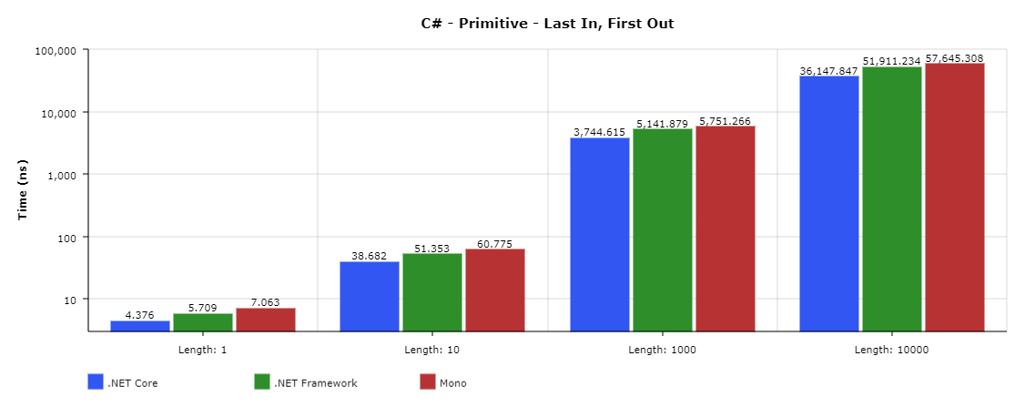
Figure 1. Time taken (ns) for C# Primitive LIFO tests.
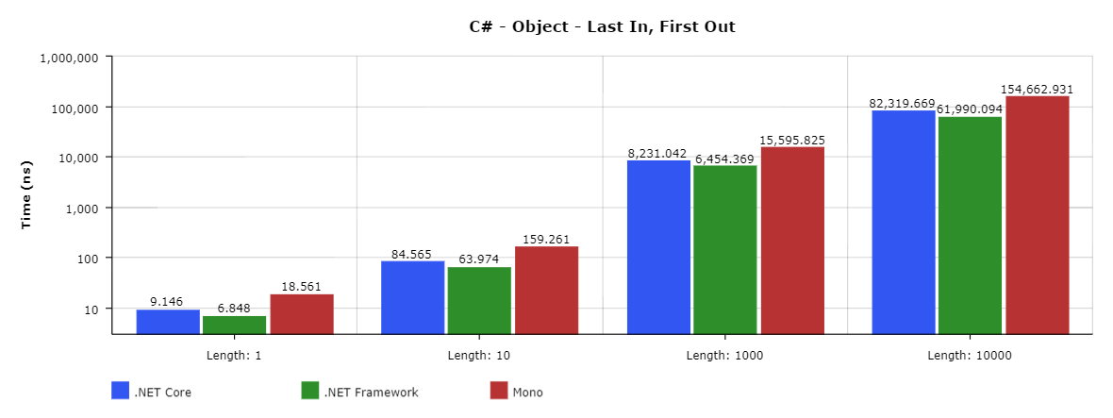
Figure 2. Time taken (ns) for C# Object LIFO tests.

First In, First Out (FIFO)
Using the Queue class, the time taken to enqueue and dequeue different numbers of types was measured. Contrary to the Stack class, .NET Core outperformed .NET Framework on both primitive and class types in these tests. While .NET Framework did not take a massive performance hit between primitive and class types, the performance on primitive types led to it being outperformed considerably by both .NET Core and Mono.
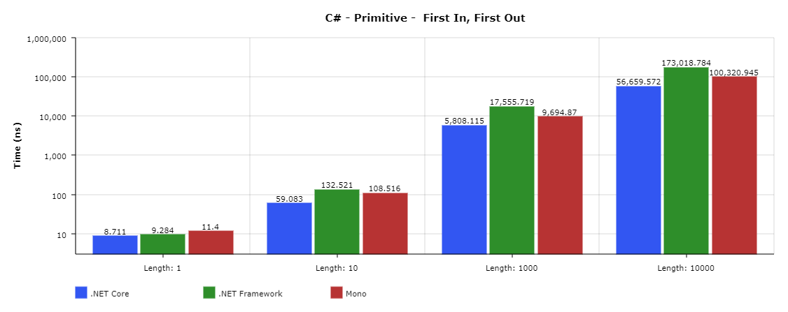
Figure 3. Time taken (ns) for C# Primitive FIFO tests.
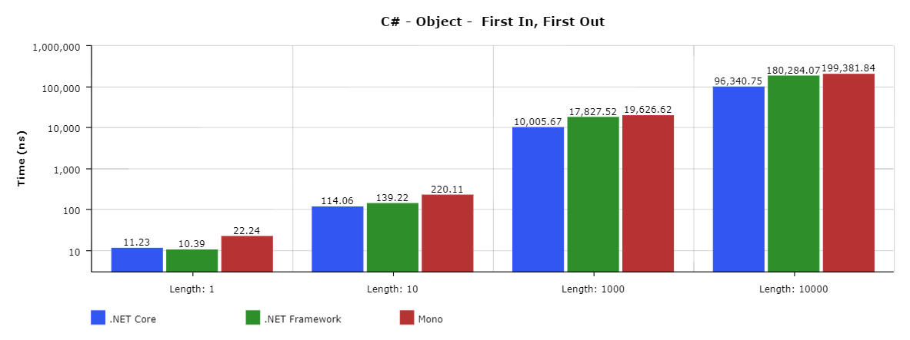
Figure 4. Time taken (ns) for C# Object FIFO tests.
Sequential Access
Using the LinkedList class, the time taken to find the last matching instance of a certain list member was measured. While .NET Core outperformed the other implementations and runtimes several times during these tests, when the linked list had a length of 10000, .NET Framework managed to come out on top. When it came to the object tests, the performance rankings were in reverse order to what was typically seen; Mono consistently outperformed both .NET Core and .NET Framework.
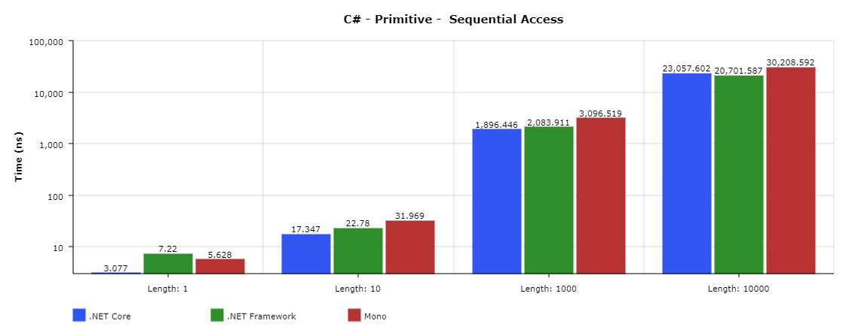
Figure 5. Time taken (ns) for C# Primitive Sequential Access tests.
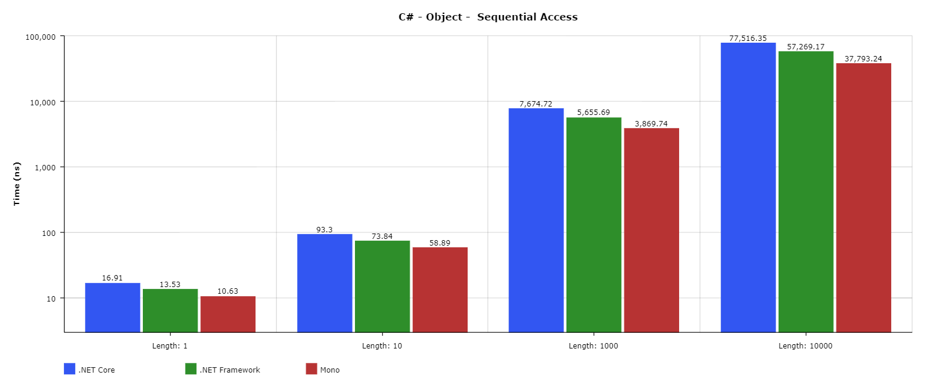
Figure 6. Time taken (ns) for C# Object Sequential Access tests.
Index Access
Using the List class, the time taken to get a member of a list by its index in the list was measured. As is a recurring theme throughout the C# tests, .NET Core managed to slightly outperform .NET Framework while Mono lagged behind. Something of note is that the length of the collections seemed to have a negligible effect on how long it would take to retrieve the object.
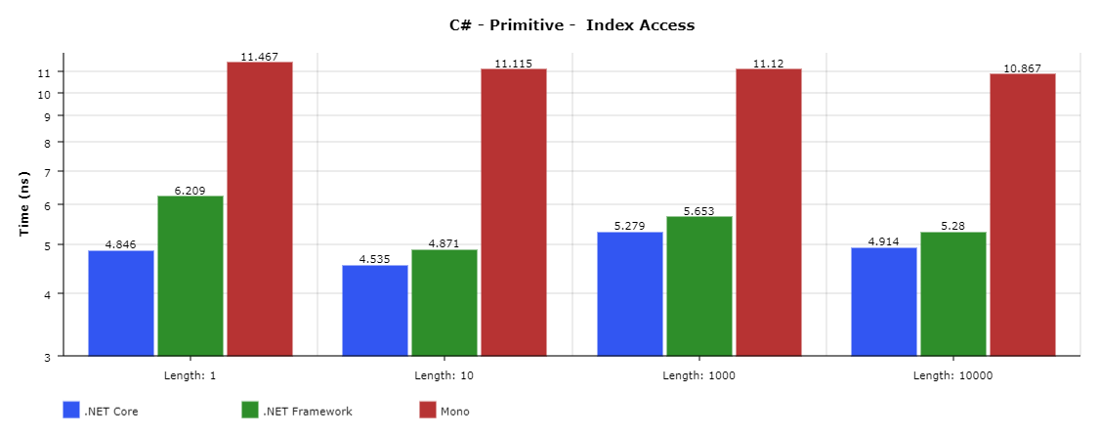
Figure 7. Time taken (ns) for C# Primitive Index Access tests.
Key Access
Using the Dictionary class, the time taken to get a member of a dictionary by its key in the dictionary was measured. Consistent with other results, the usual order of performance remained with .NET Core in the lead although Mono did not suffer as greatly compared to the index access tests. Something of note is that while, like with the index access on the list class, the time taken did not seem to increase with collection length, the base time taken seems to differ greatly with the dictionary.
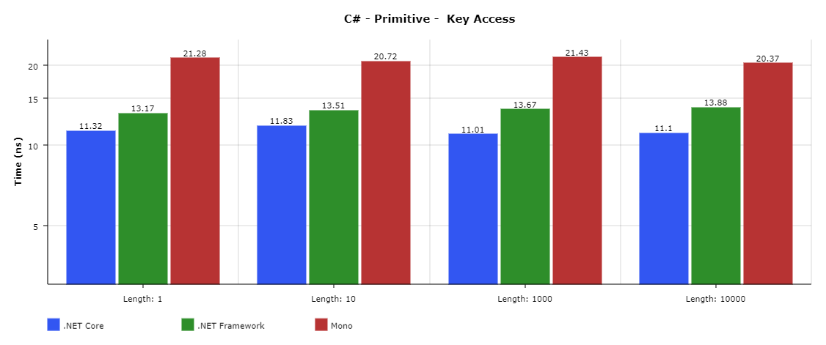
Figure 8. Time taken (ns) for C# Primitive Key Access tests.
Section Summary
For the C# tests, a consistent theme was observed across most of the tests: .NET Core would lead with .NET Framework very close behind, followed lastly by Mono. While there were exceptions to this theme such as with the larger sequential access tests and the smaller LIFO and FIFO tests, .NET Core had the edge most of the time. Even though Mono was almost always the worst performing implementation/runtime, it, like .NET Framework, definitely has its place in the C# world. This will be discussed later on in the recommendations section.

Java
Last In, First Out (LIFO)
Using the ArrayDeque class, the time taken to push and pop different amounts of objects was measured. OpenJDK’s (Java) performance for small collections was better with primitive types, but as the collection got bigger, primitive performance became worse than object collections.
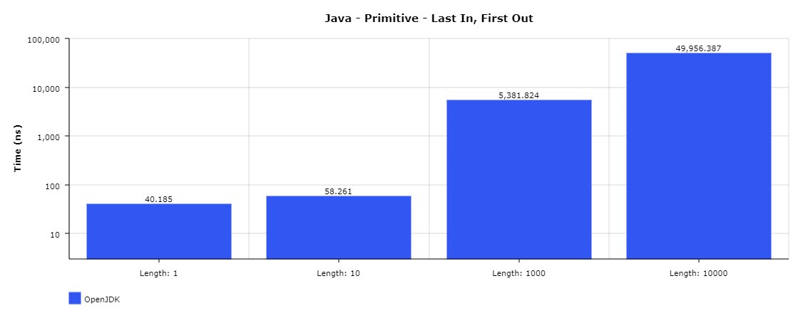
Figure 9. Time taken (ns) for Java Primitive LIFO tests.
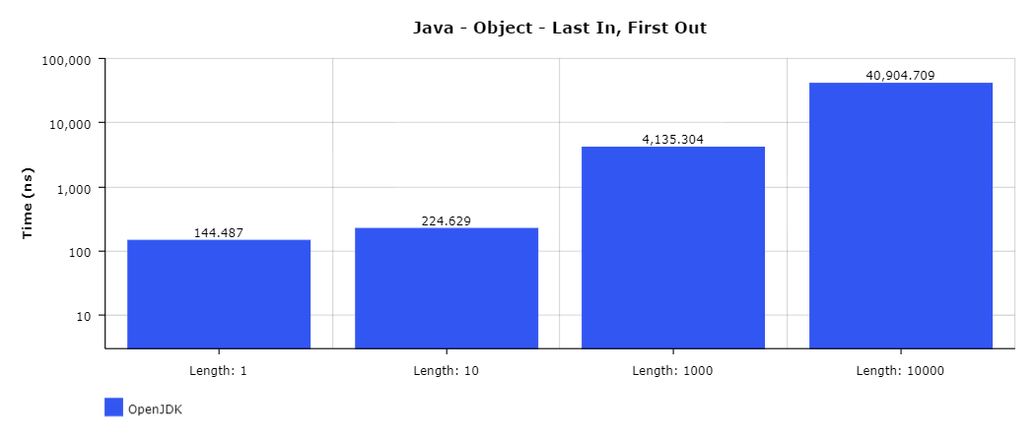
Figure 10. Time taken (ns) for Java Object LIFO tests.

First In, First Out (FIFO)
Using the LinkedList class, the time taken to enqueue and dequeue various amounts of objects was measured. As has been observed before, the performance with primitive types is consistently better than with the objects in these tests.
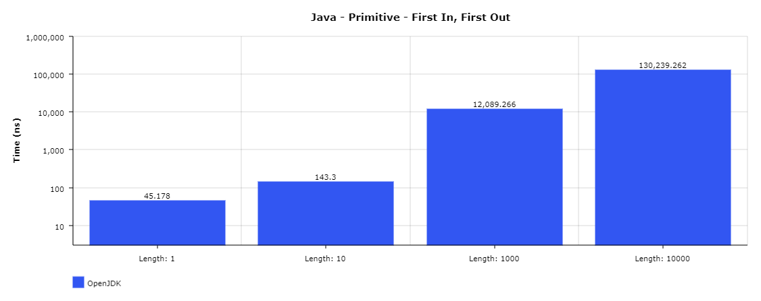
Figure 11. Time taken (ns) for Java Primitive FIFO tests.
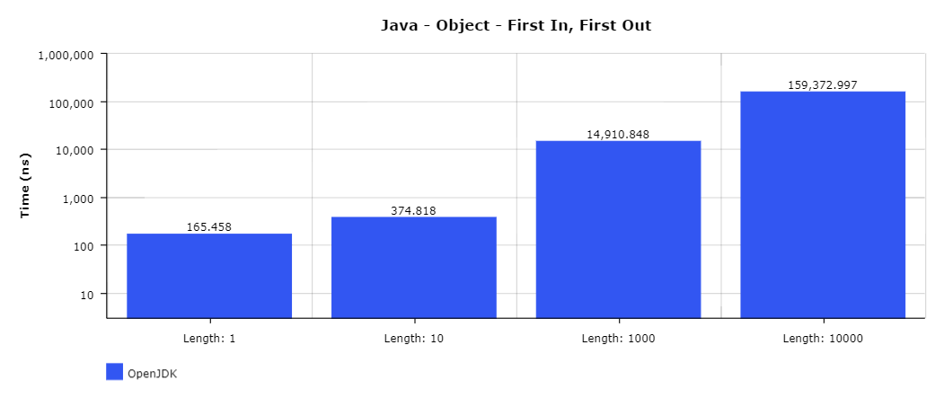
Figure 12. Time taken (ns) for Java Object FIFO tests.
Sequential Access
Using the LinkedList class, the time taken to navigate all the way through the list was measured. While tests using a collection to hold instances of an object scaled in a linear manner, the primitive tests saw negligible differences in performance until the length of the collection was at 10000.
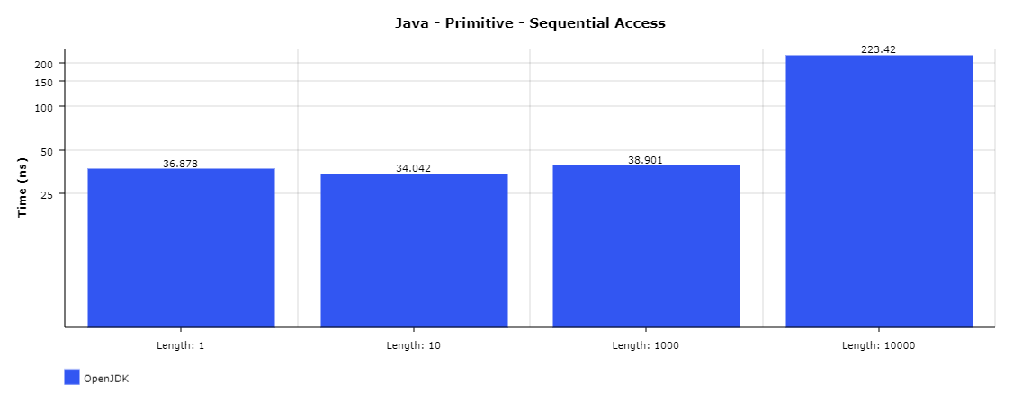
Figure 13. Time taken (ns) for Java Primitive Sequential Access tests.
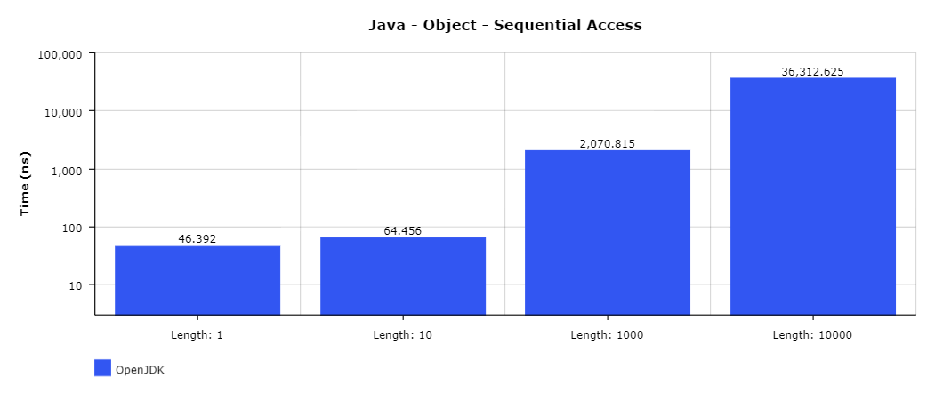
Figure 14. Time taken (ns) for Java Object Sequential Access tests.
Index Access
Using the ArrayList class, the time taken to access a single member of a list of varying sized was measured. In a fashion similar to the sequential access tests, for index access, the object tests suffered little on the performance until the collection length was at 10000. The primitive collection also behaved in a similar manner.
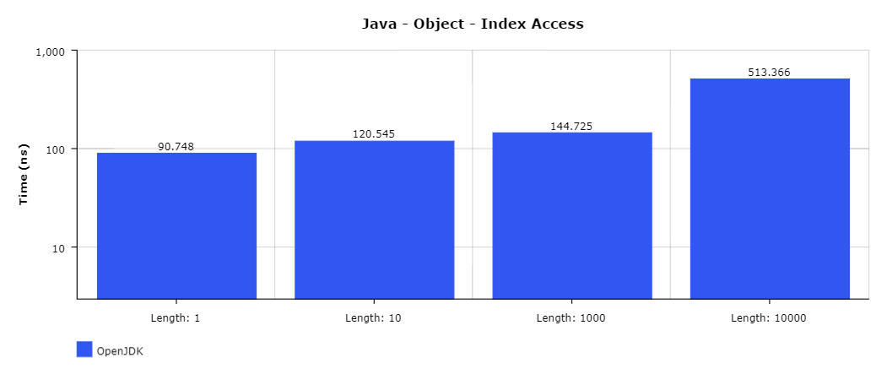
Figure 15. Time taken (ns) for Java Object Index Access tests.
Key Access
Using the HashMap class, the time taken to retrieve a single member of a dictionary/map of varying size was measured. Like the results of the index access tests, the key access tests, for both primitive and object types, saw very little difference in the small length collections, but with the collection of length 10000 there was a more considerable increase of time taken.
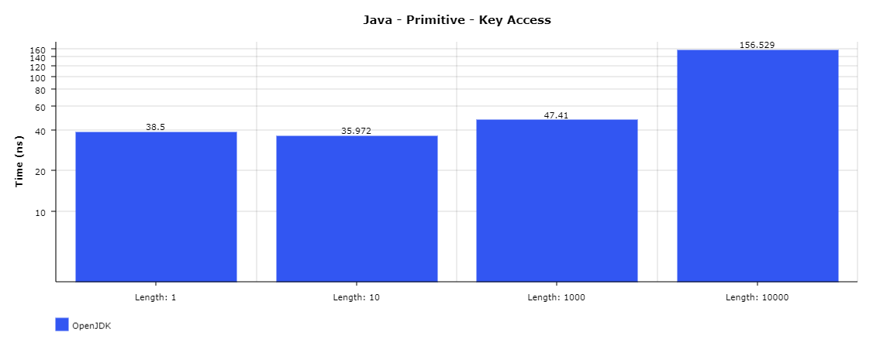
Figure 16. Time taken (ns) for Java Primitive Key Access tests.
Section Summary
For the Java tests, there were two recurring themes observed in the results of these tests. In some tests, the results would scale in a linear fashion with respect to the length of the collection. On the other hand, some other tests would have their time taken increase but not by a considerable margin until the tests involving a collection of length 10000.

Python
Last In, First Out (LIFO)
Using the deque class, the time taken to effectively push (push was achieved by usage of the append method) and pop various numbers of objects was measured. From the results of these tests, it can be observed that PyPy seems to perform a considerable amount worse than CPython. While there are improvements from PyPy 2.7 to 3.5 in the larger collections, both versions were consistently worse than CPython.
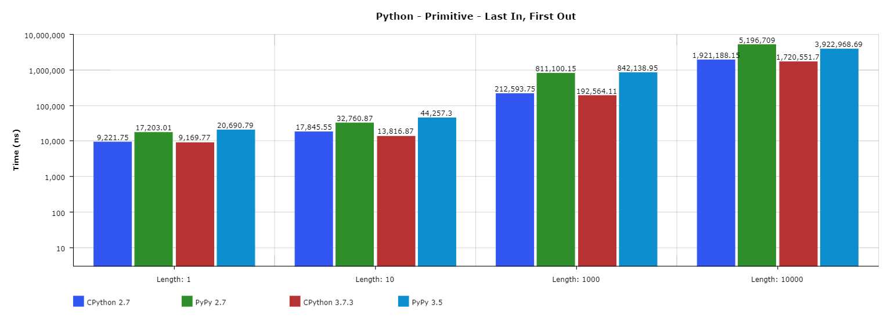
Figure 17. Time taken (ns) for Python Primitive LIFO tests.
First In, First Out (FIFO)
Using the deque class, the time taken to effectively (enqueue was achieved by usage of the append method and dequeue was achieved by usage of the popleft method) enqueue and dequeue various numbers of objects was measured. Consistent from the LIFO tests, both PyPy versions were outperformed by CPython at all collection sizes. However, one thing of note is PyPy 3.5’s times from primitive to object on the collection of size 10000 as PyPy 3.5’s performance actually improves whereas the other Python implementation versions all see considerable jumps in time taken.
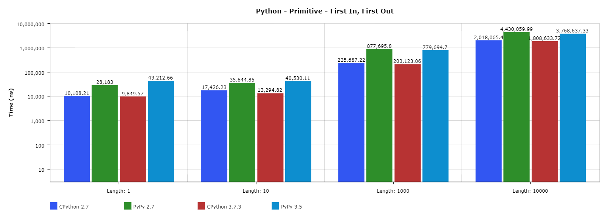
Figure 18. Time taken (ns) for Python Primitive FIFO tests.

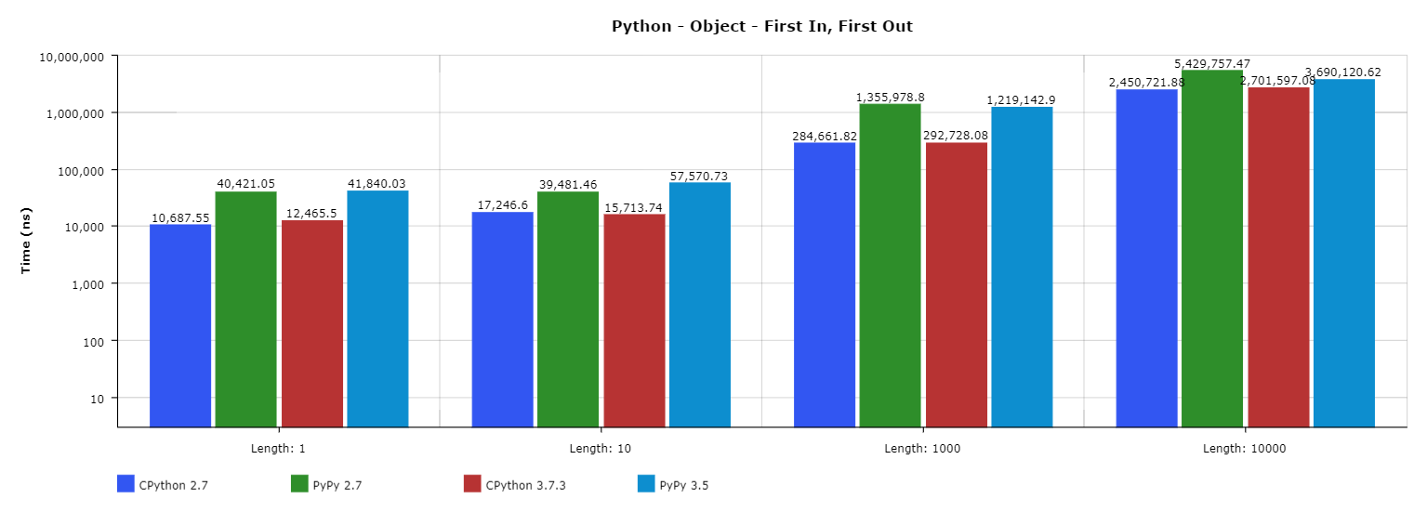
Figure 19. Time taken (ns) for Python Object FIFO tests.
Sequential Access
Using the deque class, the time taken to find and remove the last member of linked lists of various sized was measured. While CPython 2.7’s performance in tests involving larger object collections, CPython 3.7.3’s performance more than made up for it in comparison to the two PyPy versions. However, this difference could be relevant if required to use a Python 2 implementation.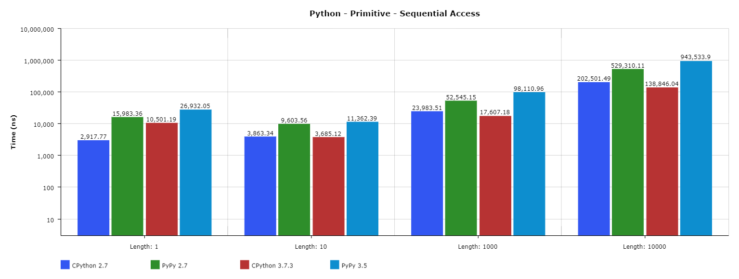
Figure 20. Time taken (ns) for Python Primitive Sequential Access tests.
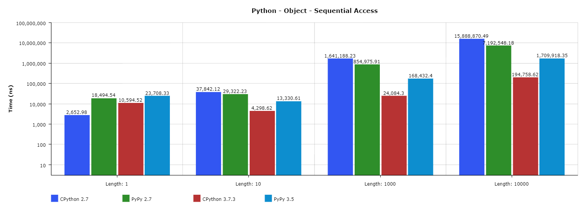
Figure 21. Time taken (ns) for Python Object Sequential Access tests.
Index Access
Using the list class, the time taken to access a single member of lists of various sizes was measured. Mostly consistent with other tests, both CPython versions outperformed both PyPy versions.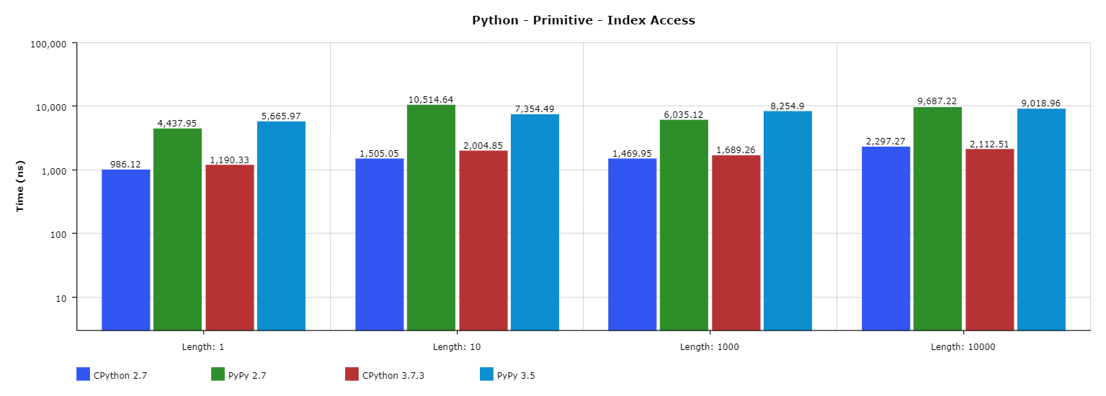
Figure 22. Time taken (ns) for Python Primitive Index Access tests.
Key Access
Using the dict class, the time taken to access a single member of dictionaries of various sizes was measured. In these tests, like the FIFO tests, PyPy 3.5’s performance actually increased in larger collections when changing from primitive types to the objects. Despite this, both PyPy versions were again outperformed by the CPython versions in all collection sizes.
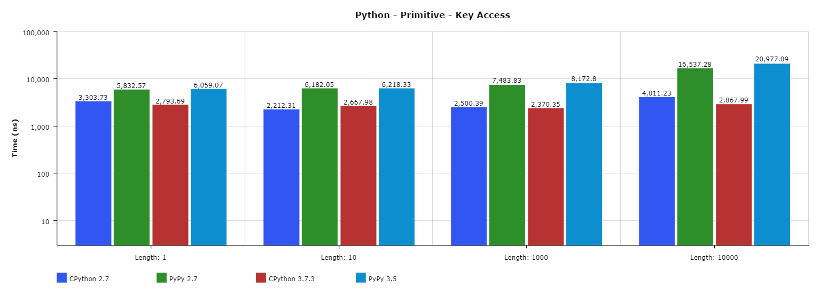
Figure 23. Time taken (ns) for Python Primitive Key Access tests.
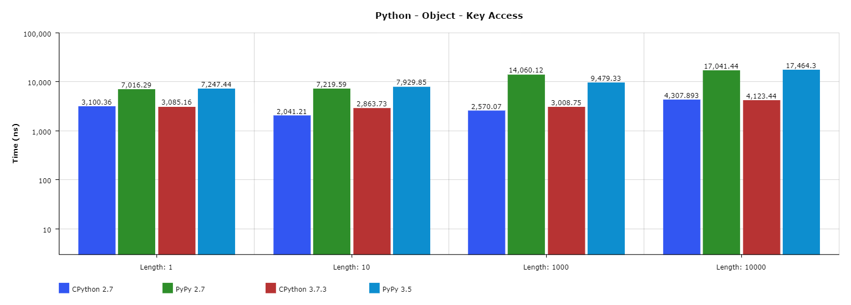
Figure 24. Time taken (ns) for Python Object Key Access tests.
Section Summary
In the results of the Python tests, there were two notable observations. The first was that while PyPy is said to improve the performance of Python code, it failed to consistently do so in these tests; it is of course worth noting that microbenchmarks such as these may no give PyPy the opportunity to display its benefits, and perhaps the results of greater benchmarks would tell a different tale. The other observation was that there was never one clear winner in performance between each Python 2 and Python 3 implementation version; it was not uncommon for CPython 2.7 to occasionally outperform CPython 3.7.3 and the same can be said for PyPy 2.7 and PyPy 3.5.

Best of the Best
Based on the results that have been seen so far, the following implementations from the languages have been chosen to be compared across languages:
- C# – .NET Core 2.2
- Java – OpenJDK 12
- Python – CPython 3.7.3
While some of the excluded implementations may have some advantages over others (which will be acknowledged in the recommendations section), the implementations to be further analysed will be based solely on the performance in the tests.
Last In, First Out (LIFO)
In this comparison of the three languages, while C# mostly outperformed both Java and Python, when it came to collections of objects with lengths 1000 and 10000, Java performed better with a time of roughly half of C#’s time. Python, on the other hand, was considerably outperformed in all the tests with Java in one test finishing the test over 73 times faster.
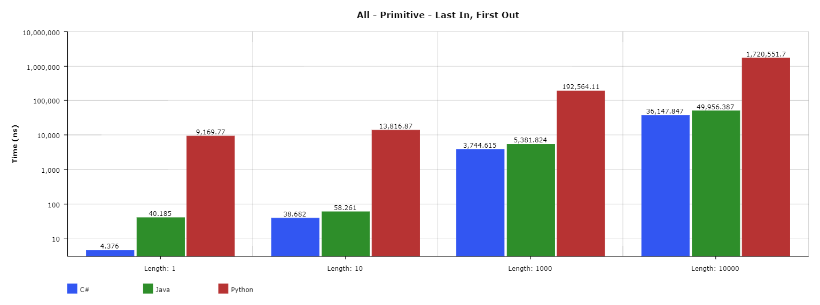
Figure 25. Time taken (ns) for all languages Primitive LIFO tests.
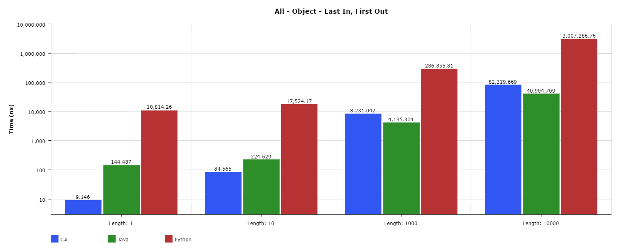
Figure 26. Time taken (ns) for all languages Object LIFO tests.
First In, First Out (FIFO)
Like with the LIFO tests, C# was the most consistently performing language – beating out both Java and Python in every FIFO test. Once again, the gap between C# and Python is very considerable.
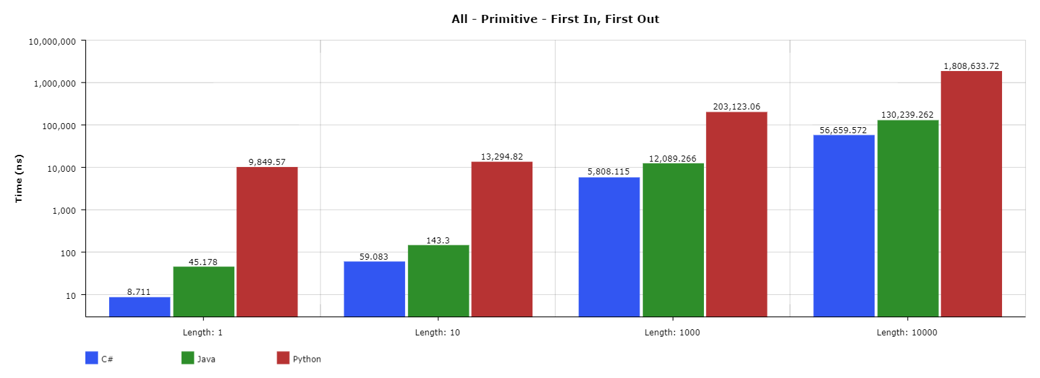
Figure 27. Time taken (ns) for all languages Primitive FIFO tests.
Sequential Access
In these tests, C# performed the best with a collection of size 1, but as the size of the collections grew, its performance waned and Java started taking over. With the primitive test, Java’s performance was considerably greater than C#s – Java finished the primitive length 10000 collection test over 100 times faster than C#. While .NET Core was not the most consistent performer for C# in these tests, all C# implementations came close to each other.
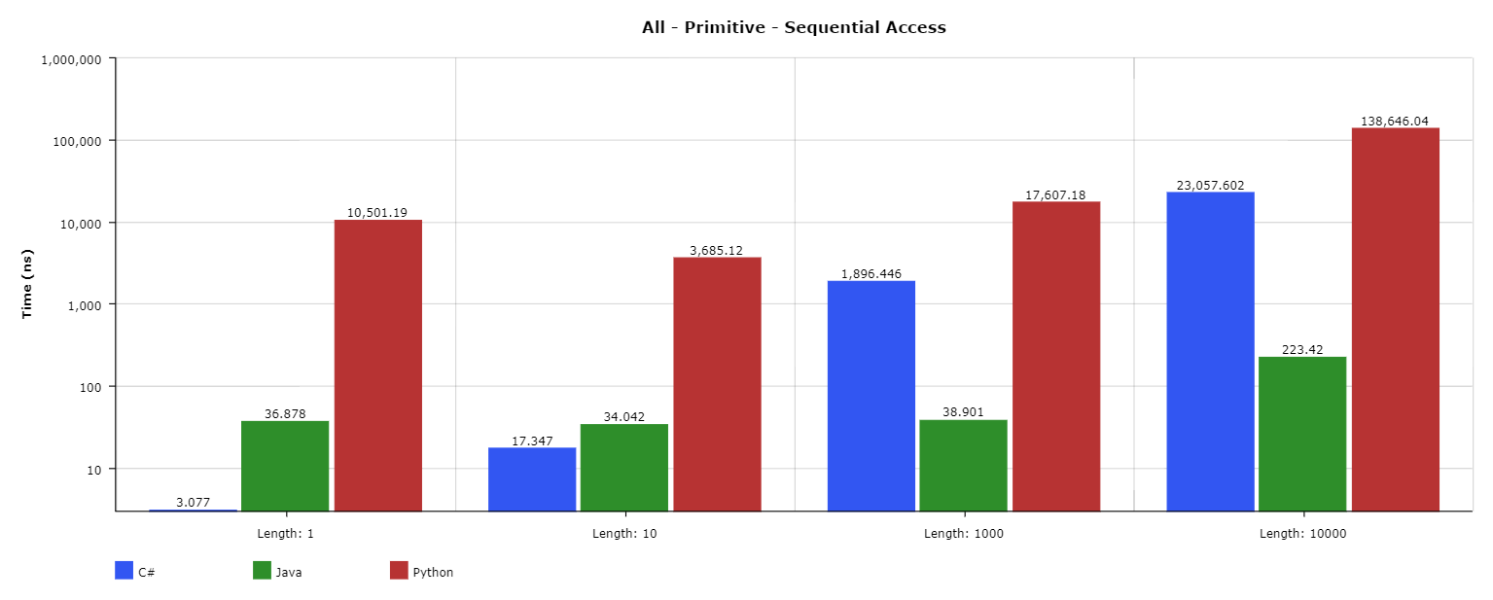
Figure 28. Time taken (ns) for all languages Primitive Sequential Access tests.
Index Access
In the index access tests, C# consistently outperformed both Java and Python in both primitive and object tests. Something worth noting is that while Java’s time taken seemingly scales based on the length of the collection, Python only experiences the same with a collection of objects and not with primitives. C#, however, saw very little difference based on the size of the collection, and even performed better with collections of objects than of primitives.
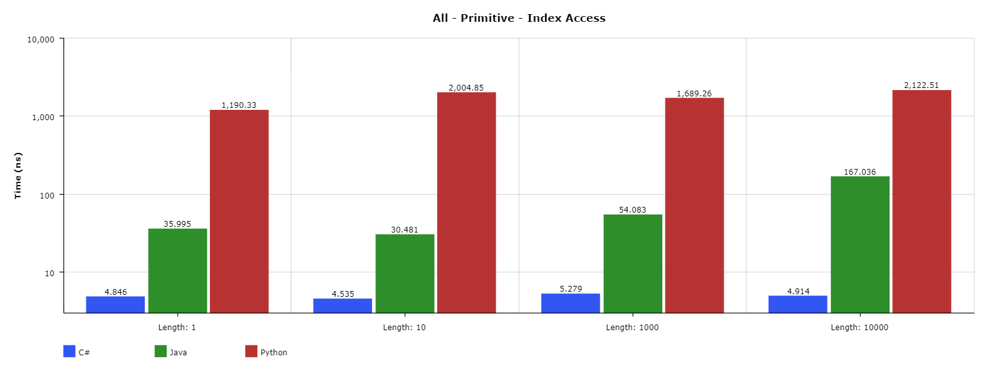
Figure 29. Time taken (ns) for all languages Primitive Index Access tests.
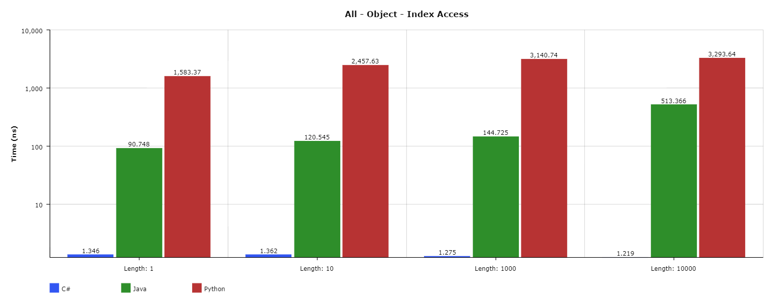
Figure 30. Time taken (ns) for all languages Object Index Access tests.
Key Access
In this last set of tests, the observations made about the index were again relevant to the results of the key access tests. C#, once again, saw a negligible difference in time taken with respect to the collection size and once again outperformed both Java and Python. Python saw more consistent times taken when handling collections of primitives. Java’s times generally scaled with the size of the collection.
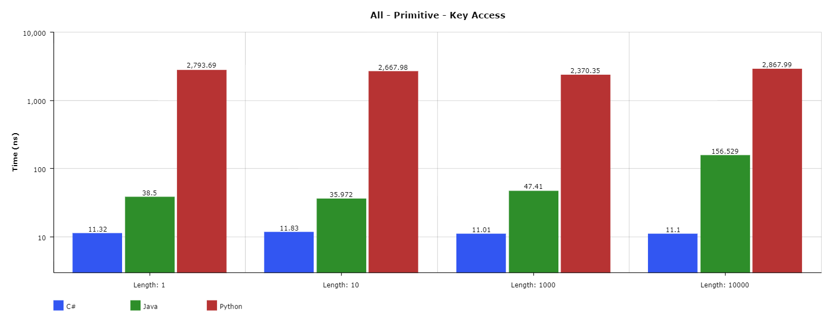
Figure 31. Time taken (ns) for all languages Primitive Key Access tests.

Conclusion
In this section, different implementations of each language – excluding Java – were tested against each other in order to find the most consistently best-performing implementation of each language. With the best implementations of each language found, they were then compared against each other to find the best-performing language in these collection microbenchmarks.
For C#, .NET Core performed the best most consistently, but definitely had areas that could be improved. An example of such an area could be with what was seen in the sequential access tests because while Mono was typically the worst C# implementation, it outperformed both .NET Core and .NET Framework consistently in the collections of objects.
For Java, because there was only one implementation to test, OpenJDK naturally performed the best and was chosen to represent Java in final comparisons.
For Python, as mentioned previously, although PyPy has been showed to improve the performance of Python code, those improvements could not be seen in the test results. Perhaps because of that, CPython (the reference Python implementation) was the best performing between it and PyPy in the tests. CPython 3.7.3. was chosen to represent Python in the final comparison because of two reasons. The first reason was that while CPython 2.7 frequently outperformed CPython 3.7.3, the margin between the two was often rather small, but CPython 3.7.3 had tests in which is considerably outperformed CPython 2.7. Secondly, because Python 3 is under continuous active development, it was viewed as more valuable to use as a representation of Python.
In the final comparison between the three languages, the results showed that C# was typically the most performant language of the three that were tested with Java close behind. While there were cases in which Java would outperform C#, these cases were too uncommon to be viewed as consistently better. Python, on the other hand, repeatedly performed magnitudes worse than C# and Java in every single test.
It is worth noting, however, that while there may be a language whose performance was consistently better than others, no implication is made that the other languages are any less relevant or useful based on that fact. This will be expanded up in the recommendations section.

Conclusion and Recommendations

Conclusions
This study has shown that like many parts of a system, the performance of applications is important in relation to the behaviour, and subsequently other aspects of the system as a whole. While it is possible to overlook something that may seem small when developing software such as a collection type, the choice of collection can, over time, have noticeable effects on the performance of an application. To go further into this, when developing software that could benefit from having the best performance possible for the available hardware, it is important to make the most informed, thought-out, and beneficial decisions regarding aspects such language choice and software structure. This study delved into the importance of choosing the right programming language and implementation by benchmarking several collections and the methods for which the collections should be used.
Several language implementations were chosen between C#, Java, and Python, and with those languages, collections were chosen based on their application. For example, a collection was chosen from each language that had the purpose of providing an efficient means to access a member of a collection by a key.
In order to get a range of data that covered most scenarios (while also allowing for further data to be extrapolated from the results), two different types of things happened. One course of action taken was prior to running the tests, the collections would be populated with an amount of data, and then the tests would be run against that to see how well the language would handle small and large collections of data. Secondly, the tests would be run with the goal of executing a certain method a certain number of times to see how quickly the language could get through the data and process everything required. For example, with the LIFO tests, a stack-like collection was used in each language to see how quickly it could push up to 10000 items to a collection and then pop them all out of it.
A consistent theme found throughout all the tests was that the languages frequently took more time to finish a test when the number of items inside the collection increased. While this would be expected for tests such as the last in first out tests because it would require more methods to be called, it was also present in the index access tests where languages would be tasked with retrieving a single item from a collection based on the index.
In order to get fair results, frameworks and packages such as BenchmarkDotNet and JMH were used that helped remove any aspects of a language implementation that would skew the results or produce unhelpful data. On top of this, considerations had to be made when writing the tests to ensure that aspects such as compiler optimisations could not interfere when processes that eliminate dead code were run.
While the results of the data showed C#’s .NET Core to be the best performing language implementation and runtime out of the five that were tested, a lot more needs to be considered before making decisions based on microbenchmarks such as these. From aspects such as language features and packages to infrastructure and hardware, a lot more exists in a system that should be considered before simply choosing .NET Core as the implementation of choice when creating new software which has some reliance on collections as part of its core functionality.

Future Works
While this study covered an important area of collections in C#, Java, and Python, it also left room for further research that could further guide decisions into choosing languages for software. For example, in systems that use hardware that have limited amounts of processing power, while some languages and their collections may be fast with unlimited resources, research should be conducted that investigates which collections perform best with limited or restricted processing power. In a similar vein, research could also be carried out that carries out a similar process on devices with low amounts of memory (RAM). This research could prove useful, for example, in embedded systems or IoT devices which typically are very low power devices whose specifications pale in comparison to the average desktop computer. With this, it could be possible to get the most performance out of devices least associated with performance in order to improve user experiences or allow for more functionality and features to be made possible with this knowledge.

Recommendations
Based on some aspects of the results created for this study, it may still be unclear which language implementation or runtime to use. While C#’s .NET Core appears to have the upper hand when only consider the results of the tests there are many other aspects to consider. Some examples of these aspects will be discussed below.
Language implementations may not display results consistent with their performance in the microbenchmarks over other language implementations in bigger applications and systems. A notable example of this is Python’s PyPy and CPython; while PyPy has been proven to be capable of outperforming CPython in many different applications, it did not manage to outperform CPython in any of the Python tests. With that in mind, it is worth considering these other benchmark aspects when making language decisions.
Additionally, how useful a language is can be attributed to more than the code. There are many aspects of languages that make them popular without being a feature built-in to the language itself. For example, languages often have libraries of classes and interfaces each with their own methods and functionality that allow a language to be useful out-of-the-box. Taking C# for example, none of the collections tested were built-in parts of the language; they were all provided in the System.Collections namespace. Namespaces and libraries like these allow programs to be written without needing to figuratively re-invent the wheel when it comes to parts of a program such as writing to a log file. However, it is worth noting the other side of this argument, if one language has libraries available that easily enable some type of functionality (such as drawing), but another language does not, then the language that has these libraries may become a better choice because of this. While one example has been covered, there are countless other aspects of languages that make them better or worse choices for specific applications.
Another aspect of language implementations and runtimes that needs to be considered expands on the points mentioned previously: compatibility. An example of this can be seen easily when looking at C#. C#’s .NET Framework provides a lot a functionality out-of-the-box such as its class libraries and aspects such as WinForms and services. However, a lot of this functionality is restricted to Windows machines, and so cannot be used on a Unix or macOS machine. Mono, however, provides a means for applications such as services to be run on Unix machines in forms such as daemons. While .NET Core aims to figuratively bring the .NET Framework to operating systems such as macOS and Unix, there are areas not yet covered by it that makes difficult to choose it over Mono.
For these reasons listed above, more consideration should be applied to decisions involving software to get a greater picture of the limitations of the languages and their implementations if a choice were to be made solely based on the results of the testing in this study.

Applying this Data
As stated previously, there are numerous factors that influence decisions regarding software and languages. While some of the aforementioned factors can have greater impact on the quality of a system than the topics covered in this study, the data from the testing for the study has shown that C# definitely has some advantages with its collections over both Java and Python. In the worst case, the data from this study provides people with more information to help in the decision-making process. This data, along with further data from other benchmarks such as The Computer Language Benchmarks Game serve to be used as one argument or point in discussions.

Final Thoughts - Consider Everything
It is in any organisation’s or person’s benefit to conduct their own benchmarking on applications to get more accurate benchmark readings more specific to their needs instead of relying solely on pre-existing micro or macro benchmarks. It is important to bear in mind that while the data from this study can be helpful and can help choosing a language and implementation which may be faster than another, other factors can affect and change a system as times goes on that can be avoided by making more informed decisions.
As a final re-iteration of the findings of this study, consider all other influencing factors before making a decision and later asking a language “Got anything faster?”

Bibliography
.NET Foundation (2018). The Roslyn .NET Compiler. [online] GitHub. Available at: https://github.com/dotnet/roslyn [Accessed 2 Dec. 2018].
Bader, D. (2017). Linked Lists in Python. [Blog] dbader.org. Available at: https://dbader.org/blog/python-linked-list [Accessed 23 Mar. 2019].
Balliauw, M. (2018). Performance is a Key .NET Core Feature. [online] InfoQ. Available at: https://www.infoq.com/articles/performance-net-core [Accessed 11 Nov. 2018].
Bell, R. (2009). A beginner's guide to Big O notation. [Blog] Rob Bell. Available at: https://rob-bell.net/2009/06/a-beginners-guide-to-big-o-notation/ [Accessed 31 Jan. 2019].
BenchmarkDotNet. (2019). dotnet/BenchmarkDotNet. [online] Available at: https://github.com/dotnet/BenchmarkDotNet [Accessed 23 Mar. 2019].
BenchmarkDotNet. (n.d.). Overview | BenchmarkDotNet. [online] Available at: https://benchmarkdotnet.org/articles/overview.html [Accessed 15 Apr. 2019].
Bothner, P. (2003). Compiling Java with GCJ. [online] Linux Journal. Available at: https://www.linuxjournal.com/article/4860 [Accessed 25 Jan. 2019].
Boyer, B. (2008). Robust Java benchmarking - Issues. [online] IBM Developer. Available at: https://www.ibm.com/developerworks/java/library/j-benchmark1/index.html [Accessed 31 Jan. 2019].
Chen, H. (2010). Comparative Study of C, C++, C# and Java Programming Languages. Thesis. Vaasa University of Applied Sciences.
Computer Language Benchmarks Game. (n.d.). C# .NET Core measurements. [online] Available at: https://benchmarksgame-team.pages.debian.net/benchmarksgame/measurements/csharpcore.html [Accessed 17 Jan. 2019].
Computer Language Benchmarks Game. (n.d.). C# .NET Core vs Java - Which programs are faster? [online] Available at: https://benchmarksgame-team.pages.debian.net/benchmarksgame/faster/csharp.html [Accessed 17 Jan. 2019].
Computer Language Benchmarks Game. (n.d.). How programs are measured. [online] Available at: https://benchmarksgame-team.pages.debian.net/benchmarksgame/how-programs-are-measured.html [Accessed 17 Jan. 2019].
Computer Language Benchmarks Game. (n.d.). Java measurements. [online] Available at: https://benchmarksgame-team.pages.debian.net/benchmarksgame/measurements/java.html [Accessed 17 Jan. 2019].
Computer Language Benchmarks Game. (n.d.). Trust, and verify. [online] Available at: https://benchmarksgame-team.pages.debian.net/benchmarksgame/sometimes-people-just-make-up-stuff.html [Accessed 17 Jan. 2019].
Computer Language Benchmarks Game. (n.d.). Which benchmark programs are faster? [online] Available at: https://benchmarksgame-team.pages.debian.net/benchmarksgame/ [Accessed 17 Jan. 2019].
Cuni, A. (2010). Cuni, Antonio. High performance implementation of Python for CLI/.NET with JIT compiler generation for dynamic languages. Ph.D. University of Genova.
Daalia, S. (2017). Difference between various Implementations of Python. [Blog] Geeks for Geeks. Available at: https://www.geeksforgeeks.org/difference-various-implementations-python/ [Accessed 30 Jan. 2019].
Decker, C. (2017). caliper/Tutorial.java. [online] google/caliper. Available at: https://github.com/google/caliper/blob/master/caliper-examples/src/main/java/tutorial/Tutorial.java [Accessed 25 Mar. 2019].
Driscoll, M. (2016). Python 101: An Intro to Benchmarking your code. [Blog] The Mouse Vs. The Python. Available at: https://www.blog.pythonlibrary.org/2016/05/24/python-101-an-intro-to-benchmarking-your-code/ [Accessed 25 Mar. 2019].
Google Groups. (2014). JMH vs Caliper: reference thread. [online] Available at: https://groups.google.com/forum/#!topic/mechanical-sympathy/m4opvy4xq3U [Accessed 25 Mar. 2019].
Google Open Source. (n.d.). caliper. [online] Available at: https://opensource.google.com/projects/caliper [Accessed 25 Mar. 2019].
Grand, M. (2009). Selecting the Best Java Collection Class for Your Application. [Blog] Developer.com. Available at: https://www.developer.com/java/article.php/10922_3829891_4/Selecting-the-Best-Java-Collection-Class-for-Your-Application.htm [Accessed 31 Jan. 2019].
Hanselman, S. (2016). Benchmarking .NET code. [Blog] Scott Hanselman. Available at: https://www.hanselman.com/blog/BenchmarkingNETCode.aspx [Accessed 18 Jan. 2019].
Javadoc Extreme. (2014). org.openjdk.jmh.annotations (JMH Core 0.9 API). [online] Available at: http://javadox.com/org.openjdk.jmh/jmh-core/0.9/org/openjdk/jmh/annotations/package-summary.html [Accessed 15 Apr. 2019].
Kestelyn, J. (2011). Moving to OpenJDK as the Official Java SE 7 Reference Implementation. [Blog] Oracle Blogs - The Java Source. Available at: https://blogs.oracle.com/java/moving-to-openjdk-as-the-official-java-se-7-reference-implementation [Accessed 4 Feb. 2019].
Kokosa, K. (2018). Pro .NET Memory Management. 1st ed. Apress, p.197.
Lamonica, M. (2007). Sun picks GPL license for Java code. [Blog] CNET. Available at: https://www.cnet.com/news/sun-picks-gpl-license-for-java-code/ [Accessed 4 Feb. 2019].
Lewis, L. (2011). Java Collection Performance. [Blog] DZone Performance. Available at: https://dzone.com/articles/java-collection-performance [Accessed 31 Jan. 2019].
Markovic, V. (2019). Valloric/jmh-playground. [online] jmh-playground. Available at: https://github.com/Valloric/jmh-playground [Accessed 23 Mar. 2019].
Microbenchmarking with Java. (2018). [Blog] Baeldung. Available at: https://www.baeldung.com/java-microbenchmark-harness [Accessed 23 Mar. 2019].
Microsoft Docs. (2017). Collections and Data Structures. [online] Available at: https://docs.microsoft.com/en-us/dotnet/standard/collections/ [Accessed 31 Jan. 2019].
Microsoft Docs. (n.d.). Stopwatch Class (System.Diagnostics). [online] Available at: https://docs.microsoft.com/en-us/dotnet/api/system.diagnostics.stopwatch [Accessed 18 Jan. 2019].
Microsoft. (2019). Download .NET (Linux, macOS, and Windows). [online] Available at: https://dotnet.microsoft.com/download [Accessed 23 Mar. 2019].
Mindfire Solutions (2017). Difference between .Net Core and .Net Framework. [Blog] Mindfire Solutions. Available at: https://medium.com/@mindfiresolutions.usa/difference-between-net-core-and-net-framework-c0588e734b99 [Accessed 2 Dec. 2018].
Mogensen, T. (2010). Basics of Compiler Design. Copenhagen: lulu.com, pp.1, 3, 147.
Mono (2018). Home. [online] Mono. Available at: https://www.mono-project.com/ [Accessed 2 Dec. 2018].
Mono. (2018). Supported Platforms. [online] Available at: https://www.mono-project.com/docs/about-mono/supported-platforms/ [Accessed 25 Jan. 2019].
NULLSTONE. (2002). Java Compiler Performance Comparison. [online] Available at: http://www.nullstone.com/htmls/results/java.htm [Accessed 25 Jan. 2019].
OpenJDK. (2006). HotSpot Group. [online] Available at: https://openjdk.java.net/groups/hotspot/ [Accessed 4 Feb. 2019].
OpenJDK. (2007). The Compiler Group. [online] Available at: https://openjdk.java.net/groups/compiler/ [Accessed 4 Feb. 2019].
OpenJDK. (2014). JMHSample_08_DeadCode.java. [online] Available at: http://hg.openjdk.java.net/code-tools/jmh/file/f2e982b7c51b/jmh-samples/src/main/java/org/openjdk/jmh/samples/JMHSample_08_DeadCode.java [Accessed 25 Mar. 2019].
OpenJDK. (2019). code-tools/jmh: 5984e353dca7 /jmh-samples/src/main/java/org/openjdk/jmh/samples/. [online] Available at: https://hg.openjdk.java.net/code-tools/jmh/file/tip/jmh-samples/src/main/java/org/openjdk/jmh/samples/ [Accessed 15 Apr. 2019].
OpenJDK. (n.d.). OpenJDK: jmh. [online] Available at: https://openjdk.java.net/projects/code-tools/jmh/ [Accessed 23 Mar. 2019].
Oracle Docs. (2018). Collections Framework Overview. [online] Available at: https://docs.oracle.com/javase/7/docs/technotes/guides/collections/overview.html [Accessed 23 Mar. 2019].
Python Documentation. (2019). collections — Container datatypes. [online] Available at: https://docs.python.org/3.7/library/collections.html [Accessed 31 Jan. 2019].
Python Documentation. (2019). The Python Profilers. [online] Available at: https://docs.python.org/2/library/profile.html [Accessed 25 Mar. 2019].
Python Documentation. (2019). The Python Profilers. [online] Available at: https://docs.python.org/3.7/library/profile.html [Accessed 25 Mar. 2019].
Python Wiki. (2016). PythonSpeed/PerformanceTips. [online] Available at: https://wiki.python.org/moin/PythonSpeed/PerformanceTips#Profiling [Accessed 25 Mar. 2019].
Python Wiki. (2017). TimeComplexity. [online] Available at: https://wiki.python.org/moin/TimeComplexity [Accessed 31 Jan. 2019].
Python Wiki. (2018). FrontPage - Python Wiki. [online] Available at: https://wiki.python.org/moin/ [Accessed 30 Jan. 2019].
Python Wiki. (2018). PythonImplementations - Python Wiki. [online] Available at: https://wiki.python.org/moin/PythonImplementations [Accessed 30 Jan. 2019].
Redondo, J. and Ortin, F. (2015). A Comprehensive Evaluation of Common Python Implementations. IEEE Software, [online] 32(4), pp.76-84. Available at: https://ieeexplore.ieee.org/document/6879048 [Accessed 29 Jan. 2019].
Reitz, K. (2011). Picking a Python Interpreter (3 vs 2). [online] The Hitchhiker’s Guide to Python. Available at: https://docs.python-guide.org/starting/which-python/ [Accessed 30 Jan. 2019].
Sale, A. (1977). Primitive Data Types. The Australian Computer Journal, [online] 9(2), pp.63-71. Available at: https://eprints.utas.edu.au/139/1/PrimitiveData.pdf [Accessed 11 Nov. 2018].
Sestoft, P. (2010). Numeric performance in C, C# and Java. [ebook] Copenhagen: IT University of Copenhagen. Available at: http://www.itu.dk/~sestoft/papers/numericperformance.pdf [Accessed 11 Nov. 2018].
Shaw, A. (2018). Which is the fastest version of Python? [Blog] Hackernoon. Available at: https://hackernoon.com/which-is-the-fastest-version-of-python-2ae7c61a6b2b [Accessed 30 Jan. 2019].
Skeet, J. (2016). TRACKING DOWN A PERFORMANCE HIT. [Blog] Jon Skeet's coding blog. Available at: https://codeblog.jonskeet.uk/2016/06/09/tracking-down-a-performance-hit/ [Accessed 18 Jan. 2019].
Smith, C. and Williams, L. (2000). Software Performance AntiPatterns. In: 2nd International Workshop on Software and Performance. [online] Ottawa: Software Engineering Research and L&S computer Technology, Inc. Available at: https://www.researchgate.net/profile/Connie_Smith5/publication/221445272_New_Software_Performance_AntiPatterns_More_Ways_to_Shoot_Yourself_in_the_Foot/links/02e7e52b25ec54d113000000.pdf [Accessed 11 Nov. 2018].
TechEmpower. (2019). GitHub - TechEmpower/FrameworkBenchmarks: Source for the TechEmpower Framework Benchmarks project. [online] Available at: https://github.com/TechEmpower/FrameworkBenchmarks [Accessed 13 Jan. 2019].
TechEmpower.com. (2018). Round 17 results. [online] Available at: https://www.techempower.com/benchmarks/ [Accessed 13 Jan. 2019].
The Linux Information Project. (2006). Machine Code Definition. [online] Available at: http://www.linfo.org/machine_code.html [Accessed 25 Jan. 2019].
Toub, S. (2017). Performance Improvements in .NET Core. [online] Blogs.msdn.microsoft.com. Available at: https://blogs.msdn.microsoft.com/dotnet/2017/06/07/performance-improvements-in-net-core/ [Accessed 11 Nov. 2018].
Tromey, T. (2016). The Deletion of gcj. [Blog] The Cliffs of Inanity. Available at: http://tromey.com/blog/?p=911 [Accessed 5 Feb. 2019].
Trzaska, M. (2010). Benchmarks Java vs MS C# vs MS C++. [online] Polish-Japanese Academy of Information Technology. Available at: http://users.pja.edu.pl/~mtrzaska/Files/Misc/Benchmarks100224.pdf [Accessed 5 Feb. 2019].
Wheeler, D. and Friedman, D. (2008). Alternative Java Implementations. [online] DWheeler.com. Available at: https://dwheeler.com/java-imp.html [Accessed 4 Feb. 2019].
Wilke, J. (2017). The 6 Memory Metrics You Should Track in Your Java Benchmarks. [Blog] cruftex.net. Available at: https://cruftex.net/2017/03/28/The-6-Memory-Metrics-You-Should-Track-in-Your-Java-Benchmarks.html [Accessed 23 Mar. 2019].
Williams, L. and Smith, C. (1998). Performance Evaluation of Software Architectures. [ebook] Santa Fe and Boulder: Performance Engineering Services and Software Engineering Research. Available at: https://pdfs.semanticscholar.org/4740/23725d55a75bf95fd73c19462f495de40c3a.pdf [Accessed 11 Nov. 2018].

