SmartRPD Web Application
Master Document -- Consolidated Reference
This document is a compiled copy of every document listed below, assembled 24 August 2026. It is NOT auto-generated and has no automatic sync -- when any source document changes in a way that matters, this file must be manually regenerated or hand-edited to match. Treat the Table of Contents entries below as links to the copies in THIS file; for the maintained, authoritative version of any section, open the source document listed against it.

Table of Contents
- SmartRPD Documentation
- Handover Document
- How to Setup
- DevOps and Deployment
- Application Workflow -- Summary
- Application Workflow -- Detailed
- Automated Test Suite Report
- UAT Report
- UAT Protocol SOP
- Cybersecurity Protocol Document
- Feedback and Triage Report
- Traceability Document
- Maintenance and Operational Runbook
- Deploy Documentation Review (process)
- Setup Guide -- Overview
- Setup Guide -- 1. Local Development Setup
- Setup Guide -- 2. Branching and Collaboration
- Setup Guide -- 3. CI/CD and Deployment Setup
- Setup Guide -- 4. Troubleshooting
- Setup Guide -- 5. 2D Annotation Architecture

SmartRPD Documentation

NDCS · SmartRPD
SmartRPD Web Application
Technical Documentation Report

Last Updated:  24 August 2026 | Status:  Deployed — Internal Testing
Prepared by:  Shafik Hakim Bin Abdul Wahid  Nyunt Sin Htet | Test Suite:  19 suites — 582 tests — All Pass

Table of Contents
Table of Contents 2
1. Overview 4
2. Application Structure 4
3. Main User Workflows 6
4. Implemented Feature Status 10
5. 2D Annotation and RPD Design 11
5.1 Module Breakdown 11
5.1.1 Entry Point & Shared State 11
5.1.2 2D Design Component Modules 11
5.1.3 Persistence Modules 11
5.1.4 Visual/Interaction Modules 12
5.1.5 Supporting Modules 12
5.1.6 Clinical & Reporting Modules 12
6. 3D Viewer Architecture 13
6.1 Scene Layers 13
6.2 Mesh Loading 14
6.3 Render Loop 14
6.4 Mesh Quality Selection (2D-Embedded Preview) 14
7. Polylines, Artificial Teeth and Heatmaps 16
7.1 Polyline System 16
7.2 Artificial Teeth 16
7.3 Undercut and Occlusion Heatmaps 17
8. Loading, API and Reliability 18
8.1 Loading Strategy 18
8.2 ApiClient 18
9. Responsive UI and Collaboration 19
9.1 Viewer Shell 19
9.2 Case Chat 19
10. Build, Test and Release 21
10.1 Application Status 21
11. Testing 22
11.1 Automated Test Results 22
11.2 Test Coverage Areas 22
12. UAT Report 25
12.1 Scope 25
12.2 Test Cases 25
13. High-Level Architecture 28
13.1 High-Level Architecture 28
13.2 Layer Summary 28
13.3 Data Flow 29
14. API References 30
14.1 Endpoint Summary 30
14.2 Common Request Envelope 30
15. Data Schema 31
15.1 Entity Relationship Overview 31
15.2 Key Field Types 32
15.3 ERD Diagram 34
16. Handover Items 35
16.1 Items Completed in This Document 35
16.2 Items in other documents 35
Appendix 36

1. Overview
SmartRPD Web Application is a multi-page browser application for removable partial denture (RPD) case management, clinical information capture, 2D RPD design annotation, and 3D jaw and design review. The application is served as static HTML, JavaScript, CSS and bundled assets, with REST API calls used for authentication, case data, jaw meshes, design overlays, chat, notifications and report generation workflows. The current application is in deployment. Implementation evidence exists for all main user workflows, while formal requirements sign-off, UAT results and production validation are recorded in the repository.

2. Application Structure
The application is loaded as a static multi-page web app, built with Webpack and served from GitHub Pages (nyunt/dev-W7.1 branch), published by the “Deploy Test Site” GitHub Actions workflow on every push to nyunt/dev-deploy. Navigation between pages occurs through URL redirects, with secure user flow, passed as an encrypted query parameter. The application layer only serves pages and renders data.
Page / Area | Primary Files | Purpose
Login | index.html, src/js/pages/login.js, src/js/shared/passwordReset.js, changePassword.js | Authentication entry point (password + OTP, currently disabled), password reset/change, and the loggedInUser client-side guard check.
Case List | src/pages/case_list.html, src/js/pages/caseManagement.js | Browse, sort, manage, duplicate, rename, delete, open, download and share cases.
Case Creation | src/js/pages/createCase.js, css/createCase.css | Create cases, upload STL/reference files, assign users and send invitations.
2D Annotation | src/pages/2DAnnotation.html, src/js/2D/* | Design RPD components on upper/lower jaw diagrams, manage clinical information and save structured jaw data.
3D Viewer | src/pages/ThreeDViewer.html, src/viewer3d/index.js, src/viewer3d/newControls.js | Render jaw meshes, design overlays, artificial teeth, heatmaps and review controls in Three.js.
Shared Shell | src/js/shared/appSidebar.js, src/js/pages/viewerShell.js, src/js/shared/chat.js, src/js/pages/notifications.js | Shared navigation, footer, chat, version history, notifications and status UI.
Dashboard | src/js/pages/dashboard.js | Overview — case list management, captured views, and assigned user roles.
Version History | src/pages/VersionHistory.html,  src/js/pages/versionHistory.js | Review and compare past design iterations for a case.
2D Design (component placement engine within 2D Annotation) | src/js/2D/components.js, src/js/2D/components.mesh.js, src/js/2D/components.plate.js, src/js/2D/components.minor.js, src/js/2D/components.major.js, src/js/2D/components.bar.js, src/js/2D/components.clasp.js, src/js/2D/components.rest.js, src/js/2D/annotationCatalog.js, src/js/2D/annotationPlacement.js, src/js/2D/annotationRender.js, src/js/2D/annotationLocks.js, src/js/2D/annotationVisuals.js, src/js/2D/annotationTeethModel.js, src/js/2D/criteria.js,  src/js/2D/constants.js | The rules-and-rendering engine behind 2D design: the catalogue of RPD parts, where each part is legally allowed to sit, how it's drawn, drag/lock behaviour, and per-tooth state — one file per component family (rests, clasps, bars, plates, connectors, meshes).
Upload Additional STL Files (1–4) | src/js/2D/preview3D.js (uploadExtraStl, fetchExtraStlsForCase, renderExtraStl, deleteExtraStl, toggleExtraStlVisibility)  src/pages/2DAnnotation.html (upload button) | Let user attach up to four extra reference STL files to a case (stored as jaw_stls_extra_slot_1...4), shown/hidden individually in the 3D viewer.
QR Code | src/js/pages/caseManagement.js (showThreeDViewerQr)  src/pages/case_list.html (loads qrcodejs via CDN) | Generates a scannable QR code for a case's 3D viewer link, so it can be shared to another device without sending the URL anywhere else.
Filtering | src/js/pages/caseManagement.js  (applyClientFilters) | Narrows the case list by status, date, or other criteria, entirely client-side.
Case Status Change | src/js/pages/caseManagement.js  (status dropdown handler, valueToApiStatus) | Let user update a case's workflow status (e.g. in-progress, approved) directly from the case list.
Help Assistant | src/js/shared/helpBot.js, helpMatcher.js, helpTopics.js | Contextual, page-aware help panel reachable from the app sidebar; local rules-based matcher, no external calls.
Admin | src/js/admin/adminMachineId.js, adminUsers.js | Admin-only machine-ID management, case-ownership transfer, and user management (create/edit/delete, role toggle).

3. Main User Workflows
A Workflow Diagram and a High-Level Use Case Diagram is included in the foot of this section. For each use case the diagram is appended in appendix.
Diagram accuracy pass (2026-08-24): the Workflow Diagram and three Appendix use-case diagrams (2D Annotation, Embedded 3D Preview, Add STL Files) were rebuilt against current src/ after a review found them out of date. The High-Level Use Case, Data Flow, and ERD diagrams, and the remaining eight Appendix diagrams, were re-checked the same day and found still accurate, so their content is unchanged -- their captions are dated 24 August too since that's when the re-check happened, not because anything in them was edited. Every use-case-style diagram in this document (12 of the 15 images -- all except Data Flow and ERD) has been re-embedded from a plain-text source in Documentations/SmartRPD Diagrams/ (Mermaid .mmd.txt for the Workflow Diagram, PlantUML .puml.txt for the rest) so every one of them can be regenerated the same way, not just the four that changed. There is no automatic sync between those sources and the images pasted into this document -- re-render and re-paste by hand if a source changes again.
- Login & Authentication — User logs in through the login page (index.html, src/js/pages/login.js) with a password and OTP-verification (OTP currently disabled via a TEMP-OTP-DISABLED code path — see Cybersecurity_Protocol_Document.docx §4.2). A client-side check of localStorage's loggedInUser record (referenced in code comments as “authGuard”; no single dedicated authGuard.js file remains post-restructuring) then bounces every other page back to login if it's missing. A forgot-password / change-password flow (src/js/shared/passwordReset.js, changePassword.js) is part of this same workflow — see §11.2.
- Case List — User opens the case list (src/pages/case_list.html, src/js/pages/caseManagement.js) to browse, search/filter (applyClientFilters()) and sort cases, change a case's workflow status inline (valueToApiStatus()), or duplicate/rename/delete/open an existing case.
- Case Creation — User creates a new case via src/js/pages/createCase.js, css/createCase.css — uploading upper/lower jaw STL files plus optional reference images, assigning roles through an inline invite list (pendingInvites, addInvite()), and sending invitations.
- Dashboard — From a case, the user opens the per-case dashboard (src/js/pages/dashboard.js) for a production overview: computed process-step progress (computeSteps(), countCompletedStages()), captured views (resolveCaptureSlots()), and user roles, rendered as an overlay (buildOverlay()) without leaving the current workspace.
- Collaboration — While staying inside the current case (list, dashboard, or viewer), user can open case chat with image messages (chat.js) and check the notification bell (notifications.js) — both surfaced as overlays through the shared shell (appSidebar.js, viewerShell.js) rather than separate page navigations.
- 2D Annotation — User enters src/pages/2DAnnotation.html (src/js/2D/*) to record clinical information and notes (clinicalInfo.js, caseNote.js), freehand-mark instructions on jaw images (instructionEditor.js), and design RPD components on the upper/lower jaw diagrams via the placement engine — the catalogue of parts, where each is legally allowed to sit, how it's drawn, and drag/lock behaviour, split one file per component family (components.js, .mesh/.plate/.minor/.major/.bar/.clasp/.rest.js, annotationCatalog.js, annotationPlacement.js, annotationRender.js, annotationLocks.js, annotationVisuals.js, annotationTeethModel.js, criteria.js, constants.js) — then save the result as structured jaw-structure data (jawStructApi.js, jawStructApply.js, jawStructCodec.js, jawStructCodes.js). Components can also be placed automatically via “Load Proposed Design” (JawDesign.js, JawDesignProposal.js), a Kennedy-classification-driven proposal fetched from a server-side DLL, with a manual picker fallback.
- Embedded 3D Preview – Within 2D annotation page, inspect jaw geometry, review design overlays and artificial-teeth placement, and toggle per-component undercut and occlusion analysis modes. Can toggle between high- and low-quality mesh and 4 STL files.
- Version History — User reviews and compares past design iterations for a case with modal overlay (src/js/pages/versionHistory.js).
- 3D Viewer — User opens the 3D viewer either standalone from case management (src/pages/ThreeDViewer.html, src/viewer3d/index.js, src/viewer3d/newControls.js) or embedded live inside the 2D workflow as a preview pane (preview3D.js), to inspect jaw geometry, review design overlays and artificial-teeth placement, and toggle per-component undercut and occlusion analysis modes.
- Add STL Files – Within the same workspace, the user can also attach up to four extra reference STL files per case (preview3D.js: uploadExtraStl(), loadExtraStlsIntoPreview(), renderExtraStl(), deleteExtraStl(), toggleExtraStlVisibility(), stored as jaw_stls_extra_slot_1..4), each shown/hidden independently in the embedded 3D preview/viewer.
- Download / Export / Share — From case management, the user can download a case's raw OFF/STL files directly (downloadCaseFiles(), triggerBlobDownload()), or generate a compiled report combining 2D design images and clinical data (noticeboard.js buildReportHtml()/generateReport(), converted to .docx via accessibility.js reportHtmlToDocxBytes()). Export/Share builds a 3D viewer link under a fixed, shared, non-personal viewer identity (VIEWER_UUID in config.js), with the case ID obfuscated via XOR+Base64 encoding (crypt.js lol()) rather than passed in plain text. Sharing that link as a scannable QR code (showThreeDViewerQr(), qrcodejs via CDN in case_list.html).
- Help Assistant — A contextual, page-aware AI-powered help panel (src/js/shared/helpBot.js, helpMatcher.js, helpTopics.js), reachable from the app sidebar on every page. Runs entirely client-side against a bundled knowledge base — confirmed no outbound network calls (Cybersecurity_Protocol_Document.docx §6.4). New this branch; not yet covered by a standing UAT-xx case (§12.2).
- Admin (Machine ID & User Management) — Admin-only pages (src/js/admin/adminMachineId.js, adminUsers.js) for machine-ID registration, case-ownership transfer, and user create/edit/delete with role management. The local isAdmin flag only controls what UI is shown — the server's own is_admin check is authoritative (Cybersecurity_Protocol_Document.docx §4.3). New this branch; not yet covered by a standing UAT-xx case (§12.2).

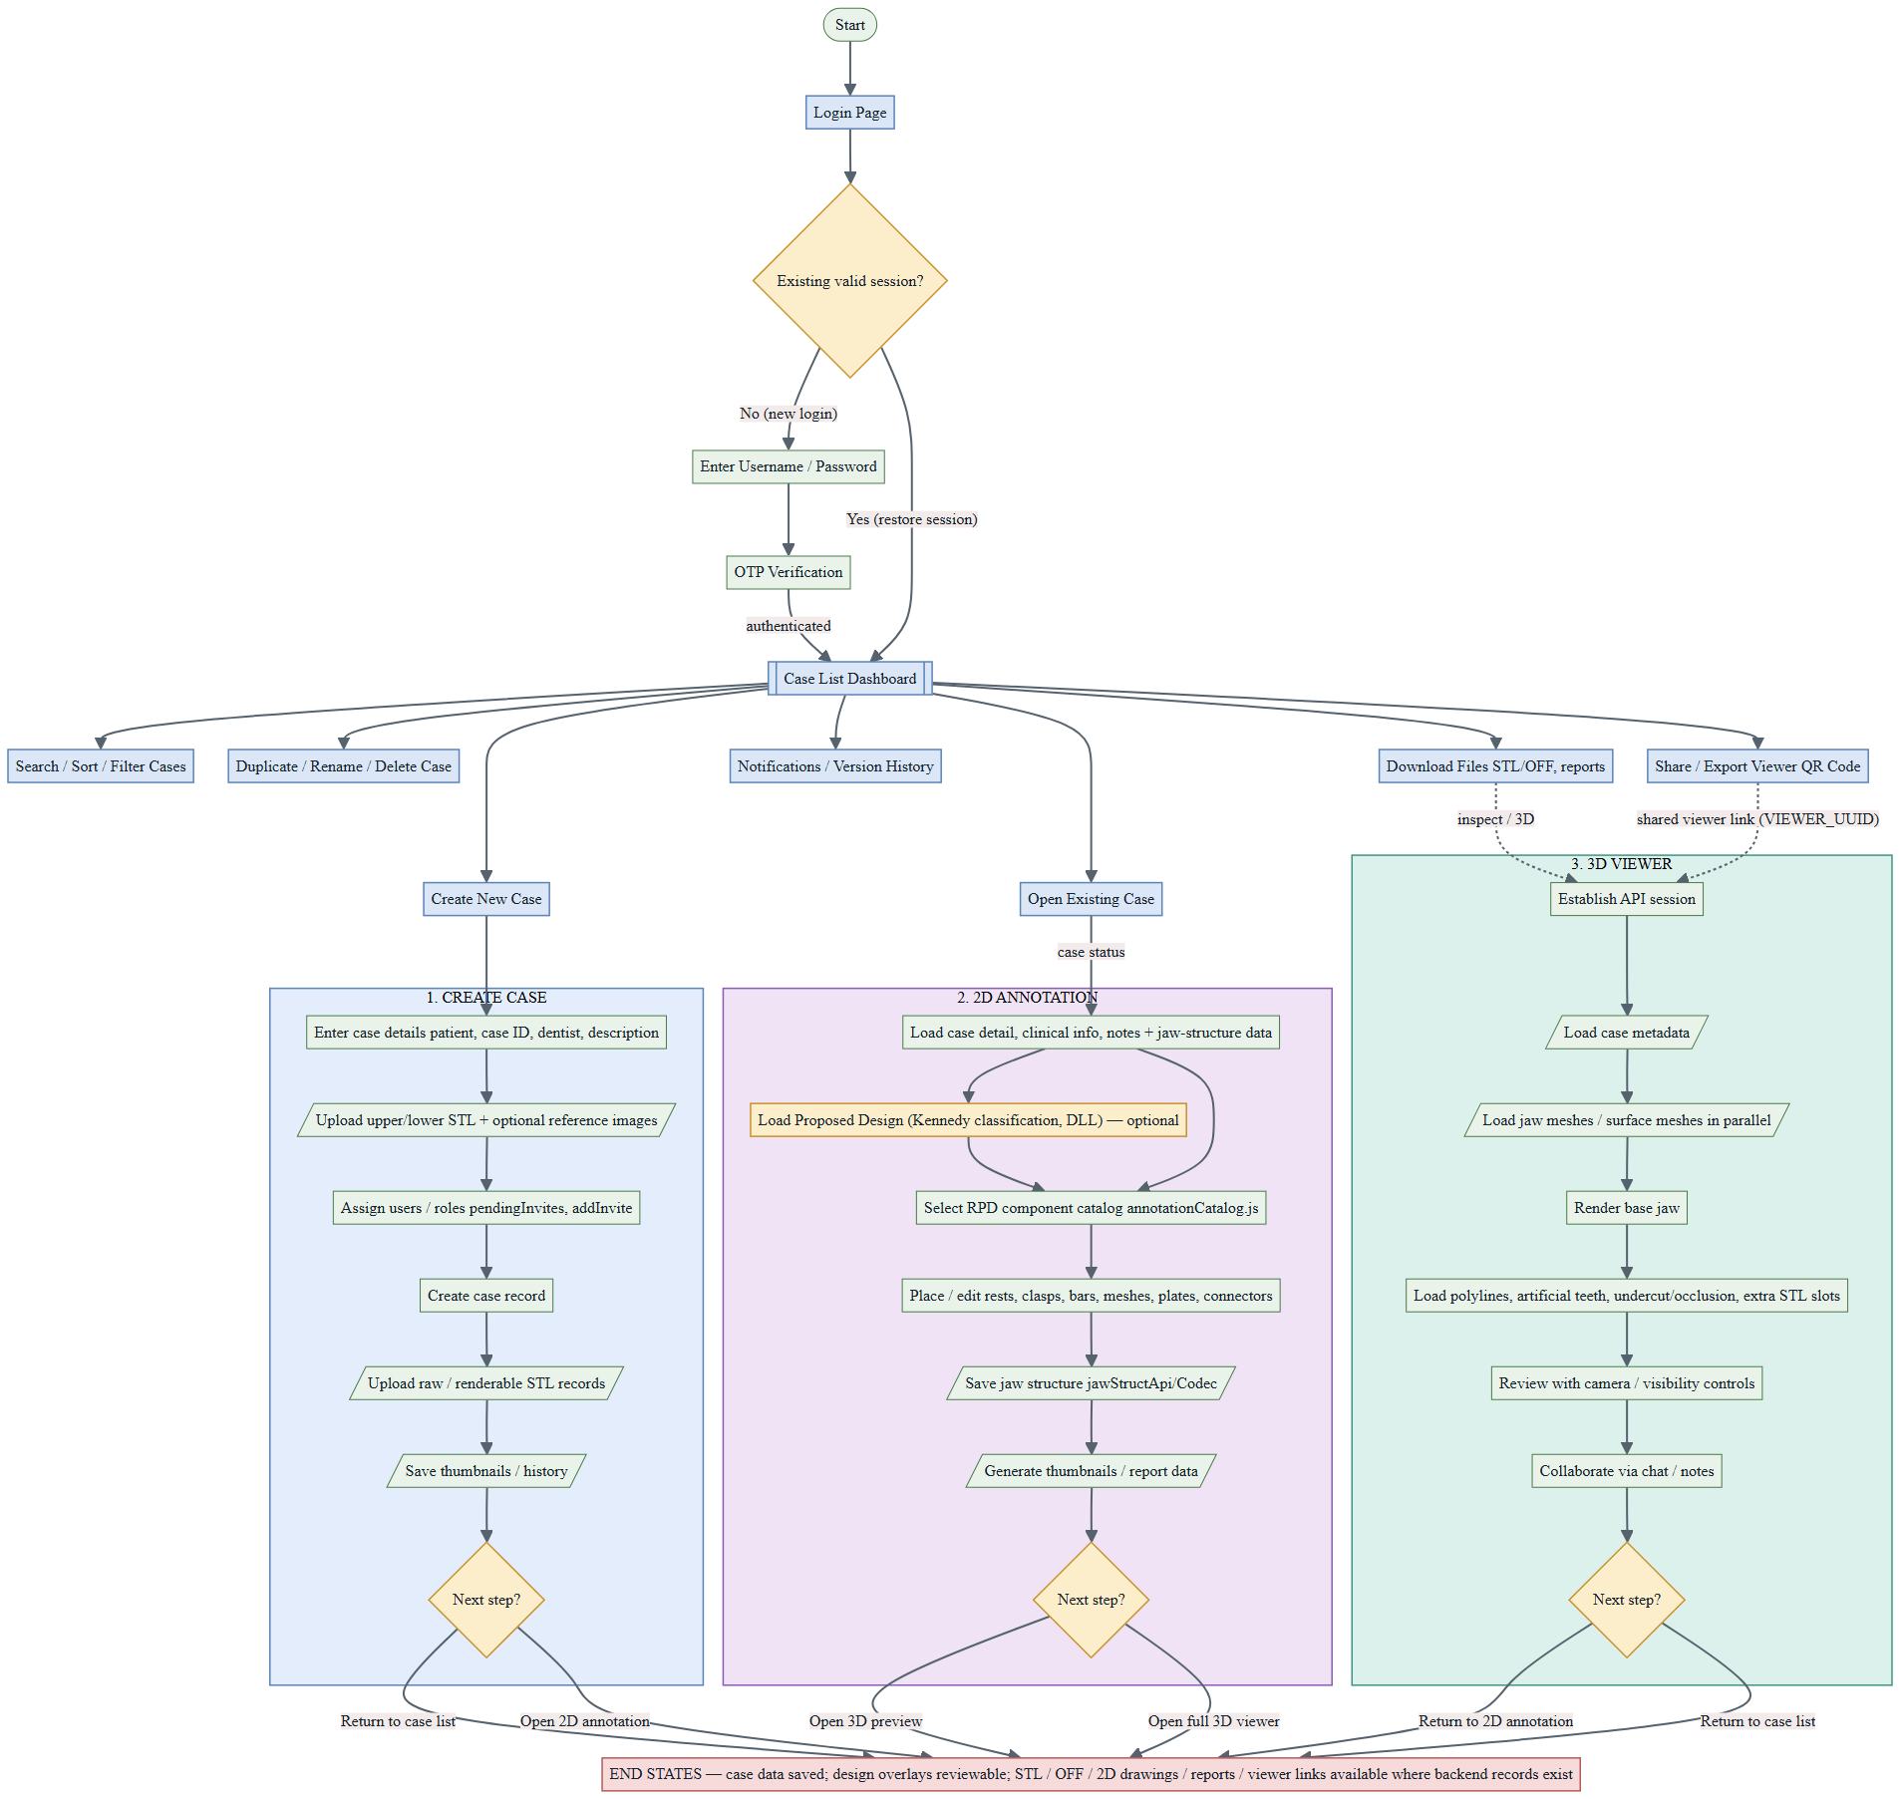

Workflow Diagram (last updated 24 August)
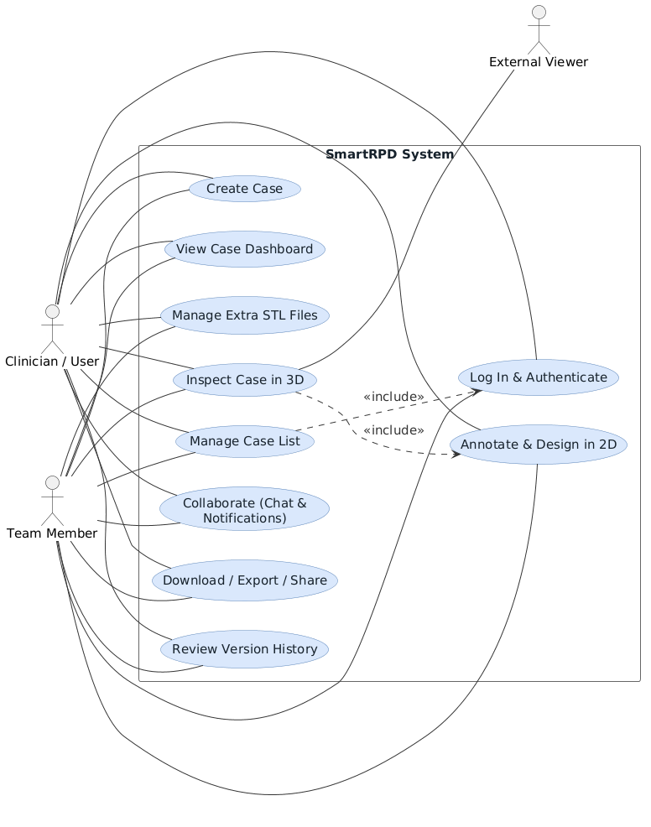

High-Level Use Case Diagram (last updated 24 August)

4. Implemented Feature Status
Feature Area | Status | Repository Evidence
Login and authentication guard | Implemented | login.js and the loggedInUser localStorage check present; no dedicated automated test for the guard itself (see Cybersecurity_Protocol_Document.docx §4.3).
Case list and case management | Implemented | caseManagement.js handles filtering (applyClientFilters()), sorting, status changes (valueToApiStatus()), duplicate/rename/delete; caseEnrichment.test.mjs passes.
Case creation and uploads | Implemented | createCase.js (STL/reference-image upload, team invites) and preview3D.js (extra STL slots 1–4) present. No dedicated automated test on this branch.
2D annotation workspace | Implemented | Modules under src/js/2D handle catalog, placement, rendering, jaw structure and save flow; jawStruct.test.mjs, placementRules.test.mjs, assemblies.test.mjs, mergeInstructions.test.mjs pass.
Clinical information | Implemented | Clinical info assets present; clinicalInfoCodec.test.mjs passes.
3D jaw and design rendering | Implemented | Three.js viewer, OFF/STL loaders, polyline overlays and artificial-teeth modules present; artificialTeethDecode.test.mjs passes.
Responsive 3D viewer | Implemented | Mobile/tablet/desktop layout switching (isMobileDevice()) present in src/viewer3d/newControls.js and src/viewer3d/index.js (consolidated from the former control.js/ThreeDMobile.js during the 2026-07-19 restructuring).
Chat, notifications and version history | Implemented | notifications.js and versionHistory.js present and integrated into the shared shell. No dedicated automated test for chat/notifications on this branch.
QR code sharing | Implemented | showThreeDViewerQr() in caseManagement.js (with qrcodejs via CDN)
Build and automated tests | Build passes; 19/19 suites passing | Production Webpack build succeeds (dist/bundle.js); 582/582 tests passing -- re-verified 2026-08-24 against nyunt/dev-W7.1 (live branch) (Automated_Test_Suite_Report.docx).
Password reset / change password | Implemented | src/js/shared/passwordReset.js, changePassword.js; passwordReset.test.mjs passes (22 tests). Note: signed-in change relies on the same email-key flow as forgot-password,
Help assistant | Implemented | src/js/shared/helpMatcher.js, helpTopics.js; helpBot.test.mjs passes (87 tests as of the 2026-08-24 re-run, down slightly from the 94 recorded 2026-07-31 -- not re-investigated this pass). No standing UAT-xx case in the cross-document backlog, though a UAT-13 draft exists below (12.2).
Admin (machine ID & user management) | Implemented | src/js/admin/adminMachineId.js, adminUsers.js. No automated test; no standing UAT-xx case; server-authoritative is_admin check confirmed in code.
Load Proposed Design / Kennedy classification | Implemented (new) | JawDesign.js (classifyArch), JawDesignProposal.js (buildDesignProposal, applyDesignProposal), wired into 2DAnnotation.js (tryLoadDllProposedDesign, bindKennedyProposalDialog). JawDesign.test.mjs (20 tests) and JawDesignProposal.test.mjs (57 tests) pass. No standing UAT-xx case for the DLL-proposal path specifically -- see Traceability_Document.docx (TSK-031).

5. 2D Annotation and RPD Design
The 2D annotation workspace is implemented through src/pages/2DAnnotation.html and the modules under src/js/2D/*. It provides upper/lower jaw display, component catalogue tabs, tooth-level placement, undo/redo history, save/back handling, clinical information panels, case notes, noticeboard content, chat access and a linked 3D preview area. RPD component placement is split into focused modules for rests, clasps, bars, meshes, plates, minor connectors and major connectors. Jaw-structure modules encode, decode, apply and persist the structured design data so it can be reloaded and round-tripped through the backend API.

5.1 Module Breakdown

5.1.1 Entry Point & Shared State
2DAnnotation.js — entry point for the workspace; also hosts shared annotation state and UI helpers so other modules can import from a single place. Feature modules are loaded via dynamic import() during init specifically to avoid circular-import timing issues (TDZ errors) between the entry point and the modules that depend on it.

5.1.2 2D Design Component Modules
- components.rest.js, components.clasp.js, components.bar.js — placement/asset logic for occlusal rests, retentive clasps, and connecting bars.
- components.mesh.js, components.plate.js — mesh spans (for missing-tooth coverage) and lingual/palatal plates.
- components.minor.js, components.major.js — minor connectors and major connectors (the largest module — full arch-spanning connector logic).
- components.js — the shared catalog root these all register into (COMPONENT_BY_ID, COMPONENT_CATALOG, COMPONENT_TABS).

5.1.3 Persistence Modules
- jawStructCodec.js — encodes and decodes base64 jaw-structure text; pure text↔JS conversion, no I/O.
- jawStructApply.js — applies a decoded design onto live tooth/component state (e.g. resolving which teeth a major connector or bar spans and logging the placement summary).
- jawStructApi.js — reads from and writes to the backend jaw-structure endpoint.
- jawStructCodes.js — canonical integer↔componentId code tables, mirroring the Unity C# StructData.cs enums so both ends of the pipeline agree on part identity.

5.1.4 Visual/Interaction Modules
- annotationCatalog.js — builds the component-tab UI and renders catalog options per tab/section (initComponentCatalog(), renderComponentCatalog(), createComponentItemButton()).
- annotationPlacement.js — placement/removal side-effect rules (e.g. removing a bar clasp cleans up its reciprocating element on the paired surface).
- annotationRender.js — SVG rendering, including a Safari/iOS-specific workaround: since WebKit drops CSS filter: color chains on external <image> elements, each tint color is instead published as a named SVG <filter> def and referenced via url(#tint-...).
- annotationLocks.js — tooth status picker (present/abutment/compromised), jaw lock toggle, and multi-tooth removal mode (hold Shift to enter, with a learned-hint tooltip since the button itself is hidden above 1201px viewport width).
- annotationVisuals.js — draws placed components on each tooth (major connectors, mesh, plates, rest/clasp markers) as layered rendering passes.
- annotationTeethModel.js — per-tooth state: initializing default records, toggling presence/status, and migrating legacy component lists into the modern placement-array format.

5.1.5 Supporting Modules
- constants.js — FDI tooth-order tables, SVG namespace constant, image/scale/offset constants used across rendering (e.g. TOOTH_IMAGE_WIDTH, COMPONENT_SCALE_BY_JAW).
- criteria.js — validates whether a selected component can legally be placed on a given tooth, returning a structured failure reason + conflicting components when it can't (assessPlacementCriteria()).
- toothUtils.js — a single small helper, normalizeSurface(), that folds "occlusal" into "lingual" for surface-key consistency.

5.1.6 Clinical & Reporting Modules
- clinicalInfo.js, caseNote.js — clinical info panel and per-case note fields (owner, due date, tooth shade, work category); includes .NET BinaryFormatter envelope decoding.
- instructionEditor.js — canvas-based freehand drawing/instruction editor with crop, rotate, and drag-to-reposition for placed shapes.
- noticeboard.js — pulls together case detail, captured jaw images (captureJawJpegDataUrl() from annotationLocks.js), instruction-editor output, and 3D preview captures (capture3DPreviewDataUrl() from preview3D.js) into the case report/noticeboard content.
- preview3D.js — the 3D Preview tab specifically (one of three now sharing the preview panel's WebGL frame -- see 5.1.7); also owns the extra-STL-slot upload/preview feature covered earlier and survey-angle targeting (preview3DSurvey.js, a call-time-only circular import pair with this file by the file's own design).

5.1.7 Kennedy Classification & Design Proposal (new)
JawDesign.js — classifyArch(), a pure function deriving a Kennedy classification from tooth presence alone (Applegate rules); used both to gate DLL-proposal eligibility and by the fallback picker.
JawDesignProposal.js — derives a design proposal from each arch's Kennedy class (major connector + rest seats, per the metal/acrylic selection matrices): chooseMajorConnector(), buildDesignProposal(), applyDesignProposal(). Backs the “Load Proposed Design” button in 2DAnnotation.js (tryLoadDllProposedDesign(), bindKennedyProposalDialog()), which calls the jaw-occlusion DLL server-side (POST /dll/compute-denture-design-select) for eligible jaws and falls back to a Kennedy-classification picker modal if the DLL call fails or no jaw qualifies.

5.1.8 Preview Panel Tabs (new)
previewTabs.js — the preview panel's folder-tab strip: initPreviewTabs(), showPreviewTab(). Both 3D tabs (3D Preview, Extra 3D) share one WebGL frame so the context is never torn down between them; switching to Reference Images pauses rendering instead.
referenceImages.js — the Reference Images tab: loadReferenceImages(), closeViewer() -- gallery + full-pane view of the case's reference images.

6. 3D Viewer Architecture
The 3D viewer is built with Three.js and an orthographic camera (THREE.OrthographicCamera). An orthographic projection ensures jaw models and design overlays render at consistent scale regardless of zoom level. The scene contains anatomical jaw meshes, surface/design meshes, polyline overlays, artificial-teeth overlays, lights, camera controls and the shared viewer shell UI.

6.1 Scene Layers
Layer | Responsibility
parentObject | Hosts upper/lower jaw mesh objects and loaded STL/OFF mesh variants.
polylineOverlayGroup (named "polyline-overlay-group") | Hosts upper/lower RPD component polyline tube geometry and draggable edit handles.
artificial-tooth-overlay-group (built in src/viewer3d/artificialTeeth.js, mounted via artificialTeethRenderer) | Hosts upper/lower artificial tooth meshes and buccal/gingival guideline references, kept in sync with jaw mesh transforms every frame.
newControls.js (addVisibilityAndTransparencyControls()) | Controls object visibility, opacity, wireframe overlays, and undercut/occlusion mode switching.
resetButton.js (addResetButton()) | Owns camera reset (restores a cloned initial camera state and resets zoom to 7) and the rotation lock/unlock toggle — the "camera presets and review actions" belong here, not in newControls.js.
viewerShell.js | Provides the viewer footer (case name, logged-in user, connectivity status), the right-hand navigation drawer (wireRightNavButton()), chat entry (wireChatButton()), a notes popup (wireNotesPopup()), and sidebar links back to version history and the case list.

6.2 Mesh Loading
Jaw meshes load from backend endpoints. OFF data is parsed by src/viewer3d/OFFLoader.js and STL data by src/viewer3d/STLMeshLoader.js. The viewer supports fallback between OFF and STL payloads so cases can still render when one format is unavailable. Mesh fetches for jaw and denture meshes are initiated in parallel before either is awaited to minimise startup time.
- /parameterisation/mesh/getall — parameterised jaw mesh (OFF format)
- /surface/getall — denture/surface mesh (OFF format)
- /stl/get — closed jaw mesh variant (STL format, availability-checked first)

6.3 Render Loop
The main render loop runs in src/viewer3d/index.js. Each frame updates controls, anchors and clamps the rotation target (to prevent jaw drift), synchronises artificial teeth overlay groups to their corresponding jaw meshes, then renders the scene.

6.4 Mesh Quality Selection (2D-Embedded Preview)
When the embedded preview loads, beginMeshQualityLoad() sets meshQuality to DEFAULT_MESH_QUALITY (“high”) automatically -- there is no longer a user-facing choice modal at load time (the earlier “Choose mesh quality” prompt with Low/High options was removed; the overlay “is now purely the progress panel”, per the function's own comment). This runs concurrently with the undercut-heatmap and mesh-file fetches (Promise.all).
showMeshQualityProgress() swaps the overlay for a labeled progress bar (updateMeshQualityProgress(percent, jawLabel)), driven by updateJawMeshProgress() as each jaw parses — surfacing stage text like "Parsing Upper jaw" or "Matching undercut vertices Lower jaw" mapped across an 8%–94% range — before finishMeshQualityProgress() sets it to 100% ("3D jaw mesh ready") and clears the overlay.
Decimation logic – The original STL/OFF source bytes are kept untouched in preview3DState.qualitySource for upload/download.
- High Quality (getDisplayGeometryForQuality()): decimation is skipped entirely.
- Low Quality (createDisplayGeometry()): only triggers if the source mesh exceeds PREVIEW_MIN_SIMPLIFY_TRIANGLES (160,000 triangles) — smaller meshes render unsimplified even in "low" mode. buildClusteredGeometry() performs spatial vertex clustering: it buckets nearby vertices into grid cells sized off the mesh's bounding box, merges each cluster to its average position/color, and rebuilds deduplicated triangles from the merged vertex indices. It tries progressively larger cell sizes (multipliers 1, 1.25, 1.6, 2.05, 2.65, 3.4× a base size derived from a ~84,000-vertex target) and keeps whichever pass lands closest to the PREVIEW_MAX_DISPLAY_TRIANGLES budget (120,000 triangles), stopping early once at or under budget.
- Undercut-heatmap colouring is cluster-aware rather than naively blended: each cluster keeps the colour of its most severe undercut value instead of averaging it away, so simplification doesn't wash out clinically relevant heatmap regions.
- Post-load switching. A small HD/SD badge (updateQualityToggle()) stays visible after the initial load, letting the user re-render the already-loaded jaws at the other quality without a page reload (switchMeshQuality()) — it reuses the same progress overlay and reattaches any extra-STL-slot meshes afterward, since repopulating the jaw preview clears and rebuilds the model root. The logic is shared uniformly across both mesh source paths — OFF/parameterized (populateJawPreviewFromOFF()) and STL (populateJawPreview()) — both accept the resolved meshQuality value.

7. Polylines, Artificial Teeth and Heatmaps

7.1 Polyline System
- Loaded from /polylines/getall (POLYLINE_ENDPOINT), normalised across structured and encoded payload variants by normalizePolylineResponse() before rendering — this absorbs backend payload-shape differences into one consistent internal format regardless of how the source data was encoded.
- Rendered as tube geometry: each polyline segment becomes a THREE.TubeGeometry between adjacent points (createPolylineTubeGeometry() / createPolylineTubeGeometryBetweenPoints()), with per-component visibility toggles and draggable point handles for interactive editing.
- applyJawTransformToPolylineGroup() and getClosestJawPolylineSurfacePoint() accept a coordinateSpace of "jaw-local" or "scene-world", but the renderer doesn't just trust a source flag — it computes the median distance from the polyline points to the jaw surface under both interpretations (getMedianDistanceToJaw(points, jawType, "jaw-local") vs. "scene-world") and picks whichever produces the smaller (more plausible) distance. This avoids double-transforming data that's already in world space, or under-transforming data that's still jaw-local.
- Undo, redo and reset history are available for polyline point edits, exposed as dedicated toolbar buttons (Icon_undo2.png / Icon_redo2.png) wired directly in src/viewer3d/index.js.

7.2 Artificial Teeth
- Loaded separately through /toothPlacementData/get (distinct from the polyline and jaw-mesh endpoints), decoded via mapToothCraftData() into upper/lower ToothCraftData records (toothCraftDataUpperJaw_ / toothCraftDataLowerJaw_).
- Rendered as an independent overlay group (artificial-tooth-overlay-group, built in src/viewer3d/artificialTeeth.js); it does not modify jaw meshes or polylines — it's synced to jaw transforms every frame (syncToJawMeshes()) but never writes back into the jaw geometry itself.
- Core rule: geometry source and placement source must match. The decoder carries both toothData_ (placement) and toothSurfaceMeshData_ (geometry) as separate keyed structures per tooth (createToothRecordsFromCraftMaps()), and each rendered tooth mesh tags its own geometrySource and placementSource in userData for downstream diagnostics (e.g. mesh.userData?.source?.placementSource). Mixing surfaceMesh geometry with toothData-only placement misaligns the tooth, since the two paths aren't guaranteed to describe the same coordinate frame.
- Buccal and gingival guideline curves are rendered as separate, distinctly colored materials — buccal in orange (0xff9f1c) and gingival in cyan/blue (0x38d6ff), both semi-transparent (opacity 0.72–0.78) — for both upper and lower jaws. They are visual references only: nothing in the placement or transform code reads these curves back to snap, constrain, scale, or orient a tooth.

7.3 Undercut and Occlusion Heatmaps
- Available on supported jaw objects via the undercut/occlusion analysis mode buttons (newControls.js, per-component undercutButton/occlusionButton, toggling group.setMode("undercut"|"occlusion"|"normal")).
- The undercut mode has a dedicated measurement legend (id viewer-undercut-legend, built by createUndercutLegend() in src/viewer3d/newControls.js -- not resetButton.js as previously documented here) titled “Undercut (mm)”, with four colour-coded value-range bands (>0.75, 0.5-0.75, 0.25-0.5, <0.25) matching preview3D.js's colorForSurveyingValue palette byte-for-byte by design (the file's own comments say so explicitly, to keep the two in sync). No separate legend was found for occlusion mode in this pass -- if one exists it was not located in newControls.js; worth confirming directly rather than assuming the two modes share this panel, since that specific claim could not be verified.

8. Loading, API and Reliability

8.1 Loading Strategy
The viewer prioritises making useful content available as early as possible:
- Establish session and fetch case metadata/thumbnails.
- Start jaw mesh and surface mesh requests in parallel.
- Render the base jaw mesh — viewer becomes interactive.
- Load polylines and artificial teeth in the background, as a single parallel batch (fetchAndRenderCaseOverlays(): Promise.all([fetchAndRenderPolylines(), artificialTeethRenderer.fetchAndRender()])) rather than sequentially.
- Chat loading is decoupled more strongly than just "non-blocking" — chat.js isn't loaded at all during page load. viewerShell.js's wireChatButton() only dynamically import()s it the first time the user actually clicks the chat button, so a broken or slow chat module can never affect initial scene load.

8.2 ApiClient
src/viewer3d/ApiClient.js manages REST calls, session login, streaming download progress and fallback JSON parsing.
- Session login is guarded by a module-level singleton promise (sessionLoginPromise / getSessionLogin()).
- Streaming download progress: when Content-Length is present, the response body is read via response.body.getReader() into a ReadableStream, updating a progress bar, percentage label, and a live download-speed readout (MB/s, computed from bytes-loaded ÷ elapsed time).
- Fallback JSON parsing: when Content-Length is absent (chunked transfer encoding — confirmed as the GCP-proxy case in 8.3), it skips the streaming UI entirely and falls straight to response.json(), rather than aborting.

9. Responsive UI and Collaboration

9.1 Viewer Shell
The viewer shell has been reworked for desktop, tablet and mobile breakpoints, using css/style.css (shell chrome) and src/viewer3d/index.js (the control-panel drawer) rather than a single stylesheet:
- Breakpoints: desktop ≥1025px, tablet 769–1024px, mobile ≤768px (css/style.css), consistent with the breakpoint scheme used across the other page-specific stylesheets (2Dannotation.css uses an analogous 1201px/720px split for its own controls).
- Persistent footer (.cm-footer in style.css, populated by viewerShell.js) shows case name (footerCaseName), current user (footerUserName — hidden entirely below 768px to save space), connection state (footerConnection), a menu button (footerMenuBtn), case chat entry (footerChatBtn), and the right-panel toggle (wireRightNavButton()).
- Desktop: the control panel is a labelled drawer (#hamburger-drawer) sliding in from the right, positioned left of the sidebar, with items filling the drawer's full width.
- Tablet/mobile: the same drawer element is not replaced but re-skinned by breakpoint — on tablet (769–1024px) it shrinks to a compact 176px-wide panel pinned near the top-right; on mobile (≤768px) it narrows further to 164px and repositions to sit just above the bottom footer bar (bottom: calc(92px + safe-area-inset)) — literally "pinned above the footer," confirming that phrasing precisely.

9.2 Case Chat
Case chat (chat.js) is wired into the 3D Viewer (viewerShell.js's wireChatButton()) and the 2D Annotation page (src/js/2D/2DAnnotation.js)
Case chat supports:
- Text comments and image attachments, with client-side MIME sniffing from the base64 signature (detectImageMime() — JPEG/PNG/GIF/WebP) rather than trusting a declared content type.
- A live preview of an in-progress image upload that survives message-list refreshes (a placeholder message, PREVIEW_AUTHOR, holds its place until the real message arrives).
- Polling (pollTimer/pollTick()) for new messages, with a lightweight signature check on each poll — if the response signature is just message IDs (cheap) it skips the expensive step of re-parsing every message's inline base64 image, only doing the costly full re-render when new content appears.
- A local cache of the conversation (saveCachedMessages()/loadCachedMessages()) so reopening chat paints instantly from cache before the network fetch resolves.
- A slide-in panel layout (css/chat.css): hidden state is translateX(100%), sliding to translateX(0) over a 0.22s transition — deliberately mirroring the same slide-in pattern used by the app sidebar, per the CSS file's own comment.
- wireSidebarVersionHistory() (in viewerShell.js) lazy-imports versionHistory.js and calls openVersionHistory() when sidebarVersionHistoryBtn is clicked.

10. Build, Test and Release

10.1 Application Status
Features developed have been formally written out in project requirements and specification sheet.
Current application has finished development on main features, in UAT phase before full rollout.

Gate | Status | Notes
Requirements | Complete | Requirements have been approved against a written spec.
Specifications | Complete | UI assets, component libraries (SVG asset trees under assets/), and working implementation exist.
Development stage | Complete | Production-mode Webpack build passes (npm run build).
Integration | Complete | Features are merged through nyunt/integration_3 into nyunt/dev-deploy and auto-published to nyunt/dev-W7.1 by the “Deploy Test Site” GitHub Actions workflow (this document's branch, dev-deploy-documentation, is the source of what's currently live on nyunt/dev-W7.1).
Implementation | Complete | All main application features are implemented.
UAT | In Progress | UAT protocol and test cases are fully defined and testing is in progress.
Production | - | Production-mode compilation to be signed off after UAT complete and approval given.

11. Testing

11.1 Automated Test Results
Test run on 20 August 2026: npx jest --ci --coverage --coverageReporters=json-summary --verbose --testLocationInResults --json against nyunt/dev-W7.1 (live branch), run directly on this branch's own HEAD now that Documentations/ is maintained here rather than sourced from dev-deploy-documentation. Result: 19 suites / 582 tests, 0 failing -- see Automated_Test_Suite_Report.docx and UAT_Report.docx §2.1 for the full breakdown.

11.2 Test Coverage Areas
- Authentication, password reset and case enrichment — no dedicated automated test exists for the login()/OTP flow or the client-side loggedInUser guard itself on this branch (a coverage gap, consistent with the earlier pre-restructuring suite). passwordReset.test.mjs (22 tests) covers computePasswordStrength(), validateNewPassword(), and the request/reset API-call shaping in src/js/shared/passwordReset.js. caseEnrichment.test.mjs (24 tests, up from 13) covers the case-detail/co-owner request-and-fold layer behind the case list (src/js/shared/caseEnrichment.js).
- Dashboard — dashboard.test.mjs (19 tests): statusRank() (rank inference from exact and keyword-based status strings, case/whitespace-insensitive, later-stage keyword precedence), computeSteps() (5 stages × Upper/Lower lines, per-jaw independence, validated against the real case-1723 status value), countCompletedStages() (only counts a stage when both jaws are done), resolveCaptureSlots() (slot mapping tolerant of field-name variants, duplicate rows, and missing slot tags). Chat and create-case have no dedicated automated test on this branch — a coverage gap, same as the pre-restructuring suite.
- Artificial-teeth decoding — artificialTeethDecode.test.mjs (28 tests): MessagePack scalar/container decoding, byte-array field expansion, jaw-key normalization, point/quaternion coercion, and little-endian binary readers used by the 3D viewer’s tooth-placement pipeline (src/viewer3d/artificialTeeth.js). Thumbnail save/update and STL load have no dedicated automated test on this branch.
- Repo-wide import resolution — importResolution.test.mjs (3 tests): every relative import in src/ resolves to an existing file, every relative import/jest.mock in __tests__/ resolves, and every relative <script src> in the HTML pages resolves — a structural build-integrity check rather than a behavioural one. Orbit controls and sidebar toggling have no dedicated automated test on this branch.
- Clinical-info codec, jaw-structure round-trip — clinicalInfoCodec.test.mjs: the .NET BinaryFormatter envelope codec (valid envelope shape, 7-bit length prefix correctness, deterministic encode, decoding both self-encoded and desktop-authored blobs, edge case where a length byte collides with [ (0x5B), tolerance of junk/non-array payloads); desktop↔UI field mapping (int-enum/bool decoding, “none” sentinel handling for mobility/restoration/tilt, full 32-tooth desktop-order write-back, presence defaulting); full round-trip (lossless notes→rows→encode→decode→notes across every marker, idempotent decode∘encode on a full 32-tooth chart). jawStruct.test.mjs: upper/lower jaw save text is byte-identical to the loaded text with no edits applied.
- Jaw-structure major-connector and lingual-plate behaviour, reciprocating clasp exclusivity — this content, previously attributed here to separate jawStructMajorSwitch.test.mjs / jawStructLingualPlate.test.mjs / reciprocatingExclusivity.test.mjs files, actually lives in jawStruct.test.mjs, placementRules.test.mjs and assemblies.test.mjs on this branch — those three split-out files do not exist here. The described behaviour (lingual plate ↔ bar switching keeps the type label and connector geometry grid in sync; clasp XOR plate is enforced on the reciprocating slot; addPlacement() swaps a reciprocating clasp and plate in place of each other) has not been re-verified line-by-line against the current files for this pass — flagged for a follow-up review rather than restated as still-exact.
- Merge instructions and crypt helpers — mergeInstructions.test.mjs (5 tests): merges server/local items on a shared title key, keeps distinct keys separate, falls back title→id→preview for the merge key, tolerates null/undefined input. crypt.test.mjs (3 tests): lol() encrypts/decrypts numeric case IDs correctly, produces different ciphertext per ID, degrades gracefully — returns NaN, doesn't throw — on invalid encrypted input. mapWithConcurrency has no dedicated automated test on this branch.
- QR code sharing — showThreeDViewerQr() / buildThreeDViewerUrl() (caseManagement.js): no automated Jest coverage — depends on window.QRCode from a CDN script (qrcodejs, loaded in case_list.html) and canvas/DOM rendering outside the current jsdom setup. Verified manually per UAT-11 (script below); recommend closing the gap with a jsdom test that stubs window.QRCode.
- Password reset and help assistant — passwordReset.test.mjs (22 tests, see above) and helpBot.test.mjs (87 tests, down slightly from the 94 recorded 2026-07-31 baseline; not re-investigated this pass): normalize()/tokenize()/canonicalize() text preparation, scoreTopic()/findMatches()/relatedTopics()/suggestionsFor() ranking logic, reveal/opener resolution, and the integrity of the bundled HELP_TOPICS/TOPIC_BY_ID/PAGE_LABELS/PAGE_PATHS knowledge base (src/js/shared/helpMatcher.js, helpTopics.js). Both suites import the real src/ modules they test.

12. UAT Report

12.1 Scope
UAT checks SmartRPD Web Application workflows are acceptable to intended users on supported desktop and mobile browsers before release/sign-off. Screenshots from testing are in folder backup/uat-screens.
- Desktop: Windows laptop/desktop, current Chrome or Edge at 1366×768 or wider.
- Mobile: iOS Safari and/or Android Chrome at phone-size viewport.
- Tablet: iPad Safari and/or Android tablet Chrome, viewport in the 769–1024px range.

12.2 Test Cases
ID | Workflow | Pass Criteria | Fail Criteria
UAT-01 | Login & Authentication | User signs in with password + OTP (OTP currently disabled, see Cybersecurity_Protocol_Document.docx §4.2); the loggedInUser localStorage check allows navigation to every protected page afterward; forgot-password / change-password (src/js/shared/passwordReset.js) completes successfully. | OTP fails to verify a correct code (when enabled), or a page loads without loggedInUser in localStorage present (guard bypassed), or a valid session is bounced back to login, or password reset fails to actually update the account's password.
UAT-02 | Case List | Search/filter (applyClientFilters()) and sort return correct results; inline status change (valueToApiStatus()) persists; duplicate/rename/delete/open all operate on the correct case. | Filter/sort returns stale or wrong results; status change doesn't persist after reload; delete/duplicate acts on the wrong case ID.
UAT-03 | Case Creation | Case created with upper/lower STL + optional reference images; invited users (pendingInvites, addInvite()) receive access; case appears in Case List immediately. | Upload silently fails without error surfaced to the user; invited user has no access to the created case; case doesn't appear without a manual refresh.
UAT-04 | Dashboard | Per-case overview opens as an overlay (buildOverlay()) without navigating away; progress steps (computeSteps(), countCompletedStages()) and capture slots (resolveCaptureSlots()) match the case's actual state. | Progress/step count is wrong relative to actual case state; overlay navigates away from the current workspace instead of staying in place.
UAT-05 | Collaboration | Chat (image + text) and notifications open as overlays from list, dashboard, and viewer contexts without full page navigation; new messages/alerts appear without a manual refresh. | Chat/notification overlay forces a page reload; a sent message or triggered alert doesn't appear for the recipient within the polling interval.
UAT-06 | 2D Annotation (Design) | Clinical info/notes save (clinicalInfo.js, caseNote.js); freehand instruction marks save (instructionEditor.js); RPD components can be placed, respect per-component placement/lock rules (annotationPlacement.js, annotationLocks.js), and the saved jaw-structure data (jawStructApi.js) reloads identically. | A placed component violates a rule it should be locked against (e.g. two reciprocating elements — see §11.2's reciprocatingExclusivity coverage) and is still accepted; reload after save differs from what was saved.
UAT-07 | Embedded 3D Preview (in 2D workflow) | From within 2D Annotation, jaw geometry, design overlays and artificial-teeth placement render correctly; undercut/occlusion modes toggle per-component; HD/SD mesh-quality toggle re-renders correctly (switchMeshQuality()) without leaving stale geometry. | Toggling quality leaves a mix of old/new geometry visible; undercut/occlusion mode doesn't visually change; preview desyncs from the 2D design it's supposed to reflect.
UAT-08 | 3D Viewer (standalone) | Same correctness bar as UAT-07, plus: polyline handle drag + undo/redo/reset actually reverts (§7.1); coordinate-space detection doesn't double- or under-transform on at least one known jaw-local and one known scene-world case; artificial-teeth geometry/placement source matching holds on a mixed-source case (§7.2); camera lock-button and plate-placement fixes from 514ead3/3b120b0 haven't regressed. | Undo/redo leaves the polyline in a different state than before the edit; an overlay renders visibly offset/rotated from the jaw (transform-space bug); a tooth renders at the wrong position due to mismatched geometry/placement source.
UAT-09 | Add STL Files | Up to 4 extra reference STL slots (uploadExtraStl(), jaw_stls_extra_slot_1..4) upload, render, and can be shown/hidden (toggleExtraStlVisibility()) and deleted (deleteExtraStl()) independently of each other and of the main jaw meshes. | Toggling or deleting one extra slot affects a different slot or the main jaw mesh; a 5th slot is silently accepted past the documented 4-slot limit.
UAT-10 | Version History | Past design iterations open and display correctly, both as a standalone page (VersionHistory.html) and as a modal from other entry points (versionHistory.js); the two entry points show consistent data. | Standalone page and modal show different data for the same case; a past iteration fails to load or shows blank content.
UAT-11 | Download / Export / Share | Raw OFF/STL files download correctly (downloadCaseFiles()); compiled .docx report generates correctly (buildReportHtml()/generateReport(), reportHtmlToDocxBytes()); the 3D viewer share link works under the shared VIEWER_UUID with the case ID correctly obfuscated (crypt.js lol()); the QR code (showThreeDViewerQr()) scans and opens the same working link. | Downloaded file is corrupt/incomplete; generated .docx is missing design images or clinical data present in the case; the share link's decoded case ID resolves to the wrong case; the QR code encodes a stale or malformed link.
UAT-12 | Responsive (tablet + mobile) | Core workflows above remain usable at tablet (769–1024px, compact drawer per §9) and mobile (≤768px) breakpoints; touch-drag of a polyline edit handle (pointerdown/pointermove in src/viewer3d/index.js) works correctly; required screenshots captured per device class. | A control is unreachable/occluded at a given breakpoint; touch drag doesn't register or drags the wrong handle; layout breaks between the documented breakpoint boundaries.
UAT-13 | Help Assistant | The help panel opens from the sidebar on every page; typed questions return a relevant matched topic from the local knowledge base (helpMatcher.js) without any network request being made. | The panel fails to open on some page; a clearly-matching question returns no result or an irrelevant one; a network request is observed while using the panel.

12.3 UAT Status
UAT has been run by developers both automated testing and manual testing. Currently phased out for clinician use and feedback.

13. High-Level Architecture

13.1 High-Level Architecture
Static multi-page frontend application using HTML, CSS and ES modules, bundled for production with Webpack and runnable locally through Vite. The frontend communicates with the SmartRPD – https://live.api.smartrpdai.com/api/smartrpd.

13.2 Layer Summary
Layer | Components
Client presentation | Each page pairs with a primary controller — full page-to-file mapping in §2's Page/Area table. Key controllers: login.js (Login), caseManagement.js (Case List — including filtering, status changes, and QR-code sharing), createCase.js (Case Creation), dashboard.js (Dashboard overlay), 2DAnnotation.js + src/js/2D/* (2D Annotation), src/viewer3d/index.js (3D Viewer), versionHistory.js (Version History).
Shared client services | login.js, appSidebar.js, viewerShell.js, chat.js, notifications.js, versionHistory.js, passwordReset.js, changePassword.js, helpBot.js/helpMatcher.js/helpTopics.js, src/js/shared/crypt.js (lol() case-id obfuscation — shared by Case List's share-link/QR flow and viewer navigation). The loggedInUser localStorage check (referred to as “authGuard” in code comments) has no single dedicated file post-restructuring.
Configuration | config.js — centralizes MACHINE_ID, VIEWER_UUID, and a fallback LOGIN_CREDENTIALS object
API Connection | src/viewer3d/ApiClient.js — reusable REST, session login, progress tracking, fallback JSON parsing.
2D domain | 2DAnnotation.js coordinates state; component modules encode rests/clasps/bars/meshes/plates/connectors; jawStructCodec.js converts backend base64 jaw-structure text; preview3D.js — the embedded 3D preview and extra-STL-slot upload feature.
3D domain | src/viewer3d/index.js — Three.js scene, orthographic camera, mesh groups, polyline and artificial-teeth overlays; newControls.js — visibility, opacity, analysis modes, and the mobile-device check (isMobileDevice()) that used to live in a separate control.js/ThreeDMobile.js before the 2026-07-19 restructuring consolidated them; OFFLoader.js + STLMeshLoader.js — geometry parsers.
Backend/API | SmartRPD REST endpoints for auth, case data, roles, alerts, notes, thumbnails, clinical info, jaw-structure, STL/OFF meshes, polylines, heatmaps, email and report support.

13.3 Data Flow
A Data Flow diagram is included in the foot of this section, the Workflow Diagram is at the end of Section 3.
- User authenticates → frontend stores logged-in user/session data.
- Case list requests case records from API.
- Selected case opens 2D or 3D page → page loads metadata and design/mesh payloads.
- User edits annotations/notes/clinical data → frontend posts updated payloads to API.
- Saved data is reloaded for verification/review/download.

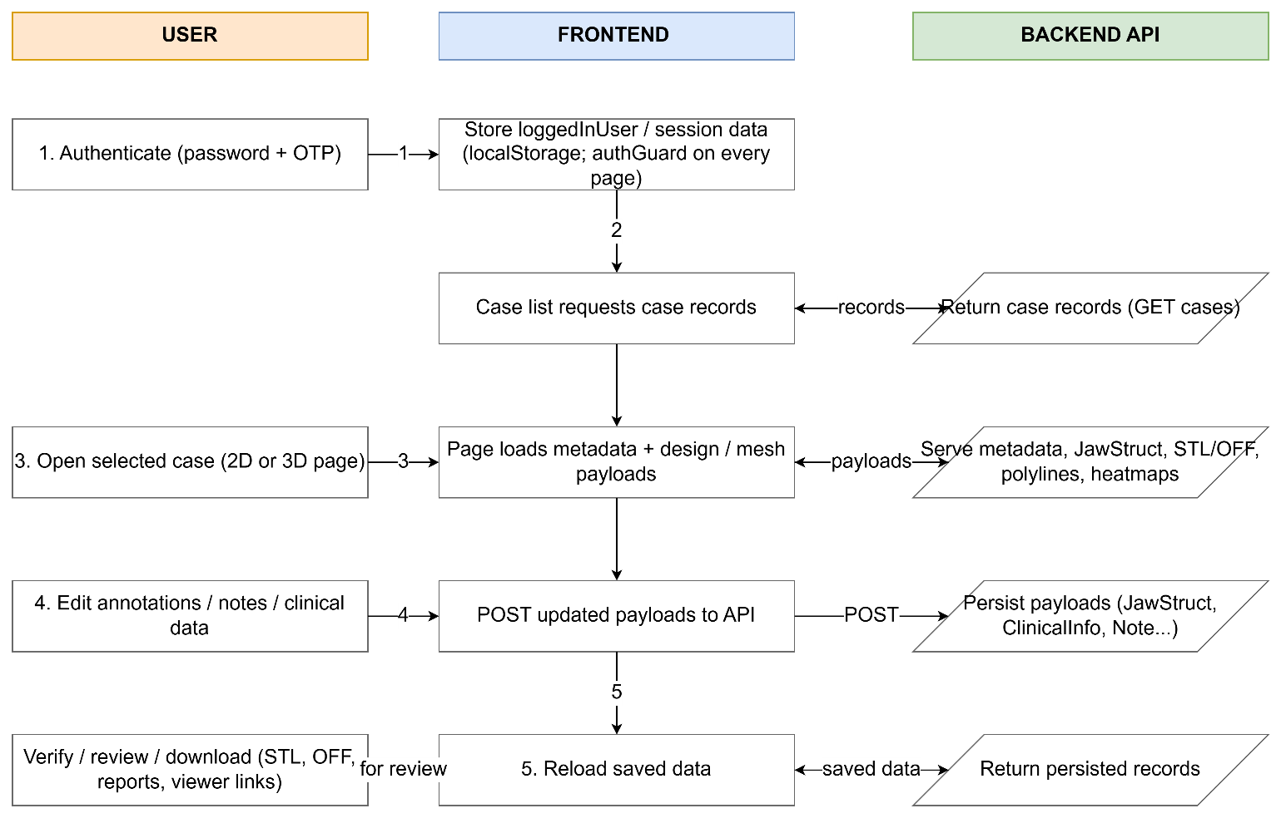

Data Flow Diagram (last updated 24 August)

14. API References

14.1 Endpoint Summary
Category | Endpoints
Authentication | POST /user/login, POST /otp, POST /otp/verify, POST /user/logout (missing from the prior list), POST /user/reqpwreset, POST /user/resetpw
Case management | POST /case/user/findall/get, POST /case/get/:id, POST /case, PUT /case/:id, POST /case/delete/:id, POST /case/duplicate, POST /case/rename/:id
Roles, invitations and alerts | POST /role, POST /role/all/get, POST /role/delete, POST /alerts, POST /alerts/getallbytouser, POST /alerts/setreadstatus
Case metadata and history | POST /additionalcasedetails/getall, POST /additionalcasedetails, POST /casehistory, POST /casehistory/getall
Jaw, surface and STL data | POST /parameterisation/mesh/getall, POST /surface/getall, POST /stl/get, POST /stl/raw/get, POST /stl/get/:type, POST /stl, POST /stl/raw
Extra STL slots | POST /stl/slot/get, POST /stl/slot/, POST /stl/slot/delete
Design overlays and analysis | POST /polylines/getall, POST /undercutheatmap/get, POST /toothPlacementData/get (missing — artificial-teeth data source, §7.2)
Clinical and jaw-structure data | POST /clinicalinfo/get/:caseId, POST /clinicalinfo, POST /jawstruct/l2/getall, POST /jawstruct/l2
Images and noticeboard | POST /thumbnails, POST /thumbnails/get, POST /noticeboard/editedview/get, POST /noticeboard/editedview, POST /noticeboard/drawnview, POST /noticeboard/drawnview/get, POST /noticeboard/view, POST /noticeboard/view/get
Chat and communication | POST /notes/get/:caseId, POST /notes/create, POST /mailinglist/add, POST /sendEmail, POST /sendCustomEmail

14.2 Common Request Envelope
Many POST payloads use an array envelope: the first object contains machine_id, uuid, and caseIntID; the second object contains the case-specific payload. machine_id identifies the client application, uuid identifies the logged-in user/session, and caseIntID identifies the numeric backend case.

15. Data Schema

15.1 Entity Relationship Overview
Entity | Key Fields | Relationships
User | uuid (PK), username, email, is_admin | 1..* → Role; 1..* → Alert (sender/recipient); 1..* → Note (sender)
Case | id/caseIntID (PK), case_id, name, created_at, new_status | 1..* → Role, AdditionalCaseDetails, JawStruct, ClinicalInfo, STL, Thumbnail, CaseHistory, Note, Polyline, UndercutHeatmap, NoticeboardEditedView
Role | id (PK), uuid (FK→User), case_int_id (FK→Case), role/permission | Connects users to cases with access permissions.
AdditionalCaseDetails | id (PK), case_id/caseIntID (FK→Case), assigned_to, due_date (Unix seconds), comments, new_status | Drives the case-list due-date colour indicator and dashboard workflow status
JawStruct | id (PK), case_id (FK), type (upper_jaw/lower_jaw), filename, data (base64) | Stores encoded RPD design data per jaw per case.
ClinicalInfo | id (PK), case_id (FK), data (base64 BinaryFormatter) | Per-tooth clinical flags: mobility, rct, restoration, crown, implant, rootStump, cracked, tilted, extraction, abutment.
STL | id (PK), case_id (FK), type, filename, data (base64/file) | Jaw geometry uploads in STL/OFF format.
Thumbnail | id (PK), case_id (FK→Case), slot/type, data (base64) | Screenshot/preview images per case; distinct from the raw STL/OFF geometry in the STL entity.
CaseHistory | id (PK), case_id (FK→Case), action/status, created_at | Backs Version History — both the standalone page and the modal read from this.
Note | id (PK), case_id (FK), sender_uuid (FK), message, image_data, created_at | Case chat messages with optional image attachments.
Alert | id (PK), to_user_uuid, from_user_uuid, caseIntID, read_status, message | In-app notifications between users on a case.
Polyline | id (PK), case_id (FK), jaw/type/component, points/data | 3D coordinate arrays rendered as tube geometry overlays.
UndercutHeatmap | id (PK), case_id (FK→Case), jaw/type, data | Backs the undercut/occlusion heatmap analysis modes.
NoticeboardEditedView | id (PK), case_id (FK→Case), filenames, data | Backs the 2D-to-desktop noticeboard report handoff (noticeboard.js).
ArtificialTeeth (ToothCraftData) | Per-case, per-jaw (toothCraftDataUpperJaw_/toothCraftDataLowerJaw_), each a Unity MessagePack struct with 7 numeric-keyed sub-maps: toothData_ (placement), toothSurfaceMeshData_ (geometry), toothLandmarkInterfaceData_, toothTransformInterfaceData_, plus initial* variants of the mesh/landmark/transform maps (src/viewer3d/artificialTeeth.js:637–672) | Fetched via /toothPlacementData/get keyed by caseIntID.
MailingList | case_int_id, email (src/viewer3d/index.js:4098–4137, POST /mailinglist/add) | An ad-hoc invite-by-email capture tied only to Case — no User/Role object attached.

15.2 Key Field Types
- UUIDs: String — used as primary/foreign keys for users, sessions and viewer fallback identity.
- Case IDs: Integer (caseIntID) in most API envelopes; String (case_id) in some older routes. This isn't just cosmetic — it's caseIntID specifically (the integer form) that gets encoded into every shared QR/viewer link. Any future work treating case_id/caseIntID as interchangeable risks a link that decodes to the wrong case, or fails to decode at all.
- Timestamps: Integer Unix seconds (due_date, created_at) or ISO String depending on endpoint.
- Binary payloads: Base64 String (jaw-structure text, clinical info, STL/OFF geometry, thumbnails).
- Clinical info data: .NET BinaryFormatter single-string envelope containing JSON rows per tooth.
- Polyline points: Array/Object/Base64 String of 3D coordinates depending on backend payload variant.
- Noticeboard filenames/data: jagged byte[][] under .NET BinaryFormatter (MS-NRBF) framing — a distinct column shape from ClinicalInfo's envelope (per-string BinaryFormatter streams for filenames, raw PNG bytes for data), worth listing separately since conflating the two invites a real decode mismatch.
- Case workflow status: (new_status): confirmed live from the Case List "Filter by Status" dropdown during this session's UAT pass — the actual enum is na, draft, 2d_design_pending, 2d_design_drafted, 2d_design_approved, 3d_design_pending, 3d_design_drafted, 3d_design_approved, in_production, out_for_delivery, delivered, completed. This replaces guesswork with the real value domain the frontend (and dashboard.test.mjs's statusRank()) has to keep in sync with.
- Artificial-teeth data: Unity MessagePack with numeric field keys (src/viewer3d/artificialTeeth.js) — a third binary encoding scheme in play alongside plain base64 (JawStruct/STL) and .NET BinaryFormatter (ClinicalInfo, Noticeboard). Three different codecs across the schema is worth keeping in mind as its own risk surface, same spirit as point 7's BinaryFormatter/MS-NRBF distinction.
- Slot addressing: slotNumber (extra STL slots) is a bare integer 1–4 with no backend-side semantic meaning — the upper/lower/metal-RPD labeling exists only in frontend constants. Any second client (or a future backend change) that assumes a different slot→label mapping would silently misfile a file under the wrong slot without either side raising an error.

15.3 ERD Diagram
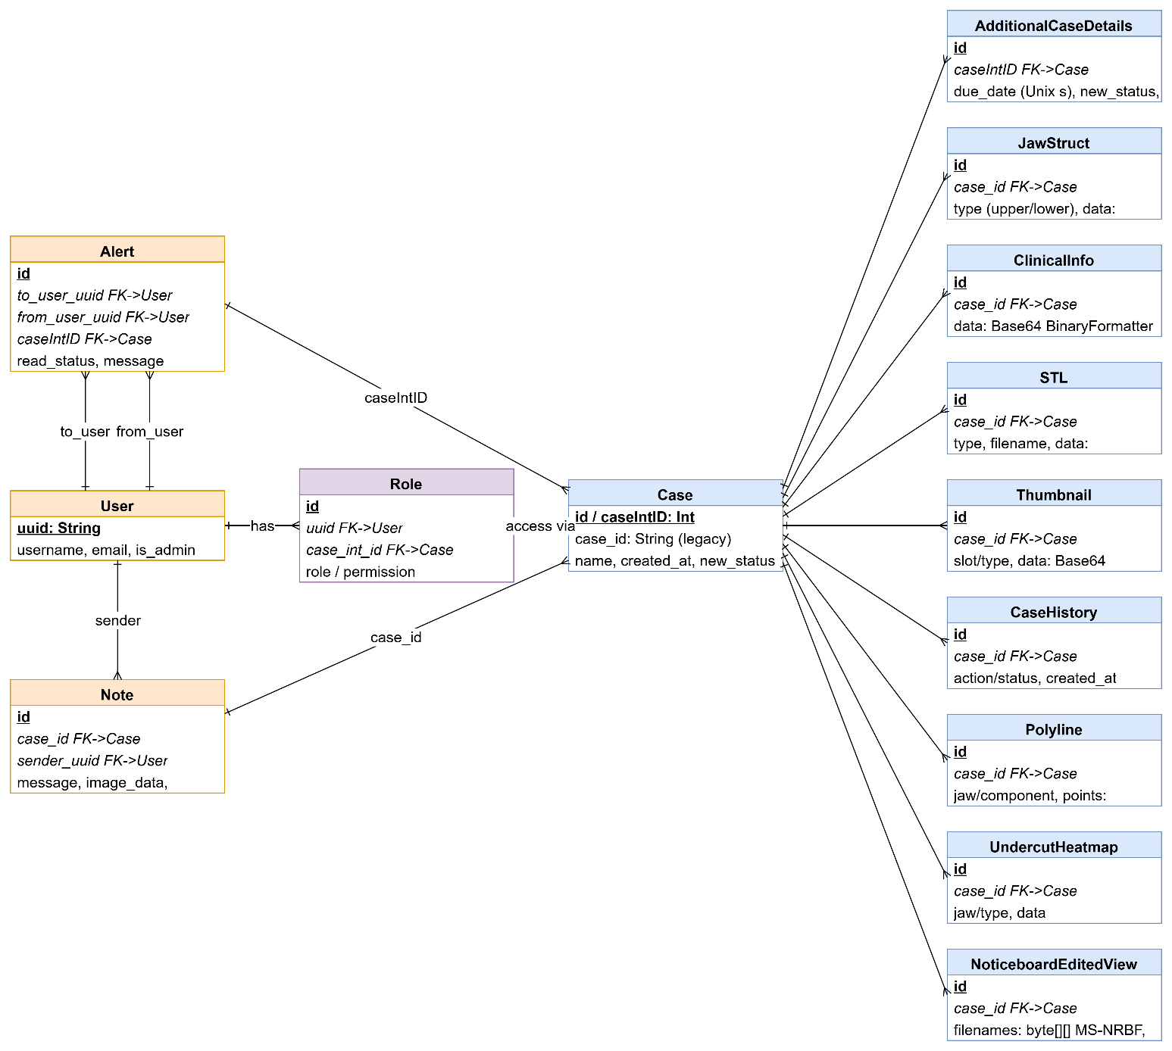

(last updated 24 August)

16. Handover Items
This section summarises the handover items, including frontend API usage; physical table names/indexes.

16.1 Items Completed in This Document
- Application overview, structure and page map
- Main user workflow documentation
- Implemented feature status with repository evidence
- 2D annotation module breakdown and persistence flow
- 3D viewer architecture and scene layer breakdown
- API endpoint reference and common request envelope
- ERD, Flowchart and Use Case Diagrams
- UAT – Test Case Definitions
- Data-schema entity

16.2 Items in other documents
- Maintenance & Operational Runbook
- DevOps/CI/CD Pipeline & Deployment Runbook
- Full commit history (.txt file)
- Data Dictionary (.txt file)
- Traceability Report
- UAT Report/Protocol
- Feedback and Triage Report

Appendix
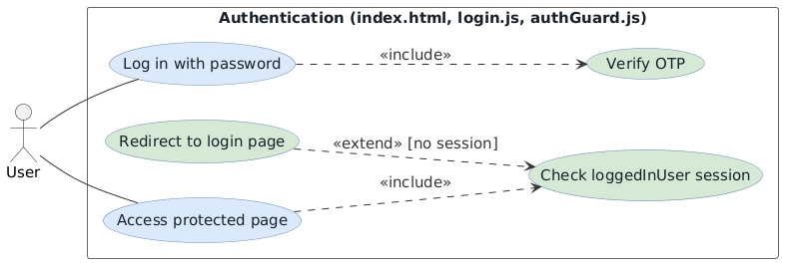
- Login & Authentication
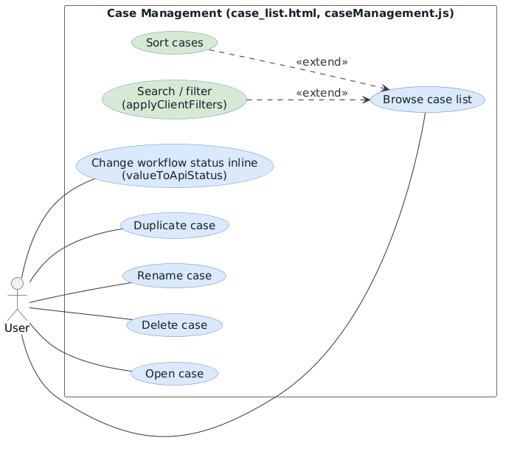
- Case List Management

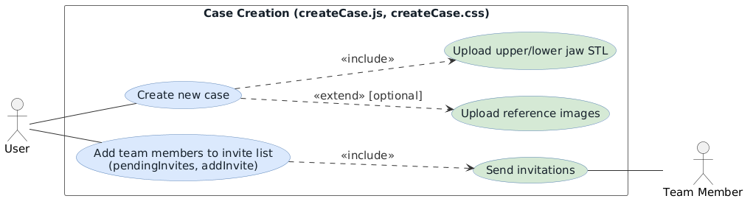
- Create Case
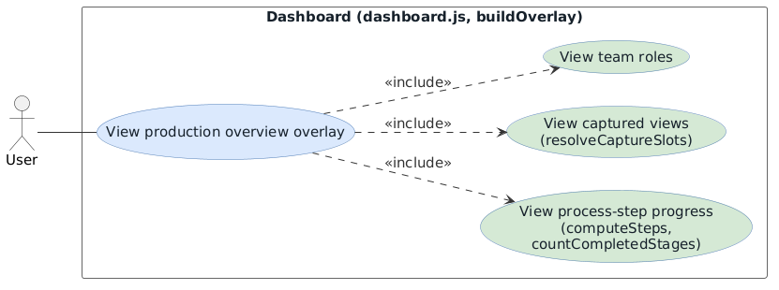
- Dashboard
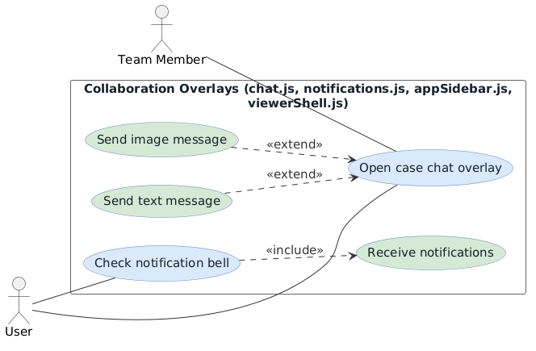
- Case Chat
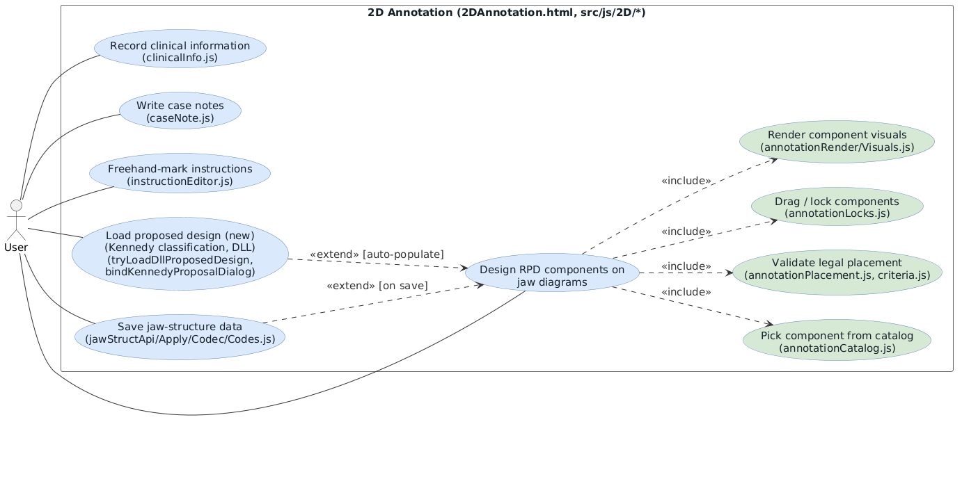
- 2D Annotation
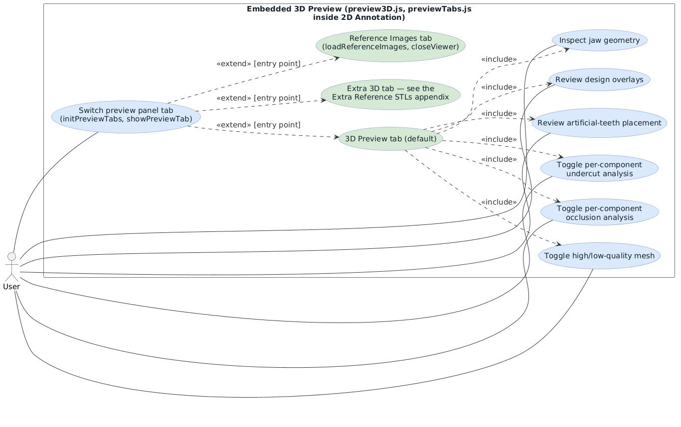
- Embedded 3D Preview
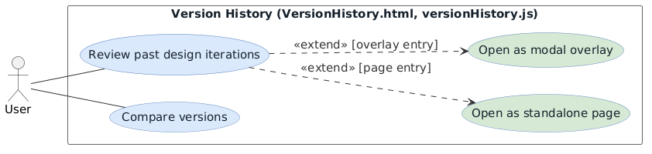

- Version History
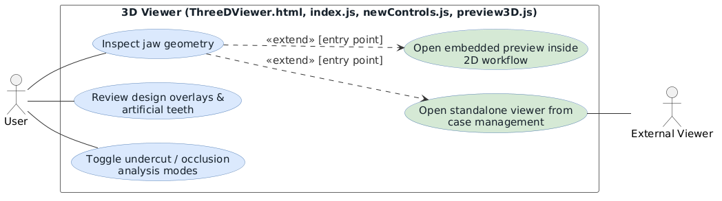
- 3D Viewer
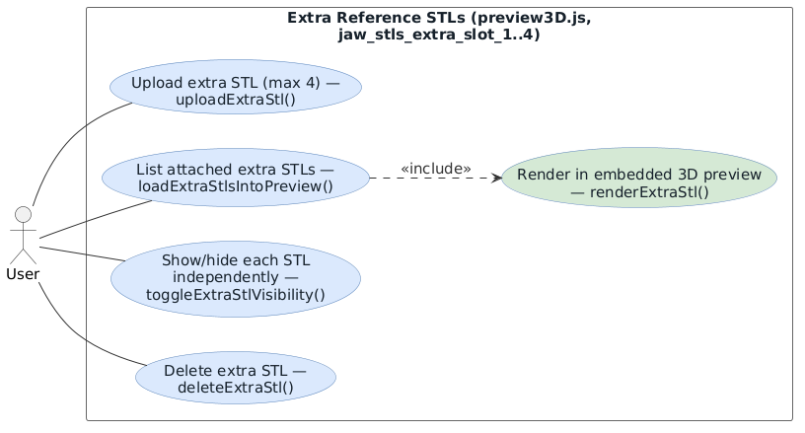
- Add STL Files
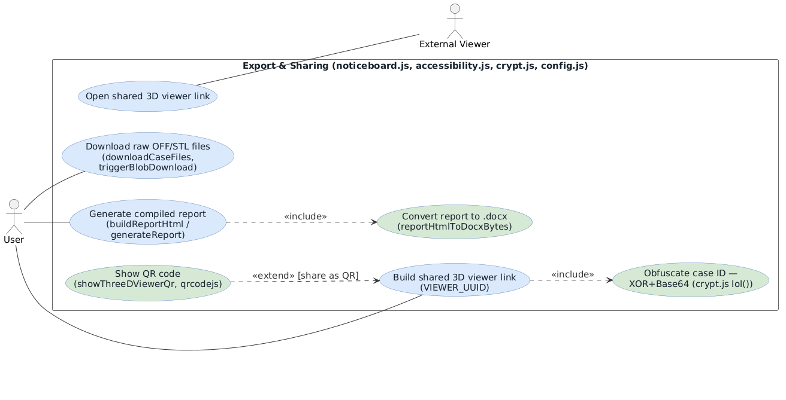
- Download/Export/Share

Handover Document
SmartRPD Web Application
Handover Document
What to read and check before touching or pushing code -- nyunt/dev-W7.1 (live branch)

1. Purpose
This document exists so a new developer, or the same developer returning after a gap, can get productive and avoid known traps without re-deriving everything from git history. It is a pointer document, not a replacement for the docs it points to -- read those, do not rely on the summaries here alone. Written 2026-08-24, after a multi-session pass that brought Documentations/ up to date and moved it to live directly on nyunt/dev-W7.1; see section 5 for what is still open.

2. Current State (as of 2026-08-24)
- Branch status. nyunt/dev-W7.1 (live branch, Documentations/ maintained here directly) -- 1 commit ahead of origin, uncommitted work in the working tree beyond that. Nothing pushed.
- dev-deploy-documentation (backup mirror of Documentations/) -- 2 commits ahead of origin, matches nyunt/dev-W7.1's Documentations/ tree exactly as of the last sync (verified by tree-hash comparison, not just a visual check).
- nyunt/dev-deploy (CI trigger branch) -- 2 commits ahead of origin, both small CI-config fixes (the deploy-review.mjs / deploy-review.yml rename). Its own Documentations/ folder was also brought current in this pass, but see section 5 for why that will not survive the next reset.
- 19 test suites / 582 tests, all passing. npm audit: 10 known vulnerabilities (3 moderate, 6 high, 1 critical), all transitive devDependencies, none reaching the production bundle. Both verified fresh against real re-runs, not carried forward from memory.
- Nothing has been pushed to origin at any point in this pass. Every commit mentioned in this document exists only in this local checkout until someone explicitly pushes it.

3. Read Before Touching Code
In order, if setting up fresh:
- Documentations/setup/README.md -- orientation, quick facts, reading order.
- Documentations/setup/01-local-development-setup.md -- prerequisites through first successful local run.
- Documentations/setup/02-branching-and-collaboration.md -- branch naming, which branch to fork from, how work ships.
- Documentations/setup/03-cicd-and-deployment-setup.md -- the deploy pipeline end to end, including the deploy-triggered doc refresh (new as of 2026-08-20).
- Documentations/setup/04-troubleshooting.md -- known gotchas, worth a skim even if nothing is broken yet.
- Documentations/setup/05-2d-annotation.md -- architecture deep-dive for the 2D Annotation workspace specifically (the largest, most complex feature area). Read this before touching src/js/2D/.
If you are touching a specific area rather than setting up fresh, jump straight to the relevant doc instead of reading all of the above in order.

4. Read Before Pushing Code
- CI gates. npm run lint and npm run test:ci both gate the deploy pipeline (fail-closed -- a failure stops the deploy, nothing ships). Run both locally before pushing to nyunt/dev-deploy.
- Branch model. nyunt/dev-deploy is not a dev branch -- nobody develops on it directly. It gets reset wholesale (not merged) to an integration branch's tip when that revision is ready to deploy. Anything committed directly to nyunt/dev-deploy that is not also on the integration branch it gets reset from will be silently discarded at the next reset. See Documentations/setup/02-branching-and-collaboration.md.
- Docs stay with the code. Documentations/ is now maintained on nyunt/dev-W7.1 directly (not dev-deploy-documentation, which is a backup mirror only). If you change something that affects documented behavior (pipeline steps, branch names, test counts), update the relevant doc in the same spirit as the code change -- see Documentations/DEPLOY_DOC_REVIEW.md for what is automated vs. what needs a manual/AI-assisted pass.
- Doc refresh on deploy. Every push to nyunt/dev-deploy also triggers an automatic Documentations/AutoTest Results/ refresh (real test counts, real npm audit) -- but only on dev-deploy-documentation, not nyunt/dev-W7.1 yet (see section 5, first item). It does not touch narrative .docx content.
- Known security posture. Documentations/Cybersecurity_Protocol_Document.docx has 13 open findings (F-1 through F-13), none yet remediated -- F-1 (shared plaintext credential shipped to the client) and F-3 (route guard is client-side) are P0/P1. Not something to fix incidentally, but know they are there before extending the authentication pattern.

5. Outstanding Work / Known Gaps
- 1. Deploy-triggered doc refresh still targets dev-deploy-documentation, not nyunt/dev-W7.1. Since Documentations/ moved to living primarily on nyunt/dev-W7.1 (2026-08-20), this part of the pipeline was never re-pointed. In practice: auto-refreshed AutoTest Results/ data lands on the backup branch first and has to be carried over by hand. Either re-point deploy.yml's DOCS_BRANCH, or accept the manual carry-over as the ongoing process -- undecided, flagged, not fixed.
- 2. nyunt/dev-deploy's Documentations/ folder will be wiped at the next reset. It was brought current as part of this pass, but nothing re-applies that automatically when the branch gets reset to an integration branch's tip. Whoever does that reset needs to remember to re-sync Documentations/, or accept the drift until the next doc pass catches it.
- 3. nyunt/integration_4 (and other integration branches) do not have the deploy-review.mjs rename or any of this session's doc work. If nyunt/dev-deploy gets reset to one of them before this is reconciled, the rename reverts along with everything else in section 2.
- 4. Application Workflow diagrams are DRAFT. The 2026-08-21 accuracy pass fixed four confirmed gaps (Load Proposed Design, the 3-tab preview restructure, signed-in Change Password, the Help Bot inconsistency) via a diff against current src/, not a fresh full extraction. Every flowchart-*.mmd.txt still carries a DRAFT header pending that fuller re-verification -- planned for the next working session.
- 5. Cybersecurity_Protocol_Document.docx, Feedback_Triage_Report.docx, and Traceability_Document.docx received data-accuracy fixes (npm audit numbers, new TSK-031/032 rows) but not a full narrative re-review. Judgment-heavy content (security findings, TSK triage, traceability rows for the roughly 90 files a stale diff baseline once flagged) was deliberately left for a dedicated pass rather than fabricated under time pressure.
- 6. This document and the Master Document (Documentations/MASTER_DOCUMENT.docx) are both new as of 2026-08-24 and have no prior version to compare against for drift -- the usual doc-review checklist does not cover them yet.

6. Roles (from Cybersecurity_Protocol_Document.docx section 11)
- Developer(s). Implement protocol items assigned to them; never reintroduce a plaintext credential or similar pattern.
- Test Coordinator / QA. Fold P0/P1 findings into whatever task-tracking this branch uses; confirm fixes against the actual code, not just the finding description.
- DevOps / Deployment Owner. Own the nginx security-header rollout and the SRI fix; keep the GitHub Actions deploy pipeline's strengths intact through any changes.
- Approving Authority. Reviews and signs off security-relevant documents before they are treated as governing.

7. Document Control
Document Type | Handover Document
Application | SmartRPD Web Application
Scope | nyunt/dev-W7.1 (live branch)
Last Updated | 24 August 2026
Prepared By | Shafik Hakim Bin Abdul Wahid (AI-assisted)
Related Documents | Documentations/setup/ (01-05), Documentations/DEPLOY_DOC_REVIEW.md, Documentations/MASTER_DOCUMENT.docx
Status | Living document -- update alongside significant handover-relevant changes, not on a fixed schedule

How to Setup
SmartRPD Web Application
How to Setup

1. What This App Is
SmartRPD Web is a static frontend (Three.js 3D viewer, 2D annotation, case management) built with Vite (dev) and Webpack (production bundle). It has no backend of its own — it talks to a live API at https://live.api.smartrpdai.com/api/smartrpd.
Repo Source | Link
Repo | https://github.com/faid123/.tmp-test-web
Live/UAT site | https://faid123.github.io/.tmp-test-web/
Local dev server | npm run dev → http://localhost:8089/index.html
Node version | 22 (matches CI)
Deploy trigger branch | nyunt/dev-deploy
Pages source branch | nyunt/dev-W7.1 (root)

2. Prerequisites
- Node.js 22.x and npm (bundled with Node) matches the version CI uses (.github/workflows/deploy.yml pins node-version: 22).
- Git.
- A GitHub account with access to faid123/.tmp-test-web.
- Recommended: GitHub CLI (gh), authenticated with gh auth login. Plain HTTPS+password won't work (GitHub requires a token); gh sets up a credential helper. Make sure the token includes the workflow scope if you'll ever touch .github/workflows/*.yml — gh auth login prompts for scopes, or add it later with gh auth refresh -s workflow.
- macOS, Linux, or Windows all work — this is a plain Node/npm project, nothing platform-specific.

3. First-Time Setup (New Machine)
Clone:
git clone https://github.com/faid123/.tmp-test-web.git
cd .tmp-test-web
Install dependencies:
npm install
If npm run build later fails with a permission error on the webpack binary, see §7.
Run the dev server:
npm run dev
OR (preferred):
npm run build
npx vite --port 8089
This starts Vite on port 8089. Open http://localhost:8089/index.html — that's the login page.
This app has no local backend. Every screen talks to the live API at https://live.api.smartrpdai.com/api/smartrpd, so you need working network access to that host and a valid SmartRPD login. Dev/test identifiers (machine ID, viewer UUID, a login credential) are already centralized in src/js/shared/config.js — that file is flagged in its own comments as a known security item (credentials shipped to the browser bundle are readable in DevTools, not actually secret; see Cybersecurity_Protocol_Document.docx §4.1), so don't extend that pattern and don't copy those values into other files or docs.
If you just want to exercise the API directly without the UI, there's a Postman collection + environment in postman/ (smartrpd.postman_collection.json, smartrpd-env.postman_environment.json).

4. Run Tests
npm test # Jest, local/watch-friendly
npm run test:ci # Jest --ci --coverage -- what CI actually runs before it will deploy
Current state: 19 suites / 582 tests, all passing, every suite importing the real src/ module it tests. Run node tools/deploy-review.mjs for a suite-by-suite breakdown mapped against the app's standing UAT workflow cases -- output goes to Documentations/AutoTest Results/. Full detail in Automated_Test_Suite_Report.docx.

5. Production Build
npm run build
This runs Webpack and produces dist/bundle.js — the single artifact that actually ships to the live site (§6). A few things worth knowing:
- dist/bundle.js is tracked in git (a legacy habit from before CI existed). Running a local build will typically show it as modified in git status — that's expected, and you don't need to commit it yourself; the deploy pipeline rebuilds and publishes its own copy on every deploy.
- webpack.config.js loads a local .env file (via dotenv) and injects the entire process.env into the bundle via DefinePlugin. There's no .env file in this repo today — keep it that way, or scope it carefully. If you ever add one for local convenience, anything in it becomes visible in the shipped, public bundle the next time someone builds and deploys (Cybersecurity_Protocol_Document.docx §5.1).
Optional: preview the production build locally:
npm run build
npm start # npx serve, serves the repo root including dist/bundle.js

6. How Deployment Actually Works
CI/CD is GitHub Actions only — .github/workflows/deploy.yml. A Jenkinsfile still exists in the repo (moved to legacy/Jenkinsfile) but is retired history, not live — local Jenkins was uninstalled 2026-07-17. Don't reference Jenkins commands or an EC2/nginx production split as current state.
GitHub Pages is the UAT/test site. https://faid123.github.io/.tmp-test-web/ is not a staging step in front of something else — it's the thing itself.
The pipeline, step by step (trigger: push to nyunt/dev-deploy, or manual workflow_dispatch):
- Checkout the pushed commit.
- Set up Node 22.
- npm ci (deterministic install from package-lock.json).
- npm run test:ci — fail-closed gate. If tests fail, the job stops here; nothing deploys.
- npm run build, then verify dist/bundle.js exists.
- Build manifest.json: revision SHA, run number, a sha256 digest over every tracked file plus the freshly built dist/bundle.js, timestamp, site URL.
- Check out the Pages branch (nyunt/dev-W7.1) into a separate path.
- Wipe that branch's contents (except .git), replace with a git archive of the verified commit, drop in the freshly built dist/bundle.js and manifest.json, touch .nojekyll.
- Commit and push to nyunt/dev-W7.1. History is preserved, so any previous deploy is one commit back if you need to roll back.
- Explicitly POST /repos/{repo}/pages/builds — pushes made with the built-in GITHUB_TOKEN don't auto-trigger GitHub's legacy Pages build, so this call is required, not optional.
To trigger a deploy: push (or fast-forward) your integration branch's tip onto nyunt/dev-deploy or go to Actions → “Deploy Test Site” → Run workflow. Full pipeline detail, including how to point it at different branches or set it up from scratch on a new repo, is in Documentations/setup/03-cicd-and-deployment-setup.md.

7. Branching and Picking Up Work
Picking up an existing branch:
git fetch origin
git checkout <branch-name>
npm install # dependencies may have changed since you last had this branch
npm run dev
Starting a new branch (ask the team which integration branch is current if unsure):
git fetch origin
git checkout -b nyunt/dev-W<next-number> origin/nyunt/integration_4
git push -u origin nyunt/dev-W<next-number>
How work eventually ships: feature branch → merged into an integration branch → integration branch's tip is pushed onto nyunt/dev-deploy → that push triggers the deploy pipeline (§6).

8. Troubleshooting
- npm run build fails with a permission error on webpack — chmod +x node_modules/.bin/webpack, then retry. Seen on some hosts after npm install; current GitHub Actions runners haven't needed this, but it's a known one from earlier Jenkins-based deploys.
- Push to .github/workflows/*.yml gets rejected — your git credential lacks the workflow OAuth scope (a plain repo scope isn't enough). If using gh: gh auth refresh -s workflow, then retry the push.
- The Action runs green but the live site doesn't show the change — the workflow's last step explicitly requests a Pages rebuild (POST /repos/{repo}/pages/builds) because pushes made with GITHUB_TOKEN don't auto-trigger GitHub's legacy Pages build; check that step's log. If it succeeded, confirm in Settings → Pages that the source branch is still nyunt/dev-W7.1 / / (admin-only visibility).
- Local dev server loads, but nothing works (login fails, case list empty, etc.) — this app has no local backend. Confirm you have network access to live.api.smartrpdai.com and a valid SmartRPD login. Expected behaviour, not a broken local setup.
- You added a .env file for convenience and now secrets show up in dist/bundle.js — webpack.config.js injects the entire process.env into the bundle. There's currently no .env in this repo — keep it that way, or be deliberate about what you put in one.
- A script you wrote to loop over repo files skips files with spaces in their names — some asset directories legitimately contain spaces (e.g. “instruction editor/”, “Plalatal Plate/”). Use null-delimited iteration (find -print0, git ls-files -z, xargs -0), not newline-splitting.
- You can't change GitHub Pages settings, add a webhook, or edit Actions permissions — push access to this repo doesn't include admin access; ask someone with admin on faid123/.tmp-test-web.
- You're not sure which branch has “the real” current code — main is stale/diverged (§7). Check the latest nyunt/integration_N or the branch you were pointed to.

9. Where to Go Next
Topic | Document
Codebase architecture and feature deep-dives | Documentations/onboarding/ (starts with 2d-annotation.md)
Full technical reference (workflows, API, data schema) | SmartRPD_Documentation.docx
Security posture and known findings | Cybersecurity_Protocol_Document.docx
Test suite detail and UAT-workflow mapping | Automated_Test_Suite_Report.docx, Documentations/AutoTest Results/
Known issues and feature backlog | Feedback_Triage_Report.docx
Day-to-day operational checks and incident triage | Maintenance and Operational Runbook.docx
How AutoTest Results / audit data stay current | Documentations/DEPLOY_DOC_REVIEW.md

10. Document Control
Field | Value
Document Type | How to Setup
Application | SmartRPD Web Application
Environment | dev-deploy-documentation (branch this doc is maintained on)
Last Updated | 24 August 2026
Source of Truth | Documentations/setup/*.md — edit those, then regenerate this docx
Supersedes | Documentations/backup/How to setup.docx, Documentations/backup/Github Pages setup information.docx (both describe a retired repo)

DevOps and Deployment
SmartRPD Web Application
DevOps and Deployment
CI/CD pipeline, environments and local development — nyunt/dev-W7.1 (live branch)

1. What Actually Runs Today
CI/CD is GitHub Actions only. .github/workflows/deploy.yml is the sole live pipeline. A Jenkinsfile still exists in the repository (moved to legacy/Jenkinsfile) but is retired history: local Jenkins was uninstalled 2026-07-17 (commit d910c78, “ci: Replace local Jenkins with GitHub Actions deploy workflow”), and the nginx/EC2 production split it implied was never actually built. Do not reference Jenkins commands or an EC2/nginx production split as current state.
GitHub Pages is the UAT/test site. https://faid123.github.io/.tmp-test-web/ is not a staging step in front of something else -- it's the thing itself.

2. CI/CD Pipeline (.github/workflows/deploy.yml)
Trigger: push to nyunt/dev-deploy, or manual workflow_dispatch.
- Checkout the pushed commit.
- Set up Node 22.
- npm ci (deterministic install from package-lock.json).
- npm run test:ci — fail-closed gate. If tests fail, the job stops here; nothing deploys.
- Archive coverage/ as a build artifact (always, even on failure).
- npm run build, then verify dist/bundle.js exists.
- Build manifest.json: revision SHA, run number, a sha256 digest over every tracked file plus the freshly built dist/bundle.js, timestamp, site URL. The digest step null-delimits filenames (several asset directories have spaces, e.g. “instruction editor/”).
- Check out the Pages branch (nyunt/dev-W7.1) into a separate path.
- Wipe that branch's contents (except .git), replace with a git archive of the verified commit, drop in the freshly built dist/bundle.js and manifest.json, touch .nojekyll.
- Commit and push to nyunt/dev-W7.1. History is preserved, so any previous deploy is one commit back for rollback.
- Explicitly POST /repos/{repo}/pages/builds — pushes made with the built-in GITHUB_TOKEN don't auto-trigger GitHub's legacy Pages build, so this call is required, not optional.
Auth is the built-in GITHUB_TOKEN (permissions: contents: write, pages: write) -- no personal access token needed. A concurrency group serializes runs so two deploys can't race.
GitHub Pages' source branch/path is set in repo Settings → Pages (nyunt/dev-W7.1, root /) -- not visible in this repo's files, only in GitHub's UI, and only an admin can change it.

2.1 Documentation Refresh on Deploy — What Runs, What's Trusted, What's Vetted
Steps 1–11 above build and ship the application. Immediately after step 11, the same deploy.yml job also refreshes the documentation branch. This runs on every successful deploy so it's checking alignment at the moment code actually goes live.
- Check out the documentation branch (dev-deploy-documentation, set via DOCS_BRANCH) into a separate path, with full git history (fetch-depth: 0) — the alignment check in the next step needs more than the default shallow checkout.
- Run npm ci, then node tools/deploy-review.mjs inside that checkout. The script: confirms the commit deployed to nyunt/dev-W7.1 (the live branch) is still an ancestor of the docs branch's own HEAD; re-runs the real Jest suite; re-runs npm audit; diffs against the last recorded state to list what changed; and writes a dated report plus an always-current status file.
- Commit and push only Documentations/AutoTest Results/ back to dev-deploy-documentation, and only if something actually changed. Nothing else in the repository is touched by this step.
This means every deploy produces two different kinds of documentation change, and only one of them is safe to trust without a human/AI pass:
Updated automatically — safe to trust as-is:
- Documentations/AutoTest Results/automated-test-run.json and -log.txt — real Jest output, regenerated from an actual run every deploy.
- Documentations/AutoTest Results/npm-audit-run.json and .txt — real npm audit output. This can change between deploys with zero code changes, since the advisory database updates on its own — that's expected, not a bug.
- Documentations/AutoTest Results/weekly-review-<date>.md and DOCS_TO_UPDATE.md — the live-branch alignment result, the test/audit delta since the last run, and a heuristic list of which .docx documents likely need a manual update given what changed (DOC_FLAG_RULES in the script).
- .weekly-review-state.json — the diff baseline for next run. Commit it; deleting it just means the next run has nothing to diff against.
NOT touched automatically — needs a human/AI-assisted vetting pass before it's treated as current:
- Every narrative .docx in Documentations/ — Automated_Test_Suite_Report.docx, UAT_Report.docx, SmartRPD_Documentation.docx, Cybersecurity_Protocol_Document.docx, Feedback_Triage_Report.docx, Traceability_Document.docx, and the rest. The deploy step never opens or edits a .docx file. Their summary tables, environment lines, TSK rows and security findings can go stale for weeks while the JSON/txt files sitting right next to them stay perfectly current — this is exactly what had happened before the 2026-08-20 pass (docs still reading “13 suites / 221 tests” against a 3-week-old commit, four commits after the live branch had moved to 19 suites / 582 tests).
- Every item in DOCS_TO_UPDATE.md's flagged-docs checklist — it's a heuristic file→doc mapping, not a judgment call. Confirm each flagged item actually needs a change before editing; a stale diff baseline can flag far more files than actually changed since the doc was last genuinely vetted.
- New TSK triage rows, security findings, and traceability rows for whatever commits landed since the last vetted pass — explicitly out of scope for the script (see Documentations/DEPLOY_DOC_REVIEW.md, “What this does NOT do”). Scope this to the commits actually landed since the last human/AI review, not the full flagged-file list, which can span much further back once a docs branch has sat stale for a while.
- A live-branch alignment result of diverged or could-not-check — treat that as the signal to find the branch that actually contains what's deployed before trusting anything else in that run's report, per DEPLOY_DOC_REVIEW.md.
Where this runs from: Documentations/ is maintained directly on nyunt/dev-W7.1 (this branch) as of 2026-08-20, with dev-deploy-documentation kept as a mirrored backup rather than the primary copy — pushed by hand alongside nyunt/dev-W7.1, not by this pipeline step. See Documentations/DEPLOY_DOC_REVIEW.md for the full process and Documentations/AutoTest Results/DOCS_TO_UPDATE.md for the current flagged-docs checklist.

3. Environment Variables
No .env file exists in this repo today, and none is required for the checked-in frontend to build -- API base URLs and fallback identifiers are hard-coded in source files (src/js/shared/config.js). webpack.config.js loads .env via dotenv and injects the entire process.env into the bundle via DefinePlugin -- if a .env is ever added for local convenience, everything in it becomes visible in the shipped public bundle on the next build. See Cybersecurity_Protocol_Document.docx §5.1.

4. Local Development
npm install # install dependencies
npm run dev # start Vite dev server on port 8089
# open http://localhost:8089/index.html
npm test # run Jest suite (local/watch-friendly)
npm run test:ci # Jest --ci --coverage -- the CI-appropriate invocation, what deploy.yml runs
npm run build # produce dist/bundle.js via Webpack
Current automated suite: 19 test suites / 582 tests, all passing, every suite importing the real src/ module it tests -- see Automated_Test_Suite_Report.docx for the full breakdown.

5. Source Tree Layout (post-restructuring)
Commit f9c9463 (“refactor: Reorganize project structure and consolidate module locations”, 2026-07-19) moved the source tree from a flat src/*.js + src/js/*.js layout to:
Path | Contents
src/viewer3d/ | 3D viewer runtime -- ApiClient.js, artificialTeeth.js, OFFLoader.js, STLMeshLoader.js, newControls.js, resetButton.js, index.js (webpack entry point).
src/js/pages/ | Per-page controllers -- caseManagement.js, dashboard.js, createCase.js, login.js, notifications.js, versionHistory.js, viewerShell.js.
src/js/shared/ | Cross-page modules -- config.js, crypt.js, apiLog.js, appSidebar.js, chat.js, toast.js, accessibility.js, caseEnrichment.js, helpBot.js, helpMatcher.js, helpTopics.js, passwordReset.js, changePassword.js.
src/js/admin/ | New: admin-only pages -- adminUsers.js, adminMachineId.js.
src/js/2D/ | Unchanged -- the 2D annotation workspace (2DAnnotation.js and its component/jaw-struct modules).

Any documentation, script, or comment referencing the old flat paths (src/config.js, src/ApiClient.js, src/js/caseManagement.js, etc.) is describing a pre-restructuring layout and should be read as historical.

6. Appendix — tools/deploy-review.mjs (full source)
Reproduced in full below rather than kept as a same-named duplicate file under Documentations/ (that reference copy, which risked drifting from the real script, was removed 2026-08-21). This is the actual script CI runs from tools/deploy-review.mjs; if it changes, this appendix goes stale until someone re-pastes it here — there is no automatic sync.
#!/usr/bin/env node
// Deploy-triggered documentation review — see Documentations/DEPLOY_DOC_REVIEW.md for the full
// process. (Renamed 2026-08-21 from weekly-doc-review.mjs -- the refresh runs on every deploy,
// not a calendar schedule, so the old name was misleading.)
//
// What this script does:
// 1. Verifies this branch's HEAD still contains the commit actually deployed to
// nyunt/dev-W7.1 (the live branch) — if it doesn't, the docs would be reviewed
// against the wrong code, so it says so loudly instead of failing silently.
// 2. Runs the real Jest suite and rebuilds the UAT-mapped rollup
// (Documentations/AutoTest Results/automated-test-run.json + -log.txt).
// 3. Runs `npm audit` and stores the raw result
// (Documentations/AutoTest Results/npm-audit-run.json + .txt).
// 4. Diffs against the last recorded review (.deploy-review-state.json) to list what
// commits landed since then, and heuristically flags which narrative .docx files
// likely need a manual/AI-assisted update as a result.
// 5. Writes a dated report (Documentations/AutoTest Results/weekly-review-<date>.md)
// and updates the state file.
//
// What this script deliberately does NOT do: it does not edit the narrative .docx
// documents itself. Editing prose that requires judgment (security findings, TSK
// triage, UAT case text) is a human/AI-assisted step guided by the report this script
// produces — see the "How to act on a report" section in DEPLOY_DOC_REVIEW.md.
import { execSync, spawnSync } from "node:child_process";
import { appendFileSync, existsSync, mkdirSync, readFileSync, writeFileSync } from "node:fs";
import path from "node:path";
import { fileURLToPath } from "node:url";
const ROOT = path.resolve(path.dirname(fileURLToPath(import.meta.url)), "..");
const AUTOTEST_DIR = path.join(ROOT, "Documentations", "AutoTest Results");
const STATE_PATH = path.join(AUTOTEST_DIR, ".deploy-review-state.json");
const LIVE_BRANCH = process.env.LIVE_BRANCH || "nyunt/dev-W7.1";
const PAGES_TRIGGER_BRANCH = process.env.TRIGGER_BRANCH || "nyunt/dev-deploy";
function run(cmd, opts = {}) {
return execSync(cmd, { cwd: ROOT, encoding: "utf8", maxBuffer: 64 * 1024 * 1024, ...opts });
}
function tryRun(cmd, opts = {}) {
try {
return run(cmd, opts);
} catch (err) {
return err.stdout ? String(err.stdout) : "";
}
}
function todayIso() {
return new Date().toISOString().slice(0, 10);
}
// -- Step 1: verify this branch still matches what's actually live -----------------
function checkLiveBranchAlignment() {
console.log(`\n== Checking alignment with ${LIVE_BRANCH} (the live branch) ==`);
let fetchOk = true;
try {
run(`git fetch origin ${LIVE_BRANCH} ${PAGES_TRIGGER_BRANCH}`, { stdio: "pipe" });
} catch {
fetchOk = false;
console.log(` (could not fetch origin/${LIVE_BRANCH} — running offline / no remote access; skipping alignment check)`);
}
if (!fetchOk) return { checked: false, aligned: null, liveSha: null, deployPending: null };
const lastPagesCommitMsg = tryRun(`git log -1 --format=%s origin/${LIVE_BRANCH}`).trim();
const match = lastPagesCommitMsg.match(/Deploy ([0-9a-f]{40})/);
if (!match) {
console.log(` Could not parse a deployed SHA out of origin/${LIVE_BRANCH}'s last commit message`);
console.log(` ("${lastPagesCommitMsg}") — skipping alignment check.`);
return { checked: false, aligned: null, liveSha: null, deployPending: null };
}
const liveSha = match[1];
let aligned = false;
try {
run(`git merge-base --is-ancestor ${liveSha} HEAD`);
aligned = true;
} catch {
aligned = false;
}
if (aligned) {
console.log(` OK: the deployed commit (${liveSha.slice(0, 7)}) is an ancestor of this branch's HEAD.`);
console.log(` This branch is still authoritative for what's live on ${LIVE_BRANCH}.`);
} else {
console.log(` ⚠️ WARNING: the deployed commit (${liveSha.slice(0, 7)}) is NOT an ancestor of this`);
console.log(` branch's HEAD. ${LIVE_BRANCH} is currently being fed by a different line of`);
console.log(` development than this branch. Everything below reflects THIS branch's code,`);
console.log(` which is not (or no longer) what's live -- this is exactly the situation that`);
console.log(` required the 2026-07-31 documentation re-audit (see git log). Before trusting`);
console.log(` this run, find which branch actually contains ${liveSha.slice(0, 7)} and either`);
console.log(` review from there, or treat this as a signal to re-target the docs again.`);
}
// Second, independent signal from the branch that actually triggers a deploy
// (fetched above alongside LIVE_BRANCH): is nyunt/dev-deploy itself ahead of what's
// currently live? A "yes" here doesn't mean docs are wrong -- it means a deploy is
// overdue, which is exactly the kind of drift-in-progress worth surfacing early
// rather than discovering only after the next `Deploy <sha>` commit lands.
let deployPending = null;
const deployBranchSha = tryRun(`git rev-parse origin/${PAGES_TRIGGER_BRANCH}`).trim();
if (deployBranchSha && /^[0-9a-f]{40}$/.test(deployBranchSha)) {
if (deployBranchSha === liveSha) {
deployPending = false;
console.log(` OK: ${PAGES_TRIGGER_BRANCH} (${deployBranchSha.slice(0, 7)}) matches what's live -- no deploy pending.`);
} else {
try {
run(`git merge-base --is-ancestor ${liveSha} ${deployBranchSha}`);
deployPending = true;
console.log(` ℹ️ ${PAGES_TRIGGER_BRANCH} (${deployBranchSha.slice(0, 7)}) has commits beyond the deployed`);
console.log(` SHA -- a deploy is pending/overdue, separate from this branch's own alignment.`);
} catch {
deployPending = null;
console.log(` Could not relate ${PAGES_TRIGGER_BRANCH}'s tip to the deployed SHA (unusual --`);
console.log(` possibly a force-push/rebase on ${PAGES_TRIGGER_BRANCH}). Skipping this signal.`);
}
}
} else {
console.log(` Could not resolve origin/${PAGES_TRIGGER_BRANCH} -- skipping the deploy-pending signal.`);
}
return { checked: true, aligned, liveSha, deployPending };
}
// -- Step 2: run Jest and rebuild the UAT-mapped rollup -----------------------------
// Suite -> UAT workflow mapping. Extend this when a new __tests__/*.test.mjs file is
// added; the script has no way to infer which UAT case a suite belongs to on its own.
const SUITE_META = {
"mergeInstructions.test.mjs": { uat: ["UAT-06"], crossCutting: false, note: "Imports real src/js/2D/mergeInstructions.js." },
"crypt.test.mjs": { uat: [], crossCutting: true, note: "Imports real src/js/shared/crypt.js. Case-ID URL obfuscation used across case list, chat, viewer, version history, annotation and create-case links -- cross-cutting, not tied to one workflow." },
"caseEnrichment.test.mjs": { uat: ["UAT-02"], crossCutting: false, note: "Imports real src/js/shared/caseEnrichment.js. Case-detail and co-owner request/fold layer behind the case list." },
"importResolution.test.mjs": { uat: [], crossCutting: true, note: "Walks src/, __tests__/ and the HTML pages checking every relative import/script-src resolves. Repo-wide build-integrity check, not tied to one workflow." },
"passwordReset.test.mjs": { uat: ["UAT-01"], crossCutting: false, note: "Imports real src/js/shared/passwordReset.js. Change-password/reset-password feature -- an extension of the Login & Authentication workflow." },
"reciprocatingExclusivity.test.mjs": { uat: ["UAT-06"], crossCutting: false, note: "Imports real src/js/2D/criteria.js, components.js and annotationTeethModel.js." },
"helpBot.test.mjs": { uat: [], crossCutting: false, note: "Imports real src/js/shared/helpMatcher.js and helpTopics.js (AI-powered help assistant). No standing UAT-xx case yet -- see Traceability_Document.docx." },
"artificialTeethDecode.test.mjs": { uat: ["UAT-07", "UAT-08"], crossCutting: false, note: "Imports real src/viewer3d/artificialTeeth.js MessagePack/coordinate decode layer used by both the embedded 3D preview and the standalone 3D viewer." },
"dashboard.test.mjs": { uat: ["UAT-04"], crossCutting: false, note: "Imports real dashboard.js pipeline functions." },
"clinicalInfoCodec.test.mjs": { uat: ["UAT-06"], crossCutting: false, note: "Imports real src/js/2D/clinicalInfo.js (.NET-compatible clinical-info envelope codec)." },
"jawStructRoundTrip.test.mjs": { uat: ["UAT-06"], crossCutting: false, note: "Imports real src/js/2D/jawStructApply.js against fixture desktop files." },
"jawStructLingualPlate.test.mjs": { uat: ["UAT-06"], crossCutting: false, note: "Imports real src/js/2D/jawStructApply.js against fixture desktop files." },
"jawStructMajorSwitch.test.mjs": { uat: ["UAT-06"], crossCutting: false, note: "Imports real src/js/2D/jawStructApply.js." },
};
const UAT_WORKFLOWS = [
["UAT-01", "Login & Authentication"],
["UAT-02", "Case List"],
["UAT-03", "Case Creation"],
["UAT-04", "Dashboard"],
["UAT-05", "Collaboration (Chat/Notifications)"],
["UAT-06", "2D Annotation"],
["UAT-07", "Embedded 3D Preview"],
["UAT-08", "3D Viewer"],
["UAT-09", "Add STL Files"],
["UAT-10", "Version History"],
["UAT-11", "Download / Export / Share"],
["UAT-12", "Responsive (Tablet + Mobile)"],
];
function runTestsWithLog() {
console.log("\n== Running Jest (this branch's actual test:ci command) ==");
// Jest's human-readable --verbose reporter goes to stderr; --json goes to stdout.
// spawnSync (rather than execSync) lets us capture both streams from one invocation
// regardless of whether Jest exits non-zero (a failing suite must still be reported).
const args = [
"jest", "--ci", "--coverage", "--coverageReporters=json-summary",
"--verbose", "--testLocationInResults", "--json",
];
// shell: true is required on Windows -- spawnSync can't exec npx.cmd directly
// (EINVAL), and it's harmless on POSIX where npx is a plain executable.
const result = spawnSync("npx", args, {
cwd: ROOT,
encoding: "utf8",
maxBuffer: 64 * 1024 * 1024,
shell: true,
});
const stdout = result.stdout || "";
const stderr = result.stderr || "";
let parsed;
try {
parsed = JSON.parse(stdout);
} catch {
console.error("Could not parse Jest JSON output -- aborting.");
console.error(stdout.slice(0, 2000));
console.error(stderr.slice(0, 2000));
process.exit(1);
}
return { parsed, log: stderr };
}
function buildRollup(parsed) {
const suites = parsed.testResults.map((tr) => {
const file = path.basename(tr.name);
const meta = SUITE_META[file] || { uat: [], crossCutting: false, note: "(no metadata registered for this suite in tools/deploy-review.mjs -- add an entry to SUITE_META)" };
const tests = tr.assertionResults.length;
const pass = tr.assertionResults.filter((a) => a.status === "passed").length;
const fail = tr.assertionResults.filter((a) => a.status === "failed").length;
const skip = tests - pass - fail;
return {
file,
status: tr.status,
tests,
pass,
fail,
skip,
durationMs: (tr.endTime || 0) - (tr.startTime || 0),
uat: meta.uat,
category: "real",
crossCutting: meta.crossCutting,
note: meta.note,
failureMessages: tr.assertionResults.filter((a) => a.status === "failed").flatMap((a) => a.failureMessages || []),
};
});
const uatRollup = UAT_WORKFLOWS.map(([id, name]) => {
const matching = suites.filter((s) => s.uat.includes(id));
const tests = matching.reduce((n, s) => n + s.tests, 0);
const pass = matching.reduce((n, s) => n + s.pass, 0);
const fail = matching.reduce((n, s) => n + s.fail, 0);
return {
id,
name,
suites: matching.map((s) => s.file),
tests,
pass,
fail,
automationConfidence: matching.length ? "Real source coverage" : "No automated coverage",
};
});
const uatWorkflowsWithNoAutomatedCoverage = uatRollup
.filter((u) => u.suites.length === 0)
.map((u) => `${u.id} ${u.name}`);
const suitesForFeaturesWithNoStandingUatCase = suites
.filter((s) => s.uat.length === 0 && !s.crossCutting)
.map((s) => ({ file: s.file, note: s.note }));
let coverageTotal = null;
const covPath = path.join(ROOT, "coverage", "coverage-summary.json");
if (existsSync(covPath)) {
const cov = JSON.parse(readFileSync(covPath, "utf8"));
coverageTotal = cov.total;
}
return {
runAt: new Date().toISOString(),
command: "npx jest --ci --coverage --coverageReporters=json-summary --verbose --testLocationInResults --json",
commandFailed: parsed.success === false,
numTotalTestSuites: parsed.numTotalTestSuites,
numPassedTestSuites: parsed.numPassedTestSuites,
numFailedTestSuites: parsed.numFailedTestSuites,
numTotalTests: parsed.numTotalTests,
numPassedTests: parsed.numPassedTests,
numFailedTests: parsed.numFailedTests,
suites,
uatRollup,
uatWorkflowsWithNoAutomatedCoverage,
suitesForFeaturesWithNoStandingUatCase,
coverageTotal,
};
}
// -- Step 3: npm audit ---------------------------------------------------------------
function runAudit() {
console.log("\n== Running npm audit ==");
const json = tryRun("npm audit --json");
const text = tryRun("npm audit");
let parsed = {};
try {
parsed = JSON.parse(json);
} catch {
parsed = { metadata: { vulnerabilities: {} } };
}
return { json, text, totals: parsed.metadata ? parsed.metadata.vulnerabilities : {} };
}
// -- Step 4/5: diff against last review, write report, update state -----------------
function loadState() {
if (!existsSync(STATE_PATH)) return null;
try {
return JSON.parse(readFileSync(STATE_PATH, "utf8"));
} catch {
return null;
}
}
// Exact filenames (not prefixes) that touch an auth/credential/dependency/CDN-script
// surface. Deliberately literal rather than a fuzzy prefix regex: a prefix like
// "src/js/shared/config" would also match a hypothetical config-adjacent file
// (e.g. configValidator.js) that has nothing to do with this doc's audit surface.
const AUTH_SURFACE_FILES = new Set([
"src/js/shared/config.js",
"src/viewer3d/ApiClient.js",
"src/js/pages/login.js",
"src/js/shared/passwordReset.js",
"webpack.config.js",
"nginx.conf",
"package-lock.json",
"src/pages/case_list.html",
"src/js/shared/crypt.js",
]);
const DOC_FLAG_RULES = [
{
test: (f) => AUTH_SURFACE_FILES.has(f) || f.startsWith("src/js/admin/"),
docs: ["Cybersecurity_Protocol_Document.docx"],
why: "touches an authentication, credential, dependency, or CDN-script surface this document audits",
},
{
test: (f) => f.startsWith("__tests__/") || f === "package.json",
docs: ["Automated_Test_Suite_Report.docx", "UAT_Report.docx (§2)", "SmartRPD_Documentation.docx (§4, §11)"],
why: "changes the test suite this document reports counts/breakdown for",
},
{
test: (f) => f === ".github/workflows/deploy.yml",
docs: ["DevOps and Deployment.docx", "UAT_Protocol_SOP.docx", "Maintenance and Operational Runbook.docx"],
why: "changes the deploy pipeline these documents describe step-by-step",
},
{
// How to Setup.docx states its own policy: "consolidated from Documentations/
// setup/*.md -- edit those files, then regenerate this docx". It also mirrors
// deploy.yml's pipeline steps in its own §6, so a deploy.yml change needs the
// same check even though nothing under Documentations/setup/ moved.
test: (f) => f.startsWith("Documentations/setup/") || f === ".github/workflows/deploy.yml",
docs: ["How to Setup.docx"],
why: "How to Setup.docx is regenerated from Documentations/setup/*.md and mirrors deploy.yml's pipeline steps -- keep it in sync with whichever changed",
},
{
// Self-referential on purpose: DEPLOY_DOC_REVIEW.md describes this script's
// schedule, its DOC_FLAG_RULES/SUITE_META mapping, and (since the deploy.yml
// change) the deploy-triggered path -- so changes to any of those three should
// prompt someone to re-read whether that description is still accurate, the
// same way any other logic change here flags a doc that describes it.
test: (f) => f === "tools/deploy-review.mjs" || f === "Documentations/deploy-review.mjs" || f === ".github/workflows/deploy-review.yml" || f === ".github/workflows/deploy.yml",
docs: ["Documentations/DEPLOY_DOC_REVIEW.md"],
why: "changes the weekly-doc-review process itself -- re-read DEPLOY_DOC_REVIEW.md to keep its description of the process in sync",
},
{
// Catch-all: only meant to fire when none of the more specific rules above
// already claimed this file (see flagDocsForCommit) -- otherwise its "not
// already covered above" reasoning would be false for whatever they matched.
test: (f) => f.startsWith("src/") || f.startsWith("css/"),
docs: ["Feedback_Triage_Report.docx (new TSK candidate?)", "Traceability_Document.docx", "SmartRPD_Documentation.docx"],
why: "is a feature-code change not already covered above -- check whether it needs a new TSK row",
fallbackOnly: true,
},
];
function flagDocsForCommit(changedFiles) {
const flagged = new Map();
const specificRules = DOC_FLAG_RULES.filter((r) => !r.fallbackOnly);
const fallbackRules = DOC_FLAG_RULES.filter((r) => r.fallbackOnly);
const applyRule = (f, rule) => {
for (const doc of rule.docs) {
if (!flagged.has(doc)) flagged.set(doc, new Set());
flagged.get(doc).add(`${f} (${rule.why})`);
}
};
for (const f of changedFiles) {
const matched = specificRules.filter((rule) => rule.test(f));
if (matched.length) {
matched.forEach((rule) => applyRule(f, rule));
} else {
fallbackRules.filter((rule) => rule.test(f)).forEach((rule) => applyRule(f, rule));
}
}
return flagged;
}
function main() {
mkdirSync(AUTOTEST_DIR, { recursive: true });
const date = todayIso();
const headSha = run("git rev-parse HEAD").trim();
const branch = tryRun("git rev-parse --abbrev-ref HEAD").trim();
const alignment = checkLiveBranchAlignment();
const { parsed, log: jestLog } = runTestsWithLog();
const rollup = buildRollup(parsed);
writeFileSync(
path.join(AUTOTEST_DIR, "automated-test-run.json"),
JSON.stringify(rollup, null, 2),
);
writeFileSync(path.join(AUTOTEST_DIR, "automated-test-run-log.txt"), jestLog);
const audit = runAudit();
writeFileSync(path.join(AUTOTEST_DIR, "npm-audit-run.json"), audit.json);
writeFileSync(path.join(AUTOTEST_DIR, "npm-audit-run.txt"), audit.text);
const prevState = loadState();
let commitsSection = "_No prior review state found -- this is the first run, so there's nothing to diff against._";
let flaggedSection = "";
if (prevState && prevState.headSha) {
const range = `${prevState.headSha}..HEAD`;
const commitLog = tryRun(`git log --oneline ${range}`).trim();
const changedFiles = tryRun(`git diff --name-only ${range}`).trim().split("\n").filter(Boolean);
commitsSection = commitLog
? "```\n" + commitLog + "\n```"
: "_No new commits on this branch since the last review._";
const flagged = flagDocsForCommit(changedFiles);
if (flagged.size) {
flaggedSection = "\n## Docs likely needing a manual/AI-assisted update\n\n" +
[...flagged.entries()].map(([doc, reasons]) =>
`- [ ] **${doc}**\n${[...reasons].map((r) => ` - ${r}`).join("\n")}`
).join("\n\n") + "\n";
} else {
flaggedSection = "\n## Docs likely needing a manual/AI-assisted update\n\nNone of the changed files matched a known flag rule.\n";
}
}
const testDelta = prevState
? `${prevState.tests.suites} suites / ${prevState.tests.tests} tests -> ${rollup.numTotalTestSuites} suites / ${rollup.numTotalTests} tests`
: `${rollup.numTotalTestSuites} suites / ${rollup.numTotalTests} tests (first recorded run)`;
const auditDelta = prevState
? `${JSON.stringify(prevState.audit)} -> ${JSON.stringify(audit.totals)}`
: `${JSON.stringify(audit.totals)} (first recorded run)`;
const alignmentNote = !alignment.checked
? "_Alignment with the live branch could not be checked (no remote access)._"
: alignment.aligned
? `✅ This branch's HEAD contains the commit deployed to \`${LIVE_BRANCH}\` (\`${alignment.liveSha.slice(0, 7)}\`). Safe to treat this run as reviewing the live branch.`
: `⚠️ **This branch has diverged from \`${LIVE_BRANCH}\`.** The deployed commit \`${alignment.liveSha.slice(0, 7)}\` is not an ancestor of HEAD. Everything below reflects this branch's code, which is not what's currently live -- find and review from whichever branch actually contains that commit before trusting this report, or treat this as the signal to re-run the branch-retargeting pass done on 2026-07-31.`;
const deployPendingNote = alignment.deployPending === null
? ""
: alignment.deployPending
? `\n\nℹ️ **A deploy is pending:** \`${PAGES_TRIGGER_BRANCH}\` has commits beyond what's currently live on \`${LIVE_BRANCH}\`. Independent of the alignment check above -- this just means the next deploy hasn't happened yet, not that anything is wrong.`
: `\n\n✅ \`${PAGES_TRIGGER_BRANCH}\` matches what's live -- no deploy pending.`;
const report = `# Weekly Documentation Review -- ${date}
Branch: \`${branch}\` @ \`${headSha.slice(0, 7)}\`
## Live-branch alignment
${alignmentNote}${deployPendingNote}
## Test suite
${testDelta}
## Dependency audit (npm audit)
${auditDelta}
## Commits since the last review
${commitsSection}
${flaggedSection}
## Raw data this run produced
- \`Documentations/AutoTest Results/automated-test-run.json\`
- \`Documentations/AutoTest Results/automated-test-run-log.txt\`
- \`Documentations/AutoTest Results/npm-audit-run.json\`
- \`Documentations/AutoTest Results/npm-audit-run.txt\`
- \`Documentations/AutoTest Results/DOCS_TO_UPDATE.md\` (same alignment status + checklist as this report, at a fixed filename)
See [Documentations/DEPLOY_DOC_REVIEW.md](../DEPLOY_DOC_REVIEW.md) for what to do with this report.
`;
writeFileSync(path.join(AUTOTEST_DIR, `weekly-review-${date}.md`), report);
// A second, non-dated copy of just the actionable bits -- overwritten every run,
// unlike weekly-review-<date>.md which is kept as history (see DEPLOY_DOC_REVIEW.md).
// The dated file requires knowing "which date is latest"; this one has a fixed name,
// so it's the thing to open when browsing the repo and wondering "does anything need
// updating right now" without digging through a list of dated reports first.
const docsToUpdate = `# Docs to update — current status
_Always-current snapshot, overwritten every run -- not a dated history file like
\`weekly-review-<date>.md\`. For full test/audit deltas and commit history, see this run's dated
copy: \`weekly-review-${date}.md\`._
Last checked: ${date} — branch \`${branch}\` @ \`${headSha.slice(0, 7)}\`
## Live-branch alignment
${alignmentNote}${deployPendingNote}
${flaggedSection || "\n## Docs likely needing a manual/AI-assisted update\n\n_No prior review state to diff against yet -- this is the first recorded run._\n"}
See [Documentations/DEPLOY_DOC_REVIEW.md](../DEPLOY_DOC_REVIEW.md) for the full process.
`;
writeFileSync(path.join(AUTOTEST_DIR, "DOCS_TO_UPDATE.md"), docsToUpdate);
// Surface the same report directly on the GitHub Actions run page -- whichever
// workflow called this (the deploy-triggered step in deploy.yml, or a manual run
// of deploy-review.yml), $GITHUB_STEP_SUMMARY is already set by the runner, so
// this needs no per-workflow YAML wiring to stay in sync. Without this, the only
// way to learn a doc needs updating was to go find and open the dated report file.
if (process.env.GITHUB_STEP_SUMMARY) {
appendFileSync(process.env.GITHUB_STEP_SUMMARY, report + "\n");
}
writeFileSync(
STATE_PATH,
JSON.stringify(
{
headSha,
branch,
date,
tests: { suites: rollup.numTotalTestSuites, tests: rollup.numTotalTests },
audit: audit.totals,
liveSha: alignment.liveSha,
aligned: alignment.aligned,
deployPending: alignment.deployPending,
},
null,
2,
),
);
console.log(`\n== Done ==`);
console.log(`Report: Documentations/AutoTest Results/weekly-review-${date}.md`);
console.log(`Current status: Documentations/AutoTest Results/DOCS_TO_UPDATE.md`);
console.log(`Tests: ${testDelta}`);
console.log(`Audit: ${JSON.stringify(audit.totals)}`);
}
main();

7. Document Control
Field | Value
Document Type | DevOps and Deployment
Application | SmartRPD Web Application
Environment | nyunt/dev-W7.1 (live branch)
Last Updated | 24 August 2026
Related Documents | Documentations/setup/03-cicd-and-deployment-setup.md (fuller version of §2), Documentations/setup/01-local-development-setup.md (fuller version of §5)

Application Workflow -- Summary

SmartRPD — Application Workflow Documentation
Summarised workflow of the live-deployed SmartRPD web application.
Document generated | 2026-08-06
Source commit | d5d5121f12287c45b91d7a0d62acf017d6d98c64 (nyunt/dev-deploy)
Deployed to live site | 2026-08-06T08:55:00Z, build 23, https://faid123.github.io/.tmp-test-web/
Prepared from | Direct source read (git archive of the commit above) — not from memory or the prior .docx bundle
Companion files | flowchart-detailed.mmd.txt, flowchart-summary.mmd.txt (same folder)

Summary flowchart
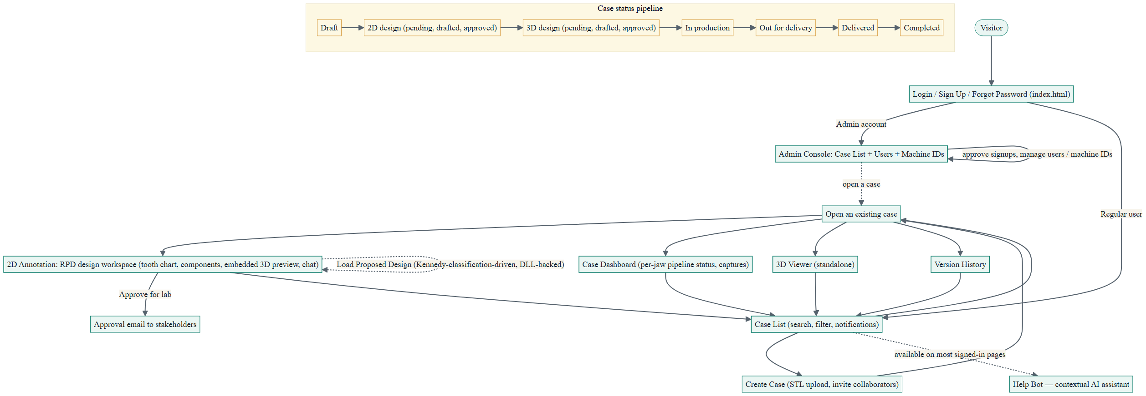
Figure 1 — top-level user journey. Teal = screen/page, amber = the status pipeline. Mermaid source: flowchart-summary.mmd.txt / Appendix B.

1. Summary Workflow
SmartRPD is a web companion to a desktop RPD (removable partial denture) design application. A dental technician logs in, works through a list of cases, and for each case: uploads jaw STL files, designs the RPD framework on a 2D tooth chart, previews/approves the 3D result, and tracks the case through a delivery pipeline. Admins separately manage user accounts, signup approvals, and machine-ID registrations.

1.1 Top-level journey
- Sign in. index.html handles Login, Sign Up (admin-approved), Forgot Password, and a currently-bypassed OTP step. Successful login routes by role.
- Land on a case list. Regular users land on case_list.html; admins land on admin/admin_case_list.html.
- Create or open a case. Creating a case is an inline pane (case name, STL upload, reference images, invite collaborators) — not a separate page.
- Design in 2D. Opening a case goes to 2DAnnotation.html — the RPD framework design workspace, with an embedded 3D preview, chat, and version history alongside it. Opening a case now also offers Load Proposed Design (Kennedy-classification/DLL-driven), not just manual placement.
- Review in 3D / approve. The embedded 3D preview supports survey-angle undercut targeting and an approval flow that emails captured images to stakeholders. A standalone, full-screen 3D Viewer is also reachable from the case list.
- Track status. Each case moves through an 11-step status pipeline from draft to completed, rolled up into three stage groups (Preparation / Delivery / Completed) shown as filter cards.
- Admin manages accounts. A separate admin console approves pending signups, manages users, and manages machine-ID registrations.

Application Workflow -- Detailed

SmartRPD — Application Workflow Documentation
Detailed workflow of the live-deployed SmartRPD web application.
Document generated | 2026-08-06
Source commit | d5d5121f12287c45b91d7a0d62acf017d6d98c64 (nyunt/dev-deploy)
Deployed to live site | 2026-08-06T08:55:00Z, build 23, https://faid123.github.io/.tmp-test-web/
Prepared from | Direct source read (git archive of the commit above) — not from memory or the prior .docx bundle
Companion files | flowchart-detailed.mmd.txt, flowchart-summary.mmd.txt (same folder)

1. Detailed Application Workflow

1.1 Authentication (index.html)
- Login. Username + password → Sign In. On success, postLoginTarget() routes admins straight to admin/admin_case_list.html and everyone else to case_list.html (avoids a redirect flash).
- Sign Up. Username + email only → POST /user/register/request. The account sits pending until an admin approves it in Admin > Users; the user is then emailed a link to set their password. (Password fields exist in the DOM but are hidden — the backend discards any password submitted at request time.)
- Forgot Password. Two-stage: Stage 1 emails a reset key (POST /user/reqpwreset); Stage 2 submits that key plus a new password (POST /user/resetpw).
- Change Password (signed-in, sidebar-accessible, reuses the reset-key flow)
- OTP. An OTP view exists in the markup but is currently bypassed — a TEMP flag in login.js sends the OTP and then routes straight to postLoginTarget() without waiting for it to be entered.
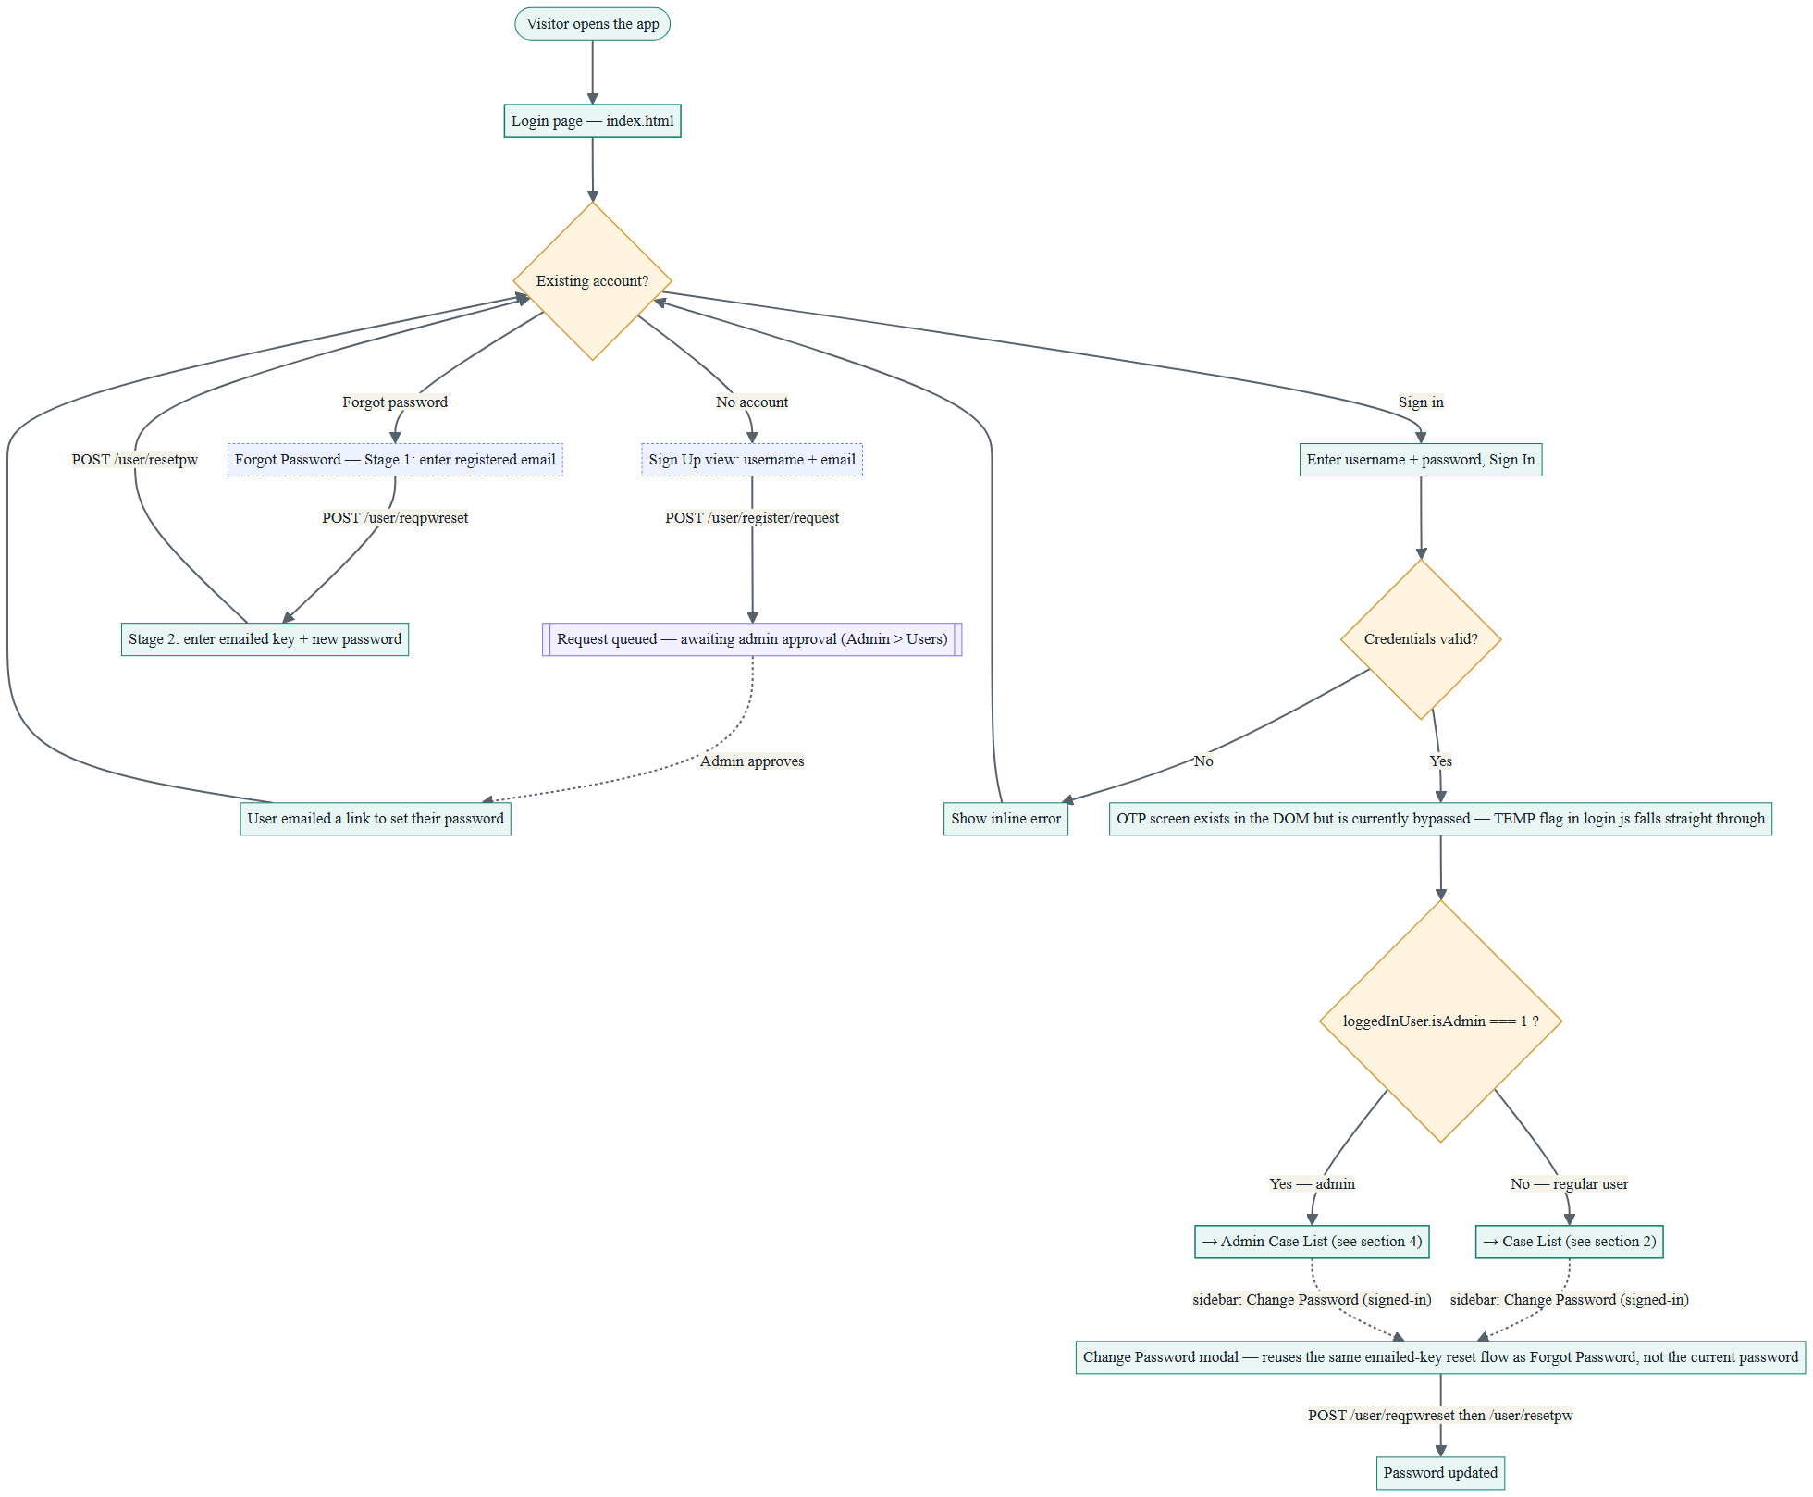
Figure 2 — authentication, including the admin-approval loop for sign-ups and the two-stage password reset.

1.2 Case List & Case Lifecycle (case_list.html)
- Header controls. Search by name or ID, date filter, status filter, sort, a Notifications bell (unread badge, popup, mark-all-read), and Create Case.
- Stage filter cards. All / Preparation / Delivery / Completed — click to filter the table by the status-group mapping in section 2.10.
- Case table. Click a row to open the Case Detail pane for that case.

1.2.1 Create Case (inline pane)
Not a separate page — an inline panel on case_list.html:
- Case name, auto-filled owner and create date, a request/due date.
- Invite collaborators via a search-and-add widget; invitees show in a running list before save.
- Upload jaw STL files (upper / lower).
- Upload reference images.
- Free-text instructions.
- Save creates the case and returns to the case list, where it now appears.

1.2.2 Case Detail actions (⋮ dropdown)
- View Dashboard — opens the Case Dashboard overlay (2.5).
- Rename, Edit User Access (collaborators/roles), Duplicate, Delete (confirm dialog),
New suggest/autocomplete roster.
- View Version History — a panel listing saved jawstruct versions with restore.
- Download References — exports the uploaded reference images.
- Change status — moves the case along the 11-step pipeline (2.10).
- View 3D — opens the standalone 3D Viewer (2.7) for this case.
- Open the case (row/thumbnail click) — goes to the 2D Annotation workspace (2.6).
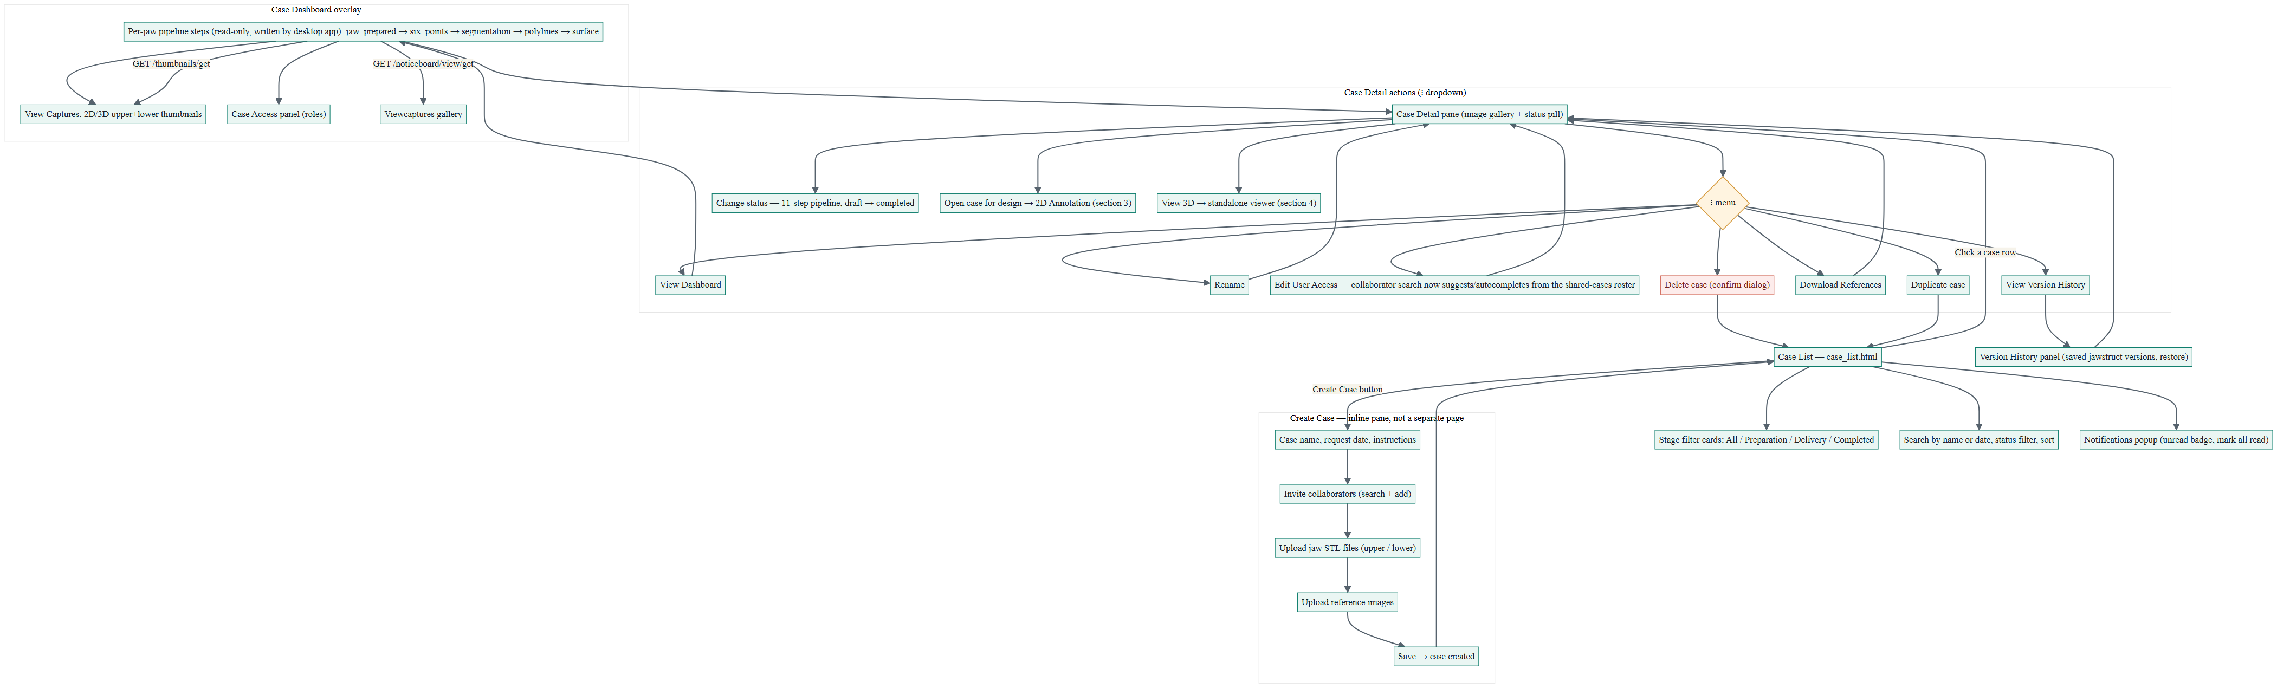
Figure 3 — case list, the inline Create Case pane, the Case Detail dropdown, and the Case Dashboard overlay (2.5) they lead to. Red = destructive action, amber diamond = a menu/decision point.

1.3 Case Dashboard overlay
Recreates the SmartRPD desktop dashboard for one case: a left column of per-jaw pipeline steps (jaw_prepared → six_points → segmentation → polylines → surface — read-only, written by the desktop app), a centre “View Captures” area (2D upper/lower and 3D upper/lower thumbnails from /thumbnails/get), and a right column with a Case Access panel (roles) above a Viewcaptures gallery (/noticeboard/view/get).

1.4 2D Annotation — RPD design workspace (2DAnnotation.html)
The core design screen, reached as 2DAnnotation.html?id=<encrypted case id>. Despite the name, it is the full RPD framework design workspace, not a simple image-annotation tool — plus several adjacent tools reachable from its footer/modals:
- Tooth chart (odontogram). Mark each tooth present, missing, an abutment, or compromised.
- Component catalog. Place framework pieces — mesh, clasps, bars, plates, rests, minor/major connectors — onto the chart. Save posts the design to /jawstruct/l2 (autosave is off by default; Save is a deliberate action).
- Load Proposed Design. A button that calls the jaw-occlusion DLL server-side (POST /dll/compute-denture-design-select) for whichever jaw(s) are eligible (partially edentulous, per a Kennedy classification check) and applies the returned design through the same pipeline as a hand-placed or server-loaded one. If the DLL call fails or no jaw qualifies, a Kennedy-classification picker modal opens as a fallback so the user can confirm which jaw(s) to apply to.
- Instruction Editor. The literal freehand image-annotation tool — crop, sticker, text, pencil — on a captured screenshot, nested inside Noticeboard.
- Noticeboard. Gallery of instruction screenshots and 3D view captures, synced with the desktop app.
- Clinical Info. A second, independent per-tooth chart for clinical condition (mobility, decay, crowns) — separate data and endpoint from the main design chart.
- Case Note. A small per-case form (owner, due date, shade, work category, comment), mostly localStorage-backed.
- Preview panel. Three tabs sharing one WebGL frame: 3D Preview (live Three.js view of the case's jaw STL files, including survey-angle targeting for undercuts with gesture controls), Extra 3D (upload/view other 3D files into slots 1–4), and Reference Images (gallery + full-pane view of the case's reference images). Switching tabs stages/pauses rendering rather than tearing the WebGL context down and rebuilding it.
- Approval flow. From the embedded preview, “Approve for lab” opens a [For Lab Only] confirmation overlay that emails the captured images to chosen recipients.
- Chat panel. Per-case comment thread with image attachments; polls for updates only while the panel is open and the tab is visible.
- Version History (embedded). The same version data as the case-list modal, available as a side panel here.
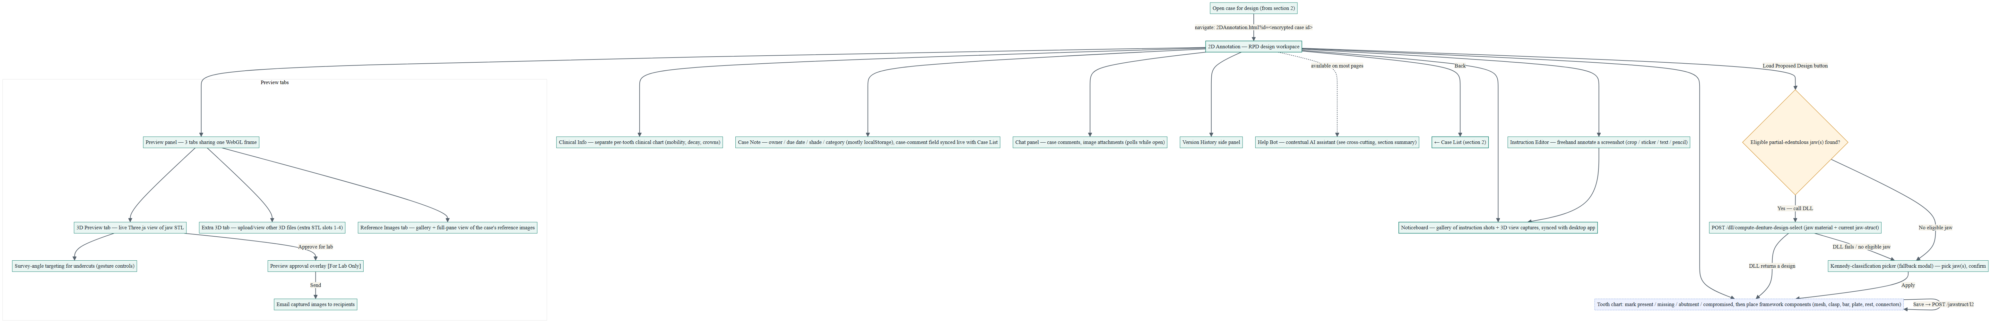
Figure 4 — the design workspace and its adjacent tools, all hung off the same page. This diagram is wide; open flowchart-03-2d-annotation.png directly for full resolution if the print size below is too small.

1.5 3D Viewer — standalone (ThreeDViewer.html)
A full-screen Three.js viewer (the webpack-built dist/bundle.js) for a case's jaw STL files, reached via the case list's “View 3D” link. Reads ?id=<encrypted case id> and decodes it client-side; a back button returns to the case list.

1.6 Admin Console
- Admin Case List (admin/admin_case_list.html). The same case-management UI as case_list.html, admin-scoped. Role-guard redirects send non-admins away from admin pages back to case_list.html, and send admins away from case_list.html to here.
- Admin > Users (admin_users.html). Lists all users (active / deactivated / pending). A pending badge on the bell shows signup requests awaiting approval — approving one turns a soft-deleted, password-less row into an emailed “set your password” invite. Admins can also register a user directly, edit, deactivate, or reactivate.
- Admin > Machine IDs (admin_machineid.html). Add, comment-edit, or hard-delete machine-ID registrations (the web counterpart of the desktop app's machine-ID admin screen).
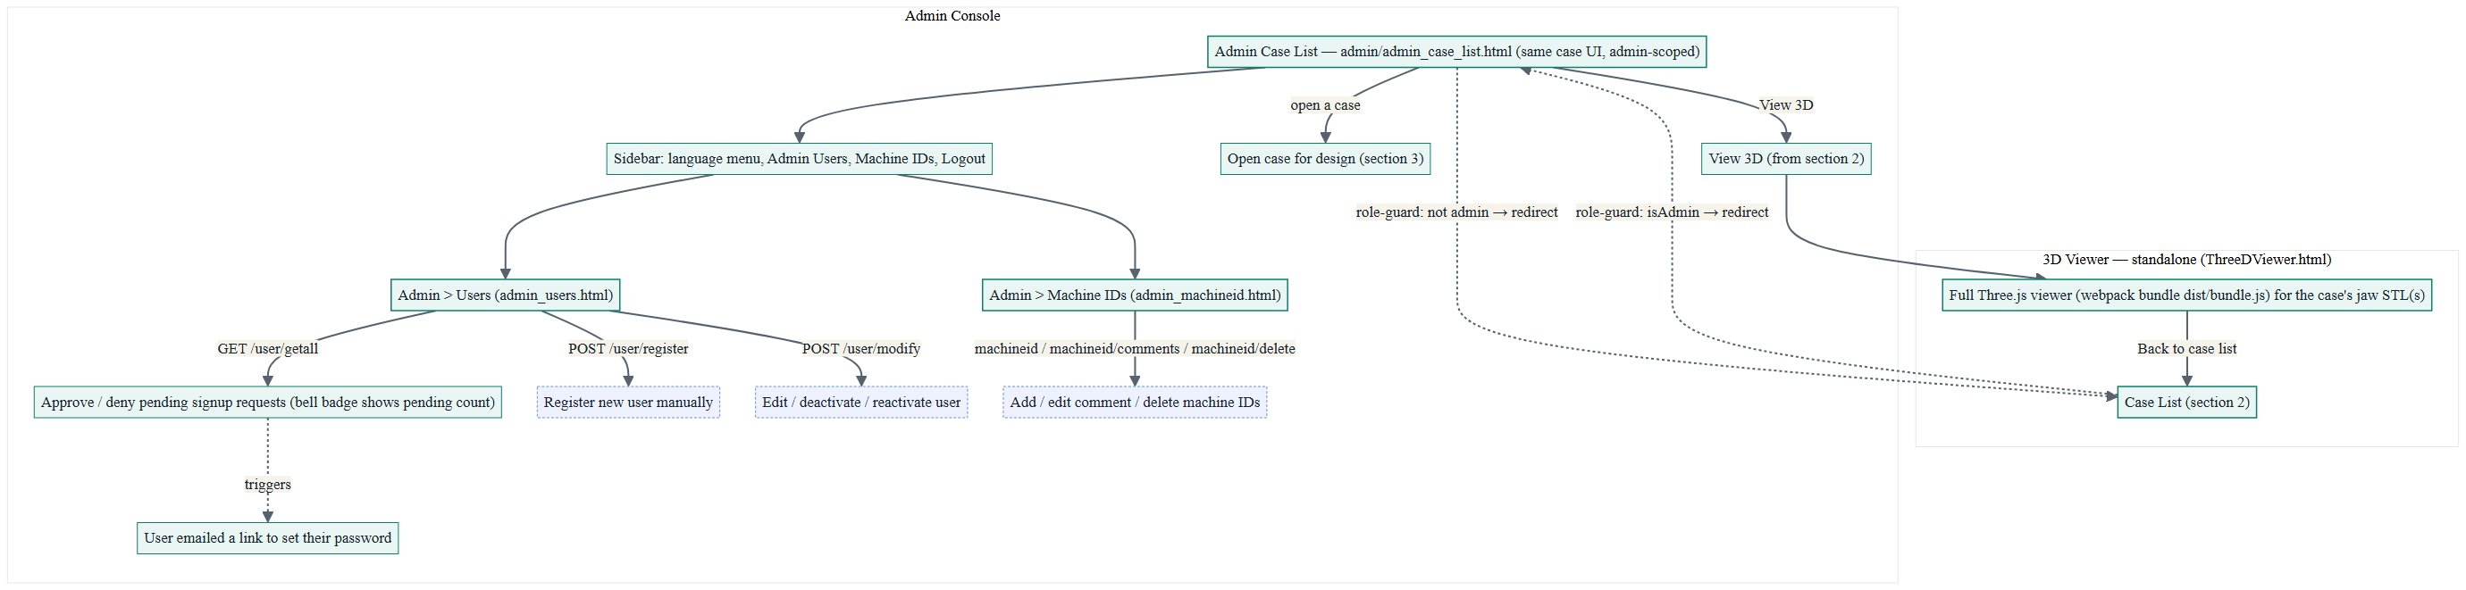
Figure 5 — the standalone 3D viewer and the admin console, including the role-guard redirects between the admin and regular case lists.

1.7 Cross-cutting features
- Help Bot. A contextual AI-powered assistant available across the app's pages; it can open collapsed containers before highlighting the UI element it's pointing to.
- Notifications. Bell icon + popup on case_list/admin_case_list with an unread badge and mark-all-read.
- App Sidebar. Shared footer menu — language switch, conditional admin links (only unhidden when loggedInUser.isAdmin === 1), and logout back to index.html.

1.8 Case status pipeline
A case's status (case_list.html's status dropdown and stat filter cards) moves through 11 values, grouped into three stages:
Stage group | Status values (in order) | Shown as
Preparation | draft → 2d_design_pending → 2d_design_drafted → 2d_design_approved → 3d_design_pending → 3d_design_drafted → 3d_design_approved | “Preparation” stat card
Delivery | in_production → out_for_delivery → delivered | “Delivery” stat card
Completed | completed | “Completed” stat card

2. Source Basis & Data-Integrity Notes
2026-08-21 review note: the Mermaid sources and this prose were re-checked against this branch's actual current src/ (diffed against the d5d5121 baseline below, not a fresh full git-archive extraction) after user review flagged the diagrams as visibly out of date. Load Proposed Design, the Preview-panel tab restructure, signed-in Change Password, and the collaborator-suggest roster were added as a result. Treat this pass as a correction layer on top of the original build, not a full re-verification — the next full extraction should confirm these and re-check for anything this diff-based pass missed.
This document and its companion Mermaid files were built by reading source directly from a git archive extraction of commit d5d5121f12287c45b91d7a0d62acf017d6d98c64 — the commit nyunt/dev-deploy actually deployed on 2026-08-06 (08:55 UTC, build 23) to nyunt/dev-W7.1, i.e. what is live today at https://faid123.github.io/.tmp-test-web/.

Appendix A — Companion files
Every diagram in this document is generated from a plain-text Mermaid source file, and can be re-rendered or edited by pasting that file's contents into https://mermaid.live. All files live alongside this document in Documentations/Application Workflow/.
Mermaid source | Rendered image | Covers
flowchart-summary.mmd.txt | flowchart-summary.png | Figure 1 — top-level journey
flowchart-01-authentication.mmd.txt | flowchart-01-authentication.png | Figure 2 — sign in / up / reset
flowchart-02-case-list-and-lifecycle.mmd.txt | flowchart-02-case-list-and-lifecycle.png | Figure 3 — case list, create, detail, dashboard
flowchart-03-2d-annotation.mmd.txt | flowchart-03-2d-annotation.png | Figure 4 — 2D design workspace
flowchart-04-viewer-and-admin.mmd.txt | flowchart-04-viewer-and-admin.png | Figure 5 — 3D viewer + admin console
flowchart-detailed.mmd.txt | flowchart-detailed.png | All of the above combined on one canvas (reference only — wide; the split files above are easier to read)

Appendix B — Mermaid source: summary flowchart
Reproduced in full below, the other four are in their own .mmd.txt files per the table above.
%%{init: {'theme': 'base', 'themeVariables': { 'primaryColor': '#eaf6f3', 'primaryBorderColor': '#0d7d6c', 'primaryTextColor': '#16212b', 'lineColor': '#56626d', 'tertiaryColor': '#fdf8e3', 'fontFamily': 'Segoe UI, Helvetica, Arial, sans-serif', 'fontSize': '18px' }, 'flowchart': { 'curve': 'basis', 'nodeSpacing': 45, 'rankSpacing': 75, 'htmlLabels': true } } }%%
%% SmartRPD — Summary Application Flowchart
%% DRAFT — needs re-verification against a real git-archive extraction before this replaces the
%% published diagram (see chat, 2026-08-21 mermaid review). Not yet re-rendered to .png.
%% Paste into https://mermaid.live (or any Mermaid renderer) to view.

flowchart TD
classDef screen fill:#eaf6f3,stroke:#0d7d6c,stroke-width:1.5px,color:#16212b;
classDef pipe fill:#fdf8e3,stroke:#d69b3f,stroke-width:1px,color:#16212b;

A(["Visitor"]) --> B["Login / Sign Up / Forgot Password (index.html)"]
B -->|"Admin account"| C["Admin Console: Case List + Users + Machine IDs"]
B -->|"Regular user"| D["Case List (search, filter, notifications)"]

D --> E["Create Case (STL upload, invite collaborators)"]
D --> F["Open an existing case"]
E --> F

F --> G["2D Annotation: RPD design workspace (tooth chart, components, embedded 3D preview, chat)"]
F --> H["Case Dashboard (per-jaw pipeline status, captures)"]
F --> I["3D Viewer (standalone)"]
F --> J["Version History"]

G -->|"Approve for lab"| K["Approval email to stakeholders"]
G --> D
H --> D
I --> D
J --> D

C -->|"approve signups, manage users / machine IDs"| C
C -.->|"open a case"| F

D -.->|"available on most signed-in pages"| HelpBot["Help Bot — contextual AI assistant"]
G -.->|"Load Proposed Design (Kennedy-classification-driven, DLL-backed)"| G

subgraph PIPE["Case status pipeline"]
direction LR
L1["Draft"] --> L2["2D design (pending, drafted, approved)"] --> L3["3D design (pending, drafted, approved)"] --> L4["In production"] --> L5["Out for delivery"] --> L6["Delivered"] --> L7["Completed"]
end

class B,C,D,G,H,I,J screen;
class L1,L2,L3,L4,L5,L6,L7 pipe;

Automated Test Suite Report
SmartRPD Web Application
Automated Test Suite Report
Full Jest suite, per-test results and coverage — nyunt/dev-W7.1 (live)

1. Purpose
This report captures the complete, currently passing automated test suite as run directly against nyunt/dev-W7.1, the live deployed branch. It expands on the one-line automated-gate summary with the full per-suite, per-test breakdown and coverage detail, for reference.

2. How This Was Run
The command run is the same test:ci script the “Deploy Test Site” GitHub Actions workflow runs as a fail-closed gate before every deploy (.github/workflows/deploy.yml). This branch does not carry the tools/run-uat-automated-tests.mjs wrapper script present on some other branches, so this run was invoked directly: npx jest --ci --coverage --coverageReporters=json-summary --verbose --testLocationInResults --json.

3. Summary
Metric | Result
Environment Under Test | nyunt/dev-W7.1 (live) @ 4d7438b (working HEAD); last deployed commit was 6107a90 -- “fix(case-management): Remove auto-refresh on visibility change” (run 35, 2026-08-17 16:02:39 +0800)
Command | npx jest --ci --coverage --coverageReporters=json-summary --verbose --testLocationInResults --json
Test Suites | 19 passed, 19 total
Tests | 582 passed, 582 total
Failures | 0

4. Change Since the Previous Recorded Baseline
The last recorded baseline (this same document, as it existed on dev-deploy-documentation) was 13 suites / 221 tests, from a run on 2026-08-17 while that branch had already diverged from nyunt/dev-W7.1's actual live code. Current count, run directly against this branch's own HEAD: 19 suites / 582 tests. Two things changed: the four jaw-struct suites that baseline listed as split apart (jawStructLingualPlate.test.mjs, jawStructMajorSwitch.test.mjs, jawStructRoundTrip.test.mjs, reciprocatingExclusivity.test.mjs) do not exist on this branch -- that content lives in jawStruct.test.mjs, placementRules.test.mjs and assemblies.test.mjs, same as the pre-baseline structure -- and seven new feature suites were added on top of that:
- JawDesign.test.mjs (20 tests) and JawDesignProposal.test.mjs (57 tests) -- Kennedy classification and the DLL-backed “Load Proposed Design” feature (deploy run 34, 2026-08-17); the two most recent commits on this branch extend this same feature (jaw occlusion DLL wiring, load-proposed-design for metal/acrylic RPD).
- caseComment.test.mjs (6 tests), caseEmailBody.test.mjs (13 tests) and userSuggest.test.mjs (12 tests) -- case-comment and email/suggestion features (deploy run 33, 2026-08-14); imageFiles.test.mjs (19 tests, deploy run 34, 2026-08-17); and pageTour.test.mjs (114 tests, the single largest addition, deploy run 18, 2026-08-01 -- present before the last recorded baseline but apparently never picked up into that count).
Every suite in this run imports the real src/ module it claims to test -- spot-checked by reading each new suite's import statements directly, not inferred from naming. No suite here is a hardcoded placeholder or hand-copied reimplementation.

5. Per-Suite Breakdown
Test File | Describe Groups | Test Count | Result
__tests__/JawDesign.test.mjs | 3 | 20 | PASS
__tests__/JawDesignProposal.test.mjs | 6 | 57 | PASS
__tests__/artificialTeethDecode.test.mjs | 7 | 28 | PASS
__tests__/assemblies.test.mjs | 18 | 70 | PASS
__tests__/caseComment.test.mjs | 1 | 6 | PASS
__tests__/caseEmailBody.test.mjs | 3 | 13 | PASS
__tests__/caseEnrichment.test.mjs | 8 | 24 | PASS
__tests__/clinicalInfoCodec.test.mjs | 3 | 13 | PASS
__tests__/crypt.test.mjs | 1 | 3 | PASS
__tests__/dashboard.test.mjs | 4 | 19 | PASS
__tests__/helpBot.test.mjs | 9 | 87 | PASS
__tests__/imageFiles.test.mjs | 4 | 19 | PASS
__tests__/importResolution.test.mjs | 1 | 3 | PASS
__tests__/jawStruct.test.mjs | 6 | 15 | PASS
__tests__/mergeInstructions.test.mjs | 1 | 5 | PASS
__tests__/pageTour.test.mjs | 12 | 114 | PASS
__tests__/passwordReset.test.mjs | 4 | 22 | PASS
__tests__/placementRules.test.mjs | 7 | 52 | PASS
__tests__/userSuggest.test.mjs | 3 | 12 | PASS

6. Coverage Summary
Metric | Covered / Total | %
Statements | 2923/14531 | 20.11
Branches | 1823/9345 | 19.5
Functions | 503/2104 | 23.9
Lines | 2592/12734 | 20.35

Coverage is only collected for modules touched transitively by the current suites -- most UI wiring, page controllers and much of the 3D viewer runtime have no automated coverage. Full per-file detail is in Documentations/AutoTest Results/automated-test-run.json (coverageByFile) and coverage/coverage-summary.json (regenerated locally each run, gitignored).

7. Traceability Gap
The following UAT workflows currently rely entirely on manual UAT execution with no automated regression backstop: UAT-03 Case Creation, UAT-05 Collaboration (Chat/Notifications), UAT-09 Add STL Files, UAT-10 Version History, UAT-11 Download / Export / Share, UAT-12 Responsive (Tablet + Mobile). helpBot.test.mjs (87 tests) also has no standing UAT-xx case to attach to -- see UAT_Report.docx §2.6 for the full breakdown.

8. Document Control
Field | Value
Document Type | Automated Test Suite Report
Application | SmartRPD Web Application
Environment Under Test | nyunt/dev-W7.1 (live) -- Documentations/ now maintained directly on this branch
Last Updated | 21 August 2026
Prepared By | Shafik Hakim Bin Abdul Wahid, Nyunt Sin Htet
Related Document | UAT_Report.docx §2 (UAT-mapped rollup of this same data)

UAT Report
SmartRPD Web Application
User Acceptance Testing (UAT) Report

1. Purpose and Scope
This report records UAT results for the SmartRPD Web Application and tracks what's needed for the next round. It also carries the full automated-test-to-UAT-workflow rollup (§2) that used to live in a separate Automated_UAT_Test_Run_Report.docx -- the two were merged 2026-07-31 so there's a single UAT report to maintain. Pushes to nyunt/dev-deploy trigger the “Deploy Test Site” GitHub Actions workflow, which runs the automated test gate, builds a production bundle, and publishes the verified revision to nyunt/dev-W7.1 (GitHub Pages), live at https://faid123.github.io/.tmp-test-web/.

2. Automated Test Coverage (Current)
Every push to nyunt/dev-deploy runs npm run test:ci as a fail-closed gate before the site can be published. Current recorded run on nyunt/dev-W7.1 (live branch): 19/19 test suites, 582/582 tests, 0 failing. Automated coverage and manual UAT are not substitutes for each other -- see §4's coverage-gap list for what's still manual-only, and §2.1–§2.8 below for the full automated-test-to-UAT-workflow rollup.

2.1 How This Was Run
Script: not present on this branch -- the underlying Jest command is invoked directly (below) rather than through a checked-in wrapper script. tools/deploy-review.mjs (run on demand, or automatically after a deploy) refreshes the raw data files this section is built from -- see Documentations/DEPLOY_DOC_REVIEW.md.
Underlying command: npx jest --ci --coverage --coverageReporters=json-summary --verbose --testLocationInResults --json
Commit tested: this branch's own working HEAD (4d7438b), run directly rather than against a specific deployed commit. Last commit actually deployed: 6107a90 -- “fix(case-management): Remove auto-refresh on visibility change” (run 35, 2026-08-17 16:02:39 +0800). Run timestamp: 2026-08-20T08:21:58Z.
Raw output: Documentations/AutoTest Results/automated-test-run.json (structured) and automated-test-run-log.txt (full Jest console output), refreshed automatically each week.
This branch's suite (19 suites / 582 tests) is well ahead of the last recorded baseline (13 suites / 221 tests, run 2026-08-17 while the docs branch had already diverged from nyunt/dev-W7.1's live code). The jump has two causes: the four jaw-struct suites that baseline listed as split apart (jawStructLingualPlate/MajorSwitch/RoundTrip.test.mjs, reciprocatingExclusivity.test.mjs) do not exist on this branch -- that content lives in jawStruct.test.mjs, placementRules.test.mjs and assemblies.test.mjs -- and seven new feature suites were added since (JawDesign, JawDesignProposal, caseComment, caseEmailBody, imageFiles, pageTour, userSuggest). Every suite imports the real src/ module it claims to test -- see §2.4 for the per-suite detail; none is a hardcoded placeholder or a hand-copied reimplementation.

2.2 Summary
Metric | Result
Test Suites | 19 passed, 19 total
Tests | 582 passed, 582 total
Failures | 0
Tests by category | real=221, copy/reimplementation=0, stub/placeholder=0
UAT workflows with zero automated coverage | UAT-03 Case Creation, UAT-05 Collaboration (Chat/Notifications), UAT-09 Add STL Files, UAT-10 Version History, UAT-11 Download / Export / Share, UAT-12 Responsive (Tablet + Mobile)
Suites for features with no standing UAT case | helpBot.test.mjs
Overall coverage (statements) | 20.11%
Overall coverage (branches) | 19.5%

2.3 Results by UAT Workflow (UAT-01 – UAT-12)
“Automated Coverage Confidence” reflects the category (§2.4) of the linked suite(s), not just pass/fail. Every mapped suite here is “real”, so any workflow with at least one linked suite shows genuine source coverage, not a false-positive placeholder.
ID | Workflow | Linked Suite(s) | Pass/Total | Automated Coverage Confidence
UAT-01 | Login & Authentication | passwordReset.test.mjs | 22/22 | Real source coverage
UAT-02 | Case List | caseEnrichment.test.mjs; caseComment.test.mjs; userSuggest.test.mjs | 42/42 | Real source coverage
UAT-03 | Case Creation | — | 0/0 | No automated coverage
UAT-04 | Dashboard | dashboard.test.mjs | 19/19 | Real source coverage
UAT-05 | Collaboration (Chat/Notifications) | — | 0/0 | No automated coverage
UAT-06 | 2D Annotation | mergeInstructions.test.mjs; clinicalInfoCodec.test.mjs; jawStruct.test.mjs; placementRules.test.mjs; assemblies.test.mjs; JawDesign.test.mjs; JawDesignProposal.test.mjs; caseComment.test.mjs | 238/238 | Real source coverage
UAT-07 | Embedded 3D Preview | artificialTeethDecode.test.mjs | 28/28 | Real source coverage
UAT-08 | 3D Viewer (standalone) | artificialTeethDecode.test.mjs | 28/28 | Real source coverage
UAT-09 | Add STL Files | — | 0/0 | No automated coverage
UAT-10 | Version History | — | 0/0 | No automated coverage
UAT-11 | Download / Export / Share | — | 0/0 | No automated coverage
UAT-12 | Responsive (Tablet + Mobile) | — | 0/0 | No automated coverage

2.4 Per-Suite Breakdown and Test-Quality Categorization
Every suite was read directly and classified by whether it imports the real src/ module it claims to test, reimplements a local copy of that logic, or asserts a hardcoded placeholder value. All 19 suites import real src/ modules directly -- confirmed by reading each file's import statements, not inferred from naming.
Real (imports the actual src/ module under test)
Copy (reimplements the logic locally; does not import src/)
Stub (hardcoded placeholder assertion; no source under test)
Test File | Pass/Total | Category | Linked UAT(s) | Note
JawDesign.test.mjs | 20/20 | real | UAT-06 | Imports real src/js/2D/JawDesign.js. Kennedy classification from tooth presence (Applegate rules); gates DLL-proposal eligibility.
JawDesignProposal.test.mjs | 57/57 | real | UAT-06 | Imports real src/js/2D/JawDesignProposal.js. Derives major-connector/rest-seat design proposal from Kennedy class; backs Load Proposed Design.
artificialTeethDecode.test.mjs | 28/28 | real | UAT-07, UAT-08 | Imports real src/viewer3d/artificialTeeth.js MessagePack/coordinate decode layer used by both the embedded 3D preview and the standalone 3D viewer.
assemblies.test.mjs | 70/70 | real | UAT-06 | Imports real src/js/2D/2DAnnotation.js placement pipeline. Assembly recipes and auto-reciprocation rule -- the content the pre-restructuring reciprocatingExclusivity.test.mjs covered.
caseComment.test.mjs | 6/6 | real | UAT-02, UAT-06 | Imports real src/js/2D/caseNote.js (publishCaseComment/watchCaseComments). Cross-tab sync between the case-list CASE INSTRUCTIONS field and the 2D Case Note Special Instruction field.
caseEmailBody.test.mjs | 13/13 | real | unmapped (needs review) | Imports real src/js/2D/caseNote.js (caseEmailBody/emailImagesHtml/emailLinkHtml). Builds the approval-request email body -- no standing UAT-xx case obviously covers the approval-email flow; needs a Test Coordinator decision rather than a forced mapping.
caseEnrichment.test.mjs | 24/24 | real | UAT-02 | Imports real src/js/shared/caseEnrichment.js. Case-detail and co-owner request/fold layer behind the case list.
clinicalInfoCodec.test.mjs | 13/13 | real | UAT-06 | Imports real src/js/2D/clinicalInfo.js (.NET-compatible clinical-info envelope codec).
crypt.test.mjs | 3/3 | real | cross-cutting | Imports real src/js/shared/crypt.js. Case-ID URL obfuscation used across case list, chat, viewer, version history, annotation and create-case links -- cross-cutting, not tied to one workflow.
dashboard.test.mjs | 19/19 | real | UAT-04 | Imports real dashboard.js pipeline functions.
helpBot.test.mjs | 87/87 | real | unmapped (new feature) | Imports real src/js/shared/helpMatcher.js and helpTopics.js (AI-powered help assistant). New feature with no standing UAT-xx case yet -- needs one added to the 12-case set rather than being force-mapped to an existing workflow.
imageFiles.test.mjs | 19/19 | real | cross-cutting | Imports real src/js/shared/imageFiles.js. HEIF sniffing, fit-to-box maths and re-encode rename -- the pure half of the upload pipeline shared across features; the canvas/decoder half needs a browser.
importResolution.test.mjs | 3/3 | real | cross-cutting | Walks src/, __tests__/ and the HTML pages checking every relative import/script-src resolves. Repo-wide build-integrity check, not tied to one workflow.
jawStruct.test.mjs | 15/15 | real | UAT-06 | Imports real src/js/2D/jawStructApply.js against fixture desktop files. Round-trip + bar/plate switch -- the content the pre-restructuring jawStructRoundTrip.test.mjs/jawStructLingualPlate.test.mjs/jawStructMajorSwitch.test.mjs covered.
mergeInstructions.test.mjs | 5/5 | real | UAT-06 | Imports real mergeInstructions() from src/js/2D/noticeboard.js (its only consumer).
pageTour.test.mjs | 114/114 | real | cross-cutting | Imports real src/js/shared/tourSteps.js and pageTour.js. Guided page-tour step data + reachability-filter engine, spans nearly every page -- not tied to one workflow.
passwordReset.test.mjs | 22/22 | real | UAT-01 | Imports real src/js/shared/passwordReset.js. Change-password/reset-password feature -- an extension of the Login & Authentication workflow.
placementRules.test.mjs | 52/52 | real | UAT-06 | Imports real src/js/2D/annotationPlacement.js. Per-component-family placement rules -- part of the content the pre-restructuring reciprocatingExclusivity.test.mjs covered.
userSuggest.test.mjs | 12/12 | real | UAT-02 | Imports real src/js/shared/userSuggest.js. Invite-box roster ('N shared cases' count) on the case list.

2.5 Cross-Cutting Suites (Not Tied to One UAT)
importResolution.test.mjs -- Walks src/, __tests__/ and the HTML pages checking every relative import/script-src resolves. Repo-wide build-integrity check, not tied to one workflow.
crypt.test.mjs -- Imports real src/js/shared/crypt.js. Case-ID URL obfuscation used across case list, chat, viewer, version history, annotation and create-case links -- cross-cutting, not tied to one workflow.

2.6 Coverage Gaps and Findings
6 of 12 UAT workflows have no automated suite mapped to them: UAT-03 Case Creation, UAT-05 Collaboration (Chat/Notifications), UAT-09 Add STL Files, UAT-10 Version History, UAT-11 Download / Export / Share, UAT-12 Responsive (Tablet + Mobile). These workflows simply never had a dedicated Jest suite written for them on this line of development -- they rely entirely on manual UAT execution for regression coverage. Two more suites (caseEmailBody.test.mjs, and the pre-existing helpBot.test.mjs) also have no confident mapping to any of the 12 -- see §2.4.
helpBot.test.mjs (87 tests) covers the AI-powered help assistant feature but has no standing UAT-xx case to attach to -- a UAT-13 draft already exists in SmartRPD_Documentation.docx §12.2 and should be adopted into the standing set rather than leaving an 87-test suite structurally invisible to the UAT rollup.
passwordReset.test.mjs (22 tests) is treated here as part of UAT-01 (Login & Authentication) since it's a sibling of the login flow; if UAT-01's documented pass criteria don't already mention password reset, they should be extended to cover it.
UAT-06 (2D Annotation) is by far the most heavily covered workflow in this run (238 tests across eight suites, including the new Kennedy-classification/design-proposal suites), followed by UAT-02 (Case List, 42 tests) and UAT-01 (Login & Authentication, including password reset, 22 tests). Coverage is only collected for modules touched transitively by these 19 suites -- most UI wiring, page controllers and the 3D viewer runtime beyond artificialTeeth.js still have no automated coverage; see §2.7.

2.7 Code Coverage Summary
Metric | Covered / Total | %
Statements | 2923/14531 | 20.11
Branches | 1823/9345 | 19.5
Functions | 503/2104 | 23.9
Lines | 2592/12734 | 20.35
Per-file coverage is in coverage/coverage-summary.json (regenerated locally each run, gitignored, not checked in) and in the full text log automated-test-run-log.txt.

2.8 Automated-Coverage Recommendations
Add a UAT-xx case for the help assistant feature (helpBot.test.mjs) and decide a mapping for the approval-email flow (caseEmailBody.test.mjs) the next time the standing UAT case set is revised, so neither stays structurally excluded from UAT traceability.
Confirm UAT-01's documented pass criteria explicitly cover password reset/change password, given passwordReset.test.mjs is mapped there as an extension rather than its own case.
Prioritize automated coverage for the 6 gap workflows in §2.6 (UAT-03 Case Creation, UAT-05 Collaboration (Chat/Notifications), UAT-09 Add STL Files, UAT-10 Version History, UAT-11 Download / Export / Share, UAT-12 Responsive (Tablet + Mobile)) -- manual UAT is currently the only regression backstop for each of them.
Keep this pattern (import the real src/ module, not a local copy) for any new suite -- it's the main quality difference between this branch's test tree and the older, pre-restructuring one.
This section refreshes automatically on demand (or after a deploy, once the automatic path is wired up on this branch's own tooling) -- tools/deploy-review.mjs re-runs the underlying Jest command and regenerates the raw data files it's built from. The rollup text itself (this section) still needs a manual/AI-assisted refresh when the suite list changes -- see Documentations/DEPLOY_DOC_REVIEW.md.

3. Last Executed Round (Historical — Different Branch/Commit)
Round conducted against nyunt/dev-deploy @ 69f1d26, published live on nyunt/dev-W7.1, dated 20 July 2026 (carried over from shafik_nyunt_2_integration). All 12 core workflows were exercised; 11 of 12 passed cleanly and 1 (UAT-08) was a partial pass pending TSK-007. Full detail preserved below for reference; none of it should be assumed to still hold against this branch's current code without re-testing.
ID | Workflow | Result (20 Jul round) | Notes
UAT-01 | Login & Authentication | Pass | Predates password-reset feature (TSK-022, §4) -- re-test required.
UAT-02 | Case List | Pass | Predates header search/filter toolbar (TSK-028, §4) -- re-test required.
UAT-03 | Case Creation | Pass | No change noted at the time.
UAT-04 | Dashboard | Pass | No change noted at the time.
UAT-05 | Collaboration (Chat/Notifications) | Pass | No change noted at the time.
UAT-06 | 2D Annotation | Pass | Predates denture-base material selection (TSK-027, §4) -- re-test required.
UAT-07 | Embedded 3D Preview | Pass | Predates jaw-preview survey angle targeting (TSK-026, §4) -- re-test required.
UAT-08 | 3D Viewer (standalone) | Partial | TSK-007 unresolved; TSK-026's camera/control changes make re-test more important, not less.
UAT-09 | Add STL Files | Pass | No change noted at the time.
UAT-10 | Version History | Pass | No change noted at the time.
UAT-11 | Download / Export / Share | Pass | No change noted at the time.
UAT-12 | Responsive (tablet + mobile) | Pass | Predates TSK-028's mobile search-field changes -- re-test required.

4. What's Changed Since the Last Round (Re-Test Required)
- TSK-022 — password reset / change-password flow (extends UAT-01). UAT-01's pass criteria should be updated to include the reset/change flow before re-testing.
- TSK-023, TSK-024 — admin machine-ID and user-management pages. No standing UAT case; Test Coordinator to decide whether these need a formal UAT-14 or are covered under a separate admin-acceptance process.
- TSK-025 — AI-powered help assistant. No standing UAT case in this backlog's own set, though a UAT-13 draft already exists in SmartRPD_Documentation.docx §12.2 and should be adopted formally (94 automated tests already back it, per Automated_Test_Suite_Report.docx, but that's not a substitute for a UAT pass/fail against real usage).
- TSK-026 — jaw-preview survey angle targeting. Extends UAT-07/UAT-08 and touches the same camera/control surface as the still-open TSK-007 -- prioritize this in the next 3D Viewer UAT pass.
- TSK-027 — denture-base material selection and component restrictions. Extends UAT-06.
- TSK-028 — case-list header search/stage-filter toolbar, including mobile-specific behaviour. Extends UAT-02 and UAT-12.

TSK-029 — template jaw-loading modal and 3D viewer layout redesign (full-viewport, command-dock controls). Touches the same 3D-viewer surface as TSK-007/TSK-026 -- prioritize alongside them in the next 3D Viewer UAT pass. Extends UAT-06/UAT-07/UAT-08.

TSK-030 — unified scrolling behavior in case-details detail panels and an adjusted component tab-strip touch-device breakpoint. CSS/layout-only; extends UAT-02/UAT-06/UAT-12.

TSK-031 – DLL-backed “Load Proposed Design”: POST the current jaw-struct to a server-side native DLL and apply the returned design for eligible partially-edentulous jaws, with a Kennedy-classification picker as fallback. Supersedes TSK-029's template-jaw modal. Extends UAT-06, also touches the UAT-07/UAT-08 eligibility check. Automated: JawDesign.test.mjs (20 tests) + JawDesignProposal.test.mjs (57 tests) cover the classification/proposal logic; the UI orchestration itself (tryLoadDllProposedDesign()/bindKennedyProposalDialog()) has no dedicated test.

TSK-032 – repositioned the occlusion heatmap toggle button to sit beside the undercut heatmap toggle. CSS-only bug fix; extends UAT-07. No automated test (styling-only, low risk).

5. Entry Criteria for the Next Round
- UAT-01's pass criteria updated to cover password reset/change-password (§4).
- UAT-13 (Help Assistant) drafted and added to the standing case set.
- Test Coordinator decision recorded on whether the admin module (TSK-023/024) needs a formal UAT case.
- Manual UAT-06/UAT-07/UAT-08 pass on both metal and full-acrylic material covering the new DLL-backed Load Proposed Design flow (TSK-031); low-priority visual check of the occlusion heatmap toggle's new position (TSK-032).
- Manual UAT-07/UAT-08 pass covering the new jaw-loading modal / viewer layout (TSK-029), and a responsive pass confirming the scroll/touch-breakpoint change (TSK-030).
- manifest.json on the live nyunt/dev-W7.1 site confirmed to match the commit this round is meant to test, per UAT_Protocol_SOP.docx §4.

6. Overall UAT Verdict
NOT YET ASSESSED for this branch. The 20 July round (§3) remains the last executed UAT pass and should not be cited as covering this branch's current feature set. Recommend scheduling a new round once §5's entry criteria are met.

7. Sign-off (Pending — Next Round)
Role | Name / Signature | Date
UAT Tester | ________________________ | ____ / ____ / 2026
Test Coordinator | ________________________ | ____ / ____ / 2026
Approving Authority | ________________________ | ____ / ____ / 2026

8. Document Control
Field | Value
Document Type | UAT Report
Application | SmartRPD Web Application
Environment | nyunt/dev-W7.1 (live branch)
Live URL | https://faid123.github.io/.tmp-test-web/
Last Updated | 24 August 2026
Prepared By | Shafik Hakim Bin Abdul Wahid, Nyunt Sin Htet
Overall Status | No new round executed — historical round from a different branch/commit carried forward for reference (§3); next-round entry criteria listed in §5.

UAT Protocol SOP
SmartRPD Web Application
UAT Protocol (Standard Operating Procedure)

1. Purpose
This SOP defines the standard, repeatable procedure for planning, executing, logging and signing off User Acceptance Testing (UAT) for the SmartRPD Web Application. It applies to every UAT round run against the nyunt/dev-deploy branch prior to a change being considered accepted for the live nyunt/dev-W7.1 site.

2. Scope and Applicability
Applies to all functional changes (features, improvements, bug fixes) merged into nyunt/dev-deploy that are intended to reach the live site at https://faid123.github.io/.tmp-test-web/. Purely cosmetic or documentation-only changes may be exempted at the Test Coordinator's discretion, but the exemption itself must be recorded in the relevant Feedback & Triage Report entry.

3. Roles and Responsibilities
Role | Responsibility
Developer(s) | Merge intended changes into nyunt/dev-deploy only once the automated suite passes locally; update the corresponding Feedback & Triage Report row(s) to Completed with a remark describing the change.
Test Coordinator | Confirms the automated gate passed on the deploy workflow, prepares/updates the UAT test case set, assigns testers, and consolidates results into the UAT Report.
UAT Tester(s) | Executes assigned test cases on the required device/browser matrix against the live nyunt/dev-W7.1 site, records Pass/Fail/Partial with evidence (screenshot).
Approving Authority | Reviews the completed UAT Report, accepts or rejects residual risk on any open findings, and signs off for production readiness.

4. Environment and Access
- Source of truth for UAT: nyunt/dev-deploy branch. All changes intended for a UAT round must be merged here first — this is the only branch that triggers deployment.
- Deployment mechanism: GitHub Actions workflow “Deploy Test Site” (.github/workflows/deploy.yml), triggered on push to nyunt/dev-deploy or via manual workflow_dispatch.
- Automated gate: npm run test:ci runs as a fail-closed step -- the workflow does not proceed to build/deploy if any test fails. Current suite: 19 test suites / 582 tests.
- Published artifact: the verified build is committed to nyunt/dev-W7.1 (the GitHub Pages branch) together with a manifest.json recording revision (commit SHA), buildId, a sha256 digest, and the timestamp — this manifest is the authoritative record of exactly which revision UAT was run against.
- Live site under test: https://faid123.github.io/.tmp-test-web/
- Before starting a UAT round, testers must open the live site's manifest.json and confirm its revision field matches the commit the round is meant to test.

5. Entry Criteria
- All features/fixes intended for this round are merged into nyunt/dev-deploy.
- The “Deploy Test Site” workflow has completed successfully (green) and republished nyunt/dev-W7.1.
- manifest.json on the live site reflects the intended revision.
- The UAT test case set (§6) is up to date, including any new/changed test cases needed for this round's changes.
- The Feedback & Triage Report rows targeted by this round are marked Completed by the developer with a remark.

6. Test Case Preparation
Each core application workflow has a standing test case (UAT-01 through UAT-12), covering Login & Authentication, Case List, Case Creation, Dashboard, Collaboration, 2D Annotation, Embedded 3D Preview, 3D Viewer (standalone), Add STL Files, Version History, Download/Export/Share, and Responsive (tablet + mobile).
For each UAT round, the Test Coordinator must: (a) identify which standing UAT-xx case(s) each Feedback & Triage Report task ID exercises, (b) write a new UAT-xx case if a task introduces a workflow not already covered, and (c) record the task-to-case mapping in the Traceability Document.

7. Execution Procedure
- Confirm entry criteria (§5) are met before starting.
- For each required device/browser class (Desktop: Chrome/Edge ≥1366×768; Tablet: iPad/Android Chrome 769–1024px; Mobile: iOS Safari/Android Chrome ≤768px), execute every in-scope UAT-xx case against https://faid123.github.io/.tmp-test-web/.
- For each case, record the actual result against the case's documented Pass Criteria and Fail Criteria.
- Capture a screenshot for each executed case (or each failure, at minimum).
- Log every failure or partial result immediately per §8 — do not batch defect logging to the end of the round.
- On completion, consolidate all case results into a UAT Report (using the current UAT_Report.docx as the template for structure).

8. Defect Logging and Triage
Any UAT case that returns Fail or Partial must be logged as a row in the Feedback & Triage Report with a new or existing Task ID, Module, Description, Type (Bug/Improvement/Feature), and Status of Open. The Test Coordinator assigns an initial priority (P0–P3) at logging time.
P0/P1 defects block sign-off of the workflow(s) they affect until resolved and retested. P2/P3 items may be sign-off-accepted with the Approving Authority's explicit note in the UAT Report.

9. Exit / Sign-off Criteria
- Every in-scope UAT-xx case has a recorded result (Pass, Fail, or Partial with rationale).
- No open P0 or P1 defect remains against an in-scope workflow, unless explicitly risk-accepted in writing by the Approving Authority.
- The UAT Report for the round is complete and includes the manifest.json revision tested.
- Screenshot evidence exists for at least each failure and each first-time pass of a new/changed workflow.
- The Approving Authority has signed the UAT Report.

10. Documentation Maintenance
This SOP, the UAT Report, the Feedback & Triage Report and the Traceability Document should be treated as a set and updated together at the end of every UAT round, per the Documentation Maintenance Policy in Maintenance and Operational Runbook.docx.

11. Version History
Version | Date | Author | Change
1.0 | 20 July 2026 | Shafik Hakim Bin Abdul Wahid | Initial SOP, formalising the ad hoc UAT process already in use for nyunt/dev-deploy → nyunt/dev-W7.1.
1.1 | 24 July 2026 | Shafik Hakim Bin Abdul Wahid (AI-assisted) | Adapted for dev-deploy-shafik-2: retired-Jenkins note (§4), current 13/198 suite count (§4), UAT-01/UAT-13 gap note for password reset / help assistant (§6).
1.2 | 31 July 2026 | Shafik Hakim Bin Abdul Wahid (AI-assisted) | Re-targeted from dev-deploy-shafik-2 to nyunt/dev-W7.1 (the live branch): current 13/221 suite count (§4), noted the existing UAT-13 draft in SmartRPD_Documentation.docx, and flagged TSK-029/030 (viewer layout, scroll/touch-breakpoint work) as needing UAT coverage.
1.3 | 24 August 2026 | Shafik Hakim Bin Abdul Wahid (AI-assisted) | Added TSK-031 (Load Proposed Design) and TSK-032 (occlusion toggle reposition) to UAT_Report.docx §4, which previously stopped at TSK-030 despite both being Completed in Feedback_Triage_Report.docx/Traceability_Document.docx. §4's suite count (19/582) was already current as of the 2026-08-20 pass.

12. Document Control
Field | Value
Document Type | UAT Protocol / SOP
Application | SmartRPD Web Application
Environment Under Test | nyunt/dev-deploy (source) -> auto-deployed to nyunt/dev-W7.1 (GitHub Pages, live)
Live URL | https://faid123.github.io/.tmp-test-web/
Last Updated | 24 August 2026
Prepared By | Shafik Hakim Bin Abdul Wahid, Nyunt Sin Htet
Document Version | 1.2

Cybersecurity Protocol Document
SmartRPD Web Application
Cybersecurity Protocol Document

1. Purpose and Scope
This document defines the current cybersecurity posture of the SmartRPD Web Application on nyunt/dev-W7.1 (the live, deployed branch, built from dev-deploy-documentation), catalogues the concrete exposures found in the codebase and pipeline as of this draft, and sets out the protocol for closing them. It covers the frontend web client (this repository), its build/deploy pipeline (the GitHub Actions “Deploy Test Site” workflow -- see Documentations/setup/03-cicd-and-deployment-setup.md), and the data it handles -- including per-tooth clinical/case information treated here as sensitive patient-adjacent data even where no formal regulatory classification has been assigned.
Out of scope: the backend API (live.api.smartrpdai.com) and its infrastructure, which are not in this repository and cannot be audited from here. Every finding below is scoped to what the frontend controls, sends to, or exposes about that backend.
Note on Jenkinsfile: a Jenkinsfile exists in this repo (moved to legacy/Jenkinsfile as part of a repository cleanup pass) but is explicitly documented as retired -- local Jenkins was uninstalled 2026-07-17 and the nginx/EC2 production split it describes was never actually built (Documentations/setup/03-cicd-and-deployment-setup.md). GitHub Actions is the only live pipeline. This document evaluates that pipeline, not the retired Jenkins one.

2. Current Security Posture — Executive Summary
The application authenticates every session against a single shared service account whose plaintext credentials are committed to source control and shipped to every browser in the production bundle. Multi-factor authentication (OTP) exists in the codebase but is currently disabled by a temporary code path. Route protection is client-side, though the newer admin module is a genuinely better pattern -- it explicitly treats the server's is_admin check as authoritative and the local flag as UI-only (§4.3). There are no HTTP security headers configured, and three third-party CDN scripts load without integrity checks (§6.3). Against that, the CI/CD pipeline itself is a real strength: a fail-closed test gate plus a sha256-digested, timestamped manifest on every deploy (§8.1) -- better provenance than many larger projects have, and worth preserving as this app matures.
Overall posture rating: Weak / High Risk on the client-auth findings (§10, F-1/F-2/F-3), offset by a genuinely solid deploy pipeline (§8.1).

3. Data Classification
Case records handled by this application include per-tooth clinical notes (src/js/2D/clinicalInfo.js), patient case identifiers, dental lab and clinician usernames/emails, and 3D scan/model data. This is healthcare-adjacent data even though the application is a dental-lab design tool rather than a clinical record system. This document treats it as Sensitive for the purposes of the recommendations in §4–§9, regardless of whether a formal regulatory regime (e.g. HIPAA-equivalent) has been confirmed as applicable. New this pass: the same class of clinical design data (full upper/lower L2 jaw-struct text, base64-encoded) is now also sent to a new backend route, POST /dll/compute-denture-design-select (src/js/2D/jawStructApi.js's generateDentureDesignSelect(), added for the “Load Proposed Design” feature), server-side to a native DLL and back. It uses the same case_id/uuid payload shape and auth pattern as the existing save/load jaw-struct endpoints, so it does not change the posture in §4 -- flagged here only so this data flow is in the inventory; the backend service itself remains out of scope per §1.

4. Authentication and Access Control

4.1 Shared service-account credentials shipped to the client
Confirmed in code. src/js/shared/config.js exports LOGIN_CREDENTIALS containing a live username and plaintext password, plus a MACHINE_ID and VIEWER_UUID. src/viewer3d/ApiClient.js's login() calls POST /user/login with these exact credentials to establish the session every API call in the app depends on. The module's own comment already flags this (“centralizing them here does NOT make them secret”) and points at a CODE_FLAGS.md that is not present in this repo checkout -- worth locating or recreating so the referenced context isn't a dead link.
Protocol: authentication must move server-side -- either a short-lived token exchange after the user's own login succeeds, or a backend proxy that holds the service credential and is never exposed to the browser. Until that lands, rotate the current value immediately -- it is already public in this repository's git history and rotating config.js alone does not remove the old value from history.

4.2 Multi-factor authentication is currently disabled
Confirmed in code. src/js/pages/login.js's sendOTP() stores the logged-in user and returns success immediately after the initial username/password call; the OTP-generation and redirect logic is still present but commented out under a `TEMP-OTP-DISABLED` marker. The verifyAndLogin() function and the full OTP-entry UI still exist and are wired up, so MFA can be restored by re-enabling this block.
Protocol: treat re-enabling OTP as a priority item, or if it's staying off deliberately for this environment, record that decision explicitly (who approved it, for which environment, why) rather than leaving it as a commented-out code block that anyone could re-enable or further disable without review.

4.3 Client-side route guard, but a good server-authoritative pattern in the new admin module
The app's route protection (referred to as “authGuard” in code comments, e.g. src/js/pages/viewerShell.js) gates on localStorage.loggedInUser.uuid, which is client-controlled and provides no real access control by itself -- the API backend's own per-request authorization is the only real gate, and this document cannot verify that gate from the frontend repository.
The new admin module (src/js/admin/adminUsers.js, adminMachineId.js) is a better example worth generalizing: its own comments state “the server checks is_admin (Auth.authIsAdmin) from the caller uuid ... the local isAdmin flag only decides what UI to show; the server stays authoritative,” and the code explicitly reconciles when “server disagrees with local isAdmin flag -- server wins.” That is the right mental model for client-side state everywhere in this app, not just the admin pages.
Protocol: confirm with the backend team that every non-admin endpoint independently authorizes each request the same way the admin endpoints already do; use the admin module's server-wins reconciliation pattern as the template when reviewing other client-trust assumptions in this codebase.

4.4 Signed-in password change relies on the same email-key flow as a forgotten password
Confirmed in code. src/js/shared/passwordReset.js (new this branch) is shared by both the signed-out “Forgot password” flow and the signed-in “Change Account Password” sidebar item. Its own comment states: “There is no endpoint that verifies a current password, so a signed-in change goes through the same key” -- i.e. changing your password while logged in proves nothing about your current password, only possession of the account's email inbox. Separately, MIN_PASSWORD_LENGTH (8) is enforced client-side only: “The backend enforces nothing, so this guard lives entirely on the client” -- a direct API call can set an arbitrarily short/weak password.
Protocol: for the signed-in change-password path specifically, prefer verifying the current password (or an equivalent re-auth step) over routing through the email-key flow -- an attacker with a live, already-authenticated session shouldn't need mailbox access to change the password out from under the legitimate user, and vice versa a compromised mailbox alone becoming sufficient to reset an otherwise-secure account is a real risk worth reducing. Ask the backend team to enforce a minimum password policy server-side -- the client-only check is a UX nicety, not a control.

4.5 Open-redirect protection — working as intended (positive finding)
postLoginTarget() in login.js validates that a stashed post-login redirect URL is same-origin before honoring it, and consumes the stash after one use. A correct, deliberate mitigation already in place.

4.6 auto_user URL identity token — resolved since the earlier draft of this document
An earlier review of this application (on a different branch) found an `auto_user=<base64>` query parameter carrying identity data into a shared 3D-viewer link. That parameter is not present in this branch's showThreeDViewerQr()/export-link code -- confirmed by search, not just absence of a comment. Noted here so the fix isn't silently lost track of if branches merge back together.

5. Secrets and Credential Management

5.1 Build-time environment variables are injected wholesale into the public bundle
Confirmed in code. webpack.config.js:
new webpack.DefinePlugin({ 'process.env': JSON.stringify(process.env) })
This serializes the entire process.env of whatever machine runs npm run build into dist/bundle.js, not just variables the app actually references. Documentations/setup/01-local-development-setup.md and 04-troubleshooting.md both already warn about this explicitly and confirm there is currently no .env file in the repo -- the warning is live onboarding guidance, not a stale note.
Protocol: replace the unscoped DefinePlugin with an explicit allow-list of the specific variables the app needs, so a CI secret or credential set in the build environment for an unrelated purpose can never leak into a public bundle by accident.

5.2 Repository hygiene
- dist/bundle.js and dist/bundle.js.LICENSE.txt are committed to git -- documented in Documentations/setup/01-local-development-setup.md as “a legacy habit from before CI existed,” and confirmed harmless for the live deploy (the pipeline rebuilds and publishes its own copy every time, per §8.1). Still worth noting: combined with §5.1, any secret ever accidentally baked into a locally-built dist/bundle.js and committed would persist in git history.
- cookies.json (a Postman cookie-jar file, currently empty) is tracked in git, now moved to legacy/cookies.json as part of a repository cleanup pass. Empty today, but a cookie jar is exactly the kind of file that accidentally gains real session cookies during local debugging and then gets committed without anyone noticing -- recommend removing it from tracking entirely and adding it to .gitignore rather than leaving it archived.

6. Client-Side Application Security

6.1 No HTTP security headers
Confirmed in code. nginx.conf configures gzip and cache headers only -- no Content-Security-Policy, X-Frame-Options, X-Content-Type-Options or Referrer-Policy anywhere. Recommended minimum addition:
add_header X-Content-Type-Options "nosniff" always;
add_header X-Frame-Options "DENY" always;
add_header Referrer-Policy "strict-origin-when-cross-origin" always;
add_header Content-Security-Policy "default-src 'self'; connect-src 'self' https://live.api.smartrpdai.com; script-src 'self' https://cdnjs.cloudflare.com; ..." always;
Note this nginx.conf is not what actually serves the live GitHub Pages site (§8.1) -- it matters only if it's ever wired up for a future non-Pages deployment target. GitHub Pages' own header set should be checked separately, since it can't be configured from this repo.

6.2 Third-party CDN scripts load without Subresource Integrity
Confirmed in code. src/pages/case_list.html loads three scripts directly from cdnjs.cloudflare.com (jszip, html2canvas, qrcodejs) with no `integrity=` attribute:
<script src="https://cdnjs.cloudflare.com/ajax/libs/jszip/3.10.1/jszip.min.js"></script>
<script src="https://cdnjs.cloudflare.com/ajax/libs/html2canvas/1.4.1/html2canvas.min.js"></script>
<script src="https://cdnjs.cloudflare.com/ajax/libs/qrcodejs/1.0.0/qrcode.min.js"></script>
Without SRI, a compromise of cdnjs (or a MITM on that connection, though HTTPS limits this) could serve modified JavaScript that runs with full access to this page's DOM, localStorage (including loggedInUser) and any in-page API calls. cdnjs publishes SRI hashes for every file it serves, so this is a low-cost fix.
Protocol: add `integrity="sha384-..."` and `crossorigin="anonymous"` to all three script tags using the hashes cdnjs publishes for the pinned versions already in use.

6.3 Session/identity state and XSS blast radius
Session/identity state lives in localStorage (loggedInUser), readable by any script running in the page's origin. Standard for an SPA of this shape, but it means an XSS vulnerability anywhere in the app -- including via §6.2's unpinned CDN scripts -- would be sufficient to fully impersonate the logged-in session. Raises the value of §6.1's CSP recommendation as a defense-in-depth layer, not a checkbox.

6.4 Help assistant (feature under active development) -- re-verified local-only, no data exfiltration
The AI-powered help assistant (src/js/shared/helpMatcher.js, helpTopics.js, helpBot.js) was re-checked on this branch after two feature commits landed since the prior draft: an FAQ/fallback-guidance expansion (commit d583fbb, 2026-07-27) and reveal controls that click a topic's opener control before highlighting its target (commit e621194, 2026-07-28). Neither introduces an outbound network call -- a search for fetch/XMLHttpRequest/WebSocket across all three files returns nothing. It remains a local, rules-based text matcher over a static knowledge base bundled with the app; user questions typed into it are not sent to any third-party service. The reveal-control feature programmatically clicks existing UI controls and polls their visibility state -- it does not accept or render arbitrary HTML from user input. No finding here, re-confirmed given the feature grew substantially (helpBot.test.mjs: 71 -> 94 tests) since the prior review.

7. Cryptography and Data-in-Transit

7.1 src/js/shared/crypt.js is obfuscation, not encryption — and is scoped correctly today
Confirmed in code. The lol() function XORs input against a hardcoded static key and base64-encodes the result to obfuscate numeric case IDs in URLs. This provides no real confidentiality and the module's own comment correctly calls it obfuscation, not encryption. Its actual use -- making case-ID URLs non-obvious, not protecting genuinely sensitive data -- is defensible provided real access control happens server-side (§4.3) rather than relying on the case ID being unguessable.
Protocol: keep lol() scoped to cosmetic URL obfuscation only; do not extend its use to anything needing genuine confidentiality without a real algorithm (e.g. AES-GCM via the Web Crypto API) and a non-hardcoded key.

7.2 Transport encryption
API calls to live.api.smartrpdai.com use https:// consistently. Confirm TLS termination and certificate configuration for the GitHub Pages live site (handled by GitHub automatically) and for any future non-Pages deployment target using nginx.conf -- that config currently defines only a plain port-80 server block with no TLS block of its own.

8. Infrastructure and CI/CD Security

8.1 GitHub Actions deploy pipeline — a real strength (positive finding)
Confirmed by reading .github/workflows/deploy.yml directly. Every push to nyunt/dev-deploy runs: npm ci (deterministic, lockfile-pinned install) -> npm run test:ci as a fail-closed gate (the job stops here if any test fails) -> npm run build with an explicit dist/bundle.js existence check -> a manifest.json build recording the commit SHA, run number, a sha256 digest over every tracked file plus the built bundle, and a timestamp -> an atomic replace of the Pages branch content via git archive (preserving rollback history) -> an explicit Pages rebuild API call (required because GITHUB_TOKEN pushes don't auto-trigger it). Coverage is also archived as a build artifact on every run. This is meaningfully better provenance than most projects this size have, and worth explicitly preserving rather than only auditing for gaps.
Protocol: no change needed to the pipeline mechanics; the main risk to this strength is scope creep (e.g. a future contributor adding a deploy path that bypasses the test gate). Keep this workflow as the only way anything reaches the Pages branch.

8.2 Retired Jenkins/EC2 pipeline no longer live
A Jenkinsfile is still present in the repository (moved to legacy/Jenkinsfile in this cleanup pass) describing a `sudo rm -rf /var/www/html/*` + `sudo cp` deploy with no automated test gate. Documentations/setup/03-cicd-and-deployment-setup.md confirms this is retired history: local Jenkins was uninstalled 2026-07-17, and the nginx/EC2 production split it implies was never actually built. No live risk from this pipeline as of this draft -- flagged only so it isn't mistaken for an active deployment path by someone new to the repo, and so it doesn't quietly get resurrected without the same rigor as §8.1.

9. Dependency and Supply-Chain Security
`npm audit` against the current lockfile reports 10 known vulnerabilities (3 moderate, 6 high, 1 critical) as of this re-audit (20 August 2026) -- down from the 27 (3 moderate, 23 high, 1 critical) recorded in the prior draft, and down further from the 6 (3 moderate, 2 high, 1 critical) recorded in the draft before that. The count moves independently of code changes on this branch -- package.json/package-lock.json have not changed -- because npm's advisory database and npm audit's own occurrence-counting both shift over time (the prior 27 count included per-path occurrences of the same brace-expansion advisory fanning out through 20+ Jest-toolchain packages; this run's 10 counts unique vulnerable packages instead). Two advisories are newly visible since the prior draft that were not previously listed: js-yaml (CVE-2026-59870, quadratic CPU consumption in !!omap resolution) and nanoid (non-secure/custom generators can loop indefinitely on a zero or negative size). All reported vulnerabilities remain transitive devDependencies (webpack-dev-server's sockjs/uuid chain, uglify-js pulled in via the unused top-level `require` package, plus the fast-uri, postcss, brace-expansion, js-yaml and nanoid advisories) -- none currently reach the production bundle, limiting real-world exploitability, but a dev-server or build-time issue is still a risk to anyone running `npm run dev` or CI itself.
Package | Severity | Advisory | Notes
uglify-js <=2.5.0 | Critical | ReDoS / minification correctness | Pulled in via the unused top-level `require` dependency (also flagged separately, High, as the direct dependency); no fix available without removing/replacing `require`.
brace-expansion (via minimatch/glob/Jest toolchain) | High | DoS via unbounded expansion length, plus a second bypass of the CVE-2026-14257 mitigation (GHSA-mh99-v99m-4gvg) | Fix available via `npm audit fix`.
js-yaml | High | Quadratic CPU consumption in !!omap resolution -- CVE-2026-59870 fix not backported to the 3.x/4.x lines in use | New advisory since the prior draft. Fix available via `npm audit fix`.
nanoid | High | Non-secure/custom generators can loop indefinitely when size is zero or negative | New advisory since the prior draft. Fix available via `npm audit fix`.
postcss <=8.5.17 | High | Path traversal in sourceMappingURL auto-loading -- an incomplete fix of a prior advisory (GHSA-6g55-p6wh-862q) | Fix available via `npm audit fix`.
fast-uri | High | Host confusion via literal backslash authority delimiter | Fix available via `npm audit fix`.
sockjs / uuid / webpack-dev-server | Moderate | sockjs pulled in transitively; uuid missing a buffer bounds check in v3/v5/v6 | Transitive via webpack-dev-server. Fix requires a semver-major webpack-dev-server bump (`npm audit fix --force`).

Protocol: run `npm audit fix` for the non-breaking fixes (fast-uri, postcss); evaluate `npm audit fix --force` for the brace-expansion/Jest chain and the uglify-js/uuid chains separately, since both pull in breaking-change upgrades that need a full test-suite re-run before accepting; evaluate removing the unused `require` package to drop the uglify-js chain outright; keep `npm audit` as a release-checklist item so this list doesn't silently regrow, and re-run it whenever this document is revisited -- the registry's advisory database changes independently of this repository's own commits.

10. Findings Summary
ID | Priority | Finding | Location | Detail
F-1 | P0 | Shared service-account plaintext credentials shipped to every client | src/js/shared/config.js:14-24 | §4.1
F-2 | P1 | OTP/MFA disabled via a temporary code path | src/js/pages/login.js:160-193 | §4.2
F-3 | P1 | Route guard is client-side (localStorage check); admin module shows a better pattern | src/js/pages/viewerShell.js; src/js/admin/ | §4.3
F-4 | P1 | Signed-in password change proves mailbox access, not current password; min length is client-only | src/js/shared/passwordReset.js | §4.4
F-5 | P1 | Entire build-time process.env injected into the public bundle | webpack.config.js | §5.1
F-6 | P1 | No HTTP security headers (CSP/X-Frame-Options/etc.) | nginx.conf | §6.1
F-7 | P1 | Third-party CDN scripts (jszip, html2canvas, qrcodejs) load with no Subresource Integrity | src/pages/case_list.html | §6.2
F-8 | P2 | Built bundle (dist/bundle.js) committed to git, compounding F-5 | dist/bundle.js | §5.2
F-9 | P2 | Tracked empty cookie-jar file (now legacy/cookies.json) — hygiene risk | legacy/cookies.json | §5.2
F-10 | P2 | 10 known dependency vulnerabilities (dev-only today; down from 27 at the prior draft) | package-lock.json | §9
F-11 | P2 | crypt.js naming/comments invite future misuse beyond its safe cosmetic scope | src/js/shared/crypt.js | §7.1
F-12 | P3 | Retired Jenkinsfile could be mistaken for a live pipeline by a newcomer | legacy/Jenkinsfile | §8.2
F-13 | P3 | No confirmed data-classification / regulatory regime for clinical case data | — | §3

Positive findings (not defects, called out so they aren't lost when this list is actioned): the GitHub Actions deploy pipeline's fail-closed test gate and sha256 manifest (§8.1), the admin module's server-authoritative pattern (§4.3), the resolved auto_user URL token issue (§4.6), the login flow's same-origin redirect check (§4.5), and the help assistant's confirmed local-only operation (§6.4).

11. Roles and Responsibilities
Role | Responsibility
Developer(s) | Implement the protocol items assigned to them; never reintroduce a plaintext credential, unscoped env injection, or unpinned third-party script once removed; run npm audit before release.
Test Coordinator / QA | Fold P0/P1 findings from §10 into whatever task-tracking this branch uses; confirm OTP's actual current state is reflected in UAT documentation before the next UAT round.
DevOps / Deployment Owner | Own the nginx security-header rollout (§6.1) and the SRI fix (§6.2); keep the GitHub Actions pipeline (§8.1) as the only live deploy path.
Approving Authority | Reviews and signs off this document before it is treated as the governing protocol; risk-accepts in writing any P0/P1 item the team chooses to defer.

12. Remediation Roadmap
- Immediate: rotate the credential in src/js/shared/config.js (F-1) -- already exposed in git history and cannot be un-published; add SRI attributes to the three CDN scripts in case_list.html (F-7, low cost, high value); remove legacy/cookies.json from tracking entirely and add it to .gitignore (F-9).
- Near-term: scope webpack's DefinePlugin to an explicit variable allow-list (F-5); add baseline HTTP security headers to nginx.conf (F-6); decide and document OTP's intended state (F-2); add current-password verification (or equivalent re-auth) to the signed-in change-password path (F-4).
- Medium-term: design and implement server-side session issuance to replace the shared-credential model entirely (F-1, F-3), generalizing the admin module's server-authoritative pattern to the rest of the app.
- Ongoing: npm audit as a release-checklist item (F-10); periodic review of this document alongside every security-relevant change.

13. Document Control
Field | Value
Document Type | Cybersecurity Protocol Document
Application | SmartRPD Web Application
Environment Reviewed | nyunt/dev-W7.1, the live branch (built from dev-deploy-documentation @ e621194; frontend repository only — see §1 Scope)
Last Updated | 21 August 2026
Prepared By | Shafik Hakim Bin Abdul Wahid (AI-assisted draft from direct code/config review)
Related Documents | Documentations/setup/01-local-development-setup.md, 03-cicd-and-deployment-setup.md, 04-troubleshooting.md

14. Version History
Version | Date | Author | Change
0.1 (Draft) | 24 July 2026 | Shafik Hakim Bin Abdul Wahid (AI-assisted) | Initial draft on dev-deploy-shafik-2: posture summary, 13 findings + 5 positive findings from direct code review, remediation roadmap.
0.2 (Draft) | 31 July 2026 | Shafik Hakim Bin Abdul Wahid (AI-assisted) | Re-targeted from dev-deploy-shafik-2 to nyunt/dev-W7.1 (the live/deployed branch, sourced from dev-deploy-documentation). All file-level findings re-verified as unaffected by the branch divergence except §6.4 (help assistant, re-checked after two new feature commits) and §9 (npm audit refreshed -- 27 vulnerabilities vs. 6, driven by two new registry advisories published since the prior draft, not a code change).
0.3 (Draft) | 21 August 2026 | Shafik Hakim Bin Abdul Wahid (AI-assisted) | Re-audited npm dependencies (27 -> 10 known vulnerabilities; two new advisories, js-yaml and nanoid, now visible). Logged the new /dll/compute-denture-design-select data flow in §3. No change to F-1 through F-13; findings remain open.

Feedback and Triage Report
SmartRPD Web Application
Feedback & Triage Report

1. Purpose
This report consolidates all feedback items raised during testing of the SmartRPD Web Application, assigns each a priority, and records a triage decision. It is the working backlog referenced by the UAT Report and the Traceability Document.

2. Priority Scale
Priority | Definition | Handling
P0 – Critical | Crash, data loss, or a defect blocking a core clinical workflow (e.g. file export). | Fix immediately; block release until resolved.
P1 – High | Defect or gap materially affecting design/viewer accuracy or export correctness. | Fix before the next UAT sign-off.
P2 – Medium | Usability or workflow improvement requested by clinical users. | Schedule into the next development cycle.
P3 – Low | Cosmetic or minor convenience item, or an item already resolved/confirmed not a defect. | Schedule opportunistically.

3. New Items Since the Last Report (TSK-022 – TSK-032)
Task ID | Module | Description | Type | Status | Evidence / Remark
TSK-022 | Authentication | Add password reset flow (forgot-password + signed-in change-password) with strength meter | Feature | Completed | df67de0 (2026-07-14), refactored into src/js/shared/passwordReset.js + changePassword.js in d38ff71 (2026-07-24). Covered by passwordReset.test.mjs (22 tests). Note: signed-in change-password reuses the email-key flow rather than verifying the current password -- see Cybersecurity_Protocol_Document.docx §4.4.
TSK-023 | Admin | Add machine ID management page with case ownership transfer | Feature | Completed | 9057f94 (2026-07-13). src/js/admin/adminMachineId.js. Server-authoritative is_admin check (Cybersecurity_Protocol_Document.docx §4.3). No dedicated automated test.
TSK-024 | Admin | Add user management page with admin controls and overview stats | Feature | Completed | 1f29e7a (2026-07-11). src/js/admin/adminUsers.js. No dedicated automated test.
TSK-025 | Help / Onboarding | Add AI-powered help assistant with contextual, page-aware support | Feature | Completed | d38ff71 (2026-07-24). src/js/shared/helpMatcher.js + helpTopics.js, local rules-based matcher (confirmed no external network calls, Cybersecurity_Protocol_Document.docx §6.4). Expanded twice since on this branch: FAQ/fallback-guidance (d583fbb, 2026-07-27) and reveal controls (e621194, 2026-07-28). Covered by helpBot.test.mjs (87 tests, re-run 2026-08-24) -- but has no standing UAT-xx case; see Traceability_Document.docx.
TSK-026 | 3D Viewer / Jaw Preview | Add survey angle targeting with gesture controls and visual feedback (undercut surveying) | Feature | Completed | 117ecd9, 196426e, b1ab2b3 (2026-07-21 to 2026-07-23). No dedicated automated test; touches the same 3D viewer camera/control surface as the still-open TSK-007 -- worth an incidental re-check of TSK-007 next UAT round given how much camera/control code changed here.
TSK-027 | 2D Annotation | Add denture-base material selection (metal / full acrylic) and restrict components by material type | Feature | Completed | 16757f8 (2026-07-07). state.jawMaterial in src/js/2D/2DAnnotation.js. No dedicated automated test.
TSK-028 | Case Management | Add header search and stage-filter cards to the case list toolbar | Feature | Completed (partially addresses TSK-020) | 6e72c8e (2026-07-22). Search field hides on mobile rather than compressing to icons as TSK-020 originally specified -- re-verify against TSK-020's original mobile intent before closing that item outright.
TSK-029 | 3D Viewer / Case Details | Add template jaw loading modal (drag-and-drop file upload) and redesign the 3D viewer layout to full-viewport width with a command-dock control UI | Feature | Completed | c749f2c (2026-07-24). Largest single-commit surface on this branch since the fork from dev-deploy-shafik-2 -- also touches src/js/2D/2DAnnotation.js, instructionEditor.js, mergeInstructions.js, preview3D.js, viewerShell.js, notifications.js. No dedicated automated test; recommend a manual UAT-07/UAT-08 pass before sign-off. SUPERSEDED 2026-08-17/18 (see TSK-031): the drag-and-drop template-jaw-file modal described here was replaced by a DLL-backed “Load Proposed Design” flow -- the #loadTemplateJawModal markup added here was repurposed as the Kennedy-classification fallback picker rather than a file-upload dialog. The full-viewport layout/command-dock work in this item is unaffected and remains current.
TSK-030 | Case Management / 2D Annotation | Unify scrolling behavior in case-details detail panels to a single inner scroll region and adjust the component tab-strip touch-device breakpoint (1023px -> 1200px) | Improvement | Completed | bdd9a74 (2026-07-25). css/2Dannotation.css, css/case_list.css only -- CSS/layout change, no JS logic touched. No dedicated automated test; recommend a manual UAT-02/UAT-06/UAT-12 responsive pass to confirm tablet-breakpoint behavior.
TSK-031 | 2D Annotation | Add DLL-backed “Load Proposed Design”: POST the current L2 jaw-struct to a server-side native DLL (compute_denture_design_select) and apply the returned design for eligible (partially edentulous) jaws, with a Kennedy-classification picker as fallback | Feature | Completed | 9950df7, f117b5d (2026-08-17/18). src/js/2D/jawStructApi.js (generateDentureDesignSelect(), new route POST /dll/compute-denture-design-select), src/js/2D/2DAnnotation.js (tryLoadDllProposedDesign(), bindKennedyProposalDialog()), src/js/2D/JawDesign.js + JawDesignProposal.js (Kennedy classification + fallback proposal). Supersedes TSK-029's template-jaw-file modal. See docs/load-proposed-design-context.md for the backend/native-DLL integration history. Covered by JawDesign.test.mjs (20 tests) and JawDesignProposal.test.mjs (57 tests); new backend data flow logged in Cybersecurity_Protocol_Document.docx §3. No dedicated automated test for tryLoadDllProposedDesign()/bindKennedyProposalDialog() themselves (UI orchestration only); recommend a manual UAT-06/UAT-07/UAT-08 pass on both metal and full-acrylic material before sign-off.
TSK-032 | 2D Annotation / Occlusion Preview | Reposition the occlusion heatmap toggle button to sit beside the undercut heatmap toggle | Bug fix | Completed | f665d4d (2026-08-18). css/2Dannotation.css only -- CSS/layout change, no JS logic touched. No dedicated automated test (styling-only); low risk.

4. Backlog Items Re-Verified Against This Branch (TSK-014 – TSK-021)
- TSK-014 / TSK-018 (Quick Text Box, Case Details & Create Case): no evidence found (searched for quick-text-related identifiers across src/js) -- still Open / Backlog.
- TSK-015 (extra-STL upload icon): uploadExtraStl() already existed before this report; the specific ask (upload icon in the lower panel, file-type scoping) was not found addressed -- still Open, scope still ambiguous.
- TSK-016 (reposition/hide dashboard): buildOverlay() in src/js/pages/dashboard.js is structurally unchanged -- still Open / Backlog.
- TSK-017 (thumbnail layout): a pre-existing thumbnail/dashboard UI fix (fa35a41, 2026-06-23) predates this item being logged and was already accounted for when the item was still marked Open on 20 July -- still Open / Backlog, no newer evidence found.
- TSK-019 (default high-quality render): the HD/SD toggle button exists (28b0c69, 2026-07-08) but no evidence of default-to-high-quality logic was found -- still Open, partially implemented as before.
- TSK-020 (compress mobile search/filter): partially addressed by TSK-028 (§3) -- but via responsive hiding, not icon compression. Recommend re-verifying against the original ask before closing.
- TSK-021 (mobile case-details layout): not independently re-verified against current code in this pass -- still Open / Backlog.

5. Full Priority Listing (TSK-001 – TSK-021, Unchanged from Prior Report)
Priority | Task ID | Module | Description | Type | Status | Triage Decision
P0 | TSK-009 | File Export | Investigate ‘Access violation’ crashes in module 3Shape_3DViewer.exe when opening exported STL assets | Bug | Completed | Closed – verified in UAT-11
P0 | TSK-012 | 3D Viewer / Mobile app | Fix mobile application ‘Runtime Error: Array buffer allocation failed’ in STLLoader.decode / cordova.js layout loading pipeline | Bug | Completed | Closed – verified in UAT-12
P1 | TSK-005 | 3D Viewer / Design Scene | Assign distinct custom colors for structural 3D file layers | Improvement | Completed | Closed – verified in UAT-07/UAT-08
P1 | TSK-007 | 3D Viewer | Investigate and correct the floating/de-centered camera perspective bug (Intranet-only) | ? | Open | Needs investigation — reproduce specifically on the Intranet environment; see TSK-026 note above
P1 | TSK-010 | File Export | Provide choice or change default export format from .OFF to .STL | Improvement | Completed | Closed – verified in UAT-11
P2 | TSK-004 | Case Management | Consolidate repetitive download/link action icons into a QR code generator | Improvement | Completed | Closed – verified in UAT-11
P2 | TSK-013 | Authentication | Provide toggle config to remove OTP MFA for verified Dental Lab external accounts | Improvement | Deferred (KIV) | KIV – blocked pending IT security approval
P2 | TSK-014 | Case Management / Case Details | Add a Quick Text Box for clinical instructions | Feature | Open | Backlog – pair with TSK-018; not yet built (§4)
P2 | TSK-015 | Case Management / Case Details | Add file uploading icon in the lower panel | UI/Feature | Open | Needs scoping (§4)
P2 | TSK-018 | Case Management / Create Case | Quick text for clinical users | Feature | Open | Backlog – pair with TSK-014; not yet built (§4)
P2 | TSK-019 | 2D Annotation / Preview 3D | Default to high quality view; add slow-connection preview toggle | Optimization / Feature | Open | Backlog – button exists, default logic missing (§4)
P2 | TSK-020 | Mobile Responsive UI (Case Management) | Compress top search/filter control area for mobile view | Mobile UI | Open | Partially addressed by TSK-028 — re-verify (§4)
P2 | TSK-021 | Mobile Responsive UI (Case Details) | Adjust mobile case layout & controls | Mobile UI | Open | Backlog, pair with TSK-020 (§4)
P3 | TSK-001 | Authentication | Fix “Remember me” function on login page | Feature | Completed | Closed – verified in UAT-01
P3 | TSK-002 | Case Management | Allow direct inline editing of the “Due Date” field | Feature | Completed | Closed – verified in UAT-02
P3 | TSK-003 | Case Management | Implement traffic-light color coding for due dates | Feature | Completed | Closed – pre-existing, verified in UAT-02
P3 | TSK-006 | 2D Annotation | Fix bug where deleted instruction screenshots reappear | Not a Bug | Completed | Closed – Not-a-Bug, verified in UAT-06
P3 | TSK-008 | 3D Viewer | Add two additional preset diagonal angle shortcuts to the compass widget | ? | Open | Backlog – nice-to-have viewer shortcut
P3 | TSK-011 | 2D Annotation | Allow dragging comment/annotation text boxes anywhere on screen | Improvement | Completed | Closed – verified in UAT-06
P3 | TSK-016 | Case Management / Case Details | Remove dashboard or shift it to a side corner | UI/Improvement | Open | Backlog (§4)
P3 | TSK-017 | Case Management / Case Details | Change layout for thumbnail picture | UI/Layout | Open | Backlog (§4)

6. Summary
- Completed and verified (prior round): TSK-001, TSK-002, TSK-003, TSK-004, TSK-005, TSK-006 (Not-a-Bug), TSK-009, TSK-010, TSK-011, TSK-012.
- Completed (new this round, §3): TSK-022, TSK-023, TSK-024, TSK-025, TSK-026, TSK-027, TSK-028, TSK-029 (superseded 2026-08-17/18, see TSK-031), TSK-030, TSK-031, TSK-032.
- Open engineering items: TSK-007 (needs Intranet-specific reproduction; TSK-026's camera-adjacent work makes it worth re-checking), TSK-008 (not yet implemented).
- Deferred/KIV: TSK-013, blocked on IT security approval.
- Backlog (not yet built, or only partially addressed): TSK-014, TSK-015, TSK-016, TSK-017, TSK-018, TSK-019, TSK-020 (partial via TSK-028), TSK-021.

7. Document Control
Field | Value
Document Type | Feedback & Triage Report
Application | SmartRPD Web Application
Environment | nyunt/dev-W7.1 (live branch)
Last Updated | 24 August 2026
Prepared By | Shafik Hakim Bin Abdul Wahid, Nyunt Sin Htet
Total Items | 32 (20 Completed -- one, TSK-029, now superseded by TSK-031 -- 1 Not-a-Bug/Closed, 2 Open engineering, 1 Deferred/KIV, 8 Backlog)

Traceability Document
SmartRPD Web Application
Traceability Document

1. Purpose and Caveats
This is a rough-draft traceability matrix linking each feedback item (TSK-001 – TSK-032) to the module it affects, the standing UAT test case (if any), and the repository evidence that confirms it was implemented.
Confidence levels are marked explicitly:
- Confirmed by commit message — the commit subject/body directly and unambiguously describes the fix.
- Probable — the item falls within a batch commit covering multiple TSK items, or within a family of related commits, and should be confirmed by the implementing developer before this document is treated as audit-grade.
- Not yet implemented / No code evidence — expected for Open, Deferred and Backlog items; listed for completeness.
This document should be treated as a working draft, not a final audit trail, until the “Probable” rows are confirmed against the actual diffs by the developers who made them.

2. Traceability Matrix — TSK-001 – TSK-021
Task ID | Module | Linked UAT Case | Repo Evidence | Commit Evidence | Confidence | Status
TSK-001 | Authentication | UAT-01 Login & Authentication | login.js, authGuard concept (viewerShell.js) | 5f11589 (2026-07-03, batch commit) | Probable | Verified in UAT-01
TSK-002 | Case Management | UAT-02 Case List | caseManagement.js (inline status/date editing) | 5f11589; cdc5a7a; 4cffcb3 | Confirmed by commit message | Verified in UAT-02
TSK-003 | Case Management | UAT-02 Case List | caseManagement.js (due-date colour indicator) | be9df47 (2026-06-24) | Confirmed by commit message | Verified in UAT-02 (pre-existing)
TSK-004 | Case Management | UAT-11 Download / Export / Share | caseManagement.js — showThreeDViewerQr() | 6e2c14b (2026-07-04) | Confirmed by commit message | Verified in UAT-11
TSK-005 | 3D Viewer / Design Scene | UAT-07, UAT-08 | 3D scene-layer modules | 5f11589 (2026-07-03) | Confirmed by commit message | Verified in UAT-07/UAT-08
TSK-006 | 2D Annotation | UAT-06 2D Annotation | instructionEditor.js | 5f11589 (2026-07-03) | Confirmed by commit message | Closed – Not a Bug
TSK-007 | 3D Viewer | UAT-08 3D Viewer | 3D viewer camera/orbit controls | No direct fix commit; TSK-026 touched adjacent code | Not yet implemented | Open — needs Intranet-specific reproduction, re-check after TSK-026
TSK-008 | 3D Viewer | UAT-08 3D Viewer | 3D viewport compass/orientation widget | No fix commit identified | Not yet implemented | Open
TSK-009 | File Export | UAT-11 | STL export / 2D design page download path | eb69572; dd3d3ab; 87d2055 | Probable | Verified in UAT-11
TSK-010 | File Export | UAT-11 | downloadCaseFiles() | 6e2c14b (2026-07-04) | Confirmed by commit message | Verified in UAT-11
TSK-011 | 2D Annotation | UAT-06 | annotationPlacement.js | 5f11589 (2026-07-03) | Confirmed by commit message | Verified in UAT-06
TSK-012 | 3D Viewer / Mobile app | UAT-12, UAT-11 | STLLoader.decode / cordova.js mobile pipeline | Same family as TSK-009 | Probable | Verified in UAT-12
TSK-013 | Authentication | UAT-01 | login.js OTP flow (TEMP-OTP-DISABLED block) | 362c4f5 (2026-07-03, “temp disable the OTP”) | Confirmed — disabled state persists on this branch | Deferred (KIV), pending IT security approval
TSK-014 | Case Mgmt / Case Details | Extension of UAT-06 | clinicalInfo.js (existing capture) | Not yet implemented | N/A | Backlog — new UAT-06 sub-case needed once built
TSK-015 | Case Mgmt / Case Details | Extension of UAT-09 | uploadExtraStl() (existing path) | Not yet implemented | N/A | Backlog — scope ambiguous
TSK-016 | Case Mgmt / Case Details | Extension of UAT-04 | Dashboard overlay (buildOverlay()) | Not yet implemented | N/A | Backlog — confirmed structurally unchanged
TSK-017 | Case Mgmt / Case Details | Extension of UAT-02 | Case list thumbnail rendering | Not yet implemented | N/A | Backlog
TSK-018 | Case Mgmt / Create Case | Extension of UAT-03 | createCase.js | Not yet implemented | N/A | Backlog — pairs with TSK-014
TSK-019 | 2D Annotation / Preview 3D | Extension of UAT-07 | switchMeshQuality() (HD/SD toggle) | 28b0c69 adds the toggle button only | Probable — button only, default-render logic still missing | Backlog — partially implemented
TSK-020 | Mobile Responsive (Case Mgmt) | Extension of UAT-12 | Case list header/filter controls | 6e72c8e (TSK-028) — partial | Probable — addresses the desktop/hide behaviour, not icon compression | Partially addressed via TSK-028, re-verify
TSK-021 | Mobile Responsive (Case Details) | Extension of UAT-12 | Case Details mobile layout | Not yet implemented | N/A | Backlog
TSK-022 | Authentication | Extension of UAT-01 | src/js/shared/passwordReset.js, changePassword.js | df67de0 (2026-07-14); d38ff71 (2026-07-24) | Confirmed by commit message | Verified by passwordReset.test.mjs; no standing UAT-01 pass-criteria text for it yet
TSK-023 | Admin | No standing case — new area | src/js/admin/adminMachineId.js | 9057f94 (2026-07-13) | Confirmed by commit message | No automated test; no UAT case
TSK-024 | Admin | No standing case — new area | src/js/admin/adminUsers.js | 1f29e7a (2026-07-11) | Confirmed by commit message | No automated test; no UAT case
TSK-025 | Help / Onboarding | No standing case — new area | src/js/shared/helpMatcher.js, helpTopics.js, helpBot.js | d38ff71 (2026-07-24); expanded by d583fbb (2026-07-27), e621194 (2026-07-28) | Confirmed by commit message | Verified by helpBot.test.mjs (87 tests, re-run 2026-08-24); no UAT case -- see §4
TSK-026 | 3D Viewer / Jaw Preview | Extension of UAT-07/UAT-08 | Survey angle targeting (jaw preview module) | 117ecd9; 196426e; b1ab2b3 | Confirmed by commit message | No automated test; manual verification only
TSK-027 | 2D Annotation | Extension of UAT-06 | state.jawMaterial (src/js/2D/2DAnnotation.js) | 16757f8 (2026-07-07) | Confirmed by commit message | No dedicated automated test
TSK-028 | Case Management | Extension of UAT-02/UAT-12 | Case list toolbar search/filter (caseManagement.js, case_list.css) | 6e72c8e (2026-07-22) | Confirmed by commit message | No automated test; partially resolves TSK-020
TSK-029 | 3D Viewer / Case Details | Extension of UAT-07/UAT-08 | Template jaw-loading modal, viewer layout redesign (viewerShell.js, 2DAnnotation.js, instructionEditor.js, mergeInstructions.js, preview3D.js, notifications.js) | c749f2c (2026-07-24) | Confirmed by commit message | No automated test; manual verification only; SUPERSEDED 2026-08-17/18 by TSK-031 for the file-upload-modal portion (layout redesign portion still current)
TSK-030 | Case Management / 2D Annotation | Extension of UAT-02/UAT-06/UAT-12 | css/2Dannotation.css, css/case_list.css (scroll unification, touch breakpoint) | bdd9a74 (2026-07-25) | Confirmed by commit message | No automated test; CSS/layout-only change
TSK-031 | 2D Annotation | Extension of UAT-06 (also touches UAT-07/UAT-08 eligibility check) | src/js/2D/jawStructApi.js (generateDentureDesignSelect), 2DAnnotation.js (tryLoadDllProposedDesign, bindKennedyProposalDialog), JawDesign.js, JawDesignProposal.js | 9950df7; f117b5d (2026-08-17/18) | Confirmed by commit message | Verified by JawDesign.test.mjs (20 tests) + JawDesignProposal.test.mjs (57 tests); UI orchestration itself has no automated test; no standing UAT case for the DLL-proposal path specifically -- see §4
TSK-032 | 2D Annotation / Occlusion Preview | Extension of UAT-07 | css/2Dannotation.css (heatmap toggle button position) | f665d4d (2026-08-18) | Confirmed by commit message | No automated test; CSS-only change

3. Coverage Gaps Identified
- UAT-08 (3D Viewer) still has no sub-case distinguishing Intranet vs. Internet-facing camera behaviour — needed to properly close TSK-007, and now doubly relevant given TSK-026 touched adjacent camera/control code.
- TSK-012's evidence trail assumes the mobile app's STLLoader.decode/cordova.js pipeline is fixed by the same commits as TSK-009 in this repository; if the mobile app ships from a separate repository, that repository's own commit history should be checked and cited here instead.
- Six backlog items (TSK-014, TSK-015, TSK-016, TSK-017, TSK-018, TSK-021) have no corresponding UAT-xx case yet, because none of them are built.
- TSK-015's scope is not yet finalised (file type and upload flow both marked as open questions), so no meaningful commit or module evidence can be attached until scoping is complete.
- New: TSK-023, TSK-024 (admin module) and TSK-026 (jaw-preview survey) have no automated test coverage at all, and no standing UAT-xx case — the admin module in particular (user/machine-ID management) is new attack surface (Cybersecurity_Protocol_Document.docx) with zero regression protection beyond manual testing.
- New: TSK-029 (jaw-loading modal / viewer layout redesign) and TSK-030 (scroll/touch-breakpoint unification) are untraced in the same way TSK-023/024/026 are -- no automated test, no UAT case. TSK-029 is additionally superseded: its drag-and-drop template-jaw-file modal was replaced by TSK-031's DLL-backed Load Proposed Design flow on 2026-08-17/18; the layout/command-dock work in TSK-029 is unaffected.
- New: TSK-025 (help assistant) has strong automated coverage (87 tests as of the 2026-08-20 re-run, down slightly from the 94 recorded 2026-07-31 -- not re-investigated this pass) following the d583fbb and e621194 follow-on commits, but still has no standing UAT-13 case -- see §4. TSK-031 (Load Proposed Design) has automated coverage for its classification/proposal logic (JawDesign.test.mjs, JawDesignProposal.test.mjs, 77 tests combined) but none for the UI orchestration that wires the DLL call to the button; TSK-032 is CSS-only and untested by design.

4. Next Steps
- Developers confirm or correct each “Probable” row against the actual commit diff.
- Test Coordinator drafts the missing UAT-xx sub-cases identified in §4, including a new UAT-13 for the help assistant and, if the admin module is to be formally UAT'd, a UAT-14.
- Re-verify TSK-020's status specifically — confirm with the developer whether TSK-028's “hide search on mobile” approach is an acceptable resolution of the original “compress to icons” ask, or whether TSK-020 should stay open as a distinct item.
- Re-issue this document as a confirmed (non-draft) traceability matrix once items 1–3 are complete.

5. Document Control
Field | Value
Document Type | Traceability Document
Application | SmartRPD Web Application
Environment | nyunt/dev-W7.1 (live branch)
Last Updated | 24 August 2026
Prepared By | Shafik Hakim Bin Abdul Wahid, Nyunt Sin Htet
Basis | Feedback_Triage_Report.docx (TSK-001 – TSK-030)

Maintenance and Operational Runbook
SmartRPD Web Application
Maintenance and Operational Runbook

1. Regular Checks
- Verify login, password reset, case list load, 2D annotation save/load, 3D viewer mesh render, chat/notifications, the help assistant, and download against a non-production test case.
- Watch browser console for JavaScript errors, failed API requests, CORS issues, missing static assets and failed save/mesh requests.
- Production is served from the nyunt/dev-W7.1 GitHub Pages branch, published entirely by the “Deploy Test Site” GitHub Actions workflow -- check that workflow's run log in the Actions tab, not a local or EC2 host. The earlier ambiguity about which target actually serves production (EC2 vs. bare host) is resolved on this branch: GitHub Pages is it (Documentations/setup/03-cicd-and-deployment-setup.md).

2. Before Release
- Run npm run test:ci and confirm all test suites pass.
- Run npm run build and review console output for bundle-size warnings.
- Open the built app and smoke-test login, password reset, case list, 2D annotation, 3D viewer and the help assistant.
- Confirm the build was run.
- Run npx jest --ci --coverage --coverageReporters=json-summary --verbose --testLocationInResults --json (this branch does not carry the tools/run-uat-automated-tests.mjs wrapper script) and confirm the UAT-workflow rollup (UAT_Report.docx §2) doesn't show a new coverage gap that wasn't there before.

3. Deployment Runbook
- Build & deploy: push (or fast-forward) to nyunt/dev-deploy, or run “Deploy Test Site” manually from the Actions tab. The workflow builds, tests, and publishes -- there is no manual build-then-copy step on this branch's live path.
- Verify: open the live site, confirm manifest.json's revision field matches the commit just deployed, then smoke-test /index.html, /src/pages/case_list.html and /src/pages/ThreeDViewer.html.
- Rollback: the Pages branch (nyunt/dev-W7.1) keeps full history -- any previous deploy is one commit back. Revert that branch to the prior commit and push, or re-run the workflow against the last known-good commit on nyunt/dev-deploy.

4. Incident Triage
- Identify whether the issue is frontend static hosting (GitHub Pages), API availability, authentication/session data, browser cache, case-specific data, payload size or device/browser compatibility.
- Reproduce with a known-good test case before changing code.
- For save/load issues, avoid overwriting the affected case until the latest backend state is inspected.
- Credential rotation: if exposed browser credentials are rotated, update src/js/shared/config.js (moved from src/config.js in the 2026-07-19 restructuring), rebuild, redeploy and verify login/viewer/API calls -- grep for the literal value across the codebase first, since MACHINE_ID is duplicated as a literal in several files, not sourced from config.js everywhere (see Cybersecurity_Protocol_Document.docx §4.1).

5. Documentation Maintenance Policy
This document should be updated whenever any of the following occurs:
- A new API endpoint is added, removed, or changed (request/response shape, path, or auth requirement) -- e.g. the password-reset endpoints (POST /user/reqpwreset, POST /user/resetpw) added 2026-07-14.
- The data schema changes -- a new entity, a renamed/retyped field, or a changed relationship.
- A UAT session is executed -- record the date, tester, device/browser, build/commit hash, and pass/fail result, even if partial.
- A deployment change occurs -- a new environment, a change to the CI/CD pipeline, or a change to which host/mechanism serves production (as happened 2026-07-17 with the Jenkins-to-GitHub-Actions cutover).
- A security-relevant change is made -- credential rotation, a new exposed identifier, or a fix to an existing exposure.
- A major feature is released, or a feature is deliberately deferred/descoped.
Keep current, specifically:
- The Known Issues list -- remove items once genuinely fixed (with the commit/date that fixed them), don't just leave them accumulating.
- The commit history section -- prune to recent/relevant entries rather than growing unbounded.

6. Document Control
Field | Value
Document Type | Maintenance and Operational Runbook
Application | SmartRPD Web Application
Environment | nyunt/dev-W7.1 (live branch)
Last Updated | 21 August 2026
Related Documents | DevOps and Deployment.docx, Cybersecurity_Protocol_Document.docx

Deploy Documentation Review (process)

Deploy Documentation Review
*(Renamed 2026-08-24 from `WEEKLY_DOC_REVIEW.md` — the refresh is deploy-triggered, not
calendar-scheduled. The manual-trigger workflow, `.github/workflows/weekly-doc-review.yml`, was
renamed the same day to `deploy-review.yml` for the same reason — see "What runs it" below. The
dated `weekly-review-<date>.md` reports keep their existing name for now, unchanged by this pass.)*
**`Documentations/` itself now lives on `nyunt/dev-W7.1` as the primary copy (since 2026-08-20),
mirrored by hand to `dev-deploy-documentation`.** What this page describes hasn't changed, though:
`Documentations/AutoTest Results/`'s raw data (test counts, coverage, dependency-audit) is still
refreshed automatically on `dev-deploy-documentation` specifically, whenever there's a push to the
live deploy branch — that part of the pipeline was built before the primary-copy move and hasn't
been re-pointed at `nyunt/dev-W7.1`. In practice this means the auto-refreshed data lands on the
*backup* branch first; carry it over to `nyunt/dev-W7.1` by hand (or re-run
`node tools/deploy-review.mjs` directly against `nyunt/dev-W7.1`, as this session did on
2026-08-20) until/unless the pipeline itself gets updated to target the new primary branch. This
exists because documentation can silently drift from what's actually live if nothing is checking —
see `git log` for what that looked like in practice before this process existed.

What runs it
- **Automatic:** a step at the end of [`.github/workflows/deploy.yml`]
(../.github/workflows/deploy.yml) on `nyunt/dev-deploy`. After every successful deploy it checks
out `dev-deploy-documentation`, runs the script, and pushes back whatever changed — this checks
alignment at the moment code actually goes live, rather than on any kind of fixed clock. *(Live as
of 2026-08-20 — the `ci/deploy-doc-refresh` step is merged into `nyunt/dev-deploy`'s
`deploy.yml`; no manual step needed for this path anymore.)*
- **Manual, on demand:** [`​.github/workflows/deploy-review.yml`]
(../.github/workflows/deploy-review.yml) via **Actions → Deploy Documentation Review (Manual
Trigger) → Run workflow**, or `node tools/deploy-review.mjs` locally. Useful for anything the
automatic path wouldn't catch — e.g. `npm audit` output can change with zero code changes (the advisory database
updates on its own), so a review can be worth running even in a week with no deploys at all.
- **Branch it runs on:** both checkout and push back to `dev-deploy-documentation` (this branch) —
set via `DOCS_BRANCH` in `deploy.yml`, or `REVIEW_BRANCH` in the manual-trigger workflow.
Each run:
- **Checks live-branch alignment — two signals.** First, parses the commit SHA out of
`nyunt/dev-W7.1`'s latest `Deploy <sha> (run N)` commit message and confirms that SHA is still
an ancestor of this branch's `HEAD`. If it isn't, the report says so loudly at the top — the docs
branch has fallen behind what's actually live, and everything else in the report should be
treated as reviewing the wrong code until that's resolved. Second, and independently, checks
whether `nyunt/dev-deploy` (the branch that triggers a deploy) has moved past that deployed SHA
— if so, a deploy is pending/overdue, which is informational rather than alarming on its own.
- **Re-runs the real test suite** (`npx jest --ci --coverage --coverageReporters=json-summary
--verbose --testLocationInResults --json`) and rebuilds
`Documentations/AutoTest Results/automated-test-run.json` and `-log.txt` from the actual
result — not copied from memory.
- **Re-runs `npm audit`** and stores the raw output as `npm-audit-run.json` / `.txt`. Vulnerability
counts can change even with zero code changes (the advisory database updates on its own), so
this is re-run fresh every time rather than assumed stable.
- **Diffs against the last recorded review** (`Documentations/AutoTest Results/
.deploy-review-state.json`, renamed 2026-08-21 from `.weekly-review-state.json` — the refresh
is deploy-triggered, not calendar-scheduled, so the old name was misleading) to list what
commits landed since then, and heuristically flags which `.docx` documents likely need a
manual update as a result (see `DOC_FLAG_RULES` in the script if you need to tune the mapping).
- **Writes a dated report:** `Documentations/AutoTest Results/weekly-review-<YYYY-MM-DD>.md`, plus
two ways to notice it without going and finding that file:
- **`Documentations/AutoTest Results/DOCS_TO_UPDATE.md`** — a second copy of just the alignment
status and the flagged-docs checklist, overwritten every run at a fixed filename. Unlike the
dated report, there's no "which date is latest" to figure out — it's just always current.
- When running in GitHub Actions, the full report is also appended straight into that run's own
Summary tab (`$GITHUB_STEP_SUMMARY`) — visible on the deploy's Actions run page directly.
- **Commits and pushes** the refreshed `Documentations/AutoTest Results/` files back to
`dev-deploy-documentation`. It does **not** touch anything under `.docx` itself.

What this does *not* do
The script updates data — test counts, coverage, vulnerability numbers, a list of what changed.
It does **not** rewrite the narrative `.docx` documents (security findings, TSK triage rows, UAT
case text). That content requires judgment a script can't safely automate: re-verifying which
findings still apply, writing new TSK rows for untriaged commits, and reconciling npm-audit deltas
against what actually changed in code versus what the advisory database changed on its own.
**How to act on a weekly report:**
- Open the newest `Documentations/AutoTest Results/weekly-review-<date>.md`.
- If the live-branch alignment check failed (⚠️), stop and resolve that first — figure out which
branch actually contains what's deployed, and retarget the docs branch properly rather than
refreshing data on top of the wrong code.
- Otherwise, work through the "Docs likely needing a manual/AI-assisted update" checklist. For
each flagged document, open it, compare against the current commits/test data, and update the
prose table by table, verifying each claim against the actual code/data rather than
search-and-replacing branch names.
- Commit the `.docx` changes yourself (or ask an AI assistant to, pointing it at the week's
report) — this part is intentionally not automated.

Automatic path status
The former `ci/deploy-doc-refresh` step is merged into `nyunt/dev-deploy`'s `deploy.yml` (confirmed
2026-08-20). It's a `push` trigger on `deploy.yml`, so — unlike a `schedule:` trigger, which GitHub
Actions only reads from the repository's default branch — it fires on every deploy regardless of
which branch is actually the default. The manual trigger below still exists for anything the
automatic path wouldn't catch (e.g. weeks with no deploy at all).

Local / manual run
npm ci # or npm install, if you haven't already
node tools/deploy-review.mjs
Requires `git fetch` access to `origin` for the live-branch alignment check (step 1); it degrades
gracefully (skips that check with a note) if there's no remote access, so it still works fully
offline for the test/audit refresh.

Files this process owns
File | Purpose
`tools/deploy-review.mjs` | The script CI actually runs. Renamed 2026-08-21 from `weekly-doc-review.mjs` — the refresh is deploy-triggered, not calendar-scheduled, so the old name was misleading.
`DevOps and Deployment.docx` §6 (Appendix) | Full source of `tools/deploy-review.mjs`, reproduced for reference. Replaced a same-named `Documentations/deploy-review.mjs` file on 2026-08-21 (too easy to confuse with the real script, and it risked drifting since the two weren't symlinked). **Not** what CI runs and has no automatic sync — re-paste it here if the script changes.
`.github/workflows/deploy-review.yml` | Manual/on-demand trigger only (Run workflow button) — see "Automatic path status" above. Renamed 2026-08-24 from `weekly-doc-review.yml`, same reasoning as the script rename.
`.github/workflows/deploy.yml` | Also runs this, from its last few steps, after every successful deploy (see "What runs it" above) — not owned by this process, but a change here can affect it.
`Documentations/AutoTest Results/automated-test-run.json` | Structured Jest results, UAT-mapped.
`Documentations/AutoTest Results/automated-test-run-log.txt` | Full Jest console output.
`Documentations/AutoTest Results/npm-audit-run.json` / `.txt` | Raw `npm audit` output.
`Documentations/AutoTest Results/weekly-review-<date>.md` | One dated report per run — kept, not overwritten, so there's a history to look back on.
`Documentations/AutoTest Results/DOCS_TO_UPDATE.md` | Always-current snapshot of just the alignment status + flagged-docs checklist, overwritten every run — the fixed-filename version of the dated report above.
`Documentations/AutoTest Results/.deploy-review-state.json` | Last-reviewed commit/date/counts, used to compute the diff each run. Commit this file — deleting it just means the next run has nothing to diff against. Renamed from `.weekly-review-state.json` on 2026-08-21, alongside the matching `STATE_PATH` fix in `tools/deploy-review.mjs`.

Extending the suite→UAT mapping
`tools/deploy-review.mjs`'s `SUITE_META` object maps each `__tests__/*.test.mjs` file to the
UAT workflow(s) it backs. When a new test file is added, add an entry there — otherwise the script
will still count its tests correctly but won't know which UAT workflow (if any) it covers, and will
flag it as having no metadata registered.

Setup Guide -- Overview

SmartRPD Web — Setup Documentation
This folder is the current, git-trackable setup guide for this repo. It replaces the setup
steps in `Documentations/backup/How to setup.docx` and `Github Pages setup information.docx`,
which describe an older, retired repo (`Wyl-ASG/webrpd_code` → `Wyl-ASG/finale`) with a
hardcoded IP API endpoint and a manual two-repo copy/paste deploy. None of that applies here
anymore — everything below reflects what's actually running today.

What this app is
SmartRPD Web is a static frontend (Three.js 3D viewer, 2D annotation, case management) built
with Vite (dev) and Webpack (production bundle). It has **no backend of its own** — it talks to
a live API at `https://live.api.smartrpdai.com/api/smartrpd`.

Quick facts
Repo | `https://github.com/faid123/.tmp-test-web`
Live/UAT site | `https://faid123.github.io/.tmp-test-web/`
Local dev server | `npm run dev` → `http://localhost:8089/index.html`
Node version | 22 (matches CI)
Deploy trigger branch | `nyunt/dev-deploy`
Pages source branch | `nyunt/dev-W7.1` (root)

Scenarios covered
- **[Local development setup](01-local-development-setup.md)** — setting up this project from
scratch on a new machine: prerequisites, install, run, test, build.
- **[Branching and collaboration](02-branching-and-collaboration.md)** — picking up an existing
branch, starting a new one, and how this repo's branch naming/flow works.
- **[CI/CD and deployment setup](03-cicd-and-deployment-setup.md)** — how the current GitHub
Actions → GitHub Pages pipeline works, how to point it at different branches, and how to
rebuild the whole pipeline from scratch on a new repo.
- **[Troubleshooting](04-troubleshooting.md)** — known setup gotchas and how to resolve them.
If you're setting this up for the first time, read them in order (1 → 4). If you already have
the project running and just need one specific thing, jump straight to the relevant doc.
Once your environment is running, **[2D Annotation architecture](05-2d-annotation.md)** covers
the codebase itself — architecture and feature deep-dives, starting with 2D Annotation (the RPD
framework design workspace). It's numbered 5 for folder ordering, not because it's a setup step —
read 1 → 4 to get running, then 5 whenever you're ready to dig into the code. *(Moved here from
`Documentations/onboarding/` on 2026-08-21 — that folder no longer exists.)*

See also
The `.docx` documents in `Documentations/` (UAT reports, security protocol, traceability, etc.)
are kept current by an automated check — refreshed on every deploy, plus available on demand —
rather than by memory. See [Deploy Documentation Review](../DEPLOY_DOC_REVIEW.md) for how that
works and what to do with its reports.

Setup Guide -- 1. Local Development Setup

Scenario: Local development setup (from scratch)
For a brand-new machine that has never had this project on it before.

Prerequisites
- **Node.js 22.x** and npm (bundled with Node). This matches the version CI uses
(`.github/workflows/deploy.yml` pins `node-version: 22`) — using the same major version avoids
"works in CI, not locally" surprises.
- **Git**.
- A GitHub account with access to `faid123/.tmp-test-web`.
- Recommended: [GitHub CLI](https://cli.github.com/) (`gh`), authenticated with `gh auth login`.
Plain HTTPS+password won't work (GitHub requires a token); `gh` sets up a credential helper for
you. Make sure the token includes the `workflow` scope if you'll ever touch
`.github/workflows/*.yml` (see [03](03-cicd-and-deployment-setup.md)) —
`gh auth login` prompts for scopes, or add it later with `gh auth refresh -s workflow`.
- macOS, Linux, or Windows all work — this is a plain Node/npm project, nothing platform-specific.

1. Clone
git clone https://github.com/faid123/.tmp-test-web.git
cd .tmp-test-web

2. Install dependencies
npm install
If `npm run build` later fails with a permission error on the webpack binary, see
[Troubleshooting](04-troubleshooting.md).

3. Run the dev server
npm run dev
This starts Vite on port 8089. Open **http://localhost:8089/index.html** — that's the login page.
This app has **no local backend**. Every screen talks to the live API at
`https://live.api.smartrpdai.com/api/smartrpd`, so you need working network access to that host
and a valid SmartRPD login. Dev/test identifiers (machine ID, viewer UUID, a login credential)
are already centralized in `src/js/shared/config.js` — that file is flagged in its own comments
as a known security item (credentials shipped to the browser bundle are readable in DevTools, not
actually secret), so don't extend that pattern and don't copy those values into other files or
docs.
If you just want to exercise the API directly without the UI, there's a Postman collection +
environment in `postman/` (`smartrpd.postman_collection.json`,
`smartrpd-env.postman_environment.json`).

4. Run tests
npm test # Jest, local/watch-friendly
npm run test:ci # Jest --ci --coverage — what CI actually runs before it will deploy
As of 2026-08-20: **19 suites / 582 tests**, all passing, and every suite imports the real
`src/` module it claims to test (no hardcoded-placeholder or hand-copied-logic suites in the
current tree). Covers login/password-reset, dashboard, case enrichment (including case-comment
sync and approval-email body generation), 2D annotation (jaw-struct codec, clinical info,
reciprocating-component rules, Kennedy classification and the DLL-backed design-proposal flow),
image-upload utilities, the guided page tour, the shared-cases invite roster, the artificial-teeth
3D decode layer, the help assistant, and a repo-wide import-resolution check. It does **not** yet
cover case creation, chat/notifications, STL upload, version history, download/export, or
responsive layout — those rely on manual UAT for now.
To get a suite-by-suite breakdown mapped against the app's 12 standing UAT workflow cases (which
suites are real vs. placeholder, which UAT workflows have zero automated coverage), run:
node tools/deploy-review.mjs
This branch does not carry a `tools/run-uat-automated-tests.mjs` wrapper script (some other
branches do) — `deploy-review.mjs` invokes the underlying Jest/`npm audit` commands directly
and regenerates `Documentations/AutoTest Results/automated-test-run.json` (structured),
`automated-test-run-log.txt` (full Jest output), and an `npm-audit-run.json`/`.txt` pair. It also
writes a dated review report (`Documentations/AutoTest Results/weekly-review-YYYY-MM-DD.md`)
flagging which of the narrative `.docx` documents likely need a manual update given what changed
since the last run — see [Documentations/DEPLOY_DOC_REVIEW.md](../DEPLOY_DOC_REVIEW.md) for the
full process. `UAT_Report.docx` §2 (the UAT-mapped automated rollup) and the other narrative
reports are authored separately, not auto-generated — re-run the script, read its report, then
update the relevant `.docx` files (by hand, or by asking whoever/whatever last built them to redo
it) so neither goes stale.

5. Production build
npm run build
This runs Webpack and produces `dist/bundle.js` — the single artifact that actually ships to the
live site (see [03](03-cicd-and-deployment-setup.md)). A few things worth knowing:
- `dist/bundle.js` is **tracked in git** (a legacy habit from before CI existed). Running a local
build will typically show it as modified in `git status` — that's expected, and you don't need
to commit it yourself; the deploy pipeline rebuilds and publishes its own copy on every deploy.
- `webpack.config.js` loads a local `.env` file (via `dotenv`) and injects the **entire**
`process.env` into the bundle via `DefinePlugin`. There's no `.env` file in this repo today —
keep it that way, or scope it carefully. If you ever add one for local convenience, anything in
it becomes visible in the shipped, public bundle the next time someone builds and deploys.

6. Optional: preview the production build locally
npm run build
npm start # npx serve, serves the repo root including dist/bundle.js

Setup Guide -- 2. Branching and Collaboration

Scenario: Working on (or setting up) a different branch

`main` is not where active work happens
`main` has diverged a long way from the active development line — it's not an ancestor of the
current work. Don't branch from `main` expecting to get today's app; branch from the latest
integration branch instead (see below). Treat `main` as legacy/historical unless you've confirmed
otherwise with the team.

Branch naming you'll see in this repo
- `nyunt/dev-W<n>[.<m>]` — Nyunt's weekly dev branches (e.g. `nyunt/dev-W7.1`).
- `devNN_description` / `shafik-devNN_description` — individual feature branches.
- `nyunt/integration_N`, `shafik_nyunt_2_integration` — integration branches that merge multiple
feature branches together before they go out.
- `nyunt/dev-deploy` — **not a dev branch**. It's a plain code branch that only exists as the CI
deploy trigger. Nobody develops on it directly; it gets reset to an integration branch's tip
when that revision is ready to deploy. See
[03 — CI/CD and deployment setup](03-cicd-and-deployment-setup.md).
Run `git branch -a` for the current full list — branches get created and retired often enough
that this doc won't try to enumerate all of them.

Picking up an existing branch
git fetch origin
git checkout <branch-name>
npm install # dependencies may have changed since you last had this branch
npm run dev

Starting a new branch
Branch from the integration branch you're building on top of (ask the team which one is current
if unsure — at the time of writing it's `nyunt/integration_3`/`nyunt/integration_4`):
git fetch origin
git checkout -b nyunt/dev-W<next-number> origin/nyunt/integration_4
git push -u origin nyunt/dev-W<next-number>

How work eventually ships
Feature branch → merged into an integration branch → integration branch's tip is pushed onto
`nyunt/dev-deploy` → that push triggers the deploy pipeline. The full mechanics (and how to point
this at different branches) are in
[03 — CI/CD and deployment setup](03-cicd-and-deployment-setup.md).
That same push also refreshes `Documentations/AutoTest Results/` on `dev-deploy-documentation` —
test counts, coverage, and dependency audit re-run against whatever the deploy just shipped. This
step is merged and live in `deploy.yml` on `nyunt/dev-deploy` (confirmed 2026-08-20). See
[Deploy Documentation Review](../DEPLOY_DOC_REVIEW.md) for how that works.

Setup Guide -- 3. CI/CD and Deployment Setup

Scenario: CI/CD and deployment setup
Covers three things: how the current pipeline works, how to point it at different branches, and
how to rebuild the whole thing from scratch on a new repo.

What actually runs today
CI/CD is **GitHub Actions only** — `.github/workflows/deploy.yml`. There is a `Jenkinsfile` still
sitting in the repo root; it's retired history, not live. Local Jenkins was uninstalled
2026-07-17. Don't reference Jenkins commands, `~/.jenkins` paths, or the nginx/EC2 production
split described in `.kiro/specs/git-based-uat-deployment/design.md` — that design doc's UAT/prod
nginx split was never actually built. What's live is simpler:
**GitHub Pages *is* the UAT/test site.** `https://faid123.github.io/.tmp-test-web/` is not a
staging step in front of something else — it's the thing itself.

The pipeline, step by step
Trigger: push to **`nyunt/dev-deploy`**, or manual `workflow_dispatch` from the Actions tab.
- Checkout the pushed commit.
- Set up Node 22.
- `npm ci` (deterministic install from `package-lock.json`).
- `npm run test:ci` — **fail-closed gate**. If tests fail, the job stops here; nothing deploys.
- `npm run build`, then verify `dist/bundle.js` exists.
- Build `manifest.json`: revision SHA, run number, a sha256 digest over every tracked file plus
the freshly built `dist/bundle.js`, timestamp, site URL. (The digest step null-delimits
filenames — several asset directories have spaces in their names, e.g. `instruction editor/`.)
- Check out the Pages branch (`nyunt/dev-W7.1`) into a separate path.
- Wipe that branch's contents (except `.git`), replace them with `git archive` of the verified
commit, drop in the freshly built `dist/bundle.js` and `manifest.json`, touch `.nojekyll`.
- Commit and push to `nyunt/dev-W7.1`. History is preserved, so any previous deploy is one commit
back if you need to roll back.
- Explicitly `POST /repos/{repo}/pages/builds` — pushes made with the built-in `GITHUB_TOKEN`
don't auto-trigger GitHub's legacy Pages build, so this call is required, not optional.
- Check out the documentation branch (`dev-deploy-documentation`) into a separate path, full
history (needed for the alignment check in the next step).
- `npm ci`, then `node tools/deploy-review.mjs` inside that checkout — confirms the commit
just deployed is still an ancestor of the docs branch, re-runs the real Jest suite and
`npm audit`, and rewrites the raw data under `Documentations/AutoTest Results/`.
- Commit and push only `Documentations/AutoTest Results/` back to `dev-deploy-documentation`,
if anything actually changed.
Steps 11–13 are an event-driven replacement for a `schedule:` trigger, which GitHub Actions only
reads from the repository's default branch (`main` here, not this one, so a cron would never
fire). They refresh raw test/audit data only — narrative `.docx` documents are never touched by
this step; see [Documentations/DEPLOY_DOC_REVIEW.md](../DEPLOY_DOC_REVIEW.md) for the full split
between what's automatic and what needs a manual/AI-assisted pass. **Documentations/ itself is now
maintained directly on `nyunt/dev-W7.1` (as of 2026-08-20)** — `dev-deploy-documentation` is a
mirrored backup, pushed by hand alongside this branch, not the primary copy.
Auth is the built-in `GITHUB_TOKEN` (`permissions: contents: write, pages: write` in the
workflow) — no personal access token needed for the pipeline itself. A `concurrency` group
serializes runs so two deploys can't race and push the Pages branch at the same time.
GitHub Pages' **source branch/path is set in repo Settings → Pages** (`nyunt/dev-W7.1`, root `/`)
— that's not visible in this repo's files, only in GitHub's UI, and only an admin can change it.

How to trigger a deploy
Push (or fast-forward) your integration branch's tip onto `nyunt/dev-deploy`:
git push origin nyunt/integration_3:nyunt/dev-deploy
Or go to Actions → "Deploy Test Site" → Run workflow.

Pointing the pipeline at different branches
If `nyunt/dev-deploy` or `nyunt/dev-W7.1` ever need to change (retired, renamed, or you're setting
up a second, independent deploy target):
- Edit `.github/workflows/deploy.yml`:
- `on.push.branches` — the trigger branch (currently `[nyunt/dev-deploy]`).
- `env.PAGES_BRANCH` — the branch GitHub Pages actually serves (currently `nyunt/dev-W7.1`).
- `env.SITE_URL` — cosmetic, goes into `manifest.json`.
- Make sure the new Pages branch exists. If it doesn't yet:
git checkout --orphan <new-pages-branch>
git rm -rf .
git commit --allow-empty -m "init pages branch"
git push origin <new-pages-branch>
- Update **Settings → Pages → Build and deployment → source branch** to match (needs admin
access on the repo — see note below).
- Push a commit to the new trigger branch and confirm the Action runs green end-to-end.
Pushing changes to `.github/workflows/*.yml` yourself requires a git credential with the
`workflow` OAuth scope — see [Troubleshooting](04-troubleshooting.md) if that push is rejected.

Setting this up from scratch on a brand-new repo
For a fork, a migrated repo, or disaster recovery where the GitHub-side config is gone even
though the code is intact:
- Push the codebase to the new repo (all branches you care about, or at least a trigger branch
and a Pages branch — they can be the same branch if you don't need the separate-branch
indirection this repo uses).
- Copy `.github/workflows/deploy.yml` in, and update `branches`, `PAGES_BRANCH`, and `SITE_URL`
for the new repo.
- **Settings → Actions → General → Workflow permissions**: set to "Read and write permissions".
This is what lets the built-in `GITHUB_TOKEN` satisfy the workflow's `contents: write` and
`pages: write` — no PAT/secret needs to be created for this pipeline.
- **Settings → Pages**: set source = your Pages branch, folder `/`.
- Push to the trigger branch (or run the workflow manually) and confirm: green run → commit
lands on the Pages branch → site loads at the new Pages URL.

Access note
Push access to this repo does **not** imply admin access. Changing the Pages source branch,
adding webhooks, or changing Actions permissions requires a repo admin — if you hit a wall on any
of the Settings-based steps above, that's why.

Superseded documentation
`Documentations/backup/How to setup.docx` and `Github Pages setup information.docx` describe an
earlier, different repo (`Wyl-ASG/webrpd_code` → `Wyl-ASG/finale`), a hardcoded IP-based API
endpoint, and a manual two-repo (source repo + separate build repo, copy-pasted `bundle.js`)
deploy process. None of that reflects this repo. This document is the current source of truth for
deployment.

Setup Guide -- 4. Troubleshooting

Troubleshooting setup issues
**`npm run build` fails with a permission error on webpack**
`chmod +x node_modules/.bin/webpack`, then retry. Seen on some hosts after `npm install`; the
current GitHub Actions runners haven't needed this, but it's a known one from earlier
Jenkins-based deploys.
**Push to `.github/workflows/*.yml` gets rejected**
Your git credential lacks the `workflow` OAuth scope (a plain `repo` scope isn't enough for
GitHub to accept changes under `.github/workflows/`). If you're using `gh`:
gh auth refresh -s workflow
Then retry the push.
**The Action runs green but https://faid123.github.io/.tmp-test-web/ doesn't show the change**
The workflow's last step explicitly requests a Pages rebuild
(`POST /repos/{repo}/pages/builds`) because pushes made with `GITHUB_TOKEN` don't auto-trigger
GitHub's legacy Pages build — check that step's log for a failure. If it succeeded, also confirm
in **Settings → Pages** that the source branch is still `nyunt/dev-W7.1` / `/` — only a repo admin
can see/change this, so ask one if you don't have access.
**Local dev server loads, but nothing works (login fails, case list empty, etc.)**
This app has no local backend. Everything goes through the live API at
`https://live.api.smartrpdai.com/api/smartrpd` — confirm you have network access to that host and
a valid SmartRPD login. This is expected behavior, not a broken local setup.
**You added a `.env` file for convenience and now secrets show up in `dist/bundle.js`**
`webpack.config.js` loads `.env` via `dotenv` and injects the *entire* `process.env` into the
bundle via `DefinePlugin`. There's currently no `.env` in this repo — keep it that way, or be
deliberate about what you put in one. This bundle ships to a public GitHub Pages URL.
**A script you wrote to loop over repo files skips files with spaces in their names**
Some asset directories legitimately contain spaces (e.g. `instruction editor/`,
`Plalatal Plate/`). Use null-delimited iteration (`find -print0`, `git ls-files -z`, `xargs -0`),
not newline-splitting — the deploy workflow's own manifest-digest step does this for the same
reason.
**You can't change GitHub Pages settings, add a webhook, or edit Actions permissions**
Push access to this repo doesn't include admin access. Those are admin-only settings — ask
someone with admin on `faid123/.tmp-test-web`.
**You're not sure which branch has "the real" current code**
`main` is stale/diverged — see [02 — Branching and collaboration](02-branching-and-collaboration.md).
Check the latest `nyunt/integration_N` branch instead.
**`Documentations/AutoTest Results/` looks stale after a deploy**
The deploy-triggered refresh step is merged and live in `deploy.yml` (confirmed 2026-08-20), so
first check whether it actually ran (Actions tab, the deploy run's last few steps) — a failed
alignment check or `npm ci` error there would skip the rest silently-ish. If it ran clean, it may
just have found nothing changed (`npm audit`/test output can be identical between two deploys —
that's not a bug). Run it manually to force a check: `node tools/deploy-review.mjs` from a
`dev-deploy-documentation` checkout. Remember: this only refreshes `AutoTest Results/`'s raw data,
never the narrative `.docx` documents — and since 2026-08-20, `Documentations/` itself lives on
`nyunt/dev-W7.1` as the primary copy, with `dev-deploy-documentation` as a mirrored backup, not
the source of truth. See [Deploy Documentation Review](../DEPLOY_DOC_REVIEW.md).

Setup Guide -- 5. 2D Annotation Architecture

2D Annotation — codebase & feature guide
This is a conceptual + architectural guide, not a line-by-line reference — read it once fully, then use
the section headers to come back to whichever part you're touching.

What this feature actually is
Despite the name, "2D Annotation" is not a simple "draw on a photo" tool — it's the **RPD
framework design workspace**: the screen where a technician charts which teeth are present,
missing, or compromised, then places the metal/acrylic framework components (rests, clasps,
bars, mesh, plates, connectors) onto a 2D tooth diagram (an "odontogram"). It's the digital
equivalent of what a dental lab technician used to sketch by hand or design in the existing
**SmartRPD desktop Windows app** — and staying compatible with that desktop app's file formats
is the source of most of this code's complexity.
One page, `src/pages/2DAnnotation.html`, hosts this AND several adjacent tools you reach from
its footer/modals:
Feature | What it is | Don't confuse it with
The main workspace | The tooth chart + component catalog described above | —
**Instruction Editor** | The *actual* freehand image-annotation tool — crop, sticker, text, pencil, on a captured screenshot | The page name; this is the literal "annotate an image" feature, nested inside Noticeboard
**Noticeboard** | Gallery of instruction screenshots + 3D view captures, synced with the desktop app | —
**Clinical Info** | A *second*, independent per-tooth chart for clinical condition (mobility, decay, crowns, etc.) | The main RPD design chart — different data, different backend endpoint
**Case Note** | Small per-case form (owner, due date, shade, work category, comment) | Mostly `localStorage`-only; see below
3D preview panel | 3 tabs sharing one WebGL frame: live Three.js jaw-STL view (including survey-angle targeting for undercuts), Extra 3D (upload/view extra STL slots), Reference Images | —
Chat / Version History | Case comments and save-history side panels | Separate, simpler features
It's reached by opening a case from the case list: `2DAnnotation.html?id=<encrypted-case-id>`
(see `createCase.js`/`caseManagement.js` for the navigation call).

Before you touch this code
- **No build step for this feature.** `webpack.config.js`'s entry point is
`src/viewer3d/index.js` (the 3D-viewer bundle) — it does not touch `src/js/2D/`.
`2DAnnotation.html` loads `src/js/2D/2DAnnotation.js` directly as a browser ES module. Edit a
file under `src/js/2D/`, hard-refresh, done — `npm run build` is irrelevant here.
- **There is no local backend or test data.** Every screen here talks to the live API
(`https://live.api.smartrpdai.com/api/smartrpd`) against real case data. There's no seed/mock
mode.
- **A lot of this code exists purely for desktop-file-format compatibility**, not because the
web app "wants" the format that way. When something looks unnecessarily convoluted (byte-level
encoders, "preserve this raw field we can't regenerate"), that's almost always why — see
[The jawstruct L2 format](#the-jawstruct-l2-format) below.
- **The tests are the best spec of the trickiest behavior.** `__tests__/jawStruct.test.mjs`
(round-trip + bar/plate switch), `__tests__/placementRules.test.mjs`, and
`__tests__/assemblies.test.mjs` encode real, hard-won rules as executable examples — reading them
is often faster than reading the prose comments.
- Console logs are prefixed by module for a reason: `[jawStructApi]`, `[jawStructApply]`,
`[2D-post]`, `[annotationCatalog]`, etc. Filter the DevTools console by these when debugging.

Core domain concepts
- **FDI tooth numbering.** Teeth are IDed as two digits: quadrant (1=upper-right, 2=upper-left,
3=lower-left, 4=lower-right) + position 1–8 from the front midline (1=central incisor →
8=third molar/"wisdom tooth"). `constants.js`'s `TOOTH_ORDER` lists both arches in this order.
- **Tooth state.** Each tooth is a record in `state.teeth[fdi]` (defined/mutated in
`annotationTeethModel.js`): `isPresent` (boolean) + `status` (`presence` / `abutment` /
`compromised` / `missing`) + `componentPlacements` (the list of framework pieces on it).
- **The component catalog** (`components.js`, `COMPONENT_CATALOG`) is the domain vocabulary —
every placeable piece, grouped into tabs: **Mesh** (missing-tooth saddle fill: tori/stripe/
hole/flange/cross/plate), **Assembly** (pre-built multi-piece *recipes* — see below),
**Rests** (rest-seat/onlay), **Clasps** (retainer/reciprocating/ring), **Bars** (I/S/U/Y/T
shape), **Plate** (proximal/mesh reciprocating plates), **Major Connector** (the arch-spanning
piece: palatal strap/plate/hole/horseshoe/bar for upper, lingual bar/plate/kennedy for lower).
- **Assembly vs. individual placement — two paths to a similar result.** The **Assembly** tab
(`assembly-ibar`, `assembly-tbar`, `assembly-circ*`) places a *bundle* — bar + reciprocating
clasp + rest-seat together — via dedicated functions in `annotationPlacement.js`
(`placeAssemblyIBarOnTooth`, etc.). The plain **Bars**/**Clasps**/**Rests** tabs place one
component at a time via the generic `placeSelectedComponentOnTooth`. Don't be surprised to
find two different code paths that both end up placing a bar — they're intentionally separate.
- **Placements have a surface.** A `componentPlacement` is `{componentId, surface}` — surface is
a string like `mesial_buccal`, `distal_lingual`, `lingual` (`"occlusal"` is normalized to
`"lingual"` — see `toothUtils.js`). Surfaces drive both the visual position (asset + offset
lookup tables in each `components.*.js`) and the encoded desktop field on save.
- **Placement rules are declarative.** Each catalog entry carries `requiresPresence` /
`requiresMissing`, `conflictsWith: [...]`, and `actionUponFailure`
(`PreventPlacement` or `RemoveThenPlace`). `criteria.js`'s `assessPlacementCriteria` is the one
function that evaluates these before a placement is allowed.
- **The "reciprocating slot" is a single-slot concept.** `reciprocating-clasp`, `plate-prox`,
and `plate-crossmesh` are mutually exclusive on one tooth (a tooth reciprocates with a clasp OR
a plate, never both) — enforced at the lowest level, `addPlacement()` in
`annotationTeethModel.js`, so every placement path (including the multi-piece assemblies)
respects it automatically.
- **Placing a bar auto-adds its reciprocating clasp** (a bar is a buccal retentive element and
clinically needs reciprocation) — done in `placeSelectedComponentOnTooth`
(`annotationPlacement.js`), gated on the tooth not already having a reciprocating element.

Codebase map
34 files under `src/js/2D/` (~26.5k lines). Grouped by what they do:
**Orchestration**
File | Size | Purpose
`2DAnnotation.js` | 64KB | Entry point. Owns `state`, undo/redo history, tooth click-popup, remove-component dialog, save/load orchestration (including Load Proposed Design — see below), panel layout, sidebar/footer wiring. Read this *last* — it's the glue.
**Canvas core** (tooth state, validation, rendering)
File | Size | Purpose
`constants.js` | 5KB | FDI tooth order, pixel positions/scale/calibration for the SVG chart. No dependencies — good first read.
`criteria.js` | 5KB | `assessPlacementCriteria` — the placement validation gate.
`toothUtils.js` | 0.2KB | One function: surface-name normalization.
`annotationTeethModel.js` | 6.5KB | The tooth data model: init/toggle/add-placement/remove-placement.
`annotationCatalog.js` | 28KB | Renders the component-catalog side panel; also hosts the Case Note form UI.
`annotationPlacement.js` | 25KB | The placement engine — one function per component family, plus the assembly recipes and auto-reciprocation rule.
`annotationRender.js` | 19KB | Draws both arches; owns the tooth click/right-click/double-click DOM listeners.
`annotationVisuals.js` | 66KB | Pure SVG-fragment builders (icons, markers, overlays) — no events, no fetch. Only used by `annotationRender.js`.
`annotationLocks.js` | 46KB | Lock/design-mode toggle, save-to-localStorage, JPEG/PNG export + thumbnail upload, bridges to the 3D preview.
**Kennedy classification & design proposal** (backs "Load Proposed Design" — see above)
File | Size | Purpose
`JawDesign.js` | 5.9KB | `classifyArch()` — Kennedy classification from tooth presence alone, pure function (Applegate rules). Used both to gate DLL-proposal eligibility and by the fallback picker.
`JawDesignProposal.js` | 29KB | Derives a design proposal from each arch's Kennedy class — major connector + rest seats, per the metal/acrylic selection matrices (`chooseMajorConnector`, `buildDesignProposal`, `applyDesignProposal`).
**RPD component types** (geometry + per-family helpers, funneled through one barrel)
File | Size | Purpose
`components.js` | 17KB | The **barrel**: owns `COMPONENT_CATALOG`/`COMPONENT_TABS`, and re-exports everything below. Nothing outside this cluster imports the files below directly.
`components.major.js` | 45KB | Major connectors — the biggest and most self-contained (only depends on `constants.js`).
`components.clasp.js` | 26KB | Retainer/reciprocating/ring clasps.
`components.bar.js` | 20KB | I/S/U/Y/T bars — geometry is coupled to per-tooth tuning tables (see gotcha below).
`components.mesh.js` | 18KB | Mesh types + the shared asset-path root most other component files import.
`components.rest.js` | 16KB | Rest-seats/onlays, cingulum rests.
`components.plate.js` | 12KB | Proximal/mesh plates + the sync rule that keeps them consistent with the major connector.
`components.minor.js` | 7KB | Minor connectors — geometry only, not an independently placeable catalog item.
**Save/load pipeline** (the jaw-struct wire format — see dedicated section below)
File | Size | Purpose
`jawStructCodec.js` | 33KB | Pure, DOM-free codec: decode/resolve (load) and encode (save).
`jawStructCodes.js` | 4KB | Int-enum ↔ web-componentId lookup tables mirroring the desktop's C# enums.
`jawStructApply.js` | 5KB | Replays a decoded design onto live `state` using the real placement primitives.
`jawStructApi.js` | 4KB | HTTP layer: `POST /jawstruct/l2/getall` (load) and `POST /jawstruct/l2` (save).
`dotnetBinaryFormatter.js` | 8KB | Byte-level .NET BinaryFormatter encoder, used by `noticeboard.js` only.
**Adjacent modal features** (embedded in the same page)
File | Size | Purpose
`noticeboard.js` | 58KB | Instruction/screenshot gallery + printable case-report generator. Most API-heavy file here. Exports the pure `mergeInstructions()` (local+server dedupe) for its unit test.
`instructionEditor.js` | 85KB | The actual canvas image-annotation modal (crop/sticker/text/pencil). Self-contained, one export.
`clinicalInfo.js` | 23KB | The separate clinical-condition tooth chart.
`caseNote.js` | 36KB | Case Note fields (owner, due date, shade, work category, comment) — grown well past "data-only" since the last pass through this doc; the form itself still lives in `annotationCatalog.js`, but skim this file directly rather than trusting that split.
**3D preview**
File | Size | Purpose
`preview3D.js` | 173KB | The largest file by far. Only 3 exports (`loadInteractiveJawPreview`, `capture3DPreviewDataUrl`, `teardown3DPreview`); wired in via `annotationLocks.js` and `noticeboard.js`, not directly by `2DAnnotation.js`.
`preview3DSurvey.js` | 38KB | Set Survey Angle: aim, save and apply jaw insertion angles for undercut surveying (`.jaw-preview-survey-btn`). Imports `state` from `2DAnnotation.js` and a chunk of `preview3D.js`'s internals (THREE, `preview3DState`, the undercut-surface builders); `preview3D.js` imports its entry points back (`handleSurveyButtonClick`, `exitSurveyAiming`, `autoApplySavedSurveyAngles`) — a call-time-only circular pair by design, the file's own top comment says so explicitly.
`preview3DApproval.js` | 11KB | The Extra 3D panel's Request-confirmation dialog — reuses `caseNote.js`'s approval dialog almost entirely; differs only in capture source (the tab's camera button), mail target (3D viewer link), and a single "Send" button.
`previewTabs.js` | 2KB | The preview panel's folder tabs. Both 3D tabs share one WebGL frame (Extra 3D just stages files into it, so the context is never torn down); Reference Images pauses it.
`referenceImages.js` | 12KB | The Reference Images pane: gallery + full-pane view of the case's reference images. Its tab lives in `previewTabs.js`.

Architecture patterns worth understanding before you get confused
- **`components.js` is a deliberate barrel.** The 7 `components.<type>.js` files are never
imported by name from outside this cluster — everything goes through `components.js`'s
re-exports. If you're adding a new component type, follow that pattern.
- **`2DAnnotation.js` splits its imports into static + dynamic on purpose.** It statically
imports only `constants.js`, `components.js`, and the `jawStruct*.js` trio. Everything else
(`annotationRender.js`, `annotationCatalog.js`, `annotationPlacement.js`, `annotationLocks.js`,
`noticeboard.js`, `clinicalInfo.js`) is loaded via `await import(...)` from inside its own
functions (mainly `init()`). Reason: those modules import `state`/`setMessage`/etc. *back*
from `2DAnnotation.js`, so a static/eager import would form a circular dependency and hit a
temporal-dead-zone crash. `2DAnnotation.js` is both the static-import root and the
dynamic-import dispatcher — there's no separate router module.
- **`registerRender`/`registerMeshAnnotationEnv` are bridge functions**, not real
implementations. `2DAnnotation.js` exports `renderJaw`/`renderJaws` as proxies that do nothing
until `annotationRender.js` calls `registerRender({renderJaw, renderJaws})` during init and
fills them in. If `renderJaw()` seems to silently no-op, check that init actually ran.

Data flow
**Placing a component** (e.g., clicking a tooth with a clasp selected):
- Click lands on the tooth's DOM listener, bound in `annotationRender.js`'s `renderJaw()`.
- → `placeSelectedComponentOnTooth()` (`annotationPlacement.js`) looks up the component in
`COMPONENT_BY_ID`, validates via `assessPlacementCriteria()` (`criteria.js`), then calls
`addPlacement(tooth, componentId, surface)` (`annotationTeethModel.js`), which mutates
`state.teeth[fdi].componentPlacements` — the single source of truth.
- → the handler calls `renderJaw(jaw)` (proxied back into the real `annotationRender.js`
implementation), which redraws using `annotationVisuals.js`'s SVG builders, reading straight
from `componentPlacements`.
- → `recordHistoryIfChanged()` (`2DAnnotation.js`) turns the change into one undo step.
**Saving**: Save button → `saveAnnotation()` (`annotationLocks.js`) writes a `localStorage`
snapshot, then calls `postJawStructToServer()` (`2DAnnotation.js`) → `saveJawStructFromState()`
(`jawStructApi.js`) → `encodeJawStructBase64()` per jaw (`jawStructCodec.js`, using
`jawStructCodes.js`'s enum maps) → two parallel `POST /jawstruct/l2` calls (one per jaw, upsert
on case+type).
**Loading**: `2DAnnotation.js`'s `init()` → `fetchJawStruct()`
(`POST /jawstruct/l2/getall`, `jawStructApi.js`) → `decodeJawStructResponse()` +
`resolveJawStructDesign()` (`jawStructCodec.js`) → `applyJawStructDesign()`
(`jawStructApply.js`, replays onto `state.teeth` via the same `addPlacement`/`hasPlacement`
primitives so a loaded design behaves like a hand-placed one) → `renderJaws()`.
**Loading a proposed design** (`tryLoadDllProposedDesign()` in `2DAnnotation.js`, new): the "Load
Proposed Design" button (`#loadProposalBtn`) calls the jaw-occlusion DLL via
`generateDentureDesignSelect()` for whichever jaws are eligible (`classifyArch()` reports a
Kennedy class, i.e. partially edentulous), passing the case's current `jawMaterial` and
`caseIntID`. The DLL response is decoded with the same `decodeJawStructResponse()` used for
server loads, then applied per jaw through the *exact* `resolveJawStructDesign()` →
`applyJawStructDesign()` pipeline the server-load path uses (above) — a DLL-proposed design
behaves like a hand-placed one, not a special case. If the DLL call fails, no eligible jaw exists,
or nothing decodes, `bindKennedyProposalDialog()` falls back to a Kennedy-classification picker
modal (`#loadTemplateJawModal` / `#kennedyClassPanel`) so the user can confirm which jaw(s) to
apply to — then it re-renders the component catalog/edit-mode UI and both jaws, and records one
undo step.

The jawstruct L2 format
This is the single most complex, most bug-prone part of the feature, because it's a
compatibility layer with a **desktop Windows app's file format** (originally a Unity/.NET
`StructData.cs` model), not something this team designed freely.
- **Pipeline**: `parseJawStructText` → `decodeJawStructResponse` → `resolveJawStructDesign`
(all in `jawStructCodec.js`, deliberately DOM-free/pure so they're unit-testable) produce a
normalized `design` object; `jawStructApply.js` replays it onto live UI state.
- **The encoder is not a passthrough.** `encodeJawStructText` is a *hybrid*: fields the web
model genuinely owns (presence, placements, derived surfaces) are generated fresh from live
state; fields the web has no concept of (a 16×16 minor-connector routing grid, raw tooth
position coordinates) are preserved verbatim from what was loaded, because the web can't
regenerate them. A from-scratch design (nothing loaded) still encodes a complete, valid file
using sane defaults.
- **Round-trip fidelity is tested, not assumed** — `__tests__/jawStruct.test.mjs` loads
a real fixture, runs it through the full decode→resolve→apply→encode pipeline, and asserts the
output is byte-identical to the original (modulo the re-stamped timestamp). If you change
anything in this pipeline, run this test.
- **A few hard-won rules, so you don't relearn them the expensive way:**
- Presence is a inverted-looking field: in the raw format, `0` = present, `1` = missing.
- The bar surface label (`mesial`/`distal`) returned by `getBarPlacementSurfaceForTooth`
(`components.bar.js`) is not just "which side" — it's matched 1:1 to a per-tooth visual
tuning table. Flipping the general rule to fix one tooth's rendering breaks other teeth
(this happened once — see the file's own comments). Fix the specific tooth's tuning entry
instead.
- `plate-prox` is intentionally a real, removable *component* (not something implied by the
major connector type) so it shows up in the remove-component list and persists correctly —
an earlier "hardcode which connectors imply plating" approach was tried and reverted.
- A reciprocating clasp's surface is *derived* from the retentive component's surface
(arch-side flipped, same mesial/distal) — the desktop format has no field for it on its own.

The .NET BinaryFormatter angle (Noticeboard + Clinical Info)
Two features — Noticeboard and Clinical Info — persist data as **byte-for-byte .NET
BinaryFormatter blobs**, because the desktop app reads these database columns directly and
expects that exact serialization, not JSON. Worth knowing: this is implemented **twice,
independently, and not shared**:
- `dotnetBinaryFormatter.js` — a general jagged-`byte[][]` encoder, used only by `noticeboard.js`
(screenshot filenames + PNG bytes).
- `clinicalInfo.js` — hand-rolls its own, simpler, single-`String`-envelope variant for its own
`data` column, with its own header/footer byte constants.
If you're fixing a "desktop can't read what the web wrote" bug in one of these features, don't
assume a fix in one encoder applies to the other.

Adjacent sub-features, quick reference
- **Noticeboard** (`noticeboard.js`) — instruction screenshots + 3D view captures, shown to the
desktop app's own "2D Design"/"3D Design" tabs. Sync rules here are unusually fragile (desktop
classifies a slide as 2D vs. 3D purely by filename prefix, and has historically needed *exact*
filename conventions to load web-saved content at all) — if you touch this file, test an actual
round trip with the desktop app if you can, not just that the POST succeeds.
- **Instruction Editor** (`instructionEditor.js`) — the real freehand-annotation canvas (crop,
sticker, text, pencil). Fully self-contained: no network calls, returns a Promise the caller
(`noticeboard.js`) awaits and then persists.
- **Clinical Info** (`clinicalInfo.js`) — a second, independent odontogram for clinical
condition (mobility, RCT, restorations, crowns, implants, etc.), `POST /clinicalinfo`. Don't
confuse its per-tooth data with the main RPD design chart's `state.teeth`.
- **Case Note** (`caseNote.js` for data, `annotationCatalog.js` for the form UI) — mostly
`localStorage`-only; the one field that round-trips to the backend is "Date Required", which
is actually the case's `due_date` (same value shown as "Due" in the case list).
- **3D preview** (`preview3D.js`) — a live, interactive Three.js viewer of the case's upper/lower
jaw STL files, embedded in the left panel and resizable via a splitter. Huge file, tiny public
surface (3 exports) — treat it as a black box unless you're specifically working on 3D
rendering.
- **Survey angle targeting** (`preview3DSurvey.js`, new) — lets the user aim, save and apply
jaw insertion angles for undercut surveying from within the embedded 3D preview (gesture-drag
aiming, a placement arrow, saved-angle auto-apply on load). Shares `preview3D.js`'s state
rather than owning its own — read it alongside `preview3D.js`, not as a standalone module.

Suggested reading order
- `constants.js` → `components.js` (skim `COMPONENT_CATALOG`) — learn the vocabulary.
- `annotationTeethModel.js` → `criteria.js` — the state shape and validation rule.
- `annotationPlacement.js` — how a placement actually happens (including the assembly recipes
and auto-reciprocation).
- `annotationRender.js` + skim `annotationVisuals.js` — how state becomes pixels.
- `jawStructCodes.js` → `jawStructCodec.js` → `jawStructApply.js` → `jawStructApi.js` — the
save/load pipeline, in dependency order.
- `2DAnnotation.js` — now that you know what it's wiring together, the orchestrator makes sense.
- Whichever adjacent modal you actually need to touch (`noticeboard.js`, `clinicalInfo.js`,
`instructionEditor.js`, `preview3D.js`, `preview3DSurvey.js`, `caseNote.js`).
Alongside the code, skim `__tests__/jawStruct.test.mjs`, `__tests__/placementRules.test.mjs`, and
`__tests__/assemblies.test.mjs` — they're concrete, runnable examples of the rules described
above.
See also [Documentations/setup/](README.md) for environment/deployment setup (this file now lives
alongside those, moved from `Documentations/onboarding/` on 2026-08-21), and the existing
`Documentations/Maintenance and Operational Runbook.docx` for release/incident process.

Document Control
Document Type | Master Document (Consolidated Reference)
Application | SmartRPD Web Application
Last Updated | 24 August 2026
Prepared By | Shafik Hakim Bin Abdul Wahid (AI-assisted compilation)
Maintenance | NOT auto-generated, no automatic sync to source documents. Any major change to any individual document must be manually re-applied here to keep this file current.
Source Documents | 20 documents compiled in full, listed in the Table of Contents

