NDCS · SmartRPD
SmartRPD Web Application
Technical Documentation Report

Last Updated:  13 July 2026 | Status  Deployed – Developer/Internal Testing
Prepared by  Shafik Hakim Bin Abdul Wahid  Nyunt Sin Htet | Test Suite  20 suites · 98 tests · All Pass

Table of Contents
Table of Contents 2
1. Overview 4
2. Application Structure 4
3. Main User Workflows 6
4. Implemented Feature Status 10
5. 2D Annotation and RPD Design 11
5.1 Module Breakdown 11
5.1.1 Entry Point & Shared State 11
5.1.2 2D Design Component Modules 11
5.1.3 Persistence Modules 11
5.1.4 Visual/Interaction Modules 12
5.1.5 Supporting Modules 12
5.1.6 Clinical & Reporting Modules 12
6. 3D Viewer Architecture 13
6.1 Scene Layers 13
6.2 Mesh Loading 14
6.3 Render Loop 14
6.4 Mesh Quality Selection (2D-Embedded Preview) 14
7. Polylines, Artificial Teeth and Heatmaps 16
7.1 Polyline System 16
7.2 Artificial Teeth 16
7.3 Undercut and Occlusion Heatmaps 17
8. Loading, API and Reliability 18
8.1 Loading Strategy 18
8.2 ApiClient 18
9. Responsive UI and Collaboration 19
9.1 Viewer Shell 19
9.2 Case Chat 19
10. Build, Test and Release 21
10.1 Application Status 21
11. Testing 22
11.1 Automated Test Results 22
11.2 Test Coverage Areas 22
12. UAT Report 25
12.1 Scope 25
12.2 Test Cases 25
13. High-Level Architecture 28
13.1 High-Level Architecture 28
13.2 Layer Summary 28
13.3 Data Flow 29
14. API References 30
14.1 Endpoint Summary 30
14.2 Common Request Envelope 30
15. Data Schema 31
15.1 Entity Relationship Overview 31
15.2 Key Field Types 32
15.3 ERD Diagram 34
16. Handover Items 35
16.1 Items Completed in This Document 35
16.2 Items in other documents 35
Appendix 36

1. Overview
SmartRPD Web Application is a multi-page browser application for removable partial denture (RPD) case management, clinical information capture, 2D RPD design annotation, and 3D jaw and design review. The application is served as static HTML, JavaScript, CSS and bundled assets, with REST API calls used for authentication, case data, jaw meshes, design overlays, chat, notifications and report generation workflows. The current application is in deployment. Implementation evidence exists for all main user workflows, while formal requirements sign-off, UAT results and production validation are recorded in the repository.

2. Application Structure
The application is loaded as a static multi-page web app behind a nginx server in a Docker container. Navigation between pages occurs through URL redirects, with secure user flow, passed as an encrypted query parameter. The application layer only serves pages and renders data.
Page / Area | Primary Files | Purpose
Login | index.html, src/js/login.js, src/js/authGuard.js | Authentication entry point, OTP session-restore and guarded navigation.
Case List | src/pages/case_list.html, src/js/caseManagement.js | Browse, sort, manage, duplicate, rename, delete, open, download and share cases.
Case Creation | src/js/createCase.js, css/createCase.css | Create cases, upload STL/reference files, assign users and send invitations.
2D Annotation | src/pages/2DAnnotation.html, src/js/2D/* | Design RPD components on upper/lower jaw diagrams, manage clinical information and save structured jaw data.
3D Viewer | src/pages/ThreeDViewer.html, src/index.js, src/newControls.js | Render jaw meshes, design overlays, artificial teeth, heatmaps and review controls in Three.js.
Shared Shell | src/js/appSidebar.js, src/js/viewerShell.js, src/js/chat.js, src/js/notifications.js | Shared navigation, footer, chat, version history, notifications and status UI.
Dashboard | src/js/dashboard.js | Overview — case list management, captured views, and assigned user roles.
Version History | src/pages/VersionHistory.html,  src/js/versionHistory.js | Review and compare past design iterations for a case.
2D Design (component placement engine within 2D Annotation) | src/js/2D/components.js, src/js/2D/components.mesh.js, src/js/2D/components.plate.js, src/js/2D/components.minor.js, src/js/2D/components.major.js, src/js/2D/components.bar.js, src/js/2D/components.clasp.js, src/js/2D/components.rest.js, src/js/2D/annotationCatalog.js, src/js/2D/annotationPlacement.js, src/js/2D/annotationRender.js, src/js/2D/annotationLocks.js, src/js/2D/annotationVisuals.js, src/js/2D/annotationTeethModel.js, src/js/2D/criteria.js,  src/js/2D/constants.js | The rules-and-rendering engine behind 2D design: the catalogue of RPD parts, where each part is legally allowed to sit, how it's drawn, drag/lock behaviour, and per-tooth state — one file per component family (rests, clasps, bars, plates, connectors, meshes).
Upload Additional STL Files (1–4) | src/js/2D/preview3D.js (uploadExtraStl, fetchExtraStlsForCase, renderExtraStl, deleteExtraStl, toggleExtraStlVisibility)  src/pages/2DAnnotation.html (upload button) | Let user attach up to four extra reference STL files to a case (stored as jaw_stls_extra_slot_1...4), shown/hidden individually in the 3D viewer.
QR Code | src/js/caseManagement.js (showThreeDViewerQr)  src/pages/case_list.html (loads qrcodejs via CDN) | Generates a scannable QR code for a case's 3D viewer link, so it can be shared to another device without sending the URL anywhere else.
Filtering | src/js/caseManagement.js  (applyClientFilters) | Narrows the case list by status, date, or other criteria, entirely client-side.
Case Status Change | src/js/caseManagement.js  (status dropdown handler, valueToApiStatus) | Let user update a case's workflow status (e.g. in-progress, approved) directly from the case list.

3. Main User Workflows
A Workflow Diagram and a High-Level Use Case Diagram is included in the foot of this section. For each use case the diagram is appended in appendix.
- Login & Authentication — User logs in through the login page (index.html, src/js/login.js) with a password and OTP-verification. src/js/authGuard.js then guards every other page, checking localStorage for a loggedInUser record on load and bouncing back to login if it's missing.
- Case List — User opens the case list (src/pages/case_list.html, src/js/caseManagement.js) to browse, search/filter (applyClientFilters()) and sort cases, change a case's workflow status inline (valueToApiStatus()), or duplicate/rename/delete/open an existing case.
- Case Creation — User creates a new case via src/js/createCase.js, css/createCase.css — uploading upper/lower jaw STL files plus optional reference images, assigning roles through an inline invite list (pendingInvites, addInvite()), and sending invitations.
- Dashboard — From a case, the user opens the per-case dashboard (src/js/dashboard.js) for a production overview: computed process-step progress (computeSteps(), countCompletedStages()), captured views (resolveCaptureSlots()), and user roles, rendered as an overlay (buildOverlay()) without leaving the current workspace.
- Collaboration — While staying inside the current case (list, dashboard, or viewer), user can open case chat with image messages (chat.js) and check the notification bell (notifications.js) — both surfaced as overlays through the shared shell (appSidebar.js, viewerShell.js) rather than separate page navigations.
- 2D Annotation — User enters src/pages/2DAnnotation.html (src/js/2D/*) to record clinical information and notes (clinicalInfo.js, caseNote.js), freehand-mark instructions on jaw images (instructionEditor.js), and design RPD components on the upper/lower jaw diagrams via the placement engine — the catalogue of parts, where each is legally allowed to sit, how it's drawn, and drag/lock behaviour, split one file per component family (components.js, .mesh/.plate/.minor/.major/.bar/.clasp/.rest.js, annotationCatalog.js, annotationPlacement.js, annotationRender.js, annotationLocks.js, annotationVisuals.js, annotationTeethModel.js, criteria.js, constants.js) — then save the result as structured jaw-structure data (jawStructApi.js, jawStructApply.js, jawStructCodec.js, jawStructCodes.js).
- Embedded 3D Preview – Within 2D annotation page, inspect jaw geometry, review design overlays and artificial-teeth placement, and toggle per-component undercut and occlusion analysis modes. Can toggle between high- and low-quality mesh and 4 STL files.
- Version History — User reviews and compares past design iterations for a case with modal overlay (src/js/versionHistory.js).
- 3D Viewer — User opens the 3D viewer either standalone from case management (src/pages/ThreeDViewer.html, src/index.js, src/newControls.js) or embedded live inside the 2D workflow as a preview pane (preview3D.js), to inspect jaw geometry, review design overlays and artificial-teeth placement, and toggle per-component undercut and occlusion analysis modes.
- Add STL Files – Within the same workspace, the user can also attach up to four extra reference STL files per case (preview3D.js: uploadExtraStl(), fetchExtraStlsForCase(), renderExtraStl(), deleteExtraStl(), toggleExtraStlVisibility(), stored as jaw_stls_extra_slot_1..4), each shown/hidden independently in the embedded 3D preview/viewer.
- Download / Export / Share — From case management, the user can download a case's raw OFF/STL files directly (downloadCaseFiles(), triggerBlobDownload()), or generate a compiled report combining 2D design images and clinical data (noticeboard.js buildReportHtml()/generateReport(), converted to .docx via accessibility.js reportHtmlToDocxBytes()). Export/Share builds a 3D viewer link under a fixed, shared, non-personal viewer identity (VIEWER_UUID in config.js), with the case ID obfuscated via XOR+Base64 encoding (crypt.js lol()) rather than passed in plain text. Sharing that link as a scannable QR code (showThreeDViewerQr(), qrcodejs via CDN in case_list.html).

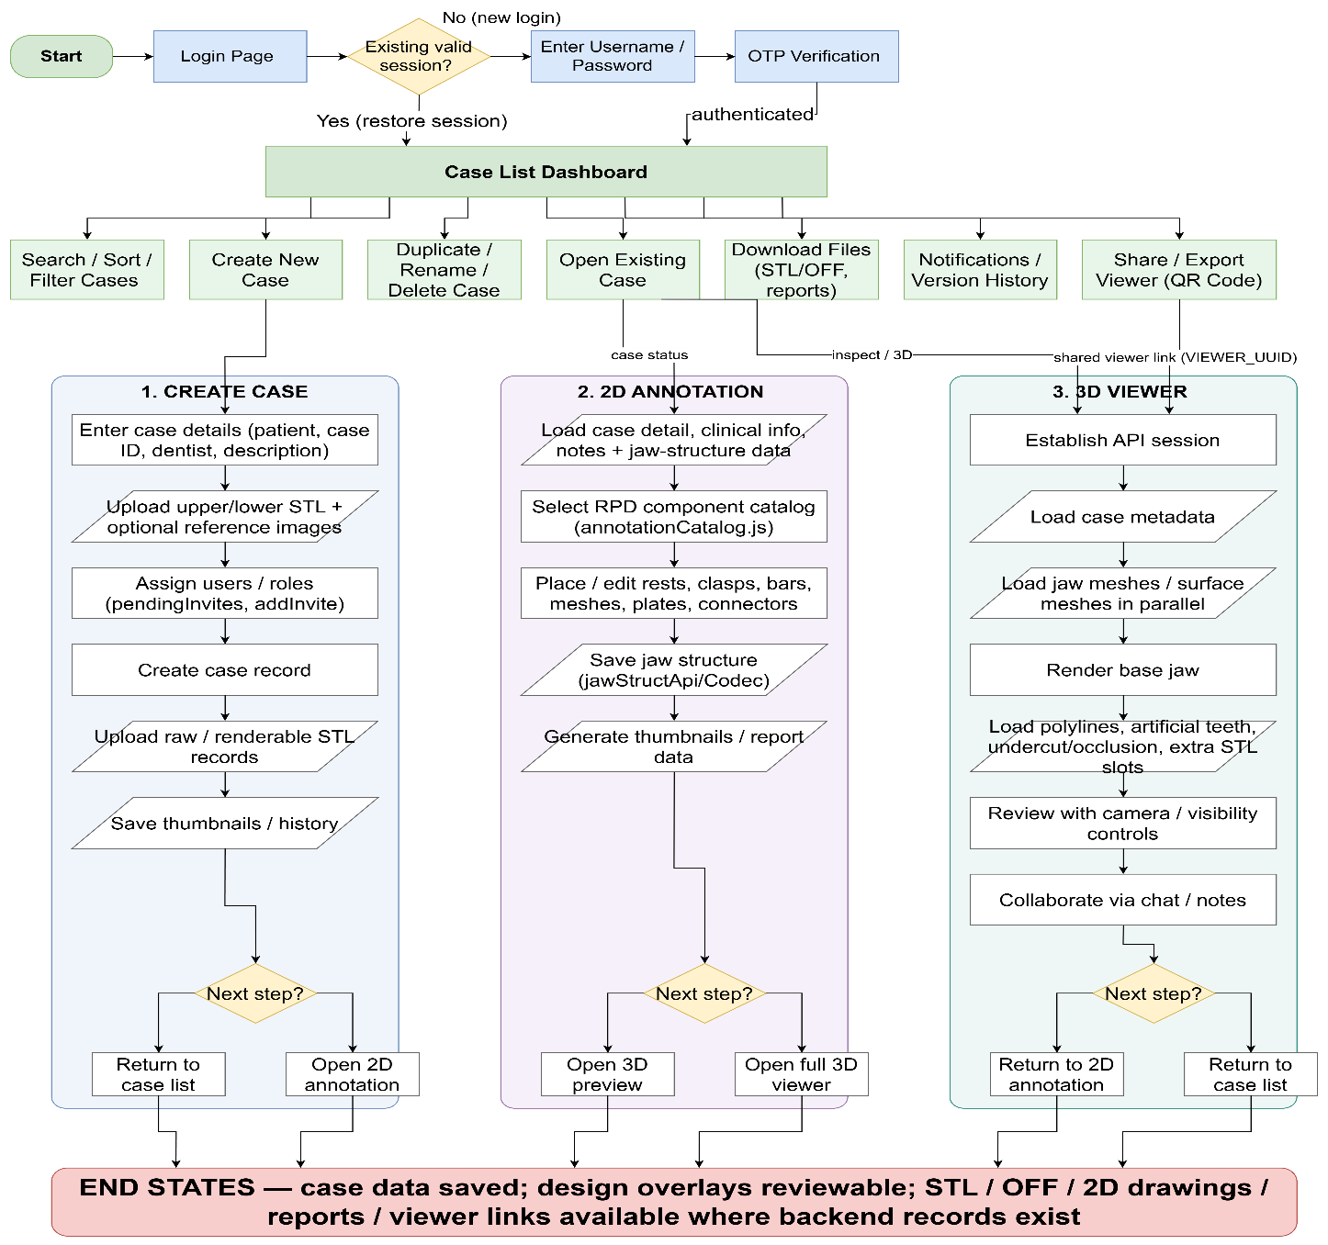

Workflow Diagram
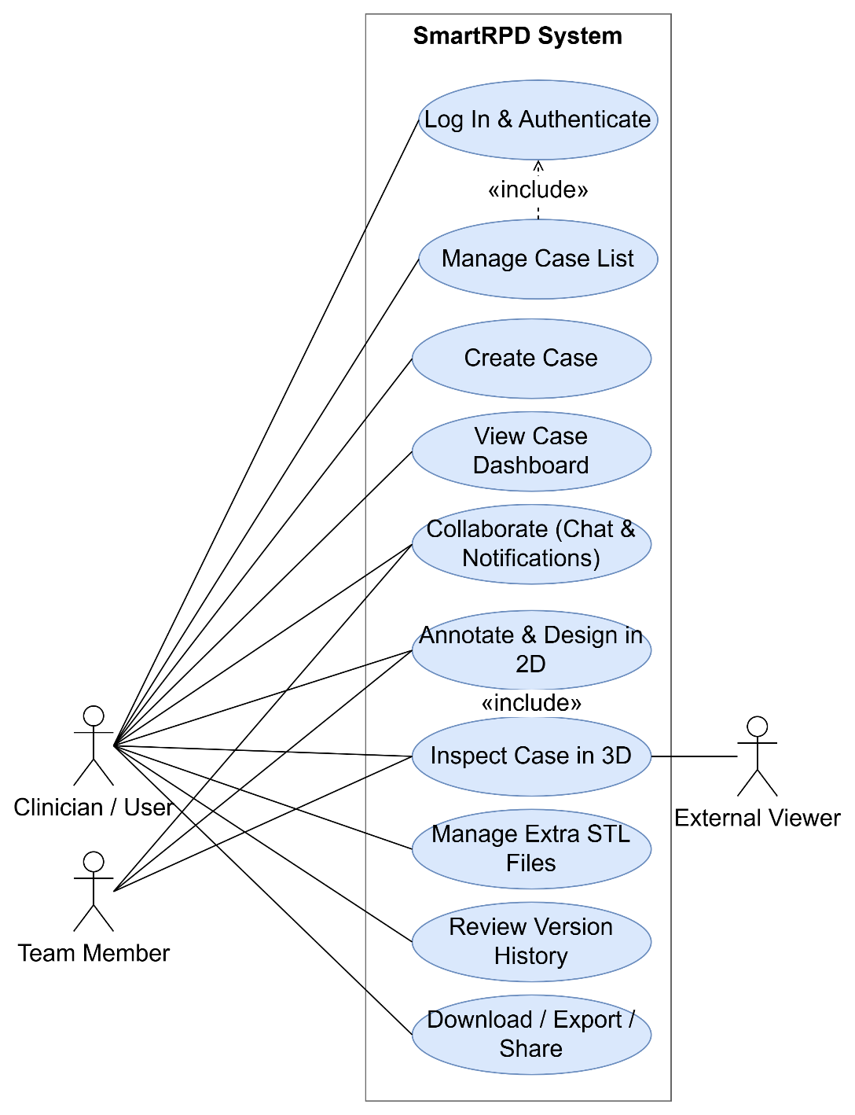

High-Level Use Case Diagram

4. Implemented Feature Status
Feature Area | Status | Repository Evidence
Login and authentication guard | Implemented | login.js, authGuard.js, and login.test.mjs/authGuard.test.mjs pass.
Case list and case management | Implemented | caseManagement.js handles filtering (applyClientFilters()), sorting, status changes (valueToApiStatus()), duplicate/rename/delete; sortCases.test.mjs passes.
Case creation and uploads | Implemented | createCase.js (STL/reference-image upload, team invites) and preview3D.js (extra STL slots 1–4) present; createCase.test.mjs passes.
2D annotation workspace | Implemented | Modules under src/js/2D handle catalog, placement, rendering, jaw structure and save flow; jawStructRoundTrip.test.mjs, jawStructMajorSwitch.test.mjs, jawStructLingualPlate.test.mjs, mergeInstructions.test.mjs pass.
Clinical information | Implemented | Clinical info assets present; clinicalInfoCodec.test.mjs passes.
3D jaw and design rendering | Implemented | Three.js viewer, OFF/STL loaders, polyline overlays and artificial-teeth modules present; stlLoad.test.mjs, orbitControl.test.mjs pass.
Responsive 3D viewer | Implemented | Mobile/tablet/desktop layout switching (isMobileDevice()) present in control.js, index.js, ThreeDMobile.js
Chat, notifications and version history | Implemented | chat.test.mjs passes; notifications.js and versionHistory.js present and integrated into the shared shell.
QR code sharing | Implemented | showThreeDViewerQr() in caseManagement.js (with qrcodejs via CDN)
Build and automated tests | Build passes; 20/20 suites passing | Production Webpack build succeeds (bundle.js, 820 KiB, warnings only on bundle size); 98/98 tests passing — re-verified live today, 2026-07-10.

5. 2D Annotation and RPD Design
The 2D annotation workspace is implemented through src/pages/2DAnnotation.html and the modules under src/js/2D/*. It provides upper/lower jaw display, component catalogue tabs, tooth-level placement, undo/redo history, save/back handling, clinical information panels, case notes, noticeboard content, chat access and a linked 3D preview area. RPD component placement is split into focused modules for rests, clasps, bars, meshes, plates, minor connectors and major connectors. Jaw-structure modules encode, decode, apply and persist the structured design data so it can be reloaded and round-tripped through the backend API.

5.1 Module Breakdown

5.1.1 Entry Point & Shared State
2DAnnotation.js — entry point for the workspace; also hosts shared annotation state and UI helpers so other modules can import from a single place. Feature modules are loaded via dynamic import() during init specifically to avoid circular-import timing issues (TDZ errors) between the entry point and the modules that depend on it.

5.1.2 2D Design Component Modules
- components.rest.js, components.clasp.js, components.bar.js — placement/asset logic for occlusal rests, retentive clasps, and connecting bars.
- components.mesh.js, components.plate.js — mesh spans (for missing-tooth coverage) and lingual/palatal plates.
- components.minor.js, components.major.js — minor connectors and major connectors (the largest module — full arch-spanning connector logic).
- components.js — the shared catalog root these all register into (COMPONENT_BY_ID, COMPONENT_CATALOG, COMPONENT_TABS).

5.1.3 Persistence Modules
- jawStructCodec.js — encodes and decodes base64 jaw-structure text; pure text↔JS conversion, no I/O.
- jawStructApply.js — applies a decoded design onto live tooth/component state (e.g. resolving which teeth a major connector or bar spans and logging the placement summary).
- jawStructApi.js — reads from and writes to the backend jaw-structure endpoint.
- jawStructCodes.js — canonical integer↔componentId code tables, mirroring the Unity C# StructData.cs enums so both ends of the pipeline agree on part identity.

5.1.4 Visual/Interaction Modules
- annotationCatalog.js — builds the component-tab UI and renders catalog options per tab/section (initComponentCatalog(), renderComponentCatalog(), createComponentItemButton()).
- annotationPlacement.js — placement/removal side-effect rules (e.g. removing a bar clasp cleans up its reciprocating element on the paired surface).
- annotationRender.js — SVG rendering, including a Safari/iOS-specific workaround: since WebKit drops CSS filter: color chains on external <image> elements, each tint color is instead published as a named SVG <filter> def and referenced via url(#tint-...).
- annotationLocks.js — tooth status picker (present/abutment/compromised), jaw lock toggle, and multi-tooth removal mode (hold Shift to enter, with a learned-hint tooltip since the button itself is hidden above 1201px viewport width).
- annotationVisuals.js — draws placed components on each tooth (major connectors, mesh, plates, rest/clasp markers) as layered rendering passes.
- annotationTeethModel.js — per-tooth state: initializing default records, toggling presence/status, and migrating legacy component lists into the modern placement-array format.

5.1.5 Supporting Modules
- constants.js — FDI tooth-order tables, SVG namespace constant, image/scale/offset constants used across rendering (e.g. TOOTH_IMAGE_WIDTH, COMPONENT_SCALE_BY_JAW).
- criteria.js — validates whether a selected component can legally be placed on a given tooth, returning a structured failure reason + conflicting components when it can't (assessPlacementCriteria()).
- toothUtils.js — a single small helper, normalizeSurface(), that folds "occlusal" into "lingual" for surface-key consistency.

5.1.6 Clinical & Reporting Modules
- clinicalInfo.js, caseNote.js — clinical info panel and per-case note fields (owner, due date, tooth shade, work category); includes .NET BinaryFormatter envelope decoding.
- instructionEditor.js — canvas-based freehand drawing/instruction editor with crop, rotate, and drag-to-reposition for placed shapes.
- noticeboard.js — pulls together case detail, captured jaw images (captureJawJpegDataUrl() from annotationLocks.js), instruction-editor output, and 3D preview captures (capture3DPreviewDataUrl() from preview3D.js) into the case report/noticeboard content.
- preview3D.js — the linked 3D preview area embedded in this workspace; also owns the extra-STL-slot upload/preview feature covered earlier.

6. 3D Viewer Architecture
The 3D viewer is built with Three.js and an orthographic camera (THREE.OrthographicCamera). An orthographic projection ensures jaw models and design overlays render at consistent scale regardless of zoom level. The scene contains anatomical jaw meshes, surface/design meshes, polyline overlays, artificial-teeth overlays, lights, camera controls and the shared viewer shell UI.

6.1 Scene Layers
Layer | Responsibility
parentObject | Hosts upper/lower jaw mesh objects and loaded STL/OFF mesh variants.
polylineOverlayGroup (named "polyline-overlay-group") | Hosts upper/lower RPD component polyline tube geometry and draggable edit handles.
artificial-tooth-overlay-group (built in src/artificialTeeth.js, mounted via artificialTeethRenderer) | Hosts upper/lower artificial tooth meshes and buccal/gingival guideline references, kept in sync with jaw mesh transforms every frame.
newControls.js (addVisibilityAndTransparencyControls()) | Controls object visibility, opacity, wireframe overlays, and undercut/occlusion mode switching.
resetButton.js (addResetButton()) | Owns camera reset (restores a cloned initial camera state and resets zoom to 7) and the rotation lock/unlock toggle — the "camera presets and review actions" belong here, not in newControls.js.
viewerShell.js | Provides the viewer footer (case name, logged-in user, connectivity status), the right-hand navigation drawer (wireRightNavButton()), chat entry (wireChatButton()), a notes popup (wireNotesPopup()), and sidebar links back to version history and the case list.

6.2 Mesh Loading
Jaw meshes load from backend endpoints. OFF data is parsed by src/OFFLoader.js and STL data by src/STLMeshLoader.js. The viewer supports fallback between OFF and STL payloads so cases can still render when one format is unavailable. Mesh fetches for jaw and denture meshes are initiated in parallel before either is awaited to minimise startup time.
- /parameterisation/mesh/getall — parameterised jaw mesh (OFF format)
- /surface/getall — denture/surface mesh (OFF format)
- /stl/get — closed jaw mesh variant (STL format, availability-checked first)

6.3 Render Loop
The main render loop runs in src/index.js. Each frame updates controls, anchors and clamps the rotation target (to prevent jaw drift), synchronises artificial teeth overlay groups to their corresponding jaw meshes, then renders the scene.

6.4 Mesh Quality Selection (2D-Embedded Preview)
When the embedded preview loads, promptMeshQualityChoice() shows a modal overlay ("Choose mesh quality") with two options — Low Quality ("Faster") and High Quality ("Original") — that runs concurrently with the undercut-heatmap and mesh-file fetches (Promise.all).
showMeshQualityProgress() swaps the overlay for a labeled progress bar (updateMeshQualityProgress(percent, jawLabel)), driven by updateJawMeshProgress() as each jaw parses — surfacing stage text like "Parsing Upper jaw" or "Matching undercut vertices Lower jaw" mapped across an 8%–94% range — before finishMeshQualityProgress() sets it to 100% ("3D jaw mesh ready") and clears the overlay.
Decimation logic – The original STL/OFF source bytes are kept untouched in preview3DState.qualitySource for upload/download.
- High Quality (getDisplayGeometryForQuality()): decimation is skipped entirely.
- Low Quality (createDisplayGeometry()): only triggers if the source mesh exceeds PREVIEW_MIN_SIMPLIFY_TRIANGLES (160,000 triangles) — smaller meshes render unsimplified even in "low" mode. buildClusteredGeometry() performs spatial vertex clustering: it buckets nearby vertices into grid cells sized off the mesh's bounding box, merges each cluster to its average position/color, and rebuilds deduplicated triangles from the merged vertex indices. It tries progressively larger cell sizes (multipliers 1, 1.25, 1.6, 2.05, 2.65, 3.4× a base size derived from a ~84,000-vertex target) and keeps whichever pass lands closest to the PREVIEW_MAX_DISPLAY_TRIANGLES budget (120,000 triangles), stopping early once at or under budget.
- Undercut-heatmap colouring is cluster-aware rather than naively blended: each cluster keeps the colour of its most severe undercut value instead of averaging it away, so simplification doesn't wash out clinically relevant heatmap regions.
- Post-load switching. A small HD/SD badge (updateQualityToggle()) stays visible after the initial load, letting the user re-render the already-loaded jaws at the other quality without a page reload (switchMeshQuality()) — it reuses the same progress overlay and reattaches any extra-STL-slot meshes afterward, since repopulating the jaw preview clears and rebuilds the model root. The logic is shared uniformly across both mesh source paths — OFF/parameterized (populateJawPreviewFromOFF()) and STL (populateJawPreview()) — both accept the resolved meshQuality value.

7. Polylines, Artificial Teeth and Heatmaps

7.1 Polyline System
- Loaded from /polylines/getall (POLYLINE_ENDPOINT), normalised across structured and encoded payload variants by normalizePolylineResponse() before rendering — this absorbs backend payload-shape differences into one consistent internal format regardless of how the source data was encoded.
- Rendered as tube geometry: each polyline segment becomes a THREE.TubeGeometry between adjacent points (createPolylineTubeGeometry() / createPolylineTubeGeometryBetweenPoints()), with per-component visibility toggles and draggable point handles for interactive editing.
- applyJawTransformToPolylineGroup() and getClosestJawPolylineSurfacePoint() accept a coordinateSpace of "jaw-local" or "scene-world", but the renderer doesn't just trust a source flag — it computes the median distance from the polyline points to the jaw surface under both interpretations (getMedianDistanceToJaw(points, jawType, "jaw-local") vs. "scene-world") and picks whichever produces the smaller (more plausible) distance. This avoids double-transforming data that's already in world space, or under-transforming data that's still jaw-local.
- Undo, redo and reset history are available for polyline point edits, exposed as dedicated toolbar buttons (Icon_undo2.png / Icon_redo2.png) wired directly in src/index.js.

7.2 Artificial Teeth
- Loaded separately through /toothPlacementData/get (distinct from the polyline and jaw-mesh endpoints), decoded via mapToothCraftData() into upper/lower ToothCraftData records (toothCraftDataUpperJaw_ / toothCraftDataLowerJaw_).
- Rendered as an independent overlay group (artificial-tooth-overlay-group, built in src/artificialTeeth.js); it does not modify jaw meshes or polylines — it's synced to jaw transforms every frame (syncToJawMeshes()) but never writes back into the jaw geometry itself.
- Core rule: geometry source and placement source must match. The decoder carries both toothData_ (placement) and toothSurfaceMeshData_ (geometry) as separate keyed structures per tooth (createToothRecordsFromCraftMaps()), and each rendered tooth mesh tags its own geometrySource and placementSource in userData for downstream diagnostics (e.g. mesh.userData?.source?.placementSource). Mixing surfaceMesh geometry with toothData-only placement misaligns the tooth, since the two paths aren't guaranteed to describe the same coordinate frame.
- Buccal and gingival guideline curves are rendered as separate, distinctly colored materials — buccal in orange (0xff9f1c) and gingival in cyan/blue (0x38d6ff), both semi-transparent (opacity 0.72–0.78) — for both upper and lower jaws. They are visual references only: nothing in the placement or transform code reads these curves back to snap, constrain, scale, or orient a tooth.

7.3 Undercut and Occlusion Heatmaps
- Available on supported jaw objects via the undercut/occlusion analysis mode buttons (newControls.js, per-component undercutButton/occlusionButton, toggling group.setMode("undercut"|"occlusion"|"normal")).
- Both modes share a single toggleable measurement legend panel managed by src/resetButton.js — a <section class="legend-container"> (initially legend-hidden) titled "Heatmap," with a close button (legend-close) and per-section color-coded value ranges for each mode, so switching between undercut and occlusion analysis doesn't require separate legend UI.

8. Loading, API and Reliability

8.1 Loading Strategy
The viewer prioritises making useful content available as early as possible:
- Establish session and fetch case metadata/thumbnails.
- Start jaw mesh and surface mesh requests in parallel.
- Render the base jaw mesh — viewer becomes interactive.
- Load polylines and artificial teeth in the background, as a single parallel batch (fetchAndRenderCaseOverlays(): Promise.all([fetchAndRenderPolylines(), artificialTeethRenderer.fetchAndRender()])) rather than sequentially.
- Chat loading is decoupled more strongly than just "non-blocking" — chat.js isn't loaded at all during page load. viewerShell.js's wireChatButton() only dynamically import()s it the first time the user actually clicks the chat button, so a broken or slow chat module can never affect initial scene load.

8.2 ApiClient
src/ApiClient.js manages REST calls, session login, streaming download progress and fallback JSON parsing.
- Session login is guarded by a module-level singleton promise (sessionLoginPromise / getSessionLogin()).
- Streaming download progress: when Content-Length is present, the response body is read via response.body.getReader() into a ReadableStream, updating a progress bar, percentage label, and a live download-speed readout (MB/s, computed from bytes-loaded ÷ elapsed time).
- Fallback JSON parsing: when Content-Length is absent (chunked transfer encoding — confirmed as the GCP-proxy case in 8.3), it skips the streaming UI entirely and falls straight to response.json(), rather than aborting.

9. Responsive UI and Collaboration

9.1 Viewer Shell
The viewer shell has been reworked for desktop, tablet and mobile breakpoints, using css/style.css (shell chrome) and src/index.js (the control-panel drawer) rather than a single stylesheet:
- Breakpoints: desktop ≥1025px, tablet 769–1024px, mobile ≤768px (css/style.css), consistent with the breakpoint scheme used across the other page-specific stylesheets (2Dannotation.css uses an analogous 1201px/720px split for its own controls).
- Persistent footer (.cm-footer in style.css, populated by viewerShell.js) shows case name (footerCaseName), current user (footerUserName — hidden entirely below 768px to save space), connection state (footerConnection), a menu button (footerMenuBtn), case chat entry (footerChatBtn), and the right-panel toggle (wireRightNavButton()).
- Desktop: the control panel is a labelled drawer (#hamburger-drawer) sliding in from the right, positioned left of the sidebar, with items filling the drawer's full width.
- Tablet/mobile: the same drawer element is not replaced but re-skinned by breakpoint — on tablet (769–1024px) it shrinks to a compact 176px-wide panel pinned near the top-right; on mobile (≤768px) it narrows further to 164px and repositions to sit just above the bottom footer bar (bottom: calc(92px + safe-area-inset)) — literally "pinned above the footer," confirming that phrasing precisely.

9.2 Case Chat
Case chat (chat.js) is wired into the 3D Viewer (viewerShell.js's wireChatButton()) and the 2D Annotation page (src/js/2D/2DAnnotation.js)
Case chat supports:
- Text comments and image attachments, with client-side MIME sniffing from the base64 signature (detectImageMime() — JPEG/PNG/GIF/WebP) rather than trusting a declared content type.
- A live preview of an in-progress image upload that survives message-list refreshes (a placeholder message, PREVIEW_AUTHOR, holds its place until the real message arrives).
- Polling (pollTimer/pollTick()) for new messages, with a lightweight signature check on each poll — if the response signature is just message IDs (cheap) it skips the expensive step of re-parsing every message's inline base64 image, only doing the costly full re-render when new content actually appears.
- A local cache of the conversation (saveCachedMessages()/loadCachedMessages()) so reopening chat paints instantly from cache before the network fetch resolves.
- A slide-in panel layout (css/chat.css): hidden state is translateX(100%), sliding to translateX(0) over a 0.22s transition — deliberately mirroring the same slide-in pattern used by the app sidebar, per the CSS file's own comment.
- wireSidebarVersionHistory() (in viewerShell.js) lazy-imports versionHistory.js and calls openVersionHistory() when sidebarVersionHistoryBtn is clicked.

10. Build, Test and Release

10.1 Application Status
Features developed have been formally written out in project requirements and specification sheet.
Current application has finished development on main features, in UAT phase before full rollout.

Gate | Status | Notes
Requirements | Complete | Requirements have been approved against a written spec.
Specifications | Complete | UI assets, component libraries (SVG asset trees under assets/), and working implementation exist.
Development stage | Complete | Production-mode Webpack build passes (npm run build).
Integration | Complete | Features are merged into shafik_nyunt_2_integration and brought to live development branch – nyunt/dev-W7.1.
Implementation | Complete | All main application features are implemented.
UAT | In Progress | UAT protocol and test cases are fully defined and testing is in progress.
Production | - | Production-mode compilation to be signed off after UAT complete and approval given.

11. Testing

11.1 Automated Test Results
Test run on 13 July 2026: npm test (Jest) against /nyunt/dev-W7.1.
Result: PASS — 20 test suites, 98 tests, 0 failing, 5.7s total runtime.
Environment: Jest with jsdom where required, Babel/Jest configuration from jest.config.cjs.

11.2 Test Coverage Areas
- Authentication guard, login and OTP — authGuard.test.mjs (guard mock/smoke check — does not yet exercise a real OTP flow), login.test.mjs (login(): rejects empty username/password; surfaces "login failed" on invalid credentials; redirects and stores user info on success; surfaces an error on fetch failure).
- Chat, create-case workflow, dashboard/case sorting — chat.test.mjs (handleSendMessage(): blocks send with no message and no image; sends text-only; sends image-only; clears input fields after send); createCase.test.mjs (currently a placeholder/dummy test — no real assertions on the create-case flow yet, a coverage gap worth flagging); sortCases.test.mjs (sortCases(): sorts by case_id ascending, username descending, creation_date ascending); dashboard.test.mjs — statusRank() (rank inference from exact and keyword-based status strings, case/whitespace-insensitive, later-stage keyword precedence), computeSteps() (5 stages × Upper/Lower lines, per-jaw independence, validated against the real case-1723 status value), countCompletedStages() (only counts a stage when both jaws are done), resolveCaptureSlots() (slot mapping tolerant of field-name variants, duplicate rows, and missing slot tags).
- Endpoint configuration, thumbnail save/update, STL load handling — endpoints.test.mjs covering fetchAdditionalCaseDetails (POST /additionalcasedetails/getall — request shaping, response reduction, concurrency cap, login/empty-list short-circuit, partial-failure tolerance), fetchCoOwners (POST /role/all/get — body shape, co-owner filtering, failure handling), and the chat notes endpoints (POST /notes/get/:id, POST /notes/create — URL/body shaping, content/image normalization, no-op without a case id); thumbnailSave.test.mjs and updateThumbnail.test.mjs (default vs. existing-thumbnail update paths); stlLoad.test.mjs (STL model load — currently a single smoke assertion, not a geometry-correctness check).
- Orbit controls, sidebar toggling — orbitControl.test.mjs, toggleSidebar.test.mjs — both single smoke-level assertions (control active / sidebar visible after toggle) rather than interaction-sequence tests.
- Clinical-info codec, jaw-structure round-trip — clinicalInfoCodec.test.mjs: the .NET BinaryFormatter envelope codec (valid envelope shape, 7-bit length prefix correctness, deterministic encode, decoding both self-encoded and desktop-authored blobs, edge case where a length byte collides with [ (0x5B), tolerance of junk/non-array payloads); desktop↔UI field mapping (int-enum/bool decoding, "none" sentinel handling for mobility/restoration/tilt, full 32-tooth desktop-order write-back, presence defaulting); full round-trip (lossless notes→rows→encode→decode→notes across every marker, idempotent decode∘encode on a full 32-tooth chart). jawStructRoundTrip.test.mjs: upper/lower jaw save text is byte-identical to the loaded text with no edits applied.
- Jaw-structure major-connector switching — jawStructMajorSwitch.test.mjs: loaded design correctly encodes lingual plate (type 7); switching to lingual bar encodes type 6 and back to plate re-encodes type 7; confirms the bar↔plate switch updates both the type label and the connector geometry grid together (not just one or the other).
- Lower lingual plate behaviour, reciprocating clasp exclusivity — jawStructLingualPlate.test.mjs: BAR round-trips to the desktop bar file; BAR→PLATE switch encodes the desktop plate file; loading a lingual PLATE creates exactly one plate-prox per present tooth; PLATE→BAR→reopen leaves no leftover plate-prox (the Section 10.2 regression case). reciprocatingExclusivity.test.mjs: clasp XOR plate is enforced on the reciprocating slot — placing a plate-prox/plate-crossmesh/reciprocating-clasp against an existing conflicting element is rejected; a retainer clasp may coexist with a reciprocal plate (different slot); addPlacement() swaps a reciprocating clasp and plate in place of each other rather than allowing both.
- Merge instructions, crypt helpers and concurrency mapping — mergeInstructions.test.mjs (mergeInstructions(): merges server/local items on a shared title key, keeps distinct keys separate, falls back title→id→preview for the merge key, tolerates null/undefined input); crypt.test.mjs (lol(): encrypts/decrypts numeric case IDs correctly, produces different ciphertext per ID, degrades gracefully — returns NaN, doesn't throw — on invalid encrypted input); mapWithConcurrency.test.mjs (preserves input order regardless of resolution order, never exceeds the concurrency limit, calls the mapper exactly once per item, handles empty lists, caps in-flight count when the limit exceeds the item count).
- QR code sharing — showThreeDViewerQr() / buildThreeDViewerUrl() (caseManagement.js): no automated Jest coverage — depends on window.QRCode from a CDN script (qrcodejs, loaded in case_list.html) and canvas/DOM rendering outside the current jsdom setup. Verified manually per §12.2 UAT-11 (script below); recommend closing the gap with a jsdom test that stubs window.QRCode.

12. UAT Report

12.1 Scope
UAT checks SmartRPD Web Application workflows are acceptable to intended users on supported desktop and mobile browsers before release/sign-off. Screenshots from testing are in folder uat-screens.
- Desktop: Windows laptop/desktop, current Chrome or Edge at 1366×768 or wider.
- Mobile: iOS Safari and/or Android Chrome at phone-size viewport.
- Tablet: iPad Safari and/or Android tablet Chrome, viewport in the 769–1024px range.

12.2 Test Cases
ID | Workflow | Pass Criteria | Fail Criteria
UAT-01 | Login & Authentication | User signs in with password + OTP; authGuard.js allows navigation to every protected page afterward. | OTP fails to verify a correct code, or a page loads without loggedInUser in localStorage present (guard bypassed), or a valid session is bounced back to login.
UAT-02 | Case List | Search/filter (applyClientFilters()) and sort return correct results; inline status change (valueToApiStatus()) persists; duplicate/rename/delete/open all operate on the correct case. | Filter/sort returns stale or wrong results; status change doesn't persist after reload; delete/duplicate acts on the wrong case ID.
UAT-03 | Case Creation | Case created with upper/lower STL + optional reference images; invited users (pendingInvites, addInvite()) receive access; case appears in Case List immediately. | Upload silently fails without error surfaced to the user; invited user has no access to the created case; case doesn't appear without a manual refresh.
UAT-04 | Dashboard | Per-case overview opens as an overlay (buildOverlay()) without navigating away; progress steps (computeSteps(), countCompletedStages()) and capture slots (resolveCaptureSlots()) match the case's actual state. | Progress/step count is wrong relative to actual case state; overlay navigates away from the current workspace instead of staying in place.
UAT-05 | Collaboration | Chat (image + text) and notifications open as overlays from list, dashboard, and viewer contexts without full page navigation; new messages/alerts appear without a manual refresh. | Chat/notification overlay forces a page reload; a sent message or triggered alert doesn't appear for the recipient within the polling interval.
UAT-06 | 2D Annotation | Clinical info/notes save (clinicalInfo.js, caseNote.js); freehand instruction marks save (instructionEditor.js); RPD components can be placed, respect per-component placement/lock rules (annotationPlacement.js, annotationLocks.js), and the saved jaw-structure data (jawStructApi.js) reloads identically. | A placed component violates a rule it should be locked against (e.g. two reciprocating elements — see §11.2's reciprocatingExclusivity coverage) and is still accepted; reload after save differs from what was saved.
UAT-07 | Embedded 3D Preview (in 2D workflow) | From within 2D Annotation, jaw geometry, design overlays and artificial-teeth placement render correctly; undercut/occlusion modes toggle per-component; HD/SD mesh-quality toggle re-renders correctly (switchMeshQuality()) without leaving stale geometry. | Toggling quality leaves a mix of old/new geometry visible; undercut/occlusion mode doesn't visually change; preview desyncs from the 2D design it's supposed to reflect.
UAT-08 | 3D Viewer (standalone) | Same correctness bar as UAT-07, plus: polyline handle drag + undo/redo/reset actually reverts (§7.1); coordinate-space detection doesn't double- or under-transform on at least one known jaw-local and one known scene-world case; artificial-teeth geometry/placement source matching holds on a mixed-source case (§7.2); camera lock-button and plate-placement fixes from 514ead3/3b120b0 haven't regressed. | Undo/redo leaves the polyline in a different state than before the edit; an overlay renders visibly offset/rotated from the jaw (transform-space bug); a tooth renders at the wrong position due to mismatched geometry/placement source.
UAT-09 | Add STL Files | Up to 4 extra reference STL slots (uploadExtraStl(), jaw_stls_extra_slot_1..4) upload, render, and can be shown/hidden (toggleExtraStlVisibility()) and deleted (deleteExtraStl()) independently of each other and of the main jaw meshes. | Toggling or deleting one extra slot affects a different slot or the main jaw mesh; a 5th slot is silently accepted past the documented 4-slot limit.
UAT-10 | Version History | Past design iterations open and display correctly, both as a standalone page (VersionHistory.html) and as a modal from other entry points (versionHistory.js); the two entry points show consistent data. | Standalone page and modal show different data for the same case; a past iteration fails to load or shows blank content.
UAT-11 | Download / Export / Share | Raw OFF/STL files download correctly (downloadCaseFiles()); compiled .docx report generates correctly (buildReportHtml()/generateReport(), reportHtmlToDocxBytes()); the 3D viewer share link works under the shared VIEWER_UUID with the case ID correctly obfuscated (crypt.js lol()); the QR code (showThreeDViewerQr()) scans and opens the same working link. | Downloaded file is corrupt/incomplete; generated .docx is missing design images or clinical data present in the case; the share link's decoded case ID resolves to the wrong case; the QR code encodes a stale or malformed link.
UAT-12 | Responsive (tablet + mobile) | Core workflows above remain usable at tablet (769–1024px, compact drawer per §9) and mobile (≤768px) breakpoints; touch-drag of a polyline edit handle (pointerdown/pointermove in src/index.js) works correctly; required screenshots captured per device class. | A control is unreachable/occluded at a given breakpoint; touch drag doesn't register or drags the wrong handle; layout breaks between the documented breakpoint boundaries.

13. High-Level Architecture

13.1 High-Level Architecture
Static multi-page frontend application using HTML, CSS and ES modules, bundled for production with Webpack and runnable locally through Vite. The frontend communicates with the SmartRPD – https://live.api.smartrpdai.com/api/smartrpd.

13.2 Layer Summary
Layer | Components
Client presentation | Each page pairs with a primary controller — full page-to-file mapping in §2's Page/Area table. Key controllers: login.js (Login), caseManagement.js (Case List — including filtering, status changes, and QR-code sharing), createCase.js (Case Creation), dashboard.js (Dashboard overlay), 2DAnnotation.js + src/js/2D/* (2D Annotation), src/index.js (3D Viewer), versionHistory.js (Version History).
Shared client services | authGuard.js, login.js, appSidebar.js, viewerShell.js, chat.js, notifications.js, versionHistory.js, crypt.js (lol() case-id obfuscation — shared by Case List's share-link/QR flow and viewer navigation).
Configuration | config.js — centralizes MACHINE_ID, VIEWER_UUID, and a fallback LOGIN_CREDENTIALS object
API Connection | ApiClient.js — reusable REST, session login, progress tracking, fallback JSON parsing.
2D domain | 2DAnnotation.js coordinates state; component modules encode rests/clasps/bars/meshes/plates/connectors; jawStructCodec.js converts backend base64 jaw-structure text; preview3D.js — the embedded 3D preview and extra-STL-slot upload feature.
3D domain | src/index.js — Three.js scene, orthographic camera, mesh groups, polyline and artificial-teeth overlays; newControls.js — visibility, opacity, analysis modes; OFFLoader.js + STLMeshLoader.js — geometry parsers; control.js — addVisibilityAndTransparencyControls(), a dat.gui-based visibility/transparency panel with its own mobile-device check (isMobileDevice()), imported separately from newControls.js.
Backend/API | SmartRPD REST endpoints for auth, case data, roles, alerts, notes, thumbnails, clinical info, jaw-structure, STL/OFF meshes, polylines, heatmaps, email and report support.

13.3 Data Flow
A Data Flow diagram is included in the foot of this section, the Workflow Diagram is at the end of Section 3.
- User authenticates → frontend stores logged-in user/session data.
- Case list requests case records from API.
- Selected case opens 2D or 3D page → page loads metadata and design/mesh payloads.
- User edits annotations/notes/clinical data → frontend posts updated payloads to API.
- Saved data is reloaded for verification/review/download.

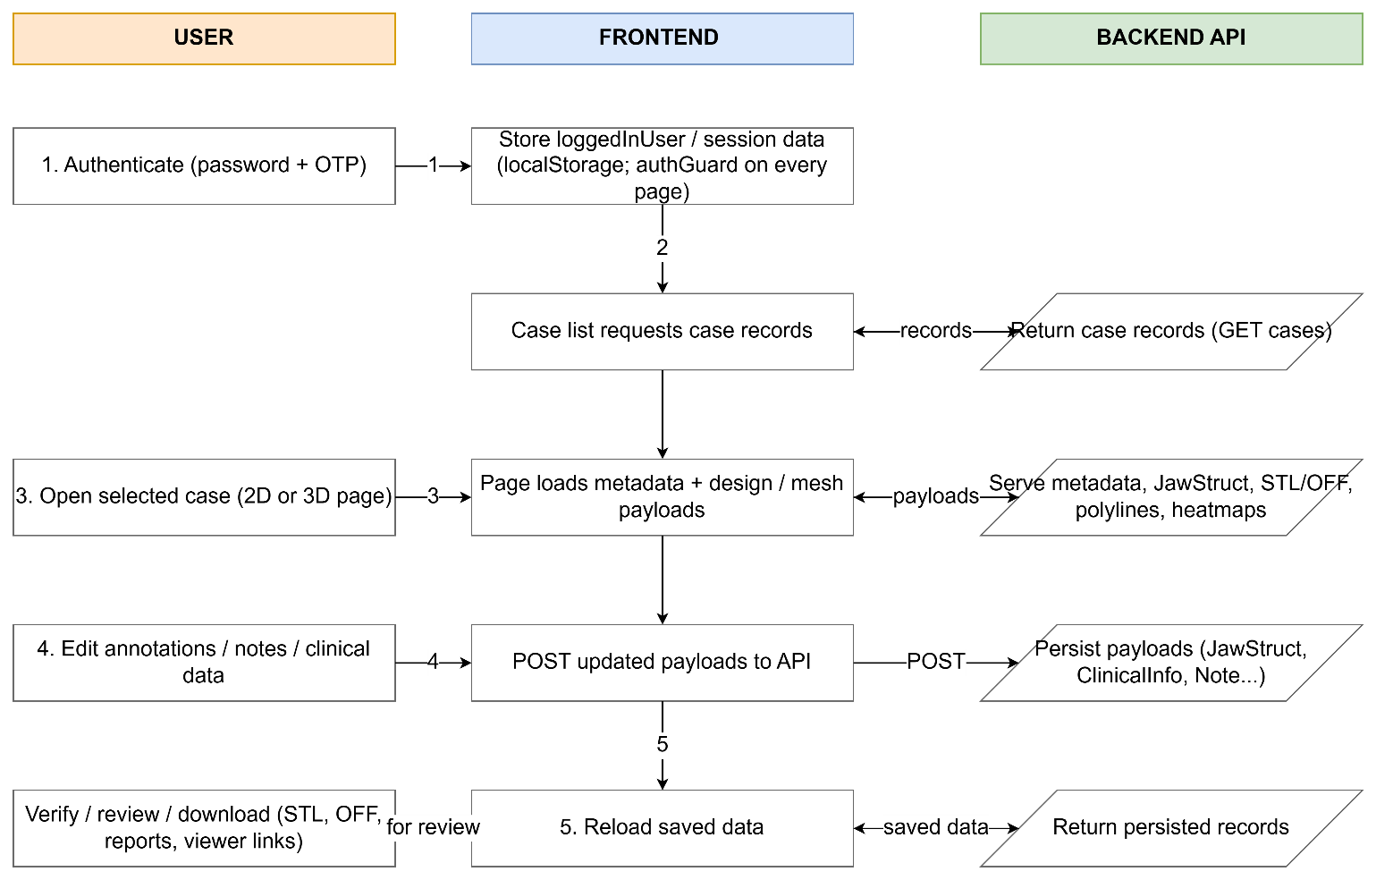

Data Flow Diagram

14. API References

14.1 Endpoint Summary
Category | Endpoints
Authentication | POST /user/login, POST /otp, POST /otp/verify, POST /user/logout (missing from the prior list)
Case management | POST /case/user/findall/get, POST /case/get/:id, POST /case, PUT /case/:id, POST /case/delete/:id, POST /case/duplicate, POST /case/rename/:id
Roles, invitations and alerts | POST /role, POST /role/all/get, POST /role/delete, POST /alerts, POST /alerts/getallbytouser, POST /alerts/setreadstatus
Case metadata and history | POST /additionalcasedetails/getall, POST /additionalcasedetails, POST /casehistory, POST /casehistory/getall
Jaw, surface and STL data | POST /parameterisation/mesh/getall, POST /surface/getall, POST /stl/get, POST /stl/raw/get, POST /stl/get/:type, POST /stl, POST /stl/raw
Extra STL slots | POST /stl/slot/get, POST /stl/slot/, POST /stl/slot/delete
Design overlays and analysis | POST /polylines/getall, POST /undercutheatmap/get, POST /toothPlacementData/get (missing — artificial-teeth data source, §7.2)
Clinical and jaw-structure data | POST /clinicalinfo/get/:caseId, POST /clinicalinfo, POST /jawstruct/l2/getall, POST /jawstruct/l2
Images and noticeboard | POST /thumbnails, POST /thumbnails/get, POST /noticeboard/editedview/get, POST /noticeboard/editedview, POST /noticeboard/drawnview, POST /noticeboard/drawnview/get, POST /noticeboard/view, POST /noticeboard/view/get
Chat and communication | POST /notes/get/:caseId, POST /notes/create, POST /mailinglist/add, POST /sendEmail, POST /sendCustomEmail

14.2 Common Request Envelope
Many POST payloads use an array envelope: the first object contains machine_id, uuid, and caseIntID; the second object contains the case-specific payload. machine_id identifies the client application, uuid identifies the logged-in user/session, and caseIntID identifies the numeric backend case.

15. Data Schema

15.1 Entity Relationship Overview
Entity | Key Fields | Relationships
User | uuid (PK), username, email, is_admin | 1..* → Role; 1..* → Alert (sender/recipient); 1..* → Note (sender)
Case | id/caseIntID (PK), case_id, name, created_at, new_status | 1..* → Role, AdditionalCaseDetails, JawStruct, ClinicalInfo, STL, Thumbnail, CaseHistory, Note, Polyline, UndercutHeatmap, NoticeboardEditedView
Role | id (PK), uuid (FK→User), case_int_id (FK→Case), role/permission | Connects users to cases with access permissions.
AdditionalCaseDetails | id (PK), case_id/caseIntID (FK→Case), assigned_to, due_date (Unix seconds), comments, new_status | Drives the case-list due-date colour indicator and dashboard workflow status
JawStruct | id (PK), case_id (FK), type (upper_jaw/lower_jaw), filename, data (base64) | Stores encoded RPD design data per jaw per case.
ClinicalInfo | id (PK), case_id (FK), data (base64 BinaryFormatter) | Per-tooth clinical flags: mobility, rct, restoration, crown, implant, rootStump, cracked, tilted, extraction, abutment.
STL | id (PK), case_id (FK), type, filename, data (base64/file) | Jaw geometry uploads in STL/OFF format.
Thumbnail | id (PK), case_id (FK→Case), slot/type, data (base64) | Screenshot/preview images per case; distinct from the raw STL/OFF geometry in the STL entity.
CaseHistory | id (PK), case_id (FK→Case), action/status, created_at | Backs Version History — both the standalone page and the modal read from this.
Note | id (PK), case_id (FK), sender_uuid (FK), message, image_data, created_at | Case chat messages with optional image attachments.
Alert | id (PK), to_user_uuid, from_user_uuid, caseIntID, read_status, message | In-app notifications between users on a case.
Polyline | id (PK), case_id (FK), jaw/type/component, points/data | 3D coordinate arrays rendered as tube geometry overlays.
UndercutHeatmap | id (PK), case_id (FK→Case), jaw/type, data | Backs the undercut/occlusion heatmap analysis modes.
NoticeboardEditedView | id (PK), case_id (FK→Case), filenames, data | Backs the 2D-to-desktop noticeboard report handoff (noticeboard.js).
ArtificialTeeth (ToothCraftData) | Per-case, per-jaw (toothCraftDataUpperJaw_/toothCraftDataLowerJaw_), each a Unity MessagePack struct with 7 numeric-keyed sub-maps: toothData_ (placement), toothSurfaceMeshData_ (geometry), toothLandmarkInterfaceData_, toothTransformInterfaceData_, plus initial* variants of the mesh/landmark/transform maps (src/artificialTeeth.js:637–672) | Fetched via /toothPlacementData/get keyed by caseIntID.
MailingList | case_int_id, email (src/index.js:4098–4137, POST /mailinglist/add) | An ad-hoc invite-by-email capture tied only to Case — no User/Role object attached.

15.2 Key Field Types
- UUIDs: String — used as primary/foreign keys for users, sessions and viewer fallback identity.
- Case IDs: Integer (caseIntID) in most API envelopes; String (case_id) in some older routes. This isn't just cosmetic — it's caseIntID specifically (the integer form) that gets encoded into every shared QR/viewer link. Any future work treating case_id/caseIntID as interchangeable risks a link that decodes to the wrong case, or fails to decode at all.
- Timestamps: Integer Unix seconds (due_date, created_at) or ISO String depending on endpoint.
- Binary payloads: Base64 String (jaw-structure text, clinical info, STL/OFF geometry, thumbnails).
- Clinical info data: .NET BinaryFormatter single-string envelope containing JSON rows per tooth.
- Polyline points: Array/Object/Base64 String of 3D coordinates depending on backend payload variant.
- Noticeboard filenames/data: jagged byte[][] under .NET BinaryFormatter (MS-NRBF) framing — a distinct column shape from ClinicalInfo's envelope (per-string BinaryFormatter streams for filenames, raw PNG bytes for data), worth listing separately since conflating the two invites a real decode mismatch.
- Case workflow status: (new_status): confirmed live from the Case List "Filter by Status" dropdown during this session's UAT pass — the actual enum is na, draft, 2d_design_pending, 2d_design_drafted, 2d_design_approved, 3d_design_pending, 3d_design_drafted, 3d_design_approved, in_production, out_for_delivery, delivered, completed. This replaces guesswork with the real value domain the frontend (and dashboard.test.mjs's statusRank()) has to keep in sync with.
- Artificial-teeth data: Unity MessagePack with numeric field keys (src/artificialTeeth.js) — a third binary encoding scheme in play alongside plain base64 (JawStruct/STL) and .NET BinaryFormatter (ClinicalInfo, Noticeboard). Three different codecs across the schema is worth keeping in mind as its own risk surface, same spirit as point 7's BinaryFormatter/MS-NRBF distinction.
- Slot addressing: slotNumber (extra STL slots) is a bare integer 1–4 with no backend-side semantic meaning — the upper/lower/metal-RPD labeling exists only in frontend constants. Any second client (or a future backend change) that assumes a different slot→label mapping would silently misfile a file under the wrong slot without either side raising an error.

15.3 ERD Diagram
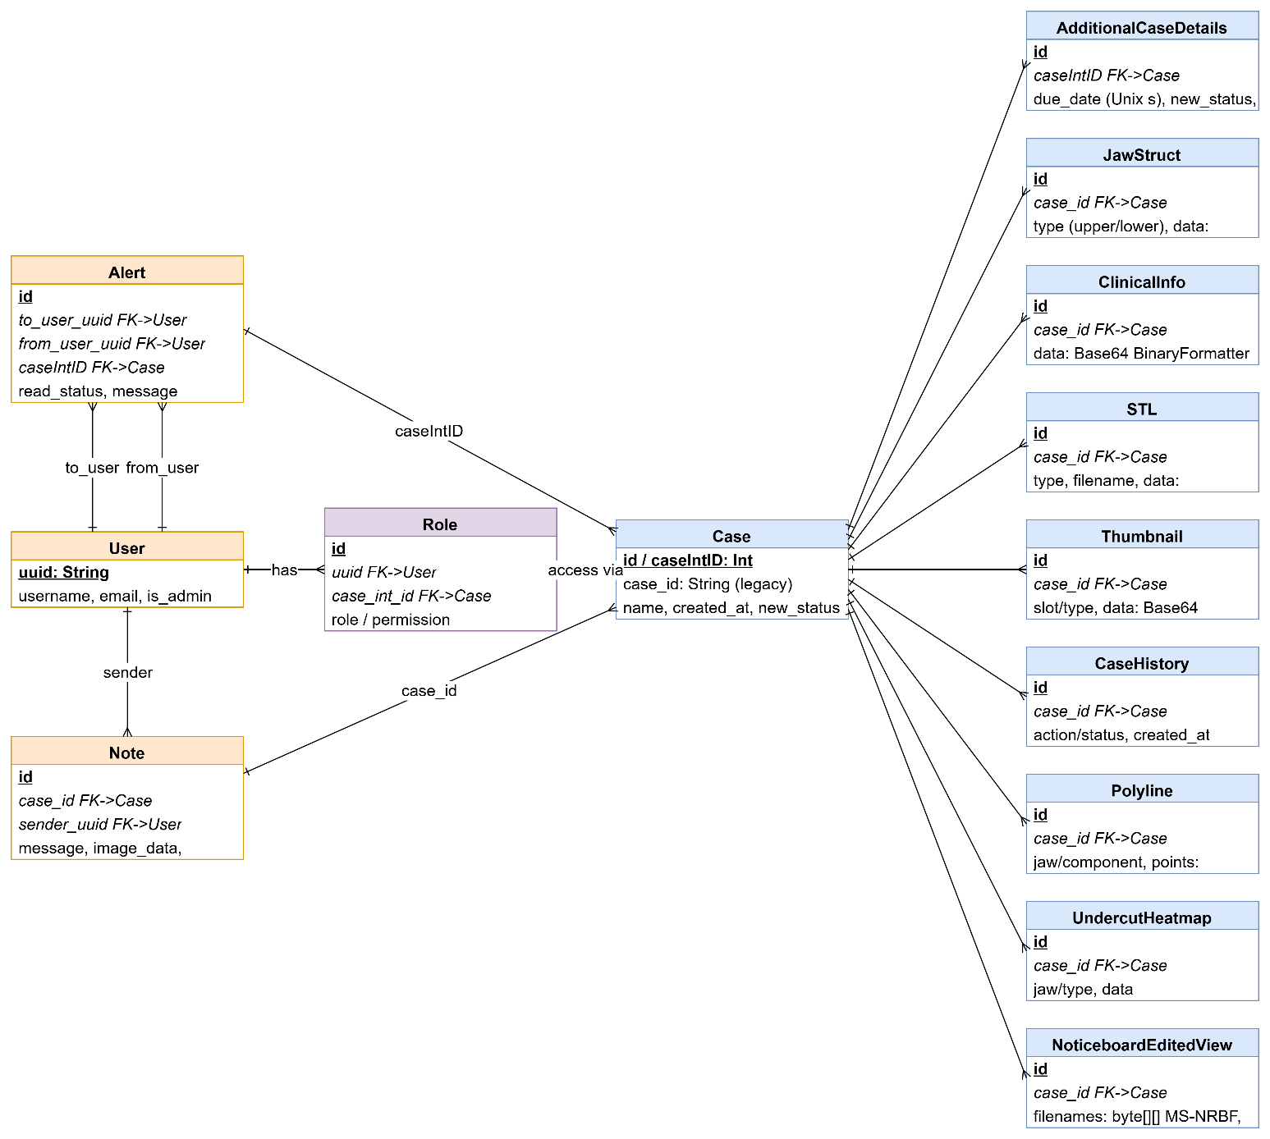

16. Handover Items
This section summarises the handover items, including frontend API usage; physical table names/indexes.

16.1 Items Completed in This Document
- Application overview, structure and page map
- Main user workflow documentation
- Implemented feature status with repository evidence
- 2D annotation module breakdown and persistence flow
- 3D viewer architecture and scene layer breakdown
- API endpoint reference and common request envelope
- ERD, Flowchart and Use Case Diagrams
- UAT protocol with test case definitions
- Data-schema entity

16.2 Items in other documents
- Maintenance & Operational Runbook
- DevOps/CI/CD Pipeline & Deployment Runbook
- Recent commit history – live dev branch
- Data Dictionary
- Security posture and data privacy protocols
- Known issues and constraints backlog

Appendix
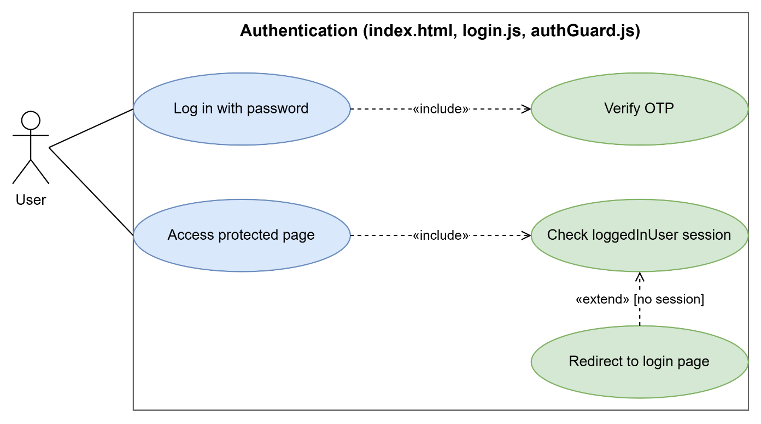
- Login & Authentication
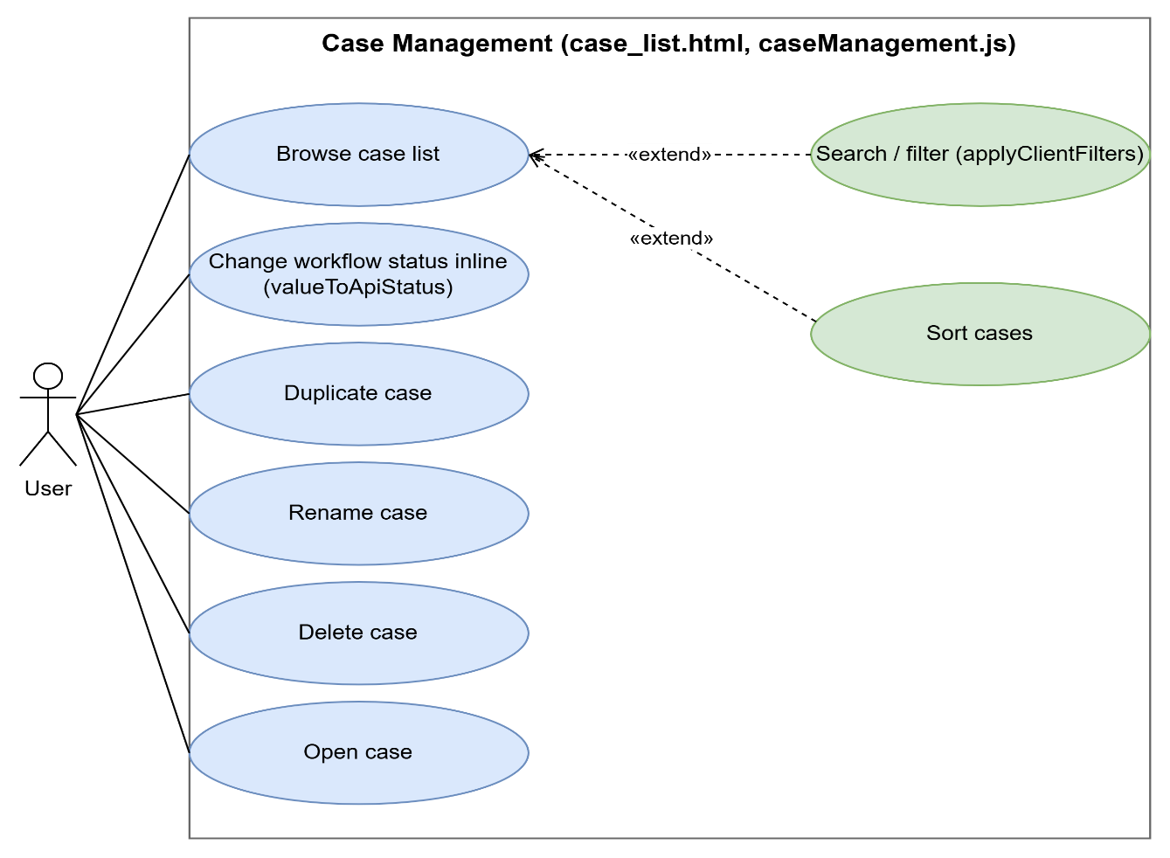
- Case List Management

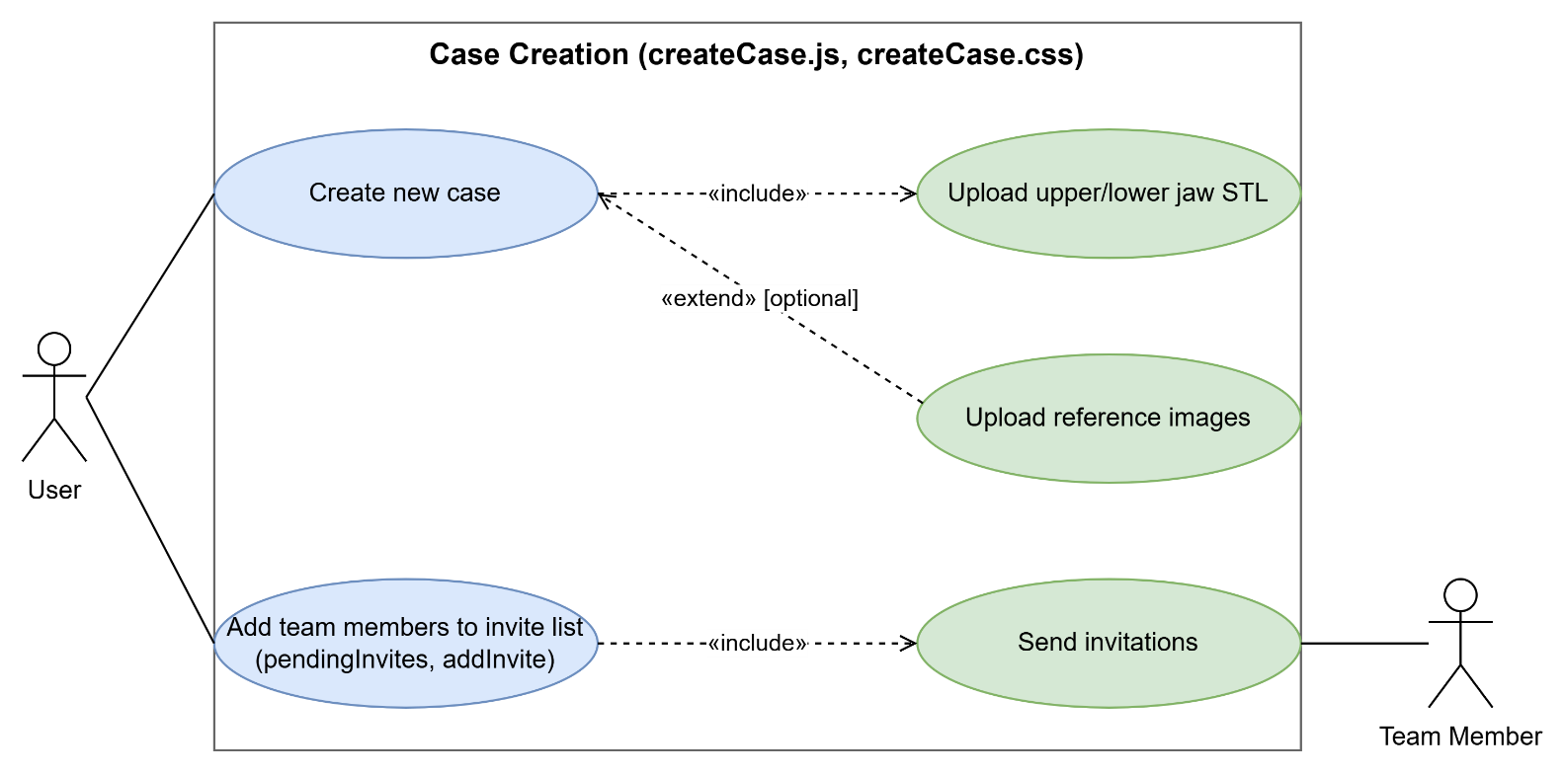
- Create Case
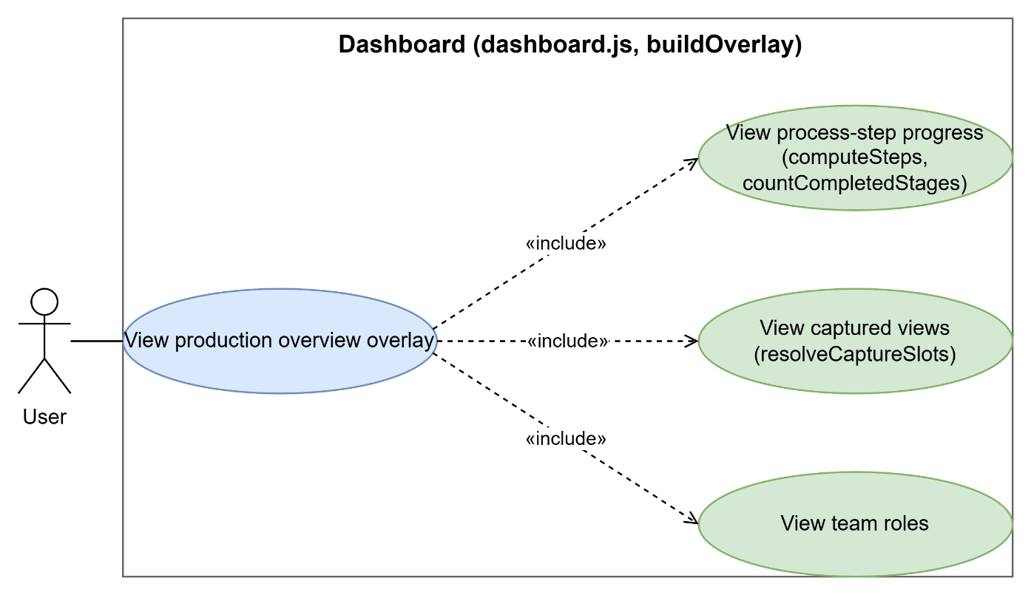
- Dashboard
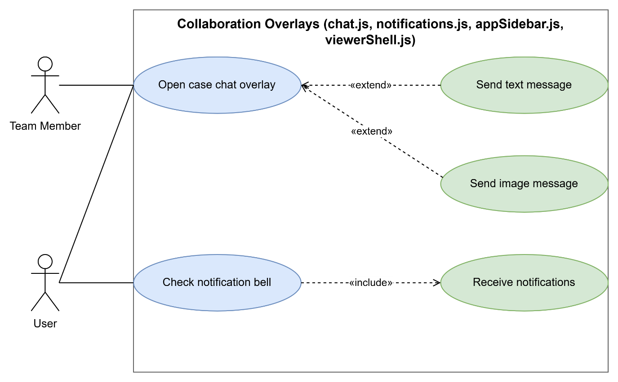
- Case Chat
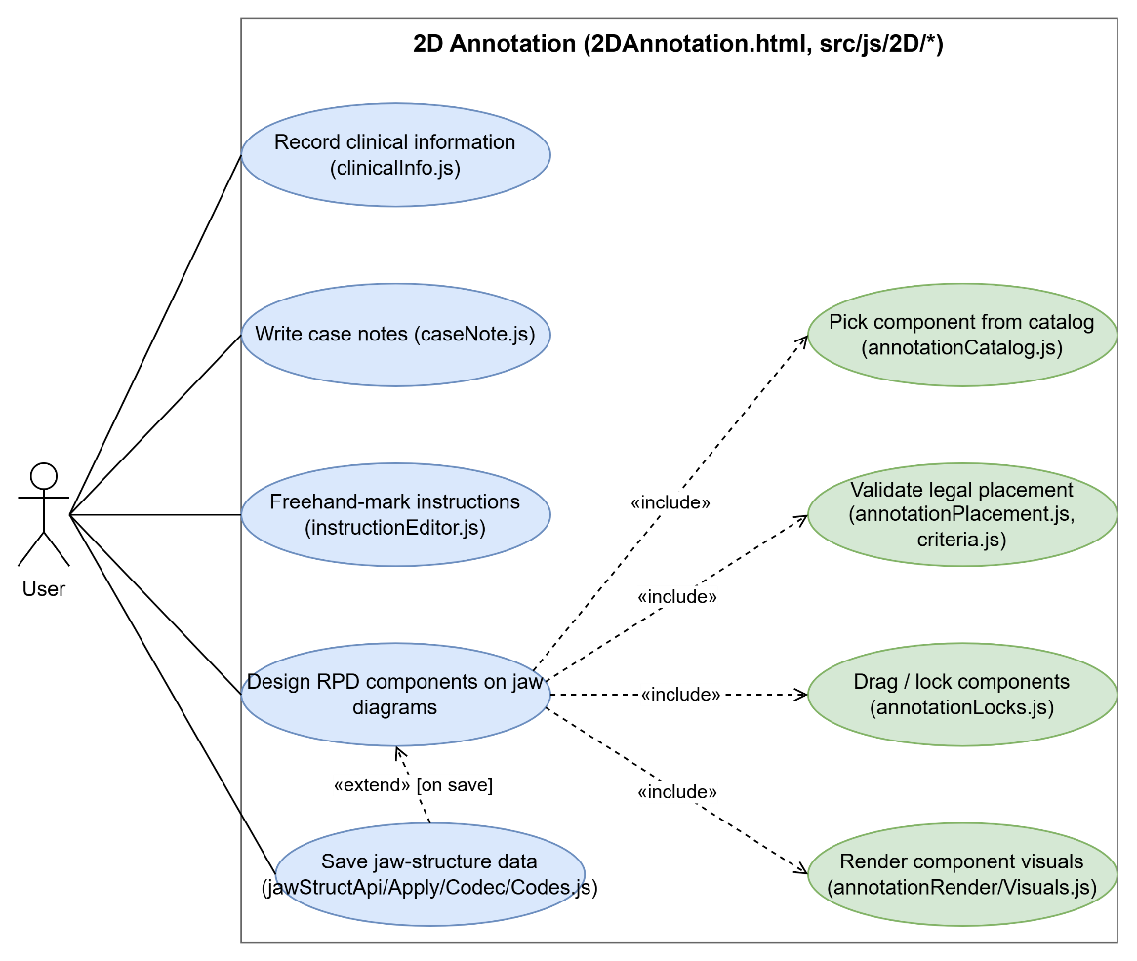
- 2D Annotation
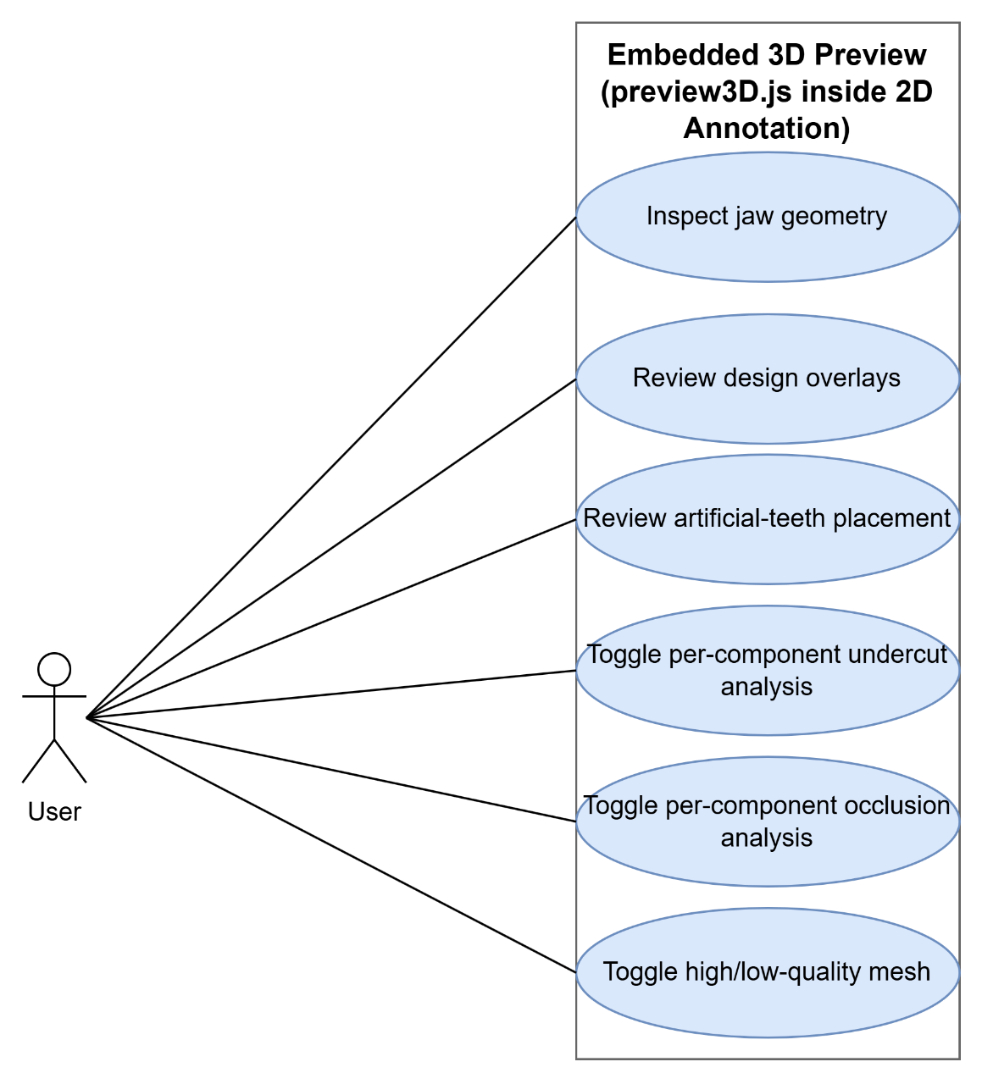
- Embedded 3D Preview
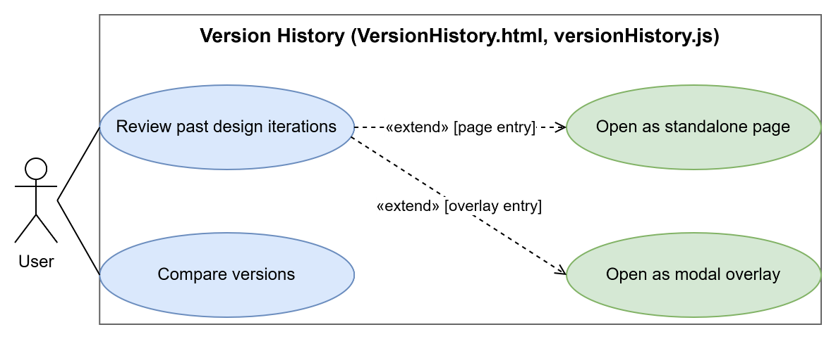

- Version History
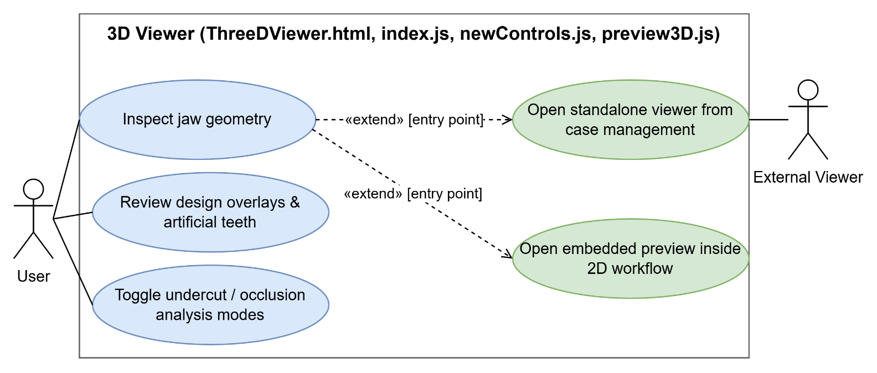
- 3D Viewer
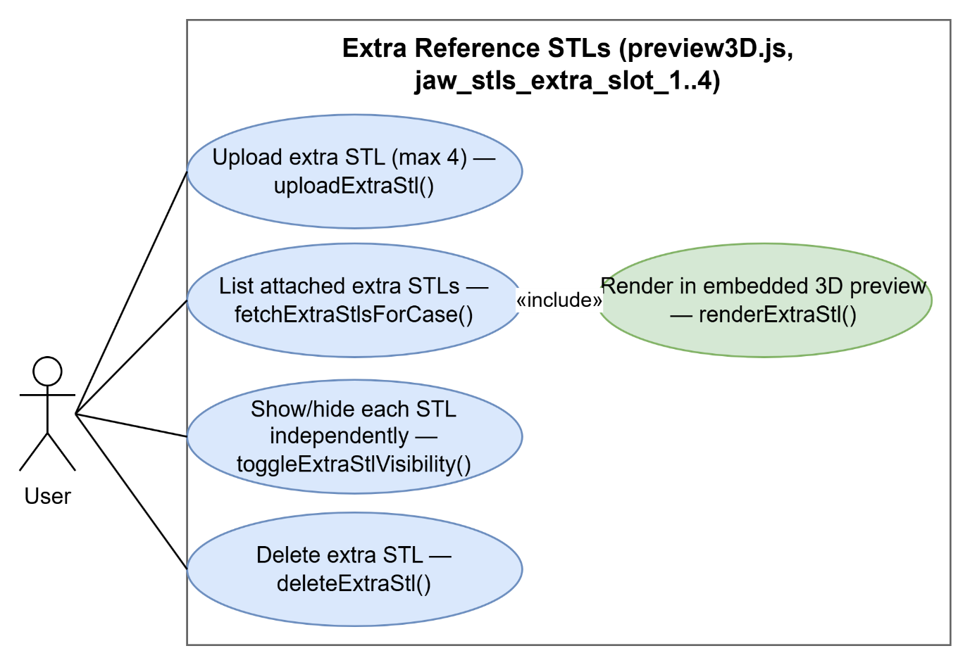
- Add STL Files
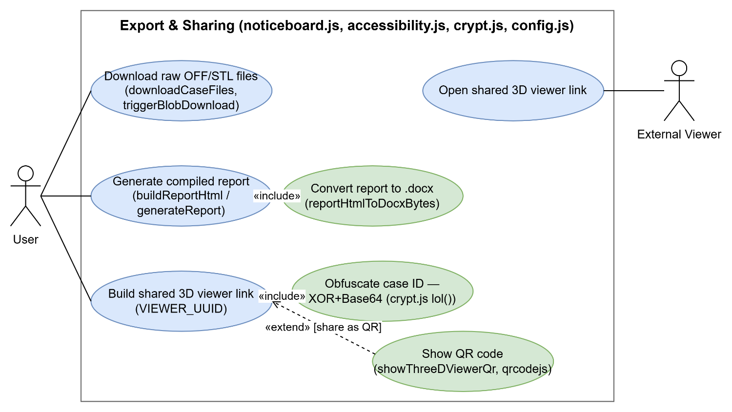
- Download/Export/Share

